
Module: Marketing Management
(LCMB7024_BIRM)
Title: Marketing Environmental Analysis of the Digital Streaming Industry: A Critical Comparative Study of Netflix as Platform Pioneer and Disney+ as Strategic Follower under Technological and Socio-Cultural Forces
Student Name:Navinkumar Jayakumar
Student Number: 2506813
Lecturer Name
Taonga Kaonga Sobere-Snithers

Table of Contents

1. Executive Contextualisation: The Streaming Wars in a Platform Economy 3
2. Conceptual Foundations: Platform Competition and Cultural Strategy 4
3. Industry Architecture: Evolution of the Global Streaming Ecosystem 6
4. Task 1: Macro-Environmental Analysis 7
4.1 Technological Macro-Environment: Algorithmic Capitalism and Data Infrastructure 7
4.2 Socio-Cultural Macro-Environment: Changing Media Consumption and Cultural Hybridisation 10
5. Strategic Positioning Outcomes: Platform Power and Brand Identity 14
6. Task 2: Strategic Responses and Growth Evaluation 16
6.1 Competitive Logic through Platform Strategy Framework 16
6.2 Growth Trajectories through Strategic Renewal Lens 19
7. Forward-Looking Critical Synthesis: The Future of Streaming Competition 20
8. Conclusion: Strategic Implications for Marketing Management in Platform Industries 21
Reference 22

1. Executive Contextualisation: The Streaming Wars in a Platform Economy

This study examines how technological and socio-cultural macro-environmental elements affect global digital streaming competitive positioning. Netflix leads and Disney+ follows. Data-driven on-demand streaming has supplanted linear broadcast television in the recent decade. People make, share, and profit from things differently (Lobato, 2019; Cunningham and Craig, 2019). The "streaming wars" hurt more than Hollywood. Companies that employ algorithms to globalize culture, increase subscribers, and personalize services compete.

Cloud computing, hybrid monetization models with ads, and AI-powered recommendation systems have transformed business marketing. Because people binge-watch, expect content that matches their identity, and are tired with subscriptions, their interests have altered (Wayne, 2021). Netflix's algorithms and early start made it the greatest streaming provider. Disney+ launched in 2019 and became famous for combining characters and storylines from several places. The study integrates macro-environmental theory to platform competition. They debate how technology and culture affect things and how to adapt and stay ahead.

2. Conceptual Foundations: Platform Competition and Cultural Strategy

PESTLE provides the best overall perspective. Platform operators worry about technology, social issues, and culture because they affect usage and ecosystem strength (Johnson, Scholes, and Whittington, 2020). Culture and technology shape streaming.
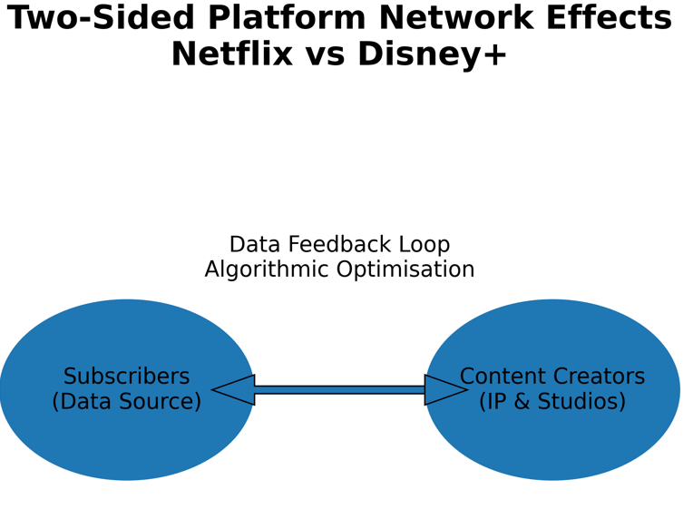
Source: Author’s own diagram based on Parker, Van Alstyne and Choudary (2016)

It shows how indirect network effects and subscriber-content creator data feedback loops boost competition.

Platform economics (Rochet and Tirole, 2003; Evans and Schmalensee, 2016) describes streaming services as two-sided marketplaces that use algorithms to connect content creators and viewers. More signups equal more data. Concepts and facts are better and more accurate. Thus, network effects are stronger. Netflix has an advantage over its competitors since it started collecting user usage data first. Disney+ has great fun but lacked information at initially. This clearly proves how technology can affect things drastically.

The attention economy enhances the process of analysis of how the Digital markets value purchasers' attention over content (Davenport and Beck, 2001; Wu, 2016). People are presently abandoning the streaming services. They are presently more focusing on gaming and social media interests. Interface design, algorithmic personalization, and autoplay engage users. The Netflix suggestion algorithm uses attention to distinguish shows, changing how over 80% of TV viewers watch.

Localization and globalization have tremendous effect on large-scale social and cultural factors. Digital platforms provide global material, but they also cater to the regional tastes and needs (Jin, 2016). Netflix's "glocalization" efforts mainly to generate Korean and Spanish episodes in the recent times, are source to demonstrate this uneven method. Disney+ is popular for Star Wars and Marvel. Franchisees market this company's culture.

Advocates of the late-mover advantage say pioneers shouldn't lead. Markides and Oyon (2010) suggest brand strength and bundling can help followers with complementary assets outperform pioneers. Disney+ promoted its programs on its own channels using its IP. How well a streaming service uses technology, integrates culture, and manages its environment affects its market performance.

3. Industry Architecture: Evolution of the Global Streaming Ecosystem

After years of digital transmission, streaming became SVOD in the 2010s. Netflix rented DVDs before becoming the first streaming service. Starting a paid service made it a global corporation (Lobato, 2019). However, many believed ad-supported tiers would work in the 2020s. Since subscriptions stopped rising, this was the only option to make money.

Data costs are rising for businesses. User analytics can help you track content, user retention, and targeted advertising costs (Napoli, 2019). People in society and culture are tired of paying. People may change subscriptions or acquire multi-service packages when new platforms launch (Wayne, 2021). Disney+ includes Hulu, ESPN+, and Disney+. Ecosystem-based competition.

Netflix had over 260 million customers in 190 countries in 2024, according to its annual report. The 2024 Disney Investor Report reports 150 million Disney+ users, unchanged from 2023. These numbers indicate various businesses and growth potential.

More people want to win. Regional options like Apple TV+, Amazon Prime Video, and others are too many. Platform markets are emphasizing data, innovative content, and cross-industry collaboration to gain structural dominance. Netflix's strength comes from being the first, and Disney's components work nicely together.

Streaming companies compete fiercely, and social and cultural conventions change swiftly. First steps are vital since the next step is to examine the situation more closely.

4. Task 1: Macro-Environmental Analysis

4.1 Technological Macro-Environment: Algorithmic Capitalism and Data Infrastructure
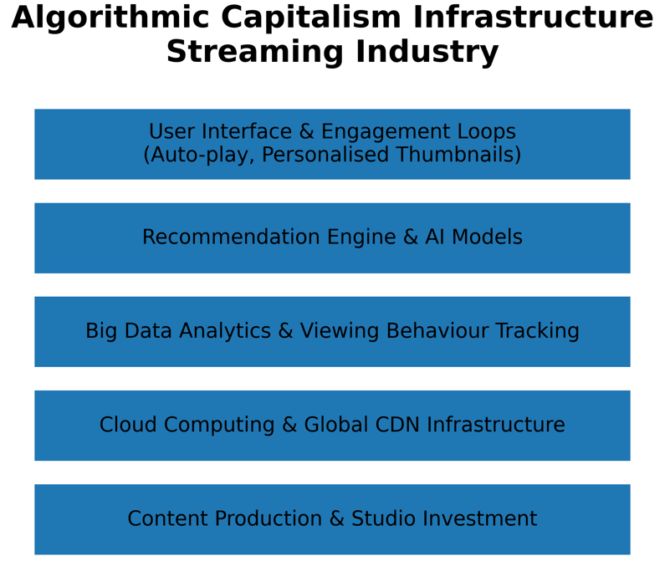
Source: Author’s own model based on Kitchin (2017); Bucher (2018)
Design layers demonstrate content creation, AI ideas, and usage throughout time.

In the streaming economy, algorithmic capitalism is prevalent. Data extraction, predictive analytics, and automated recommendation systems are increasingly vital for making money (Zuboff, 2019; Beer, 2017). For competitive advantage, streaming services collect data. Netflix was an early adopter of AI-based recommendation algorithms, giving it a structural edge. Smith and Telang (2016) and Hallinan and Striphas (2016) found that algorithms that indicated users' interests kept them on the site longer. Netflix lets you choose the movies and TV episodes you watch.

Big data analytics simplifies content creation. Netflix increasingly uses predictive analytics to determine shows. These algorithms evaluate a show's viewership, completion, and overall performance. This shows a shift from intuition to facts for creative project decisions (Wayne, 2018). Applying Statistics can affect content strategy around the globe by showing Korean drama popularity. Disney+ was the first platform that exploited well-known IP brands. These companies attract the viewers. But, Netflix's data-driven programming gives them much better options.

Cloud computing and streaming media infrastructure are new technologies. A more-user-capable CDN is more reliable. Netflix and Amazon Web Services created a global cloud infrastructure to broadcast movies and TV shows without lag and store backups. Tryon (2015) says service is great. Despite investing heavily in backend technology, Disney+ lagged behind competing streaming services worldwide. Technology's age affects its reliability and performance.

The application of User interfaces and engagement cycles are the primary part of algorithmic capitalism. The use of simple UID and simple but effective Autoplay, more customizable thumbnails, and nonstop navigation features, all have contributed to follow the attention economy, according to Bucher (2018). Netflix's interface study and in-depth research clearly demonstrates how to increase viewership. Disney+ separates material by classification based on brand and franchise. It's more vital to know someone than to fear computers, meaning to progress towards technologies. Disney+ builds trademark environments, whereas Netflix utilizes accurate statistics and real-time analytics to recommend content.

However, the speed of technological change are source to scare many. Open algorithms and data privacy are high priority issue that matter most to the regulators. Naspoli (2019) says this may hinder the process of customization. Generative AI technologies that change manufacturing threaten morality, ethical factors and creativity. AI and humans may not get along together, as shown by the 2023 Hollywood writers' strike. Technological advancement may still worsen the social and political issues (Lotz, 2022). Due to its heavy use of statistics and technologies, Netflix's shows may be overly predictable and uncreative not addressing the actual needs. Disney+ may struggle to innovate if it overuses its own IP.

Netflix has better technology, information, and algorithms than the competition. Building Disney+ infrastructure and maximizing its resources helps the service grow quickly. Both sides of algorithmic ecosystems have ethical, creativity, and regulatory difficulties.
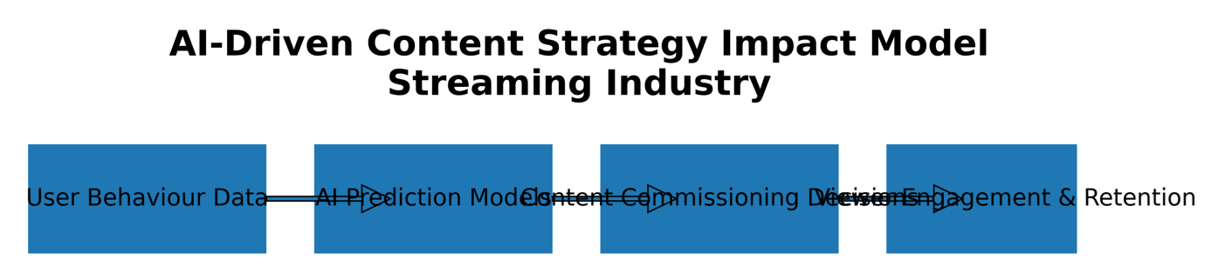
Source: Author’s conceptual flow model
End-to-end process showing user data → AI models → commissioning → retention loop.
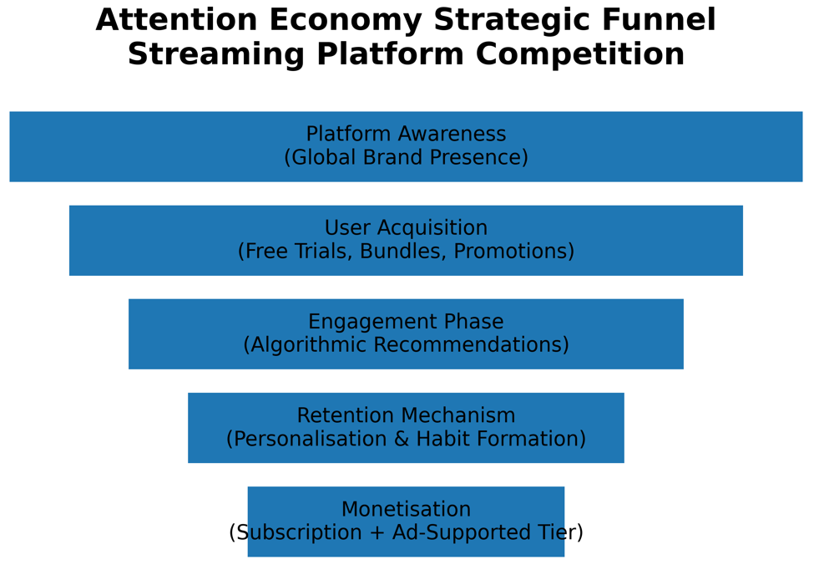
Source: Author’s conceptual model informed by Wu (2016)
Funnel structure illustrating user journey from awareness to monetisation in streaming platforms.

4.2 Socio-Cultural Macro-Environment: Changing Media Consumption and Cultural Hybridisation

Streaming is helpful for media consumption because of the socio-cultural macro-environment. The ability to binge-watch entire seasons makes it easier than ever (Matrix, 2014). This is how many people live today, especially young people. Netflix's engaging extended storylines encouraged binge-watching. Disney+ used to regularly release new episodes of popular shows. It now uses event-style scheduling and binge-watching to draw viewers.
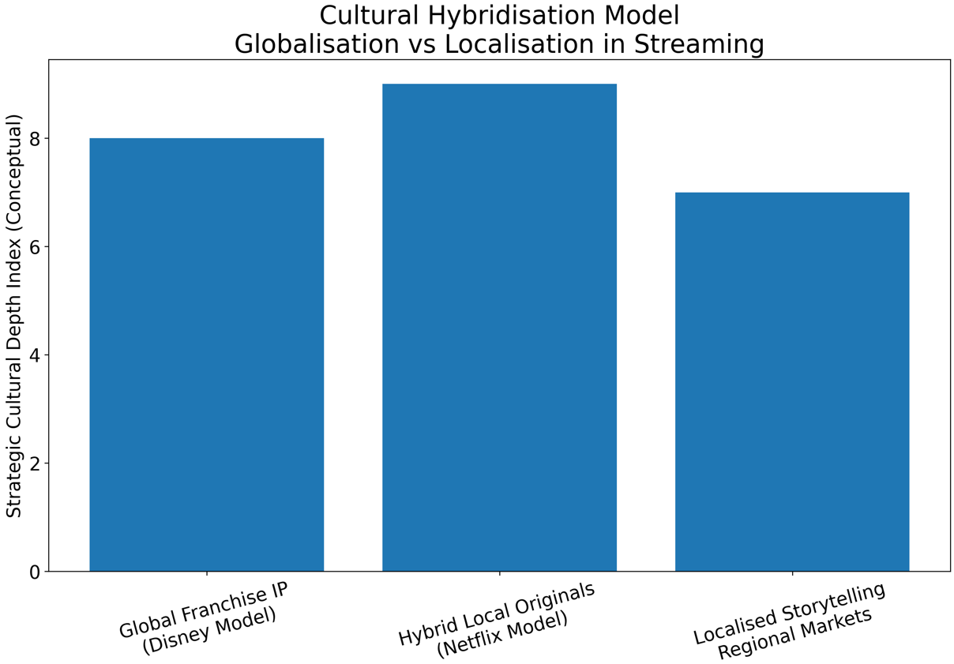
Source: Author’s conceptual model informed by Straubhaar (2019
Visual comparison of global franchise IP versus hybrid local originals strategy.

The streaming market is competitive beyond long-form. Many additional social and cultural factors matter and increase degree of complexity. In the current times, Short videos on TikTok and YouTube are major attraction factor for Gen Z and they make it hard to stand out. Many forms of media have shared screen time (Kaye, Chen, and Zeng, 2021). Gen Z is challenging to keep up with for streaming services, as their needs change faster. Whereas the OTT platforms that rely algorithmic virality instead of focusing on increasing the subscriptions by addressing the needs of customers. Netflix previews and interactive contents have been successful and works well on the context of smart phones and tablet devices. Hence, a unique adaptive marketing method is essential in the present context. Disney+ competes less with kid-friendly short-form channels because it's purely for families. Just remember that fewer kids watch TV.

Cultural and community dynamics can shift when globalization and localization clash. Cultural hybridization theory (Iwabuchi, 2015) states that the finest global platforms share stories from around the world with universal themes. Netflix bought Spanish, Korean, and Indian original shows to "glocalize." More individuals are joining, making the culture feel more authentic. Disney+ uses global trademarks that the West altered. This way of thinking is known worldwide, yet others may consider it encourages cultural conformity.

Discussions on identity politics and representation have altered media production. People want more gender, sexuality, and cultural diversity (Gill, 2016). Netflix's exhibit showcases the brand and global cultures with its gorgeous and inviting design. Disney has adjusted to appeal to younger people but never abandoned its family ideals. This can alter political views. In real life, people discuss about content diversity, showing how social and cultural aspects affect brand perception and government relations.

Competitive identity is more personal because people and families express themselves differently. Disney+'s family-friendly logo and childhood movies and TV shows aim to appeal to all ages. Netflix offers more popular adult dramas, documentaries, and experimental genres. You have many investments, so you don't need one company. However, this makes you care more about community or cultural issues.
Culture and society can improve or worsen things. Netflix's global branding and localization are inclusive. Disney+ needs emotional franchise capital and family trust. Because the media is so divided, representation politics are changing, and consumers are weary of the same things, streaming's future is unclear.

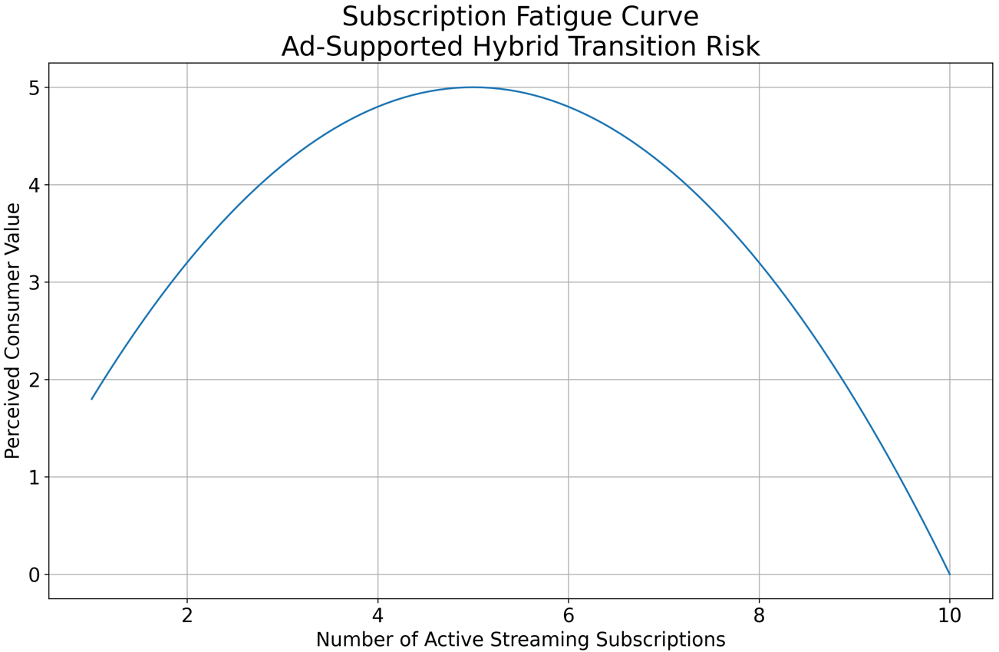
Source: Author’s conceptual illustration based on Wayne (2021)
Graphical representation of diminishing consumer value as subscription volume increases.

5. Strategic Positioning Outcomes: Platform Power and Brand Identity
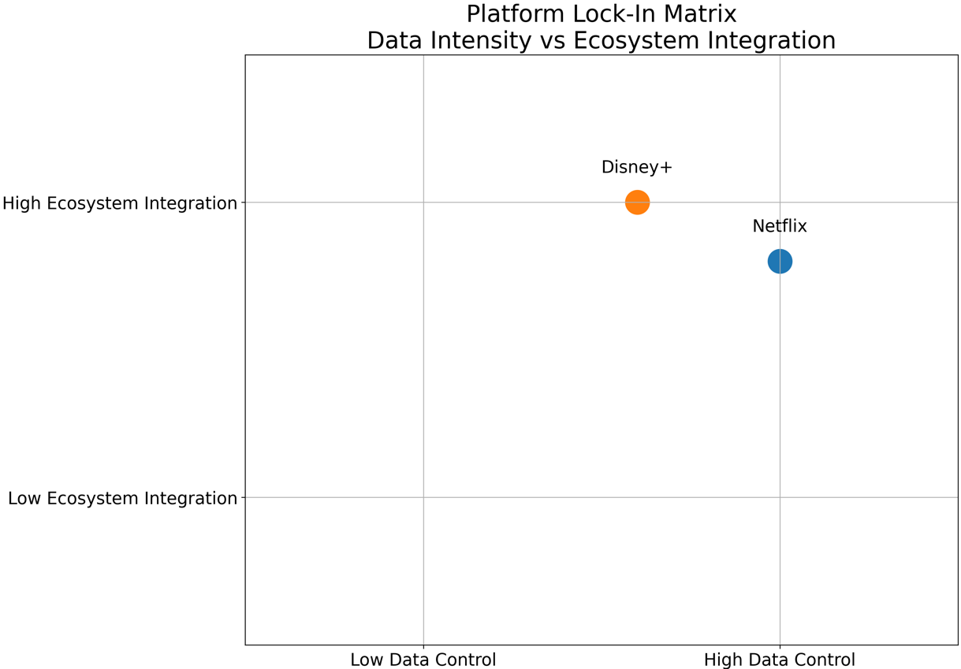
Source: Author’s analytical matrix based on Seaver (2019)
2×2 matrix mapping Netflix and Disney+ across data intensity and ecosystem integration.

Netflix and Disney+'s data usage and role are shown in a 2x2 grid.

Disney+ and Netflix disagree on the platform economy because technology shapes culture and society. The number of subscribers and their data usage influence subscriber power. Many people worldwide utilize Netflix. The number will exceed 260 million by 2024. With more behavioral data, algorithms operate better and more correctly. Parker, Van Alstyne, and Choudary (2016) say this strengthens indirect network effects. Disney+ has fewer subscribers than its competitors, but its followers are committed. Arvidsson and Caliandro (2016) discuss brand publics, not groupings.

The merits and cons of global and franchise-driven organizations show the difference. Netflix's global localization creates content ecosystems that welcome multiple cultures, making the globe safer (Athique, 2018). Disney+ makes many "tentpole" movies using various intellectual property. Franchises attract more customers, but massive launches can fail.
Data ownership determines switching costs. People get habituated to Netflix's algorithms due of its distinct suggestion histories and customized interfaces. End result: consumers are trapped (Seaver, 2019). Disney+'s lack of algorithmic customisation may make it hard to engage users. The economy and Hulu and ESPN+'s relationship make changing plans more expensive.

There are still major gaps in civilization authenticity. Netflix claims global compatibility. Disney aspires to be more diversified but must preserve its family-friendly roots. Netflix and Disney have algorithmic and intellectual property capital, which hurts the market. Changes in the big picture strengthen the platform.

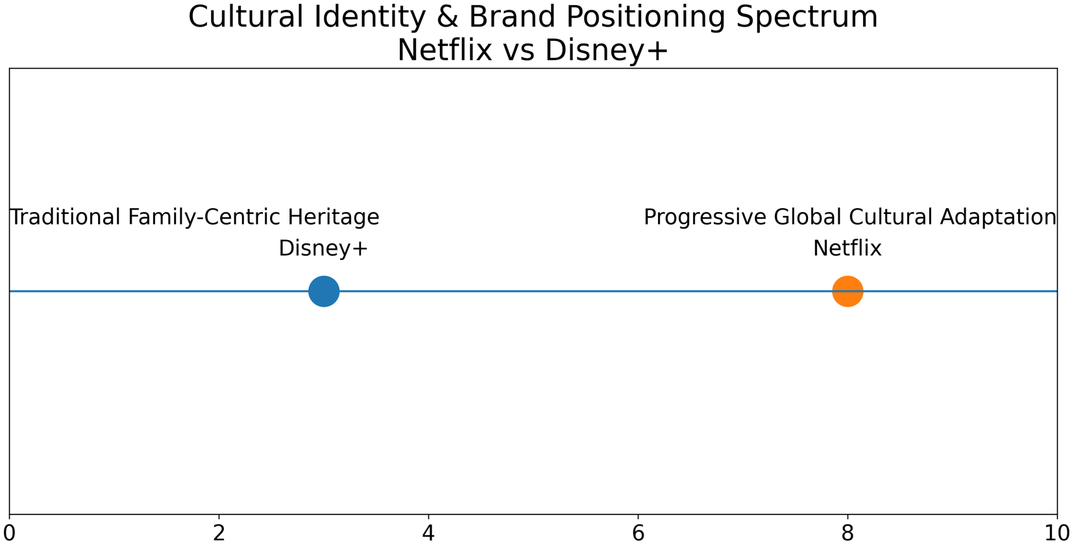
Source: Author’s conceptual spectrum model
Positions Netflix (progressive global identity) and Disney+ (family-franchise heritage) along identity continuum.

6. Task 2: Strategic Responses and Growth Evaluation

6.1 Competitive Logic through Platform Strategy Framework

Parker, Van Alstyne, and Choudary (2016) argue that platform strategy theory's emphasis on network effects, ecosystem orchestration, and governance design makes companies successful over time. More subscribers give you data insights to decide what to make and promote. This indirectly affects streaming networks. Netflix aims to stand out via algorithms. Netflix's AI-powered recommendations are useful.

This retains customers and reduces turnover (Kitchin, 2017). Data, not franchisees, drove its competitiveness. Platform governance theory assumes monitoring user data stabilizes the ecosystem.

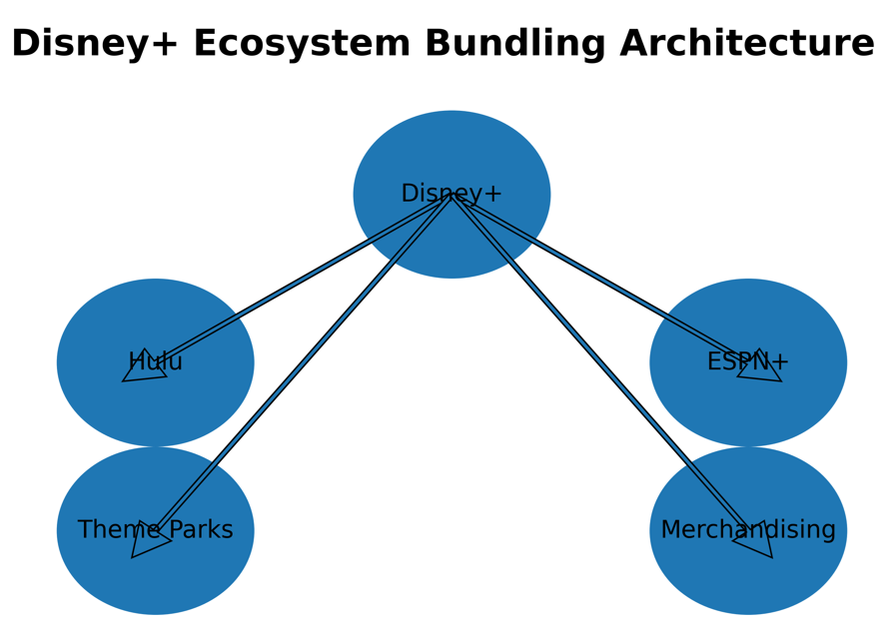
Source: Author’s own diagram based on ecosystem strategy theory
Disney+ uses Hulu and ESPN+ programming to attract users. They apply cross-business assets creating switching cost structures.

Disney+ uses "content-franchise leverage." Movies, TV, and theme parks make Disney money. Long-standing intellectual property is used. One way to beat your competitors is to use what you have (Teece, 2018). Disney would rather fail computer tests. Using famous franchises distinguishes it from competitors.

Compete by offering pricing and membership packages. Netflix increased ads as fewer people signed up. Businesses that don't gain enough attention may modify their revenue streams (Lotz, 2022). Disney+ had advertising, but Hulu and ESPN+ made it better for customers. People leave less reluctantly after buying packaged things because they think they got more.

If technology improves and people trust each other, these ideas will succeed. Netflix should be investigated for data handling and biased algorithm claims. Disney may lose fans if they cease making movies and TV series. Large companies like Amazon Prime Video hurt both companies. Ecosystems must change to stay ahead.

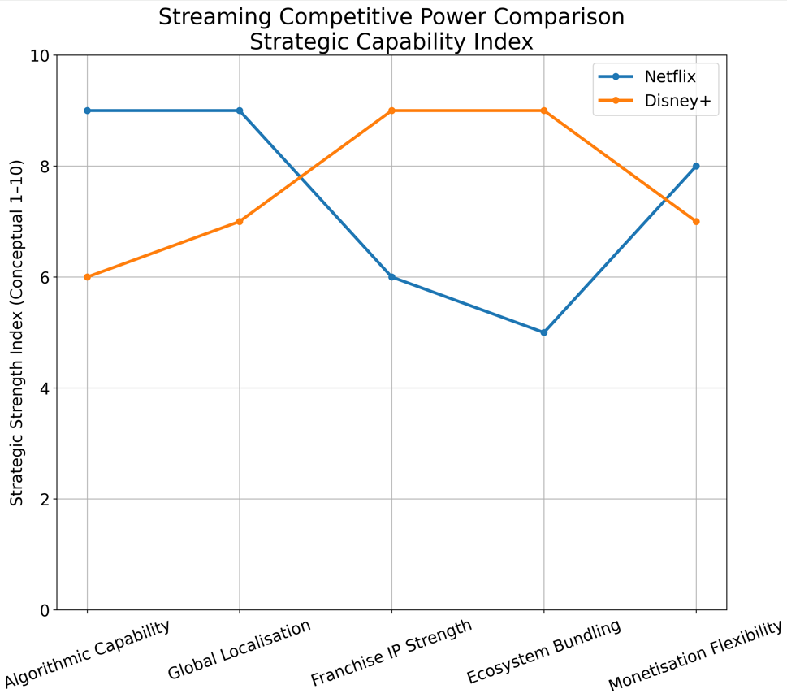

Source: Author’s strategic heatmap model

This figure shows Considerations for producing money, IP rights, algorithms, packaging, and localization.

6.2 Growth Trajectories through Strategic Renewal Lens
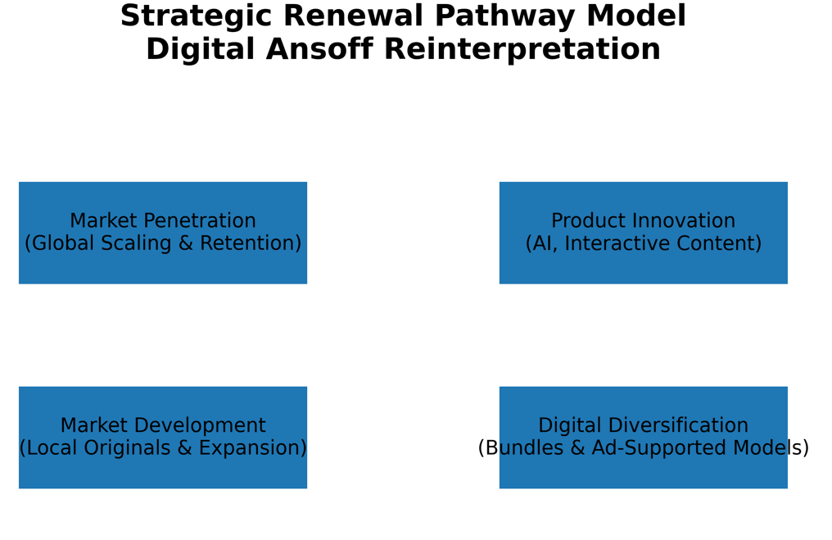
Source: Author’s conceptual model based on Ansoff (1957) reinterpreted for digital platforms

Ansoff's digital adaptation shows how to build, sort, and transform an ecosystem.

Ansoff's Growth Matrix (1957) suggests digital service startups. In today's digital economy, companies must reach more individuals and target certain groups. Product creation requires new information sharing and technologies. Netflix's strong efforts to translate content and generate new series outside are market development. Cultural closeness theory says people choose stories from their own culture (Straubhaar, 2019). Thus, North American stories are few.

Netflix invests more on interactive storytelling and personalized streaming. These new ideas show us how to produce service-based goods instead of physical ones. Disney+ changes settings for fun. Disney is shedding properties by airing sports and pornography on ESPN+ and Hulu. Strategic renewal holds that organizations must acquire new skills to adapt (Agarwal and Helfat, 2009).

Investment in original content has a different growth rate than innovation based on current intellectual property. Netflix could be more creative with its program budget. But this makes it harder to predict how much the company will need to borrow. Using well-known intellectual property simplifies the story but limits Disney's creativity. Streaming growth models struggle to make money, as shown by 2023 and 2024 spending cuts and large write-offs.

It's vital that methods operate consistently. Netflix stays ahead of the competition in algorithmic innovation and localization because it is a global digital-native platform. Despite its many responsibilities, Disney must balance its streaming goals with its film and TV studios. Profiting from diversification makes planning harder. Disney wants its departments to collaborate, but its internal growth goals are more like Netflix's.

7. Forward-Looking Critical Synthesis: The Future of Streaming Competition

The next streaming war will be critical because culture and technology are merging. AI-generated things is problematic. It may reduce production costs but stifles innovation (Kaye, Chen, and Zeng, 2021). Subscription weariness may accelerate hybrid ad-supported models. Because of them, firms and customers would change their preferences (Lotz, 2022).

As AI becomes more widespread, mixing technologies may make organizational algorithms less unique. If you are tech-savvy, valued by the brand, and fit the culture, it may matter. Disney's franchise capital is strong where sentiments matter, but Netflix can satisfy people worldwide.

Netflix succeeds due to its large data infrastructure and ability to quickly adapt to different cultures. Disney's platform integration may increase relocation costs. The competitive edge changes with time. Consider how much a company could lose.

8. Conclusion: Strategic Implications for Marketing Management in Platform Industries

This study examined technological and socio-cultural macroenvironmental factors affecting digital streaming's competitiveness. Netflix owns its data, uses algorithms to manage itself, and has the latest technology, giving them an edge. Disney+ uses franchise ecosystems like Netflix. People use media, view themselves, and interact with non-native speakers differently. All of these factors diversify brand structures.

As shown in Task 1, global modifications affect platform results. Task 2 implies that only platform theory and digital growth frameworks can provide long-term answers. Managers must know technology, cultures, and how to modify plans when things go wrong to stay ahead of the competition. Long-term success requires constant change.

Reference
Agarwal, R. and Helfat, C.E. (2009) ‘Strategic renewal of organizations’, Organization Science, 20(2), pp. 281–293. https://doi.org/10.1287/orsc.1090.0423
Arvidsson, A. and Caliandro, A. (2016) ‘Brand public’, Journal of Consumer Research, 42(5), pp. 727–748. https://doi.org/10.1093/jcr/ucv053
Athique, A. (2018) Transnational Audiences: Media Reception on a Global Scale. Cambridge: Polity Press.
Beer, D. (2017) The Social Power of Algorithms. Information, Communication & Society, 20(1), pp. 1–13. https://doi.org/10.1080/1369118X.2016.1216147
Bucher, T. (2018) If...Then: Algorithmic Power and Politics. Oxford: Oxford University Press.
Cunningham, S. and Craig, D. (2019) Social Media Entertainment: The New Intersection of Hollywood and Silicon Valley. New York: NYU Press.
Disney (2024) Investor Relations Report 2024. Accessed on 25/02/2026. Available at: https://thewaltdisneycompany.com/investor-relations
Evans, D.S. and Schmalensee, R. (2016) Matchmakers: The New Economics of Multisided Platforms. Boston: Harvard Business Review Press.
Gill, R. (2016) ‘Postfeminism and cultural politics’, European Journal of Cultural Studies, 19(6), pp. 610–626. https://doi.org/10.1177/1367549416636065
Gomez-Uribe, C.A. and Hunt, N. (2016) ‘The Netflix recommender system: Algorithms, business value, and innovation’, ACM Transactions on Management Information Systems, 6(4), pp. 1–19. https://doi.org/10.1145/2843948
Hallinan, B. and Striphas, T. (2016) ‘Recommended for you: The Netflix Prize and the production of algorithmic culture’, New Media & Society, 18(1), pp. 117–137. https://doi.org/10.1177/1461444814538646
Iwabuchi, K. (2015) Resilient Borders and Cultural Diversity: Internationalism, Brand Nationalism and Multiculturalism in Japan. Lanham: Lexington Books.
Kaye, D.B.V., Chen, X. and Zeng, J. (2021) ‘The co-evolution of two Chinese mobile short video apps’, Mobile Media & Communication, 9(2), pp. 229–253. https://doi.org/10.1177/2050157920950200
Kitchin, R. (2017) ‘Thinking critically about and researching algorithms’, Information, Communication & Society, 20(1), pp. 14–29. https://doi.org/10.1080/1369118X.2016.1154087
Lobato, R. (2019) Netflix Nations: The Geography of Digital Distribution. New York: NYU Press.
Lotz, A.D. (2022) Media Disrupted: Surviving Pirates, Cannibals, and Streaming Wars. Cambridge, MA: MIT Press.
Napoli, P.M. (2019) Social Media and the Public Interest: Media Regulation in the Disinformation Age. New York: Columbia University Press.
Netflix (2024) Annual Report 2024. Accessed on 25/02/2026. Available at: https://ir.netflix.net
Parker, G.G., Van Alstyne, M.W. and Choudary, S.P. (2016) Platform Revolution. New York: W.W. Norton.
Seaver, N. (2019) ‘Captivating algorithms’, Journal of Material Culture, 24(4), pp. 421–436. https://doi.org/10.1177/1359183519855344
Smith, M.D. and Telang, R. (2016) Streaming, Sharing, Stealing: Big Data and the Future of Entertainment. Cambridge, MA: MIT Press.
Straubhaar, J.D. (2019) World Television: From Global to Local. 2nd edn. Thousand Oaks: Sage.
Wayne, M.L. (2018) ‘Netflix, Amazon, and branded television content’, Media, Culture & Society, 40(5), pp. 725–741. https://doi.org/10.1177/0163443717736118
Wayne, M.L. (2021) ‘Subscription fatigue and the streaming economy’, Television & New Media, 22(4), pp. 437–455. https://doi.org/10.1177/1527476420982234
Wu, T. (2016) The Attention Merchants: The Epic Scramble to Get Inside Our Heads. New York: Knopf.
Zuboff, S. (2019) The Age of Surveillance Capitalism. London: Profile Books.

