Research, Build and Deploy, a Virtualised Network

Wayne Howell (2207408)
Network Operating Systems and Services (ACCA5023)
BSC2-PT Computing: Data & Information Systems
University of Wales Trinity Saint David
Contents
1.Introduction 3
2.Task 1 – Research 4
2.1 Hypervisor 4
2.2 IP Addressing 7
2.3 Routing 9
2.4 Network Services 11
3.Task 2 – Technical Documentation 12
3.1 Chosen Hypervisor 12
3.2 Download and Setup 13
3.3 Configuring IP Addressing 18
3.4 Testing and Troubleshooting 22
4.Task 3 – Reflection 28
4.1 Technical Reflection 28
4.2 Personal Reflection 28
5.References 29
6.Figures 30

1.Introduction

Virtualisation is a crucial aspect of modern network infrastructure, offering scalability and efficiency. This assignment involves both research and practical implementation to design and deploy a virtualised network for NOSS2025, a multinational corporation operating in Swansea and Cardiff.
The research and in-depth understanding will serve as the foundation for the practical task, guiding the selection of the hypervisor and overall network architecture. Through a critical review of recent academic and industry literature, key concepts of virtualisation technologies will be analysed, ensuring an informed approach to network virtualisation.
The practical component requires the step-by-step deployment of a virtual network, following the given topology, and documented through timestamped screenshots to ensure authenticity and structured progress.
Finally, a reflection will evaluate the deployment process, highlighting challenges encountered, solutions applied, and the integration of research with practical implementation to develop both theoretical knowledge and technical skills.

2.Task 1 – Research

2.1 Hypervisor
Hypervisors are vital for virtualisation because they allow various operating systems to run on one physical computer. They are mainly divided into two types: Type 1 (bare-metal) and Type 2 (hosting) hypervisors.
Type 1 Hypervisors operate directly on hardware, offering superior performance, reliability and security. Gowri [1], emphasises how Type 1 hypervisors enhance efficiency in cloud computing environments. They eliminate dependency on a host Operating System (OS), reducing latency, improving efficiency, and provide direct access to physical hardware resources.
Architecturally, Type 1 hypervisors function as a thin layer between the hardware and the virtual machines (VMs). They dynamically manage hardware resources, ensuring that VMs operate independently without interference. Some implementations also include kernel-based security features and advanced network virtualisation capabilities to facilitate large-scale deployments. They are commonly used in data centres, enterprise IT environments, and cloud infrastructure due to their scalability, excellent availability, and robust security mechanisms.
Type 2 Hypervisors run on a host OS. Macpherson [2] provides an open explanation. They leverage the host OS device drivers and resource management, making them easier to deploy but less efficient in high-demand environments. In design, they are an additional software layer between the hardware and VMs, that allow users to create and manage VMs without requiring dedicated hardware or complex setup configurations. They are used predominately for software development, testing, and educational purposes due to limited scalability.
Types of Hypervisors are depicted in Figure 1.
Figure 1: The Structure of the Different Types of Hypervisor
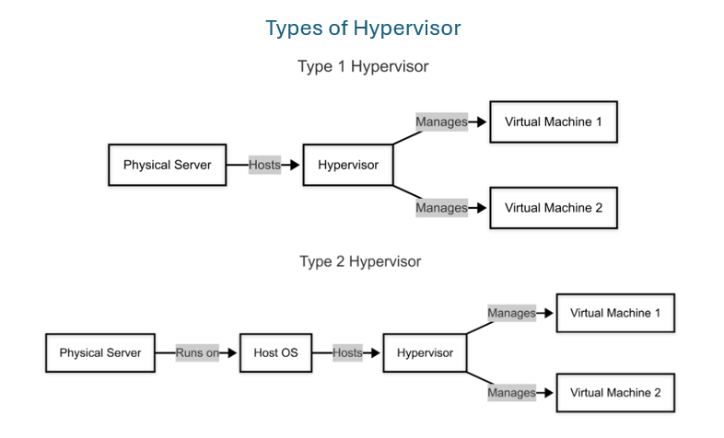
In terms of security, type 1 hypervisors provide stronger security due to their direct interaction with hardware, which reduces attack surfaces. They are frequently accompanied by enterprise-level security measures. In contrast, type 2 hypervisors inherit vulnerabilities from the host OS, making them more susceptible to security breaches.
Type 1 hypervisors are primarily designed for enterprises, optimised for data centres and cloud infrastructure. They tackle high-performance workloads with dedicated hardware such as CPUs, large RAM capacities and dedicated storage. In contrast, Type 2 hypervisors are more versatile in OS compatibility, allowing installation on various hosts such as Windows, Linux and Mac. They require sufficient RAM and processing power to ensure stable performance.
The hypervisor market offers various solutions. Cost being a key factor, as Type 1 hypervisors typically require higher initial investment in enterprise-grade hardware and licensing, whereas Type 2 hypervisors are more budget-friendly, leveraging existing hardware and often available as free or open-source solutions.
Figure 2 shows Type 1 and Type 2 hypervisors solutions, listing key features.
Figure 2: Hypervisor Solutions and Key Features
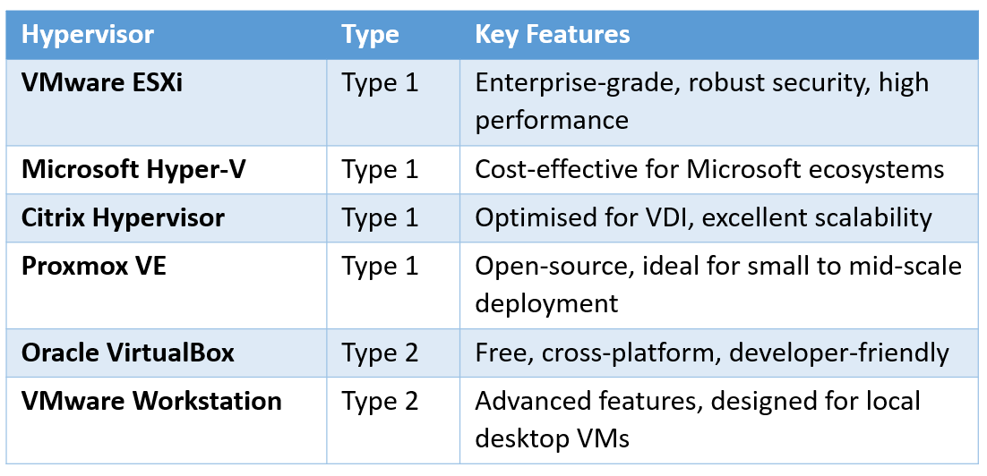

In summary, Type 1 hypervisors are best for enterprise situations that need great scalability, security, and performance, while Type 2 hypervisors allow testing and development. Organisations must choose based on use case, workload, security, and budget. Figure 3 provides a summary of each hypervisor.

Figure 3: Type 1 v Type2 Hypervisors Comparison
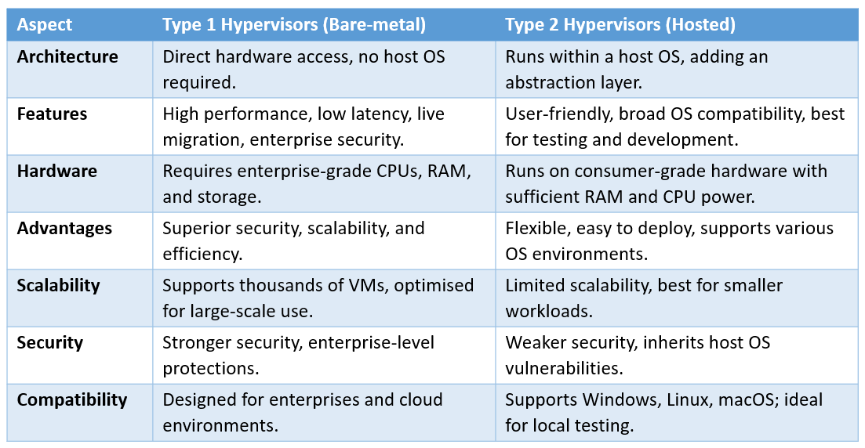

2.2 IP Addressing
Internet Protocol (IP) addressing is a system used to uniquely identify devices within a network, allowing them to communicate with one another. IBM [3] provides a thorough explanation of IP addresses. They consist of a unique numerical label assigned to each device participating in a network. The IP facilitates the routing of data packets by specifying the source and destination addresses.
There are two primary formats of IP addresses:
- IPv4 is a 32-bit numerical address consisting of four decimal octets, each ranging from 0 to 255 represented in dotted decimal format. The first 3 octets contain the network address while the 4th contains the host address.
Figure 4: Illustrates the IPv4 address structure
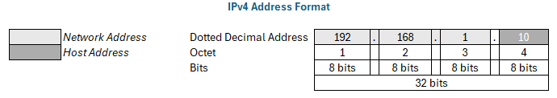

- IPv6 is a 128-bit hexadecimal address consisting of eight groups of four hexadecimal digits, separated by colons. These were designed to overcome IPv4 address exhaustion while also improving network security and efficiency.
Figure 5: IPv6 Address Format – Illustrating 128-bit structure
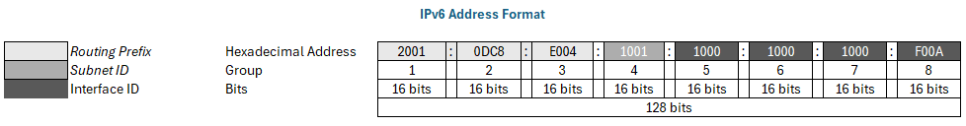

Nath and Uddin [5] provide a structured explanation outlining how data is transmitted across networks. Data transmission uses packet switching and the Transmission Control Protocol (TCP)/IP model. Data is packetized when sent between devices. Each packet comprises a header with source and destination IP addresses to ensure data delivery. Before being reassembled into the original data, these packets travel independently through the network, guided by routers. This process relies on IP addresses as unique identifiers to route packets to the right endpoint. Figure 6 shows the data provided in Ipv4 and Ipv6 packet headers.

Figure 6: IPv4 and Ipv6 Packet Header Structures
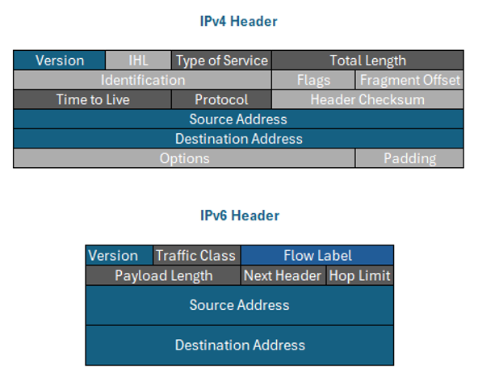

Duan [6] offers a comprehensive understanding of the roles that routers and switches play in network communication. Routers determine the best path for packets to travel using routing tables that store information about different network destinations. Routers facilitate communication between multiple networks, ensuring efficient data transmission. Whereas, switches manage internal network traffic by forwarding data based on MAC addresses. This enables communication between devices within the same network, reducing congestion and improving efficiency.
IP addressing is key to network performance, scalability, and security. With more internet-connected devices, IPv4's limitations necessitated IPv6, which has a larger address pool and better security. Subnetting optimises networks as it divides a large network into smaller subnetworks to improve address allocation and security. A subnet mask separates network and host addresses. These processes use addresses efficiently, reduces waste and improves routing.
To simplify, IP addressing can be compared to a postal system. Each IP address functions as a unique home address, ensuring that messages (data packets) reach the correct recipient. Subnets act like postal districts, Routers like post offices, directing messages between different locations, while switches function as internal sorting centres, ensuring proper delivery within a building or local area.

2.3 Routing
Routing is a process in computer networks that determines the best paths for data packets to travel from a source to a destination. This process is essential for efficient data transmission across interconnected networks.
Routers, which operate at Layer 3 of the OSI model, play a critical role in selecting paths based on network addresses. They use routing protocols to exchange routing information, update their routing tables, and dynamically adapt to network changes. The process involves discovering network routes, selecting the optimal path based on various metrics such as hop count, bandwidth, and latency, and then forwarding packets accordingly.
Routing tables store the paths to known networks and can be configured in two ways. Indeed [7] provides a practical explanation.
- Static Routing – Routes are manually configured by network administrators and remain unchanged unless manually updated.
- Dynamic Routing – Routes are automatically updated using routing protocols, allowing the network to adjust to changes without manual intervention.
Figure 7 illustrates the key differences between static and dynamic routing protocols
Figure 7: Key differences between static and dynamic routing protocols
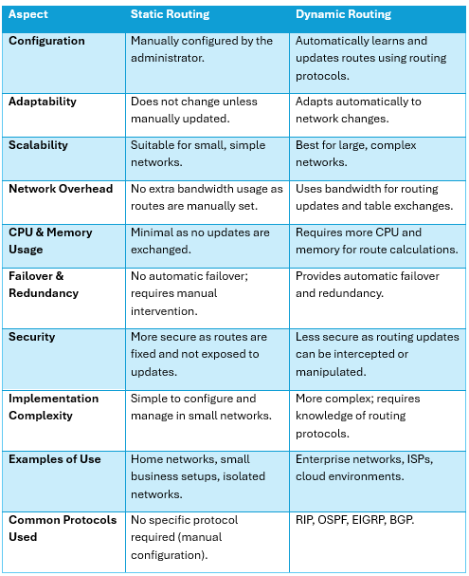

Routing protocols vary in design, purpose and functionality, making some more suitable for deployment in specific real-time network environments. For example, home users typically have a single router connected to an Internet Service Provider (ISP), with a limited number of devices. Since the topology is simple and does not change frequently, static routing is often sufficient. Whereas, small/medium enterprise networks may use Routing Information Protocol (RIP) for simplicity, however it lacks scalability. In contrast, large enterprise networks with multiple branches and data centres use Open Shortest Path First (OSPF) due to its scalability, efficiency and fast updates. Froehlich [8] compares Border Gateway Protocol (BGP) and OSPF showing when to use them. BGP is more suitable for routing between ISPs and large corporations to route traffic between different networks. It ensures stable and policy-driven routing at a global scale, but requires expert management.
Borthakur [9] study provides valuable insights into the performance differences between single-area and multi-area OSPF configurations within a campus network environment. It helps to understand how OSPF is applied in real world deployments and how it organises networks for efficiency. However, it lacks the comparison to other routing protocols and focuses more on network performance metrics rather than providing step-by-step OSPF configuration.
Figure 8 provides a concise comparison of different routing protocols based on their network application, real-world use cases, deployment characteristics, benefits, and challenges.
Figure 8: Routing Protocols Comparison
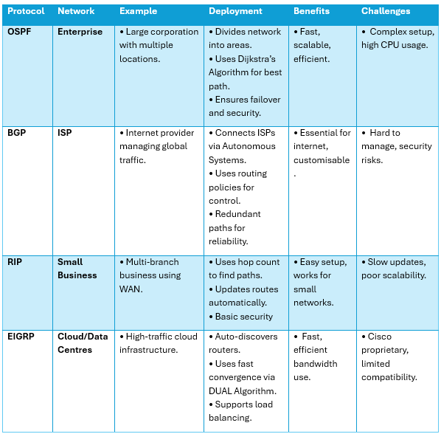

2.4 Network Services
Network services are essential for maintaining the efficiency, security, and functionality of modern IT infrastructures. These services enable communication between devices, facilitate secure access to resources, and ensure proper management of network components.
Virtual Private Network (VPN): Creates an encrypted tunnel over a public network, allowing secure remote access to private systems.
Dynamic Host Configuration Protocol (DHCP): Automatically assigns IP addresses to devices, ensuring efficient network management.
Active Directory Domain Services (AD DS): Provides centralised authentication, authorisation, and user management in enterprise networks.
Certificate Authority (CA): Issues digital certificates to verify identities, ensuring secure communication and encryption.
Figure 9 provides a summarised table of each service
Figure 9: Summarised Table of Network Services
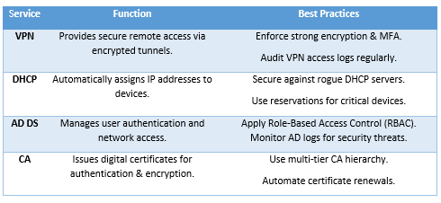

3.Task 2 – Technical Documentation

3.1 Chosen Hypervisor
Based on the research conducted in Task 1, Oracle VirtualBox (Type 2 Hypervisor) was selected for this implementation due to its ease of use, flexibility, and suitability. VirtualBox operates on top of an existing operating system, making it ideal for testing and development of virtual networks without dedicated hardware.
The decision to use VirtualBox was influenced by several key factors:
- Cross-platform compatibility: VirtualBox supported multiple operating systems such Windows, macOS, and Linux, making it a versatile tool for multiple OS environments.
- Open-source and cost-effective: VirtualBox is freely available, making it accessible for educational purposes.
- Easy setup and management: VirtualBox provides a user-friendly interface that simplifies the creation and management of virtual machines.
- Scalability for coursework 2: The chosen network topology will be expanded in Coursework 2, where VirtualBox's built-in snapshot feature will allow for progressive network changes without data loss. Additionally, VirtualBox’s internal networking features help advanced services such as Active Directory, VPN, and DHCP.
Ultimately, Oracle VirtualBox was chosen due to its cross-platform support, open-source nature, and straightforward setup which was essential for this assignment.

3.2 Download and Setup
Oracle VirtualBox was downloaded from Oracle’s official website and installed manually [10].
The topology dictated that Swansea’s network would use Windows Server 2022 and Windows 10, while Cardiff’s network would utilise Debian Linux.
To ensure a stable and secure setup, the following operating system versions were sourced from their respective official websites:
- Windows Server 2022 [11]
- Windows 10 [12]
- Debian Linux [13]
Figure 10: Debian Download Website
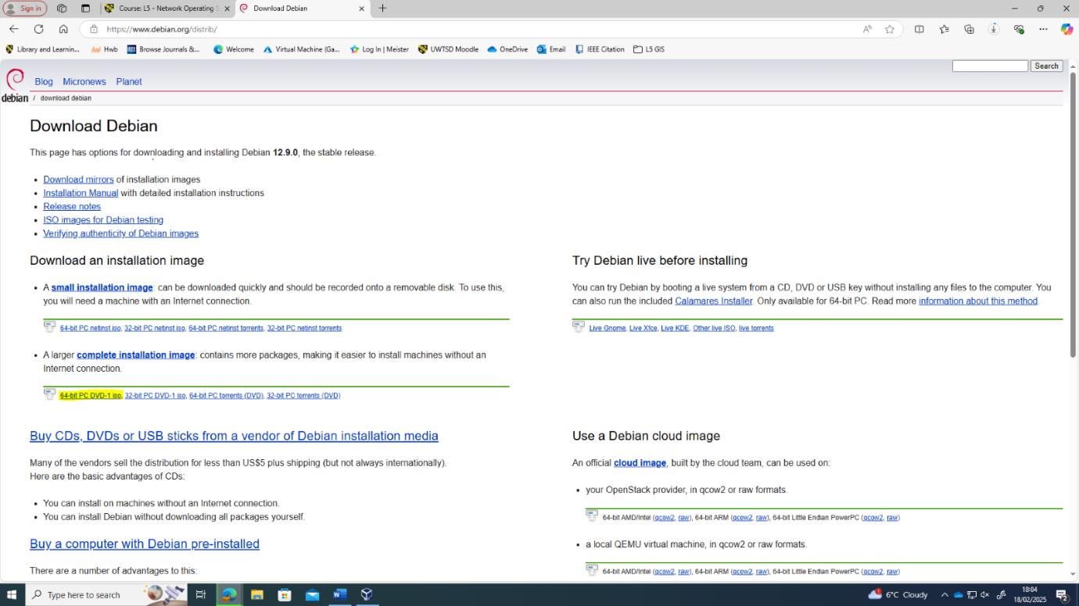

Figure 11: Downloaded Files
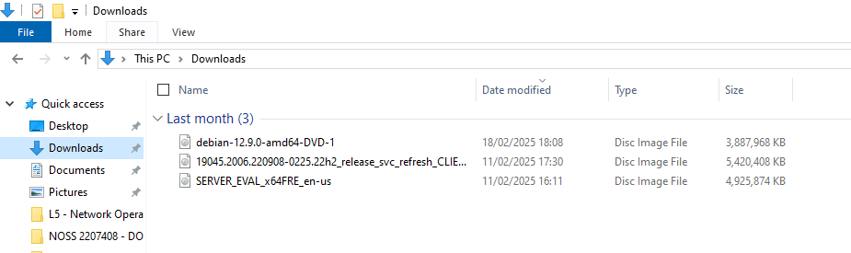
Swansea’s network was the first to be setup. Windows Server 2022 was installed on a VM called S-DC, while windows 10 would be on a VM called ClientS1.
Windows Server 2022 setup (S-DC)
Machine Name: S-DC
Hard Disk: 80 GB
RAM: 8192 MB
Processors: 6
Network Adapter 1: External
Network Adapter 2: LAN
Figure 12: S-DC Windows Server Setup in Oracle Virtual Box
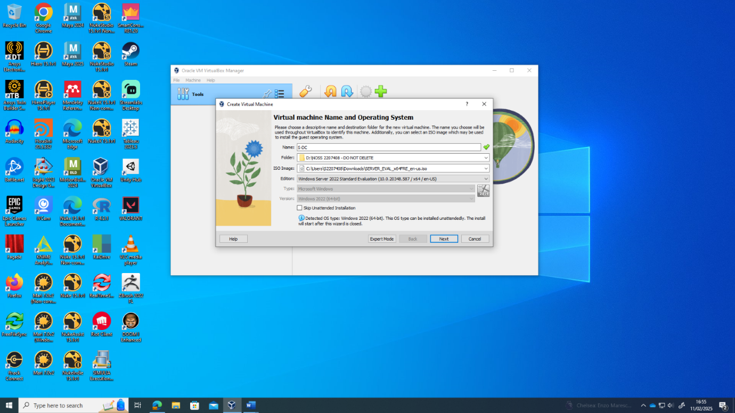
Windows 10 Setup (ClientS1)
Machine Name: ClientS1
Hard Disk: 50 GB
RAM: 8192 MB
Processors: 4
Network Adapter 1: Ethernet

Figure 13: Virtual Hard Disk Setup of ClientS1
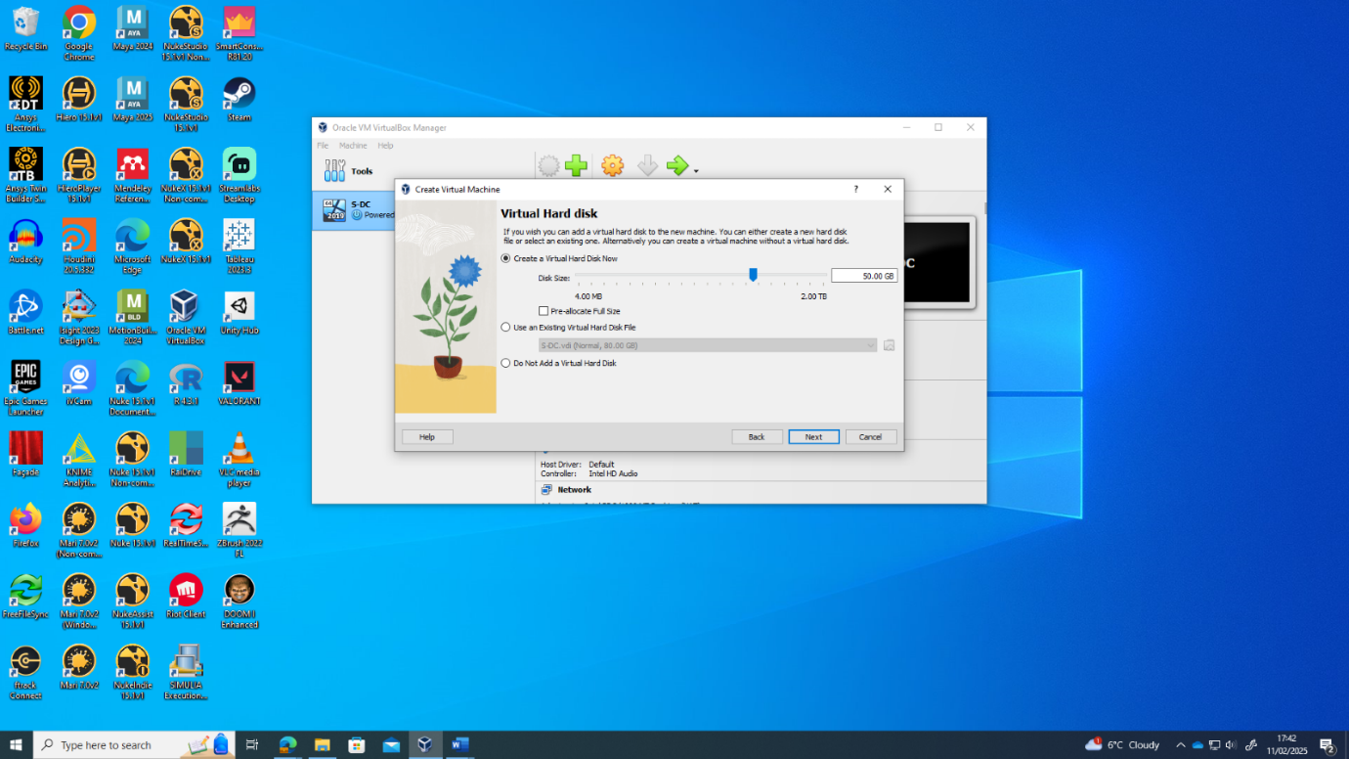

The Cardiff network would be set up using Debian Linux. Two VM’s were setup C-Server and Client-C1.
Debian Linux Setup (C-Server)
Machine Name: C-Server
Hard Disk: 40 GB
RAM: 4 GB
Processors: 4
Network Adapter 1: Internal
Network Adapter 2: External
Network Adapter 3: NAT

Figure 14: C-Server Login and Network Adapter Check after Debian Linux Installation
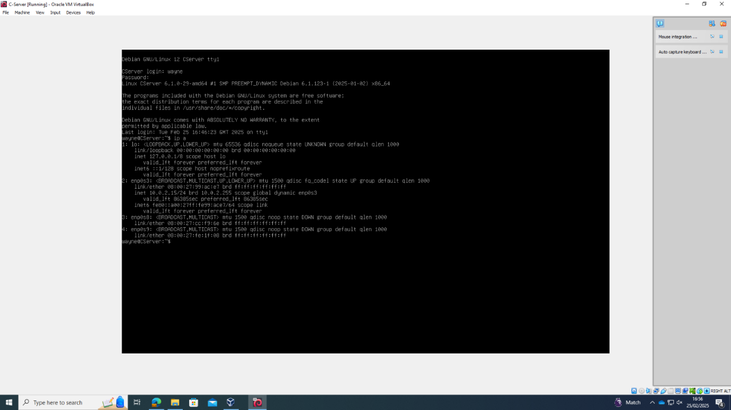
Debian Linux Setup (ClientC1)
Machine Name: ClientC1
Hard Disk: 40 GB
RAM: 4 GB
Processors: 4
Network Adapter 1: Ethernet
Figure 15: Configuring the Network of ClientC1
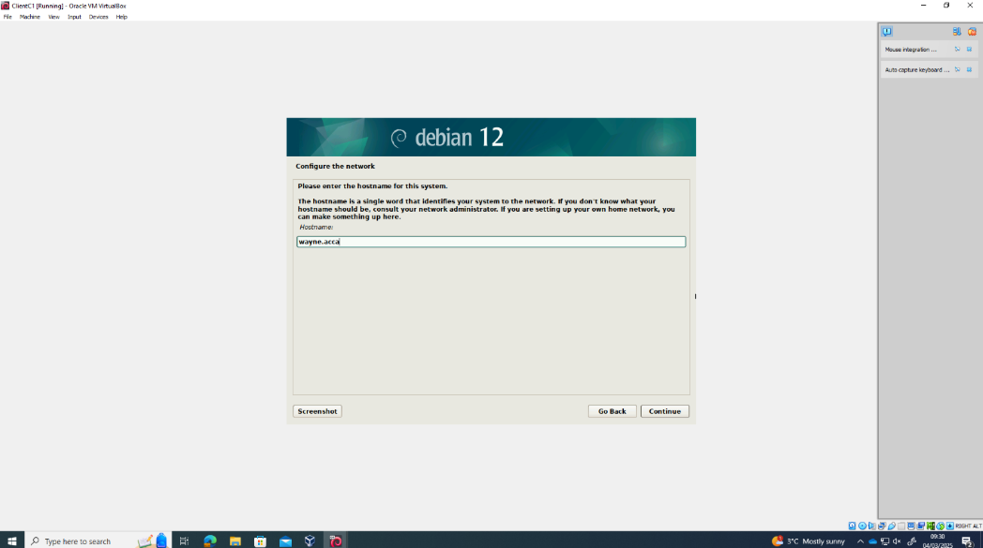

Figure 16 shows all 4 VM’s set up in Oracle Virtual Box
Figure 16: VM's Setup in Oracle Virtual Box
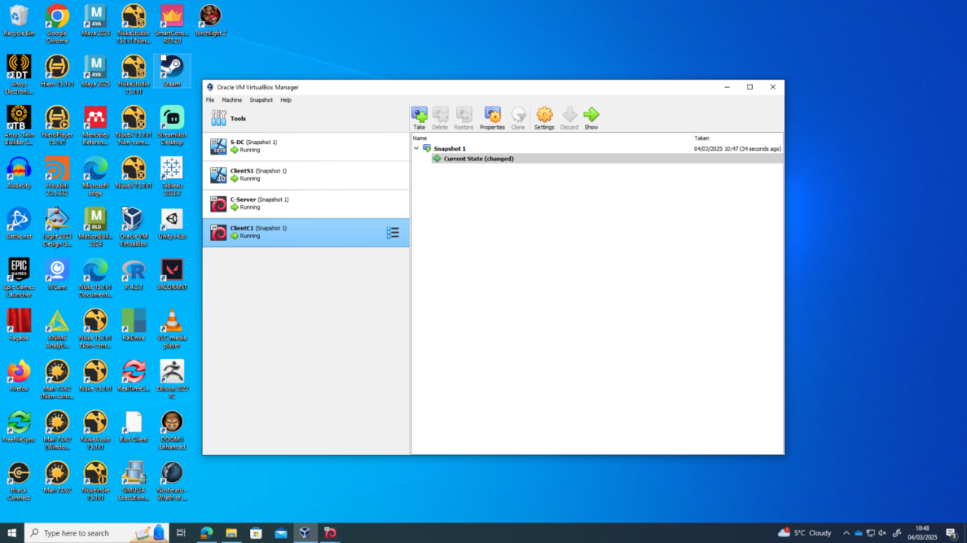

3.3 Configuring IP Addressing
The following section provides the IP addressing schema applied to the Swansea and Cardiff Networks.
S-DC
The network configuration of S-DC was set up with two network interfaces.
External
Internet facing for external communication. The IP Address, Default Gateway and Subnet Mask match the topology in the assignment. The preferred DNS was set to local, as S-DC will run its own DNS services. Google Public DNS is used as the alternative DNS server.
LAN
Connects to the internal network (Swansea Network) and acts as a default gateway for internal hosts. The subnet mask allows for 254 usable addresses, accommodating multiple internal devices.
Figure 17: S-DC IP Addressing
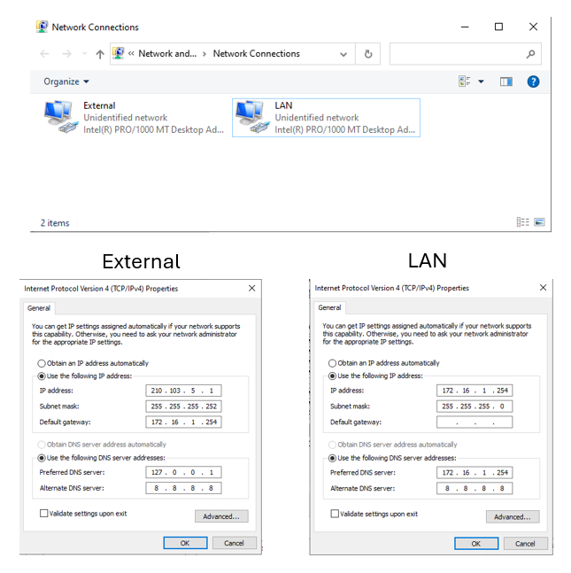

ClientS1
ClientS1 was assigned an unique IP address within the 172.16.1.0/24 subnet to enable communication within the Swansea Network.
Figure 18: ClientS1 IP Addressing
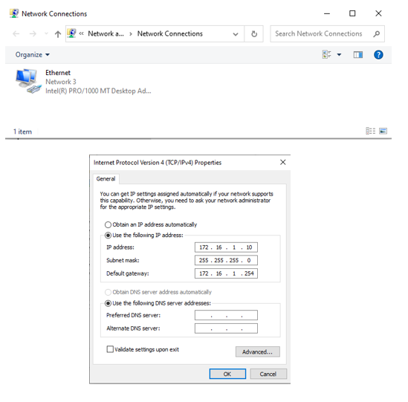

C-Server
The network configuration of C-Server was set up with three network interfaces
NAT
Obtains its IP address automatically and is configured for external communication using DHCP.
External
Connects to the S-DC (Swansea Network). The IP Address, Default Gateway, and Subnet Mask match the assignment topology.
Internal
Connects to the internal network (Cardiff Network) and acts as a default gateway for internal hosts. The subnet mask allows for 254 usable addresses, accommodating multiple internal devices.
Figure 19: C-Server IP Addressing
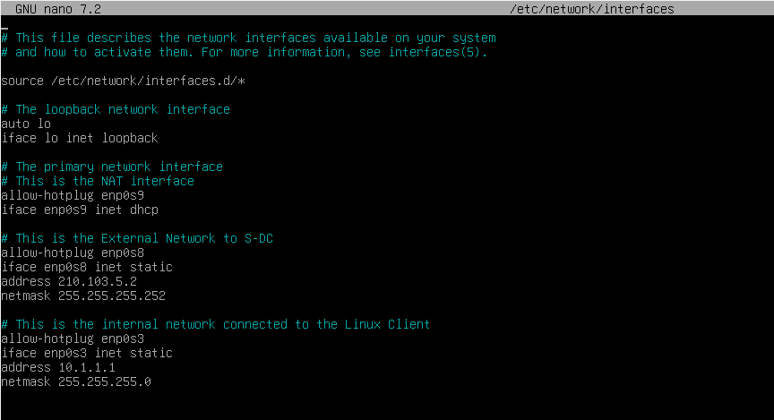

ClientC1
ClientC1 was assigned an unique IP address within the 10.1.1.1/24 subnet to enable communication within the Cardiff Network.
Figure 20: ClientC1 IP Addressing
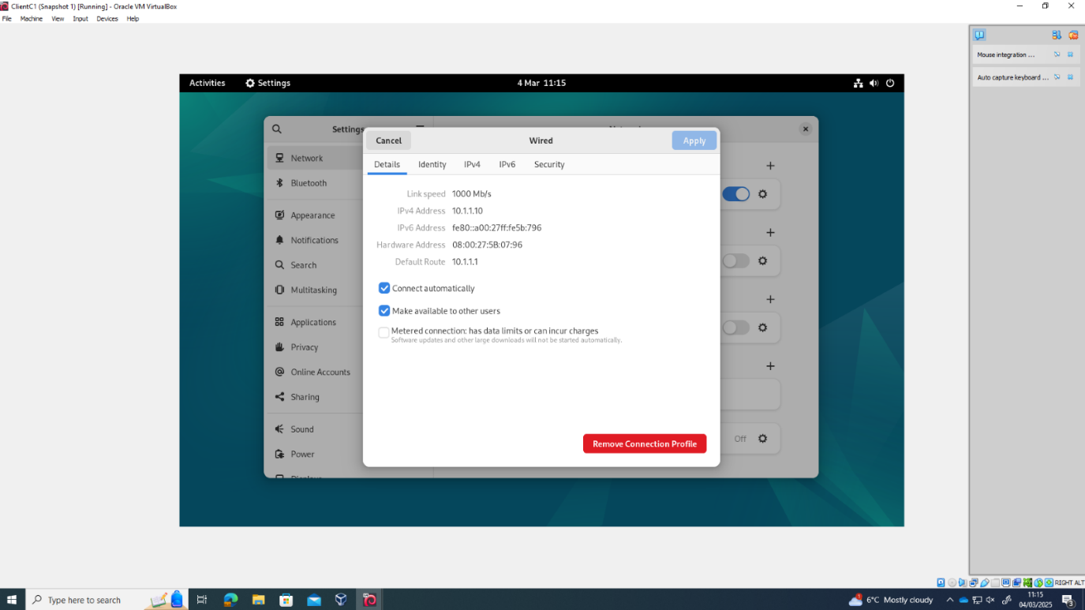
Figure 21 shows the topology and IP address schema for Swansea and Cardiff Networks
Figure 21: Network Topology and IP Addressing Schema for Swansea and Cardiff Networks
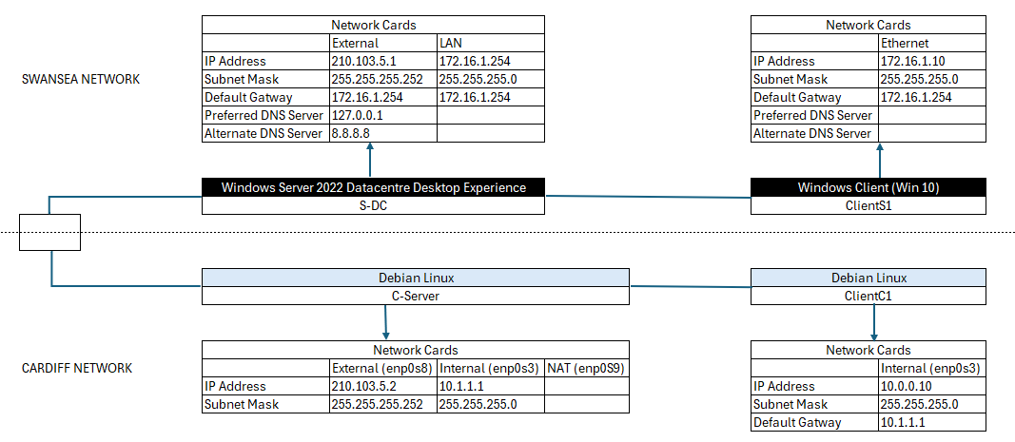

3.4 Testing and Troubleshooting
Multiple connectivity tests were performed within each network, followed by troubleshooting to resolve any identified issues.
Test 1 – Swansea Network: S-DC to ClientS1
Command Prompt and Ping were used to check connections. Figure 22 shows a failed attempt.
Figure 22: Test 1 - S-DC to ClientS1 Connection Failure
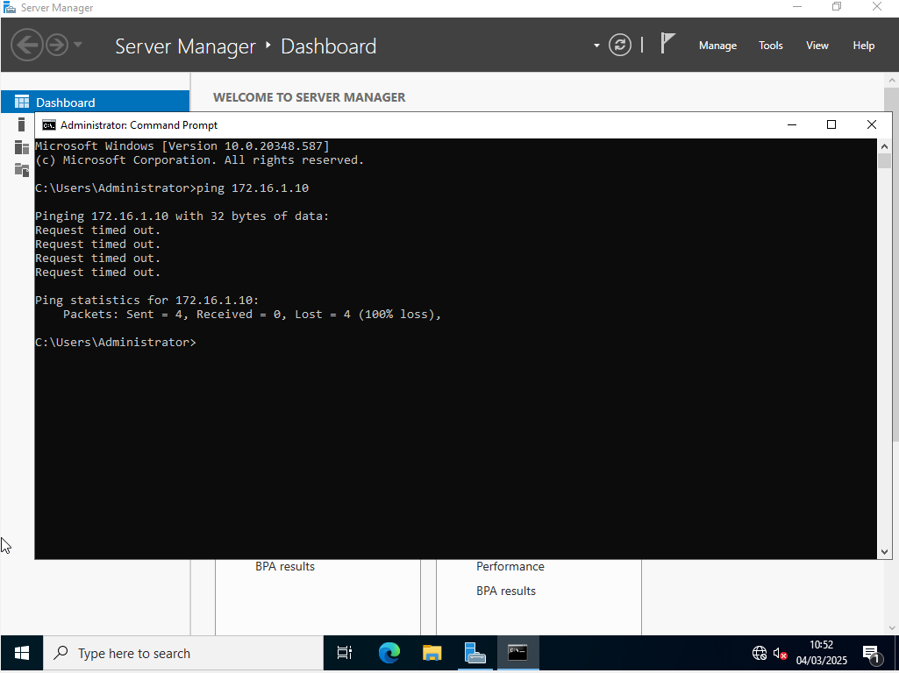
Ping failed with "Request timed out" and statistics show that all packets were dropped (100% loss), indicating that S-DC could not reach ClientS1.
S-DC and ClientS1 had Windows Firewall enabled which prevents ping requests unless firewall rules are defined. Due to unset firewall rules, packets were discarded, preventing communication.
To re-establish connectivity, S-DC and ClientS1 firewalls were switched off.

Figure 23: Disabled Firewalls
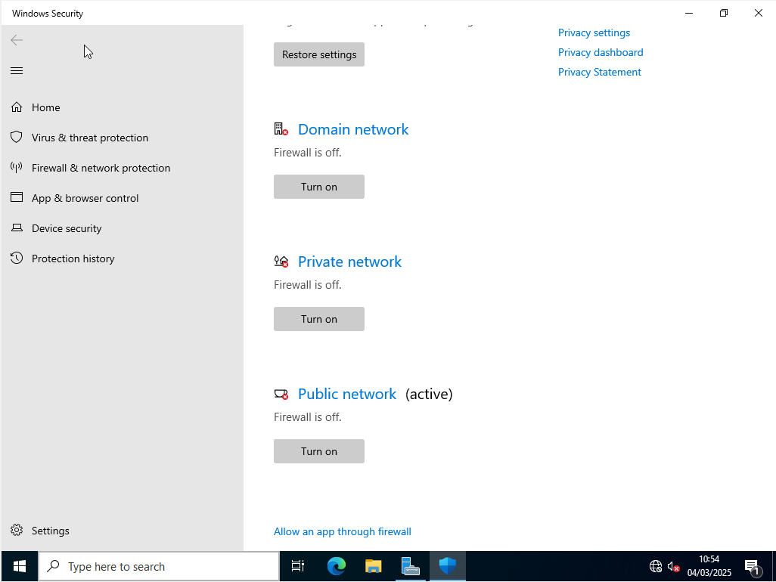

Test 2 – Retest Swansea Network: S-DC to ClientS1 and ClientS1 to S-DC
The retest was successful and connectivity was established between S-DC and ClientS1 as depicted in figure 24.

Figure 24: Test 2 - Swansea Network Internal Connectivity Successful Test
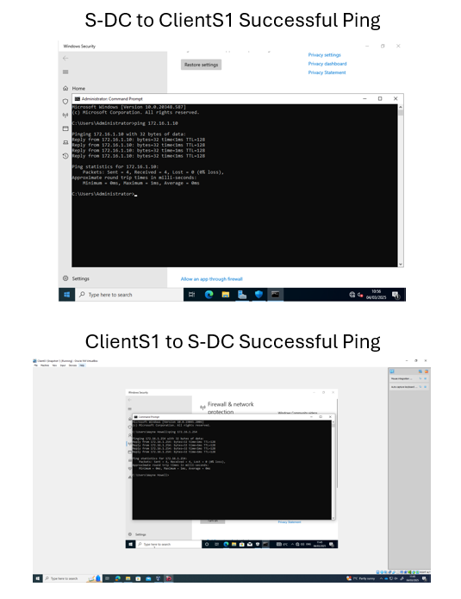

Test 3 - Cardiff Network C-Server to ClientC1 and ClientC1 to C-Server
Figure 25 shows a successful test between C-Server and ClientC1 in the Cardiff Network.

Figure 25: Test 3 - Cardiff Network Internal Connectivity Success Test
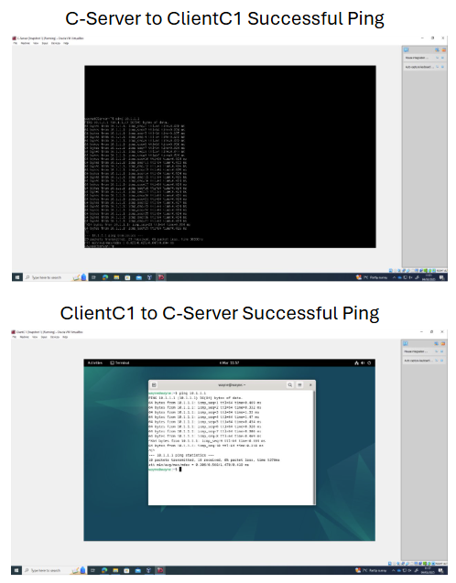

Test 4 - Cardiff Network to Swansea Network
Figure 26 shows an unsuccessful connectivity test between the Cardiff and Swansea Networks.
Figure 26: Test 4 - Network to Network Connectivity Test
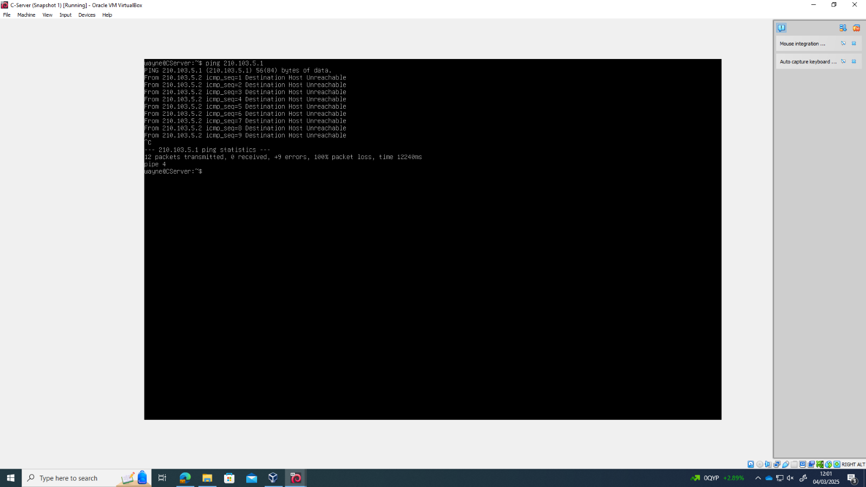
Investigation revealed that network adaptors were misconfigured for cross-network communication. SD-C Adaptor 2 was converted to Internal to fix it.
Figure 27: Troubleshooting Network to Network Connectivity Failure
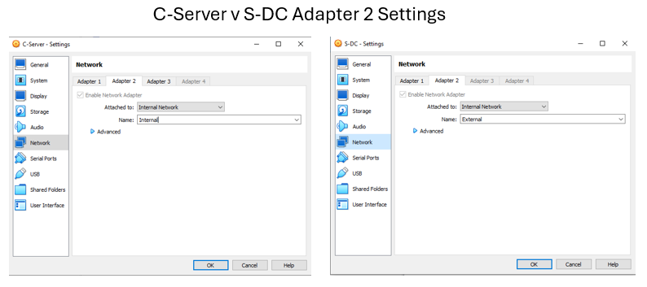

Figure 28 shows the successful connection between the Cardiff and Swansea Networks.
Figure 28: Test 5 - Successful Network to Network Connectivity
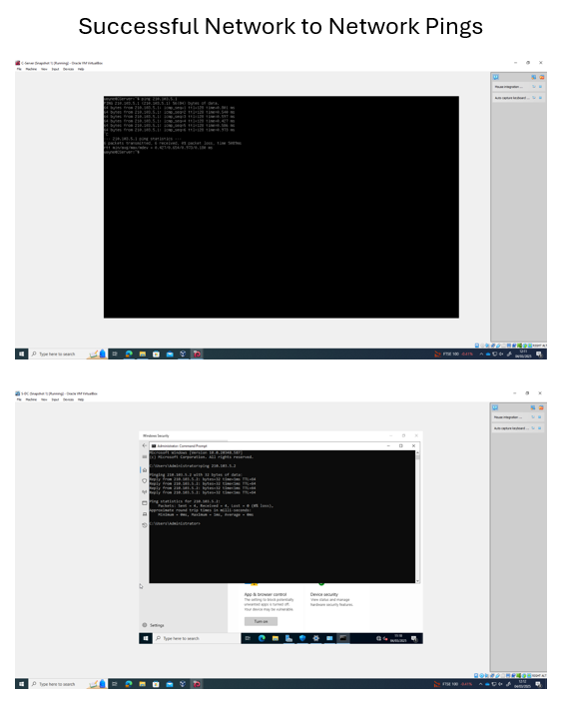

4.Task 3 – Reflection

4.1 Technical Reflection
During network deployment, key challenges included IP address conflicts, firewall restrictions, and misconfigured adapters. Initial ping tests failed due to Windows Firewall blocking connectivity, which was resolved by disabling it. Additionally, network-to-network communication failed due to incorrect adapter configurations. Systematic troubleshooting involved ping tests, adapter checks (Figure 29) , and reviewing settings to verify network connectivity.
Figure 29: Linux Adapter Checks for C-Server using ip a command
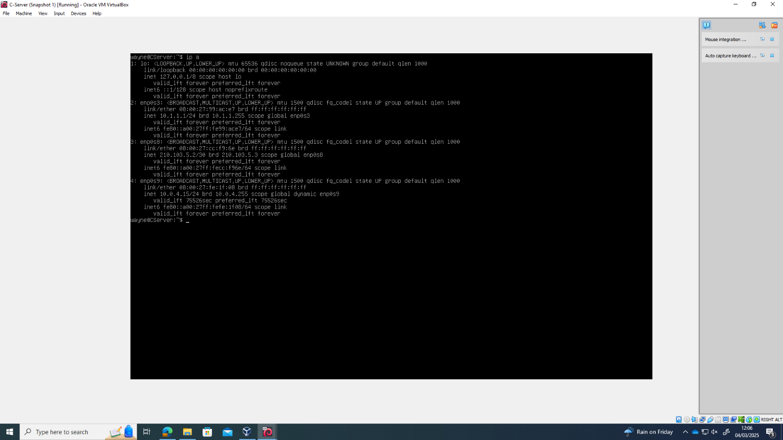

4.2 Personal Reflection
This assignment has enhanced my network troubleshooting, hypervisor configuration, and subnetting skills. Overcoming technical challenges reinforced my ability to diagnose, document, and resolve network issues systematically.

5.References

[1] A. S. Gowri, "Impact of Virtualisation Technologies in the Development and Management of Cloud Applications," International Journal of Intelligent Systems and Applications in Engineering, vol. 7, no. 2, pp. 104–110, Jan. 2019. doi: https://doi.org/10.18201/ijisae.2019252789
[2] J. Macpherson, "What Is a Hypervisor? – Types, Benefits & How Does It Work?," Park Place Technologies, Feb. 14, 2022. [Online]. Available: https://www.parkplacetechnologies.com/blog/what-is-hypervisor-types-benefits/ (accessed Feb. 04, 2025).
[3] IBM, “TS4500 Tape Library,” Ibm.com, Jan. 18, 2022. https://www.ibm.com/docs/en/ts4500-tape-library?topic=functionality-ipv4-ipv6-address-formats (accessed Feb. 09, 2025).
[4] Router-Switch.com, “IPv4 vs. IPv6. Why We Need IPv6 Now?,” Router-switch.com, Jan. 15, 2018. https://www.router-switch.com/faq/ipv4-vs-ipv6-ip-protocol-features.html (accessed Feb. 09, 2025).
[5] P. Nath and Uddin, “TCP-IP Model in Data Communication and Networking,” American Journal of Engineering Research (AJER), vol. 4, no. 10, pp. 102–107, 2015, Accessed: Feb. 09, 2025. [Online]. Available: https://www.ajer.org/papers/v4%2810%29/N04101020107.pdf?
[6] Z. Duan, “Research on Switching Mechanism of Computer Virtual Network Routing,” Journal of Physics Conference Series, vol. 1648, no. 4, pp. 042041–042041, Oct. 2020, doi: https://doi.org/10.1088/1742-6596/1648/4/042041.
[7] Indeed, “Static Routing vs. Dynamic Routing: What’s the Difference?,” Indeed Career Guide, 2025. https://www.indeed.com/career-advice/career-development/dynamic-routing-vs-static-routing (accessed Feb. 18, 2025).
[8] A. Froehlich, “BGP vs. OSPF: When to use each protocol,” SearchNetworking, Jul. 23, 2021. https://www.techtarget.com/searchnetworking/tip/BGP-vs-OSPF-When-to-use-each-protocol (accessed Feb. 18, 2025).
[9] J. Borthakur, “A comparison study of single area OSPF Network to multiple area OSPF Network implementation in a Campus area Network,” IEEE Xplore, Oct. 01, 2022. https://ieeexplore.ieee.org/document/9984627
[10] Oracle, “Oracle VM VirtualBox - Downloads | Oracle Technology Network | Oracle United Kingdom,” www.oracle.com. https://www.oracle.com/uk/virtualization/technologies/vm/downloads/virtualbox-downloads.html (accessed Feb. 28, 2025).
[11] Microsoft, “Windows Server 2022 | Microsoft Evaluation Center,” www.microsoft.com. https://www.microsoft.com/en-us/evalcenter/evaluate-windows-server-2022 (accessed Feb. 28, 2025).
[12] Microsoft, “Microsoft Evaluation Center,” Microsoft.com, 2019. https://www.microsoft.com/en-us/evalcenter/evaluate-windows-10-enterprise (accessed Feb. 28, 2025).
[13] Debian, “Debian -- Getting Debian,” Debian.org, 2019. https://www.debian.org/distrib/ (accessed Feb. 28, 2025).

6.Figures

Figure 1: The Structure of the Different Types of Hypervisor 4
Figure 2: Hypervisor Solutions and Key Features 5
Figure 3: Type 1 v Type2 Hypervisors Comparison 6
Figure 4: Illustrates the IPv4 address structure 7
Figure 5: IPv6 Address Format – Illustrating 128-bit structure 7
Figure 6: IPv4 and Ipv6 Packet Header Structures 8
Figure 7: Key differences between static and dynamic routing protocols 9
Figure 8: Routing Protocols Comparison 10
Figure 9: Summarised Table of Network Services 11
Figure 10: Debian Download Website 13
Figure 11: Downloaded Files 13
Figure 12: S-DC Windows Server Setup in Oracle Virtual Box 14
Figure 13: Virtual Hard Disk Setup of ClientS1 15
Figure 14: C-Server Login and Network Adapter Check after Debian Linux Installation 16
Figure 15: Configuring the Network of ClientC1 16
Figure 16: VM's Setup in Oracle Virtual Box 17
Figure 17: S-DC IP Addressing 18
Figure 18: ClientS1 IP Addressing 19
Figure 19: C-Server IP Addressing 20
Figure 20: ClientC1 IP Addressing 21
Figure 21: Network Topology and IP Addressing Schema for Swansea and Cardiff Networks 21
Figure 22: Test 1 - S-DC to ClientS1 Connection Failure 22
Figure 23: Disabled Firewalls 23
Figure 24: Test 2 - Swansea Network Internal Connectivity Successful Test 24
Figure 25: Test 3 - Cardiff Network Internal Connectivity Success Test 25
Figure 26: Test 4 - Network to Network Connectivity Test 26
Figure 27: Troubleshooting Network to Network Connectivity Failure 26
Figure 28: Test 5 - Successful Network to Network Connectivity 27
Figure 29: Linux Adapter Checks for C-Server using ip a command 28

