REPORT  Lecturer: Saquib | UNIVERISTY OF WALES TRINITY SAINT DAVID  Alina Ionela Ghinea 2020634  EFFECTIVE TEAM WORKING AND COMMUNICATION

Write a report of 2000 words demonstrating your understanding of the models of communication and the communication skills discussed in class and refer to any case studies done to show how these helped your understanding. Give examples of poor communication in your own or your friend’s workplace and suggest how it could be improved by using your findings from published literature (i.e., refer to theory).

TABLE OF CONTENTS

- Introduction
- Communication
  - What is communication?
  - Communication in the Workplace
- Communication Skills
- Models of communication
  - Berlo’s SMRC Model of communication
  - Shannon and Weaver Model of communication
  - Schramm’s Model of communication
- Reference List
- Appendix

INTRODUCTION

In this report I will describe communication skills, communication skills at the workplace, models of communications and also, I will present real life example of bad communication skills.

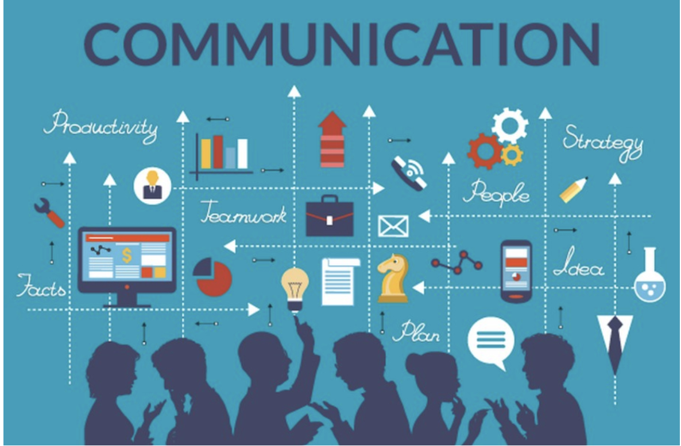

COMMUNICATION

Good communication skills are essential to rise at a higher level in business. Efficient communications skills can endear you among your co-workers, raise your value among your superiors, and let you be admired among those subordinates to you.

1.2 What is communication?
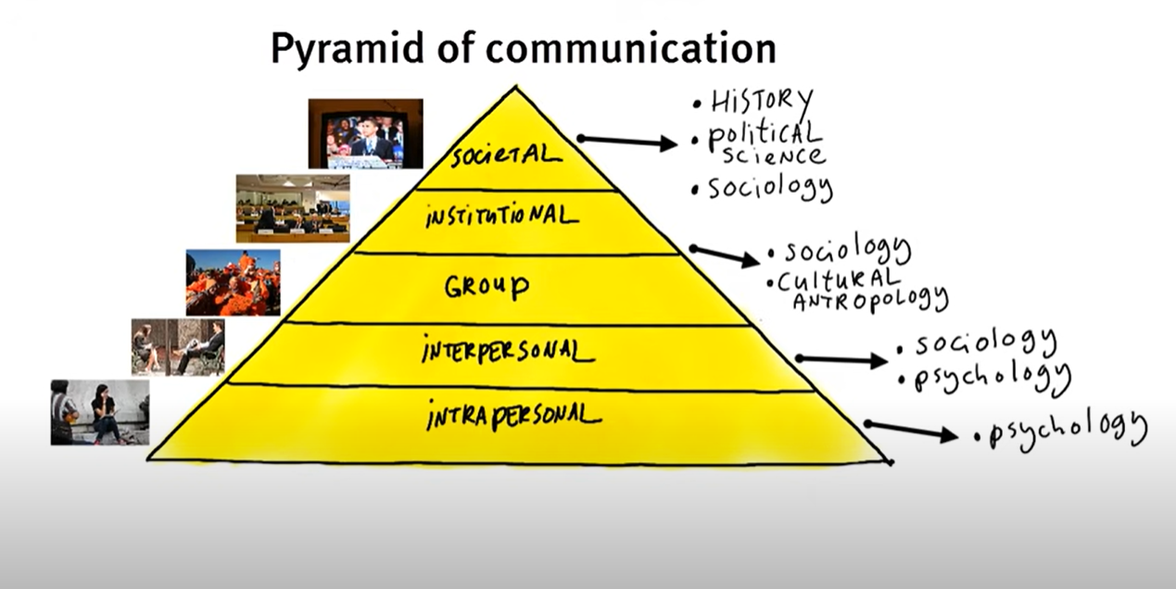
On the highest level of this pyramid, we can find societal communication which is by its nature aimed at a large mass audience. Therefore, mainly historians’ political scientists and sociologists studied this perspective.
Under that is the level of INSTITUTIONAL COMMUNICATION, which is performed by political parties organized religions, large corporations, and such.
Then comes the level of GROUP COMMUNICATION. Groups are audiences that feel an important level of group identification, for instance, a family or a Fanclub.
We have now arrived at the level of INTERPERSONAL COMMUNICATION basically the communication between two or more people. Both sociologists and psychologists study this field. Finally, there is the level of INTERPERSONAL COMMUNICATION. This would be the communication you have with yourself. With this we mean all information processing, thinking internalizing information, and process of giving meaning to the world around us.
2.2 Communication in the Workplace
Regardless of your major or the career path you eventually follow, effective communication will be essential to your success in the workplace. (Quintanilla, 2018)
According to experts, people often confuse communication with persuasion. Communication is the transmission of messages among people or groups; persuasion is a person or group’s deliberate attempt to make another person or group adopt a certain idea, belief, or action.
Expressing differences is a vital part of workplace communication, as long as you avoid an accusatory tone when doing so. Jackie Sloane, president of Sloane Communications, offered the following advice in the Chicago Tribune: “If you’re having a challenging encounter with the boss, ask yourself, ‘What does my boss want? What might he/she be terrified about?’
To understand better how important Communication in the workplace is, we will analyze Tom’s case study from ‘Business and Professional Communication: KEYS for Workplace Experiences’- Kelly M. Quintanilla, Shawn T. Wahl
Tom is a recent college graduate who landed a job as an information technology manager at a computer manufacturing plant. Tom never really enjoyed talking to new people, so he made sure his degree involved working with computers so that could minimize his interactions with coworkers. However, once he began his new job, it became obvious that a great deal to his work involved interacting with other people. Because Tom disliked communicating with his coworkers, he was often perceived as grumpy and unfriendly. Management made several attempts to coach Tom in his communications skills, but he refused to make any effort to work well with others. His lack of communication led to technical problems going unaddressed and sabotaged the company’s team based working environment. Tom was eventually fired from his position and tried to find another job that did not require him to interact with other employees.
Questions to consider:
- Is Tom wrong to assume that there are a lot of jobs out there that do not require communication skills?
- What could Tom have done differently to save his job at that company?
Answer to question number 1.
In my opinion yes, Tom is wrong assuming there are many jobs that do not require communication skills. Firstly, he is wrong because, as we already know there is not artificial intelligence to replace human labor. Secondly, regardless of the profile in which you are active, there will always be a need for changes of opinion. More opinions mean more possibilities in which one thing can be done in the best way.
Answer to question number 2.
Whether you’re writing, listening, speaking, or attending meetings, communication skills are critical to your success in the workplace Tom had to accept the help offered by the company, realizing that first of all it benefits him and then the company. The fact that the company invests in staff is magnificent. It's also hard for me to believe that Tom will find a job where he won't have to interact with colleagues (unless he's on a night shift in a cemetery.)

Communication skills

Communication skills are foundational for individual, team, and organizational success (Kinnick & Parton, 2005).
A person must be able to communicate excellently to make it effective and influence the listeners. He should know where to pause, when to repeat and should appropriately pronounce words, etc. The receiver also must be able to interpret the message. Otherwise, the communication is not considered effective.
Communication is a vital part of our daily routines. We sit in school and listen to teachers. We read books and magazines. We talk to friends, watch television, and communicate over the Internet. The workplace is no different.
Experts tell us that 70–80 percent of our working time is spent in communication. We’re reading and writing memos, listening to our co-workers, or having one-tone conversations with our supervisors.
Communication involves at least two people: the sender and the receiver. In this book, we’ll look at four types of communication between senders and receivers: writing, speaking, listening, and conducting meetings. Each one is important to your success in the workplace. For example, a poorly written cover letter can prevent you from being hired for a job.
On the other hand, the ability to write effectively and make clear presentations can make the difference between your being promoted or being left behind. As Ken Matejka and Diane Ramos explain in their book Hook ‘Em: Speaking and Writing to Catch and Keep a Business Audience, “You need effective, persuasive communication skills for career advancement.” (Worth, 2004)

4.Models of communication

3.1 Berlo’s SMRC Model of communication
In 1960, David Berlo developed Berlo’s Sender-Message-Channel-Receiver (SMCR) model of communication from Shannon Weaver’s Model of Communication (1949). He described factors affecting the individual components in the communication making the communication more efficient. (Gaikwad 2021)
The model also focuses on encoding and decoding which happens before sender sends the message and before receiver receives the message, respectively.
Berlo’s Model has mainly, four components to describe the communication process. They are sender, message, channel and receiver. Each part is affected by many factors.

Effective communication, according to Berlo’s model, is possible if the sender and receiver are on the same page. The message may not impact the same way as desired if the receiver and sender are not at the same level.

3.2 Shannon and Weaver Model of communication

Shannon Weaver model of communication was created in 1948 when Claude Elwood Shannon wrote an article “A Mathematical Theory of Communication” in Bell System Technical Journal with Warren Weaver.
Shannon was an American mathematician whereas Weaver was a scientist. The Mathematical theory later came to be known as Shannon Weaver model of communication or “mother of all models.” This model is more technological than other linear models.
This model is specially designed to develop the effective communication between sender and receiver. Also, they find factors which affecting the communication process called “Noise”. At first the model was developed to improve the technical communication. Later it’s widely applied in the field of Communication.

Concepts in Shannon Weaver Model
- Sender (Information source) – Sender is the person who makes the message, chooses the channel, and sends the message.
- Encoder (Transmitter) –Encoder is the sender who uses machine, which converts message into signals or binary data. It might also directly refer to the machine.
- Channel –Channel is the medium used to send message.
- Decoder (Receiver) – Decoder is the machine used to convert signals or binary data into message or the receiver who translates the message from signals.
- Receiver (Destination) –Receiver is the person who gets the message or the place where the message must reach. The receiver provides feedback according to the message.
- Noise –Noise is the physical disturbances like environment, people, etc. which does not let the message get to the receiver as what is sent.
(Businesstopia, 2018)
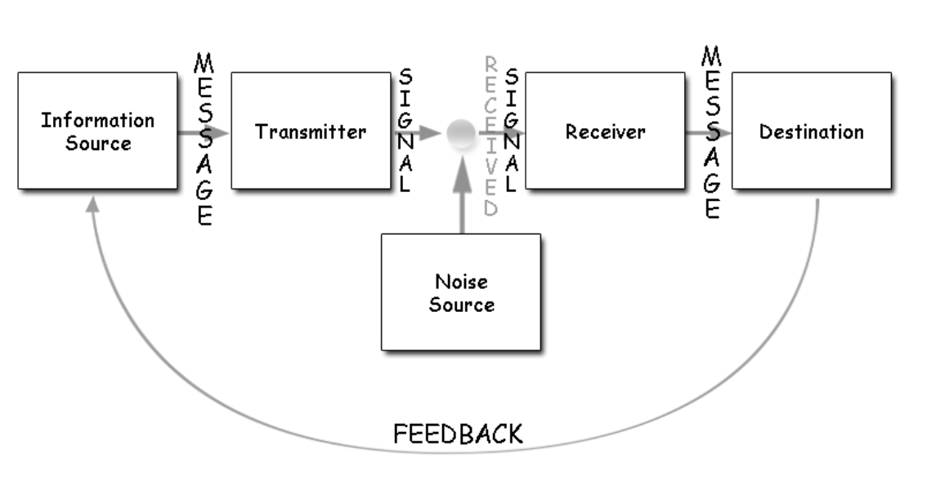

Example of Shannon Weaver Model
A businessman sends a message via phone text to his worker about a meeting happening about their brand promotion. The worker does not receive the full message because of noise. It goes like this:
Businessman: We have a meeting at the office (“at 8 am” goes missing due to phone network disruption or noise)
Worker (feedback): At what time?
Here,
Sender: Businessman
Encoder: Telephone network company
Channel: Mobile network
Noise: Missing text due to disruption
Decoder: Mobile phone
Receiver: Worker
The transmission error is the noise in this case. The feedback lets the businessman know that the message reached incomplete. The receiver gets the chance to get the full message only after his feedback.

Schramm’s Model of Communication
After learning the Shannon weaver model, let’s find out about Schramm’s model of communication which has its roots from the Shannon weaver model itself.
Wilber Schramm proposed the model of communication in 1954.
Information is of no use unless and until it is carefully put into words and conveyed to others. Encoding plays a very important role because it initiates the process of communication by converting the thought into content. When the information reaches the recipient, his prime responsibility is to understand what the speaker intends to convey. Unless and until the second party can understand or decode the information what the sender wants to communicate, the message is actually of no use. Thus, encoding and decoding are two most important factors of an effective communication without which information can never flow between two individuals. Schramm’s model also revolves around the above principle. According to the Schramm’s model, coding and decoding are the two essential processes of an effective communication.
He also emphasizes that the communication is incomplete unless and until the sender receives feedback from the recipient. Imagine a person sharing his thoughts with his friend and his friend not responding to him. Is the communication complete? NO. Schramm believed that communication is a two-way process between the first party and the second party. 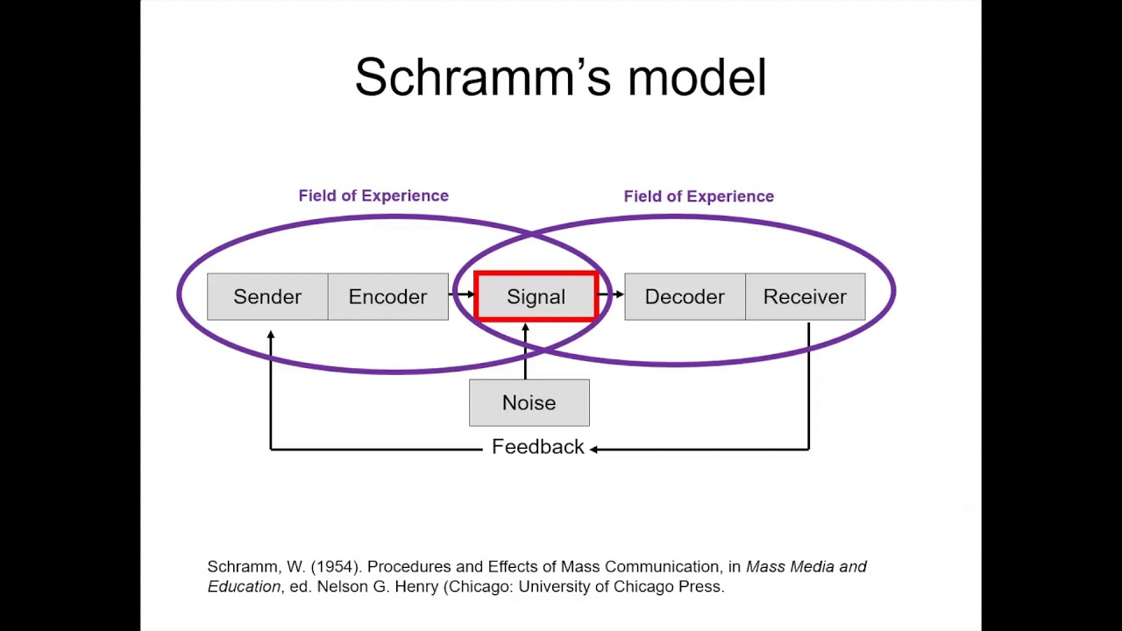
M - Stands for message
Schramm believed that an individual’s knowledge, experience and cultural background also play an important role in communication. Individuals from diverse cultures, religion or background tend to interpret the message in different ways.
To conclude according to this model of communication when a sender passes on the information to the receiver, the receiver must interpret it in the desired form the sender wants and give him the feedback or respond accordingly. Any communication where the sender does not get the feedback, the communication is not complete and thus ineffective.
S-----------------------M-----------------------C-------------------R
S -R

Example of bad communication skills

I work in a warehouse that imports and exports goods for various brands. At the client's request, we also store and process their goods according to their requirements. A few weeks ago my colleague, Zina was making entries for one of our clients' goods. But because she is a new employer in our department, she didn’t know exactly how to do it and she called our manager. Because my manager has Italian nationality his accent when he is speaking English is pretty hard to be understood and because Zina doesn't have a high level of English she didn't understand what the manager said to her to do but still she didn't ask for more details / explanations, and this is how she did 300 hundred pieces limbo in our system.
The problem was that there was a lack of communication between Zina and my manager. They have not been on the same page of knowledge. Exactly how Berlo’s model of communication is saying: communicating also means that the person needs to be knowledgeable about the subject or topic.

REFERENCE LIST

Businesstopia "Shannon and Weaver Model of Communication," in Businesstopia, January 6, 2018, https://www.businesstopia.net/communication/shannon-and-weaver-model-communication.
Gaikwad U. (2021) Free Courses.NET Berol’s Model of Communication Explained – Components, Structure and Criticism Available at ://freecourses.net/marketing/berlos-model-of-communication/
Kinnick, K. N., & Parton, S. R. (2005). Workplace communication: What The Apprentice teaches about communication skills. Business communication quarterly, 68(4), 429-456.
Quintanilla, K. M., & Wahl, S. T. (2018). Business and professional communication: Keys for workplace excellence. Sage Publications.
WORTH, Richard. (2004) Communication skills. Infobase Publishing. 2-3.

