Old-fashioned is New Again

by Linh Duong (P148666)

BA Graphic Design

Submitted in partial fulfilment of the requirements for the degree of
BA (Hons) University of Wales Trinity Saint David, Swansea

9th December 2018

Word Count: 5747
Table of Contents

I. Summary 3
II. Introduction 4
III. Chapter 1 7
1. Brief History of Typography 7
2. Artists in the Past Who Had Also Rebelled Against Their Time 10
IV. Chapter 2 14
1. Contemporary Artists and Societies with Retro-driven Focuses 14
2. Vietnamese Creatives’ Responses to Retro 24
V. Chapter 3 32
1. On the Existence of Retro 32
2. Contrasting Opinions Regarding Retro 37
VI. Conclusion 41
VII. Bibliography 44
VIII. List of Illustrations 48

Summary

Old-fashioned is new again. This dissertation studies the resurgence of interest with design styles and processes from the past among young graphic designers today. Using examples from designers and creative minds in both the past and the present, this piece will inform the reader of retro style, of how it has existed for many centuries and is not a new trend that our generation came up with. On the other hand, there are references to individual creatives as well as design firms and societies who focus on working with past trends so as to exemplify the appearance of retro in the modern day. Moreover, the dissertation discusses the different ways people view retro, especially between millennial artists and the older generation.

Introduction

The year is 2018 and civilisation has never been so diverse and advanced, as is graphic design. Graphic design develops hand-in-hand with mankind; as civilisation progresses into another year, the world surrounding it changes drastically. Intertwining with a great amount of constant social change and the demanding, diverse definitions of beauty, technology has allowed graphic design to exist as a culturally distinctive feature to each and every generation. Graphic design has a reliable presence within our society and it is a profession that is rapidly increasing in popularity, although sometimes we forget that it exists for it has also become transparent to a large body of the public.
The demand for sophisticated media design has led to mass production, and the computer has acted as an equaliser, erasing the difference between text, images, sounds and films. (Olding-Smee and Ford, 2002).

Tactile graphic design was alive before the invention of advanced computer technology and the Macintosh. Such was a time that each design element was created by hand with careful calculations and revised actions in order to produce an outcome as close to the creator’s intention as possible. Utilising methods and processes like letterpress, screen-printing, hand-painting, etc., creatives of the past generated works using techniques that nowadays, we would consider old. However, those processes have not vanished thanks to a growing number of designers and artists who still recognise the beauty and potential within older techniques and styles. They refer to these historical techniques with the term retro.

In the first few decades of the 21st century, there has been a noticeable surge of interest from millennial graphic designers for retro design alongside the fast-progressing technology and the ever-changing taste of the public. This phenomenon generates an excitement and a dilemma; some designers are against it while some celebrate it. This dissertation aims to study retro as a style in more depth and consider its reasoning more thoughtfully. Using examples from designers and creative minds in both the past and the present, I hope to inform the reader of this dynamic trend that has in fact been evident within graphic design for many centuries.

In the first chapter, I mention briefly the history of typography as well as discuss artists and trends in the past that rejected their own modern time, thus further illustrating the existence of retro style. Within this chapter, I intend to highlight the point of argument that our generation is not the first to have thought of introducing past styles into modern work.

In the second chapter, I turn the focus of the dissertation more specifically to contemporary retro in graphic design as well as other platforms. Artists in the 21st century tend to navigate towards retro design in their work or in their lifestyles, I hope to acknowledge this observation and study it in more detail. With reference to individual creatives as well as design firms and societies who focus on working with trends from the past, I aim to exemplify the appearance of retro in the modern day in contrast to the first chapter. The designers discussed come from different countries, including the United Kingdom and Vietnam; this is to illustrate that retro is popular internationally.

In the final chapter, I discuss in more detail the positives and negatives regarding retro style. I will also talk about the reasoning behind the rising popularity of retro with contrasting arguments found in my research. Through this, I hope that the reader becomes more aware of the style, where it can originate from, and how it appears in different aspects of our lives.

Chapter 1

Brief History of Typography
As graphic design changes, typography transforms with it, because typography is one of the principal elements that make up a successful piece of visual communication. The history of it exceeds the history of graphic design and goes back to the beginning of human intelligence. Since Johannes Gutenberg invented movable type in the 15th century, typography has been steadily developing in terms of both material and style.

History has witnessed many significant changes regarding human taste. Similar to fine art with movements like the Pre-Raphaelites and Impressionists, typography has also progressed through numerous eras and movements, all of which are indispensable when talking about the history of design. Many graphic design works produced in the past, despite the changes in preferences throughout the years, are still used on a daily basis nowadays; a famous example of this case is the work of Edward Johnston for the London Underground system, including its entire typeface and the iconic roundel symbol (fig.1).

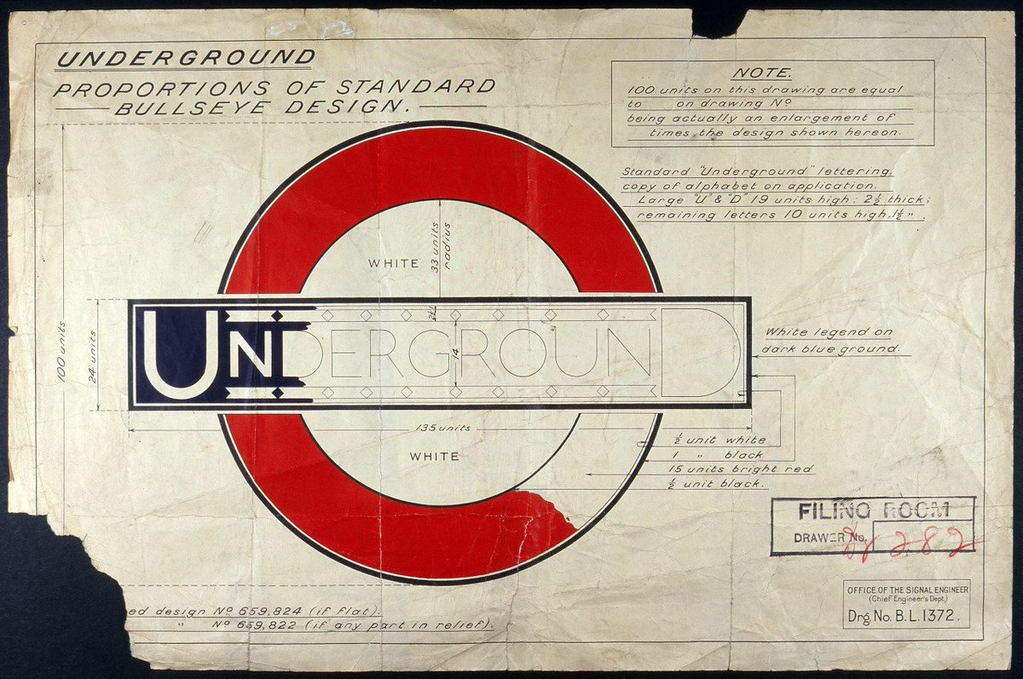
Fig. 1: Proportions of Standard Bullseye Design (Johnston, 1916)

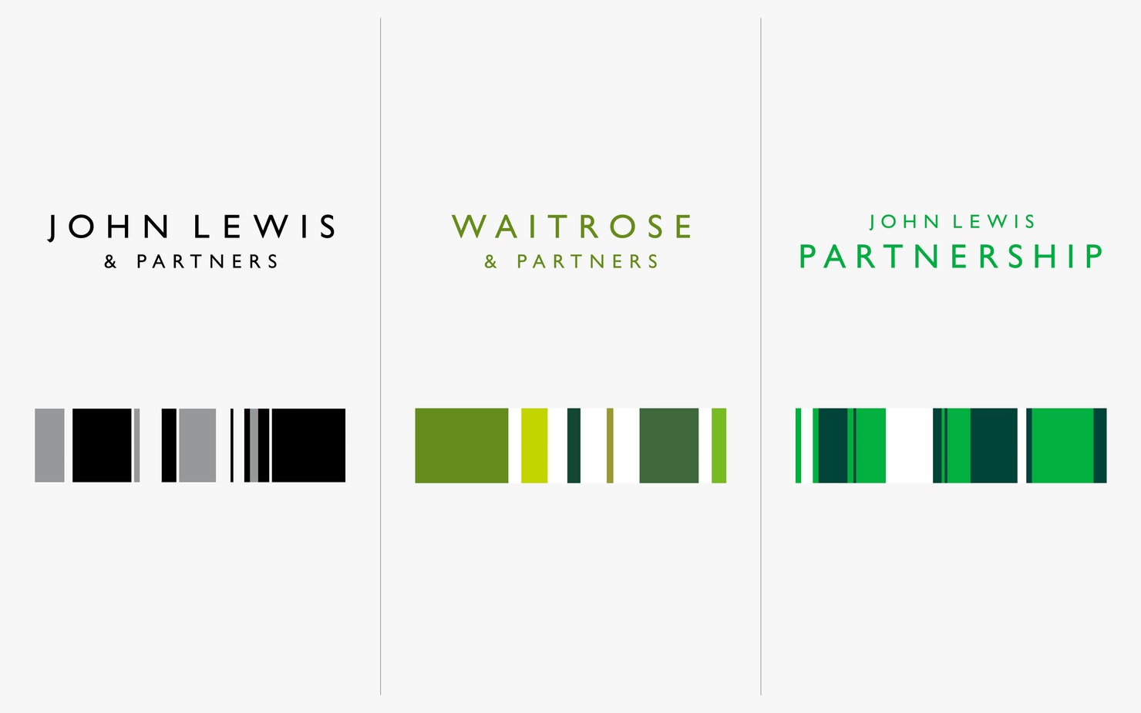
Fig. 2: John Lewis & Partners New Brand Identity (Pentagram, 2018)

Typefaces produced in the past are still favoured and very often utilised by modern day designers. Futura was created by Paul Renner in 1927 and it is still popular now due to its timelessness, making it as relevant now as it was nearly 100 years ago. In 1957, Edouard Hoffmann and Max Miedinger designed Helvetica; this typeface continues to be loved by designers after its time of creation. Undoubtedly, past designers and typographers play a strongly influential part in today’s design. Their masterpieces are reminders that keep us from forgetting them and the hard work they have contributed. Gill Sans, Georgia, Garamond, Univers, Futura, and many well-crafted typefaces of past centuries are often used, borrowed, imitated, plagiarised, based upon, taken apart and so on (fig.3).

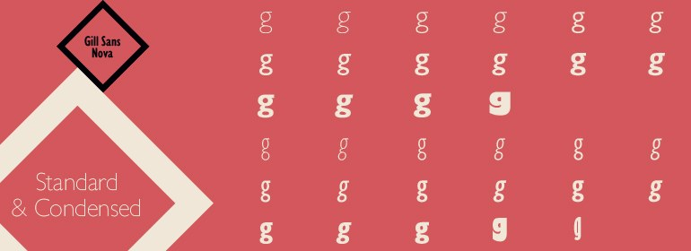
Fig. 3: Gill Sans Nova Standard & Condensed (Monotype, 2015)

Similar to typefaces, the design works that past designers have produced are still circulating and internationally influencing today’s designers. The old designs are studied and considered. By studying the past, one learns how the preceding designers had created successfully, and from that, one would be able to apply their knowledge of history to their own practice in the modern time.
A study of the past does not mean that one must try to print like John Day or Christopher Plantin or Bodoni, but it does mean that if one is trying to do good printing he must have a head full of memories of how good printers in the past have printed. (Rollins, 1995)

Artists in the Past Who Have Also Rebelled Against Their Time
By making use of the old elements and bringing them back into the spotlight, historic graphic design work is appreciated in the guise of retro design. Retro is derived from retrospect, meaning a review of past time. In its purest form, retro is a style with conscious efforts to be similar to trends, lifestyles or tastes of the past. Retro in graphic design can give modern work a certain sense of history.

However, retro design is neither new nor a fresh trend. It is ancient in itself but it is also timeless, it has existed and been utilised since the beginning of graphic design, as suggested by Breathnach and Dermody (2010). Graphic designers find inspiration everywhere and every-when, even in a different time perspective. With each generation of graphic designers, there is certain to be a group of inspired individuals who follow a trend influenced by historical styles. Twenty-first century designers are not the first creative minds to have reminisced about the time before their own.

Artists in the 19th and 20th century had also looked back in time for inspirations. William Morris (1834-1896) studied the past “to find perfect craftsmanship” (McClean, 1995). Morris is heavily associated with the Arts and Crafts Movement as a textile designer and a typographer, but in his own time period, he was widely known for his poetry which was heavily influenced by John Ruskin. Morris agreed with Ruskin’s philosophy that the creation of art should be affordable and handmade, and he rejected the industrialism of the then modern day Victorian era while agreeing strongly with the Romanticists (fig.4) (Thompson, 1955)

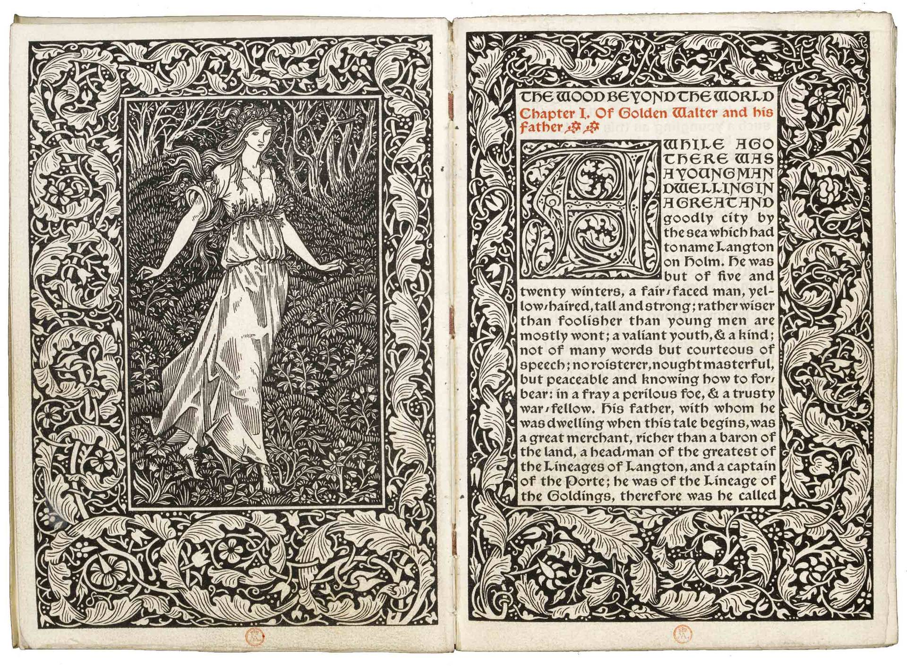
Fig. 4: The Wood Beyond the World (Morris, 1894)

Instead of working with the most advanced technology of that time for his textile printing, Morris chose to study and implement old techniques as well as working with mainly raw materials and natural dyes (Parry, 1983). Rejecting the trends of his own time and being adamant on learning a technique before applying it, the late designer appears to be one of the earliest known examples of artists who had rejected the new, choosing the old-fashioned instead.

In the mid 20th century, Swiss style (fig.5) was fashionable internationally; it was the dominating art style with a structured look, sans-serif typefaces and a certain anonymity across different brands and establishments (Odling-Smee and Ford, 2002). With the evident favouritism among modern graphic designers when it comes to clean typefaces like Akzidenz Grotesk or Helvetica, Swiss style is as popular now as it was many years ago. However, there were artists of the time who rebelled against the “norms of mainstream society” and preferred vibrant colours and distorted typography instead (Breathnach and Dermody, 2010). The style as such, psychedelia (fig.6), portrays the need to go against the mainstream, it demonstrates a recurring theme among young people despite time periods.

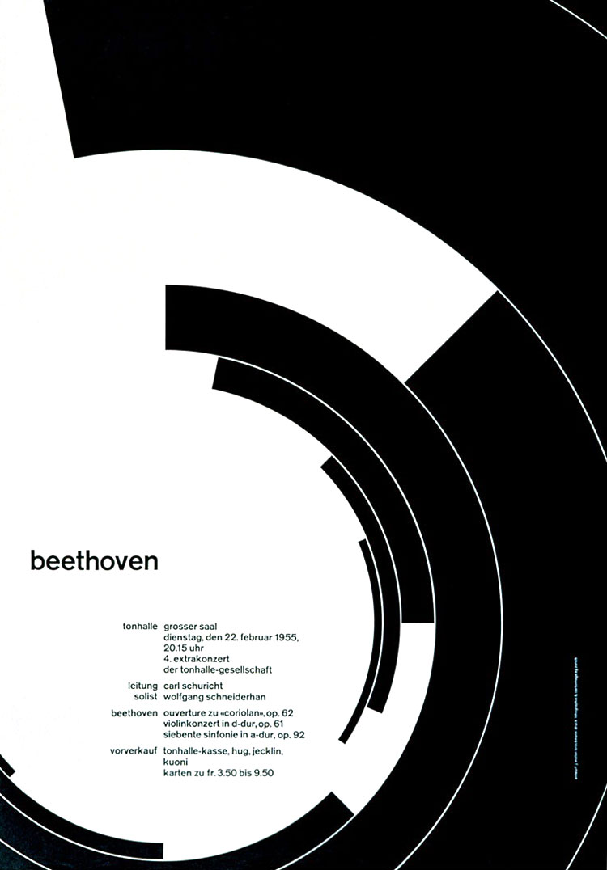
Fig. 5: Zurich Town Hall Poster (Muller-Brockmann, 1955)

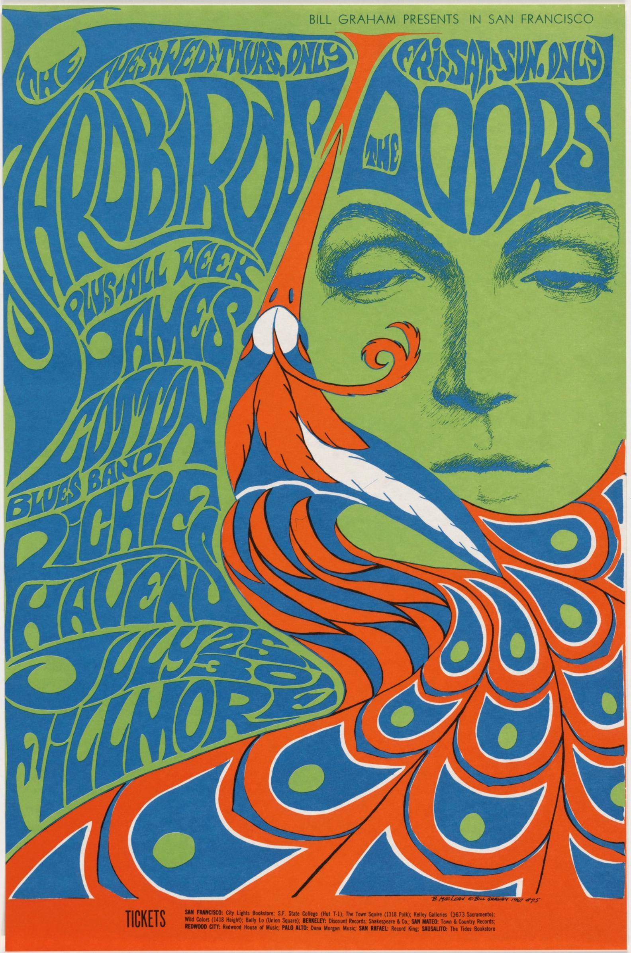
Fig. 6: The Yardbirds, The Doors (Maclean, 1967)

Chapter 2

Contemporary Artists and Societies with Retro-driven Focuses
Nowadays, the label retro most often brings to one’s mind the styles taken from the 1970s to 2000s (Breathnach and Dermody, 2010) (fig.7). Occasionally, this trend has been referred to more specifically as “modern retro” (Cousins, 2017). Retro materialises in multiple aspects of the graphic design industry: it can be seen in today’s editorial design, packaging, promotional, identity as well as type design (fig.8). It also appears within other art forms like film-making, surface pattern, fashion design or sign painting. All around the world, there are numerous artists and creative firms who dedicate their practice to analogue aesthetics and techniques.

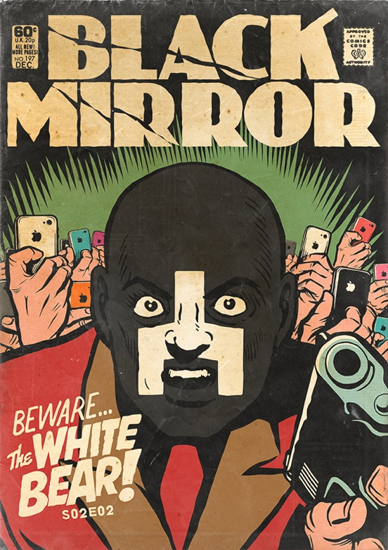
Fig. 7: Two Examples of Black Mirror Being Reimagined as 70’s Comics (Butcher Billy, 2016)


Fig. 8: Butcher’s Bone Broth Vintage Packaging (The Creative Pack, 2017)

Ashby Design, or Neal Ashby, of Washington D.C. was drawn to the cover art of Revolver, a classic 1966 Beatles’ album (fig.9), and went on to use this inspiration and collaborate with illustrator Matthew Curry to design a cover for the band Thievery Corporation (fig.10) (Eaton, 2009). Ashby’s design has clear similarities to his reference point with features such as the colour scheme containing high black and white contrast, and a stemming motion from the central pieces of the designs.

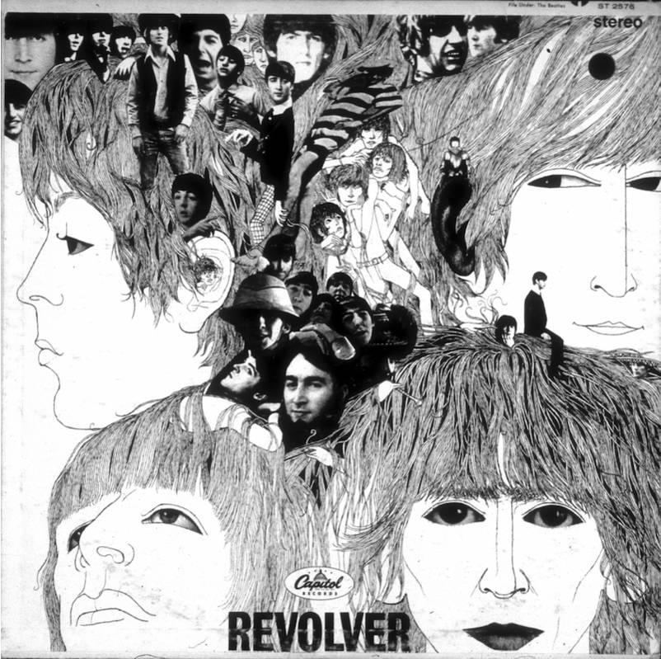
Fig. 9: Revolver (Voorman, 1966)

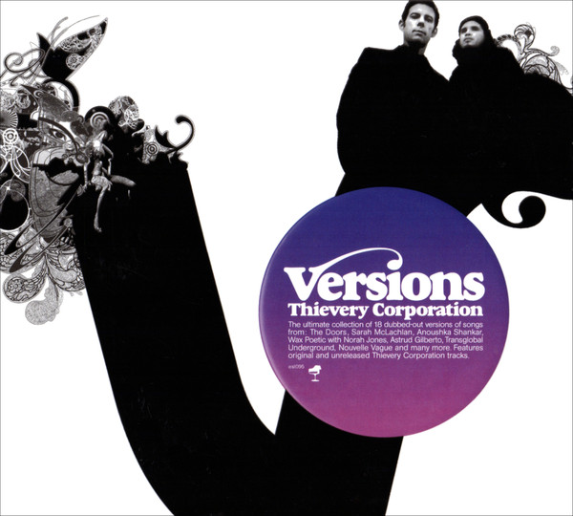
Fig. 10: Thievery Corporation’s Versions Album Cover (Ashby, 2006)

Mucca Design of New York is another example of contemporary designers taking great interest in keeping alive old-fashioned characteristics. Their works contain multiple elements of past aesthetics like hand-drawn illustration with earthy, muted colour schemes that reminisce the palettes of the 1920s Art Deco (mucca.com, 2014) (fig.11).

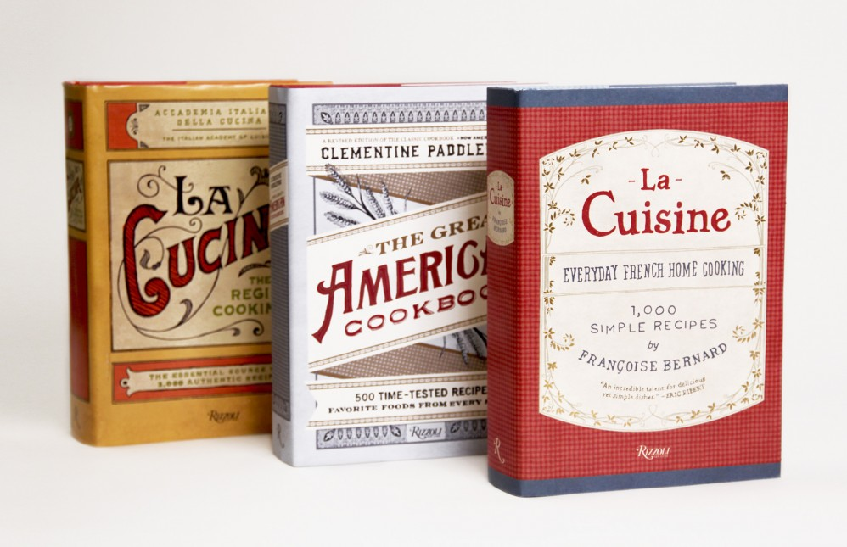
Fig. 11: Mucca Design’s Book Covers for Rizzoli, (Mucca Design, 2014)

Directors Dorota Kobiela and Hugh Welchman of Loving Vincent (2017) were adamant on creating the said feature-length film using a purely hand-painted process because “computers could never replicate this kind of authenticity” (Welchman, as interviewed by CBS News, 2017) (fig.12). Over 100 painters worked tirelessly for six years, studying and painting in the style of Vincent van Gogh to create a beautiful homage to the late artist (CBS News, 2017).

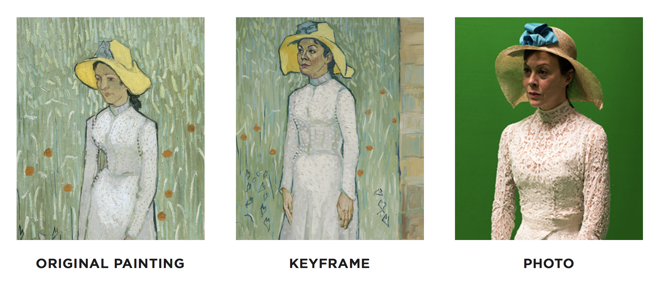
Fig. 12: Process for a Scene in Loving Vincent (2017)

Sign painting is another art form that is generating a resurgence of interest from designers and retro enthusiasts alike. A UK community dedicated to popularising “a renewed interest in craftsmanship and the aesthetics of our built environment” has also been advocating this handmade beauty since 2010; they call themselves The Pre-Vinylite Society (The PVS) (fig.13). They place their main focus on sign painting and the artists behind such works, and they also actively encourage everyone to be more aware of their surroundings and more appreciative towards their neighbourhood signage. (The PVS, 2010)

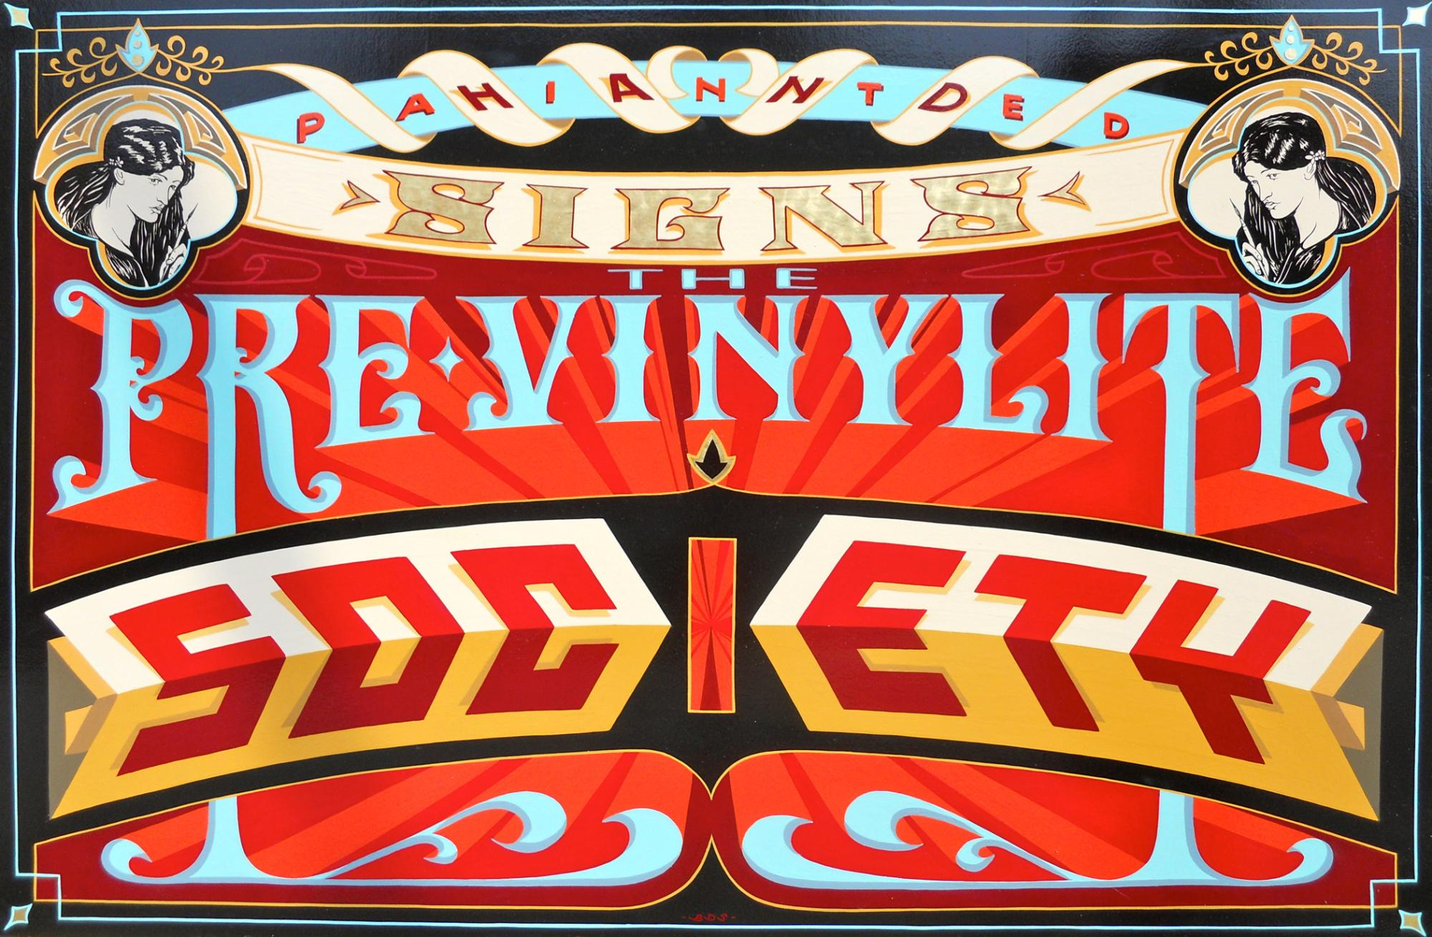
Fig. 13: The Pre-Vinylite Society (2010)

Founded by a couple of sign enthusiasts, they derived their name from the Pre-Raphaelite Brotherhood from the 19th century. They resonate with their predecessors’ idea of going against “the academic conventions of their day”, but they are forward thinking; instead of completely neglecting the existence of modern technology, they value new art that shows understanding and respect regarding the past’s processes and techniques. (The PVS, 2010) (fig.14)

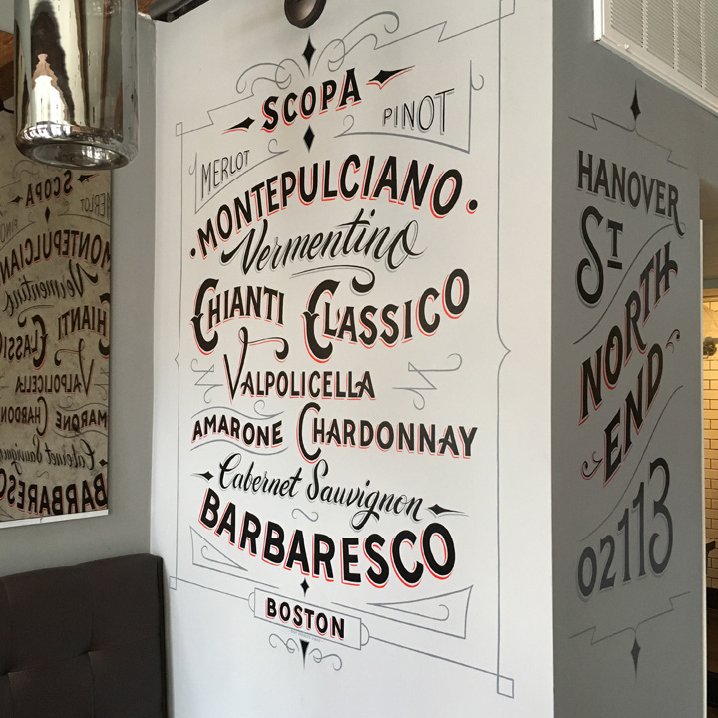
Fig. 14: Sign Painting for Scopa Wine Bar (Luke, 2016)

Alan Giberson takes part in the faithful and constant application of sign painting (fig.15). He contributes a large amount of time to painting signs in the traditional way, and his signs are becoming a signature characteristic of the streets of Cleveland, Ohio. “In a world dominated by messages delivered in digital, Giberson’s signs offer a reminder of the human pulse behind the walls of the places those signs cover” (Delamotte, 2018). Giberson’s work is classical, yet utterly modern. He confesses that no matter how detailed a piece of work is, he would like to keep it simple. Combining both a vintage sensibility and simplicity, he has made a name for himself among businesses in Cleveland, some of which let him paint on their walls (fig.17). He likes doing those, he says, for the ones that are painted on the outside walls of buildings are those who can “stand the test of time”. (Delamotte, 2018)

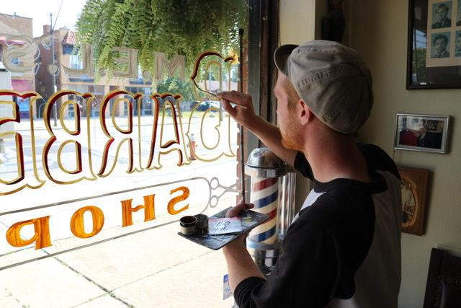
Fig. 15: Photograph of Alan Giberson Painting a Shop Window (Giberson, n.d.)

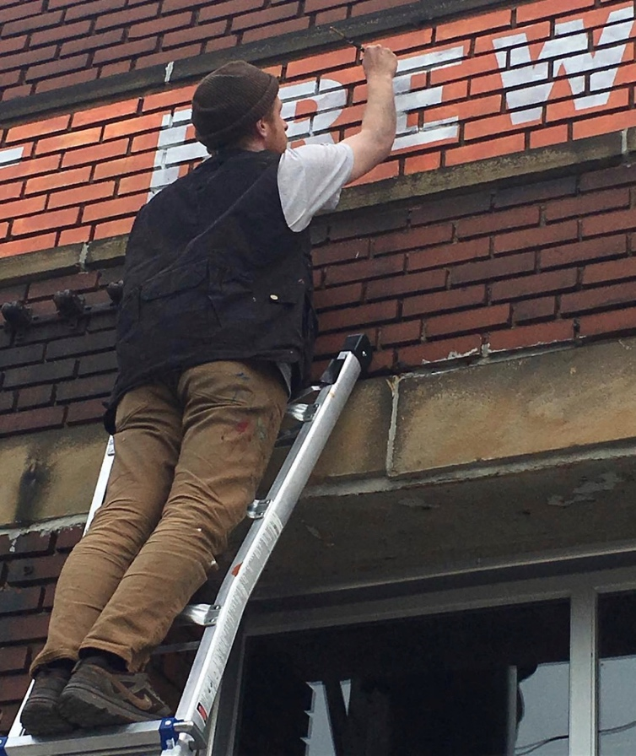
Fig. 16: Photograph of Alan Giberson Painting on a Wall (Giberson, 2017)

After some time, those signs that are painted on the building exteriors start to disappear, slowly, but not entirely. The visible remnants of those signs are given an ambiguous yet intriguing and quite appropriate name: Ghost Signs. A UK-based non-profit organisation with the same name was founded in 2006 when sign painter Sam Roberts spotted his first ghost sign in Stoke Newington, London (fig.17). Today, the organisation has over 4,000 followers on Facebook and the terminology grows in popularity. Roberts organises walking tours for supporters of dated typography to help them explore the city and observe the faded signs at first hand. He also gives talks regarding the subject to place the signs under a modern spotlight so that the busy Londoners would be aware of them and give them the attention they deserve instead of neglecting them on their repetitive daily commutes.

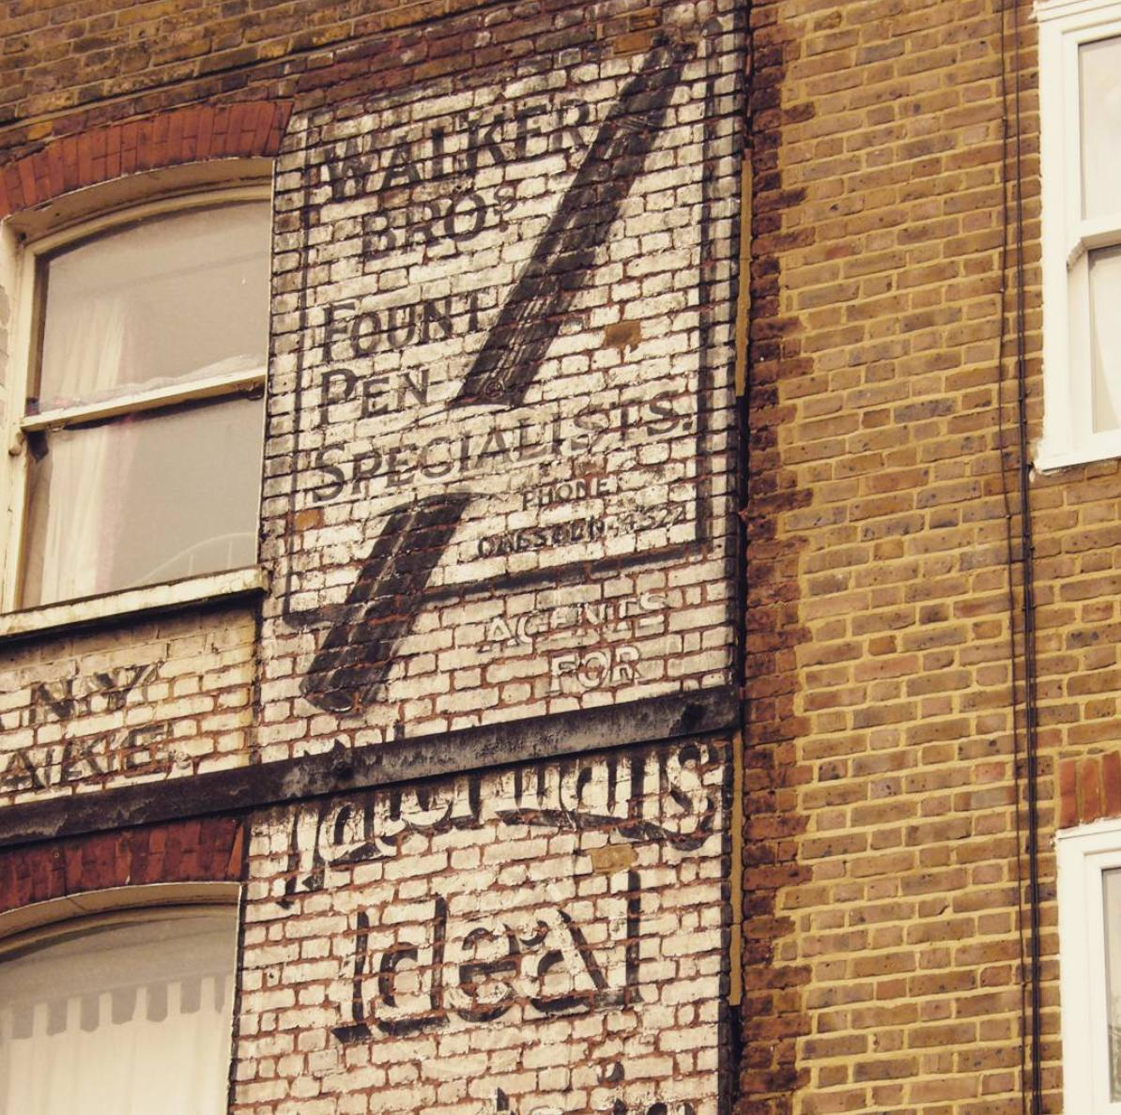
Fig. 17: Photograph of the First Ghost Sign Sam Roberts Spotted (Roberts, 2006)

Sam Roberts is an associate of fellow enthusiasts London Mural Preservation Society (LMPS) (fig.18). This association focuses on commemorating murals all around London with a manifesto to “protect, preserve and celebrate” the murals. They collect and build an archive of information for everyone to access; they help restore ruined murals; and they host events to raise awareness about the murals within their own communities as well as to a wider audience (LMPS, 2018). Such passion from admirers of historical art styles is an important factor in keeping alive the authentic and human charm of the past in this predominantly technology-driven era. Without the initial love and admiration, there would not be the aforementioned motivated actions that follow.

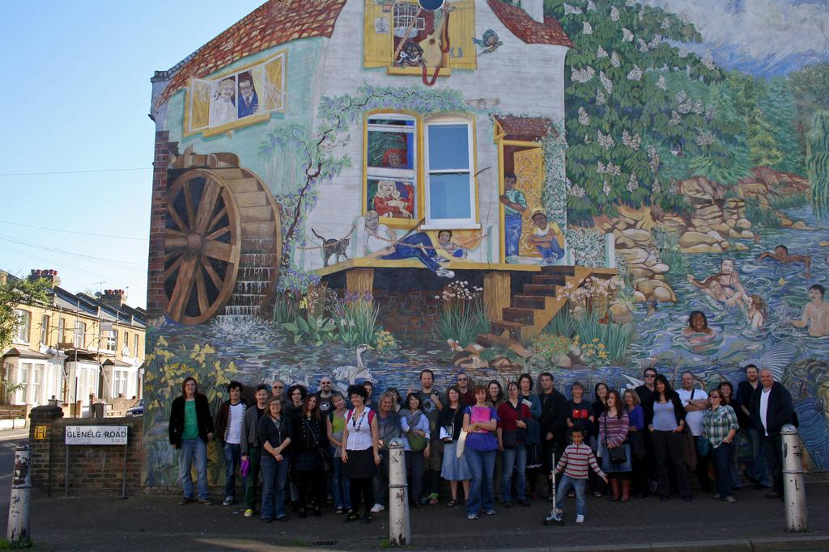
Fig. 18: London Mural Preservation Society (n.d.)

Vietnamese Creatives’ Responses to Retro
Even though the appropriation of historical styles is a common theme internationally, the admiration for past trends is particularly popular among young Vietnamese artists and designers in the past few years. The Vietnamese design scene has witnessed many major changes in terms of consumers’ preferences and there has been an increase in demands for retro design within the young-adult audience. Besides catering to the consumers’ needs with retro projects, the creative minds are actively advocating the appreciation of Vietnam’s fascinating history of art and culture, which they are passionately proud of.

Being a developing country that was under many different influences because of the wars, Vietnam has seen and absorbed into itself a multicultural attitude, from the Chinese heritage to the American modernisation. Still, with the pride and love of the people, folk art styles are still purely Vietnamese; they remain practised and handed down from generations to generations (fig.19). That is, until the invasion of technology, when such traditions became less favourable among Vietnamese citizens, especially young people.

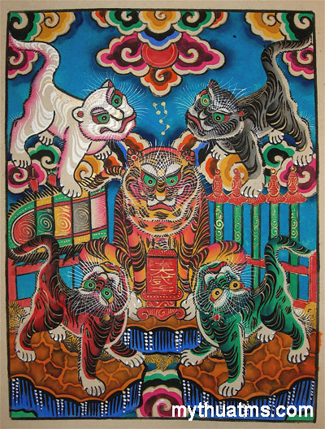
Fig. 19: An Example of a Hàng Trống Traditional Painting (n.d.)

Realising the traditions are losing their connection within the juvenile group, numerous millennial artists in Vietnam are taking actions to preserve and once again familiarise the general public with the past art style and techniques. Inspired by the energy of folk paintings, young artists aspire to keep the past alive so that the people of Vietnam would not neglect their roots (Thu, 2018). With technology’s help, artists recreate traditional paintings and embody them in more conventional items, both to better suit today’s consumer needs and to exhibit the paintings in a more contemporary way.

Nguyễn Xuân Lam is a millennial artist who is dedicated to the promotion of old painting styles. Rather than learning to make the folk art the traditional way, he utilises modern technology to recreate the looks and patterns of the old paintings and eventually applies them onto designs of stationery, tote bags and pieces of clothing (fig.20). However, this is not a suggestion that Lam does not care for the old-fashioned way of painting because he very much does. He started a project called Folk Painting - The Remake and began producing alternative versions of old paintings using advanced graphic techniques. But prior to this, he was just a young creative who was wholly captivated by the traditional paintings displayed in the Việt Nam Museum of Fine Arts, the paintings that he used to see at his grandparents’ house, the paintings that brought him to reminisce about his childhood long ago. (Thu, 2018)


Fig. 20: A design in Nguyễn Xuân Lam’s hoodie collection which embraces a folk painting of Five Tigers (2018)

In addition to the rekindling of love for traditional painting techniques, Vietnamese millennials are showing enthusiasm when it comes to finding and sharing remaining old shop signs and banners from the 70s and 80s. Rather similarly to Ghost Signs in other countries, The Lost Type Vietnam is a non-profit collaborative project started as a Facebook page in 2015. It is now a community with over 10,000 type-lovers and anyone can participate by taking pictures of old signs and forwarding them to the project (fig.21). As of September 2016, the members had contributed images of as many as 332 signs from all over Vietnam. The founders believe that once we have looked past the initial impression with the signs’ appearances, we can learn more about them and their histories. We can then feel the memories attached to a person or a piece of land throughout centuries via the signs situated at certain places. (The Lost Type, 2016)


Fig. 21: An Example of an old Vietnamese Shop Sign: Phát Hưng (Huy, 2016)

This organisation focuses on the learning of the Vietnamese type development through history, and it also helps young people on social media be more mindful of the lingering elements of the past. Projects initiated by young people for the benefit of other young people such as The Lost Type are one of the many instruments that bring retro style to a bigger audience and help it get the appreciation it deserves. With the rapid-sharing nature of social medias, young people begin to catch on to this movement and with an increase in viewers, it becomes a trend – old-fashioned typography becomes fashionable again.

Besides building an archive of old typography pieces, there are other young designers in Vietnam who are determined to construct works that can interlace old and new, harmonise past and present to achieve the perfect balance. Manh Nguyen is a renowned self-taught type designer and graphic designer in the young Vietnamese creative community. Inspired by The Lost Type project, Nguyen utilised his knowledge on typography and generated Classique Saigon (fig.22) and L’Hanoienne (fig.23), two sans-serif typefaces with characteristics taken from the dated hand-drawn street signs. The typefaces are heavily influenced by “retro hand-drawn style but it also contains uniquely aesthetic modern design” (Nguyen, 2016).

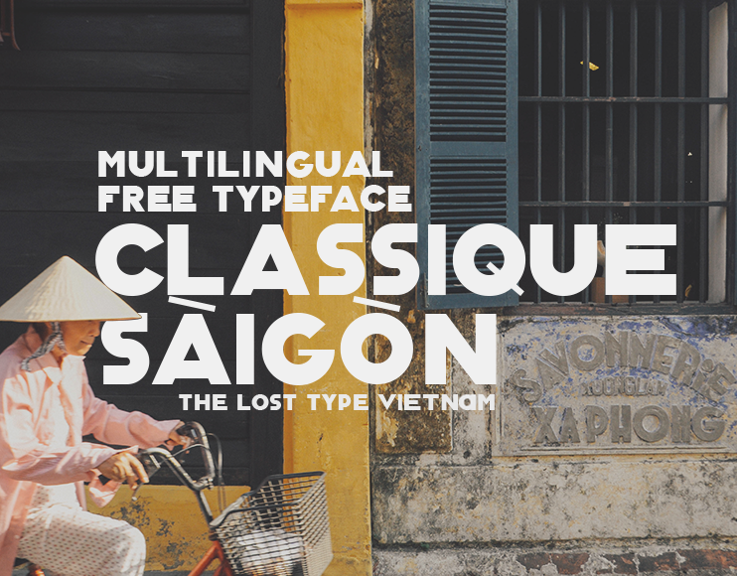
Fig. 22: Example of Classique Saigon Typeface (Nguyen, 2016)

By means of producing these so-called-classic fonts, Nguyen united artistic practices of the last century with the present time’s technological advantages in order to assemble a modern and adaptable product with the characteristics of trends belonging to the past. Additionally, he is attempting to lengthen the existence and vitality of the former hand-drawn typography by converting these typefaces into a digital format, which will forever be stored in our intangible archive that is the Internet.

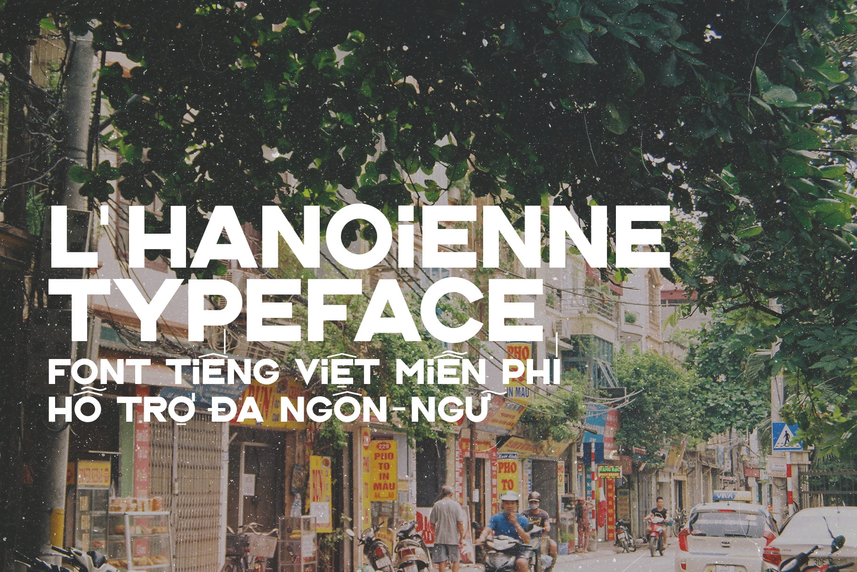
Fig. 23: Example of L’Hanoienne Typeface (Nguyen, 2018)

Despite the possibility that one day, this project Nguyen produced will in turn become an old, dated idea, this style of typography is triumphantly one of the most favoured design elements right now in the thriving graphic design field in Vietnam. There is a significant amount of books being published in the past two years that have a cover with hand-painted illustrations, a dusty over-layer and the title set in one of these retro fonts (fig.24). Coffee shops and restaurants are branding themselves using old style typography and earthy colour schemes (fig.25). Designers quite often employ Nguyen’s retro typefaces to generate promotional and informative pieces across various subjects, not exclusively old-fashioned themes.

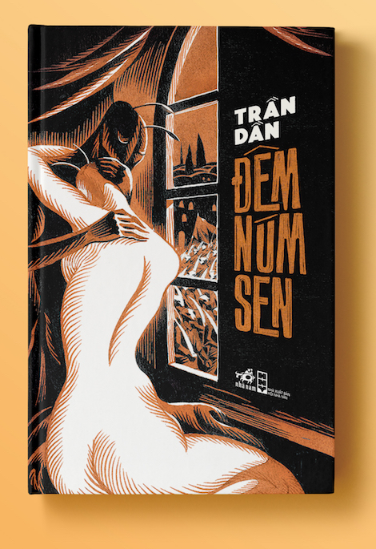
Fig. 24: Đêm Núm Sen by Trần Dần (Long, 2017)

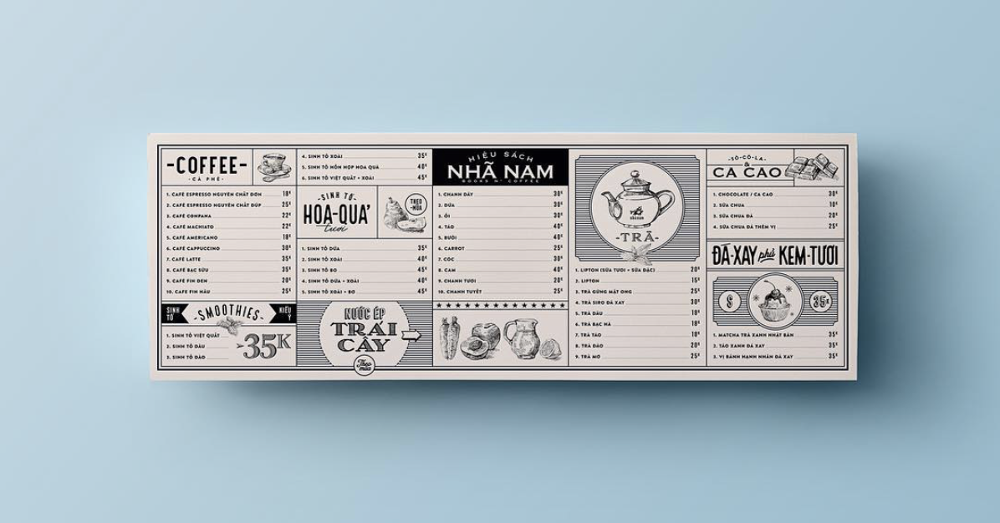
Fig. 25: A Vietnamese Cafe Menu Design (Nam, 2017)

Chapter 3

On the Existence of Retro
Learning about the past is certainly a form of appreciation of its style. Today’s designers are using characteristics of past design and incorporating these into their contemporary work. While some would say with certainty that retro is purely a trend and is anything but sentimental (Guffey, 2006), the evident practicality and application of retro prove that it contains more deeply rooted meanings than we would anticipate. There are various reasons behind the existence of retro and why it is currently gaining popularity.

The present is made from fast-evolving technology, constantly improving software programmes and most of all the popular social media lifestyle (fig.26). This leads to changes in society that we are not yet equipped to face, mentally or emotionally, and as a coping mechanism to such changes, we favour retro as a comforting reminder of the past that we are more accustomed to. In this instance, retro represents society’s fear of the ‘currentness’, of the machinery (Guffey, 2006).

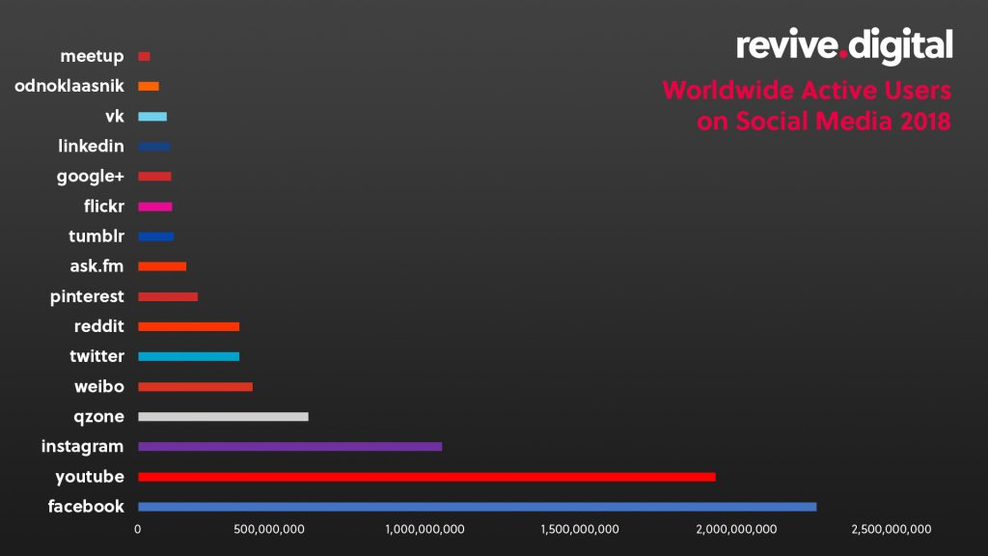
Figure 26: Worldwide Active Users on Social Media 2018 (2018)

Modern technology, however, is not always an alarming thing that separates past and present but to some, it is the means which connect the two. Thanks to the advancement of the computing industry, designers are able to produce any style of work they could possibly think of. “Contemporary graphic designers are in a more powerful position culturally than they have ever been, and have the broadest range of processes at their disposal” (Odling-Smee and Ford, 2002). With the development of technology, people are provided with easy access to everything; any works of the past are now conveniently available to browse on the Internet. Retro in this case is a statement of modern times instead; it might be seen as “an affirmation of the new technologies” that are capable of re-enacting and producing historical styles (Breathnach and Dermody, 2010).

Recreating past styles with today’s technology is time-saving and efficient, but in many cases, this act is meaningful and also portrays a great sense of admiration and appreciation of the past by graphic designers. We admire them for the work they have contributed to art and design and we are aware that without them, graphic design would not be as diverse as it is today.

Additionally, we want to also travel back to a happier time of our lives, to be in denial of the present. “Nostalgia, or homesickness, is famously not about the past but about felt absences or ‘lack’ in the present” (Samuel, 1994). The present will never have what the past had, as time moves on. Things being left behind like childhood, carefreeness, innocence, etc. will become just a fond memory of the time we all enjoyed yet is gone. Retro transfigures contemporary designs into an escape from the now, using sentimental emotions from the audience, or a graphic designer and his clients.

“We are not necessarily trying to reconstruct the past but to create an alternative present” (Jens, 2005). With it being physically impossible to get away from the present, we resort to creating an alternate universe by surrounding ourselves with retro design. Every little thing is a gateway to elsewhere than here: an old vinyl record (fig.27), an old-fashioned second-hand piece of clothing from a charity shop, a renowned company re-using their first logo for their latest rebranding and so on.
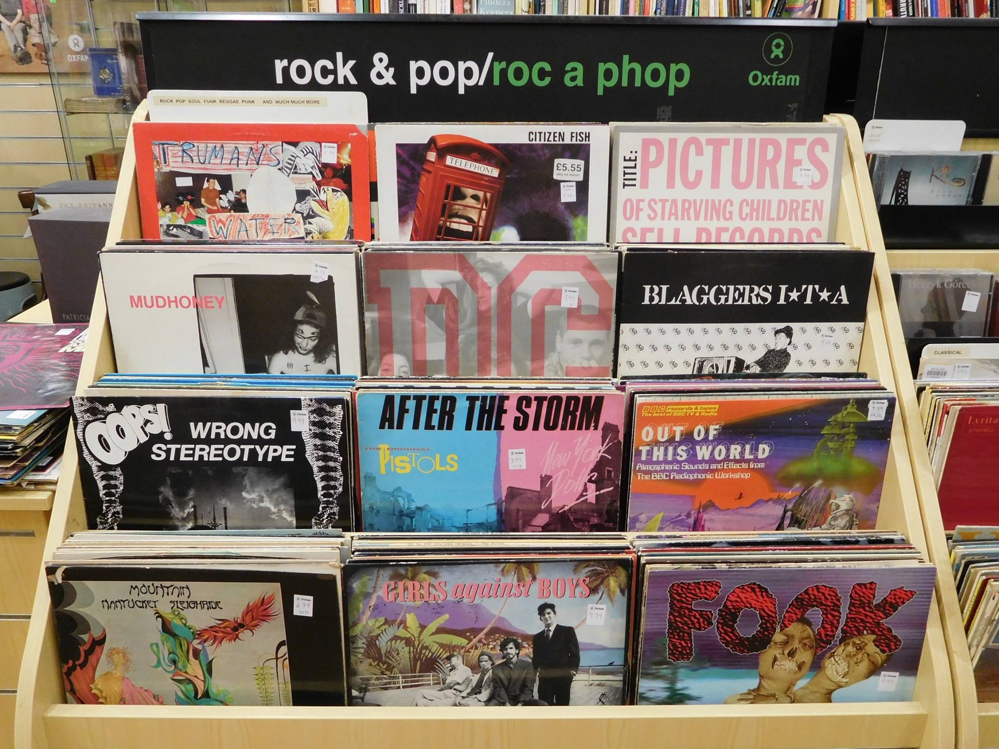
Fig. 27: Oxfam Swansea Vinyl Selection (2016)

Retro style is seen to bring to a design piece a sense of authenticity, which is consequential of the fact that, for millennial designers, characteristics used in retro design are inspired by those from a time period when designers often made work manually and there was far less or no digital production. Inspirations for retro style originate from a distant era when each product label in the market was written by hand and each stamp was inked and pressed individually (fig.28); upon looking at these labels, the buyer would get a sense of personality of the worker who had produced them. The handmade aesthetic associated with retro style is what makes it so familiar, endearing and attractive to designers and consumers alike.
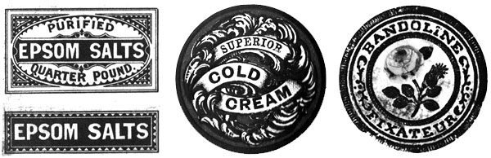
Fig. 28: Beauty Products and Bathroom Label Design (19th century)

The appreciation for the past and the curiosity about the techniques of historical art movements are further reasons why this young generation of designers are working and experimenting with retro style. When one has understood the rules, he can also break them and the possibilities of design expand significantly – this powerful connection between theory and practice is a living proof for the practicality of history and why we should embrace it.

Besides one’s interest in the aesthetics of retro style and the feeling of authenticity that it brings, millennials’ attraction towards retro is established from their uncertainty in the early years of adulthood. Young consumers have a tendency to choose retro brands because they help the consumer in their search for identity, they reflect continuity and discontinuity, they assist with the search for belongingness and they are also used as fashion statements that reflect young consumers’ points of view towards the modern days’ social situation. “Adamson and Lyxell (1996) found that questions about the future, the meaning of life in general, death, and finally questions about one’s own identity are the most crucial questions in late adolescence”. (Hemetsberger et. al, 2011)

By understanding more about the various subjects of the world, young people know more about themselves. They become conscious and anxious, all of which leads to their need to find an identity of their own in order to manifest a statement that they are individuals with their own tastes and opinions. The self-discoveries encourage young people to be more aware. They constantly seek ways to differentiate themselves from the norm, thus they navigate towards retro brands and second (or third) hand old-fashioned things.

Contrasting Opinions Regarding Retro

While some people discuss retro style as nostalgic and inspirational, there are others who think that the application of retro into graphic design is a true verification of the serious lack of real creativity within our generation (Breathnach and Dermody, 2010). Like any other art trend, retro style receives disapproval from critics as they deem it to be a divergence from the “problem solving nature of good design” (Breathnach and Dermody, 2013). Retro is considered as somewhat a cheat, an easy way out that a designer could take when faced with a design problem; said designer would use a solution to a problem of the past to solve one of his own in the present.

Jan Tschichold (McLean, 1995) thought that following past typographers’ work is an inflexible action that is not creative or forward-thinking. Experienced graphic designers such as Art Chantry believe that copying and recycling is all designers are capable of doing since World War Two, and that nothing we come up with is original anymore (Chantry, as interviewed by Brower, 2016). Similar to music and fashion, graphic design also witnesses resurrection of previous tastes and preferences. Arguably, every design idea has already been executed so is anything we do actually new?

The disagreement regarding retro design originates in the difference in backgrounds of generations; each one of them recollects the past based on their own perspective, their needs and their experiences. More than half a century ago, when politics and the war were the topics of conversation on every corner of the earth, the main focus of design would have been significantly different (fig.29). Nowadays, young people are more caught up in the development of technology, the need to claim an identity for themselves and the fight for the rights of the causes they believe in, to fight in their contemporary war.

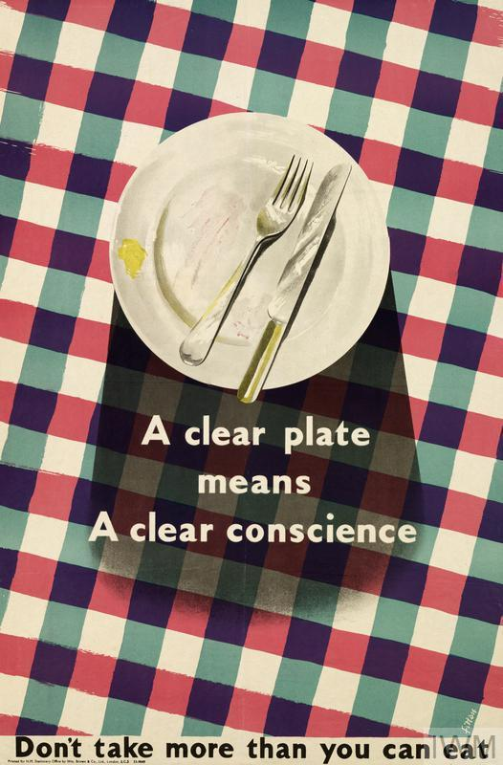
Fig. 29: Don’t Take More Than You Can Eat (WW2 period)

Each generation of graphic designers has a definition of retro design depending on a number of factors that are tailored to their particular era. An older generation may not find empathy for young people’s definition of retro, but this is simply because they associate themselves with different ideas of nostalgia. Any adult would have lived through a period of time when they were growing up, when their memory worked like an absorbent material, collecting items and images. However, a young adult in 2018 would regard the later half of the 20th century as retro; whilst the generation born in the earlier half of the 20th century only thinks the same about things happened in the 19th century. “One remembers best what is colored by emotion” (Boym, 2001), thus it is understandable how each of us may have a different perception of retro. Therefore, there is no particular time period in which one can correctly place retro style; it always happened before the present but it will always be present in the now.

Retro has certainly grown to be one of the trendiest styles among graphic designers internationally. Its existence is a declaration from millennial designers, saying that they care about the past and they are willing to keep it alive. On the other hand, young people do welcome retro design with complex emotions. For some of the younger consumers, retro is a distant ideology, yet they absorb retro products in the market because of curiosity. Retro design helps get millennials interested in old brands while those who had memories of art in the late 20th century look at retro design like an old friend, endearingly and nostalgically (Duckworth, 2016). However, compared to the middle-aged and older audience, young adults are certainly more open-minded about the coexistence of modern technology and earlier styles than their predecessors.

Even so, the appearance of retro design in today’s world is reassuring to the older group of consumers as they are transferred to a past they were accustomed to, when laptops and smartphones weren’t the norm and people still needed to talk and socialise in person. By going back to simpler days, retro design pleases the older generation of consumers.

“In a society that is taught to be critical of advertising and its messages, craftsmanship and authentic experience prove positive points of difference” (Harris, 2016). The simplicity and genuineness of retro pacify the discontent people may have towards the progression of modern technology. The existence of retro itself acts as a form of visual rebellion of those who share the same points of view with the past instead of the present time.

Conclusion

In spite of any possible downsides or negative points of view towards retro design, it is undeniably a great tactical trend that fuses the past and the present together in an effective way, which also conforms to the varying standards and expectations of consumers. Established brands like Kodak, Co-op and NatWest all have chosen to revisit and adjust their earlier identities to use as their latest rebranding, and the strategy works (Harris, 2016) (fig.30 and fig.31). The brands are attracting different age groups all the while elegantly returning to their own foundations and focusing on the initial missions they had set themselves (Alexandra, 2016).


Fig. 30: Co-op Rebrand (2016)
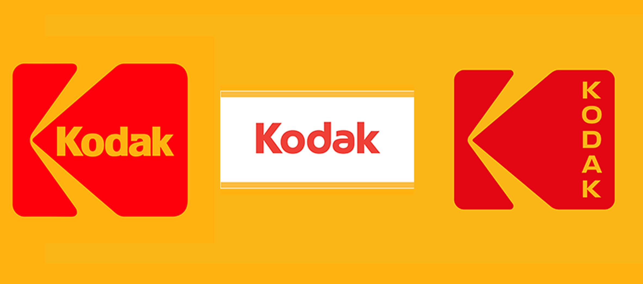
Fig. 31: Kodak 1971 Logo, Kodak 2006 Logo and Kodak 2016 Logo (2016)

There is no logical ground on which one can say that the retro design trend will vanish in the foreseeable future. The styles, upon which retro is based, were thought to have disappeared, yet they re-appeared to the joy of many designers. We will continue to see the revitalisation of design trends of the past as we move into the future. Popular design trends like motion graphics, custom typography and illustration styles may fade away in the next ten years but they are highly likely to make a re-entrance in ten more years! By that time, such techniques we classify as evolutionary might in turn be called retro.

Retro style will always be resurfacing, especially thanks to human intelligence and the technology resulted from it. Instead of opposing such a phenomenon, embracing it will benefit the designer and his clients in many ways one would not have thought of, and it will transcend the design work to an era one would not have remembered. Retro is a device that we can always rely on despite changes in taste and society.

In order to progress, we should remember to stay faithful to the origins of graphic design; one must learn the basis of type-setting before he can start designing ambitious posters. The fascination and the study of retro design is a dependable means that will guide students of graphic design back to their roots, where they are provided with knowledge and equipped with experiences for ventures of their own. Retro is not just a trend or an easy opinion, it is meaningful and beneficial for graphic designers specifically, and mankind in general to progress and grow; it helps us celebrate the design of the past whilst suggesting ways that it may be integrated by future generations.

Bibliography

Book Sources
Boym, S. (2001). The Future of Nostalgia. New York: Basic Books.
Breathnach, T. and Dermody, B. (2010). New retro: Classic Graphics, Today's Design. London: Thames & Hudson.
Butler, S. (1912). Notebooks. London: A. C. Fifield.
Gill, E. (1931). An Essay on Typography. 1st ed.
Guffey, E. (2006). Retro: The Culture of Revival. London: Reaktion.
Jong, C., Tholenaar, J. and Purvis, A. (2009). Type: A Visual History of Typefaces and Graphic Styles. Köln, Germany: Taschen.
Odling-Smee, A. and Ford, H. (2002). The New Handmade Graphics: Beyond Digital Design. Brighton: Rotovision
Parry, Linda (1983). William Morris Textiles. London: Weidenfeld & Nicolson.
Rollins, C. (1995), in McLean, R. (eds) Typographers on Type. W. W. Norton & Company.
Samuel, R. (1994). Theatres of Memory. London: Verso.
Thomas, D. (2017). Never use Futura. 1st ed. New York: Princeton Architectural Press.
Thompson, E.P. (1955). William Morris: Romantic to Revolutionary. London: Lawrence & Wishart.
Tschichold, J. (1995). McLean, R. (eds) Typographers on Type. W. W. Norton & Company.
Woodham, Jonathan M. (2004). A Dictionary of Modern Design. Oxford: Oxford University Press

Internet Article Sources
Brower, S. (2016). Unapologetic + Uncensored Graphic Designer Art Chantry Has Some Thoughts on the State of Visual Culture Today. [online] Eye on Design. Available at: https://eyeondesign.aiga.org/unapologetic-and-uncensored-graphic-designer-art-chantry-has-some-thoughts-on-the-state-of-visual-culture-today/ (Accessed: 20th September 2018).
Cbsnews.com. (2017). "Loving Vincent" Van Gogh: How the world's first hand-painted film was made. [online] Available at: https://www.cbsnews.com/news/loving-vincent-entirely-hand-painted-film-about-vincent-van-goghs-life/ (Accessed: 20th September 2018).
Ellis-Petersen, H. (2017). Record sales: vinyl hits 25-year high. [online] the Guardian. Available at: https://www.theguardian.com/music/2017/jan/03/record-sales-vinyl-hits-25-year-high-and-outstrips-streaming (Accessed: 21st September 2018).
Harris, M. (2016). Why logos are going retro. [online] Digital Arts. Available at: https://www.digitalartsonline.co.uk/features/graphic-design/why-logos-are-going-retro-update/ (Accessed: 20th September 2018).
Kelly, J. (2016). Vintage clothes sold by the kilo. [online] BBC News. Available at: https://www.bbc.co.uk/news/business-37435042 (Accessed: 21st September 2018).
Leurs, L. (2017). The history of printing | The evolution of print from Gutenberg to now. [online] Prepressure.com. Available at: https://www.prepressure.com/printing/history (Accessed: 19th September 2018).
Nguyen, N. (2017). Triển Lãm "Sài Gón 3 Mét Vuông". [online] rgb.vn. Available at: http://rgb.vn/ideas/news/trien-lam-sai-gon-3-met-vuong (Accessed: 20th September 2018).
Nikki Delamotte (2018). Alan Giberson is reviving the art of sign painting in Cleveland. [online] cleveland.com. Available at: https://www.cleveland.com/entertainment/index.ssf/2018/07/alan_giberson_is_reviving_the.html (Accessed: 18th November 2018).
Somaiya, R. (2007). Warning: graphic material. [online] Telegraph.com. Available at: https://www.telegraph.co.uk/culture/3669045/Warning-graphic-material.html (Accessed: 3rd October 2018).
Thu, M. (2018). Folk art becomes top fashion. [online] vietnamnews.vn. Available at: https://vietnamnews.vn/sunday/features/421308/folk-art-becomes-top-fashion.html#IqCRoVkfUWyQRRHW.97 (Accessed: 20th September 2018).

Internet Profiles and Work
Ashby Design (2018). [online] Ashbydesign.com. Available at: www.ashbydesign.com (Accessed: 20th September 2018).
Eaton, N. (2009). Apple - Pro - Profiles - Neal Ashby & Matthew Curry. [online] Ashbydesign.com. Available at: http://www.ashbydesign.com/archive/apple-profile/index.html (Accessed: 21st September 2018).
Mucca Design (2018). [online] Mucca.com. Available at: www.mucca.com (Accessed: 20th September 2018)
Nguyen, M. (2017). Classique Saigon Typeface. [online] Behance.net. Available at: https://www.behance.net/gallery/34244473/Classique-Saigon-Typeface-(Free-Multilingual) (Accessed: 20th September 2018).
Nguyen, M. (2017). L'Hanoinne Typeface. [online] Behance.net. Available at: https://www.behance.net/gallery/59011313/LHanoienne-Typeface-(Free-Multilingual) (Accessed: 20th September 2018).

Journal Sources
Adamson, L. and Lyxell, B. (1996). Self-concept and Questions of Life: Identity Development During Late Adolescence. Journal of Adolescence, 19(6), pp.569-582.
Breathnach, T. and Dermody, B. (2013). The Appeal of the Past: Retro Type and Typography. InPrint, [online] 2(1), pp.30-48. Available at: http://arrow.dit.ie/inp/vol2/iss1/4 (Accessed: 20th September 2018).
Brown, S., Kozinets, R. and Sherry, J. (2003). Teaching Old Brands New Tricks: Retro Branding and the Revival of Brand Meaning. Journal of Marketing, 67(3), pp.19-33.
Cattaneo, E. and Guerini, C. (2012). Assessing the revival potential of brands from the past: How relevant is nostalgia in retro branding strategies?. Journal of Brand Management, 19(8), pp.680-687.
Cousins, C. (2017). Design Trend: The Modern Retro Touch. [online] Ceros Originals. Available at: https://www.ceros.com/originals/design-trend-modern-retro-touch/ (Accessed: 20th September 2018).
Dogerlioglu-Demir, K., Tansuhaj, P., Cote, J. and Akpinar, E. (2017). Value integration effects on evaluations of retro brands. Journal of Business Research, 77, pp.124-130.
Hemetsberger, A., Kittinger-Rosanelli, C. and Mueller, B. (2011). "Grandma'S Fridge Is Cool" - The Meaning of Retro Brands For Young Consumers. Advances in Consumer Research, 38, pp.242-248.
Jens, H. (2005). ‘Sixties Dress Only! The Consumption of the Past in a Retro Scene’ in Palmer, A., and H. Clark (eds) Old Clothes, New Looks: Second Hand Fashion. Oxford

List of Illustrations

Figure 1: Johnston, E. (1916) Proportions of Standard Bullseye Design [Ink on paper]. Available at: https://twitter.com/ltmuseum/status/802429184496832512 (Accessed: 8th October 2018).
Figure 2: Pentagram (2018) John Lewis & Partners New Branding Identity. Available at: https://www.pentagram.com/work/the-john-lewis-partnership/story (Accessed: 18th November 2018).
Figure 3: Monotype (2015) Gill Sans Nova Standard & Condensed. Available at: https://www.wired.com/2015/11/gill-sans-one-of-the-most-popular-typefaces-ever-is-reborn-for-the-digital-age/ (Accessed: 24th October 2018).
Figure 4: Morris, W. (1894) The Wood Beyond the World. Available at: https://www.vam.ac.uk/articles/introducing-william-morris (Accessed: 18th November 2018).
Figure 5: Muller-Brockmann, J. (1955) Zurich Town Hall Poster. Available at: http://www.designishistory.com/1940/joseph-mueller-brockmann/ (Accessed: 18th November 2018).
Figure 6: Maclean, B. (1967) The Yardbirds, The Doors. Available at: https://www.moma.org/collection/works/5475 (Accessed: 18th November 2018).
Figure 7: Butcher Billy (2016) Two Examples of Black Mirror Being Reimagined as 70’s Comics. Available at: https://www.behance.net/gallery/46262739/Butcher-Billys-Dark-Tales-From-The-Black-Mirror (Accessed: 24th October 2018).
Figure 8: The Creative Pack (2017) Butcher’s Bone Broth Vintage Packahing. Available at: https://beta.thedieline.com/blog/2017/10/11/butchers-bone-broth (Accessed: 18th November 2018).
Figure 9: Voorman, K. (1966) Revolver. Available at: http://time.com/4435236/revolver-released-50-years-ago/ (Accessed: 8th October 2018).
Figure 10: Ashby, N. (2006) Thievery Corporation’s Versions Album Cover. Available at: https://www.discogs.com/Thievery-Corporation-Versions/release/694764 (Accessed: 8th October 2018).
Figure 11: Mucca Design (2014) Mucca Design’s Book Covers for Rizzoli. Available at: http://mucca.com/case-studies/rizzoli/ (Accessed: 20th September 2018).
Figure 12: Kobiela, D. and Welchman, H. (Directors) (2017) Process for a Scene in Loving Vincent. Available at: http://lovingvincent.com/helen-mccrory,37,pl.html (Accessed: 8th October 2018).
Figure 13: The Pre-Vinylite Society (2010) The Pre-Vinylite Society. Available at: https://www.previnylitesociety.com/ (Accessed: 18th November 2018).
Figure 14: Luke, J. (2016) Sign Painting for Scopa Wine Bar. Available at: https://bestdressedsigns.com/Scopa (Accessed: 18th November 2018).
Figure 15: Giberson, A. (n.d) Photograph of Alan Giberson Painting a Shop Window. Available at: https://www.cleveland.com/entertainment/index.ssf/2018/07/alan_giberson_is_reviving_the.html (Accessed: 18th November 2018).
Figure 16: Giberson, A. (2017) Photograph of Alan Giberson Painting on a Wall. Available at: https://www.instagram.com/p/BUXDL9TlPuy/ (Accessed: 18th November 2018).
Figure 17: Roberts, S. (2006) Photograph of the First Ghost Sign Sam Roberts Spotted. Available at: https://www.instagram.com/p/BKUwNLKBCwL/ (Accessed: 18th November 2018).
Figure 18: London Mural Preservation Society (n.d.) London Mural Preservation Society. Available at: http://londonmuralpreservationsociety.com/about/ (Accessed: 18th November 2018).
Figure 19: An Example of a Hàng Trống Traditional Painting (some time in the 17th century). Available at: https://mythuatms.com/hoc-ve-tranh-dan-gian-hang-trong-d787.html (Accessed: 8th October 2018).
Figure 20: Lam, X. (2018) A design in Nguyễn Xuân Lam’s hoodie collection which embraces a folk painting of Five Tigers. Available at: https://vietnamnews.vn/sunday/features/421308/folk-art-becomes-top-fashion.html#qMFvMQEkzxpCzGxU.97 (Accessed: 20th September 2018).
Figure 21: Huy, Q. (2016) Example of an old Vietnamese Shop Sign: Phát Hưng. Available at: https://www.facebook.com/thelosttypevietnam/photos/ms.c.eJxFzsEJAEEIQ9GOlomaMdN~;YwsKen38iAjLh~_BzSUr~;0OBMMzM~;A7eKdxcOSd6ZxOnCBlAFtdAFBrKLnWQV4kL9gblB1STwA90BJes~-.bps.a.1177920268888308/1427914357222230/?type=3&theater (Accessed: 8th October 2018) .
Figure 22: Nguyen, M. (2016) Example of Classique Saigon Typeface. Available at: https://www.behance.net/gallery/34244473/Classique-Saigon-Typeface-(Free-Multilingual) (Accessed: 20th September 2018).
Figure 23: Nguyen, M. (2018) Example of L’Hanoienne Typeface. Available at: https://www.behance.net/gallery/59011313/LHanoienne-Typeface-(Free-Multilingual) (Accessed: 20th September 2018).
Figure 24: Long, T. H. (2017) Đêm Núm Sen by Trần Dần. Available at: http://sachnhanam.com/dem-num-sen-soi-kinh-lup-de-tim-chu-tran-dan/ (Accessed: 24th October 2018).
Figure 25: Nam, T. (2017) Menu Design. Available at: https://www.instagram.com/p/BcKejWgAhlT/?taken-by=tung.nam (Accessed: 24th October 2018).
Figure 26: Revive Digital (2018) Worldwide Active Users on Social Media 2018. Available at: https://revive.digital/blog/most-popular-social-media-2018/ (Accessed: 18th November 2018).
Figure 27: Oxfam Castle Street Swansea (2016) Oxfam Swansea Vinyl Selection. Available at: https://www.facebook.com/oxfamcastlestreet/photos/a.420334538052114/940065889412307/?type=3&theater (Accessed: 18th November 2018).
Figure 28: Humber, C. and Irenses Design (19th century) Beauty Products and Bathroom Label Design. Available at: http://www.irenses.ie/tag/19th-century-design/ (Accessed: 18th November 2018).
Figure 29: Fitton, J. (WW2 preiod) Don’t Take More Than You Can Eat. Available at: https://www.iwm.org.uk/collections/item/object/9300 (Accessed: 24th October 2018).
Figure 30: (2016) Co-op Rebrand. Available at: https://www.underconsideration.com/brandnew/archives/new_logo_and_identity_for_co-op_by_north.php (Accessed: 30th October 2018).
Figure 31: (2016) Kodak 1971 Logo, Kodak 2006 Logo and Kodak 2016 Logo. Available at: https://www.dezeen.com/2016/10/27/kodak-rebrand-retro-logo-minimalist-graphic-design-work-order-technology/ (Accessed: 18th November 2018).

