Reflective report (task 2)
Name: Calah Riley-Lamb
Student ID: 2121869
Module number: BMSW4001
Lectures name: Isiah Oino

Reflective report
Introduction
Within this report I will let you know about my experience and learning across this module. It will let you know about my experience my writing task one academic report and the challenges that I found with this, and how I learnt to over them challenges being able to understand the importance of reflection. We also had to overcome the challenges of working in a group for our week eight activity doing our group presentations. What was done how we gathered data, was able to analysis it and prepare the feedback to let you know what was gained through this data collection. The ways we were able to learn how to put this altogether within our timeline frame both in writing up task one and the group presentations. Having the Gibbs reflective cycle introduced, understanding it and reflection on how to include this into our writing as individual’s and as a group.
Reflective writing
Reflective writing is different for everyone including me there are separate ways to being able to reflect on your own work or someone else’s work. The way I am best able to complete this is by looking back on my experience to be able to perform better in the future, analysing what happened. Being able to constructively criticise yourself and take in observations, in the event of your peers to. It is important to know how to reflective on your own writing as others may not always be around to give you the advice you may need to make necessary improvements to your work.
Model of reflection
I have chosen to reflect on the module BMSW4001 as this is the only module, I have completed the first term off. The module is based on so far completing a group presentation and drafting an essay based on four sources, four of which was provide for us and four we have been given to us and four we had to research ourselves. This came up of as part of the presentation finding peers to work with in a group. In drafting the essay was an individual task.
Reflection on writing task one
Through writing this essay I had to complete tasks separately to be able to create a plan to then write it up in the timeframe given. The method of writing I chose to write is primary/secondary as I was writing it in my own words but had to incorporate the research I found. Researching the sources four of which were provided and four we had to research ourselves using reliable sources such as the uwtsd library. The four sources provided for us was Armstrong & Brown (2019), CMI (2006), Cohen (2006), Phillips et al (2017). Then the additional sources I found myself through researching within the uwtsd library was two articles one is Performance-management and pay reforms keep staff in loop: help to boost motivation and attendance and other named how to motivate people. I only managed to research two articles and I was finding it hard to be able to gather information I have not already gone over and keep within the word count without going to much over. This is something I need to work on in my future writing and being able to reference correctly and improvements on abstract & contents pages. Through researching I found how to collect information key points and how to gather that into a paragraph working around the collected research, to be able to present that information, so the reader can understand it. While researching I took rough notes to be able to write a plan gaining a better understanding of knowledge about the subject then being able to translate that piece of information. Through note taking I learnt to understand how to properly take notes in a way that suited my learning style best based on the amount of information I was able to take in at once. The way I learnt is through my lecturer listening, observation and common sense. Knowing how to take the important pieces of information out of a text then going to translate it into your own words. Drafting in the way I understand it to be is having written up work into a rough draft that you wish to improve. Going back through the ideas that was written down and making improvements to writing it in a way that the reader can understand it, completing the thought process. The time management was having a realistic plan on the period you want to get your work done over the weeks, this leads you to being less stressed when it comes you to your assignment due date, being able to plan your studies. It allows you to have control of your work and better structure. My period was over the 5 weeks completing a bit more of the work each week so by the final week it is just a few changes to go over and make the improvements that you wish to make. Through listening to my lecturer each week, I was able to gain the knowledge of The Gibbs Reflective Cycle (1988), I wrote out and completed the reflective cycle with each piece of work I was doing to be more organised in my work also to gain a better understanding being able to break down the work. I was able writing up the final edits we did individually in the period through reading over the essay in the final week and correcting small errors that you wish to improve for example grammar, better use of words. Making sure you have all the information required in your work. The targets I would like to improve on is being able to understand my work given, breaking it down into a way I best understand it to be able to present my work correctly. As this was my first time ever writing up the task provided, I would like to learn how to overcome the feelings of stress when first going to start the report, having felt this myself it was hard for me to know how to overcome the issue no matter how much of the work has been broken down and put into a plan.
Reflection on group presentation (week 8)
To start if with I had to locate a group to be able to work with to complete the group presentation. When finding a group, I did this by communicating with the peers in my group to be able to gather groups quickly. In my group there was Sophie Anna Nyari 2122779 & Sophie Akhtar 2123642, as I allocated my group, I was chosen to be group leader. We communicated through emails to arrange a suitable time for everyone to meet and continued to Microsoft Teams and discuss our work. When talking about our work which was, are staff and student confident in using technology to collaborate at uwtsd? We chose two slides to do each, my slides were research timeline & hypothesis. Within my slides the work I had to do was writing out the in the amount of time we had to state in this slide what we chose to do each week to the final week and making sure all the information is provided for the reader to gain a good understanding. Over the 4-week period of the group presentation given & deadline I was clearly able to explain the process from start to finish. This was part of conducting the research to be able to put together this slide. Improvements to it had to be made going along as I could not put down a timeframe that we have not had done yet, only an estimate of what we would be completing this this period. The communication between me and my group was great we were able to speak about our points we wanted to say clearly to each other and able to support each other if one another was stuck. I was able to communicate with my group though Ms teams, email, and phone. Working with your newly met peers needed communication resources that were dependable. Having the feeling of knowing you can communicate in many ways was very usefully as you need to have faith in your group getting the things done to a good working standard. We chose a design that was easy to read so you can follow it easily. When it came the presenting the presentation to our lecturer, we prepared for this however I am not good at speaking publicly when it comes to stuff like this, so for me the presenting I found challenging. We had put together we then had to gather data from our peers into a excel. Being able to present my work is something I would like to work on and being more organised might help me with speaking in front of others. As part of our presentation, we were taught through lectures how to conduct this, applying it into our assignment. The data then collected from the questionnaires emailed to staff and students was put into excel to gain the analysis.
Personal development plan (PDP)
Below you will find the two personal targets I have set myself. The difficulties I face trying to overcome them. How I will hopefully gain a better understanding of my work in general will depend about the dedication I chose to put in. there are other targets I wish to reach beyond these two targets, pacing myself to achieve these will come in great timing. The two points I have chosen to complete is:
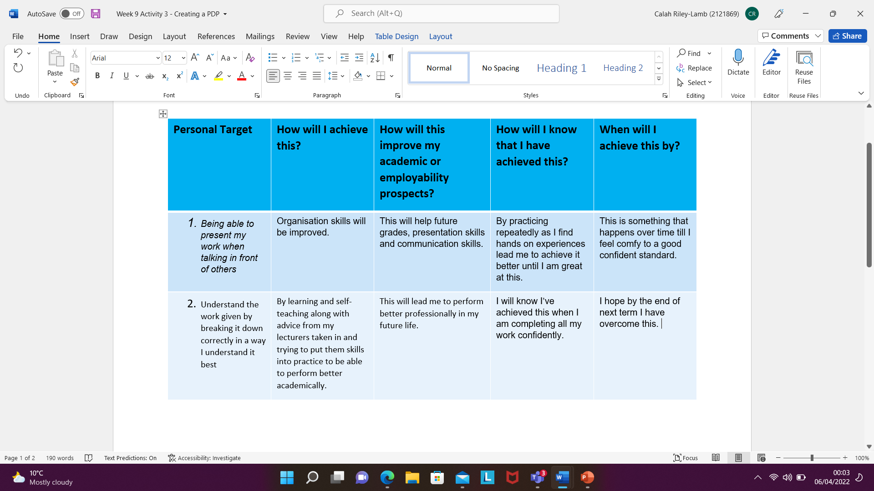

Conclusion
In this report I have covered the following points:
- Introduction
- Reflective writing
- Models of reflection
- Reflecting on task one
- Reflection on the group presentations
- Personal development plan (PDP)
I have summed up the various skills I have gained through this systemiser by being able to present this in my work. I have learnt how to put together a presentation with also gaining better communication skills. Being able to learn how to get the research ready to present this, then gain the knowledge back from peers and lecturer. I then followed on to writing up my first essay, breaking this down, carefully reading my research and putting it altogether. The things I found difficultly completing and wish to overcome in the future, and how I will choose to overcome this. Leading on to sitting down and thinking about the points I would like to improve how I will do this and the period I would like to achieve this in. the future skills I would like to develop is better leadership skills as this will follow me into my future within life itself or my job roll. Gaining this will lead me to be able to present this to my employee or even bigger plans having my own business understanding how to run a business correctly that suits all my employee’s and service users. By this I would learn how to communicate better with people being able to have better presentation skills within the classroom will lead on to also inputting this into my work life and university life.
Reference links
https://librarysearch.uwtsd.ac.uk/permalink/44WHELF_UWTSD/1pbrh66/alma99100347460202421
https://www.managers.org.uk/knowledge-and-insights/article/eight-ways-bad-managers-kill-conversations-and-motivation/
https://www.managers.org.uk/knowledge-and-insights/article/eight-ways-bad-managers-kill-conversations-and-motivation/
https://librarysearch.uwtsd.ac.uk/permalink/44WHELF_UWTSD/igoone/cdi_pubmedcentral_primary_oai_pubmedcentral_nih_gov_5735769

