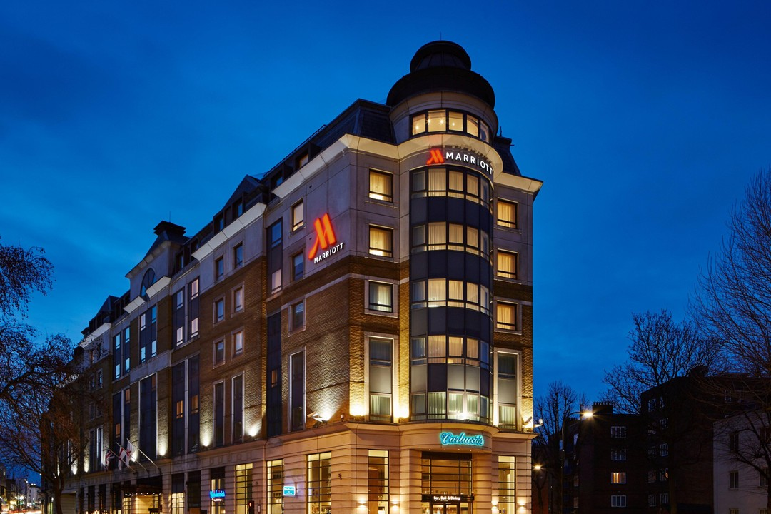

ANALYSIS OF MARRIOTT INTERNATIONAL

  - MODULE: FINANCIAL MANAGEMENT FOR HOTEL INDUSTRY
  - Module code: BMIH5013
  - lecturer: dr. Ernest wavei

  - STUDENT: ADRIANA GHIOCEL IOANICIU
  - student number:2127376
ACKNOWLEDGEMENT: In this assignment, I did not use AI.
Contents
MAIN FINDINGS 2
INTRODUCTION 2
TOTAL REVENUE 3
MARKET POSITION 4
GROWTH POTENTIAL 5
RECOMMENDATION 7
CONCLUSION 8
REFERENCES 8

MAIN FINDINGS

INTRODUCTION

In 1927, J. Willard Marriott opened a root beer stand with nine stools. This stand turned into the Hot Shoppes Restaurant chain, which in turn turned into the Marriott International hotel company we know today. Over the next 58 years, he built the Marriott brand on a set of values that are still deeply ingrained in the way the company works today. (Marriott International,2023)
In 2023, the global hotel chain Marriott International had 8,785 hotels throughout the globe, which was an increase from the previous year's total of 8,288 properties. The most plausible explanation for the rise in properties from 2015 to 2016 is that Marriott acquired the American chain Starwood Hotels and Resorts in 2015 and the Canadian brand Delta Hotels in 2016. Both acquisitions took place in the years 2015 and 2016. In 2022, Marriott expanded its worldwide footprint outside the United States, with over two thousand hotels located in various countries across the world. Within the world of hotels, it is the largest hotel company by the number of countries it serves and one of the largest by the number of sites it owns. Marriott has 38 different names, and each one has its own personality and works with a different type of customer, including pet owners. Some of the names are luxurious hotels with locations all over the world, while others are cheaper long-stay hotels in North America. Luxury hospitality is a sector in which Marriott International is well recognised as a pioneering innovator. Every one of our internationally renowned luxury brands provides owners with long-term value by way of category leadership, connection with customers who are loyal and highly sought after, and devoted premium knowledge to assist business operations.

TOTAL REVENUE

Total revenue, often termed "gross revenue," is a company's earnings before expenses. All income kinds are considered. That includes sales, interest, dividends, rent, and more. Total income indicates a company's financial health and size. Financial records begin here and reflect growth patterns, market demand, and whether a business can survive. However, overall income doesn't include costs, which are essential to determine the business's profitability.
In 2023, Marriott International earned 23.71 billion US dollars, up from 20.77 billion. Our 2020 sales dropped by 50% due to the COVID-19 epidemic. That year, global travel restrictions affected the hotel industry.
Marriott International, Inc. had the largest revenue in 2023. This hotel chain outranked MGM Resorts International, Caesars Entertainment, and Hilton. Over 8,000 Marriott International, Inc. hotels were open worldwide in 2022. In 2022, Marriott was one of the five most valuable hotel brands, at over two billion dollars. Marriott became one of the most valuable hotel brands globally.(Statista,2024).
As of the 30th of October in the year 2024, the market capitalisation or net value of Marriott International is $74.40 billion. Within a single year, its market capitalisation has climbed by 26.60%.

MARKET POSITION

When we talk about market positioning, we are referring to the power to affect how consumers perceive a brand or product in comparison to other brands or products for sale. The purpose of market positioning is to develop the image or identity of a brand or product in such a way that people perceive it in a particular manner.
Successful marketing strategies depend on a company's ability to identify and apply the best method for its industry and attract and retain customers. Many organisations may now utilise more data for market segmentation thanks to the internet and other information mediation methods. This greatly improves strategy execution. Marriott has used many market segmentation tactics to split their market into smaller, more exact 'targeted' segments. Marriott offers several hotel and accommodation services and is present worldwide. Easy geographic separation can implement a more difficult plan. This frequently starts market segmentation discussions. Several techniques helped Marriott achieve this aim. Create market-specific branding initially. Examples include the Ritz-Carlton, a network of premium hotels and resorts that targets North American high earners. Marriott Executive Apartments have global branding. It targets corporate employees and families staying in another nation for long-term leases or temporary dwellings. Some of these hotels are in Western Europe, Eastern Asia, and the US. Market segmentation works because it's easier and cheaper to tailor items and marketing to specific groups than to a wider audience. Due of this, this technique has proven effective. For Ritz-Carlton guests, this is true. Marriott has also used this strategy to choose businesses that appeal to certain markets and have related products and environments. An example could be the Caribbean and Latin America.
With approximately sixty hotels, Marriott has built a significant presence in this region. These hotels range from full-service Marriotts to timeshares and even the more affordable Courtyard and Fairfield Inn. Along with being a popular trip destination for families, the region is also a popular travel destination for people travelling to North America during the winter months. Families and individuals on vacation make up most of the guests staying at hotels in this region, and they are the target demographic for these establishments. (Aithor,2024)

GROWTH POTENTIAL

According to Marriott International Newscenter at the International Hospitality Investment Forum in Berlin, Marriott International, Inc. announced plans to add nearly 100 properties and over 12,000 rooms to its European portfolio by 2026 through hotel conversions and adaptive reuse projects. Over 40% of the company's European development pipeline is projected to open during that time.
Strong growth plans are projected to increase the company's foothold in Europe, where it has over 800 properties with almost 150,000 rooms across 25 brands in 47 countries and territories. Marriott is experiencing increasing hotel conversions and adaptive reuse projects across all brand categories in Italy, the UK, Spain, and Turkey. Since its 2023 opening, Marriott's midscale Four Points Express by Sheraton has stimulated regional conversions. Due to rising demand for trustworthy, inexpensive lodging across Europe, the Middle East, and Africa, the business launched the brand. After establishing Four Points Express by Sheraton Bursa (Türkiye), the company will open five more UK and Turkish properties by 2025. By 2026, Moxy Hotels, AC Hotels by Marriott, Four Points by Sheraton, and Residence Inn by Marriott will account for over 25% of the company's European conversions and adaptive reuse projects. In Europe, Tribute Portfolio and Autograph Collections account for almost 20% of premium sector additions.
The Luxury Collection, W Hotels, The Ritz-Carlton, and St. Regis Hotels & Resorts will account for over 10% of the anticipated additions in Europe by 2026, indicating an increase in conversion and adaptive reuse opportunities.
The International Marriott Hotel uses several strategies to help the business grow. The two that I think have the most effect are the digital marketing strategies and the marketing and advertising campaigns for Marriott International. Marriott International's unique marketing approach is a strength.
Marriott International Social Media Strategy:
Marriott heavily funds social media marketing to attract younger travellers. Marriott promoted the new properties with 27 TikTok influencers. Marriott also uses Twitch, Snapchat, and Pinterest. Marriott’s social media staff monitors guest feedback and rewards them. The hotel's favourable social media e-WOM is supported.
Marriott App promotion:
Marriott researched other creative industries to understand how to engage visitors and differentiate its app. So, they can keep drawing people.
Influenced marketing:
Marriott markets to Millennials using social media influencers. Marriott worked with Snapchat influencers to produce Snapshots of its latest luxury hotels.
Detailed Online Presence:
Marriott's website showcases its exotic hotels and provides all the information needed to arrange stays. Its easy booking allows travellers to reserve ahead.
Strategic Content Marketing:
Marriott employs a unique narrative structure to engage its target demographic on social media. The "Marriott Bonvoy Program" presented actual traveller stories to urge its target audience to try new places.
Marriott's marketing strategy emphasises its upscale hotels' comfort, care, and richness. The hotel chain's ads emphasise its beautiful rooms, hospitality, and calm atmosphere. Marriott International's memorable marketing efforts have favourably impacted viewers and increased customer engagement. Marriott International's "Golden Rule" category branding campaign brings Courtyard by Marriott, Fairfield Inn & Suites, Four Points by Sheraton, and SpringHill Suites together for the first time. The Golden Rule ad highlights Marriott's "classic select" brands, which make up a third of its 30-brand collection. It shows how the four brands are connected and how the service is human-centred. (Shastri, A ,2023)

RECOMMENDATION

In 2025, Marriott could focus on the following strategies to boost its market position and drive growth around the world.
Invest in sustainable practices: Many travellers now put sustainability first, so Marriott should step up its environmental efforts. This could mean expanding carbon-neutral programs, making all properties use renewable energy sources, and making eco-friendly amenities better. By setting clear goals for sustainability, Marriott can attract travellers who care about the environment and build brand loyalty through responsible actions.
Improve Technology to Make Guest Experiences Smoother: Marriott could spend money on cutting edge AI and digital solutions to make the guest experience even more personalised. Using AI for booking, in-room services, and customer service could make the guest experience smoother and more tailored to each person's needs. Marriott will be able to stay competitive by using AI to predict what customers will want, especially young and tech-savvy travellers.(
Add more affordable midscale and extended-stay options: As more people want to travel on a budget, Marriott can increase its growth by adding more midscale and extended-stay brands, especially in suburban areas and emerging markets. The Four Points Express and Apartments by Marriott Bonvoy brands from Marriott are set up to do well in this market. Marriott can appeal to a wider range of customers by focussing on these groups: families, remote workers, and long-stay guests.
Continue to add more high-end and unique travel options: Since luxury travel is still popular, especially after the pandemic, Marriott should keep adding more high-end and unique travel options. Luxury travellers who are willing to spend a lot of money can be attracted by adding more properties in this category (like Ritz-Carlton and St. Regis) and offering unique experiences like planned local tours, wellness retreats, or yacht stays.
Partner with other businesses to make loyalty programs stronger: Marriott can make its Bonvoy loyalty program stronger by teaming up with companies in different fields, like airlines, car rental companies, and lifestyle brands. Members can earn and spend points in more ways through these partnerships, which makes the program more appealing to frequent travellers and helps Marriott keep its loyal customers. (Menon,B . 2024)
Focus on strategic conversions and multi-unit deals: Marriott should keep focussing on conversions, especially multi-unit conversions, as a way to grow quickly without building a lot of new rooms. Rebranding existing hotels is a good way for Marriott to grow its brand presence in key areas, and this strategy can help it get a bigger share of the market. (Perkpwsky,A .2023).
By concentrating on these strategies, Marriott will be able to satisfy the ever-changing demands of the travel industry, cultivate customer loyalty, and solidify its growth path across the globe in the year 2025.

CONCLUSION

In conclusion, Marriott International is in an excellent position to achieve both long-term growth and to maintain its leading position in the hospitality industry. Marriott assures its flexibility in an industry that is characterised by rapid change and high consumer expectations by making investments in technology, exploring new markets, and adhering to practices that are ecologically friendly.

REFERENCES

@aithor (2024). Marriott Target Market Segmentation. [online] aithor.com. Available at: https://aithor.com/essay-examples/marriott-target-market-segmentation [Accessed 30 Oct. 2024].
Corporate Finance Institute (2022). Market Positioning. [online] Corporate Finance Institute. Available at: https://corporatefinanceinstitute.com/resources/management/market-positioning/ [Accessed 31 Oct. 2024].
Dayuse. (2023). London Marriott Hotel Maida Vale. [online] Available at: https://www.dayuse.co.uk/hotels/united-kingdom/london-marriott-hotel-maida-vale [Accessed 13 Oct. 2024].
DealHub. (n.d.). Total Revenue. [online] Available at: https://dealhub.io/glossary/total-revenue/ [Accessed 27 Oct. 2024].
Macrotrends.net. (2024). Marriott Revenue 2010-2024 | MAR | MacroTrends. [online] Available at: https://m.macrotrends.net/stocks/charts/MAR/marriott/revenue [Accessed 14 Oct. 2024].
Marriott International (2023a). 2023 Annual Report. [online] Available at: https://marriott.gcs-web.com/static-files/b82978a6-9d28-4e38-9855-fc4ae2cebe11 [Accessed 15 Oct. 2024].
Marriott International (2023b). Our Story. [online] www.marriott.com. Available at: https://www.marriott.com/about/culture-and-values/history.mi [Accessed 13 Oct. 2024].
Marriott International Newscenter (US). (n.d.). Marriott International Accelerates Growth Across Europe With Nearly 100 Hotel Conversions and Adaptive Reuse Projects Expected by the End of 2026. [online] Available at: https://news.marriott.com/news/2024/04/15/marriott-international-accelerates-growth-across-europe-with-nearly-100-hotel-conversions-and-adaptive-reuse-projects-expected-by-the-end-of-2026 [Accessed 29 Oct. 2024].
Shastri, A. (2023). Detailed Marketing Strategy of Marriott International | IIDE. [online] IIDE. Available at: https://iide.co/case-studies/marketing-strategy-of-marriott-international/ [Accessed 1 Nov. 2024].
Statista (2022). Marriott: hotels worldwide 2009-2018 | Statista. [online] Statista. Available at: https://www.statista.com/statistics/247285/number-of-marriott-international-hotels-worldwide/ [Accessed 14 Oct. 2024].
Statista (2024). Marriott International: revenue 1999-2023 | Statista. [online] Statista. Available at: https://www.statista.com/statistics/266279/revenue-of-the-marriott-international-inc-hotel-chain/ [Accessed 27 Oct. 2024].
Stock Analysis. (n.d.). Marriott International (MAR) Market Cap & Net Worth. [online] Available at: https://stockanalysis.com/stocks/mar/market-cap/ [Accessed 31 Oct. 2024].
UpgradedPoints.com. (2020). 32 Marriott Bonvoy Brands: Read This Before Booking Your Next Stay. [online] Available at: https://upgradedpoints.com/travel/hotels/marriott-bonvoy-hotel-brands/ [Accessed 16 Oct. 2024].
www.hotel-development.marriott.com. (n.d.). Luxury Hotel Development | Marriott International. [online] Available at: https://www.hotel-development.marriott.com/brands/luxury-brands [Accessed 14 Oct. 2024].
Environmental, Social & Governance Global Progress. (2024). Available at: https://serve360.marriott.com/wp-content/uploads/2024/07/2024ESGProgress.pdf.
Menon, B. (2024). Top 5 Travel and Hospitality Trends to watch out for in 2025. [online] CapillaryTech. Available at: https://www.capillarytech.com/blog/travel-and-hospitality-trends-2025/ [Accessed 2 Nov. 2024].
Perkowsky, A. (2023). Marriott outlines three-year growth plan. [online] hotelbusiness.com. Available at: https://hotelbusiness.com/marriott-outlines-three-year-growth-plan/ [Accessed 2 Nov. 2024].

