This application is based on the Guest Service Manager role advertised by Aloft Birmingham Eastside (Caterer.com,2026).
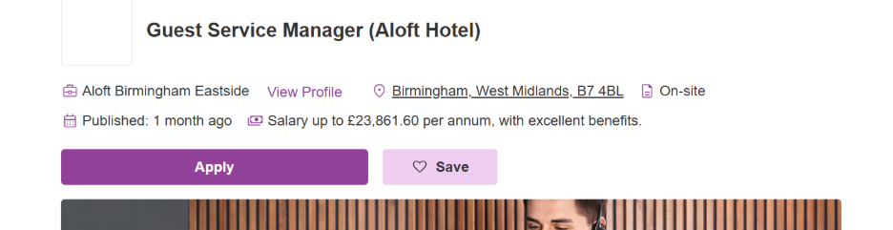

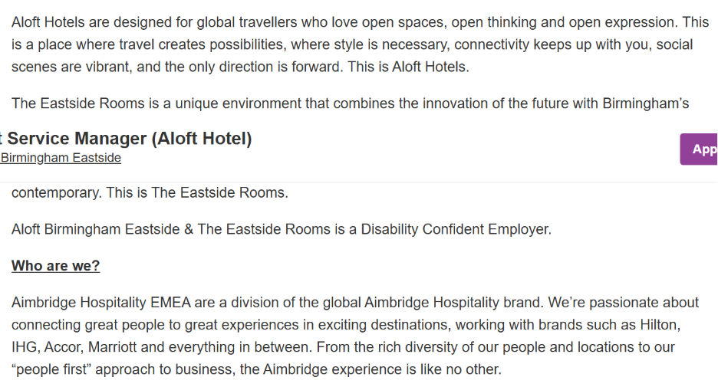
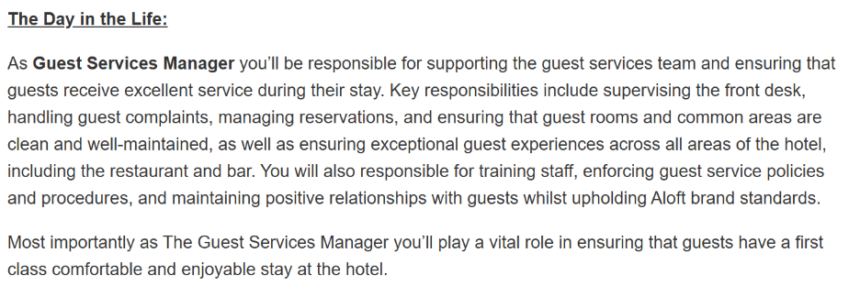
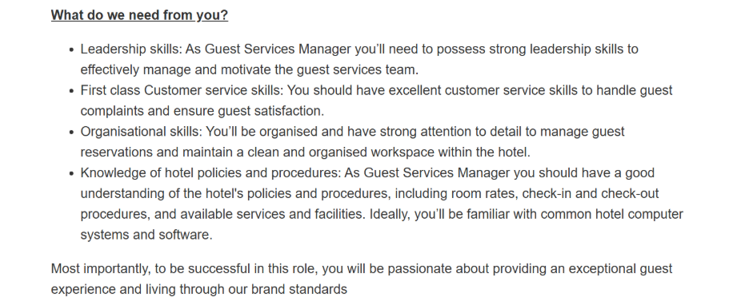

Louise Faulkner
19 Salisbury Drive
Birmingham, B46 1QH
L28faulkner@icloud.com / 07908 628 533

Thursday 8th October 2026

HR
Aloft Birmingham Eastside
Birmingham, West Midlands

Dear Management,
I am writing to express my interest in the Guest Service Manager position at Aloft Birmingham Eastside.
With over 15 years of hospitality experience across respected brands including Ibis Styles NEC, Ibis Birmingham Airport, and Express by holiday Inn, I've built a strong foundation in guest relations, team leadership and operational excellence.
I thrive in people focused environments where empathy, communication, and motivation drive success. I take pride in creating welcoming spaces that reflect brand values and consistently exceed guest expectations. My tactical learning style means I approach challenges with structure and precision- whether managing front desk operations, coaching staff, or resolving guest concerns efficiently.
I am proficient in Opera PMS, FOLS, Brilliant, Xero, and Sage, with a practical understanding of hospitality systems and team operations. As a mother of four, I’ve developed exceptional time-management and multitasking abilities that translate naturally into leading and supporting busy hotel environments.
I’m inspired by Aloft’s vibrant and modern approach to hospitality and would be thrilled to bring my experience, energy, and commitment to exceptional guest service to your team. Thank you for considering my application — I look forward to the opportunity to discuss how I can contribute to delivering the lively, memorable guest experience that defines the Aloft brand.
Yours Sincerely,
Louise Faulkner
Louise Faulkner
Address: 19 Salisbury Drive, Water Orton B46 1QH
Telephone No. 07908628533
Email: L28faulkner@icloud.com

Experienced hospitality professional with over 15 years in front-of-house and guest-service management across leading hotel brands including Ibis Styles NEC, Ibis Birmingham Airport, and Express by Holiday Inn. Skilled in guest relations, team leadership, and operational efficiency, with a proven record of delivering exceptional service and maintaining brand standards. Highly organized, adaptable, and approachable, with strong communication and problem-solving skills. As a mother of four, I bring excellent time-management and multitasking abilities that enhance my leadership and teamwork in fast-paced environments.

Key Skills
- Excellent customer service and guest-relations skills, ensuring a positive experience for every visitor.
- Strong leadership and team-management abilities, supporting colleagues, and maintaining high service standards.
- Skilled in problem-solving and decision-making within fast-paced hospitality environments.
- Proficient in Microsoft Office 365, Opera PMS, FOLS, Brilliant, Xero, and Sage.
- Highly organized, adaptable, and able to manage multiple priorities effectively.
- Confident communicator with excellent interpersonal skills and a professional, approachable manner.

Work Experience:
Sales Coordinator
SWIP Group, 30 Inkerman Street, Birmingham B7 4SB 2023 – 2025
- Managed main reception operations, including handling high-volume telephone enquiries and responding to email-based sales queries with professionalism and accuracy.
- Coordinated communication between sales, production, and transport teams to ensure stock availability, order accuracy, and timely dispatch.
- Prepared and issued order acknowledgements, picking notes, and delivery documentation, ensuring all information was precise and compliant with company procedures.
- Liaised with transport staff and drivers, providing clear loading instructions and verifying delivery documentation up to the point of final dispatch.
- Supported marketing activities by contributing to promotional video content and collaborating with the media team.
- Utilized multiple business systems including Xero, Sage, CDP Transport, and Microsoft Office to maintain accurate records and streamline workflow.
- Attended energy-efficient industry events to enhance product knowledge and support informed customer communication.
- Recognized as Employee of the Month and promoted from Sales Assistant to Sales Coordinator, reflecting strong performance, reliability, and professional growth.
Hotel Operations and Guest Services
Ibis Styles NEC / Ibis Birmingham Airport / Express by Holiday Inn
(Castle Bromwich & NEC) 2004 – 2023
- Oversaw front-desk operations including reservations, check-in/check-out, and guest enquiries.
- Managed guest relations, complaint resolution, and ensured brand-standard service delivery.
- Conducted banking, cash management, and bar service duties with accuracy and professionalism.
- Supervised staff rotas and shift operations as Duty Manager and Guest Service Manager, maintaining smooth daily operations.
- Performed stock control, replenishment, and re-ordering for bar and front-of-house supplies.
- Supported loyalty programmes such as Le Club, achieving Employee of the Year (2010) for outstanding service.
- Utilized hotel systems including PDQ (Brilliant) and reservation software to maintain operational efficiency.
- Demonstrated adaptability and leadership across multiple hotel brands, ensuring consistent guest satisfaction and team performance.
Self-Employed Beautician / Receptionist
Sylvia Jeans Hair Salon (Beauty Box), Birmingham 2016 – 2022
- Managed front-of-house reception duties, including telephone bookings, appointment scheduling, and responding to public enquiries.
- Delivered high-quality customer care, assisting clients with hair washing, refreshments, and general salon support.
- Oversaw daily banking and cash-management procedures, maintaining accurate financial records.
- Provided a range of beauty treatments including lash lifts, facials, body waxing, threading, and tinting, ensuring compliance with hygiene and professional standards.
- Maintained a welcoming and organised environment, contributing to positive client experiences and repeat business.
Working Holiday Visa
Australia 2008 – 2009
- Gained international hospitality and administrative experience across multiple organizations:
- Fulton Hogan (Qld) – Construction Administration
- Skilled Park, Movie World, Sea World – Functions and Waitressing
- Developed cross-cultural communication skills and adaptability through diverse work environments.
- Completed introductory lessons in Japanese language and culture.
Hotel Host
Thomson / Crystal (TUI), Italy 2007
- Delivered front-of-house and guest-service support for international clientele.
- Managed bookings, guest enquiries, and bar service.
- Assisted with afternoon tea service and housekeeping duties.
- Maintained high standards of presentation and customer care in a resort environment.
Administrative Support (Temporary Contract)
Container Printers, Birmingham 2005
- Supported purchase ordering, payroll, and stationery control.
- Managed reception duties, order processing, and stock control.
- Assisted with marketing and administrative coordination across departments.
Bar / Waitress
Rocco Bar, Broad Street, Birmingham 2004
- Provided bar service and waitressing support in a busy hospitality environment.
- Managed till operations, stock control, and replenishment.
Till Operator / Stock Control
Bain’s Super Store, Birmingham 2003 – 2004
- Operated tills and managed stock replenishment and ordering.
- Communicated with suppliers and maintained organized inventory records.

Silver Service Waitress
National Motorcycle Museum, Birmingham 2002 – 2003
- Delivered high-standard table service for large-scale events and functions.
- Managed reservations, order coordination, and multi-course service under pressure.
- Maintained professional presentation and guest liaison throughout events.

Education/Qualifications:

University of Wales Trinity Saint David 2026 – Present
- CertHE Business Skills for the Workplace (Level 4) Developing advanced professional and managerial competencies in business communication, leadership, and organizational practice. The programe focuses on applying theoretical knowledge to real-world workplace scenarios, enhancing employability and strategic decision-making within service and hospitality environments.
Express by Holiday Inn, Castle Bromwich 2006 – 2007
- Completed Hospitality Level 3 Intermediate Course (NVQ), advancing skills in guest service, leadership, and operational management within hospitality environments.
- Achieved Intermediate Food and Hygiene Certification (2006), demonstrating understanding of food safety and cleanliness standards.
- Attained Intermediate Health and Safety at Work Certification (2006), ensuring compliance with workplace safety procedures.
- Completed First Aid Training (2007), gaining practical knowledge of emergency response and workplace wellbeing.

Express by Holiday Inn NEC, Birmingham 2004 – 2005
- Completed Hospitality Level 2 Foundation Course (NVQ), developing practical skills in customer service, front-of-house operations, and teamwork within hospitality environments.
- Achieved Basic Health and Safety Certification (2005), demonstrating understanding of workplace safety standards and compliance procedures.
Solihull College, Birmingham 2002 – 2004
- ATA Air Travel (Level 1, 2003) – Developed foundational knowledge of airline operations and travel industry procedures.
- Communication (Level 2) – Enhanced interpersonal and professional communication skills for customer-facing environments.
- Information Technology (Level 1 & 2) – Gained proficiency in digital tools and data management relevant to hospitality and administration.
- Improving Own Learning and Performance (Level 2) – Strengthened self-management and reflective learning techniques.
- Beginners Spanish (Distinction) – Acquired basic conversational Spanish for international guest interaction.
- Travel Geography – Studied global destinations, travel routes, and tourism patterns.
- Animation and Entertainment – Explored leisure and entertainment concepts within hospitality and tourism contexts.
Whitesmore School, Birmingham 1997 – 2002
- Achieved 8 GCSEs, including English and Mathematics.
- Completed Basic Food Hygiene Certification (2001).
- Attained GNVQ Intermediate in Leisure and Tourism with Merit, developing foundational knowledge in customer service, travel operations, and hospitality environments.

Computer Skills
Proficient in Microsoft Office 365 (Word, Excel, PowerPoint, Access, Outlook) and familiar with WordPerfect and legacy Windows systems. Experienced in hospitality and business software including FOLS, Brilliant, Opera PMS, Xero, and Sage. Strong digital literacy and adaptability to new technologies.

Activities
I am a sociable and outgoing person who enjoys meeting people from diverse backgrounds. Outside of work, I stay active through gym workouts and swimming, and I have a strong passion for traveling and exploring new cultures. As a mother of four, I’ve developed excellent time-management, multitasking, and organizational skills that I bring into my professional life.

Reference List
Caterer.com (2026) Guest Service Manager (Aloft Hotel) -Aloft Birmingham Eastside. Available at: https://www.caterer.com/job/guest-service-manager-aloft-hotel/aloft-birmingham-eastside-job107922418 (Accessed: 8 October 2026)

