University of Wales Trinity Saint David
London Campus

IWD
Assignment 2 : Website design and development
Module Name: Introduction to Web and Database Concepts
Module Code: ACCA4023

Student Name: Maksim Zanev
Student ID:2436811
Group: 2

Lecturer’s Name: Suneth Fernando

Table of Contents
Introduction to your case study which you choose 2
User Requirements 2
Website Implementation 3
Validating my website 5
Self-evaluation of my website 6
Usefulness (usability and utility): 6
Search Engine Optimisation (SEO): 7
Website Accessibility: 7
Conclusion 8
References 8

Introduction to your case study which you choose
Introduction to the Case Study – IronCraft Home
For this assignment, I chose to design a fictional e-commerce website called IronCraft Home. The business is based on selling industrial-style furniture and home decor made from metal and wood, such as coffee tables, wall shelves, bar stools and lighting. I chose this type of business because it feels realistic and links well with practical, hands-on work.
IronCraft Home is designed as an online retail business where customers can view products, read information and send enquiries through the website. Even though it is not a real shop with online payments, it is built to look and work like a real furniture store.
When designing the website, I focused on key business functions such as promoting the brand, displaying products clearly and allowing customers to get in touch easily. The main aim of the website is to present the business in a professional way and make it easy for users to navigate and explore the products.

User Requirements
The user expects the website to be clear, easy to use and visually attractive. When entering the website, the user should immediately understand what the business is about and what type of products are being sold. The home page must include a short introduction to the business, a large hero banner, a slideshow showing the main products and clear navigation to the rest of the site.
The shop page is required so the user can browse all available furniture items. This page must include product images, names, short descriptions and prices so the user can quickly compare items. The user also expects to be able to select a product and view it in more detail.
The product page is needed to give full information about one specific item. This includes a large product image, a detailed description, price, size, materials and other important information that helps the user decide if the product is right for them.
The about page is required so the user can learn more about the business, its background and what makes it different. This helps to build trust and gives the brand more personality.
The contact page is needed so the user can easily send questions, request custom sizes or ask for more information. This page must include a simple contact form and clear instructions on how the user can get in touch.
Overall, the user expects the website to work well on both desktop and mobile devices, load images properly and allow smooth navigation between all pages.

Website Implementation
For this website I used Visual Studio Code as my main text editor. I chose Visual Studio Code because it is free, easy to use and has useful features such as syntax highlighting, auto-complete and a built–in file explorer. It allowed me to edit all my HTML and CSS files in one place and quickly preview changes in the browser.
The website is fully hand–coded using HTML5 for the structure and CSS3 for the design and layout. HTML5 was used to create all the pages, sections, headings, paragraphs, links, images and forms. CSS3 was used to style the pages, including the colours, fonts, hero banner, product cards, slideshow, layout grid and responsive design for different screen sizes. I also used a small amount of JavaScript to create the automated image slideshow on the home page, so the product images change automatically after a few seconds.
No website builder or template system was used. All pages were created manually in Visual Studio Code and then tested in a web browser by opening the index.html file directly from the project folder.
After the pages were completed, I took screenshots of each page in the browser to show the final design:
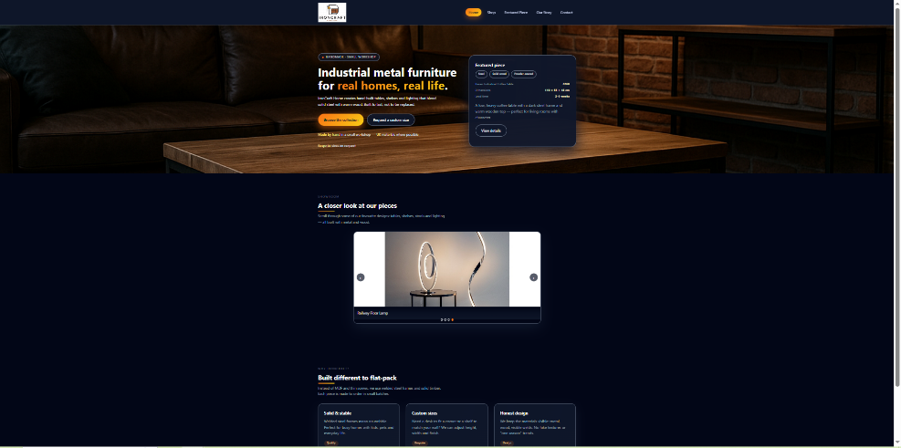
Home page with hero banner and slideshow

Shop page with product cards and images
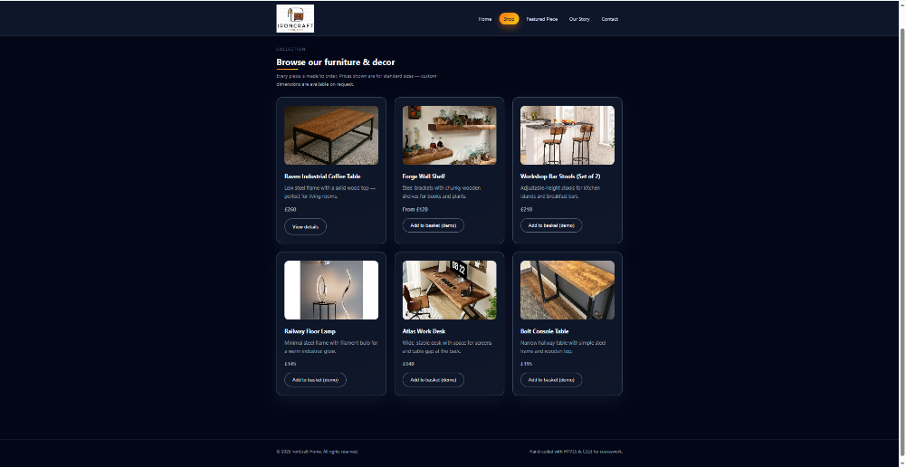

Product page with detailed information and large image
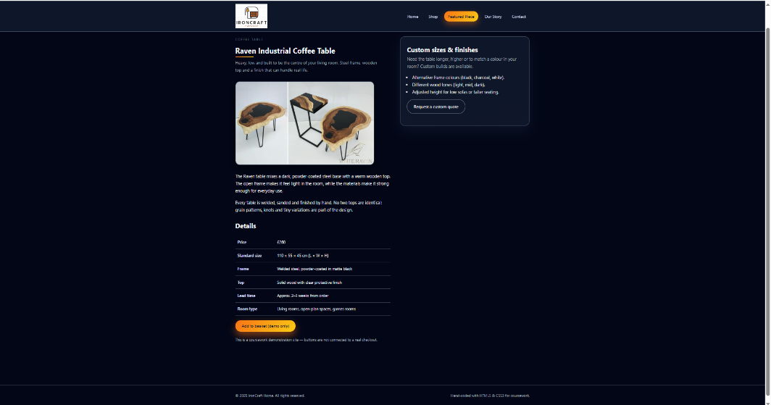

About page with text and supporting image
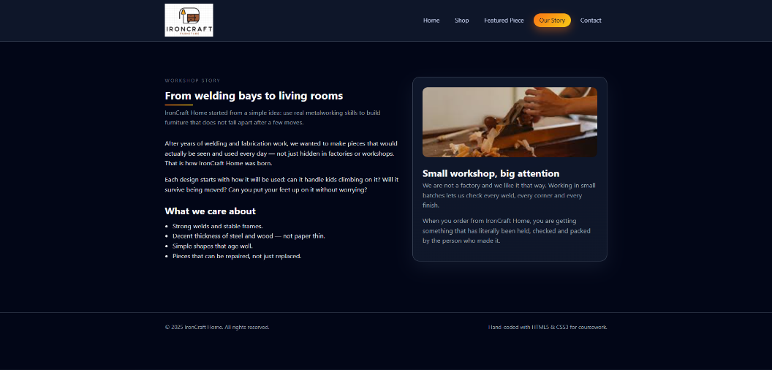

Contact page with the contact form and information panel
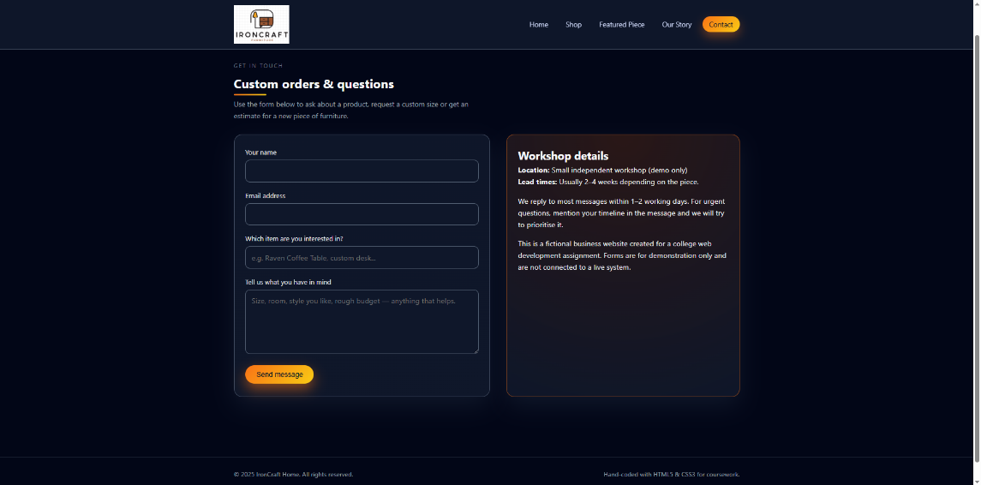

Validating my website
HTML Validation:
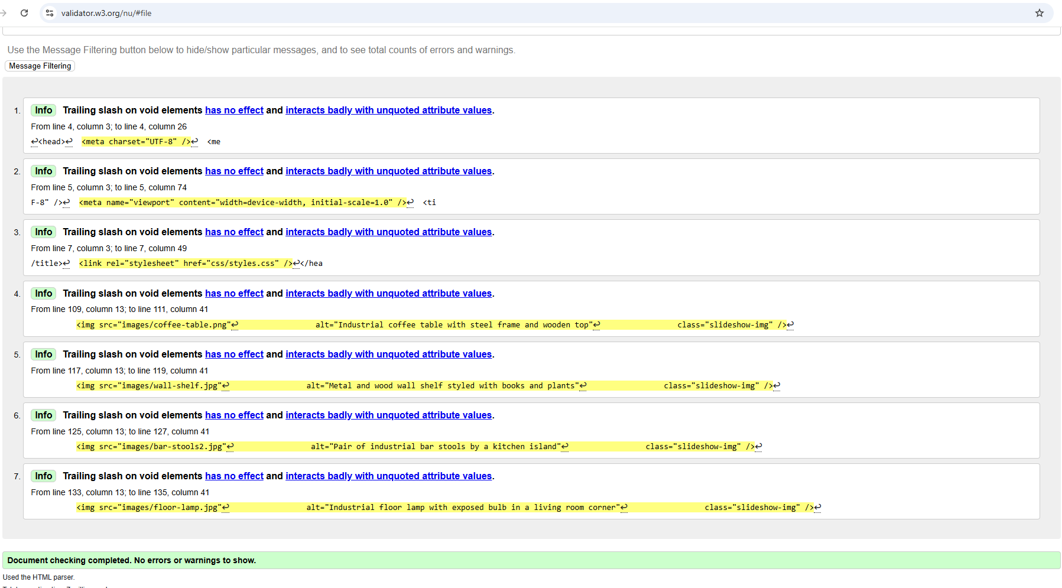
When I uploaded my HTML page to the W3C validator, the report showed no errors or warnings, which means the page meets the current HTML5 standards.

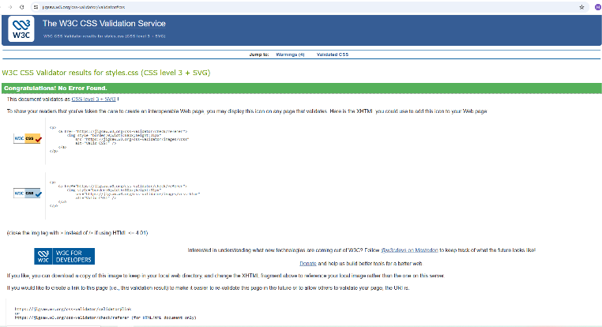
CSS Validation:

When I uploaded my styles.css file to the W3C CSS Validator, the result showed “Congratulations! No Error Found.” This means that my stylesheet follows the official CSS3 standards and contains no invalid properties, spelling mistakes or incorrect syntax.

Self-evaluation of my website

Usefulness (usability and utility):
Usability is described by Nielsen as the degree to which a system is easy to learn, efficient to use and satisfying for the user [1]. The Nielsen Norman Group also explains that good usability means users should be able to navigate a website without confusion and quickly find what they need [2]. Utility, which refers to whether the website actually provides the features users require, is another important part of a useful system.
When I compare my website to these usability principles, I believe it meets the key requirements. The navigation bar is consistent on every page, allowing users to move easily between the Home, Shop, Product, About and Contact pages. The layout is clean, the text is readable and the colour scheme supports the industrial style without reducing clarity. This follows the idea that a usable interface should be simple, predictable and easy to understand.
In terms of utility, the website provides the functions a user would expect from an online furniture shop. The shop page displays clear product images, prices and short descriptions, and the product page offers more detailed information such as materials and measurements. The contact page includes a form so users can send enquiries or request custom sizes. These features match the principle that a system must support the user’s goals in order to be considered useful [3].
I also added a slideshow on the home page to give users a quick visual overview of the main products. This improves usability by helping users understand the type of items offered without needing to browse multiple pages. Following W3C accessibility guidelines, I included descriptive alt text on all images to make the website more accessible for different users [4].
Overall, when comparing my website to recognised usability and utility standards, I believe it performs well. It is easy to navigate, visually clear and provides the main functions expected from this type of business.

Search Engine Optimisation (SEO):
Search Engine Optimisation (SEO) refers to the techniques used to help a website appear more easily in search engine results. According to Beal, SEO focuses on improving a site’s visibility by using clear structure, meaningful page titles, keywords and proper HTML tags. Search engines rely on these elements to understand what a website is about and how relevant it is to users [5].
When comparing my website with basic SEO principles, I believe I have included several features that support good optimisation. Each page has a clear and descriptive title, such as “IronCraft Home | Shop” or “IronCraft Home | Contact,” which helps search engines understand the purpose of each page. My HTML also uses headings like <h1> and <h2> in a logical way, which improves the structure and makes it easier for search engines to read the content. This follows the recommendation that search engines prefer well-organised, semantic HTML $2$.
I also used descriptive alt text for all images. This is important because search engines cannot “see” images and rely on alt text to understand them. Including alt text is also part of good accessibility practice, which is known to support SEO.
Although the website is fictional and not hosted online, the design is still based on SEO-friendly practices. The content is simple, relevant and focused on industrial furniture, which helps search engines match the website with the correct audience. The clean layout, readable text and fast-loading images also support good SEO because search engines favour sites that load quickly and offer a smooth user experience [6].
Overall, the website follows the main principles of SEO by using clear structure, proper HTML tags, descriptive page titles and meaningful alt text. These choices would help the site perform better in search engines if it were published online.

Website Accessibility:
Website accessibility refers to designing a site so that it can be used by people with different abilities, including users with visual, hearing or motor impairments. According to the World Wide Web Consortium (W3C), accessible websites allow all users to perceive, understand, navigate and interact with content regardless of their limitations. Accessibility is an important part of modern web design because it ensures that no user is excluded from using the website.
When evaluating my own website against these accessibility principles, I believe I have met several key requirements. First, I included alt text for all images, which helps screen readers describe visual content for users who cannot see it. W3C identifies alternative text as one of the most essential accessibility features. My navigation menu is simple and appears consistently on all pages, which supports easier navigation for users with cognitive or learning difficulties.
The colour scheme of my website was chosen to maintain good readability. Although the design is based on a dark theme to match the industrial style, the text uses light colours with strong contrast so users can read comfortably. This follows the recommendation that colour contrast should be high enough for visually impaired users [7].
I also used clear headings (<h1>, <h2>, <h3>) on every page, which helps screen readers understand the structure of the website. Semantic HTML tags improve accessibility and also make the page more predictable for assistive technologies [8]. Additionally, I added ARIA attributes where necessary, such as on the slideshow component, to give extra information to screen readers.
My website does not include audio, video or animations that may cause accessibility problems. The layout is responsive, meaning users on mobile devices or assistive tools can still access the content without difficulty.
Overall, the website meets the main accessibility guidelines by using alt text, good contrast, semantic HTML and a simple structure. If the site were to be published online, it could be further improved by adding keyboard navigation testing and more detailed ARIA labels, but for the scope of this project, the accessibility features are strong.

Conclusion
Overall, the project allowed me to design and develop a complete hand-coded website using HTML, CSS and JavaScript. The final site meets the main requirements for usability, accessibility and SEO, and demonstrates a clear understanding of modern web design principles.

References

[1] | J. Nielsen, Usability Engineering, San Francisco, CA, USA: Morgan Kaufmann, 1994.
[2] | J. Nielsen, “Introduction to Usability,” Usability 101:, no. https://www.nngroup.com, 2012.
[3] | C. P. Ben Shneiderman, “Designing the User Interface,” Pearson Education India, 2010.
[4] | “ “Introduction to Web Accessibility”,” W3C, 2018. [Online]. Available: https://www.w3.org/WAI/fundamentals/accessibility-intro/.
[5] | V. Beal, “Search Engine Optimization (SEO),” TechTarget, 2020.
[6] | G. Developers, “Search Engine Optimization (SEO) Starter Guide,” Google, 2023.
[7] | “Contrast and Color Accessibility,” WebAIM, 2021.
[8] | “HTML: A good basis for accessibility,” Mozilla Developer Network (MDN), 2023.

