

Programme: BA Business Management Module: Data Handling and Business Intelligence code: LCBB5000
Lecture: Dr Xavier Matieni
Assessment 2: Data Analysis and Visualisation
Student name: Aysidora Stavreva
Student ID:2030536
Date: 03.09.2023 City: London

Table of Contents
Task 1 2
Introduction 2
Data cleaning 2
Analysis 3
Conclusion 8
Task 2 10
Part 1 10
Part 2 11
Part 3 12
Part 4 13
Part 5 13
Part 6 18
Part 7 19
References 22

Task 1

Introduction
In this task we task we explore the hotel reservation data. The dataset contains 18 variables with 36275 rows of data. The dataset is based on the reservation at hotel and whether or not the reservation was cancelled.
There are numerical variables and categorical variables in the given dataset. The target variable for our study is the average reservation price.

Data cleaning

Figure 1: Number of observations per year
Initial analysis of the data reveals that there were 28038 reservations in 2018. In addition, we find that there is information pertaining to 1570 reservations for the year 2022. Since we need to evaluate for average reservation price during the period of 2017 to 2021, hence we eliminate all information pertaining to 2022.
Further, we find that there is no missing information in the given data.

Analysis

Figure 2: Trend in average Reservation price
The above chart presents a trend analysis of the average reservation price. From the chart it can be observed that for the year 2017, the average reservation price is from month7. In addition, we find that for the years from 2018 to 2021, the average reservation prices start between 50 to 80. However, the trend shows that the average prices for the period between 2018 and 2021 having an increasing trend from January to May for each year. Thereafter, the trend shows a fluctuation till September. After, September for the period between 2018 and 2021, we find a declining trend in average prices. For the year 2017 we find that from July, there was an increasing trend till September. However, from September, there has been a decline in average reservation price.

Figure 3: Average reservation price based on previous booking.
The above chart explores the average reservation price based on the history booking cancellation of the customer. Observations from the chart reveals that the average booking price is not dependent on the cancellation status of the customer. However, from the trend we find it varies to a certain extent on the number of previous bookings. The average price is more than 100 when the customer books a room for the first time. However, with each subsequent booking the average price of a room reduces to between 60 and 70.

Figure 4: Average price based on Room type
The trend in average price of a room based on room type is presented in the above chart. The bookings for room type 3 have been discontinued since 2018. During the period of 2017 to 2018 there was an increasing trend in average price of room type 3. Similarly, the booking for room type 5 was discontinues for 2019. Moreover, there has been an increasing trend in the average price of room type 5. Further, we find that for room type 2, 4 and 6 the average price has remained fairly constant during the period of 2017 to 2021. While the average price of room type 6 was between 150 and 200, for room type 4 it was between 100 and 150. Similarly, for room type 2 the average price was between 50 and 100. Moreover, for room type 7 we find that there has been an increasing trend in the average price from 2017 to 2019. During the period between 2019 and 2020 the average price remained constant above 200. During the period 2020 and 2021 there has been a decline in average price of room type 7.

Figure 5: Average price based on Car parking
In order to check for the average price based on request for car parking a new variable was created. We take into consideration that 0 in the given dataset is No Car parking and 1 signifies Car parking.
From the trend it can be observed that the average price of a room without car parking is lower than with car parking. Moreover, without car parking there has been an increasing trend in average price from 2107 to 2020. After 2020 there has been a slight decline in the average price of the room. In the case of average price with car parking, it can be observed that there has been a decline in average prices from 2018 to 2020. However, subsequent to 2020 there has been an increase in average reservation prices.

Figure 6: Average price by Children
In the above chart we explore the relation between presence of children and average price of reservation. It can be observed from the chart that the average price of reservation with children is higher than without reservation. Moreover, we find that during the period between 2017 and 2019 there has been an increasing trend in average prices of reservation with children. However, after 2019 there was a decrease in average room prices in 2020, and again it increased in 2021. On the other hand, for room prices without children, we find that there has been a cyclic trend. The room price was least in 2017.
Further, we consider the reservation price trend based on market type. Initial observation reveals that there were very few bookings for Aviation and Complimentary. Hence, the two market types – Aviation and complimentary are not considered for analysis.

Figure 7: Average price by market type
In the above chart we explore the relation between the average reservation price and market type.
Observing the trend in prices, it can be interpreted that the average price for corporate booking is the least. However, it can be observed that in 2017, the average price was 77.2 which increased to 84.6 in 2018. During 2019, the average reservation price reduced to 70.2. Since, 2019, there has been an increasing trend in average reservation price.
The average reservation price for online booking during the period under study has been the highest. During 2017, the average reservation price was 98.1, which increased to 114.5 in 2018. Since, 2018, there has been a decline in the reservation price and in 2021, the average price was 111.3.
For Offline booking, the average price has remained fairly constant. In 2017, the average reservation price was 88.4. In 2021 the average reservation price was 90.4.

Figure 8: Average reservation price with meal type
The hotel offered three different types of meals. However, meal plan 3 was discontinued in 2017. It can be observed that the average price of a room with meal plan 1 (86.88) was the least in 2017. With meal plan 1, the average price increased in 2018 to 107.24. There has been a cyclic pattern in the reservation prices with meal plan 1. In the case when meal plan has not been selected, the prices declined from 2017 to 2019. However, after 2019 it has increased to 98.50 in 2021. Reservation costs for meal plan 2, in 2017 was 100.86. There was an increasing trend in average prices from 2017 to 2019. During 2019, the average price was 126.79. Thereafter, from 2019 to 2021, we find that there has been a decline in average room prices with meal plan 2. The average price of a room with meal plan 2 in 2021 was 98.15.

Conclusion
Thus, from the above analysis we find that there are multiple factors which defines the average price of a room. The factors which have been found to influence average price are room type, previous booking history, market type, presence, and absence of children,
Exploring the data, we found that the hotel initially offered 7 different types of rooms. However, presently it offers only 6 different types of rooms. Moreover, while there have been high fluctuations in the average reservation prices of Room type 7, the average prices of room type 1, 2, 4 and 6 have remained constant for the period of study.
In addition, we find that the reservation prices increased with the request for car parking space. It is also observed that the reservation prices with car parking has increased during the period of 2020 to 2021.
Moreover, average reservation price with children is higher than without children. In addition, we find that the average price is higher while booking a room for the first time. However, with subsequent bookings there is a decline in reservation prices.
Further, we observe that there has been a great price change with meal plan. During the period of 2017 to 2019 while the average price with meal plan 2 increased, during the period of 2019 to 2021, there was a decline in average price. In 2017, the average price with meal plan 1 was the least. However, in 2021, the average price with meal plan 2 is the least. On the other hand, the average price with meal plan 1 is the highest.

Task 2
In this section we analyse students score dataset. For the analysis of the given data SPSS has been used. In this analysis we explore the relationship between students getting free lunch, gender and their grade scores.

Part 1
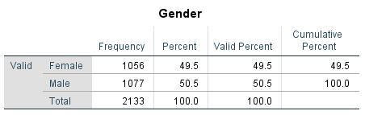
The survey was collected from 2133 students. 49.5% of the students (1056) were females, while 50.5% (1077) students were male students in the survey.
Thus, we find that there were higher number of male students in the survey than the number of female students.

Part 2

Lunch
 |  | Frequency | Percent | Valid Percent | Cumulative Percent
Valid | Does not qualify for free/reduced lunch | 1215 | 57.0 | 57.0 | 57.0
Valid | Qualify for free/reduced lunch | 918 | 43.0 | 43.0 | 100.0
Valid | Total | 2133 | 100.0 | 100.0

From the above table it can be observed that, 1215 students do not qualify for free or reduced lunch. Further, 918 students do qualify for free or reduced lunch.
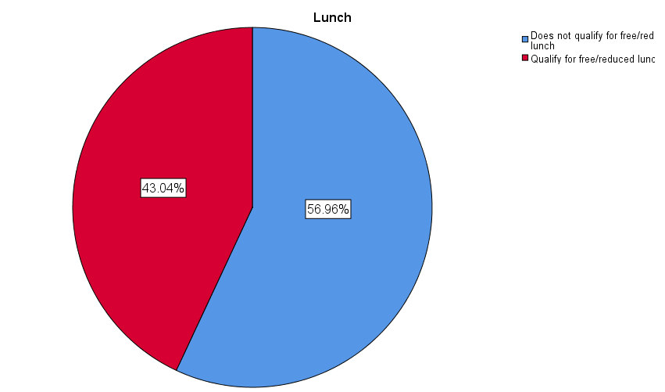

Through the pie-chart above we present the analysis of the given data on the percentage of students who qualify for free / reduced lunch. 43.04% of the students qualify for free or reduced lunch from the schools. Contrary to this, 56.96% students do not qualify for free / reduced lunch. Thus, it is observed that the percentage of students who have qualified for free lunch is far less than those who have not qualified for free lunch.

Part 3

Descriptives
Lunch |  | Statistic
 |  | Pretest | Posttest
Does not qualify for free/reduced lunch | Mean | 62.29 | 74.38
Does not qualify for free/reduced lunch | Median | 62.00 | 74.00
Qualify for free/reduced lunch | Mean | 45.25 | 57.48
Qualify for free/reduced lunch | Median | 44.00 | 55.00

In the above table we observe the descriptive statistics, mean and median values for pre and post test scores.
- For all students who have not qualified for free lunch, the mean score of pre-test and post-test is 62.29 and 74.38 respectively.
- For all students who have not qualified for free lunch, the median score of pre-test and post-test is 62.00 and 74.00 respectively.
- For all students who have qualified for free lunch, the mean score of pre-test and post-test is 45.25 and 57.48 respectively.
- For all students who have not qualified for free lunch, the median score of pre-test and post-test is 44.00 and 55.00 respectively.
Thus, from the scores it can be interpreted that the students who have qualified for free lunch, the mean and median scores for both pre and post scores are lower than those who have not qualified for free lunch.

Part 4
Lunch | Stat | Pre-test | Post-test | Difference
Does not qualify for free/reduced lunch | Mean | 62.29 | 74.38 | 12.09
Does not qualify for free/reduced lunch | Median | 62.00 | 74.00 | 12.00
Qualify for free/reduced lunch | Mean | 45.25 | 57.48 | 12.23
Qualify for free/reduced lunch | Median | 44.00 | 55.00 | 11.00

Exploring the differences in pre and post test scores we find that:
- For all students who have not qualified for free lunch, the mean and median difference is 12.09 and 12.00 respectively
- For all students who have qualified for free lunch, the mean and median difference is 12.23 and 11.00 respectively.

Part 5
Clustering is defined as a process in which data points within a given a data frame are grouped together so that individual groups have similar characteristics. Thus, clustering helps to identify similarities and dissimilarities within a given data frame.
The first step in the clustering process is to standardise all the scores of a given data frame. Since, clustering of a given data frame is dependent on distance metrics hence, standardisation is essential, since it normalises the values. It has been observed that extreme values exert higher influence in the clustering process. Thus, the influence of extreme values for a variable is reduced through standardisation.
Standardisation of a given variable is done using the formula:
$$z=\frac{x-μ}{σ}$$

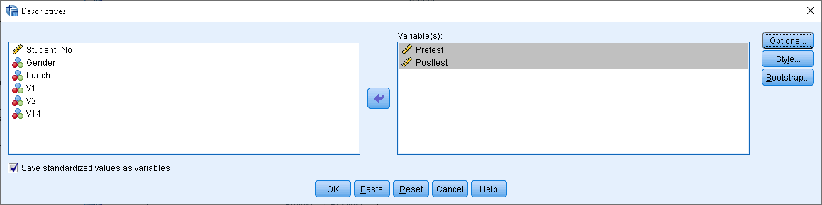

To steps used for standardisation of the variables pre and post test scores are :
Analysis > Descriptive Statistics > Descriptives
The variables pre and post test are moved to the right-hand side. Further, in the lower left-hand corner we find “save standardized values” is checked.
The above process saves the standardized scores for pre and posttest.

Descriptive Statistics
 | N | Minimum | Maximum | Mean | Std. Deviation
Pretest | 2133 | 22 | 93 | 54.96 | 13.563
Posttest | 2133 | 32 | 100 | 67.10 | 13.987
Valid N (listwise) | 2133

Descriptive Statistics for standardized scores
 | N | Mean | Std. Deviation
Z score (Pretest) | 2133 | .0000000 | 1.00000000
Z score (Posttest) | 2133 | .0000000 | 1.00000000
Valid N (listwise) | 2133

The above table presents the standardized scores. As can be seen that the scores for pre and post test have a mean 0 and standard deviation of 1.
The next step is to create the clusters.
We follow the steps as:
Analysis > Classify > K-means cluster
Move the z-scores for pre and post test to the selected variables section.
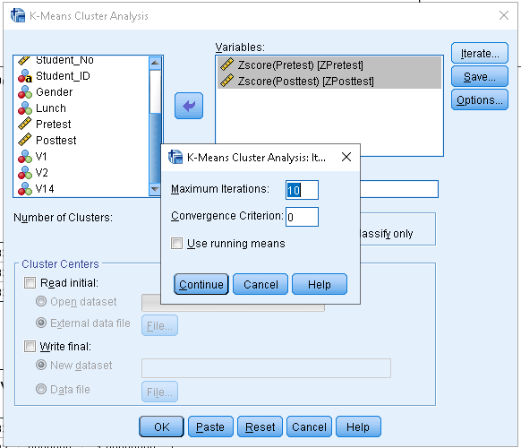
Further, on the iteration button we make the maximum number of iterations to 10.
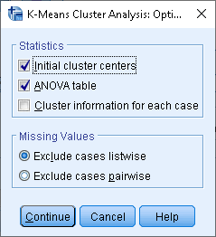
In addition, we save the initial cluster centers and the ANOVA table.

Final Cluster Centers
 | Cluster
 | 1 | 2
Z score (Pretest) | -.87764 | .76447
Z score (Posttest) | -.88650 | .77219

The final cluster centers are given in the above table. From the above table it can be observed that 2 cluster centers can be created. The pre and post test scores for 1st cluster is negative while for the 2nd cluster is positive.
Segregating the data frame into 2 clusters it can be observed that that the pre and post test scores for cluster 1 is -0.87764 and -0.88650 respectively. In addition, the pre and post test scores for cluster 2 are 0.76447 and 0.77219 respectively. Thus, we find that while the scores for cluster 1 are negative for cluster 2 they are positive.

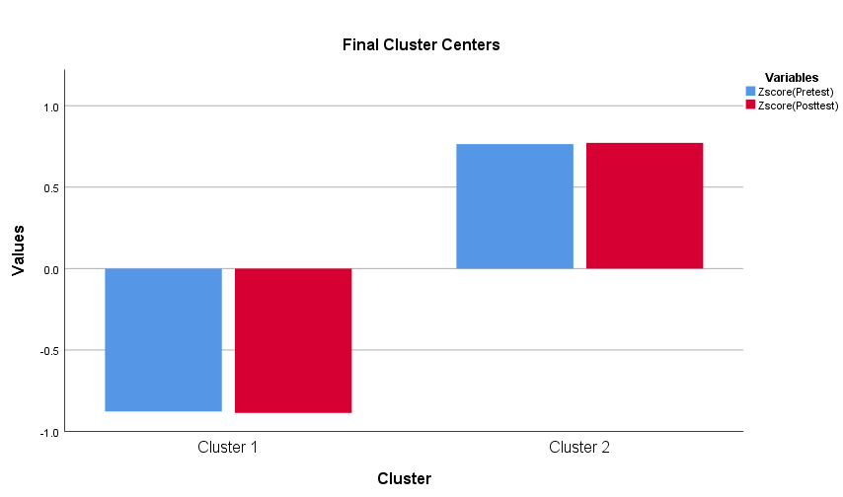
The bar chart above presents information on the clusters based on their scores.
Number of Cases in each Cluster
Cluster | 1 | 993.000
Cluster | 2 | 1140.000
Valid |  | 2133.000
Missing |  | .000

In addition, it is also found that there are 993 students in cluster 1 and 1140 students in cluster 2.

Part 6
The most common data mining processes which are used to provide insights into businesses are:
- Logistic regression – This is the simplest of all data mining processes. When in a given dataframe the target variable has two options then in order to predict the probability of occurrence of target variable logistic regression process is used. Numerical variables are used in the process.
Kumar et al., (2022) explored the relation between use of bamlanivimab and hospitalization based on various demographic factors. According to the study, the target variable was the use and use of bamlanivimab. They tested the effect of the medicine on the need for hospitalization based on the socio-demographic profile of the patient.
- Random forest model – In this datamining approach both numerical and categorical variables are used. It averages multiple decision tree models to create a random forest.
Zhu et al., (2019) used the data mining approach to predict loan defaults from the lending club. For exploring using the data mining approach the data frame had information on 115,000 original loan data. The dataset contained 102 attributes. Based on the use of decision tree model they extracted 15 most important features for further analysis.
- Text mining – This is used to mining data from text.
Zeberga et al., (2022) used text mining for analysis of anxiety and depression from social messages. According to the studies by the researcher, data can be extracted from twitter or reddit. Using various NLP techniques, the level of anxiety of the persons can be evaluated.
- Clustering is the process of grouping together based on similar characteristics.
Al-Ogaili et al., (2019) explored the most effective charging strategy of electric vehicles using clustering mechanisms. They studied the requirement of charging, the demand to charge and thus the clustering of electric demand to charge the electric vehicle.
- Forecasting uses various data mining approaches to predict the future
Speight et al., (2021) explored the possibility of surface water flooding as a result of rainfall.

Part 7
Excel | SPSS
For doing calculations formulas can be used. | There is no provision to use formulas. All analysis can be done using pull down menu.  Can work on predictive analytics
Pivot tables are used for creating tables through which insights from the data can be derived. | Can use various graphs and charts. Splitting the dataset based on features can be done to get information
Dynamic dashboards can be created | There is no provision for dashboards

References
1.Al-Ogaili, A.S., Hashim, T.J.T., Rahmat, N.A., Ramasamy, A.K., Marsadek, M.B., Faisal, M. and Hannan, M.A., 2019. Review on scheduling, clustering, and forecasting strategies for controlling electric vehicle charging: Challenges and recommendations. Ieee Access, 7, pp.128353-128371.
2. Kumar, R.N., Wu, E.L., Stosor, V., Moore, W.J., Achenbach, C., Ison, M.G. and Angarone, M.P., 2022. Real-world experience of bamlanivimab for Coronavirus Disease 2019 (COVID-19): a case-control study. Clinical Infectious Diseases, 74(1), pp.24-31.
3. Zhu, L., Qiu, D., Ergu, D., Ying, C. and Liu, K., 2019. A study on predicting loan default based on the random forest algorithm. Procedia Computer Science, 162, pp.503-513.
4. Zeberga, K., Attique, M., Shah, B., Ali, F., Jembre, Y.Z. and Chung, T.S., 2022. A novel text mining approach for mental health prediction using Bi-LSTM and BERT model. Computational Intelligence and Neuroscience, 2022.
5.Speight, L.J., Cranston, M.D., White, C.J. and Kelly, L., 2021. Operational and emerging capabilities for surface water flood forecasting. Wiley Interdisciplinary Reviews: Water, 8(3), p.e1517.

