Methodology
Within this next chapter, the methodology will be conducted. Not only will the methodology provide a detailed description of the research process that will be centred around the aim of this research topic which is as follows: evaluate the treatment of Male and Female offenders in the criminal justice system in England and Wales, but is also a vital piece of this research topic. The methodology describes the overall strategy and reasoning behind this study which will develop an approach that essentially matches the objectives of this topic. The methods and theories used within this topic area will be studied closely due to this, (Scribbr, 2024).

3:1 Research Onion
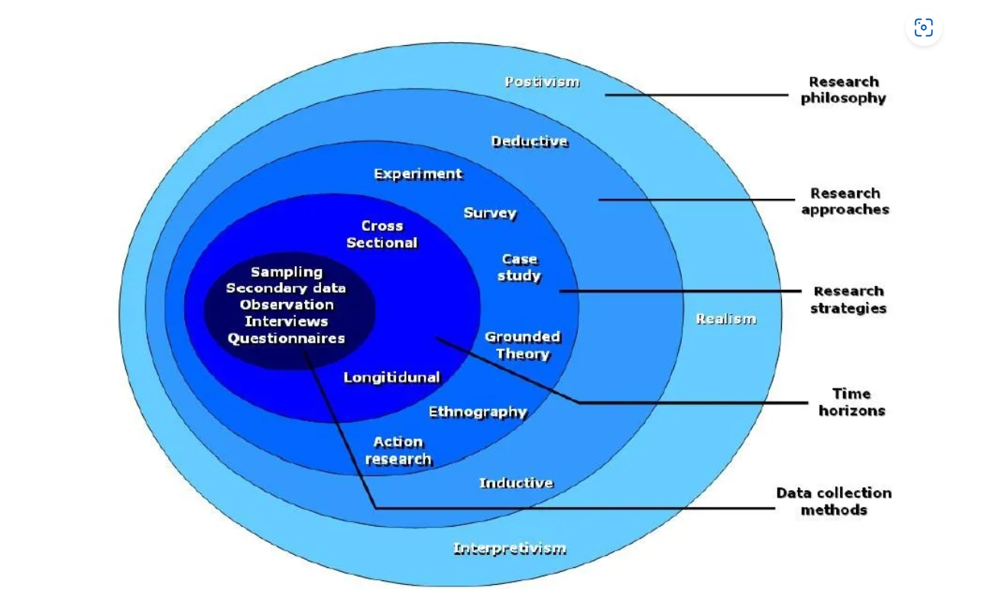
(Thesismind, 2019)

The structure of this methodology will be broken down into categories based off Saunders et al (2007) research onion. The research onion portrays the fundamental steps of how to achieve a successful and credible methodology. As presented by Thesismind (2019) the layers of the onion provide an in-depth description of the steps of the research process, working from the outer layer, making way to the centre. These steps will be a series of different decisions which need to be made based off of the research collected. The structure the research onion provides is a useful strategy which nudges the researcher into a state of holistic thinking about methodology. The research onion provides clarity when making decisions in terms of research which surrounds the methodology, (Phair and Warren, 2021).

3:2 Philosophy
The research philosophy is essentially the principles, beliefs and assumptions which will provide a concrete structure of the way in which the research will be approached, (Jansen, 2023). Also encapsulated within the research philosophy and research paradigm is the intended knowledge to be gained by undertaking this research study. This section of the methodology reflects the sort of knowledge and insight that can be expected to be gained from the selected research project.
Dudovskiy (2010), provides that the research philosophy can be viewed from two different stand points, ontology and epistemology. A central question in ontology is whether social entities should be perceived as objective or subjective. In other words, within the scope of the chosen research topic, it is essential to determine whether social phenomena are created by perceptions and actions of social actors or by the world itself. Ontology is essentially the what and how of what we know and is more or less the study of reality. In terms of epistemology however, epistemology is the ‘how’ of obtaining knowledge and understanding of things, which is typically used in scientific research. Essentially epistemology is a theory of knowledge that discusses how and from where knowledge is gathered, in simple terms. The way the data is interpreted depends heavily on how each person perceives the world and know what they know. Therefore, providing that it should make the philosophical viewpoint clear from the beginning, (Brown, 2015).
In terms of the philosophy chapter, there are many research philosophies, however whilst using the research onion to structure this methodology, Saunders et al (2007) highlights three main research philosophies which are commonly referred to. The three of these research philosophies, are that of positivism, interpretivism and pragmatism. It is common to divide philosophical positions in academic studies into positivism and interpretivism. Positivism and interpretivism which underpins the qualitative verus quantitative debate. According to Stainton (2021), positivist studies are typically scientific and test phenomena. In the late 19th and early 20th centuries, positivism gained popularity in the natural sciences. Observation and measurement should be the basis of scientific knowledge, according to the scientific method. It is assumed by positivists that there is a single reality independent of our perceptions, and that it can be understood through scientific methods that are systematic and rigorous. Whereas interpretivism claims each observer perceives and understands reality differently, therefore, interpretivist studies are often qualitative, (15 Writers, 2019). The interpretivist movement, also known as constructivism or hermeneutics, arose from the limitations of positivism in the social sciences. The term emphasizes the subjective nature of human experience and focuses on understanding social phenomena through the interpretations and meanings that individuals assign to them. Societal reality, according to interpretivists, cannot be reduced to objective laws or generalizations, since it is socially constructed and context dependent. Finally, a pragmatic approach to research seeks to bridge the gap between positivism and interpretivism. Research is encouraged to take a flexible, problem-solving approach and emphasizes the practical consequences of knowledge. According to pragmatists, knowledge's value lies in its usefulness and its ability to solve real-world problems. In terms of the research that is conducted throughout this dissertation, the research philosophy which is best suited to this topic, due to the many equal valid interpretations if reality as well as how the topic of research is based of off personal experiences within the criminal justice system in England and Wales, (Rashid, 2023).

3:3 Approach
The next layer of the research onion is the research approach. Hassan (2023), defines the research approach as the systematic and structured choices a researcher would use in order to produce their research. The research approach ranges in terms of underlying logic and methods of inquiry. The research approach has three main research approaches according to Saunders et al (2007) research onion, those three approaches are deductive, inductive and abductive.
A deductive approach begins with a hypothesis or theory, which is tested through data collection and analysis. On the basis of the theory or hypothesis, the researcher develops a research design and data collection methods. The key aim of a deductive approach is to confirm or deny the hypothesis found. However, in terms of an inductive approach data collection and analysis are the first steps in the inductive approach. Based on the patterns and themes that emerge from the data, the researcher develops a theory or explanation. An existing theory can be refined or a new one generated through this approach. The last research approach is a combination of deductive and inductive approaches is abductive reasoning. In this process, the researcher begins with an unsolved problem or phenomenon, and develops a theory or explanation that can explain the findings. After collecting and analysing more data, the researcher tests the hypothesis. The aim of the research abductive approach is to conduct a plausible explanation or theory which can later be refined or tested. Due to an inductive approaches beginning steps being based round analysis and data collection along with how a theory or explanation is developed from the research, it is clear that an inductive approach is the ideal approach as there is a clear and evident link between the male and female offenders and a difference in their treatment.

3:4 Strategy
An overall research strategy outlines how a study will be conducted. The research strategy guides the planning, execution, and monitoring of a study. In addition to providing useful support on a high level, a research strategy must be complemented by research methods that can guide the research in more detail. Data collection and analysis methods are explained to the researcher, such as interviewing, filling out questionnaires, or using statistical methods to collect data. As a result, a research strategy provides high-level guidance, while a research method is a technique or tool for carrying out a specific task, (Johannesson and Perjons, 2014).

3:5 Choices
For conducting research, the research onion, Saunders et al (2007), suggests mono-method, mixed-method and multi-method approaches. The mono-method comprises only one method for the study. The mix-method refers to the combination of qualitative and quantitative methods of research. Lastly, the multi-method approach incorporates a variety of approaches, (15 writers, n.d.). In terms of the mixed-method approach which refers to qualitative and quantitative research methods, to gain additional insights on topics that are unclear, qualitative research is often used. Methods of qualitative research include open-ended survey questions, observations of behaviour described and literature reviews of similar theories and concepts. In addition to identifying overarching themes or ides, these methods can be used to describe and interpret. Thematic analysis and textual analysis in terms of data analysis is also used within qualitative research. In terms of quantitative research, however, is the goal of testing hypotheses and theories. When conducting quantitative research methods such as closed-ended surveys and experiments are typically conducted, which typically relies on statistics. Ideally a quantitative and qualitative approach used within a survey to gather public views on the difference in treatment between male and female offenders within the criminal justice system in England and Wales, therefore providing closed-ended questions followed by open-ended questions in order to gather a greater understanding of the views of the participants, thus creating a more in-depth study, (Vale, 2023).

3:6 Time horizon
According to Saunders et al (2007), the time horizon is typically concerned with the time period in which the research in question will be conducted over. According to Alamgeer (2022), the time horizon can be concluded based off of the research in questions objectives, along with the type of investigation which will be conducted. In terms of time horizon there are two types of research; longitudinal and cross-sectional research. Longitudinal research, is concerned where the researcher gathers their form of data over a long period of time. Within longitudinal research however, the data gathered will be from samples which are repeated several times in order to collect said data at different intervals. The data collected within longitudinal research from different intervals is time-series data, which can be interpreted as a series of cross-sectional research.
However, within this dissertation cross-sectional research is typically more suitable as the research is conducted throughout the academic year. Cross-sectional research is typically concerned where the researcher collects their data once during a cross-sectional analysis. Therefore, providing that the data collected through the cross-sectional analysis will not be repeated with any other samples.

3:7 Techniques and Procedures
Therefore, the survey in question will be created through Microsoft forms thus providing a hyperlink that will be posted via social media which participants can easily access. The survey will contain questions surrounding the difference in treatment in male and female offenders within the criminal justice system in England and Wales, where participants will be approached with quantitative questions, followed by a qualitative section where participants can provide a more in-depth answer if they wish. The participants which will be provided with the option of filling out the survey will be from the typical social media age group, 18+, as well as participants selected from the student body. The social media hyper link will be provided to a social media platform with the aim to receive at least 50 responses in order to have a wider range of feedback and data results, the use of social media could potentially lead to snowballing, therefore providing a larger number of data and essentially more accurate data.
Thematic analysis is a key type of analysis which is used with qualitative data. Thematic analysis is typically present where a researcher analyses a from of text. This from of text can be any form of literature to examples such as audios and videos, (Nicolas, 2020).
Although the survey will be created with care to ensure the questions providing can add an insight to the difference in treatment to male and female offenders within the criminal justice system in England and Wales, there are in fact some limitations which could prevent the data from providing data insights. These limitations can be the lack of public knowledge on the conditions that offenders in England and Wales face throughout their journey through the criminal justice system.

Reference list;

- 15 Writers (2019). Understanding the Research Onion. [online] 15 Writers. Available at: https://15writers.com/research-onion/.
- 15 writers. (n.d.). Understanding the Research Onion | Writing Guides | 15 Writers. [online] Available at: https://15writers.com/research-onion/#:~:text=The%20mono-method%20comprises%20only%20one%20method%20for%20the.
- Alamgeer, Z. (2022). Time Horizon in Research onion. [online] The Innovidea. Available at: https://theinnovidea.com/time-horizon-in-research-onion/.
- Brown, N. (2015). Epistemology. [online] Dr Nicole Brown. Available at: https://www.nicole-brown.co.uk/epistemology/#:~:text=In%20simple%20terms%2C%20epistemology%20is%20the%20theory%20of.
- Dudovskiy, J. (2010). Ontology - Research-Methodology. [online] Research-Methodology. Available at: https://research-methodology.net/research-philosophy/ontology/.
- Hassan, M. (2023). Research Approach - Types Methods and Examples. [online] Research Method. Available at: https://researchmethod.net/research-approach/#:~:text=The%20purpose%20of%20a%20research%20approach%20is%20to.
- Jansen, D. (2023). Research Philosophy: Positivism, Interpretivism & Pragmatism. [online] Grad Coach. Available at: https://gradcoach.com/research-philosophy/.
- Johannesson, P. and Perjons, E. (2014). Research Strategies and Methods. An Introduction to Design Science, [online] pp.39–73. doi:https://doi.org/10.1007/978-3-319-10632-8_3.
- Nicolas, A. (2020). Thematic Analysis. [online] Research Prospect. Available at: https://www.researchprospect.com/thematic-analysis/.
- Phair, D. and Warren, K. (2021). Saunders’ Research Onion: Explained Simply. [online] Grad Coach. Available at: https://gradcoach.com/saunders-research-onion/.
- Rashid, M.H.A. (2023). Research Philosophy: Positivism, Interpretivism, and Pragmatism. [online] Library & Information Management. Available at: https://limbd.org/research-philosophy-positivism-interpretivism-and-pragmatism/.
- Saunders, M., Lewis, P., & Thornhill, A. (2007). Research Methods for Business Students, (6th ed.) London: Pearson
- Scribbr (2024). What’s the difference between method and methodology? [online] Scribbr. Available at: https://www.scribbr.com/frequently-asked-questions/method-vs-methodology/.
- Stainton, H. (2021). research onion - Search Videos. [online] www.bing.com. Available at: https://www.bing.com/videos/search?q=research+onion&&view=detail&mid=617D1B216075BADE9358617D1B216075BADE9358&&FORM=VRDGAR&ru=%2Fvideos%2Fsearch%3Fq%3Dresearch%2Bonion%26FORM%3DHDRSC4 [Accessed 8 Feb. 2024]
- Thesismind (2019). Analysis of Saunders Research Onion. [online] Thesismind. Available at: https://thesismind.com/analysis-of-saunders-research-onion/.
- Vale, M. (2023). Choosing the Right Research Methodology: A Guide | Elsevier. [online] Elsevier Author Services - Articles. Available at: https://scientific-publishing.webshop.elsevier.com/research-process/choosing-the-right-research-methodology-a-guide-for-researchers/#:~:text=Some%20common%20methodologies%20include%20qualitative%20research%2C%20quantitative%20research%2C [Accessed 9 Feb. 2024].

Images;
Thesismind (2019). Analysis of Saunders Research Onion. [online] Thesismind. Available at: https://thesismind.com/analysis-of-saunders-research-onion/.

