Name - Nicoleta Briceag
Student Number - 1914033
Module Title - Marketing Fundamentals
Assignment 2 - Apple organisation
Lecture's Name - Tushara Balendran

Table of Contents
Introduction 3
Discussion 3
Conclusion 11
Reference lists 13

Introduction
This assignment is developed to discuss about the role of marketing in creating value for customers. The stakeholder engagement process has also been discussed in this assignment as well. Marketing is one of the essential aspects of an organisation. It is necessary to realise that marketing is the only department that is responsible for controlling the growth and development of almost every other department within a company. The marketing department manages the finance, human resource, sales and logistics quite efficiently and is responsible for developing and suggesting strategies. There are certain advantages of marketing to consumers. One of the most potential advantages of marketing is that it keeps the consumers known to the current trends (Kotler and Armstrong, 2016). Apart from that, it helps the customers to make an excellent relationship with the brand. Customers can gain 24/7 access due to marketing. In this report, a detailed study has been done for Apple Corporation based on their marketing strategies. A detailed study will also be done based on stakeholder management theory and how it affects the company and even a comprehensive marketing strategy along with recommendations for the future.

Discussion
In this section, the concept of marketing would be discussed. Apple uses relationship marketing as a part of their marketing process. They use CRM in their retail bases to encourage a long-term relationship with the customers (Apple, 2020). Instead of urging the customers to buy their products, they focus on teaching customers to love and appreciate the advantages of using an iPhone or Ipad (Apple, 2020). It has been found that Apple generally focuses upon ensuring that customers have an experience, instead of making a simple purchase. That means they always try to create value to their customer and build a strong bond and relationship with people.
Apple also uses its networking strength that they have in the market. The company has strong and effective digital media presence so that, they try to enhance their engagement with customers through digital and social media platforms (Above Avalon, 2020). In Facebook, Twitter, Instagram and many other platforms, the company tries to engage with their customers as well as other stakeholders (Apple, 2020). Hence, the company provides its customers with a range of information about their products and similarly, customers share their feedback. Therefore, through this communication and engagement, Apple does its relationship marketing.
In order to do relationship marketing, Apple also does marketing campaigns as well as launching events to get closer to customers and other stakeholders (Kotler and Armstrong, 2016). In these events, the company shows its product specification to its customer and highlights the features that their customers demand. Hence, they indicate their customers that they always bring innovative and convenient products to fulfil their customer need and satisfy them. Hence, they do relationship marketing with the help of these processes.
Societal marketing is defined as the concept that suggests that an organisation should adopt marketing decisions while considering the needs of the customers, requirements of the organisation and the long-term interest of the society (Fiore et al., 2016).
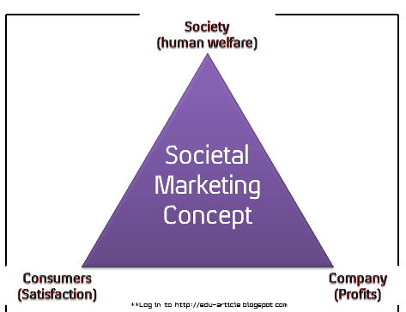
Figure 1: Societal Marketing model
(Source: Fiore et al., 2016)
There is three consideration of societal marketing, namely, society, consumers and company (Fiore et al., 2016). In terms of society, an organisation keeps in mind that they should make social contributions while making their products or opting for any strategy (Kotler and Armstrong, 2016). In the case of consumers, an organisation must keep in mind that they should bring or design their products in such a way that the needs of the customers are satisfied. In the case of a company, an organisation gives a profound focus on their profit maximisation by maintaining an effective relationship with the customers and also by providing quality products (Fiore et al., 2016). Apple is one of the most reputed organisations in the world. The organisation has various contributions to society. For example, in 2011, the organisation launched a program named "Global Volunteer" for encouraging the employees for volunteering within local communities (Dudovskiy, 2020). In China, all the offices and stores of Apple are powered with a solar panel. It contributes to the environmental aspect of the organisation.
However, in this initiative, they have opted for mounting the panels at a great height above the ground so that the local yaks can eat the growing grass (Dudovskiy, 2020). The organisation has also adopted various strategies to put the focus on the profit maximisation of them. For instance, they have never thought of lowering the price of products and instead of that, they have always insisted on providing premium quality. As a result of that, the organisation has made enough profit in the last few years. In this regard, the revenue of the organisation was $ 260.174 billion in 2019, but it increased by 3.67% and went to $ 267.981 billion at the end of March 2020 (Macrotrends, 2020). However, the primary focus of Apple is not on profit maximisation, but on customer satisfaction. In order to maintain this focus, the management of the organisation opts for Net Promoter Score on an annual basis so that they can review that what extent their products are satisfying the needs of the customers (Retently, 2020).
Branding is defined as a practice of marketing that is created by an organisation by designing a particular logo or symbol that differentiates the organisation from others (Kotler and Armstrong, 2016). After successfully making their mark in the world of technical gadgets, the organisation introduced Apple Watch in 2015 to meet the needs of the customers (Apple, 2020). Apart from that, they kept on launching new versions of I-phone every year to meet the needs of the customers and to provide them with enough satisfaction. There are numerous advantages of branding for an organisation. It is beneficial for the organisation to gain potential customers (Kotler and Armstrong, 2016). Apart from that, customer loyalty is also achieved due to efficient branding, and there is no doubt regarding Apple’s effort on it. Excellent brand equity is created due to effective branding (Kotler and Armstrong, 2016). Customers opt for finding value in the brands that enable them. The customers can easily recognise which brand can meet their needs and satisfaction from the recognition of the core value as shown under. The stakeholders of Apple recognise Apple from being a brand that encourages uniqueness, as desired by Steve Jobs himself.

Figure 2: Apple Brand Logo and core value
(Source: Apple, 2020)
Moreover, branding helps customers to maintain their strong presence as compared to their other companies. It also makes believe customers that the company provides superior products and fulfil their customer need as compared to any other company in the market. From Steve Jobs to Tim Cook, Apple has been successful in maintaining its superior position. Therefore, it creates an image in front of customers, and customers believe that they get a better product from the company because of its branding (Kotler and Armstrong, 2016). Also, branding strengthens customers’ demand and customer loyalty. With the help of effective branding, companies ensure that they bring demanded products as their customers and potential customers demanded.
This section of the essay discusses the Ansoff growth matrix analysis of Apple. Igor Ansoff proposed the framework in 1957 (Yin, 2016). The aspect of market penetration suggests that selling already existed products in the existing market (Loredana, 2016). This strategy will not be adopted by Apple as because they already have their product available in their existing market on a huge basis. For example, they sell their iPhone in various platforms such as Apple stores, their website and also from other telecommunications stores (Apple, 2020). Also, if the company start sells its existing products more, then it might be a failed strategy because the pricing of their products is high. Hence, people might ignore their products if they frequent launch similar products in their existing market. Moreover, as their availability of products is high and Apple is expanded worldwide vastly so that it would not work effectively. The next component is market development (Yin, 2016). This strategy is defined as the selling of already existing product into new markets (Loredana, 2016). However, Apple will not include this strategy because they have already made a global expansion since its inception. It has worldwide recognition and has made strong bases in Europe and Asia. They did not confine themselves within the USA but have expanded themselves into countries like China, India and Indonesia (Apple, 2020). Therefore, it can be stated that Apple should not use this strategy because it expanded vastly worldwide. It means that there remain only a few countries where Apple can launch its cash cow products. However, those countries might not be able to afford these products majorly because of high pricing. Hence, this strategy is not effective for Apple.
The brand has made a stronghold in those countries, and their sales growth has seen a rapid increase. The next component of this framework is product development. Product development is defined as introducing new products and selling them into the presently existing market. Apple will not think of adopting this strategy. The reason behind this is that they have already introduced various products. Starting from iPhone 1, they have launched products like iPad, Apple TV, iOS, iCloud, MacBook and many others (Apple, 2020). Apple can adopt this strategy because they do not launch their products in mid-range. Therefore, they should develop their products according to mid-range devises and products. Diversification is defined as the selling of new products into new markets (Loredana, 2016). Apple will opt for this strategy. The reason behind this is that they need to expand their business in the countries where they have never expanded their business, like Syria, Cuba, Sudan and many others. They need to introduce their products such as Apple Card, Apple Pay and Apple watch into these countries so that they can expand their business and enhance their revenue. Moreover, they can launch their iPhones and iPads in the budget range or reduce the pricing of their Mac books. Therefore, people in the countries as mentioned above can afford their products and Apple will be enabled in expanding effectively in these countries. This strategy will be the best strategy for Apple Inc.
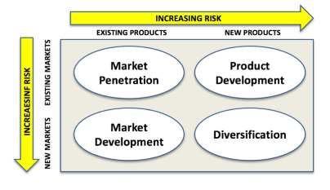
Figure 3: Ansoff Matrix
(Source: Yin, 2016)
As per the tenets of stakeholder management, it is important to realise that stakeholders are those who are directly dependent on the company in one way or the other (Ranängen, 2017). There is a prevalent interconnectedness amongst all stakeholders, as can be identified by Apple. The operations of the company are driven by the needs of the consumers, determining the firms' performance and profits. Currently, Apple has been focused on meeting the sustainable concerns of the consumer through the policy of sustainable material sourcing (Apple, 2020). Catering to the needs of the consumers through the product is a direct association with marketing, as identified in the marketing mix. The profit of Apple is high because of the superior quality of products that they deliver, compared to its rivals like Samsung. The higher profits, in turn, are the source of revenue and income for the investors, suppliers and employees, who receive considerable remuneration for being part of Apple. The compensation packages of the employees are compared with the competitive wages of Silicon Valley, ensuring the satisfaction and meeting of interests of the stakeholders (Apple, 2020).
A company must be able to identify every one of their stakeholders, and therefore, they can meet the requirements (Winch, 2017). The reason for this is that the stakeholders are varied in terms of type and diversity. Therefore, every stakeholder has its own set of demands that the company is expected to meet. On this note, it is important to understand that both employees and consumers form a part of the immediate community, which is why Apple has come up with a community outreach programme called ConnectED (Apple, 2020). Apple is a massive company, and one of the most important aspects that make the company so massive in scale is the marketing team of the company. The company has to ensure that they advertise the product in a way through which the product will attract the attention of the people (Dave, 2018). Amongst the stakeholders within the company, the marketing team is specifically focussed towards the consumers, as reflected in the previous sections. If the consumer is not satisfied, then the company has to change its course of work completed to meet the needs of the consumers (Loi, 2016).
The internal stakeholders are those that include employees, managers and owners. These are the people who are directly affected by the proceedings within the company. The external stakeholders, on the other hand, include suppliers, society, government, creditors, shareholders and consumers. These are the people who are affected by the company indirectly or maybe partially (Cardwell et al., 2020).
Shareholders are the internal stakeholders of the company and are affected quite exclusively by the business that is done by Apple. The marketing team informs the shareholders about the budget on advertising and how money the company needs in order to develop products that will meet the consumer needs (Tang, and Zhang, 2020). Therefore, the shareholders are dependent on the marketing team for information. However, they are also dependent on the marketing team as the better a product will sell, the more money the company will earn, and that means more money for the shareholders. The profit of Apple has fallen by 5% since 2018, and that has been a significant issue for the shareholders (Apple., 2020).
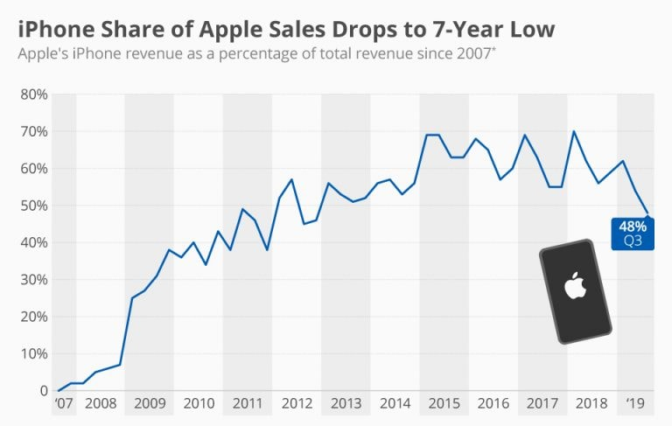
Figure 4: Apple performance
(Source: Apple, 2020)
Apple focuses explicitly on consumers, external stakeholders, ahead of the others, as was true from the era of Steve Jobs. Apple is a service-based company, and they develop unique products every year. However, in certain cases, the products have barely one or two unique features which do not make a lot of difference. Therefore, the company needs to advertise the product in a way which will make the consumer buy the product (Chen and Ann, 2016). Marketing and advertisement play a massive role in meeting consumer demands and overpowering competitors. It has been found out that Apple spent around $118 million on television commercials in the year 2017 and around $3.27 billion to advertise their iPhone (Apple, 2020). One of the aspects that need to be considered is that the sales of Apple have reduced by around 12% in the last one year; therefore, special attention needs to be given when it comes to product quality (Apple, 2020).
One of the most significant marketing strategies of Apple is that they always rethink the need for advertising their brand. The organisation opts for dropping an ample amount of money on the PPC advertisements on Google and Facebook (Neil, 2020). Alongside, the product placement in any popular show by any celebrity is the masterstroke marketing strategy of Apple. Another marketing strategy of Apple is that they have always avoided the aspect of price wars and have always emphasised on a unique value proposition. For example, a Dell laptop of i5 core processors cost $750, whereas the MacBook Pro with the same processor costs over $1000 (Neil, 2020). Therefore, providing quality products is the key for Apple as they do not believe in competition with the price. Apart from that, Apple has an excellent knowledge of their core customers, and they always like to approach them differently. For instance, they use words such as 'retina display ', 'LED backlighting ', 'edge to edge glass' and many others in their website and advertisement to attract the attention of the customers (Neil, 2020). One of the most important marketing strategies of Apple is that they always tend to keep their marketing procedures and products simple. They have forever simplified their web and sales copy so that no confusion arises among the customers.
Particular recommendations are given that can be adopted by Apple in future. One of the significant recommendations for Apple is that they can use their brand image and can expand their business more. It will benefit them to mitigate the growing competition. Another potential recommendation for Amazon is that they should think of reducing their price so that they can attract more middle-class consumers. In this regard, they can also feel of launching a beta version of some of their products at a low price so that a large segment of customers can afford it. It will be helpful for them as they can increase their profit share to a certain extent. Another potential recommendation for Apple is that they can think of establishing partnerships with more distributors so that their network of distribution can increase.

Conclusion
Therefore, it can be concluded that marketing is a massive and complicated task to undertake. The reason behind this is that the sales of a company depend on the marketing done by them. Therefore, they need to ensure that the advertisement and the marketing aspects happen at the best possible levels. In this report, particular focus has been given for the consumers of Apple and how the marketing team is linked to the consumers. A comprehensive study has been done for the Stakeholder management theory and the specific stakeholders of Apple, namely, consumers and shareholders. Finally, a detailed marketing analysis has been provided along with a series of recommendations to improve the company situation in the future.

Reference lists
Above Avalon. 2020. Above Avalon: Apple's Billion Users. [online] Available at: <https://www.aboveavalon.com/notes/2019/5/30/apples-billion-users#:~:text=Given%20my%20Mac%20and%20iPad,to%20a%20billion%20Apple%20users.> [Accessed 23 July 2020].
Apple (India). 2020. Environment. [online] Available at: <https://www.apple.com/in/environment/> [Accessed 23 July 2020].
Apple. 2020. Apple. [online] Available at: <https://www.apple.com/> [Accessed 23 July 2020].
BBC News. 2020. Apple Hints at Lower Iphone Prices. [online] Available at: <https://www.bbc.com/news/business-47047297> [Accessed 23 July 2020].
Brown, C.D., Zhang, D., Xu, N. and Corbett, S., 2018. Exploring the impact of social relationships on teachers’ use of research: A regression analysis of 389 teachers in England. International Journal of Educational Research, 89, pp.36-46.
Cardwell, L.A., Williams, S. and Pyle, A., 2017. Corporate public relations dynamics: Internal vs. external stakeholders and the role of the practitioner. Public Relations Review, 43(1), pp.152-162.
Chen, C.M. and Ann, B.Y., 2016. Efficiencies vs. importance-performance analysis for the leading smartphone brands of Apple, Samsung and HTC. Total Quality Management & Business Excellence, 27(3-4), pp.227-249.
Dave, J.G., 2018. A Case Study on Marketing Strategy: Apple I-Phone. IJRAR-International Journal of Research and Analytical Reviews (IJRAR), 5(4), pp.106-114.
Dudovskiy, J., 2020. Apple Corporate Social Responsibility (CSR) - Research-Methodology. [online] Research-Methodology. Available at: <https://research-methodology.net/apple-corporate-social-responsibility-csr/> [Accessed 23 July 2020].
Fiore, M., Vrontis, D., Silvestri, R. and Contò, F., 2016. Social media and societal marketing: a path for a better wine?. Journal of Promotion Management, 22(2), pp.268-279.
Kotler, P. and Armstrong, G., 2016. Principle of Marketing. 15𝑡ℎ edition. New Jersay
Lin, L., 2018. Enhancing Technological Advancement Through Collaboration. Surface Coatings International, 101(5), pp.187-187.
Loi, T.H., 2016. Stakeholder management: a case of its related capability and performance. Management decision, 21, pp.35-43
Loredana, EM, 2016. The Use of Ansoff Matrix in The Field of Business. In MATEC Web of Conferences (Vol. 44, p. 01006).
Macrotrends.net. 2020. Apple Revenue 2006-2020 | AAPL. [online] Available at: <https://www.macrotrends.net/stocks/charts/AAPL/apple/revenue> [Accessed 23 July 2020].
Neil Patel. 2020. 7 Key Strategies That You Must Learn From Apple's Marketing. [online] Available at: <https://neilpatel.com/blog/7-key-strategies-that-you-must-learn-from-apples-marketing/> [Accessed 23 July 2020].
Ranängen, H., 2017. Stakeholder management theory meets CSR practice in Swedish mining. Mineral Economics, 30(1), pp.15-29.
Retently. 2020. The Reasons Behind Apple’S Customer Loyalty and High NPS. [online] Available at: <https://www.retently.com/blog/apple-nps/#:~:text=Focus%20on%20customer%20value%2C%20not%20money&text=Today%2C%20Apple%20is%20one%20of,and%20more%20about%20customer%20value.> [Accessed 23 July 2020].
Tang, D.Y. and Zhang, Y., 2020. Do shareholders benefit from green bonds?. Journal of Corporate Finance, 61, p.101427.
Winch, G., 2017. Megaproject stakeholder management. The Oxford handbook of megaproject management, pp.339-361.
Yin, N., 2016. Application of AHP-Ansoff matrix analysis in business diversification: The case of Evergrande Group. In MATEC Web of Conferences (Vol. 44, p. 01006). EDP Sciences.

