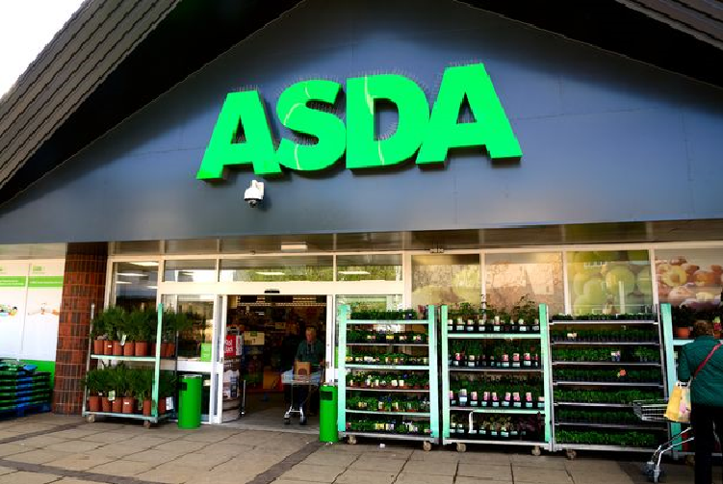

An analysis into the problem at ASDA
Problem solving and decision making

University of Wales trinity saint david
Elena Alexandra Moise | BMSK4004 | 20.03.2020

Executive summary
ASDA Store LTD is a British supermarket retailer with history since 1968, bought by the American Company Walmart in 1999, and offers a various range of products and services, that in present faces multiple problems like: poor sales since 2014, finances due huge amounts of money spend on the rents, the relationship with the suppliers , threat of job losses and store closing due poor sales, quality of in-store own-label products and Brexit, but the major problem being the continuous competition over the years, Tesco being the biggest competitor. The report is examining in detail each problem that Asda is dealing with, especially the competition and how the blocked merger between Asda and Sainsbury affect the income of the parent company Walmart. To improve the status, sales and credibility of Asda, an action plan was drawn up and details of ways of the action plan will be communicated, monitored and reviewed are shown in the report.

Contents
Executive summary 2
1.0 Introduction 5
2.0 Findings 5
2.1 Overview of ASDA Corporate 5
2.1.1 History of ASDA 6
2.1.2 Products and Services 7
2.2 Investigating Asda 8
2.2.1 Nature, Scope and Impact of Asda Competition Problem 8
A. Nature 8
B. Scope 8
D. Impact 9
2.3 SWOT Analysis – Micro 9
2.3.1 Strengths 10
2.3.2 Weaknesses 10
2.3.3 Opportunities 10
2.3.4 Threats 10
2.4 PESTLE Analysis 11
2.4.1 Politic 11
2.4.2 Economic 11
2.4.3 Social 11
2.4.4 Technologic 11
2.4.5 Legal 11
2.4.6 Environmental 11
3.0 Conclusion 12
4.0 Options 12
5.0 Action Plan 12
5.1 Communicated 13
5.2 Monitored 13
5.3 Reviewed 13
6.0 Appendices 14
7.0 References 19

1.0 Introduction

This report was compiled by Elena Alexandra Moise, at the request of UWTSD for the module BMSK4004- Problem Solving and Decision Making, and is due to be submitted on the 20.03.2020.The aim of this report is to provide an analysis of the actual competition problem faced by ASDA by using analytical tools such as SWOT and PESTEL analysis to gather information, draw a conclusion, suggest options for improvement at ASDA, explain the process of communicating, monitoring and reviewing the implementation of the decisions made through the action plan.
The information for this report have been gather through reading, studying and taking notes from books focused on Problem Solving and Decision Making, websites (Google, Google Scholar, msn, Yahoo etc. )and journals which helped writing the report findings about ASDA’s competition problem.

2.0 Findings

2.1 Overview of ASDA Corporate
ASDA Stores LTD is a British supermarket retailer with the headquarter in Leeds, West Yorkshire. The company was founded in 1959 when the Asquith brothers who owned the supermarket got united with the Associated Dairies Company of Yorkshire and got expanded between 1970-1980 into the South of England. In 1965, the name of ASDA was born through the association of the names of the Asquith chain supermarket and Associated Dairies (ASquith + DAiries = ASDA). Between 2003 and 2014, ASDA was the second largest supermarket chain in Great Britain on the market share, followed by a fall in the 3rd place until 2019, when the company regain its position on the 2nd place. In addition to its core supermarkets that provides general merchandise, clothing, food, toys, the company also offers financial services, is a mobile phone provider (Asda Mobile) since 2013. In July 1999, the American company Walmart, purchased ASDA, becoming the parent company. (FactFile 2015)
In present, ASDA offers in its largest stores owned by the company called supercenters, extended range among food, food services offers, non-food, George clothing, banks, hairdressers, dry cleaning etc. , Milton Keynes being the largest store measuring more than 100.000 sq. ft. , superstores , which have specific design for each location, famous among customers, being the most common format, where services like Coffee, Pharmacy, Optician can be found, supermarkets- the smallest stores, dispersed all over UK and Scotland and are concentrated on food and convenience, offers on non-food items, and where customers can enjoy the “Click and Collect” service. ASDA Living stores, are special custom-made for George Clothing and all non-food products, offering a variety of George Home, Fashion and general merchandise. The Petrol Filling Stations are also design to make the journey of shopping easier for the customers, making available services both pay-at-pump and pay-at-kiosk, and also small convenience store that provides a variety of food to go and travel products.
Therefore, ASDA Store have available a variety of products and services shaped on the needs and requests of customers, offering them nice experiences at good prices. (ASDA, 2018)

2.1.1 History of ASDA
It all began in 1958 (See appendices Fig. 1) when Peter and Fred Asquith brothers, who were passionate about retail, had opened their first store. In 1963, after a visit in USA, at Piggly Wiggly, the world first supermarket, they’ve opened the first self-service supermarket in Castleford and developed the concept of food discount, a real success at that time. In 1965 Asquith brothers build their first supermarket and began a retail partnership with Noel Stockdale from Associated Dairies. Between 1966-1999, ASDA turn out to be the first store that offers general merchandise, introduce the first petrol filling station, developed “Asda Brand” products, the headquarter is opened in Leeds and also distribution centers, George Davies joined Asda ,and start producing clothing for the company, becoming one of the UK’s top clothing brands, started campaigns to raise money against breast cancer, the first pharmacy is opened and join the American company Walmart to become part of the world’s bigger retail market. Beginning with year 2000, ASDA introduces the grocery and non-food home shopping, and is recognized to be as “Best Value Retailer”, Asda Living store is launched and started the expansion in North Ireland, facing a continuous growth. The program “Click & Collect” is installed, launch George Home Brand which included home accessories and bedding, and enjoys the title of “the lowest priced supermarket”, at the Grocer Gold Awards for the 20th year in a row. In 2018, ASDA developed technologies and services to help make shopping easier: the first parcel tower, voice activated shopping through Google Home, and planned to merge with Sainsbury’s PLC to create the biggest retail business. (Asda 2018)

2.1.2 Products and Services
In 2020, Asda Store provide a pack of full services useful for all the customers at all ages to make the experience of shopping more relaxing, productive and easy.
Asda Stores provide own brand products and services like carpet, travel, home insurance, loans, photo prints, tires, mobile, baby and toddler club, Among, the in-store services, except groceries, Asda can be prided to offer unique services:
- Pharmacy – the pharmacies accept NHS and private prescriptions; customers can benefit from help and advices from qualified pharmacists.
- Café –coffee and food at low prices, special offers for kids and elders.
- Asda Opticians – first introduced in stores in year 2000 and offers eye tests, contact lenses, prescriptions glasses.
- Asda Money – Over 140 Travel Money Bureaus opened 7 days a week offers: same day collection on popular currencies, 0% commission, Exchange Rate Guarantee, services that can be bought in-store, online, or over the phone.
- Scan & Go - a smart shopping technology where the customer can scan and bag the items using the handset provided in the store or the Scan & Go Mobile App which leads to a faster checkout and avoiding long queues.
- Click &Collect – an online service that provide to the costumers the facility of ordering online groceries and then pick the shopping’s at a time that suits the customer.
- Gift Cards – Asda Gift Card and another 60 different gift cards for high street retailers.
- Asda ToYou – a service that allows the customer to order, track, collect and return the parcels.
- George – a full range of clothing for women’s, men’s, kids, baby’s, home and garden products, toys and furniture which can be bought in stores or online
- Pay Point – a service that allows the customer to pay bills (transport, mobile top-up, prepay energy, tv license, prepaid cards & eMoney) (Asda, 2020)

2.2 Investigating Asda

2.2.1 Nature, Scope and Impact of Asda Competition Problem

A. Nature

In March 2019 according to The Guardian, Asda Store faced a major competition problem. In terms of market share,(see appendices fig. 2) , Asda was on the 2nd place with 15,4%, behind Tesco which was leader on the market with 27,4%, followed by Sainsburys (15,3%), Morrisons (10,3%), Aldi (8,0%), Co-Op (6,1%) (Sweney, 2019). The competition problem is caused by the rise and fall in sales during the years, the relationships with the suppliers, the threat of store closing and job losses.

B. Scope
The competition problem was caused by fluctuation in sales and statistics showed that since Nov 2014(see appendices fig.3), Asda faced a continuous drop on sales up to 6% in July 2016 and continued until June 2017, and again in March 2019 with 1.5% compared with year 2018.During that period, the German discounters Aldi and Lidl had a significant sales growth, being market leaders in front of Asda, Tesco, Morrison and Sainsbury.(Wunsch, N. G. 2019).
In 2016, Asda has suffered the worst sales fall in its 67 years history due to the mass of shoppers abandoning the supermarket, with a 5.8 drop in three months, information that was dismissed by Andy Clarke, the CEO at that time. (Neville, S 2016)
In 2017, Asda was rated “the worst supermarket in treatment of suppliers” in a survey of more than 1200 grocery suppliers made by the Industry Watchdog, and more than 12% of Asda’s suppliers said that Walmart owned chains hardly ever or never obeyed the Grocery Supply Code of Practice, being suspect of taking inaccurate deductions/payments from invoices without warning, requesting lump sums to make profit and performing forensic audits on suppliers accounts while the same survey revealed that Aldi offered the best compliance with the GSCP four years in a row. (Butler, S. 2017)
In 2018, when merge between Asda and Sainsbury was ongoing, Asda was planning 2500 job losses in 2019.BBC reported at that time that an Asda representative stated that the employees roles and working hours need to be examined, that in a competitive retail market the company needs to reflect upon role changing and that the decisions about possible changes won’t be easy to communicate. If the merge between the supermarkets will be completed, more than 500 stores may have to be offloaded as part of an investigation conducted by CMA. (Norris, P 2018)
Problems like prices where Aldi and Lidl are having lower prices and variety of items compared to Tesco, Asda, Sainsbury and Morrison (Cauter, L. 2019) (see appendices fig. 4). The latest Which? satisfaction poll in 2019 revealed that the quality of Asda’s in-store own-label products and online shopping services is poor, with a rating of one or two stars and 55% of online shoppers receive at home different/substitutes products (Munbodh, E. 2019).
In the same year, Insider Media wrote an article on how Brexit had made Asda’s sales to drop and affect their trading, with a 0.5%decine in like-for-like sales, excluding petrol. (Farrell, S. 2019)

D. Impact
The low sales at Asda and other non-US retailers own by Walmart since 2014, low fuel sales, higher-margin products combined with the customers insecurity over Brexit and the drop on market share in recent years, had decreased the corporation’s income by approximately 30% in the second quarter of the year 2019 (Menin, A. 2019)
Also, in 2019, the blocked merger between Asda and Sainsbury by the UK Competition Watchdog and CMA in order to reduce competition in supermarkets, online grocery shopping and petrol station companies, avoiding higher prices or longer checkout ques (McIntosh, S. 2019) , Walmart took in consideration selling the supermarket because the failed merger made the company lose the 42% share in the combined business. (Nazir, S. 2019)

2.3 SWOT Analysis – Micro
Conducting a Swot analysis on Asda will highlight the capacity of the company and what improvements needs to be done for the company to succeed on the retail market.

2.3.1 Strengths
Asda is recognized to be an old, well-known brand on the market since 1965 that offers a vast range of products and services designed to meet the demands of customers with more than 25 distribution centers in UK, possess their own production and manufacturing stores, exceptional marketing campaigns, good communication with its customers through social networks, organizing competitions for its customers. The numerous acquisitions made Asda a strong brand, has a variety of store formats, is an Award Winner, promotes sustainability to reduce environmental impact of their operations, has more than 15.000 employees with a strong baking of Walmart. (Bhasin, H. 2019)

2.3.2 Weaknesses
Asda has a major weakness being limited on global presence compared with its competitors, presence that created restrictions in few countries due to fear of competition from local shops, rented properties on which Asda pay huge amounts of money, the quality of some products are low and has higher prices than the German discounters, had faced numerous disputes over the years: engaging in price fixing of dairy products or the horse meat scandal when Asda’s reputation had drop in customers eyes, misrepresenting advertising campaigns and the absence of small stores like Tesco. (Sodry, S. 2020)

2.3.3 Opportunities
Asda Store can expand new areas in its business operations and also in different countries like India or China which will help the brand to win more acquaintance and acquire smaller companies to grow, keep the business present in the online market for customers that are more interested in online shopping, open small local stores to expand its market share and the goal of using 100% recyclable package, 100%sustainably sourced fish and reduction in food wastage. (Bhasin, H. 2019)

2.3.4 Threats
The price fighting and constant price cut by the competitors would have an impact over the business, the existence of other online retailers that offers almost the same products and services at the same price or lower and policies of the government that are in a continuous change. (Tushar, A.M.)

2.4 PESTLE Analysis

2.4.1 Politic
International, European and National regulations and laws that changes employment schemes, taxes payments, consumer rights, legislation or even war are factors that can have an impact over Asda and can have influence on the decision-making of the company, but Asda can pride itself with an unchanging political environment in the UK.

2.4.2 Economic
Economical factors such as national wage, cost of credit, competition, workforce supply and demand, energy, have a massive impact/influence on the strategies of establishing the prices.

2.4.3 Social
Asda’s adjustment and understanding to the social changings such as age of customers, healthy lifestyle helps the company to develop new products and services in the retail market and improve the division schemes.

2.4.4 Technologic
When the need and use of technologies is in a permanent growth, Asda must possess superfast broadband and mobile apps together with click and collect delivery service and to uses in its favor.

2.4.5 Legal
Asda must comply to the laws of the countries in which is conducting the business and respect human/employee rights.

2.4.6 Environmental
Asda is forced to demonstrate that is an environmentally friendly company due to customers awareness of the effect that companies have on the environment. (Sodry, S. 2018)

3.0 Conclusion
Asda is one of the most legendary company in UK with a strong brand, and the collaboration with Walmart made the business stronger and expand fast in different location. But is not easy to survive on the market share where competitors like Tesco, Sainsbury, Morrison, Lidl or Aldi, force the company to keep the prices low, unsuccessfully although, Asda being on the 2nd place on the retail market for the last few years, with rivals who are coming fast from behind, attracting costumers with even lower prices than Asda or Tesco, facts that are seen through the dropped sales that Asda had during the years. While Asda managed to cover almost all the area regarding products and services, its still facing problems with competition, the inability to develop in other countries, sales, suppliers, does not focus on opening local stores, fights with so called label of “bad quality products”, the dishonest advertising, the enormous amount of money spent on rents which affect Asda’s finances and the blocked merger between Asda and Sainsbury by the CMA, stopping Asda to become the biggest retail store in the UK.

4.0 Options

The problems that Asda is confronting are resolvable if the company will take in consideration to expand the business in countries that are financially growing (India, China) so the business can grow and be known internationally, to focus more on the quality of the products avoiding customers losses, rebuild the relationships with the suppliers, to take in consideration to open local stores where customers can rely on basic products and services and trying to invest in buying the land on which to build their stores avoiding the lost of the huge amounts of money spent on rents.

5.0 Action Plan

For Asda to win the endless fight for competition and low prices, the head of the company need to take in consideration the following SMART strategies:
- To develop services and products that the competitors don’t have.
- To aim in having the best customers service.
- To offer products and services cheaper or at the same price with the competitors, avoiding losing customers.
- To expand the business by opening local stores in UK and set objectives in expanding overseas.
- To develop new channels of distribution.
- To focus more on the quality of the own-label brand products.
- To make investments in land, avoiding paying rent.
- To keep an honest relationship with the suppliers by removing some charges and audits.
The SMART strategies relate to Asda’s progress will have to be:

5.1 Communicated
The action plan will be communicated to the shareholders, managers and employees. The principles of communication will be visible, accessible in a competent and professional way, will be relevant and honest, will be available to be seen whenever is necessary and clear in content and it will be done through meeting with the heads of the company and after the decisions are clear, the staff will be announced by the managers of the company. Regarding customers, the plans, changes or decisions will be communicated through different ways like newspapers, forums, TV Channels or social media. (Currie, A. 2009)

5.2 Monitored
The action plan will be monitored assessing the implementation and identifying the elements which contribute in delivering the goal by tracing the improvement and displaying results. The monitoring procedure will be organized, done on a systematic schedule, and centralized.

5.3 Reviewed
The action plan will be reviewed in order to see the performance of the operations through annual audits and consists of getting feedback from the directly implicated persons that are dealing with applying the strategies and later from the customers, assessing the changes or issues, detecting the critical factors which prevents reaching the goal and identifying productivity improvement and if the sales have had increased. (EECA, 2017)

6.0 Appendices
Figure 1 – Asda Timetable
1958 | Asquith brothers opened the first store
1963 | The first self-service supermarket is opened, and food discount concept is developed
1965 | The first supermarket is built by Peter Asquith  Asda name is born through the association between Peter Asquith and Associated Diaries
1966 | Asda becomes the first food store that offers General Merchandise
1967 | Peter Asquith introduces the first discounted petrol filling station helped by a Russian oil company named NAFTA
1968 | Association Diaries bought out the Asquith Brothers
1970-1977 | Asda had opened over 80 stores and is ready to expand  Asda Property and Asda Drive is introduced
1980 | Asda opened the 100th store
1984 | Asda developed new “Asda Brand” products
1985 | Asda and Mullard Furniture Industries (MFI) got associated  Asda initiated the building of seven new distribution centers
1988 | Asda’s new headquarter is opened in Leeds
1989 | Seven new distribution centers are opened in UK  George Davies started producing clothing for Asda
1990 | George Brand creates the first ever supermarket clothing brand
1995 | Tickled Pink Campaign is launched to raise money against breast cancer
1998 | Asda starts its online retail service
1999 | Asda joins the Walmart family
2000 | New business areas are added, new brands are introduced, new stores are opened  Asda launched the grocery and non-food online business
2002-2004 | Asda was named “The top Company to Work For” by the Sunday Times and “Best Value Retailer” by the Grocer
2005 | Asda expands into North Ireland
2008 | Asda opened its first Eco Store (an environmental store) and launched the first online George Store
2009 | Asda acquired International Produce Limited (IPL)
2010 | Asda was in a continuous grow and introduces the idea of 100 Day Satisfaction Guarantee
2011 | George Clothing becomes the sponsor for Graduate Fashion Week
2012 | Community Life Program was launched  The first drive-thru Click & Collect was installed in Queensferry
2014 | Asda launched George Home and started producing baby clothing
2015 | Asda celebrated 50 years and 25 years for George Clothing  Had opened the 600th store
2018 | Asda had developed new technologies for customers- UK’s first parcel tower and voice activated shopping
2019 | The merge between Asda and J. Sainsbury’s PLC is blocked by the Competition and Market Authority (CMA)

Figure 2 – Asda on the market share
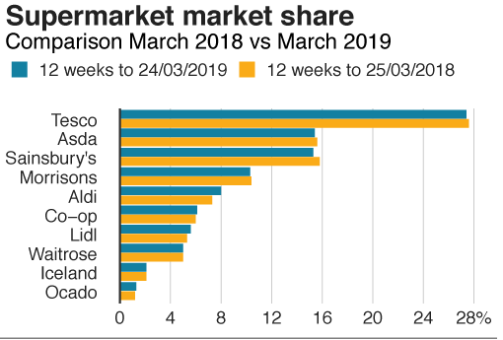
Source: Kantar

Figure 3. Change in sales - September 2014 to August 2019
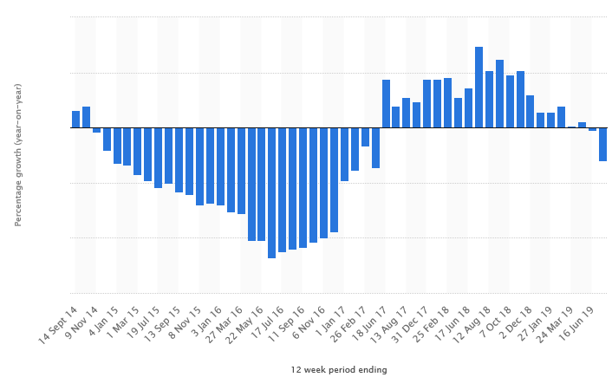
Source: Statista 2020

Figure 4 – Price difference between Aldi/Lidl and the Big Four Supermarkets
Products | £ Lidl | £ Asda | £ Tesco | £ Morrison | £ Sainsbury
Pasta | 0.78 | 0.50 | 0.95 | 1.00 | 1.05
Flakes | 0.55 | 1.38 | 0.66 | 1.10 | 0.65
Tinned tomatoes | 0.28 | 0.35 | 0.35 | 0.35 | 0.35
Tinned tuna(4pcs) | 2.49 | 2.84 | 3.25 | 3.00 | 4.00
Organic milk | 1.49 | 1.50 | 1.50 | 1.80 | 1.80
Eggs | 1.25 | 1.45 | 1.60 | 1.25 | 2.25
Loaf | 1.29 | 0.79 | 1.35 | 0.75 | 0.95
Washing powder (25 washes) | 1.99 | 2.50 | 2.50 | 3.20 | 2.50
Apples | 0.62 | 1.20 | 0.95 | 1.25 | 0.80

Figure 5 – SWOT Analysis
Strengths | Weaknesses
- is a recognized brand  - has a vast range of products and services  - has more than 25 distribution centers  - exceptional marketing campaigns  - good communication with customers  - numerous acquisitions and different store formats  - an award-winning company  - promotes sustainability  - more than 15.000 employees  - strong baking of Walmart  - possess their own production and manufacturing stores | - limited global presence  - rented properties on which Asda pays huge amounts of money  - low quality of own-label products  - higher prices compared with the German discounters  - the dispute on price fixing of dairy products  - the horse meat scandal  - misrepresentative advertising campaigns
Opportunities | Threats
- can expand new areas in its business operations  - expand in different countries that faces a financial growth like India and China  - open small local stores to expand its market share  - keep the business present in the online market  - accomplish the goal to use 100% recyclable package  - 100% sustainably sourced fish  - reduction in food wastage | - price war with the competition  - continuous change in the government policies  - constant price cut by the competitors  - existence of others online retailers

7.0 References
Asda (2018) Company Facts [online Bing] available on: https://corporate.asda.com/our-story/company-facts, (accessed on 13.02.2020)
Asda (2020) About Asda- In Store Services, [online msn] available on: https://www.asda.com/about, (accessed on 19.02.2020)
Bhasin, H. (Sept 2019) SWOT Analysis of Asda, [online Explorer] , available on: www.marketing91.com/swot-analisys-of-asda , (accessed on 04.03.2020)
Butler, S. (Jun 2017) Asda is named worst supermarket in treatment of suppliers , [online Bing], available on: https://www.theguardian.com/business/2017/jun/26/asda-supermarket-suppliers-walmart-morrisons, (accessed on 21.02.2020)
Cauter, L. (May 2019) Saving and making money- Is Lidl really cheaper than Tesco, Asda and Sainsbury? , [online google], available on: www.lovemoney.com , (accessed on 03.03.2020)
Currie , A. (June 2009) Change Management - Communication Strategy , Communication Principles , pg. 5 , HSC Business Services Organizations, [online Bing] available on: www.hscbusiness.hscni.net/pdf/ , (accessed on 11.03.2020)
EECA, (Feb 2017) Review action plan, [online Explorer], available on: https://www.eecabusiness.govt.nz/start-saving-energy/develop-an-energy-plan/evaluate-progress/review-action-plan/ , (accessed on 11.03.2020)
FactFile (Apr 2015)- Companies- 10 Facts about Asda, [online Explorer] available on: https://factfile.org/10-facts-about-asda , (accessed on 11.02.2020)
Farrell, S. (Nov 2019) Brexit concerns hot Asda’s sales , [online Google], available on: www.insidermedia.com/news/yorkshire, (accessed on 05.03.2020)
McIntosh, S. (Apr 2019) BBC- Asda merger blocked by regulator , [online Google], available on: www.bbc.co.uk/news-business , (accessed on 06.03.2019)
Menin, A. (Aug 2019) Weak Asda sales drive down Walmart’s international income, [online google] available on: www.cityam.com>weak-asda-sales-drive-down-walmarts-international-income/ , (accessed on 26.02.2020)
Munbodh, E. (Feb 2019) Asda, Sainsbury, Tesco and Morrison voted worst supermarkets by customers, [online Google], available on: www.mirror.co.uk>money>asda , (accessed on 04.03.2020)
Nazir, S. (May 2019) Asda owner Walmart mulls sale after failed Sainsbury merger , [online Bing] , available on: www.retailgazette.co.uk/blog/2019/05 , (accessed on 08.03.2019)
Neville, S. (Feb 2016) Asda suffers the worst sales fall in its 67 year history, [online Google], available on: www.independent.co.uk/News>BusinessAnalisys&Features ,(accessed on 26.02.2020)
Norris, P. (Oct 2018) UPDATED: Asda plans 2500 job losses in 2019, [online Bing], available on: www.gloucestershirelive.co.uk>News>UK&WorldNews>Asda, (accessed on 21.02.2020)
Sodry , S. (Jun 2018) Business Environment and Strategy- PESTEL Analysis of Asda , [online Bing] , available on: www.howandwhat.net/pestel-analisys-asda/ , (accessed on 06.03.2020)
Sodry, S. (Jan 2020) Business Environment and Strategy- SWOT Analysis of Asda , [online Bing] , available on: www.howandwhat.net/swot-analisys-asda/ , (accessed on 06.03.2020)
Sweney, M. (Apr 2019) Sainsburys falls behind Asda to became UK’s third biggest supermarket chain, [online Bing], available on: https://www.theguardian.com/business/2019/apr/02/sainsburys-asda-uk-supermarket-aldi-lidl , (accessed on 20.02.2020)
Tushar, A. M. (2019) [Doc] Marketing Strategy- Swot Analysis of Asda, A Part, B part -Methodology, pg. 11, Prime Research and Consultancy- University of Sunderland, [online Google Scholar], [doc]academia.edu
Wunsch, N. G. (Aug 2019) Percentage change in sales at Asda in Great Britain compared to a year earlier from September 2014 to August 2019, [online Google], available on: www.statista.com>Retail&Trade>Food&Beverage, , (accessed on 20.02.2020)

