Module Title: Problem Solving and Innovation

Module Code: BMSW4014

Student Name:Nicolae Gheorghica

Student ID:2330417

Component 2: An Analysis of the Factors Impacting Starbucks in the UK
Executive Summary
The PESTLE evaluation of Starbucks UK below, along with a stakeholder and innovation analysis, sheds light on how Brexit may have hindered its capability to perform business in a free international market by lowering the number of its labour forces. On the contrary, the present employees, who are considered skilled labourers, are pleased with its capability to reduce the gender pay gap, which it showcases through the payments of living wages above the minimum compulsory rate. Its contribution to the GDP is commendable; nevertheless, it should decrease its prices to curb inflation on behalf of its buyers. It frequently faces challenges while following whimsical consumer trends on social media and conducting market research online. By integrating cloud storage, it can minimise the possibility of data breaches. Even in spite of the fact that it follows the “Environment Act 2021” entirely, it will take a long period of time to regain its pre-COVID-19-era ranking. While its executives and the Government possess high power, employees and unions are lower in position. Its matrices of choice are market penetration, product development, and diversification through sustaining innovations. The cost leadership strategy was recommended to it for diversifying its clientele.
Table of Contents
Introduction 4
Findings 6
PESTLE Analysis 6
Political Factors 6
Economic Factors 6
Social Factors 7
Technological Factors 8
Legal Factors 10
Environmental Factors 10
Stakeholder Theory, Analysis, and Innovation Matrix 10
Conclusion 15
Recommendations 16
Reference List 17

Introduction
Starbucks is a multinational coffee chain based in the United States of America. Founded in 1971 at Pike Place Market in Seattle, the company was well-renowned for its freshly-roasted coffee beans, spices and herbs, as well as rarely-obtained tea leaves (Starbucks, 2024). Over the decades, it has come to be known for its unique blend of flavours that are coveted across the world. In the year 1986, Howard Schultz took over as the Chief Executive Officer from Zev Siegl, Jerry Baldwin, and Gordon Bowker and expanded the organisation internationally. For this reason, the coffeehouse rapidly grew to accommodate more than 32 thousand stores in nearly 100 nations (Starbucks, 2024). Despite being one of the most recognisable firms overseas, the analysis of its strengths, weaknesses, opportunities, and threats has shown that it has been strained somewhat financially owing to a loss of sufficient supply chains from Russia following the Russo-Ukrainian war, and being boycotted by Israel. Nonetheless, its emphasis on minimising the gender pay gap throughout the franchise has awarded it with a rapidly-increasing number of workers, which was raised to 228 thousand (Forbes, 2024). The report below will identify and analyse elements affecting Starbucks in the United Kingdom through theoretical tools, based on the inference of which two recommendations will be suggested to the brand.
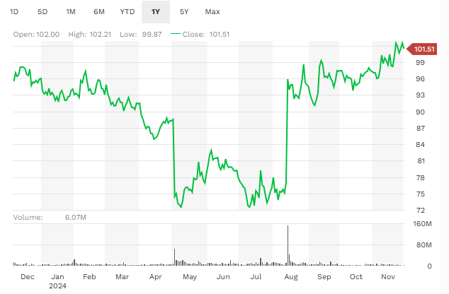
Figure 1: Starbucks’ Finances
(Source: Forbes, 2024)

Findings

PESTLE Analysis

Political Factors
Brexit was the cause for the departure of many of the European Union’s citizens, who resided in the UK for jobs within various industries. PESTLE helps analyse critical influential factors of companies’ macro external business environments (CIPD, 2024). The labour shortage slowed down productions of the food and beverage sector, decreasing the number of sales for Starbucks in Britain, pertaining to an unfavourable impact. As per Martill and Chryssogelos (2024), regardless of this, the country’s stable democracy enables its companies to operate independently in a free market. This implies that the shops of Starbucks can set their own prices and function freely without being impeded by too many high taxes, which is a positive influence. Unfortunately, the tariffs of importation and exportation have heightened as a result of the unstabilised relationship between the EU and the UK, increasing Starbucks’ supply costs.

Economic Factors
The UK economy is marked with fluctuations in the rates of the inflated prices of goods. The Consumer Price Index rose by over 2% in the month of October, 2024 (Office for National Statistics, 2024). The central Bank of England is meant to keep at exactly 2%, indicating that the aforementioned level has made products in the beverage sub-sector of the accommodation industry more expensive for customers. The suppliers of Starbucks have been forced to maximise their prices as well, toughening it for the coffee chain to purchase high-quality raw materials at low costs, affecting it unfavourably. The fiscal year which had ended in October of 2023 saw the revenue of Starbucks UK Coffee Company rise by almost 22% to £547 million (Starbucks, 2024). This can be likened to a positive influence since it means that the company has contributed heavily to the employment market and the Gross Domestic Product of England.
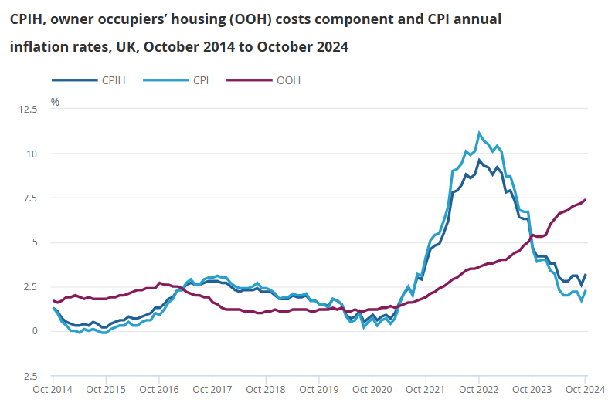
Figure 2: UK CPI Rate, October 2024
(Source: Office for National Statistics, 2024)

Social Factors
Literate workers in a nation-state aid its companies to engage in skilled labour. According to the United Nations Association, the literacy rate of the UK is 99%, meaning that 99 out of every hundred individuals are educated up to a certain decent level (UNA-UK, 2024). The ability to read, write, and speak in the common official language of English grants employees the capability to be upskilled with more convenience. Starbucks UK’s staff members, therefore, can communicate easily and perform a wide array of tasks, making this influence a good one. Nevertheless, the speedy transformations of the trends in consumer demands make it challenging for the enterprise to follow them consistently. Additionally, the flavours of the coffee, tea, and solid snacks it creates are imitated by smaller businesses which charge buyers less, taking prospective opportunities away from it and turning the effect into a poor one.

Technological Factors
Digital advancements and novel technological devices as well as appliances and other equipment, plant and machinery assist business entities to remain relevant and keep up with modern transitions. The internet penetration rate of the UK is close to 98% (Statista, 2024). Through this, Starbucks is able to optimise its own website to attain ingredients and even make sales online, making this influence a positive one of a high degree. The UK’s rate of the penetration of social media is nearing 83% this year, which is at an all-time high (Statista, 2024). The population of social media users shows that Starbucks can keep continuously ameliorating its brand image further via online advertisements, influencer marketing, and direct interactions with purchasers. The consequence of this is the fact that cybercrime, the rates of which keep rising with speed, can affect the company grievously. The levels of cyberattacks have gone up to 21%, in terms of firms that have experienced data breaches (Statista, 2024). Starbucks UK may lose its customers’ private data, the personal information of its staff, and its own intellectual property trade secrets, turning this influence into a negative one.
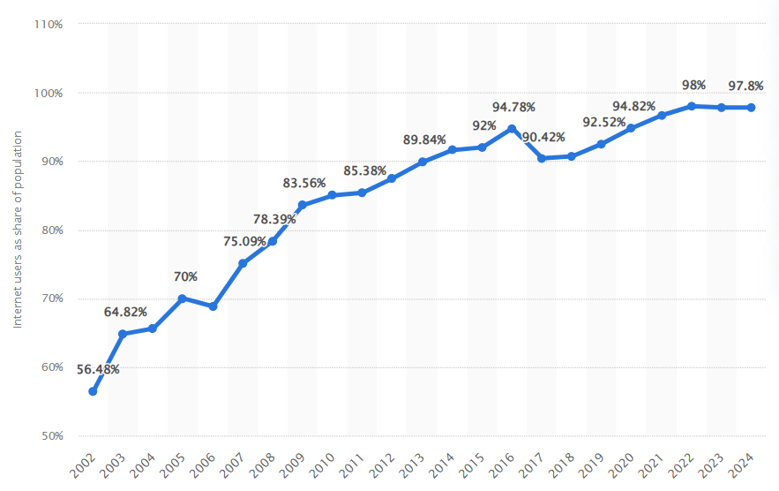
Figure 3: Internet Penetration Rate of the UK, 2024
(Source: Statista, 2024)
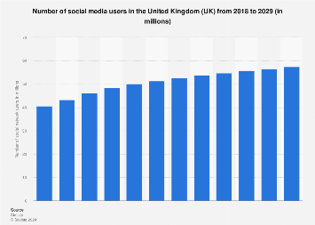
Figure 4: Social Media Usage Rate Forecast
(Source: Statista, 2024)
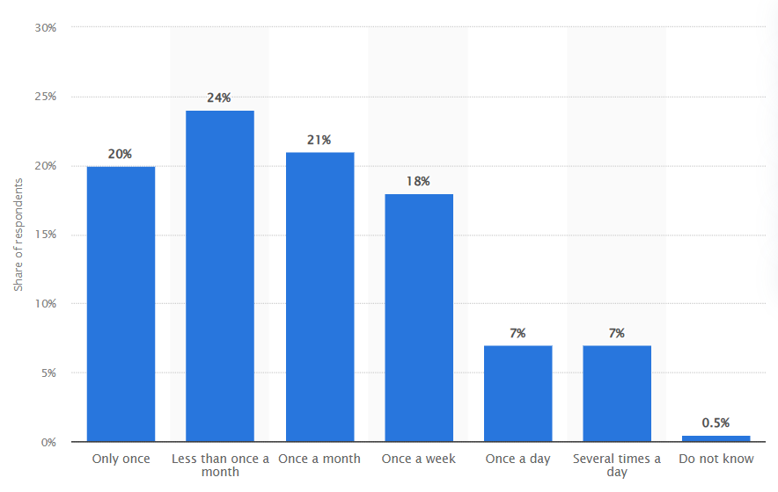
Figure 5: Frequency of the Incidents of Data Breaches
(Source: Statista, 2024)

Legal Factors
The laws governing a country regulate the operations of its businesses. The “National Minimum Wage Act 1998” expects employers to pay their workers a set standard of salaries to accommodate their living wages (Government of UK, 2024). Unfortunately, this raises the expenditures of Starbucks, posing an imminent threat. Simultaneously, however, it acts as an investment into sustainable human resources, satisfying the employees as they are paid more than the living wage rates. The “Data Protection Act of 2018” restrains employers from using customers’ and employees’ private information for malevolent purposes (Legislation, 2024). The rule can prove to be more helpful through Starbucks’ implementation of cloud storage and edge computation programmes.

Environmental Factors
The UK has paved the way for legal procedures protecting the Earth. The “Environment Act UK 2021” states that corporations should transform their fundamental production processes, machines, and other practices to give rise to eco-friendly functions (UK Government, 2024). That lets Starbucks follow its net-zero emissions strategic policies by holding itself accountable and taking responsibility for looking after the planet, for which it has gained the favour of its external stakeholders. COVID-19, on the other hand, reduced its revenues due to lockdowns, border controls, and other social distancing restrictions during 2020 and 2021 (Zhou, 2024). Pay cuts, employee absenteeism, and other aspects factored in to make this impact negative on its overall performance.

Stakeholder Theory, Analysis, and Innovation Matrix
Starbucks has taken the Stakeholder Theory of Corporate Social Responsibility into consideration. The framework opines that businesses should create ample value for all their direct internal and indirect external stakeholders (Keough, 2019). The chosen organisation, as per the critical PESTLE evaluation above, appears to have developed certain advantages for its employees. Nonetheless, its treatment of workers can be improved by accommodating the interests of trade and labour unions. Its customer demographic bases have not widened since its products are expensive, to reflect quality. Both these groups can benefit from data privacy strategies.
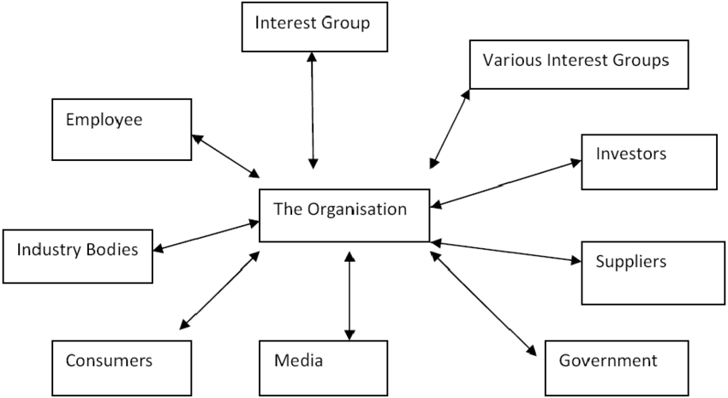
Figure 6: Stakeholder Model
(Source: Adair, 2019)
High Power-High Interest (Close Management of Key Players) | High Power-Low Interest (Meeting Satisfactory Needs)
- Executives  - Shareholders  - Board of Directors  - Investors | - Government  - Industry experts  - Suppliers
Low Influence-High Interest (Informed Consideration) | Low Influence-Low Interest (Less Important to Monitor)
- Employees  - Insurance agencies  - Communities | - Unions  - Non-Governmental Organisations
Table 1: Predictability Stakeholder Mapping
(Source: Created by the Learner)
Starbucks emphasises quality and not on minimising its luxurious prices, making Ansoff innovations based more on market penetration and product development for the same markets. Diversification is indicative of making brand-new products for previously unexplored markets (Proctor, 2019). From the aforementioned evaluation, it can be construed that it has expanded internationally using this.
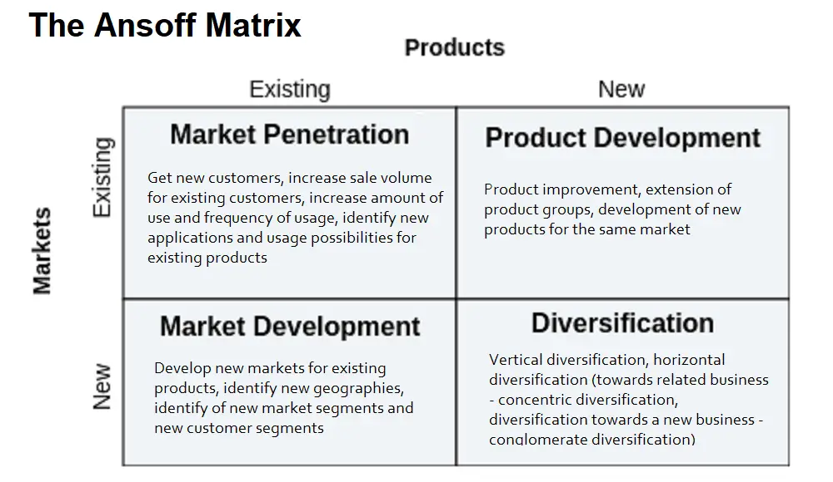
Figure 7: Ansoff Matrix
(Source: Proctor, 2019)
Starbucks often incorporates new ingredients to modify its existing goods, making this an incremental innovation. It has become a market leader in coffeehouse chains (Starbucks, 2024). Sustaining innovation is how it creates new items.
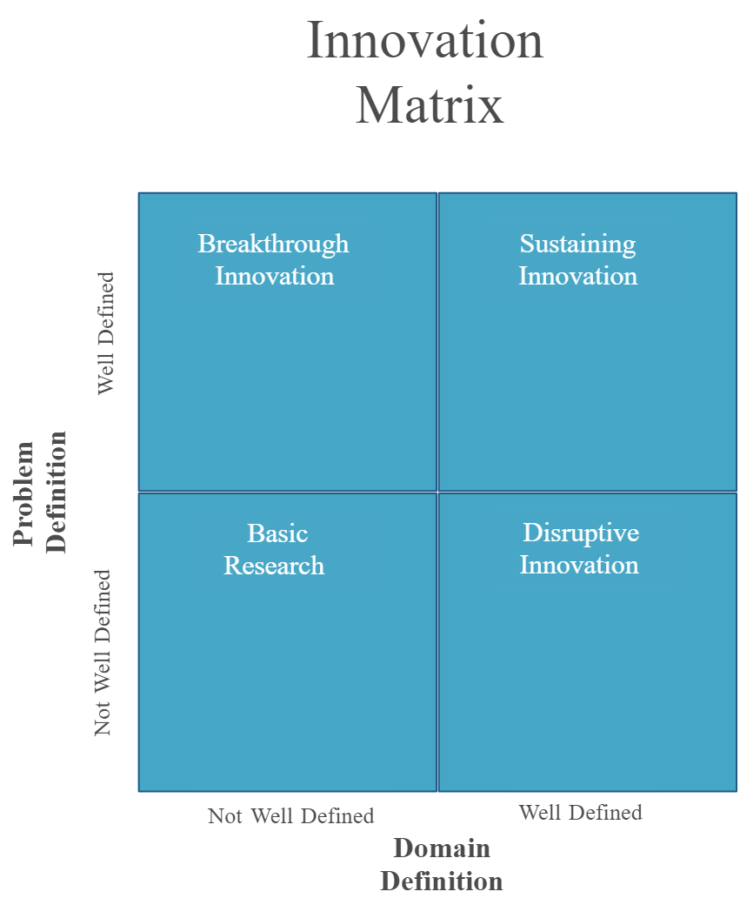
Figure 8: Innovation Matrix
(Source: Hallo, 2022)

Conclusion
Starbucks UK still experiences labour shortage due to Brexit, and inflation rates have made it slightly difficult to acquire inexpensive good-quality supplies. Fortunately, its employees are immensely skilled. The advent of the Internet and social media platforms has been a boon; however, this makes it susceptible to cyberattacks. Following the national minimum wage has helped its employees. Coronavirus lowered its sales. Starbucks emphasises product development innovations.

Recommendations
Starbucks should launch new low-cost product lines. Cost leadership strategies help compete with rival pricing policies while gaining customers with average incomes (Madecraft, 2021). It would let it maintain sales even during high inflation. Interacting with unions will enable it to look after employees’ needs, whereas data protection strategies without tracking algorithms could help consumers trust the company with their necessary private information.

Reference List
Adair, J.E., 2019. Decision making and problem solving: break through barriers and banish uncertainty at work. Fourth edition. London: Kogan Page.
CIPD, 2024. PESTLE analysis. Available at: PESTLE analysis | CIPD.
Forbes, 2024. Starbucks on the Forbes Best Employers for Women List. Forbes. [Online] Available at: <https://www.forbes.com/companies/starbucks/> [Accessed on: 02 December 2024].
Government of UK, 2024. National Minimum Wage Act 1998. [Online] Available at: <https://www.legislation.gov.uk/ukpga/1998/39/contents> [Accessed on: 02 December 2024].
Hallo, L., 2022. Holistic view of intuition and analysis in leadership decision-making and problem-solving. Administrative sciences. 12 (1), 1–25. doi:10.3390/admsci12010004.
Keough, P.D., 2019. Ethical problem-solving and decision-making for positive and conclusive outcomes. Hershey, Pennsylvania: IGI Global. doi:10.4018/978-1-5225-7582-5.
Legislation, 2024. Data Protection Act 2018. [Online] Available at: <https://www.legislation.gov.uk/ukpga/2018/12/contents> [Accessed on: 02 December 2024].
Madecraft, 2021. Conducting a SWOT Analysis. J. Belfiore (ed.). Conducting a SWOT Analysis.
Martill, B. and Chryssogelos, A., 2024. You’re projecting! Global Britain, European strategic autonomy and the discursive rescue of the internationalised state. European Security, pp.1-20.
Office for National Statistics, 2024. Consumer price inflation, UK. [Online] Available at: <https://www.ons.gov.uk/economy/inflationandpriceindices/bulletins/consumerpriceinflation/october2024> [Accessed on: 02 December 2024].
Proctor, T., 2019. Creative problem solving for managers: developing skills for decision making and innovation. Fifth edition. New York: Routledge.
Starbucks, 2024. Our Company. [Online] Available at: <https://www.starbucks.com/about-us/> [Accessed on: 02 December 2024].
Starbucks, 2024. Starbucks files UK and EMEA accounts for the fiscal year ended October 2023 - Starbucks Stories EMEA. [Online] Available at: <https://stories.starbucks.com/emea/stories/2024/starbucks-files-uk-and-emea-accounts-for-the-fiscal-year-ended-october-2023/> [Accessed on: 02 December 2024].
Statista, 2024. Active social media audience in the United Kingdom (UK) in January 2023. [Online] Available at: <https://www.statista.com/statistics/507405/uk-active-social-media-and-mobile-social-media-users/> [Accessed on: 02 December 2024].
Statista, 2024. Internet penetration in the UK 1990-2018. [Online] Available at: <https://www.statista.com/statistics/1124328/internet-penetration-uk/> [Accessed on: 02 December 2024].
Statista, 2024. UK businesses: frequency of cyber security breaches 2019 | Statista. [Online] Available at: <https://www.statista.com/statistics/586725/frequency-of-cyber-security-breaches-experience-by-businesses-in-the-uk/> [Accessed on: 02 December 2024].
UK Government, 2024. Environment Act 2021. [Online] Available at: <https://www.legislation.gov.uk/ukpga/2021/30/contents> [Accessed on: 02 December 2024].
UNA-UK, 2024. Literacy Day. [Online] Available at: <https://una.org.uk/get-involved/learn-and-teach/international-days/literacy-day> [Accessed on: 02 December 2024].
Zhou, Z., 2024. The Impact of Safety Concerns and Convenience on Consumer Consumption Channels under the Epidemic. Journal of Education, Humanities and Social Sciences, 30, pp.62-68.

