Business Plan for

Chef’s Table Cafe

Produced By: Group X

GROUP MEMBERS:
Student Name | Student No.
Ionut-Gabriel Gheorghe | 2222508
Darius Emanuel Berlan | 2244805
Larisa Alexandra Cionadi | 2127892
Florica Anamaria Ciuta | 2243597
Dated: 18.11.2024
Module Name: Entrepreneurship
Module Code: BMIH5001
Lecturer Name: Charlotte Joyner

CONTENTS

 |  |  |  | PAGE
1. | Executive Summary |  |  | 3
2. | The Business Idea |  |  | 4
3. | The Team |  |  | 4 - 5
4. | Market Research |  |  | 5 - 6
5. | Marketing Plan |  |  | 6 - 7
6. | Key Resources |  |  | 7 - 8
7. | Finances & Start-Up Support |  |  | 8 - 10
APPENDICES:
Appendix A |  |  |  | SWOT Analysis
Appendix B |  |  |  | PEST Analysis
Appendix C |  |  |  | Copy of Pitch Supporting Material

1.Executive Summary
Chef’s Table is a quaint and inviting café situated in Covent Garden at 5 Upper St. Martin’s Lane. Our aim is to deliver high-quality coffee, home-baked goods, and light meals to a wide range of customers, including office workers, students, and tourists. We are a health-taste-speed-sustainability brand that will make customers relax, work, or enjoy a quick drink.
Covent Garden, a place full of cultural diversity, is therefore an ideal location for Chef’s Table due to its high footfall and its prime position. Our café tops it all, with hand-brewed specialty coffee made from locally sourced ingredients, and a cozy atmosphere which allows both the grab-and-go customers as well as the ones looking for a nice spot to relax.
Key Highlights:
Product Offering: The branch deals in very high-quality coffee, which is accompanied by fresh and locally grown pastries, sandwiches, salads, and soups.
Target Audience: Staffs and lecturers and students as well as the passers-by are the main target groups. The promotions have been designed for them in this way loyalty programs and student discounts.
Competitive Edge: Excellent services, top-notch products, the practice of environmental safety, and a well-maintained, full-fledged, and lively place.
Marketing Strategy: By using social media, the company builds loyalty among the clients through loyalty schemes and collaborations with local businesses. This is the way to get the clients to stick to the brand.

Financial Overview:
First-Year Revenue: £540,000
Projected First-Year Profit: £325,852
Major Costs: Rent (£69,120), wages (£107,328), and stock (£12,000).

2. THE BUSINESS IDEA
Chef's Table: Rediscover the Real Flavour of Coffee
Chef's Table was founded to revive the true taste of coffee. We honour the tradition of coffee brewing and give customers the many flavours through personally handmade coffee, freshly baked pastries, and filling light meals at the core of Covent Garden.
Prioritizing quality, sustainability, and community, we provide a homey atmosphere suitable for short visits or long leisure moments. Mainly using local items, as well as smart loyalty programs, we develop a unique home-like cafe.
2.1 What We're Selling
Chef’s Table is a cafe in Covent Garden. Located at 5 Upper St. Martin’s Lane, we want it to be a fun and welcoming place. Our aim is to serve top-notch treats and beverages to both locals and newcomers. Baristas specialize in hand-brewed coffee; so, it tastes magical. Local bakers supply croissants, muffins, and scones. We also have sandwiches, fresh salads, and soups.
Chef’s Table understands how precious your time is. Our goal is to be quick while maintaining high quality. We want it to be a cozy space for leisure seekers and coworkers. We use only the best ingredients, and brew coffee perfectly, thus satisfy all customers’ needs.
Chef’s Table gives Covent Garden new life. This area is famous for its culture and major landmarks which Britain and Britishness (2024) have underlined as they sat ones. Thus, it attracts tourists and workers who contribute to the café’s growth potential.
2.2 A Quick Look at Our SWOT
We have many loyal customers thanks to our location. The location has the highest traffic projections in the town. Our staff members are highly professionally trained. We offer exclusive dishes that are premium.
However, we are not well known makes it hard for us. We are creating brand names that people would naturally love to visit. Also, we shall partner with small businesses next door to have alliances. According to Huang et al. (2022) this is best practice for firms to create value.
We will connect with local coffee shops as the UK’s coffee sector is growing extremely fast. H&C News (2024) say there might be hurdles in form of Brexit but still there’s room for business. Also, we will cut costs of service to be competitive aside from raw material costs.
3. THE TEAM

3.1 Key Personnel
Darius B. is co-head and head chef. The head chef at the restaurant Darius cleverly brings about the culinary skills and the local sources to make the dishes served at the Chef's Table. The head chef oversees the kitchen team, the quality of food and proper standard procedures.
Florica A. is co-founder and manager of the cafe. She manages day-to-day operations at the cafe to make sure staff members are customer service friendly. This position also includes leading employees and maintaining customer satisfaction.
Barista Ionut G. is in charge. Ionut possesses barista skills that assist him in making quality specialty coffee. He also coaches the other baristas, makes the drinks, and runs the coffee bar.
Larisa C. is responsible for marketing and community activities. Larisa leverages social media to promote the brand locally and engage the community. Duties are creating posts and collaborating with businesses to draw customers.
3.2 Skills Gaps & Key Partners
3.2.1 Additional Staff Requirements: We are looking for two chef assistants (21,000 £ each), one full-time waiter (20,400), and two apprentices (£6.40 per hour). Along with the theory of service and kitchen, they need training in the kitchen to bridge the gaps. Higher-capable staff is a factor that makes quality services better (Guo and Keskin, 2023).
3.2.2 Training and Development: Baristas will be trained in coffee making. The employees of the kitchen will be taught about food safety. The essence of quality and safety is in food service (Reyes Jr et al., 2024).
3.2.3 Outsourced Support/Key Partners: We are going to outsource some tasks. A financial manager will take care of the finances, a legal advisor will make sure the rules are followed, and a marketing agency will help us with the digital promotion. Thus, it allows us to be service and product oriented while still adhering to rules (Pereira et al., 2022).
4. Market Research
4.1 Market Information, Trends, and External Factors in London, numerous coffee shops account for lots of the coffee shop sector in the UK, as more than 3,000 coffee shops join the £10 billion coffee shop business. Coffee is becoming a popular item in demand, especially as people embrace high-quality and ethically made drinks. As a direct consequence of the COVID-19 pandemic, specialty coffee shops have surged in popularity as consumers have clearly made it a priority to choose quality over price. A PEST study (Appendix B) identifies several forces driving the market, among which economic challenges and increasing labour costs are the principal ones (ONS, 2023); however, young people beyond that still tend to spend their available cash on experiences. Customers are shifting these days to sustainable products, such as locally sourced, and cafes that offer areas for calm or work are the most in demand.
Chef’s Table's distinctiveness will lie in their focus on quality, proximity, and exceptional service, thus distinguishing them from the competitors. The site is strategically located in Covent Garden, and at the same time, thanks to a commitment to green practices and a homely, delightfully comfortable environment, it will be the ideal place for people who want to unwind or work.
4.2 Customer Profiles
Profile 1: Office Workers are people at work, who are aged 25-45 and are looking for a quick caffeine fix. They opt for espresso and value fast service, particularly at peak times. Thus, the office workers will benefit from Chef's Table fast service and loyalty programs which will motivate them to come back.
Profile 2: Students who are in the age group of 18-24 years have lower budgets but still, they crave high-quality coffee and snacks. Chef's Table is going to adopt a three-fold scheme of heavy discounts and longer hours for studying, as well as student bundles and refills at reduced prices if they want to cut down their expenses.
Profile 3: Passersby - This refers to both locals and tourists who are looking for a quick snack. They are attracted to appealing visuals; thus, Chef's table will eye catching decorations featuring grab-and-go items and seasonal sales will bring them in.
4.3 Competitor Profiles
Monmouth Coffee Company (Covent Garden) - Due to the passionate coffee lovers' association, Monmouth provides a friendly coffee shop atmosphere with a few seats to its visitors. Chef’s Table will be different by having a more open and roomy setting, which is conducive to the customers’ need to chill out and just hang around.
Pret A Manger - Being a chain, Pret serves fast food and coffee, while Chef's Table will offer a distinct, warm, and intimate atmosphere with locally sourced ingredients, thus catering to customers who look for more than just a grab-and-go experience.
The Espresso Room - This independent coffee shop grows in followers, yet they barely have enough space and the menu is restricted. Chef’s Table will lure more customers by diversifying the variety of pastries and light meals in a more spacious environment (Statista, 2024; ONS, 2024b; Logic vending, 2024).
5. Marketing Plan
5.1 Price Strategy
The Chef’s Table will offer standard coffee and light meals at prices like nearby coffee shops to attract local coffee drinkers and students. Exclusive specialty drinks and baked goods will be priced higher, targeting tourists in search of unique experiences.
5.2 Product Offerings
We will use labelled cups made from eco-friendly substances for all beverages. Nevertheless, it is critical to emphasize that our logo is minimally designed while at the same time underlining the fact that the colour palette is neutral. Besides that, we shall place the pastries in such a way as to urge customers to buy them immediately. All our products need to convey quality and style to the customers’ minds.
5.3 Location and Accessibility
The Chef’s Table is at Orion House, Upper St. Martins Lane, close to areas where many people work or study. This kind of location guarantees that people can see and access Chef’s Table easily. There should also be social media engagements on both Facebook and Instagram, hence telling people about its existence, thus attracting customers (The Global Economy, 2022).
5.4 Promotion
We will advertise on social media, primarily on Instagram and Facebook. We will post appealing graphics to attract people. We will target specific groups with ads, ensuring they reach the right audience. As we also promote nearby senior schools and colleges, we will offer promotional discounts. We will launch a loyalty scheme. Customers will receive stamp cards where they have stamps for every purchase they make. Afterwards, they will redeem these stamps for gifts. Specials will be available for students and other customers we target. To promote Chef’s Table, we will participate in local events and reach out to local press. Additionally, we will use platforms like Swoop funding (2024) to explore opportunities for financial support for our marketing initiatives. Insights from Tripadvisor (2024a) will guide our strategy to understand customer preferences and competitive pricing.
6. KEY RESOURCES
6.1 Premises
Chef's Table will be in the Orion House, an ideal place for foot traffic. It will serve office workers, students, and residents. Orion House has a spacious layout with comfortable seating, a service counter, and display areas for pastries and drinks. The annual rent and rates amount to £69,120. Though it is high, it is justifiable because many people can see the café and become loyal customers as it is near where they work or study. The central location will make Chef's Table easily accessible to build a strong market presence (Gov, 2024).
6.2 Equipment
To be successful, Chef's Table needs reliable, high-quality equipment. Essential equipment includes:
- Espresso Machine: This costs about £2,000.
- Grinder: Costs around £500.
- Fridges and Freezers: Total of £1,500.
- Display Cases: Approx. £800.
The total for equipment is expected to be £10,000, which is in line with what businesses in this sector spend. Reliable suppliers are Nisbets and Lockhart Catering Equipment.
6.3 Key Suppliers
For Chef's Table, quality in our ingredients is important to keep products the same and please our customers. Our supplier plan consists of the following:
- Coffee Beans: Teaming up with local roasters like Square Mile Coffee Roasters helps us to get fresh and excellent quality beans. They cost around £12 per kilo.
- Pastries and Baked Goods: Partnering with local bakeries like Bread Ahead Bakery allows us to present fresh and quality pastries. They cost about £1-£2 each wholesale.
- Fresh Ingredients: Buying from local suppliers like FreshDirect UK provides us with fresh milk, fruits, and some other perishable ingredients. The expected annual purchase total is £12,000.
By working together with these trusted suppliers, Chef’s Table can maintain ambitious standards while offering exclusive products. Using local suppliers for coffee and pastries not only guarantees freshness but also shows our dedication to sustainability and community-based business practices (Liu and Song, 2023).
7. Finances and Start-Up Support
Financial Projections Summary
Chef's Table expects to earn total income of £540,000 in the first year while incurring costs of £214,148. Thus, the net profit anticipated is £325,852.
EXPENDITURE | Year 1  £
Company Registration | £200
Rent/Rates | £69120
Staff Wages | £107.328
Travel/Accommodation | £0
Telephone (mobile) | £300
Broadband | £500
Utilities | £5000
Marketing and materials | £1000
Insurance | £1500
Capital Expenditure/Equipment | £10,000
Training & Development | £1000
Accounting/Legal | £1000
Outside Services | £1000
Stock/Materials Purchases | £12,000
Bank Charges | £100
Office Consumables | £500
Loans Repayments | £3600
Total Expenditure | £ 214,148
INCOME | Year 1 (£)
Sales A (everything that is coffee) | £261,889.94
Sales B (pastries and light meals) | £81,840.61
Sales C (other drinks and sweet treats) | £65,472.48
Capital Introduced | £32,736.24
Funding | £32,736.24
Loans/Borrowing | £65,472.48
Total Income | £540,000

YEAR ONE PROFIT/LOSS | £
Total Income | £540,000
Total Expenditure | £214,148
Profit | £325,852

Start-Up Costs and Major Expenditures
These are some of the major expenses tracked by Chef's Table:
- Rent and Rates: £69,120 per annum for a prime location essential in attracting patrons.
- Staff Wages: Total of £107,328 salary outlay for six employees including one head chef, two assistants, one manager, one barista, and one waiter, all crucial in-service delivery.
- Capital Expenditure/Equipment: £10K needed initially to set up kitchen and service.
- Stock and Material Purchases: Raw material budget is at £12K for food and drinks consumed during the operation period.
- Marketing and Materials: Only £1K budgeted towards branding efforts which are vital during the start-up period of any business.
The costs align with café industry norms where rent, salaries, and stock make up the largest share of operational expenses (Curaoğlu et al., 2023).
Revenue Streams
Chef's Table gets money from three sales areas:
- Part A: £261,889.94 from things like fancy coffee.
- Part B: £81,840.61 from snacks like pastries and light meals.
- Part C: £65,472.48 from drinks and sweet treats.
These numbers depend on how many people visit, prices that are in line with competitors, and a menu that is appealing to today’s customers in London’s cafés (Tripadvisor, 2024b).
Funding Sources and Start-Up Support
Chef's Table will have money from these sources:
- Money put in by owners: £32,736.24, from their own pockets.
- Loans and outside help: £65,472.48, coming from small business loans for local cafés (Swoopfunding, 2024).
This money not only helps at the start but also allows hiring skilled staff and getting essentials. Local programs can also give money help and advice on how to grow (H&C News, 2024).
7.1 Financial Summary
The first-year figures show profit made because of smart budgeting and investing in location and staff. Rent, salary, and stock will cost the most, but it is needed to bring in customers. Various kinds of income and loans will help through the hard first stage, paving the way for steady growth and profit (Gov, 2024).

APPENDICES

Appendix A – SWOT Analysis
Strengths  - A strong presence in the prime locations of a metropolitan city like London can be considered as the prior strength.  - Serving quality foods related to coffee, pastries and light meals can be considered another strength in which health-conscious and busy personnel can be attracted with a collaboration of local food suppliers.  - Friendly settings in high-traffic areas of London with a cosy atmosphere can also be recognised as the prior strength in which fostering customer loyalty and positive reviews can also be highlighted.  - A strong digital presence with service offerings like takeaways or seating can also attract customers while increasing their service preferences. | Weaknesses  - High operational cost can also be recognised as the prior weakness of this Cafe, especially in running business in high-traffic areas of London while decreasing the overall footprint of the busy customers.  - Limitations in managing space for the cafe with minimal seating capacity can also be recognised as the prior weakness while attending to customers in busy traffic areas.  - High staff turnover rates in the hospitality industry during the post-pandemic time can be recognised as the weakness by which service inconsistency and growing investment in employee training can be recorded.
Opportunities  - Implementation of loyalty programs like gathering coffee stamps to get free coffee can develop opportunities like encouraging customers to their repetitive visits while growing the overall profitability of this business.  - Offering a seasonal menu including holiday-themed coffees can also develop opportunities like locals and tourist attractions while increasing the chances of electronic word of mouth (eWOM) to increase customer footprints. Opening a business in a highly visited city like London can also be helpful in attracting international tourists while diversifying revenue to get sustainable competitive advantages. | Threats  - Intense competition related to the London Cafe market can be recognised in recent fiscal years by the presence of big food chains that can bring threats like reduced brand preference and revenue losses.  - The rising cost of ingredients due to the rising inflation rate in the UK with global supply chain disruption, this cafe can face potential threats like increased cost of offered products while increasing price-sensitivity among the customers.  - Rapidly changing customer preferences towards vegan and low-sugar foods can also disrupt cafe businesses by which this cafe can face business threats like reduced customer engagement and high competition.

Appendix B – PEST Analysis
Factors | Evaluation | Impact
Political | The UK has recorded a certain growth in political stability of around 0.5 within the fiscal year 2022 while increasing its score as compared to 2021 (The Global Economy, 2022). The implementation of Brexit has also reduced the number of operating hours by around 30% due to a lack of workforce in hospitality industry jobs (H&C News, 2024). | High
Economic | Focusing on the production output, a particular growth of around 0.8% has been recorded in the fiscal year 2024 (ONS, 2024a). However, a sharp increase in labour costs of around 7.9% has been recorded within the second quarter of the fiscal year 2023 (ONS, 2023). | High
Social | Evaluating the unemployment rate in the UK, a sharp downfall of around 3.8% has been recorded within the fiscal year 2024 while recording an overall employment rate of around 75% (ONS, 2024b). On the other hand, economic inactivity among the British people has been recorded to be around 21.9% in the fiscal year 2024 (ONS, 2024b). | High
Technological | The UK government has invested 21.3 billion USD in enhancing technological startup business within the fiscal year 2023 (Gov, 2024). On the other hand, the UK has also noticed an increase in its overall technological investment at around 8.9% within the same fiscal year. | Moderate

Appendix C- Branding design of Chef’s table cafe

 .
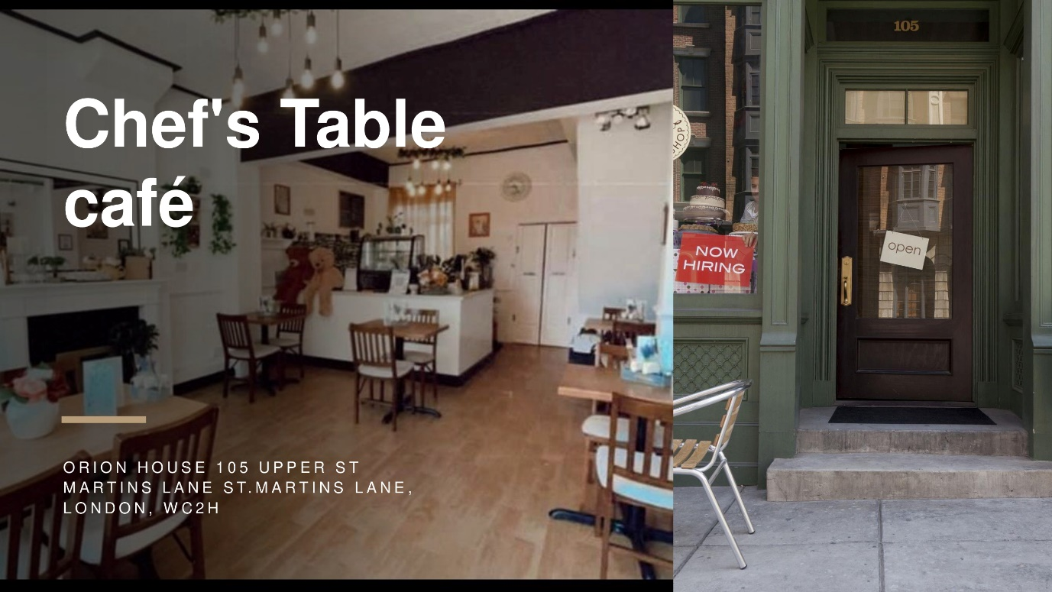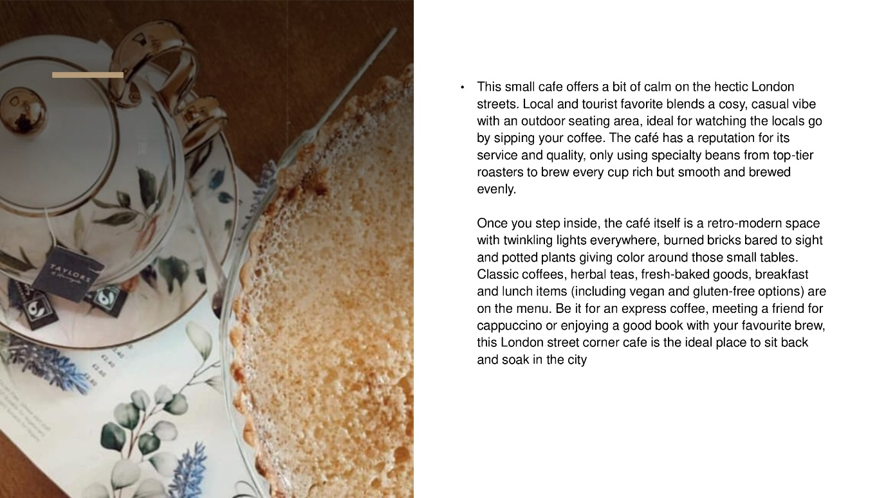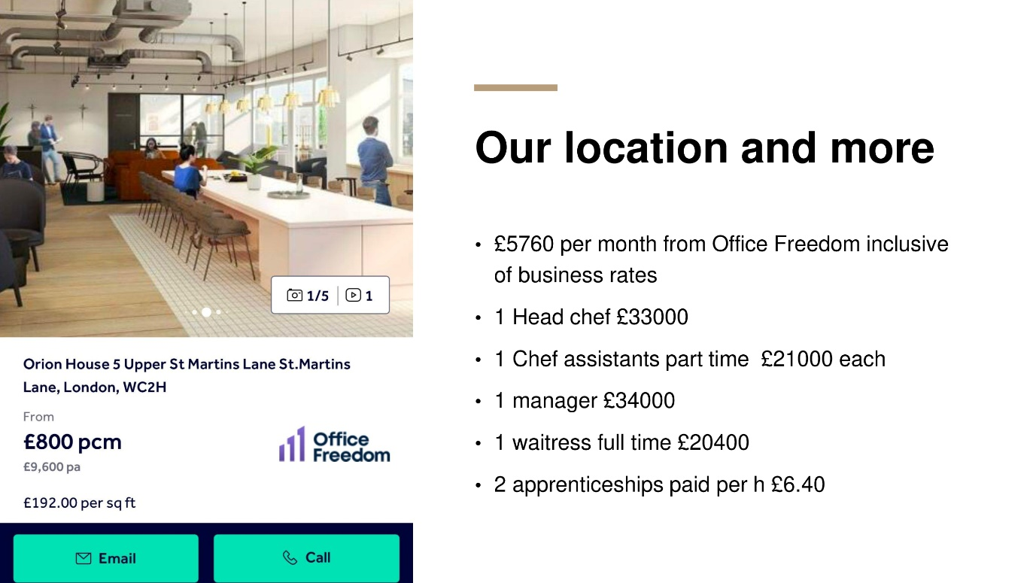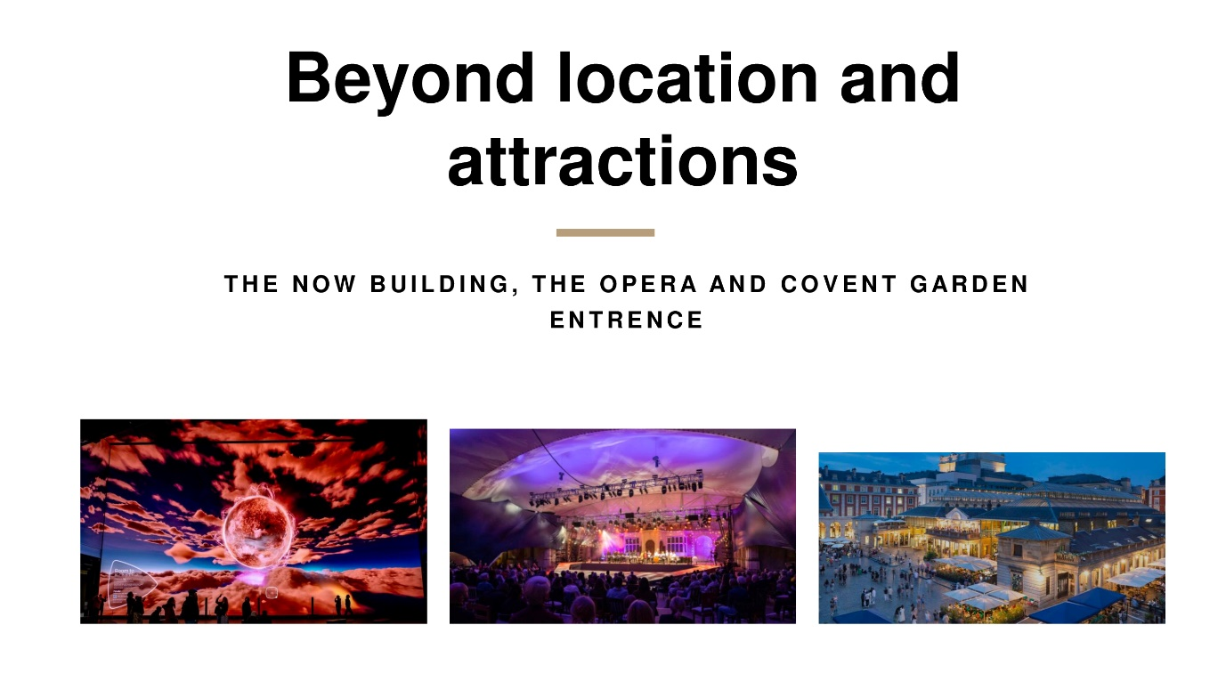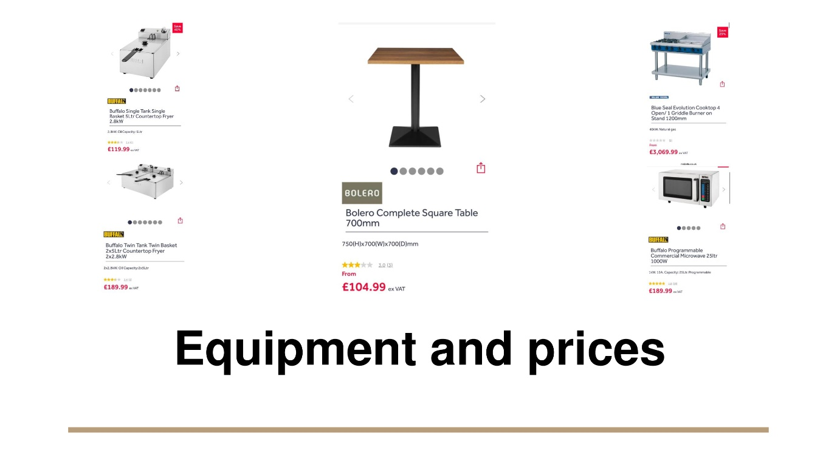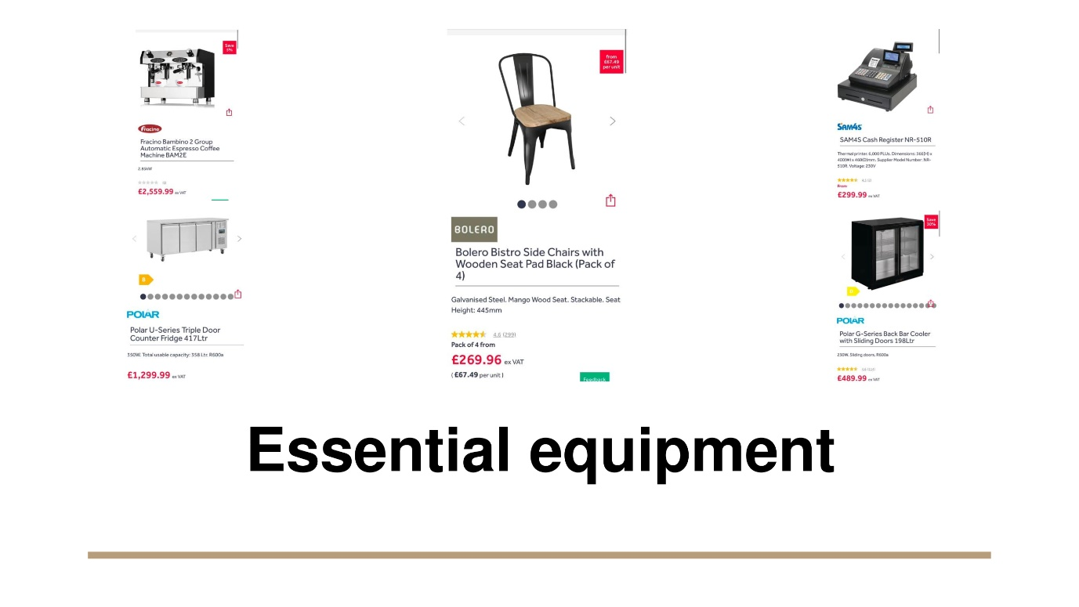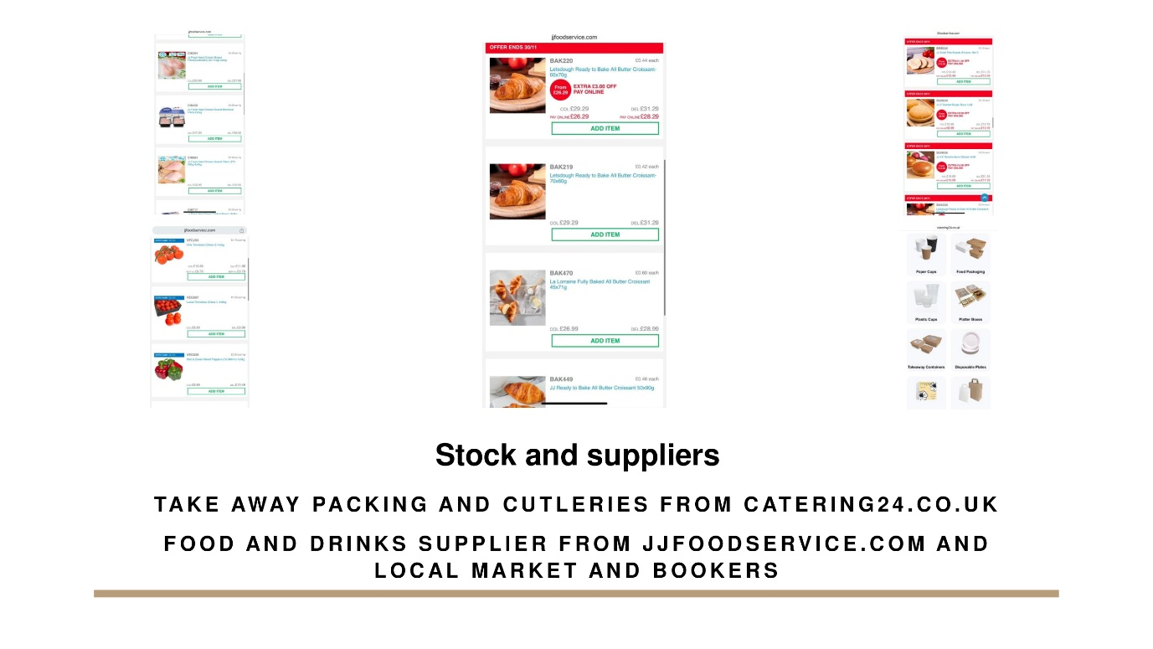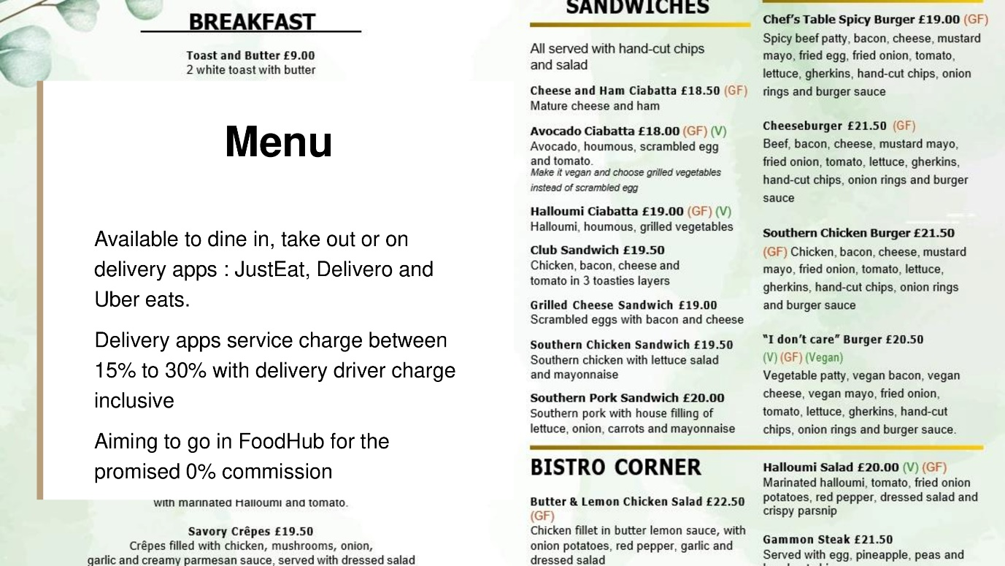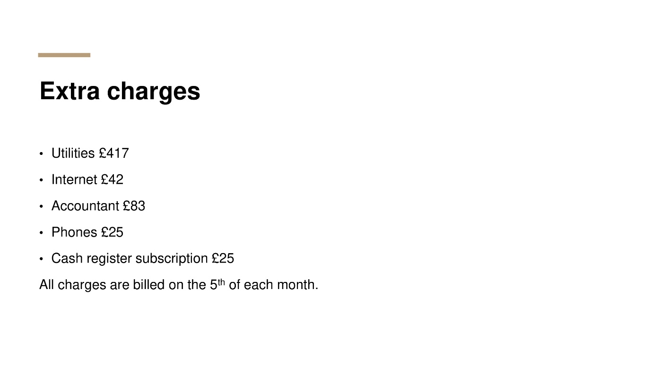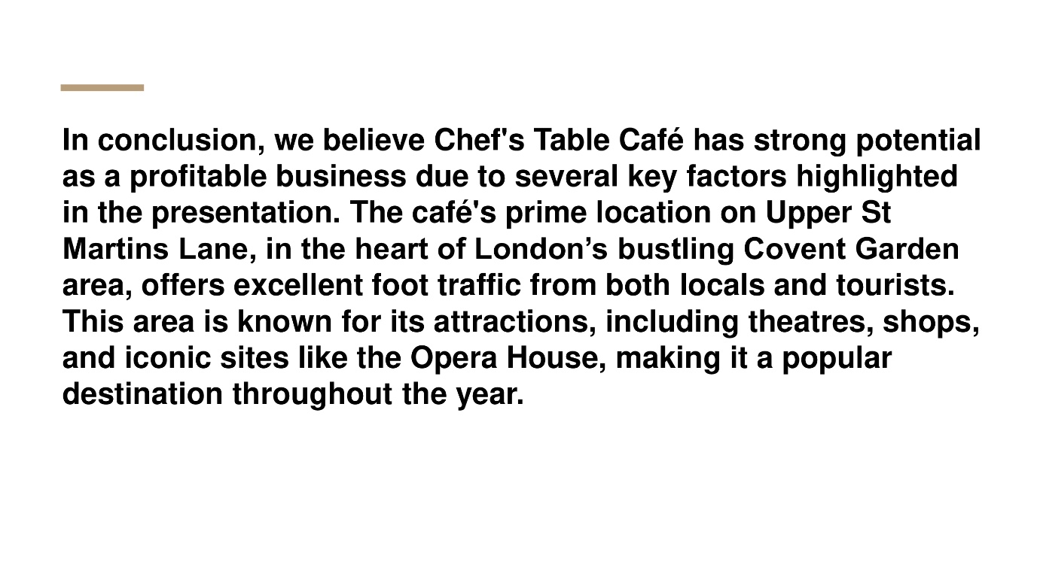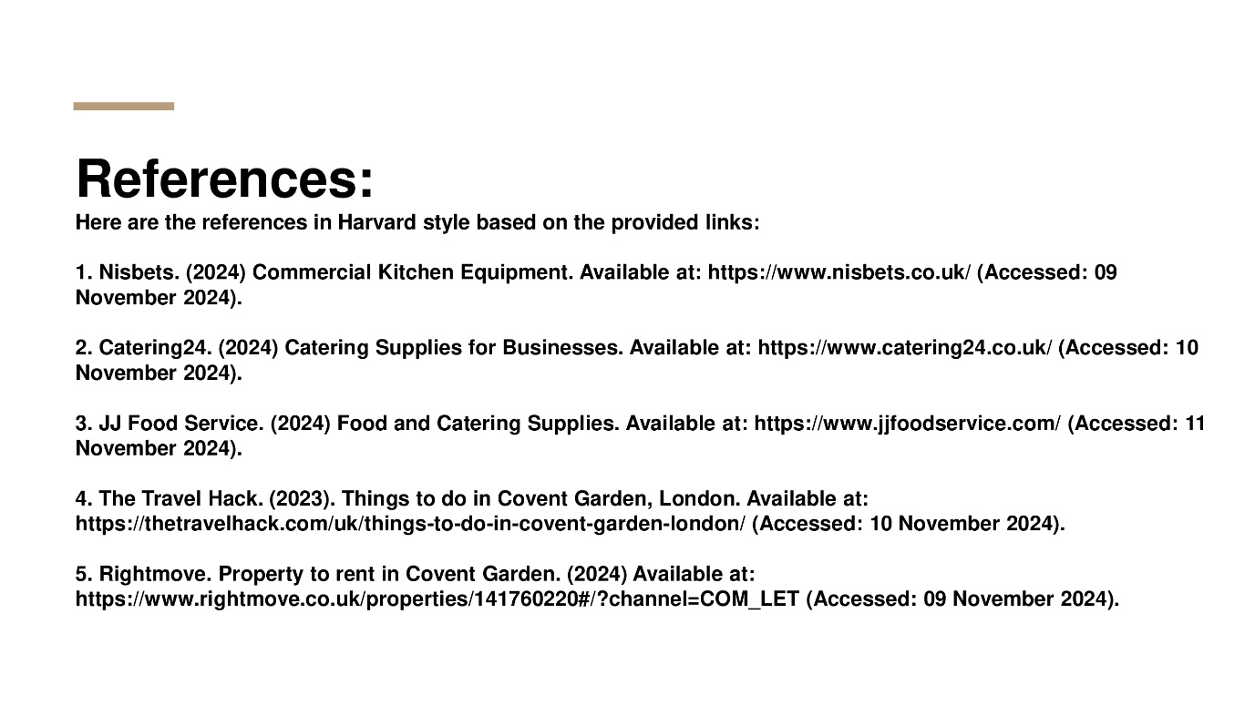

References
Britain and Britishness, 2024. 10 fascinating facts about Covent Garden, London. Available at: https://britainandbritishness.com/10-fascinating-facts-about-covent-garden-london/# (Accessed: 1 November 2024).
Curaoğlu, F., Çobanlar, G.A. and Koyuncu, Ş., 2023. Interior design codes of coffee shops as the third place during the COVID-19 pandemic: Z-generation and distance concept. Sanat ve Tasarım Dergisi, 13(2), pp.350-367.
Gov, 2024. Leading tech firms invest over £2 billion in the UK in one week. Available at: https://www.gov.uk/government/news/leading-tech-firms-invest-over-2-billion-in-the-uk-in-one-week (Accessed: 2 November 2024).
Guo, J. and Keskin, B.B., 2023. Designing a centralized distribution system for omni‐channel retailing. Production and Operations Management, 32(6), pp.1724-1742.
H&C News, 2024. The ongoing economic and cultural impact of Brexit on the UK hospitality industry: A litany of broken promises. Available at: https://www.hospitalityandcateringnews.com/2024/06/the-ongoing-economic-and-cultural-impact-of-brexit-on-the-uk-hospitality-industry-a-litany-of-broken-promises/ (Accessed: 4 November 2024).
Huang, I.Y., Manning, L., Wood, V., James, K.L., Millington, A., Grigoriadis, V. and Ward, S., 2022. Creating sustainable value through food waste management: Does retail customer value proposition matter? British Food Journal, 124(10), pp.3201-3219.
Liu, Y. and Song, G., 2023. Role of logistics integration capability in enhancing performance in omni-channel retailing: Supply chain integration as mediator. Sustainability, 15(11), p.9053.
Logicvending, 2024. About us. Available at: https://www.logicvending.co.uk/about?_gl=1*7xdh1m*_up*MQ..&gclid=Cj0KCQiAoae5BhCNARIsADVLzZfG8W0hnR0Ff-kIRS_ZM6iZsWMpgmFgaKhLvWDjL4-GQ8C0VjpeSRcaAjOtEALw_wcB (Accessed: 9 November 2024).
Ohara, M.R., 2023. The role of social media in educational communication management. Journal of Contemporary Administration and Management (ADMAN), 1(2), pp.70-76.
ONS, 2023. The role of labour costs and profits in UK inflation: 2010 to 2023. Available at: https://www.ons.gov.uk/economy/grossdomesticproductgdp/articles/theroleoflabourcostsandprofitsinukinflation/2010to2023 (Accessed: 10 November 2024).
ONS, 2024a. GDP monthly estimate, UK: August 2024. Available at: https://www.ons.gov.uk/economy/grossdomesticproductgdp/bulletins/gdpmonthlyestimateuk/august2024 (Accessed: 10 November 2024).
ONS, 2024b. Employment in the UK: February 2024. Available at: https://www.ons.gov.uk/employmentandlabourmarket/peopleinwork/employmentandemployeetypes/bulletins/employmentintheuk/february2024 (Accessed: 10 November 2024).
Palepu, K.G., Healy, P.M., Wright, S., Bradbury, M. and Coulton, J., 2020. Business analysis and valuation: Using financial statements. Cengage AU.
Pereira, D., Bozzato, A., Dario, P. and Ciuti, G., 2022. Towards foodservice robotics: A taxonomy of actions of foodservice workers and a critical review of supportive technology. IEEE Transactions on Automation Science and Engineering, 19(3), pp.1820-1858.
Reyes Jr, R.V., Nuque, L.C.T., Espenocilla, A.D., De Guzman, A.C., Dosho, M.H.B. and Abad, M.A.H., 2024. Profiling of cafe business in Talavera, Nueva Ecija: A basis for development of a standardized checklist of minimum requirements for starting up a coffee shop business. International Journal of Advanced Engineering, Management and Science, 10(5), pp.001-062.
Statista, 2024. Most popular social media platforms in the United Kingdom (UK) as of the third quarter 2023, by usage reach. Available at: https://www.statista.com/statistics/284506/united-kingdom-social-network-penetration/ (Accessed: 10 November 2024).
Swoopfunding, 2024. Startup & small business grants simplified. Available at: https://swoopfunding.com/uk/business-grants/ (Accessed: 10 November 2024).
The Global Economy, 2022. United Kingdom: Political stability. Available at: https://www.theglobaleconomy.com/United-Kingdom/wb_political_stability/ (Accessed: 10 November 2024).
Tripadvisor, 2024a. Cafés in London. Available at: https://www.tripadvisor.in/Restaurants-g186338-c8-London_England.html (Accessed: 10 November 2024).
Tripadvisor, 2024b. My Place Covent Garden. Available at: https://www.tripadvisor.co.uk/Restaurant_Review-g186338-d28054766-Reviews-My_Place_Covent_Garden-London_England.html (Accessed: 11 November 2024).
Tripadvisor, 2024c. Cafe Parisienne. Available at: https://www.tripadvisor.in/Restaurant_Review-g186338-d6171524-Reviews-Cafe_Parisienne-London_England.html (Accessed: 12 November 2024).

