

Student name: | SRAVANTHI SILVERU | Student ID | 2228080
Programme: | MSc Cyber Security and Digital Forensics Analysis
Module: | Ethical Hacking
Module code: | ACCA7033 | Contribution to Overall Module Assessment (%): | 100%
Lecturer: | Assoc. Prof. Carlene Campbel | Internal Verifier: | Munyaradzi N Murira
Assignment Title: | Research into cyber security attacks and Penetration testing for a virtualise simulated company Website | Word count (or equivalent): | 5,000
Submission deadline: | Jan 8th 2024 | Return date of provisional marks & written feedback:

LEVEL 7 ASSESSMENT SPECIFICATION

TABLE OF CONTENTS
INTRODUCTION 3
LIST OF FIGURES AND TABLES 4
Table 02: Estimated Replacement Costs 27 5
TASK 1 5
ANALYSIS OF LATEST CYBERSECURITY ATTACKS 5
RESEARCH ON CYBERSECURITY ATTACKS 6
Attack 1: Ransomware Puts Big Healthcare Company at Risk: 6
Attack 2: Insider Threat at a Software Development Company 6
Attack 3: Hack on a Software Maker's Supply Chain 7
Prevention and Recommendations 7
Specific Countermeasures for Each Attack: 7
General Recommendations: 7
TASK 2 8
RED TEAM SIMULATION AT CPC 8
INTRODUCTION 8
DETAILED CONTINGENCY POLICY FOR PENTEST 9
Risk Management Strategy 10
Backup Procedures 11
Incident Response Plan 11
CHOICE OF PENETRATION TESTING FRAMEWORK 12
Framework Selection: PTES 13
CHOICE OF PENETRATION TESTING TOOLS 13
Tool Selection: 13
Comprehensive Coverage 14
Adaptability and Integration 14
EXPLANATION OF SIMULATED ATTACKS 15
List of Targeted Vulnerabilities 15
Attack Tools Used 20
Protocols Involved 21
Attack Launch Methodology 21
Success or Failure Analysis 22
RECOMMENDED SOLUTIONS FOR DISCOVERED THREATS 23
Configuration Changes 23
New Software/Hardware Recommendations 23
Defence Strategies 24
COST OF SOLUTION 25
Replacement Costs 25
Table 02: Estimated Replacement Costs 26
Total Estimated Cost 26
TIMETABLE FOR EXECUTION AND INVOICE 27
Execution Timetable 27
Invoice for Professional Services 28
CONCLUSION 29
REFERENCE 30

INTRODUCTION

In the dynamic field of digital security, ethical hackers act as watchful defenders, performing a function similar to that of malevolent hackers' covert operations, but with one crucial and important exception: they do so with express permission. The line that separates moral behaviour from immoral behaviour becomes the pivot around which an organization's security walls tremble. Ethical hackers, who are frequently hired for penetration tests or security assessments, operate within the digital space with authorization, making sure that the boundaries between legitimate defence and illegal activity are always clearly defined. This assignment delves deeply into cybersecurity, requiring a meticulous analysis of recent cyberattacks on organizations and companies. The focus is on scrutinizing three modern attacks, utilizing forensic tools like models, diagrams, and academic articles. The objective is not only to examine but also to deduce preventive actions, establishing robust barriers against potential future cyberattacks.

We simultaneously enter a virtual cyberwarfare arena, with Cureton Pharmaceutical Company (CPC) serving as the stage. Our job as the Red Team Engineer is to create a virtualized version of CPC's vital server infrastructure and plan a multipronged attack. Finding design flaws, technological gaps, and vulnerabilities is the ultimate objective to create a proactive defence against any threats to CPC's innovative pharmaceutical endeavours. This assignment goes beyond theory; it requires a combination of technical expertise, strategic thinking, and research. It's a rallying cry for ethical hackers to use knowledge as their weapon and creativity as a defence in the never-ending battle to protect the digital space.

LIST OF FIGURES AND TABLES

Figure 01: Design of CPC…………………………………………………….…10
Figure 02: Finding Database ………………………………………………….…15
Figure 03: Finding Database…………………………………………………..…15
Figure 04: Finding Columns………………………………………………….….16
Figure 05: Cross-Site Scripting………………………………………………..…16
Figure 06: Generating pattern……………………………………………………17
Figure 07: Debugging the pattern…………………………………………….…..17
Figure 08: Finding Offset………………………………………………….….….17
Figure 09: Generating exploit code………………………………………………18
Figure 10: Performing the attack…………………………………………………18
Figure 11: Man-in the Middle attack……………………………………….…….20
Figure 12: Denial-of-Service attack……………………………………………….20

Figure 13. Scanning of ports filtered by a firewall…………………………………21

Figure 14. Running the Metasploit framework……………………………………..21

Table 01: Types of penetration Frameworks……………………………………...12

Table 02: Estimated Replacement Costs ………………………………………….26
Table 03: Estimated Implementation Costs……………………………………..…26

TASK 1

ANALYSIS OF LATEST CYBERSECURITY ATTACKS

Knowing about recent online attacks is very important for making strong defense strategies in the changing world of computer security. This study looks into three big cyberattacks that hurt businesses. It talks about how they did it, the effects and what we learned from them. The goal is to learn information that can help companies make their defenses stronger against similar threats in the future (Zou, et. Al., 2021).

RESEARCH ON CYBERSECURITY ATTACKS

Attack 1: Ransomware Puts Big Healthcare Company at Risk:

- Description: A doctor's office got attacked by ransomware, locking important patient details and stopping medical help.
- Analysis: The bad guys used weaknesses in the old systems of the provider that were not fixed. The attack happened because there was a shortage of regular software updates and not enough protection for the endpoints (Linkov, and Kott, 2019).
- Countermeasures:
- Keep all systems up-to-date and fix them regularly.
- Implement advanced endpoint protection solutions.
- Have workers learn about security often.

Attack 2: Insider Threat at a Software Development Company

- Description: The inside threat of a software making company let out confidential source code. A worker who was not happy, and had the chance to get into places where company's computer programs are stored - took them all offline. Then they posted it for everyone else on internet could see also. This behavior really hurt owned ideas and business edge.
- Analysis: The person, who had special access to secret systems that weren't watched or controlled, did it wrong based on what checks are made. Company safety was not good because there were no ways to find odd access patterns and rules for giving just the right permissions.
- Countermeasures:
- Put a rule in place that only gives employees the smallest amount of rights they need to do their jobs on computers and information.
- Check for bad intentions using User and Entity Behaviour Analytics (UEBA) by watching out for strange actions.
- Make a plan to handle emergencies and include practices against those trusted by the company. This will lessen any harm quickly.
- Check and look at important system logs, especially those with private or secret information. This will help spot unapproved access fast and stop it from happening more often.

Attack 3: Hack on a Software Maker's Supply Chain

- Description: A tricky attack on a popular software company led to spreading harmful updates for its users (Hausken, 2020).
- Analysis: The bad guys got into the process of making software, putting harmful code in a good update. This avoided usual safety steps because the update process was trusted.
- Countermeasures:
- Put in strong security tests during making and updating software.
- Use software checks tools to find weaknesses in parts from other companies.
- Teach customers to trust no one when it comes to updating their software.

Prevention and Recommendations

Specific Countermeasures for Each Attack:
- For ransomware attacks, make your data backup better and create a strong plan to deal with problems (Saeed, et. Al., 2023).
- When there is a data break, make the inner security measures stronger and check them often with tests that try to get in.
- Stop supply chain attacks by creating a safe way to make software and check on third-party risks often (Huang, et. Al., 2022).

General Recommendations:
- Continuous Security Training: Teach workers about safe internet practices often and keep them informed on new threats.
- Adoption of a Zero-Trust Model: Think that no one inside or outside the network can be trusted. Put strong limits on access and watch constantly (Annarelli, et. Al., 2020).
- Regular Security Audits and Assessments: Do big checks to find weak spots and see how well old safety steps are working.
- Invest in Advanced Security Technologies: Use AI and machine learning tools that find threats before they happen. These can also respond to them quickly.
- Create a Security-Focused Culture: Create a work environment that makes security important in all parts of running the business.
- Incident Response Planning: Make a plan for responding to an incident, update it often. This helps you act quickly and well if there is a break-in.
- Collaboration and Information Sharing: Share information with other groups and organizations about new dangers and good practices to keep updated.

By using these ways, companies can make themselves much more able to withstand computer attacks and protect their property and name in our online time.

TASK 2

RED TEAM SIMULATION AT CPC

INTRODUCTION
In a time where online dangers are changing very fast, the need for strong internet safety steps in medicine companies has never been more important. This report explains a full Red Team exercise done at Cureton Pharmaceutical Company (CPC). It is well-known in the drug business for its main work on research and making new stuff to fight respiratory viruses or make vaccines. The goal of this exercise is to strictly check and assess how strong CPC's internet security defenses are, find possible weaknesses and give helpful advice for making the company more secure from digital threats (Bahill, and Madni, 2017).

The medicine-making business holds private health information and valuable research, making it a target for cybercriminals and competing companies. A breach in internet safety can lead to problems like stolen business secrets, privacy issues, and trust loss with patients. In the worst-case scenario, it could disrupt crucial healthcare services. Recent global cyber attacks on healthcare centers highlight the importance of protecting health data. Red Team testing at CPC is vital to maintaining a good company identity and ensuring trust in health data protection. (Salvi, et. Al., 2022).

The report starts with an emergency plan, detailing risk handling, backup schemes, and crisis responses to avoid unintentional damage during test attacks at CPC. It then explains the chosen method and tools for testing security gaps, aligning them with CPC's digital system design needs.

The main section discusses simulated attacks, covering attack types, targeted weaknesses, protocols used, and task execution. Results are analyzed to understand wins and losses, leading to a tailored protection plan for CPC. This involves system updates and new strategies to prepare for future cyber-attacks. (Estay, et. Al., 2020).

DETAILED CONTINGENCY POLICY FOR PENTEST
Doing a successful attack test properly requires having a solid plan, ensuring it's done safely and quickly. CPC's security testing plan has good risk control, strong backup processes and well-made plans for handling issues.
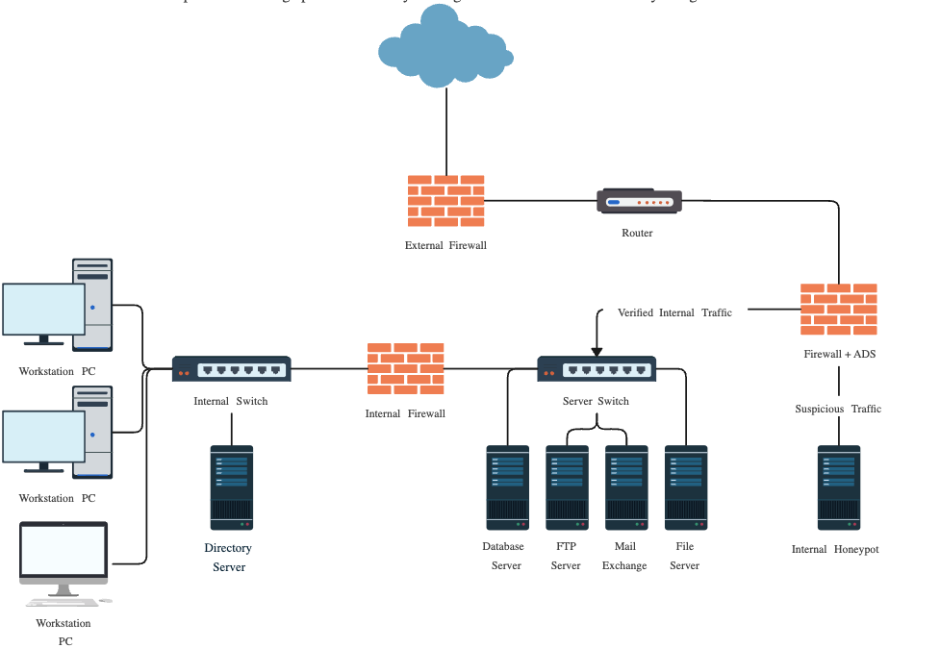

Figure 01: Design of CPC

Risk Management Strategy
The risk management strategy for the penetration test at CPC involves a three-pronged approach: Finding, measuring, and reducing of risks. The first step is to carefully look for possible risks, like troubles with important services, information leaks and unexpected harm done to systems. This step means chatting with key individuals from various areas of the business. We want to see how they use tech and discover areas where we need help (Ahmadi-Assalemi, et. Al., 2020). After learning, we thoroughly assess risks, categorizing them based on severity and likelihood using a table. High risks with serious consequences, like unintentionally turning off a critical server, are contrasted with low-risk scenarios, such as temporary loss of non-essential reporting abilities.
The last step of the plan to manage risks is reducing them. This means making plans to lessen the chances of known risks and lower their effects if they happen. Stopping actions from happening should include things like doing a security test when there isn't much going on, keeping important systems safe separately and using back-up ways to make sure everything keeps working. Also approved steps must be made for special jobs that could cause trouble if not handled carefully. All testing activities for getting into a system are checked and controlled very carefully. If any actions cause problems, there is an immediate way to return everything back as it was before the problem happened (Madni, 2017).

Backup Procedures
Before starting the test, we first make a complete copy of all important data (Abdullayeva, 2023). This procedure involves several steps to ensure the integrity and availability of the data:
- Data Identification: Finding out which important data sets need a backup, like patient records, study details, money information and business databases.
- Backup Execution: Using powerful backup tools to make full and partial copies of important data. This means not just data stored in your own buildings, but also information kept on cloud environments.
- Backup Verification: Checking the backups to make sure all data is correct and complete. This step is very important to make sure that the backup can be easily restored if needed.
- Secure Storage: Keeping the copies in safe, different areas from various parts of the world to guard against physical dangers like natural disasters.
- Documentation: Writing down the steps for making backups, such as what data is saved, when it was backed up and where those backup files are kept.

Incident Response Plan
Even with careful planning, unforeseen bad things can happen during a security test (Erstad, et. Al., 2021). To manage such events, CPC has developed an incident response plan that includes the following components:
- Incident Detection and Reporting: Establishing early problem detection methods, clear communication plans, quick machine-generated alerts, and a streamlined sharing system for the testing team..
- Initial Assessment: Rapidly assess the situation, identifying affected systems, the type of break-in, and determining immediate actions to stop the event.
- Containment and Mitigation: Doing fast actions to stop the problem and keep it from getting worse. This could mean separating impacted parts, turning on extra systems or undoing recent changes.
- Escalation Path: Utilizing a clear plan outlining when and who should be informed, including internal stakeholders like IT management, legal, and PR groups, as well as potential external groups like cybersecurity experts or regulatory watchdogs when necessary.
- Post-Incident Analysis: After fixing the problem, doing a complete study to know its main reason. This study helps make better the emergency plan and overall computer security system of CPC.
- Communication Protocol: Maintaining clear and swift communication during problem response, including internal messages and, if necessary, engaging with external partners or users.

CHOICE OF PENETRATION TESTING FRAMEWORK

S.NO. | FRAMEWORK | PROVIDER | FEATURES
01 | Open Source Security Testing Methodology Manual (OSSTMM) | Institute for Security and Open Methodologies (ISECOME) | - Security test scoping  - Rules of engagement and error handling  - Support for results disclosures
02 | OWASP Continuous Penetration Testing Framework | Open Web Application Security Project (OWASP) | - AppSec pentesting standardization  - Focus on agility and shift left principles
03 | Mitre Att&ck | Adversarial Tactics, Techniques, and Common Knowledge  Mitre Corporation | - threat intelligence,  - defense mapping,  - security assessments.
04 | NIST Cybersecurity Framework (CSF) | National Institute of Standards and Technology (NIST) | - Outcome-based approach; no step-by-step checklist  - Mapping to existing cybersecurity management efforts
05 | Penetration Testing Execution Standard (PTES) | A collection of information security experts from various organizations | - Intelligence gathering and threat modeling  - Vulnerability research  - Exploitation and post-exploitation support
06 | PenTesters Framework (PTF) | TrustedSec | - Based on PTES  - Efficient packaging and installation  - Compatible with internally developed repos

Table 01: Types of penetration Frameworks

Framework Selection: PTES
We're using Penetration Testing Execution Standard (PTES) for the CPC test due to its broad setup, versatility, and fitting well into the complex and confidential drug-making system (Liu, and Wang, 2020).. PTES stands out for its comprehensive approach to security testing, providing a holistic penetration testing process. In contrast to other systems that may target specific aspects of cybersecurity, PTES covers everything from initial discussions before the test to generating final reports afterward. This thorough methodology ensures a meticulous examination of every aspect during the testing process at CPC, crucial due to the importance of the data and systems involved. (Loke, et. Al., 2021).

The PTES framework is divided into seven main sections:
- Pre-engagement Interactions
- Intelligence Gathering
- Threat Modelling
- Vulnerability Analysis
- Exploitation
- Post Exploitation
- Reporting

Each part is carefully made so the tester can follow all steps of computer hacking test. It helps to check CPC's safety online properly and systematically (Carta, 2019).

CHOICE OF PENETRATION TESTING TOOLS

In the test at Cureton Pharmaceutical Company (CPC), a group of special tools are chosen to deal with unique issues and weaknesses that come from their systems. The picked tools - Metasploit, Nmap, Burp Suite and Wireshark are well-known in the area of keeping computers safe. Each has different features that help make testing better overall (Kayode-Ajala, 2023).

Tool Selection:
1. Metasploit:
- Purpose: Renowned for its extensive exploit collection and ability to create complex attack plans, making it effective for simulating network and app attacks to identify weaknesses.
- Relevance to CPC: Various computer programs and networks; Metasploit checks system strength against known exploits, simulating real-world attacks to ensure system resilience.
2. Nmap:
- Purpose: Discover and assess live hosts and vulnerabilities on CPC's network.Optimize security measures and ensure regulatory compliance through thorough network scanning.
- Relevance to CPC: In essence, Nmap serves as a versatile tool for CPC, offering insights into network structure, vulnerabilities, and overall security posture.

3. Burp Suite:
- Purpose: Excels in website safety checks, providing various tools for testing security, including scanning, navigating, and identifying vulnerabilities in web apps.
- Relevance to CPC: Helps find website weaknesses on CPC's information-rich site, crucial for security and preventing data leaks with private details.
4. Wireshark:
- Purpose: Studies network protocols by capturing and analyzing live Internet activity, identifying specific data and potential vulnerabilities.
- Relevance to CPC: CPC, a drugs company, prioritizes network safety using Wireshark to detect potential unauthorized access or data theft, crucial for protecting against network attacks and safeguarding business secrets.

Comprehensive Coverage
Metasploit, Nmap, Burp Suite, and Wireshark ensure CPC's computer security: Metasploit exploits weaknesses, Burp Suite safeguards web apps, and Wireshark monitors network communication for potential threats. (Venkataramanan, et. Al., 2019).

Adaptability and Integration
The tools are powerful individually and highly flexible, crucial for a strong and successful test. Wireshark findings can be integrated with Metasploit to assess potential harm, while Burp Suite tests web application updates for issues. (Mendoza, and Venables, 2023).

EXPLANATION OF SIMULATED ATTACKS
At Cureton Pharmaceutical Company (CPC), there was a Red Team exercise. People carefully made many attacks to find and use weaknesses in the company's network and apps. This part talks about types of pretend attacks, the tools used for them, how it was done and their success or failure (Ordoukhanian, 2022).

List of Targeted Vulnerabilities
- SQL Injection: A way to take advantage of internet apps by changing SQL queries with user input.
Stage 1: Finding Database
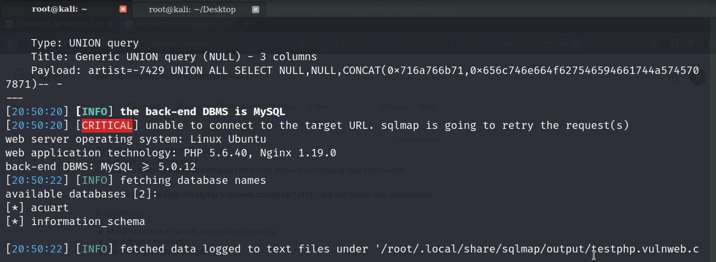

Figure 02: Finding Database
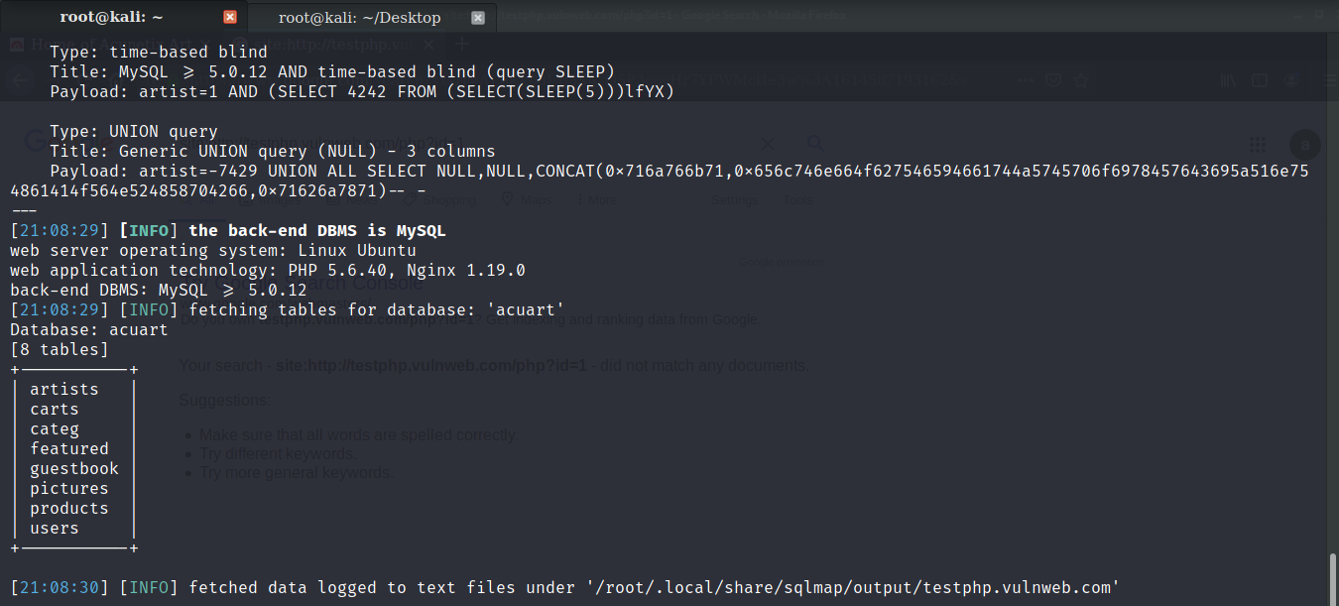
Figure 03: Finding Database
Stage 2: Finding Columns

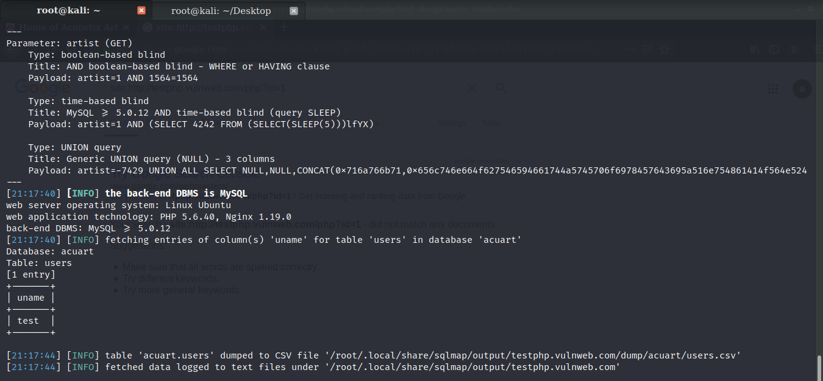

Figure 04: Finding Columns

- Cross-Site Scripting (XSS): A weakness that lets bad guys put harmful codes into web pages seen by other users.

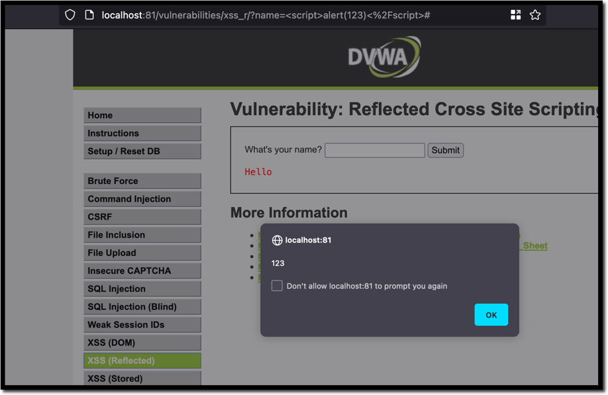

Figure 05: Cross-Site Scripting

- Buffer Overflow: When a computer program writes data to a storage space, it accidentally goes beyond its limits and changes neighboring memory. This is called buffer overflow.
Step 1:
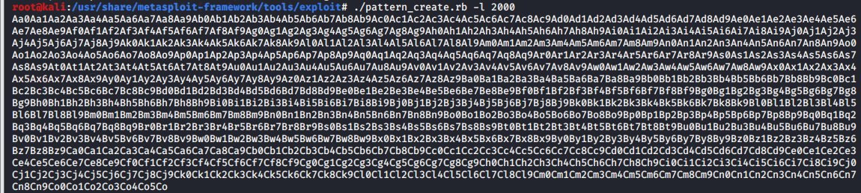

Figure 06: Generating pattern

Step 2:

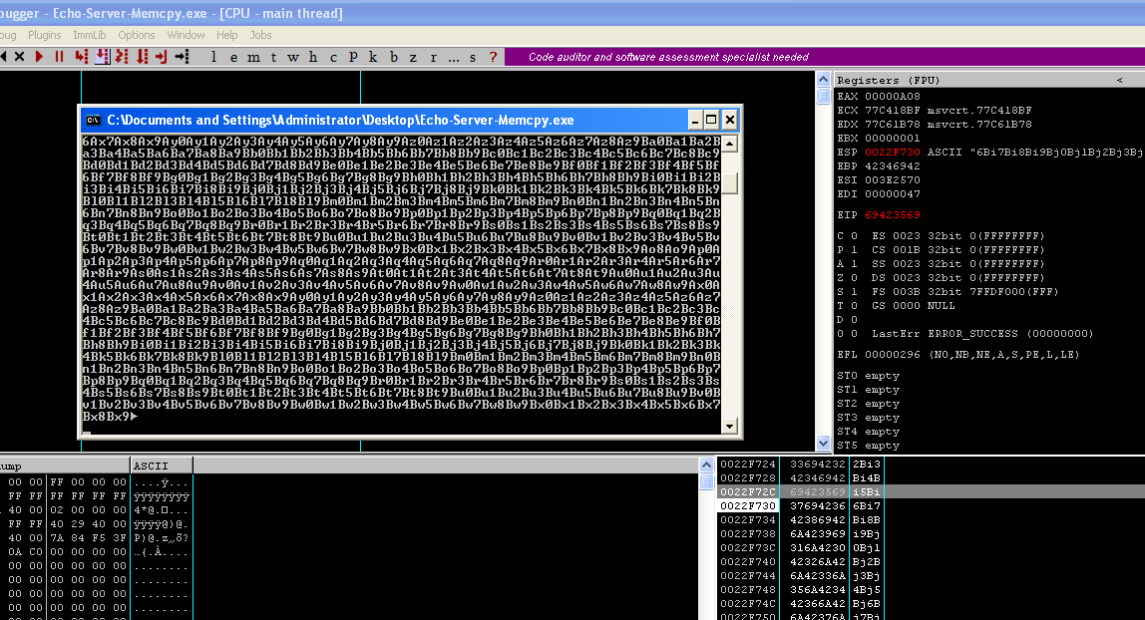

Figure 07: Debugging the pattern

Step 3:

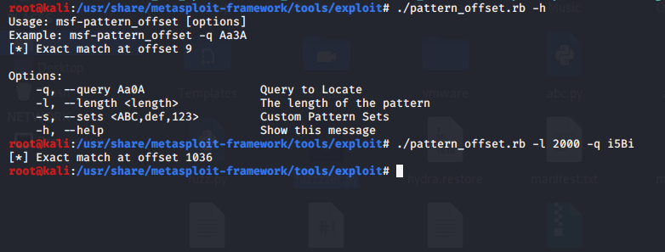

Figure 08: Finding Offset

Step 4:
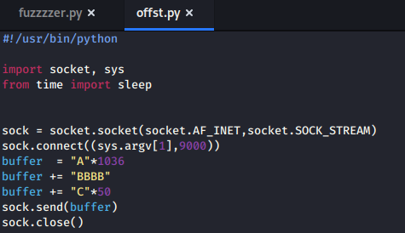

Figure 09: Generating exploit code

Step 5:

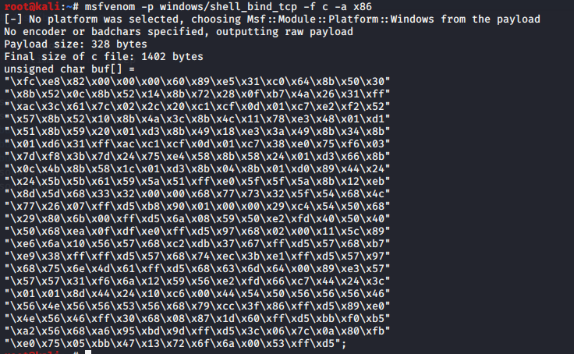

Figure 10: Performing the attack

- Man-in-the-Middle (MitM) Attacks: Stopping and changing communication between two groups without them knowing.
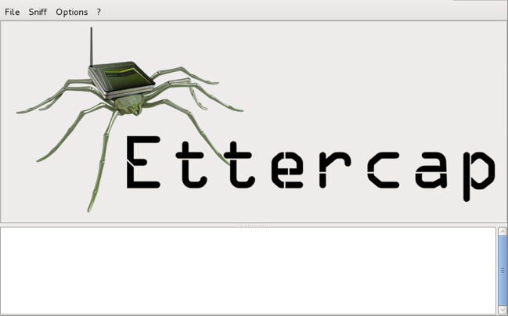
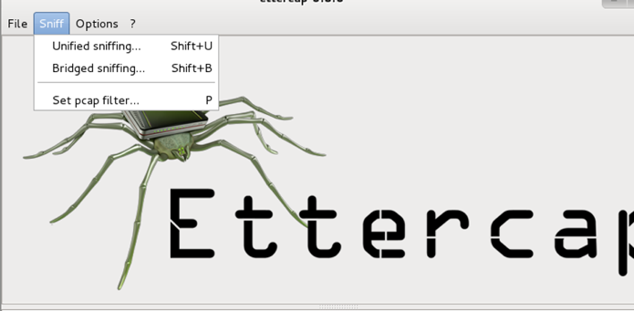
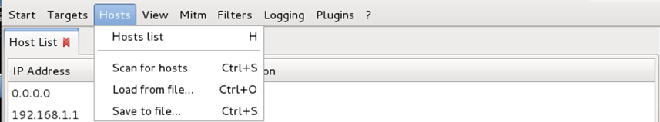
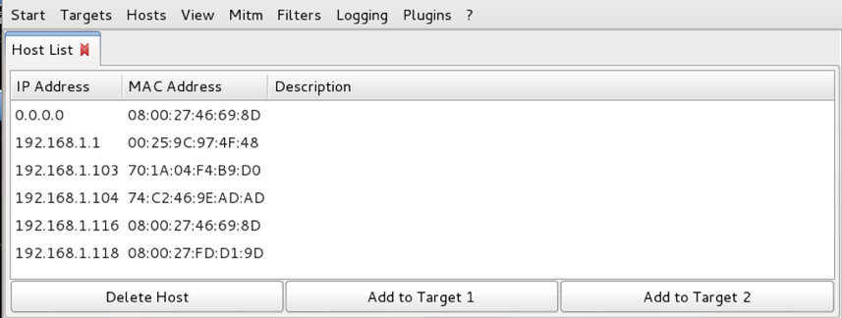
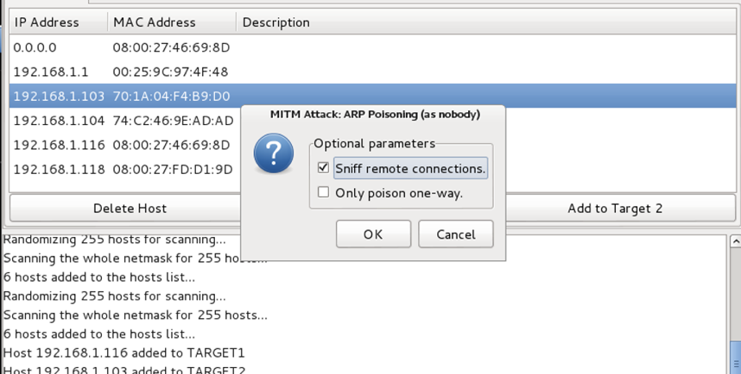
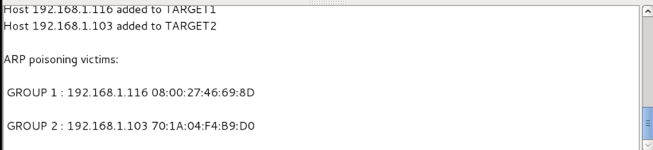
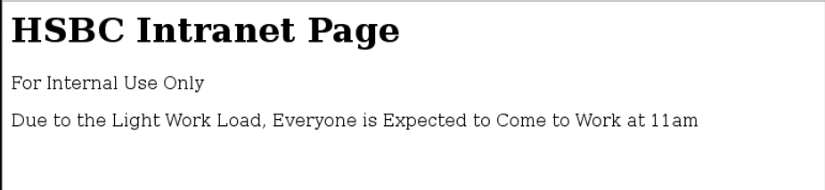
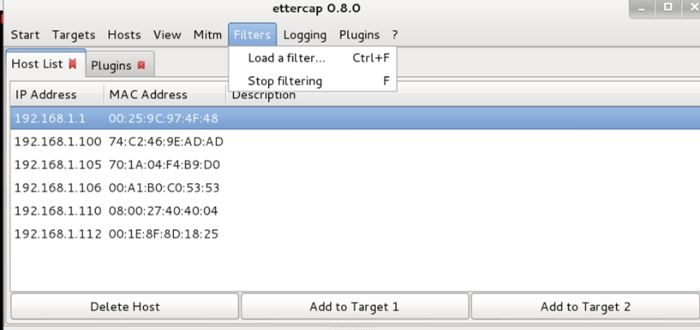

Figure 11: Man-in the Middle attack

- Denial-of-Service (DoS) Attacks: Making a system's resources so much that it can't be used by the people who should use it.
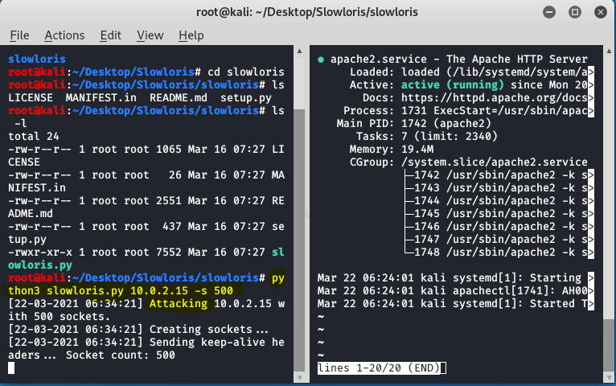

Figure 12: Denial-of-Service attack

Attack Tools Used
ZenMap: Execute vulnerability scanning script with the command 'nmap -f -sS -sV --script vuln 192.168.0.4 '.
NMAP: Gather information for vulnerability exploitation with 'nmap - T4 -A -v 192.168.0.4', revealing open port versions and absence of a firewall.
Nmap's advanced function conducts an automated deep scan via 'nmap -f -sS -sV –script-auth 192.168.0.3' for authentication validation .
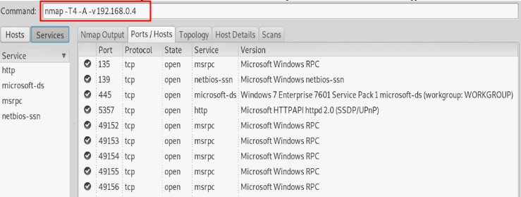

Figure 13. Scanning of ports filtered by a firewall

Wireshark: Document interaction and connection flow from attacking machine on vulnerable website server
Meterpreter: Utilize Meterpreter's varied functions and tools for compromising the victim machine.
Figure 14 displays the attack initiation, starting with running the Metasploit tool "msfconsole" as a super-user (root). The necessary services are then initialized using the commands "service postgresql start" for postgresql, "ss -ant" for ports, and "msfdb init" for the framework database.
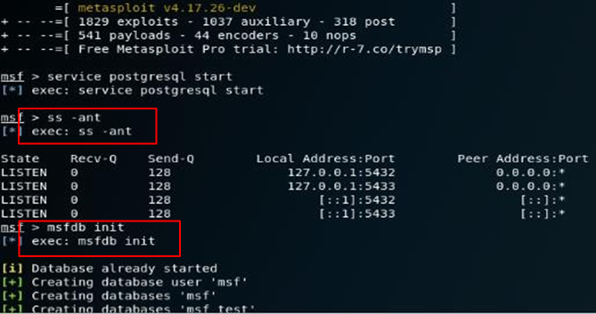

Figure 14. Running the Metasploit framework

- SQL Injection:
- Tools: SQLMap and Metasploit.
- Usage: SQLMap was used to find and use SQL injection weaknesses, while Metasploit tools were set up to make the exploitation process easier.
- Cross-Site Scripting (XSS):
- Tools: Burp Suite and OWASP ZAP.
- Usage: These tools were used to find weaknesses in web apps that could let bad code run. They let you check input fields and run scripts in the browser.
- Buffer Overflow:
- Tools: Metasploit and custom scripts.
- Usage: Metasploit was used for its ready-made exploits that attack known buffer overflow weaknesses, and special scripts were made to check out unusual weak points found in CPC's software.
- Man-in-the-Middle (MitM) Attacks:
- Tools: Wireshark and Ettercap.
- Usage: Wireshark was used for watching network traffic, and Ettercap helped catch and change communication in the system.
- Denial-of-Service (DoS) Attacks:
- Tools: LOIC (Low Orbit Ion Cannon) and personal scripts.
- Usage: LOIC was used to overload internet services with too much traffic. On the other hand, unique scripts were created to hit weak spots in CPC's network system specifically.

Protocols Involved
- SQL Injection: Focused on the HTTP protocol as SQL injections are usually done through input fields of web applications.
- XSS: Mainly using HTTP/HTTPS, it focuses on how web apps manage client-side scripts.
- Buffer Overflow: Used different methods based on the job, like TCP/IP for help with networks.
- MitM Attacks: Involved in network rules such as HTTP, HTTPS and TCP/IP. They stop and change data packets for you.
- DoS Attacks: Used TCP/IP and UDP, focusing on beating network levels and rules.

Attack Launch Methodology
- SQL Injection:
- Method: SQL Map and Metasploit were set up to check different input areas in web apps. Automated scripts looked for normal SQL injection patterns and answers.
- XSS:
- Method: With Burp Suite and OWASP ZAP, we checked each form field in web apps with different scripts to see if they run on the browser.
- Buffer Overflow:
- Method: Identified target applications and services. Used Metasploit to automatically use known hacks and make custom scripts. We then used these tools to test how things worked at the edges or when memory was being handled.
- MitM Attacks:
- Method: Wireshark was used to watch network traffic and find possible targets. Ettercap was then used to stop and change messages between the server and client.
- DoS Attacks:
- Method: Used LOIC to send lots of internet traffic to chosen servers. Custom programs were made to take advantage of weaknesses in applications, causing system resources to get too much.

Success or Failure Analysis
After completing this simulation on operating system virtualization, using tools for ethical hacking to launch computer attacks in a safe environment, and strategically planning cybersecurity, it can be said that its advancement has helped evaluate the level of information security at CPC. Gaps and weaknesses in the configuration set up for both servers were found after the organization's servers underwent a vulnerability assessment. As previously stated, this document contains a comprehensive, step-by-step tutorial on creating a computer attack using the vulnerabilities that were discovered. Additionally, it sets up the necessary guidelines, policies, and controls to stop these kinds of intrusions, improving the security of the assets that the computer compromised.

RECOMMENDED SOLUTIONS FOR DISCOVERED THREATS
At Cureton Pharmaceutical Company (CPC), the Red Team test found many weaknesses in their security. This showed that they need a big change to improve how protected their computers and systems are from cyber attacks. Solving these weaknesses needs a many-sided plan. It includes making some changes, bringing in new software and hardware tools, plus creating strong defense plans (Kasimba, et. Al., 2023).

Configuration Changes
- Enhanced Input Validation and Sanitization:
- For online apps, put strong checks on their input to stop SQL injection and XSS attacks. Make sure all user inputs are cleaned up and use prepared statements for queries in the database.
- Update and Patch Management:
- Keep all software, like operating systems and apps, up-to-date to fix known weak points. Set up a computer system that automatically updates programs on time.
- Network Segmentation and Access Control:
- Separate the network to stop possible attacks from spreading. Establish tough rules so that only what their job requires is allowed for users.
- Encryption and Secure Communication Protocols:
- Ensure that all internal and external talks use SSL/TLS encryption. Make sure you keep your secret code methods up to date so they match the current standards.
- Buffer Overflow Protection:
- Use safety tools such as stack guards and random placement of memory in computer systems to stop incorrect usage.
- Robust Authentication Measures:
- Put a double check for all systems, really when you need to reach them from far away or have control over their functions.

New Software/Hardware Recommendations
1. Advanced Intrusion Detection and Prevention Systems (IDPS):
- Put your money in IDPS tools that can fastly check for and handle possible dangers. This means searching for strange stuff, noticing trends and observing what people do.
2. Firewall and Next-Generation Antivirus:
- Change to new firewalls (NGFWs) that do a great job of carefully looking at data packets, keeping out attacks and organizing things on the app level. Match these with tough virus programs that learn how to detect dangers.
3. Web Application Firewalls (WAF):
- Install firewalls to keep web programs safe from normal damaging acts like SQL attack and cross-website scripting by watching over and checking the internet traffic between a site application online.
4. Security Information and Event Management (SIEM) System:
- Make a system called SIEM to collect and look at safety marks from various places. This helps you understand dangers before they happen, so that you can take them on in a better way.
5. Network Monitoring Tools:
- Keep using internet monitoring tools to always keep an eye on web activity. This will help you find and stop possible dangers like middle-man attacks or service denial attacks before they get too bad.
6. Hardware Security Modules (HSM):
- Keep safe the keys you use to lock up data by using HSMs. This will keep your details more secure.

Defence Strategies
1. Regular Security Audits and Assessments:
• Do normal inspections to spot and repair any safety troubles or vulnerabilities for security matters. This means looking for safety problems, finding out what could go wrong and making sure the right things are done.
2. Employee Training and Awareness Programs:
• Teach all workers about computer safety by focusing on best ways to keep their data safe, understanding threats and avoiding email scams.
3. Incident Response and Recovery Planning:
• Make a well-written plan for handling incidents that talks about how to find, stop, get rid of and fix security problems.
4. Zero Trust Security Model:
• Use a zero-trust way of thinking where you don't automatically trust anyone. Always check who is trying to get into the network and use resources, no matter if they are far away or close by.
5. Data Backup and Recovery Solutions:
• Put in place strong data safety plans and ways to deal with disasters. This will help keep your information safe and available if there's a cyber attack.
6. Continuous Monitoring and Analytics:
• Use regular checking tools with forecasting math to find possible dangers or odd things in the system before they get worse.
7. Collaboration with Cybersecurity Experts:
• Work with computer security companies to get their expert advice and keep track of the newest safety trends and tools.
8. Policy and Procedure Updates:
• Regularly check and change security rules and methods to make sure they match with growing online danger situations and rules.

COST OF SOLUTION
The planned improvements for Cureton Pharmaceutical Company (CPC) mean a mix of software and hardware changes, setting things up different ways, and smart set-ups. The price calculation for these answers is an important part of the whole plan to make things safer. This part divides the assumed costs into replacement prices, setup expenses and gives a total estimated expense (Al Yami, 2023).
This guess gives a detailed look at how much money might be needed to improve CPC's online safety position. The cost of changing is for buying new, fancy safety items. The other costs involve the work needed to put those things in and make them ready-the plan development part as well as training workers on how they use this stuff (Zhang, and Marshall, 2023).

Replacement Costs

S.No | Item | Cost
01 | Intrusion Detection and Prevention Systems (IDPS) | £12,000 - £20,000 | for enterprise-grade solutions
02 | Next-Generation Firewalls (NGFWs) | £7,900- £15,700 | Depending on the scale and features required
03 | Web Application Firewalls (WAF) | £4,000- £12,000 | For comprehensive web application protection
04 | Security Information and Event Management (SIEM) System | £15,700 - £32,000 | for an advanced SIEM solution
05 | Network Monitoring Tools | £2,400- £5,500 | For sophisticated network monitoring capabilities
06 | Hardware Security Modules (HSM) | £4,700- £9,500per unit
 | Total Estimated Cost | £47,000- £88,000

Table 02: Estimated Replacement Costs

Implementation Costs

S.No | Item | Cost
01 | Configuration Changes and System Upgrades | 100 hours at £120/hour = £12,000
02 | Training and Awareness Programs | 50 hours at £100/hour = £4,000
03 | Incident Response Plan Development | 40 hours at £150/hour = £6,000
04 | Policy and Procedure Updates | 30 hours at £150/hour = £4,500
05 | Installation and Configuration of New Software/Hardware | 80 hours at £150/hour = £12,000
 | Total Estimated Cost | £35,000

Table 03: Estimated Implementation Costs

Total Estimated Cost
- Replacement Costs: £47,000- £88,000
- Implementation Costs: £35,000
- Total: £80,000- £130,000
It's good to remember that these numbers are rough and can change depending on what the company needs, how big it is or its choices. Furthermore, these costs might look big, but they must be balanced against the possible losses from cyber-attacks such as data leaks, stolen inventions and harm to reputation. Putting strong cybersecurity in place isn't just a safeguard but also a smart move for the company to remain solid and reliable over time (Friedl, et. Al., 2015).

TIMETABLE FOR EXECUTION AND INVOICE

Making cybersecurity work for Cureton Pharmaceutical Company (CPC) needs careful planning and doing things right. This part gives a clear schedule for carrying out the suggested solutions. It ensures that everything is done right and fast. The schedule provides a clear bill for professional work (Kanonhuhwa, et. Al., 2023).

Execution Timetable
Phase 1: Initial Assessment and Planning Duration: 2 weeks
- Week 1: Check the existing structures, find important items and set targets for your project.
- Week 2: Make a detailed plan for your project, including how you will use resources and set up a schedule.

Phase 2: Hardware and Software Procurement Duration: 3 weeks
- Weeks 3-5: Picking and getting IDPS, NGFWs, WAF, SIEM system, Network Monitoring Tools and HSM.

Phase 3: System Changes and Upgrades Time Duration: 4 weeks
- Week 6: Backup of all systems and initiation of configuration changes.
- Weeks 7-8: Implementation of system upgrades and security patches.
- Week 9: Final testing and validation of configuration changes.

Phase 4: Adding New Equipment and Programs Duration: 5 weeks
- Week 10-11: Installation of IDPS, NGFWs, and WAF.
- Week 12: Installation of SIEM system and Network Monitoring Tools.
- Week 13-14: Setup and configuration of HSM and integration with existing systems.

Phase 5: Training and Awareness Programs Duration: 2 weeks
- Week 15: Make training stuff and set up times for learning.
- Week 16: Hold classes for workers on new computer systems and safe online practices.

Phase 6: Incident Response Plan Development and Policy Updates Duration: 3 weeks
- Week 17: Drafting of a new incident response plan.
- Week 18: Review and update existing security policies and procedures.
- Week 19: Finalization and dissemination of updated policies and incident response plan.

Total Duration: 19 weeks

Invoice for Professional Services
- Initial Assessment and Planning
  - 40 hours @ £150/hour = £4,750
- Hardware and Software Procurement Management
  - 30 hours @ £150/hour = £3,600
- Configuration Changes and System Upgrades
  - 100 hours @ £150/hour = £12,000
- Installation of New Hardware and Software
  - 80 hours @ £150/hour = £9,500
- Training and Awareness Program Development
  - 50 hours @ £100/hour = £4,000
- Incident Response Plan Development
  - 40 hours @ £150/hour = £4,750
- Policy and Procedure Updates
  - 30 hours @ £150/hour = £3,600
Subtotal: £42,000
Expenses:
- Travel and Accommodation (if required) = £1,600
- Miscellaneous = £400

Total: £45,000

Notes:
- Taxes and additional government charges are not included in this invoice and will be applied as per the applicable rates.
- Payment terms: 30% upfront, 40% upon completion of Phase 4, and the remaining 30% after the final report submission.
- Any additional hours or changes in scope will be billed separately.

CONCLUSION

The Cureton Pharmaceutical Company Red Team practice is really important. It found some weaknesses in how they protect their computers from attackers right now. This test not only found certain shortcomings, like possible dangers in network setups and app security but also showed why strong endless cybersecurity things are important for a very confidential drug industry (Johannes, et. Al., 2023).

The main findings indicate that CPC's current protections provide a basic safety level, but significant improvements are needed against sophisticated computer threats. The computer test underscores the necessity for enhanced safety measures, including upgraded systems for hacker detection, robust firewalls to thwart website attacks, and comprehensive contingency plans for unforeseen events.

Regular computer safety checks are crucial, particularly in a business prioritizing the security of confidential ideas and health details. Swift action is essential for CPC to strengthen its computer defenses, following the advice for addressing identified security weaknesses. Committing to cyber resilience is not just self-protection; it's a crucial plan safeguarding CPC from competition in the pharmaceutical world. (Mohammadzadeh, and Phung, 2023).

In the end, this report gives some key ideas that CPC must act on. Putting these steps into action will not only fix the weaknesses we have now, but it will also build a stronger and more flexible security system. This way our company stays ahead of new cyber attacks while making important medicines that save lives.

REFERENCE

Zou, B., Choobchian, P. and Rozenberg, J., 2021. Cyber resilience of autonomous mobility systems: cyber-attacks and resilience-enhancing strategies. Journal of transportation security, pp.1-19.
Linkov, I. and Kott, A., 2019. Fundamental concepts of cyber resilience: Introduction and overview. Cyber resilience of systems and networks, pp.1-25.
Dupont, B., 2019. The cyber-resilience of financial institutions: significance and applicability. Journal of cybersecurity, 5(1), p.tyz013.
Mihalache, S.F., Pricop, E. and Fattahi, J., 2019. Resilience enhancement of cyber-physical systems: a review. Power Systems Resilience: Modeling, Analysis and Practice, pp.269-287.
Hausken, K., 2020. Cyber resilience in firms, organizations and societies. Internet of Things, 11, p.100204.
Saeed, S., Suayyid, S.A., Al-Ghamdi, M.S., Al-Muhaisen, H. and Almuhaideb, A.M., 2023. A Systematic Literature Review on Cyber Threat Intelligence for Organizational Cybersecurity Resilience. Sensors, 23(16), p.7273.
Huang, Y., Huang, L. and Zhu, Q., 2022. Reinforcement learning for feedback-enabled cyber resilience. Annual reviews in control, 53, pp.273-295.
Annarelli, A., Nonino, F. and Palombi, G., 2020. Understanding the management of cyber resilient systems. Computers & industrial engineering, 149, p.106829.
Salvi, A., Spagnoletti, P. and Noori, N.S., 2022. Cyber-resilience of Critical Cyber Infrastructures: Integrating digital twins in the electric power ecosystem. Computers & Security, 112, p.102507.
Estay, D.A.S., Sahay, R., Barfod, M.B. and Jensen, C.D., 2020. A systematic review of cyber-resilience assessment frameworks. Computers & security, 97, p.101996.
Ahmadi-Assalemi, G., Al-Khateeb, H., Epiphaniou, G. and Maple, C., 2020. Cyber resilience and incident response in smart cities: A systematic literature review. Smart Cities, 3(3), pp.894-927.
Abdullayeva, F., 2023. Cyber resilience and cyber security issues of intelligent cloud computing systems. Results in Control and Optimization, 12, p.100268.
Erstad, E., Ostnes, R. and Lund, M.S., 2021. An operational approach to maritime cyber resilience.
Liu, Z. and Wang, L., 2020. Leveraging network topology optimization to strengthen power grid resilience against cyber-physical attacks. IEEE Transactions on Smart Grid, 12(2), pp.1552-1564.
Kayode-Ajala, O., 2023. Establishing cyber resilience in developing countries: an exploratory investigation into institutional, legal, financial, and social challenges. International Journal of Sustainable Infrastructure for Cities and Societies, 8(9), pp.1-10.
Venkataramanan, V., Srivastava, A.K., Hahn, A. and Zonouz, S., 2019. Measuring and enhancing microgrid resiliency against cyber threats. IEEE transactions on industry applications, 55(6), pp.6303-6312.
Ordoukhanian, E., 2022. Modeling and Simulation Testbed for Unmanned Systems (Doctoral dissertation, University of Southern California).
Kasimba, R., Muqayi, S. and Chirisa, I., 2023. Towards a Social Capital Resilience Model in Coping with Floods and Droughts: The Case of Muzarabani, Zimbabwe. In The Palgrave Encyclopedia of Urban and Regional Futures (pp. 1850-1869). Cham: Springer International Publishing.
Al Yami, M., 2023. The Adoption of Cloudcomputing: Towardsenhancing Egovernment Systems in the Saudi Public Sector (Doctoral dissertation, The University of Liverpool (United Kingdom)).
Zhang, Y. and Marshall, S., 2023. Transport Resilience in Urban Regions. In The Palgrave Encyclopedia of Urban and Regional Futures (pp. 1886-1893). Cham: Springer International Publishing.
Kanonhuhwa, T.N., Dumba, S. and Chirisa, I., 2023. Transportation and Mobility: Strides Toward Decarbonizing the Urban System. In The Palgrave Encyclopedia of Urban and Regional Futures (pp. 1913-1922). Cham: Springer International Publishing.
Johannes, B., Dzingirai, V. and Chirisa, I., 2023. Transnational migrants on the margin: agency, aspirations, and perceptions for the future among Malawian migrants in Zimbabwe’s Norton peri-urban. In The Palgrave Encyclopedia of Urban and Regional Futures (pp. 1876-1886). Cham: Springer International Publishing.
Mohammadzadeh, M. and Phung, S., 2023. Toward Smart Public Lighting of Future Cities. In The Palgrave Encyclopedia of Urban and Regional Futures (pp. 1843-1850). Cham: Springer International Publishing.
Mendoza, A. and Venables, A., 2023. Attributes of blended learning environments designed to foster a sense of belonging for higher education students. Journal of Information Technology Education. Research, 22, p.129.
Carta, S., 2019. Big data, code and the discrete city: Shaping public realms. Routledge.
Olumoya, M.M., 2021. Teachers’ Perceptions of Working With Parents to Address High Schoolers’ Chronic Absenteeism (Doctoral dissertation, Walden University).
Loke, S.W., Rakotonirainy, A., Loke, S.W. and Rakotonirainy, A., 2021. Automated vehicles, urban robots and drones: three elements of the automated City. The Automated City: Internet of Things and Ubiquitous Artificial Intelligence, pp.69-108.
Madni, A.M., 2017. Transdisciplinary systems engineering: exploiting convergence in a hyper-connected world. Springer.
Bahill, A.T. and Madni, A.M., 2017. Tradeoff decisions in system design (pp. p-476). Cham: Springer International Publishing.
Friedl, K.E., Knapik, J.J., Häkkinen, K., Baumgartner, N., Groeller, H., Taylor, N.A., Duarte, A.F., Kyröläinen, H., Jones, B.H., Kraemer, W.J. and Nindl, B.C., 2015. Perspectives on aerobic and strength influences on military physical readiness: report of an international military physiology roundtable. The Journal of Strength & Conditioning Research, 29, pp.S10-S23.

