In this paper, I will be reflecting on the process involved in preparing for and running an initial child protection conference under section 47 of the Children Act (2004), and the group work involved in completing the first part of EAEE5006.
Frey et al. (2009) recalls Vygotsky’s sociocultural learning theory, noting that without interaction in learning, a student becomes limited in their ability to research through their own experience. Group or team work allows individuals to expand their thought processes and seek new information through interacting with peers. Lawlor et al. (2010) supports this by adding that group work exploits each person’s Zone of Proximal Development within the group, as each member aids another’s learning.
I found that the group did serve to aid each other’s research and project work in helping each other find and understand certain legislation, framework and the assignment itself; however, I felt the group would have worked better together if every member played a part in the support network and team effort toward the finished product.
Sweet and Michaelsen (2012) argue that group work can be futile due to the temptation of group members to converse about social events rather than the content of the project. This can leave some members working tirelessly to complete their own part as well as ensuring others work is amicable, in order for the project to flow; or at worst, having to pick up the extra work from members who lack the motivation to write and research.
Chong (2007) conveys meaning in to Belbin’s 9 team roles and personality identification in arranging an optimum team work scenario. It is written that in order for a team to function at the highest capability, each role should be filled so that workload may be evenly distributed to the correct people with a leniency toward the kind of work, with each member complimenting each other’s working style.
Although all group members enjoy each other’s company socially, unfortunately, some working styles within the group did not compliment each other and thus made for difficult collaboration. I found this hard to deal with as I personally like to be organised and have control over my projects.
In regard to Belbin (2010), in hindsight I would have liked to have had the time to assess the team personalities in order to attain a higher working standard, and to ensure every part of the team were working to the same objective; although team role was not the only factor in to the complications of group working.
On reflection, I have learnt to be patient with other’s working style and time management. This will help me develop my professional approach in practice, as I am expected to work with many different people. Allowing for a helpful team work ethic if called to a multi-agency meeting and with colleagues.
This correlates with Toesland and Rivas (2005) who states group dynamic is as important as the project itself. Group culture, social integration and influence, cohesion and communication and interaction patterns all build upon the efficiency of the team; conveying that good communication avenues benefit the members work efficacy toward one goal.

Due to the distance between the places in which the members lived, face to face communication was sparse, making for very individualised pieces of work with the group mostly relying upon email and instant messaging to collaborate and update on the project.
Guirdham (2015) states that emails and instant messaging has been found to cause miscommunication through the misinterpretation of emotive suggestion, and not being able to understand others sentence structure and vocabulary; this can lead to negative experiences for all involved and prove unhelpful with the time constraints of a group project. At times, this did prove to be a problem, but luckily all members attended the few face to face meetings arranged and miscommunication could be settled.
Although according to Kock (2009) teams that collaborated through the medium of technology were shown to have improved work rates over face to face meetings, due to the quick paced and direct nature of instant messaging, email and lack of social discourse. As our written work was computer based, documents could be sent promptly and feedback given instantaneously, supported by Fulton-Calkins and Stulz (2009).
Having experienced communication difficulty within my group, I now feel that in practice I would only use professional systems of communication between colleagues, parents, and agency workers I may come in to contact with; such as email, letter and face to face correspondence. I felt these were straight forward and less likely to be misinterpreted. Furthermore I would take the time to be patient with others, regarding their work styles and differing thought patterns. Wilson and James (2007) states that agreeable team working relations continue to prove as a vital link in amicable child protection; affirming that although personal or professional issues may arise, the children must always come first. According to Owen and Hughes (2009) strong and open communication in parental partnership is supportive of safeguarding, allowing parents to speak freely with practitioners, along with professionals enabling themselves to assess the parents. This is enshrined in legislation, notably the Every Child Matters Policy (2003).
Clear communication between professionals and understanding of protocol and legislation are seen as vital points in safeguarding, due to the failings in child protection in prior years – shortcomings in communication have proved detrimental. The Bichard report (2004) aimed to aid communication between agencies in an attempt to keep records on employees within the child care sector. Whereas most recently, the Laming Report (2009) made poignant that although communication lines still needed to be addressed and were with the introduction of Local Safeguarding Boards; Every person employed to work with children should have clear understanding of the safeguarding procedures and legislation – Safeguarding is Everybody’s Business (HM Government, 2015).
Alternatively, the reported misunderstanding of safeguarding is perhaps related to the almost constant update of legislation and policy without regard for regular training. Previously as a practitioner, I have not questioned the time scale between training days such as Tier 1 Safeguarding training (Pembrokeshire County Council, 2017) or the content; however, having now taken extensive research in to these matters, I now realise that training is not sufficient for the extent of information needed for clear understanding.
This occurred to me whilst researching in to appropriate frameworks and legislation particularly. Reflection on safeguarding procedure and law has evidently changed child protection dynamic for the better, but consequently, I found myself searching for the most up to date information and specific detail on edited acts.
Department for Education and Skills (2007) advocate this, writing that it is this confusion between the correct and up to date policy and law that is leading to frustration and failing in professional working environments in addition to the children and families at risk.
Living and working in Wales has benefits in relation to this confusion, through the specified legislation written by the Welsh Government and granted by Her Majesty’s Government. I found that researching up to date, Wales specific documents was less trouble due to their over-arching nature to the country’s issues – policies, legislation and framework were direct and out rightly underpinned by relevant documentation.
According to Bentley, et al (2017), this has had a significant impact on the country’s children, accounting that children on child protection plans for emotional abuse have risen to 34% - an issue that has previously been seen as complicated, is now being understood by not only professionals but the public too. Showing that many people are beginning to understand Adverse Childhood Experience (2016) as abuse, as well as the All Wales Child Protection Procedures (2008).
The most useful knowledge arose from research. Prior to this assignment I have been disgruntled by the slow pace at which safeguarding procedure seemed to take; worried for the child’s safety and as if I could do nothing more to help.
It is this wider comprehension of Welsh legislation that has allowed me to feel competent in my own safeguarding practice; whereas I have felt overwhelmed by the statute of my position when recording information in line with Social Service and Well Being (Wales) Act (2014).
Whilst working on the case, I realised just how important vigilant observation is key to safeguarding practice in the setting; enabling practitioners to know their children holistically aids in the determination of the smallest emotional adjustment and change in behaviour patterns. Burton and Reid (2014) support this, accounting that young children may not have the language available to speak up about their home situation, and so it is the practitioner’s responsibility to decode behaviour. Little clues add up and can be useful in multi-agency working in building family background. It is this reason that makes accurate chronology vital as stated by Laming (2009), in line with All Wales Child Protection Procedures (2008); denoting that accurate recording not only supports agencies in background knowledge, but also in catering to the child and family’s needs when completing a common assessment framework in planning support (Families First Guidance, 2017).
According to Jones and Pound (2008), it is beneficial to have a wealth of knowledge in to how other agencies work and what they can offer, so that children and families can be catered for appropriately. This will aid personal participation in multi-professional meetings, saving time in explanation of involvement in line with Children and Social Work Act (2017). I feel that considering a case also developed my professional knowledge through studying the differing agencies that could become involved in a case, and what they offer to children and families.
Yet, Ridell and Tett (2001) asked whether inter-agency working is in fact helpful, or is a hinderance to the decision making process. In support of this, Conway (2009) compares the characteristics between adult and child agency support work, disseminating that failures within child protection is perhaps due to the ‘fault lines’- the breakdown in communication, between so many agencies working around the centred child.
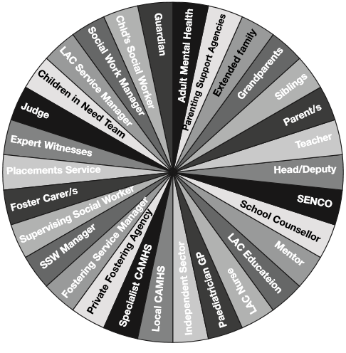
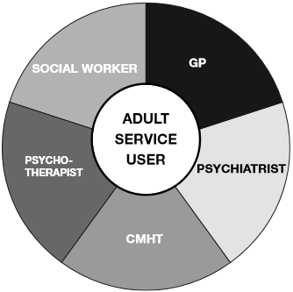
Adult compared to looked after child agency working.
Diagrams: Conway (2009).

Conway (2009) explains that each line that sections each agency can be seen as a ‘point of potential weakness’ in communication and allows for break down in the support of the child.
Munro (2010) notes that child protection inadequacies related to high profile cases have had flaws in agency communication at the centre of the issue. Although this has been addressed with updates made to legislation and procedure such as the requirement of Local Safeguarding Boards under section 13 of the Children Act, (2004). It is of paramount importance that I, as a practitioner remember these weaknesses in my attendance to conferences, constant observations and recordings; so that I may fully protect the children within my care as part of the Children Act (1989).
Having experienced the planning, preparing and running of an initial child protection conference, I now realise the current flaws that serve as the breakdown in safeguarding children are communication difficulties between agencies and colleagues, as well as inadequacies in procedural practice in settings. As stated in the Working Together To Safeguard Children (2015) document, practitioners must strive to develop their own skills and knowledge in this field accompanied by the opportunity for further training, with the intention of the ability to provide children with the utmost protection of their rights (UNCRC, 1990) as bound by the Rights of Children and Young Persons (Wales) Measure (2011), and support in facing Adverse Childhood Experience (2016).
I have gained new skills in communication. Allowing myself to work with people with different values and work styles has aided my professional development by giving me the ability to formulate action plans in a team work setting – such as that in a multi-agency conference. This skill has given value to the diversity of conference panels and to the little amount of time professionals have to act upon children and family needs, proving how important my and the childcare workforce’s understanding of following correct procedure is to this.
I have significantly improved my knowledge of safeguarding procedure and legislation. Since I did not know of the All Wales Child Protection Procedures (2008) prior to this assignment, I now intend to relate my current practice to this in particular; so that I may assess situations with higher capability, aid agencies in the correct manner and; with current practitioner training being basic level; pass on my knowledge to colleagues. I aim to research in to upcoming legislation and procedure to better adjust my practice in the ever changing face of child protection.

