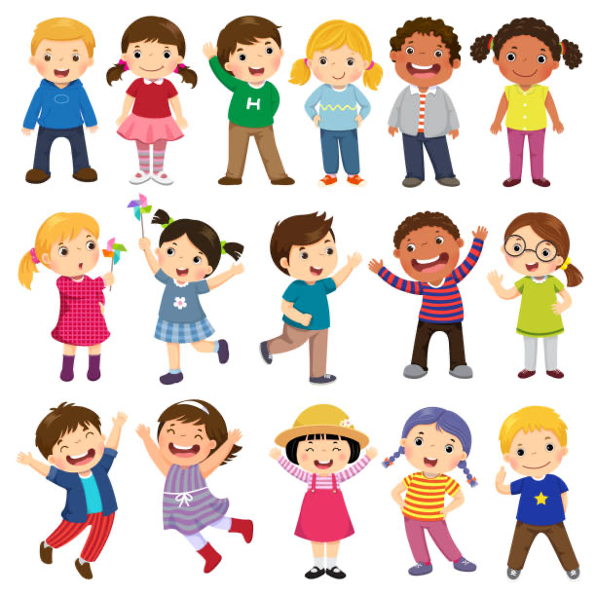
Transitions in the Early Years

(iStock: no date)

Contents page

- Introduction
- What are transitions
- Types of transitions
- Brain development through transitions
- Effects on covid-19
- Effects with additional needs
- Effective communication
- Outcomes positive relationships through transitions
- Outcomes negative relationships through transitions
- Theorists linked to transition
- Conclusion
- References

Introduction

In this handbook, the main focus will be transition and how it effects a child’s development. There will be a variety of alternative resources used throughout, such as reading books, websites, articles, videos, theorists and legislation which will support all of what will be discussed. This handbook has a targeted audience of practitioners working within the age group that is targeted , which is the 2-3 year old age group. It will show the transitions they will go through that will impact their development and will discuss how it impacts them.
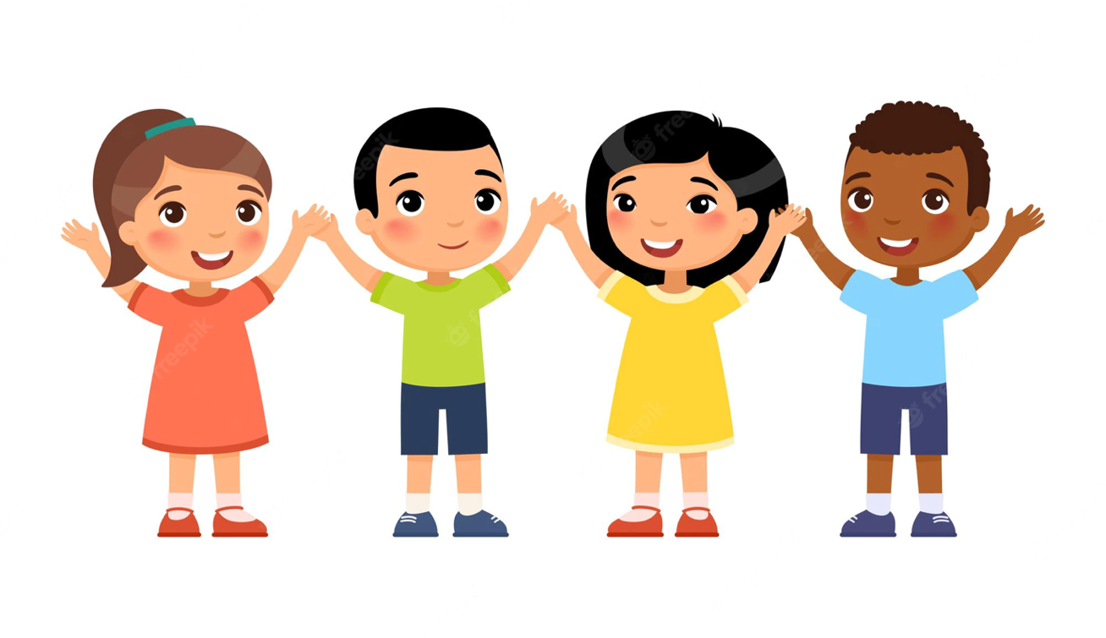

(cartoon kids images: Freepik 2020)

What are transitions?

Transition can refer to your child going through a period of change where there is movement in their life. All children face these transitions, and they can be anticipated and expected. However, there will also ones that will be unpredicted or unexpected. This can be a major change to a child's life. These transitions can happen at any time of their life. Children will need support to cope with these transitions, which are processes and not one-off events (Twinkl, no date).
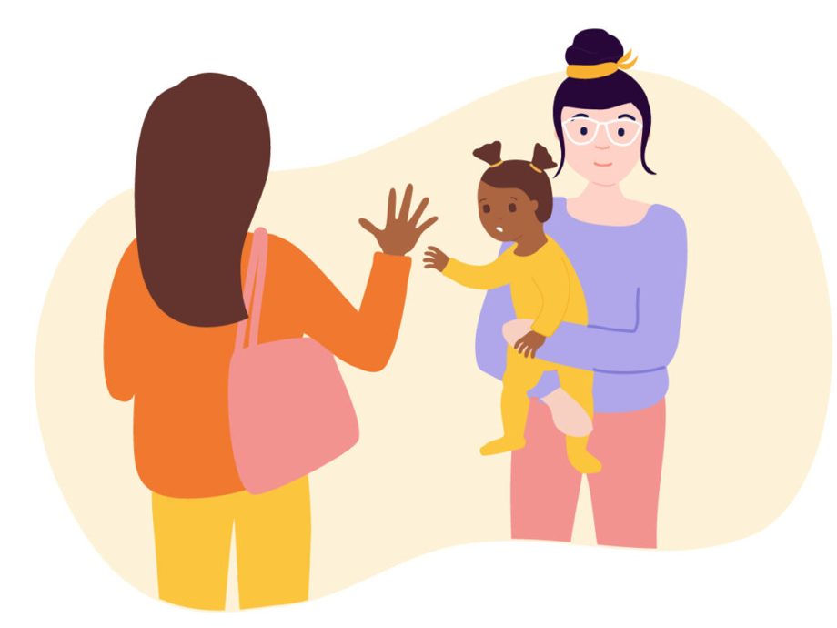

(Early years transitions and how they set up our children for life: family 2020)

Types of transitions

There are three main types of transitions that children in early years go through in their life. These are horizontal, vertical, and education-associated transitions. The horizontal transition that a child goes through in their life is the less significant events that happen in a child's life. This can be events that happen in a child's life every day, where they transition to a next activity or there is a change to their routine. Examples of these would be a child making a movement from going from their house to their car outside their house, or this could also be for a child in school going to a new class, or when they have a change of routine from instead going into school and doing their normal school day routine, they go on a school trip (The open university 2017).
The vertical transition that a child goes through is massive transition change to a child’s life. For example, this could be when a child of the ages 2-3 moves to the age of 3 and has to go from being at home with their parents for their whole life, to them starting nursery. This would be a big change for them where they will need to be supported throughout (University of Southampton 10th July 2018).
Finally, the last transition would be education-associated transitions. This means any form of change of transition that is not in an education setting and is within the home environment. For example, this would be a non-formal experience that can be with your family, carers, or the environment around you, and can affect the child because of the experience (Early Years Matters 2022).

Brain development in transitions

Brain development happens after conception and continues throughout your life. It can be affected by your sight, smell, and your thoughts. It is important to know, that all children's brain develops at different times, speeds and most importantly can develop at any age, which is normal. For a child, the brain develops mostly throughout their childhood, going through different kinds of experiences. However, the biggest changes happen as an infant. The plasticity of the child's brain supports development and allows the brain to change, because of the child’s learning within their environment. This normally is done early within a child life; however, it can happen later. When a child goes through the many transitions in their life, it has a massive positive effect on their brain development and helps them to grow and strengthen their brain cells. They are also able to learn how to deal with the new circumstances around them and to be able to learn on how to adapt (Attachment and Trauma Treatment Centre for Healing, April 2020).
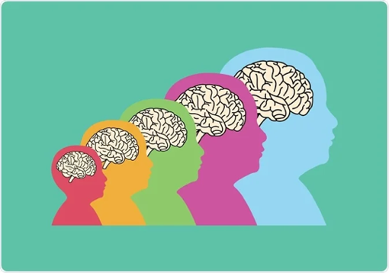

(An overview of brain development: new medial 2022)

Effects of Covid-19

Covid- 19 has impacted so many people throughout the whole of the world, however, there has been a big effect on our children in the early years. There are many effects which will give reasons behind why children who were born in the pandemic, are the way they are today. The children that were born in the pandemic, may suffer when it comes to forming any new bonds when transitioning from being home all the time with their parents, to starting nursery when they turn three years old. The pandemic held a lockdown, which lasted around approximately two years. For a child that was born at a time close to the pandemic, may find it very difficult, not just after the lockdown but may affect them for their rest of their lives in forming bonds. During a child's first 1000 days of their life, they are supposed to learn and develop new bonds which will help their development. If a child does not form any bonds in their first 1000 day of living, they may never be able to develop any form of the relationships with anyone again. If they were to form a relationship, they would find it extremely hard and would need teaching in their adulthood (Pregnancy Birth and baby 2022).
The effects after Covid-19 might affect the child for a while afterwards and it is important to be aware of the effects, so it can remind people that it is normal to experience these issues. This will help to understand the child's behaviour and will put into perspective why they are feeling that certain emotion. It will be then down to the adult to try to communicate with them and see what they need to overcome it.
Another affect might be a massive concern for coming out of the pandemic, is that the child could be starting school with all the worries of them maybe being able to make friends, anxiety of new surroundings, new faces, new routines, eating new foods, new adults around them, separation stress from family.
There are many reasons why starting school for a child after Covid-19 could be a very hard time for everyone. The ways that you could help a child with all of this, could be by doing taster days, staggered starts with hours, have toys out that the child likes, for staff to have good body language and facial expressions and finally by making sure that everyone is patient and aware. (Parents' perceptions of children's emotional well-being during spring 2020 COVID-19 restrictions: A qualitative study with parents of young children in England, no date)

Effects with additional needs
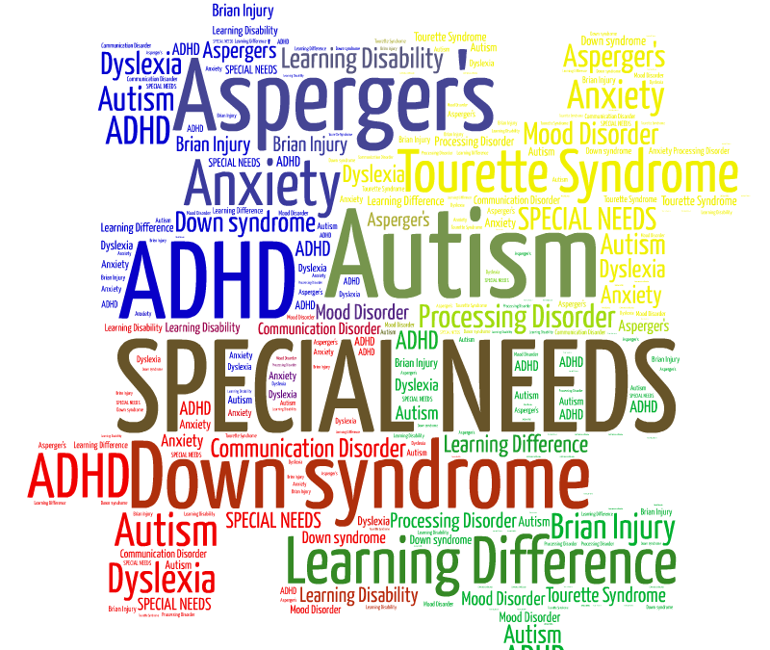

(Support for children with additional needs: windy nook primary 2020)

Transitions can be very hard in the early with years, especially for children that are growing up with additional needs. There are many additional needs that children have, which when going through different kinds of transitions will need a lot of extra support, whether they are expected or unexpected. Children with additional needs struggle generally when it comes to any form of change and find it extremely difficult to be able to adjust to new environments, people and with objects. However, every child with additional needs will adapt with experience and will react to different kinds of transitions compared to other children without additional needs. For example, children with an additional need, when going through a transition might actually benefit and like to have a change every now and then, which may help them learn to grow and develop. However, there are some children with additional need who do not like change and find it very difficult to learn how to cope with changes and find it very difficult. This can lead to bad behaviour, sleep problems and poor mental health and wellbeing.
There are ways that you can help to support a child with additional needs, when going through a transition in their early years. When they are about to start school, make sure that you give them plenty of warning in advance. This could be a month before starting there. By doing this and giving them warnings and happy positive chats about what is going to happen, where you make the transition a happy movement for them. You will be able to support their individual additional needs, this could be by showing them visuals such as the PECS system. This is could be showing the symbol of a happy face next to the school, while also showing a now and next card showing what is happening now to what is to come. Another way to be able to also support a child with additional needs could be by being very calm, kind and patient with them. They will pick up any form of negativity which will rub off on them, making them feel negative to the situation. You can also make sure you give time to them and be understandable (friendship circle, 2022).

Effective communication throughout transitions

Effective communication when a child is going through a transition in their early years, is very important. It is essential to remember that you are communicating with them in a way that will develop them further. There are many kinds of way you can communicate with a child going through a transition to make it more effective. One way would be by making sure that when you communicate, you remember to include the 5 C’s of communication. These are Collaboration, Consistency, Culture, Communication and making it Child Centred, meaning making sure the child is centre of attention with all their needs and requirements for their development are noticed (The Scottish Curriculum, no date).
When a child is about to start going through a transition, it is important that we are using the key factors of communicating, for example, being empathetic to the child, by always being aware of what the child is feeling and going through and by showing empathy. Know that it is a substantial change for them. Also, using positive body language when talking to the child, good eye contact and showing the child the excitement, you have for them. Children give off the same energy that is being released to them in their environment, so if the people around them are showing no joy for them it will be hard for the child to be happy about the transition change and find it hard to deal with emotionally (Early years, April 2019).
There are many people in the process of transition who will need to use effective communication to the early year’s child. Parents will need to be very aware and available for the child making sure they are always there to support the child. They will need to be very inclusive throughout, making sure that they are aware that different children will go through it differently, respond differently and also have different needs which may make it a difficult process.
When the child has started the transition and is now, for example, in school… it is crucial for the staff to be communicating with the child's parents/carers. This can be done by meetings, collection drop of, set up apps, journals, weekly newsletters, emails, and events. Effective communication is crucially important, not only supporting the child through the transition but also by developing them further, with their emotional development, learning how to cope with new emotions, new surroundings around them and using their communication skills to make new friends, so it develops the child. (Parent Education Programme, 2021)

Theorists linked to transition

There have been many theorists over the years, that have been very influential in early year's research, which can be linked to transition. One of the theorists that are linked to transition is Maslow’s Hierarchy Of Needs. Maslow’s theory was that for the child to be able to reach a child's full potential, they will need to reach his pyramid of needs. Maslow's pyramid of needs consisted of a pyramid form list where the bottom of the pyramid what was the child needs the most, leading to the top being where the child's needs are at that moment. Once the child achieves that need, they are to go up on the pyramid, however some children do not go up the pyramid and stay at one point which is normal.
The thought behind the pyramid is that those at the bottom of the pyramid are the Physiological Needs which are air, water, food, shelter, sleep, clothing, and reproduction which are mandatory for a child's needs. Next comes the Safety Needs, which are personal, security, employment, resources, health, and property. Following these are Love and Belonging, which covers friendship, intimacy, family, and connection to which most children have this but not all. The next one is Esteem, which covers respect, self-esteem, status, recognition, strength, and freedom. Lastly, at the top of the pyramid is Self-actualisation to which is there a desire to become the most that one can be (Simply psychology 2022).
The next theorist that is linked to transition, is John Bowlby who was a psychologist. His main theory and main focus was the attachment theory. This was his main theory and was the relationship that the early years child and their primary caregiver's bond is based around. He believed that when a child is born that they are already born programmed to be able to make and develop bonds with people and need this in order to live and survive (John Bowlby 2006).
The last theorist that is linked to transition is Bronfenbrenner. Their theory was the ecological theory, where they talk about where the child and the people the child’s life in the early years, is surrounded by who is their family, home, childcare and school in one part with the extended family, neighbour, work, and health service. The next part of the circle is ideology, laws, culture and social and class. The theory explains how the child's environment state how they are going to be as a person, which helps to develop their cognitive and physical development arises (Dede Paquette 2015).

Outcomes of positive relationships through transition

Children in the early years, are going to go through lots of different kinds of transitions that are expected and unexpected. It is crucial for the child to be able to fully develop when going through the early years. Is important for the child to have positive relationships and to have someone to be there for them to help support and guide them through it all. For many children, going through a transition it can be very unsettling for them and they need all the support that they can receive. The benefits of it are that for the child's health and wellbeing, it will make them feel like very well respected and make them feel safe and secure, with them feeling that they can get through the transition. This will make the transition go a lot cleaner and quicker, with the child feeling like they can do it.
By the child having a bond with their prime carer in their life and having that positive relationship, will help the child to be able to form new bonds. When starting their transition of starting school, it will enable them to be able to make new friends in their classes, which will help them in many ways with their development such as their social, emotional, and intellectual development (Cram, no date).

.
(Principles and values of health and social care : WJEC 2019)

Outcomes of negative relationships through transition

If a child does not have a positive relationship with their care giver, it will lead to an extremely negative transition experience and will have a negative affect on them. The child not having a positive experience may struggle to be able to fit in through the school transition. They will not be able to make friends with many children there, due to not having that experience of having a connection or a bond, with anyone at home. They will feel or be isolated when there and will be at risk of potential bullying in the future, from a child looking at things differently to everyone else. This may cause a lot of problems for the child when going through transition and may trigger bad behaviour either at home or at their new transition environment, which can show in tantrums, outbursts and complaining. This will become a very unsettling experience for the child, where they are not having any support given to them where they will need a positive role model to help guide and support them all the way through it. For a child not having any warning of a transition, not being supported throughout it or having been taught what is a transition and how to deal with it, will be a very traumatic time for the child. They may not be able to develop to their full potential.

(How to spot the signs of a toxic relationship: her world 2020)

Conclusion
It is extremely important to look at the transitions of a child during their early years. It has been shown that it can have an extreme affect, on their later years. For a child to transition through the different stages, they need to have strong bonds with their care givers, and support to work through the huge changes within their life. It is important for children to have access to these stages early, however it is still possible for them to go through them in later life.
If there is a lack of bonds or transitions, it can create situations where children are not able to develop relationships in later life which can have a huge impact on their lives.
Parents, care givers and teachers all need to make sure that these transition periods are supported and that every child gets the opportunity to grow, develop and experience a full future.
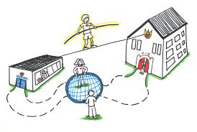

(New early childhood transition support: confident parents confident kids 2014)

Reference list

(Early years transitions and how they set up our children for life: family 2020)
Attachment and Trauma Treatment Centre for Healing (April 2020) How Attachment Impacts Brain Development & Strategies to Strengthen Connection & Emotional Awareness. Available at https://www.youtube.com/watch?v=L0zect1onlA
Chambers, Stephanie ; Clarke, Joanne ; Kipping, Ruth ; Langford, Rebecca ; Brophy, Rachel ; Hannam, Kim ; Taylor, Hilary ; Willis, Kate ; Simpson, Sharon A. (no date) Parents' perceptions of children's emotional well-being during spring 2020 COVID-19 restrictions: A qualitative study with parents of young children in England
Cram (no date) Positive Relationships During Periods of Transition. Available at https://www.cram.com/essay/Positive-Relationships-During-Periods-Of-Transition/F3UFYXR47CJP#:~:text=Children%20with%20positive%20relationships%20are,during%20their%20time%20of%20transition
Dede parquet (2015) Bronfenbrenner's Ecological systems theory. Available at https://dropoutprevention.org/wpcontent/uploads/2015/07/paquetteryanwebquest_20091110.pdf
Early years (April 2019) Communicating with parents is the key to success. Available at https://www.iris.co.uk/blog/education/early-years-communicating-parents-key-success/#:~:text=Effective%20communication%20makes%20transitions%20throughout,can%20help%20keep%20children%20safe.
Effective parent-child communication (2021) Parent education programme. Available at https://www.youtube.com/watch?v=lJMZNDvRp6I
Hilary Fabian; Aline-Wendy Dunlop: McGraw-Hill Education. (2006) Informing Transitions in the Early years https://www.simplypsychology.org/maslow.html
Jeremy Holmes. (2006) John Bowlby and Attachment theory
Pregnancy Birth and baby (June 2022) The first 1000 days. Available at https://www.pregnancybirthbaby.org.au/the-first-1000-days#:~:text=1%2C000%20days'%3F-,The%20first%201%2C000%20days%20refers%20to%20a%20child's%20life%20from,effect%20on%20your%20baby's%20future.
Simply psychology (April 2022) Maslow's Hierarchy of Needs. Available at
The open university (2017) 3 children's transitions. Available at https://www.open.edu/openlearncreate/mod/oucontent/view.php?id=79794&section=3
Transitions friendship circle (2022) 7 ways to help your child with special needs cope with. Available at https://www.friendshipcircle.org/blog/2017/05/10/coping-with-transitions/

Transitions. Early Years Matters (2022). Available at https://www.earlyyearsmatters.co.uk/eyfs/positive-relationships/transitions/

Twinkl (no date) Different types of Transition. Available at https://www.twinkl.co.uk/blog/different-types-of-transitions-in-child-development#:~:text=A%20transition%20is%20a%20period,upon%20them%20in%20different%20ways.
University of Southampton(10th July 2018) Exploring the experiences of horizontal transitions and the upcoming vertical transition to primary school from the perspectives of young autistic children and their parents and the staff at an inclusive nursery setting. Available at https://acorns-soton.org.uk/wp-content/uploads/2019/01/Jessica-Baker-Executive-Summary-FINAL.pdf

