8/11/2026
CertHE COMPUTING SKILLS FOR THE WORKPLACE
Module: COMPUTER ARCHITECTURE AND OPERATING SYSTEMS, ACCA4022_LON
Assignment 2: OPERATING SYSTEMS
Lecturer: DR. REDHWAN AI-AMRI

Student Name: Rumyana Bicheva
Student ID: 2527182
Group: 2
Email: 2527182@student.uwtsd.ac.uk
University of Wales Trinity Saint David– London campus

INTRODUCTION
Operating systems play a fundamental role in modern computing by enabling communication between users, application software, and computer hardware. They have evolved significantly over time to support increasingly complex computing environments, ranging from personal computers and servers to cloud-based and embedded systems. Alongside the development of graphical user interfaces, command-line interfaces have remained an essential tool for system administration, automation, and troubleshooting on higher administrator level.
This report explores the practical use of modern operating systems by examining their key functions and demonstrating how command-line interfaces can be used to perform a range of administrative tasks. It includes examples of Windows Batch, PowerShell, and Linux Bash commands covering process management, file and directory management, network monitoring, user management, and task scheduling. In addition, the report presents examples of scripting in both Windows and Linux environments to demonstrate how repetitive administrative tasks can be automated, improving efficiency, reducing manual effort, and supporting effective system administration.

Contents
INTRODUCTION 1
Task 1. Key Functions of General Operating Systems 3
Process Management and Processor management 3
Process management 3
Processor management 3
Memory management 6
Disk management 6
File System Management 7
Task Scheduling 8
Security and protection management 9
Task 2. Windows OS CLI commands 10
Process Management 11
File and directory management 14
User management 17
Network testing/monitoring 18
Task schedule 20
Task 3.Linux OS CLI commands 22
Process management 23
File and directory management 25
Network testing/monitoring 27
User management 28
Task scheduling 28
Task 4. Windows OS script 30
Task.5 Linux OS script 37
CONCLUSION 40
REFERENCES 41

Task 1. Key Functions of General Operating Systems
According to Andrew S. Tanenbaum, author of Modern Operating Systems and creator of the educational OS MINIX, OS is the fundamental system software that manages the hardware resources of a computer system and provides an environment for executing application programs. The most widely used OS are Windows, macOS, and Linux.[1]
The two main purposes arise from the way we view OS. If we take the perspective of the end user, or a top-down view, the OS is the first layer above the raw hardware and provides the foundation for all other software by offering abstractions that hide the complexity of the hardware and simplify the development and use of application software. Users interact with the system through a text-based Command User Interface or Graphical User Interface which uses windows, menus, and graphical elements. The Shell interprets and executes text-based commands, while the Application Programming Interface enables applications to access OS services and resources without interacting with them directly. [1]
On the other hand, considering the complexity of the computer architecture (Computer System Components), the OS acts as a resource manager in order to organize and control the efficient use of hardware resources - the processor, main memory, disk space, and input/output devices - among different programs and users, by multiplexing resources in time and space.[1]
The main functions derived from this can be categorized as follows:

Process Management and Processor management
Process management - A process is a program in execution and basic unit of work in a modern time-sharing system. It is a core function responsible for scheduling and controlling process execution through by creating, terminating, synchronising, and coordinating processes, ensuring that system resources are used efficiently. [2]
Processor management focuses on the efficient allocation of CPU time among processes through CPU scheduling in Kernel mode, ensuring efficient and fair utilization of the processor.[2]
Task Manager is a system utility in Windows that enables the monitoring and management of running applications, processes, services, and hardware resources in real time. Starting in the different interface of user mode or run mode is right click on the windows icon or Ctrl+Shift+Del and win+r , “taskmgr”.
Fig.1 shows all working processes and how they use CPU, memory and disk space.
figure 1 Processes management
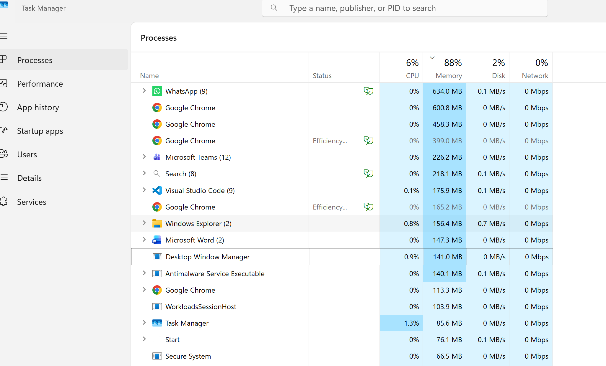
In menu performance we can see CPU, Memory, GPU, DISK, wi-fi and NPU performance, Fig.2.

figure 2 CPU, Memory Performance
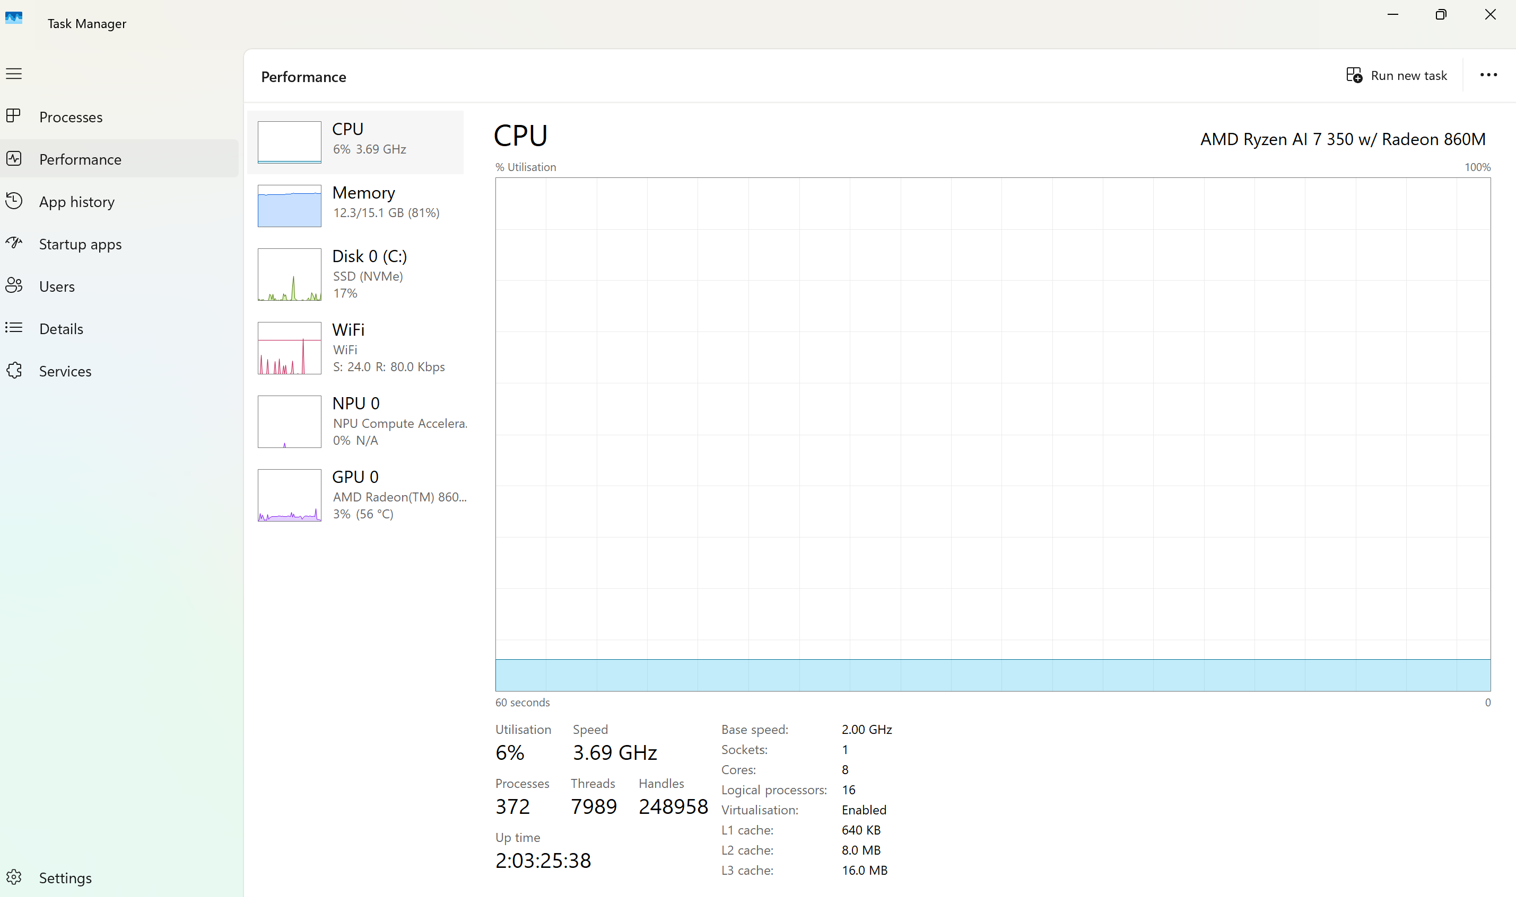

Click on the right corner of this window or writing “resmon” in Run mode open Resource Monitor, shows in detail the CPU, memory, disk and network usage of each process, Fig.3
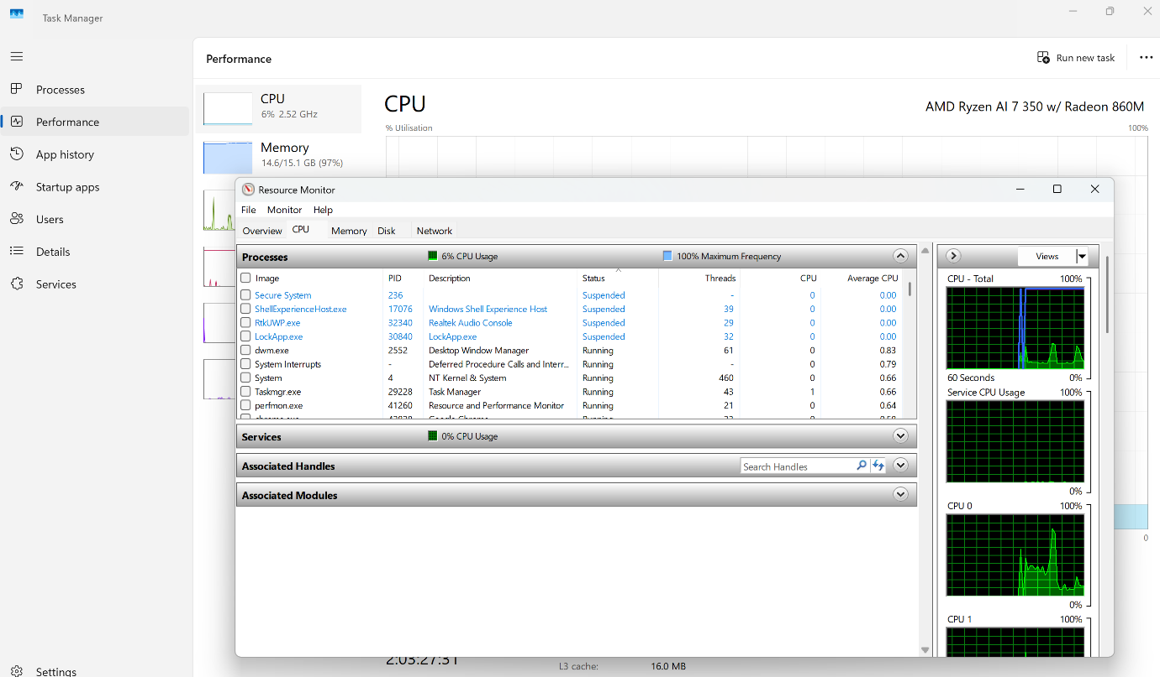
figure 3 Resource Monitoring

Memory management
Main Memory Management is responsible for controlling and coordinating the use of the computer’s main memory (RAM-Random Access Memory) among active processes. It maintains information about memory allocation, identifies which memory regions are currently in use and by which processes, and determines which processes should be loaded into memory when space becomes available. The operating system also performs dynamic allocation and deallocation of memory to ensure efficient utilization of resources and to support concurrent program execution. [2]
Main memory management can be monitored through the Performance and Processes tabs in Windows Task Manager, Fig.4.
figure 4 Main Memory management
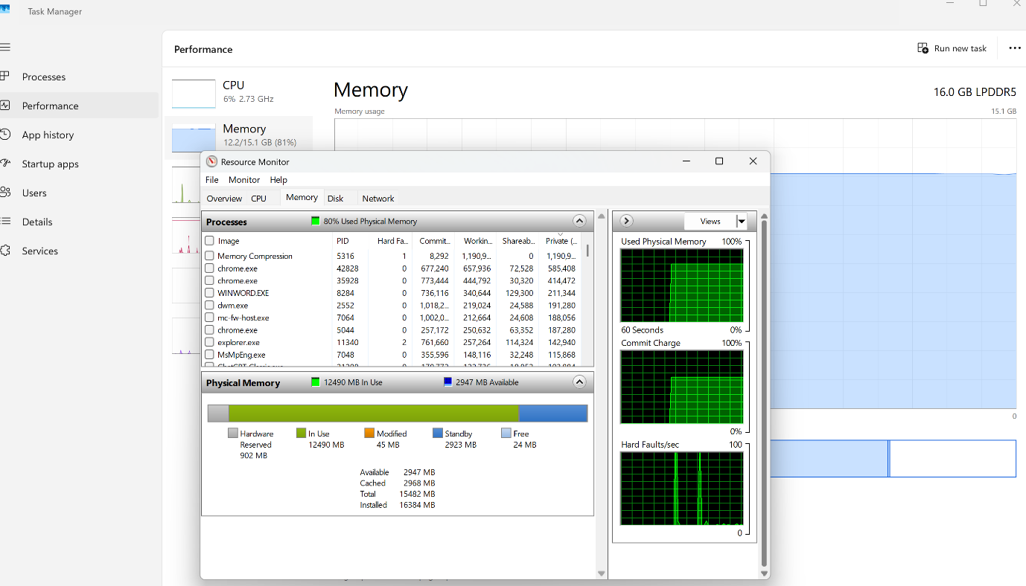

Disk management
Controls how secondary storage devices, such as hard disks and SSDs, are used. Since RAM is volatile and limited in size, secondary storage is used to permanently store programs and data. The OS manages this storage by tracking free space, allocating disk space to files, and scheduling disk operations efficiently to improve performance. It is accessed through Disk Management, Fig.5

figure 5 Disk management
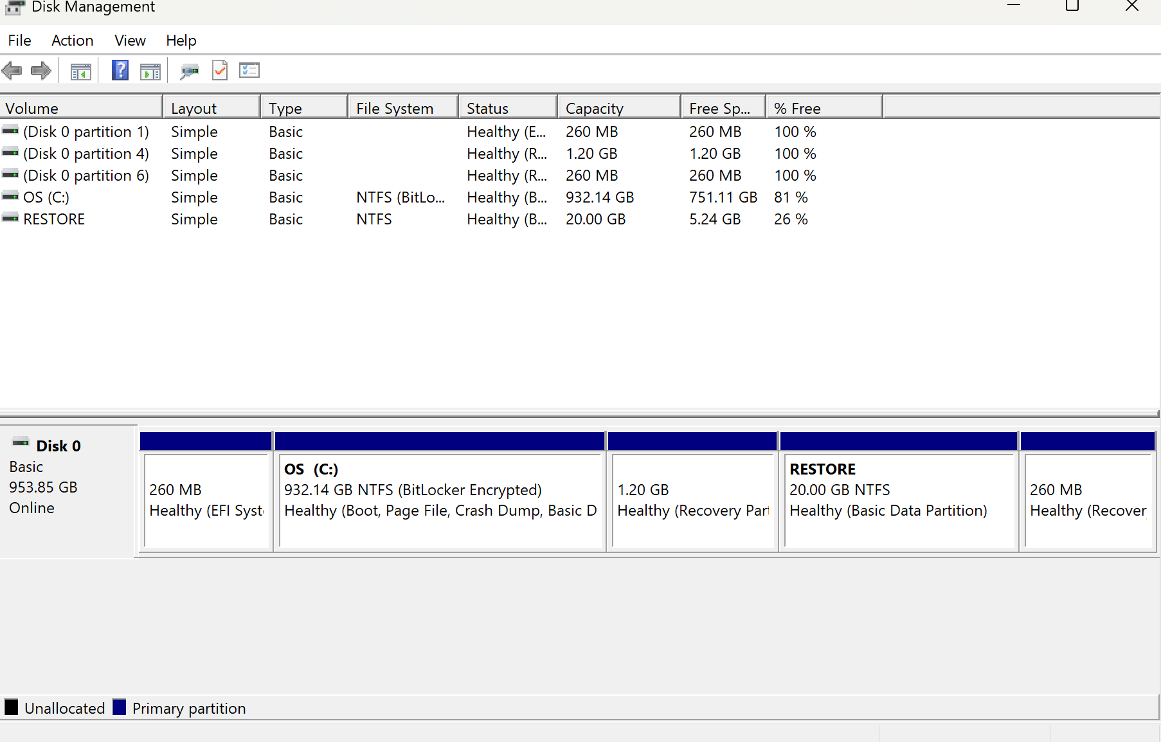

File System Management
Allows users to organize files, manage directories, and control storage structures on disk volumes. File Explorer gives this access, Fig.6
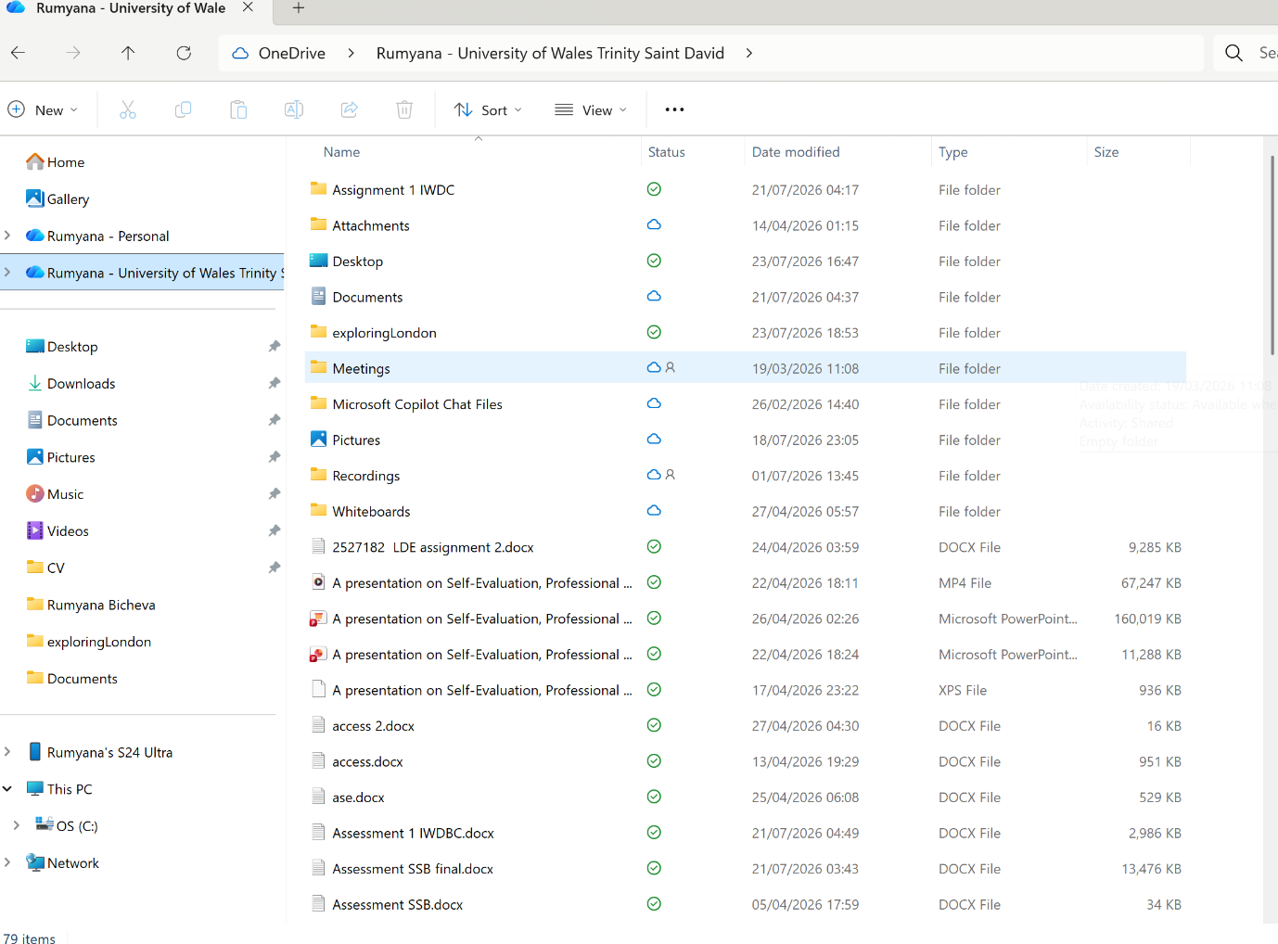
figure 6 File explorer

Task Scheduling
Function that determines when and in what order tasks are executed through automatic scheduling based on time or determined events. [2]
As an example, you can set Explorer to open when you start your computer. Much more precise conditions such as user, battery power, network connection are also possible. Via taskschd.msc in Run dialog box, task scheduler opens, Fig.7
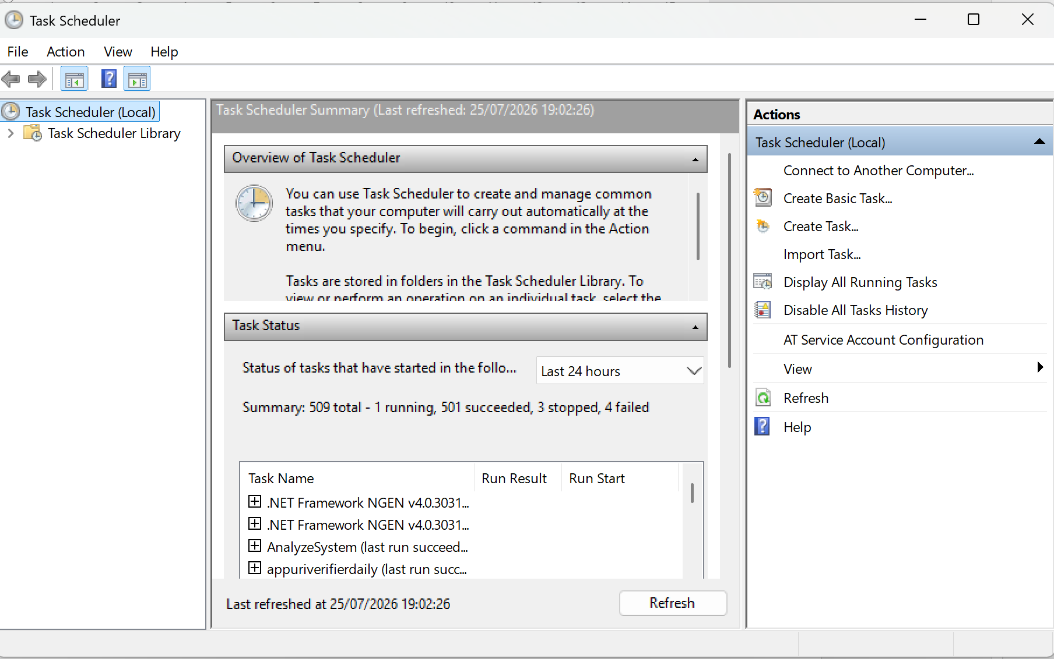
figure 7 Task scheduler

Security and protection management
Controls authentication, authorization, and the protection of system resources. Interfaces such as Windows Security and policy management tools, Fig.8.
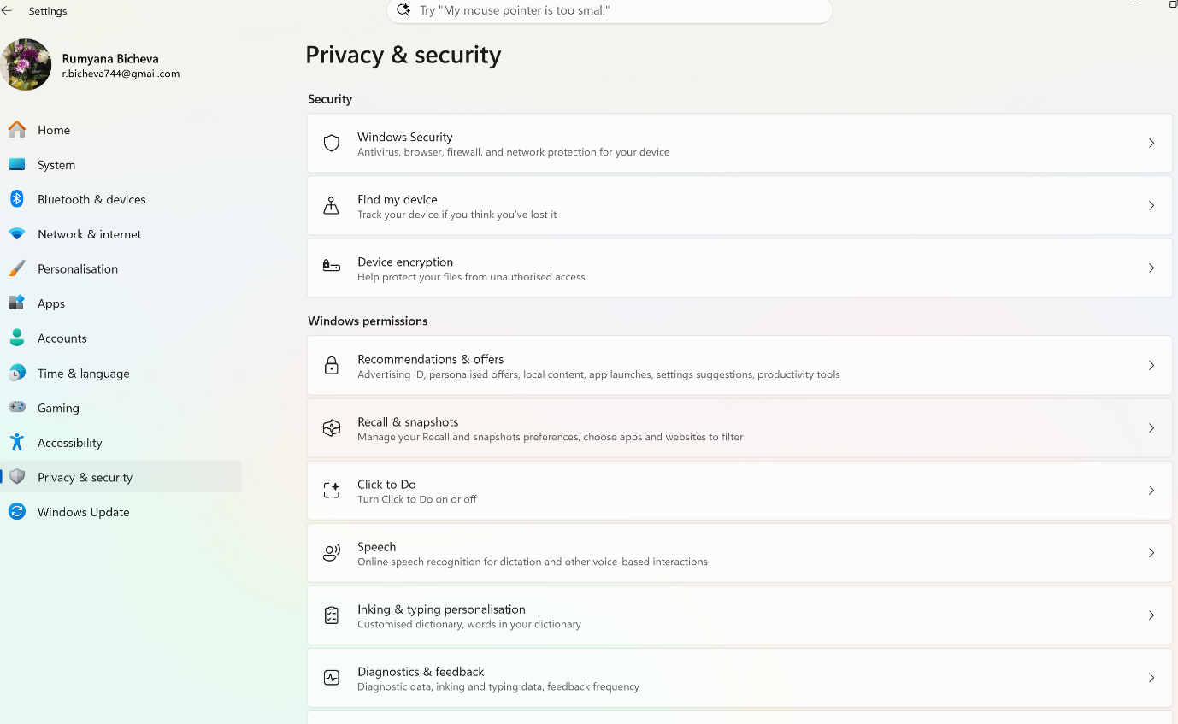
figure 8 Privacy and security settings

Highlight the core functions of the operating system clearly why Tanenbaum says, “it is the software that runs in Kernel mode - and even that is not always true”. OS is a comprehensive hierarchical system that exercises control over the hardware, linking application software with physical resources and ensuring their efficient utilization while facilitating user interaction. It simultaneously provides users with access rights and protects the underlying hardware resources.

Task 2. Windows OS CLI commands

Microsoft Windows is a family of operating systems developed by Microsoft for personal computers, laptops, and servers. First released in 1985, it provides a graphical user interface (GUI) while also supporting command-line tools such as Command Prompt and PowerShell. Windows is the world's most widely used desktop operating system due to its ease of use, broad hardware and software compatibility, regular updates, and extensive technical support. These features make it suitable for home, business, and educational use.[3]
The Windows Command Line Interface (CLI) is a text-based interface that allows users to control and administer the Windows OS by typing commands instead of using graphical user interface (GUI). It is widely used for system administration, troubleshooting, and task automation. [4]
CLI commands are important because they provide fast and efficient way to perform administrative tasks that are difficult or time-consuming through the graphical interface. They are particularly useful for automating repetitive tasks, searching for information, managing processes, and obtaining detailed system information. In many cases, the command line is faster, more accurate, and provides greater control over the operating system than GUI.[5]
For Windows OS, they are executed through two CLI: Command Prompt (CMD), which runs Batch commands, and PowerShell commands (cmdlets). Both provide a text-based interface for managing and administering the Windows operating system.
CLI commands are related to the core functions of the operating system.

Process Management
In Command prompt the following Batch command displays all currently running processes, Fig.9

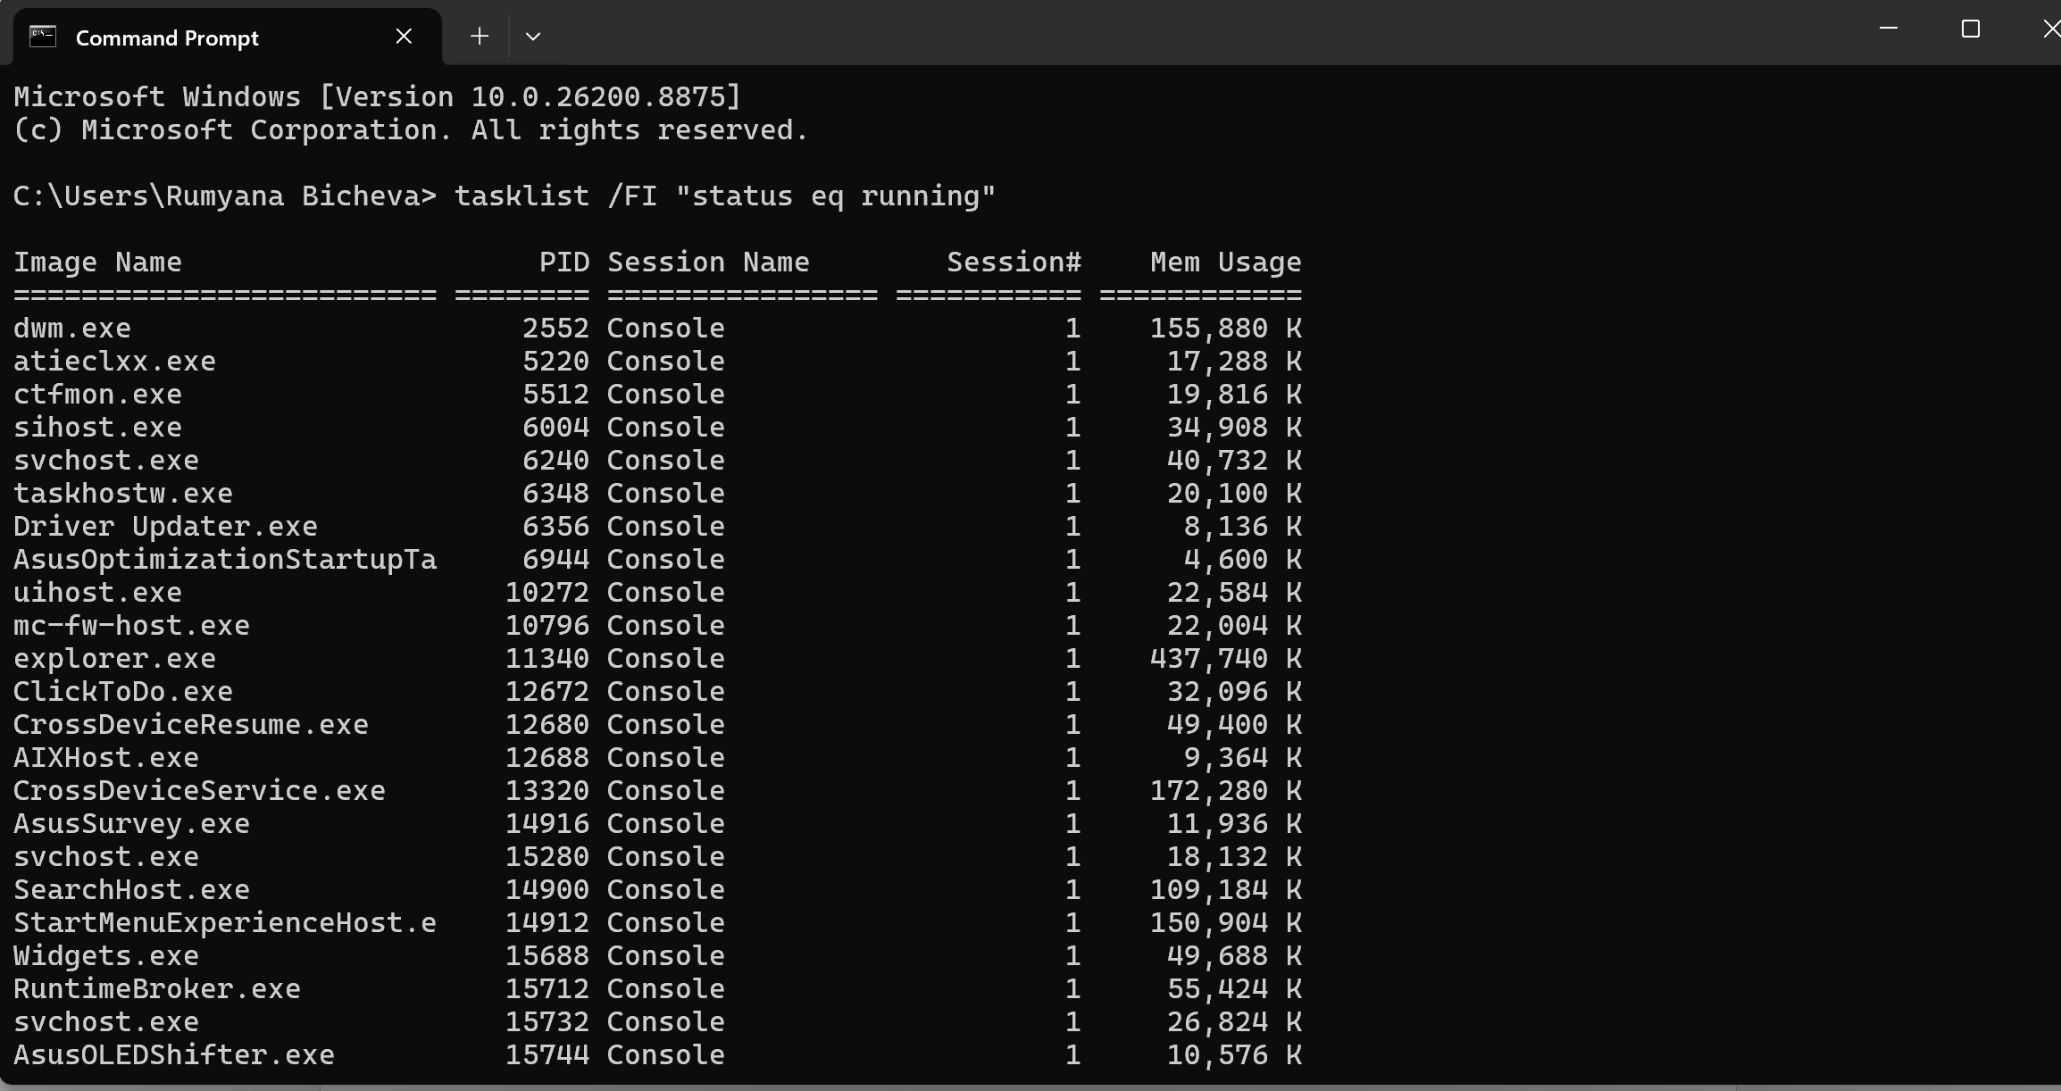
figure 9 Command Tasklist with filter

The /FI switch applies a filter, so only running processes are displayed. The output includes the process name, Process ID and memory usage. Microsoft describes tasklist as a command for displaying processes running on local or remote computers.
A process notepad.exe can be terminated using: taskkill /IM notepad.exe /F, Fig.10. /IM identifies the process by its executable name, while /F forces termination.
figure 10 Command TaskKill
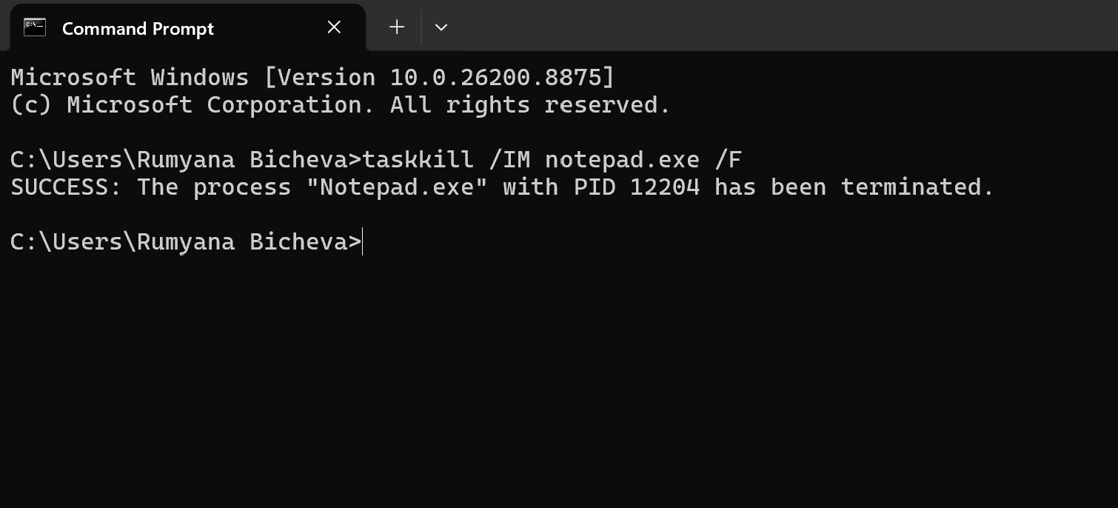
To display all running processes, will use the command Tasklist without filter, Fig.11.
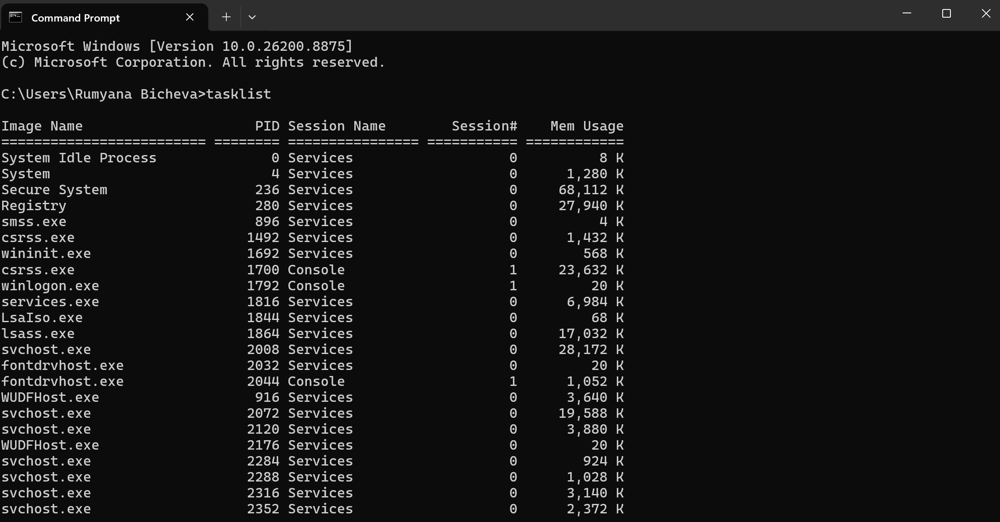
figure 11 Command Taskkill

PowerShell offers more system administration capabilities than the traditional Command Prompt (CMD). More detailed process information with PowerShell, Fig.12.
PowerShell uses a pipeline to connect multiple commands, where the output of one command becomes the input of the next. Unlike traditional command-line interpreters such as Command Prompt, PowerShell passes objects rather than plain text through the pipeline. This object-based approach makes filtering, sorting, and processing system information more efficient and simplifies task automation.[4]
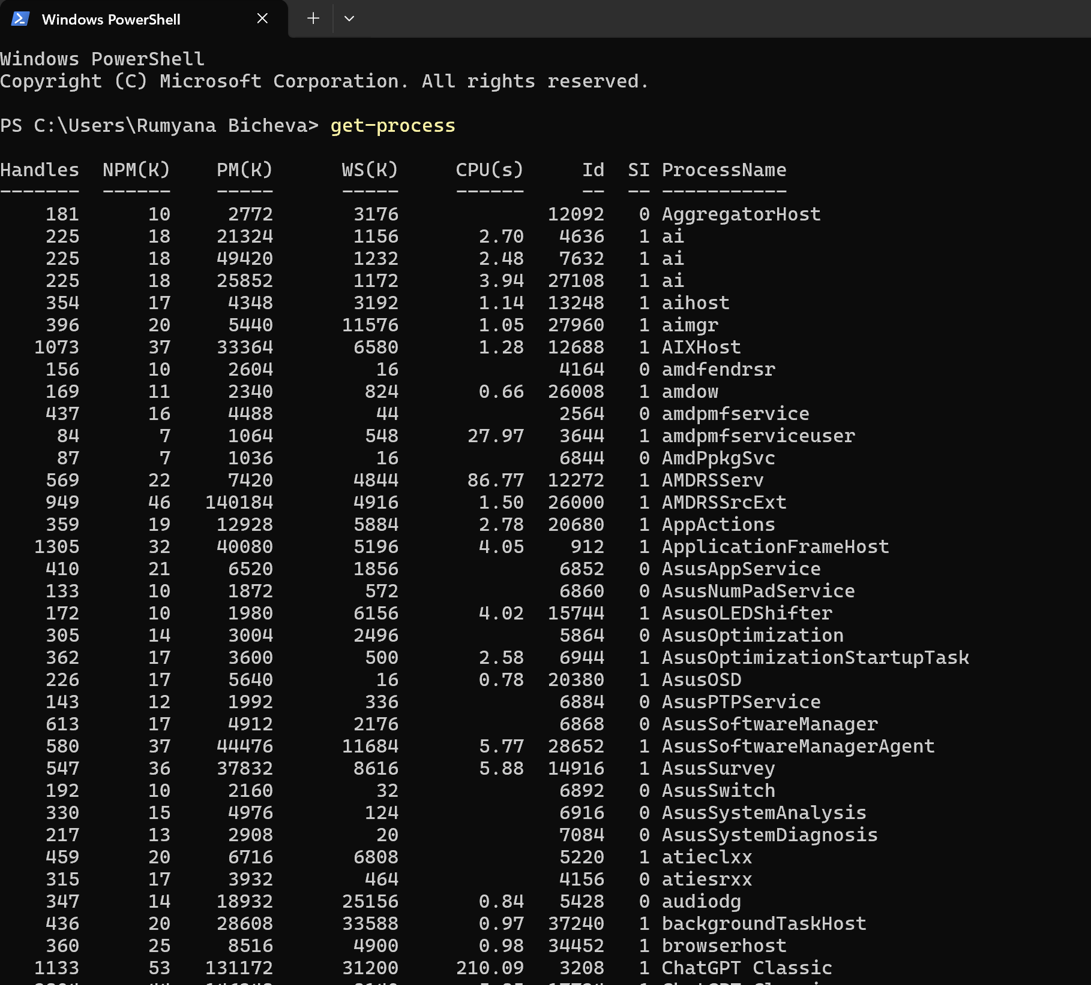
figure 12 Processes management

File and directory management
Commands are used to create, copy, move, rename, and delete files and directories, as well as to navigate through the file system.
Command Dir Displays files and directories in the current directory, Fig. 13

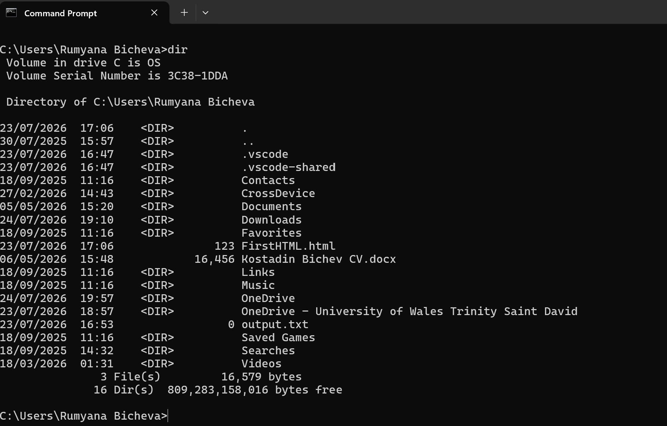
figure 13 Command DIR

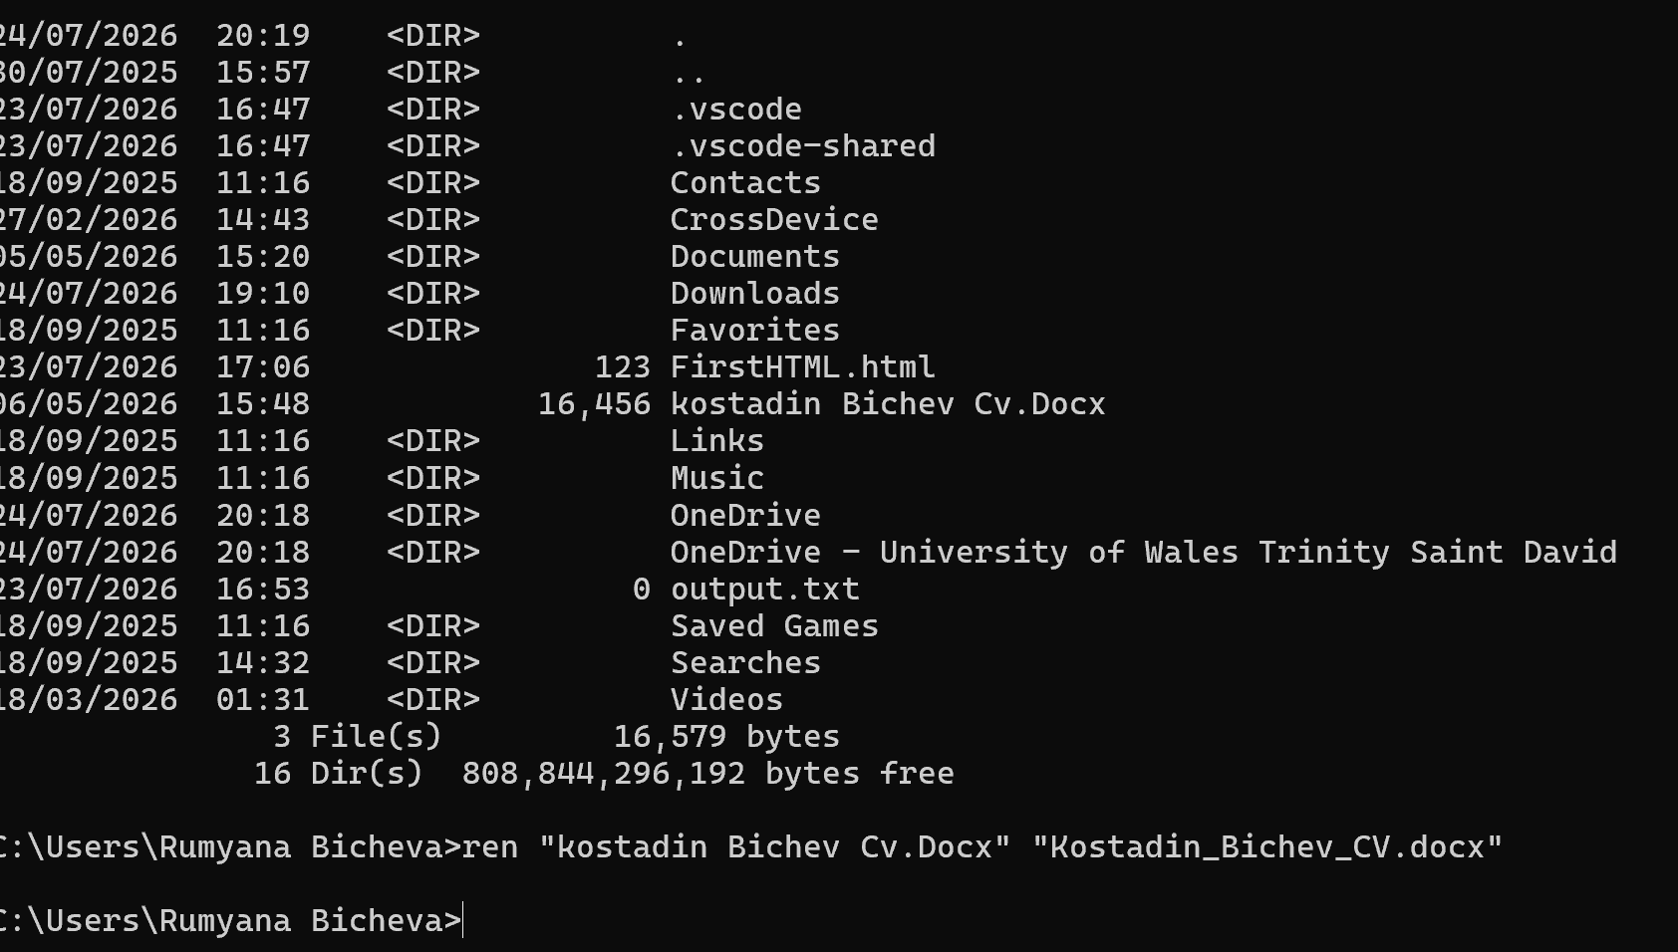
Command Ren - renamed, Fig14 and Fig.15 is result.
figure 14 Command REN

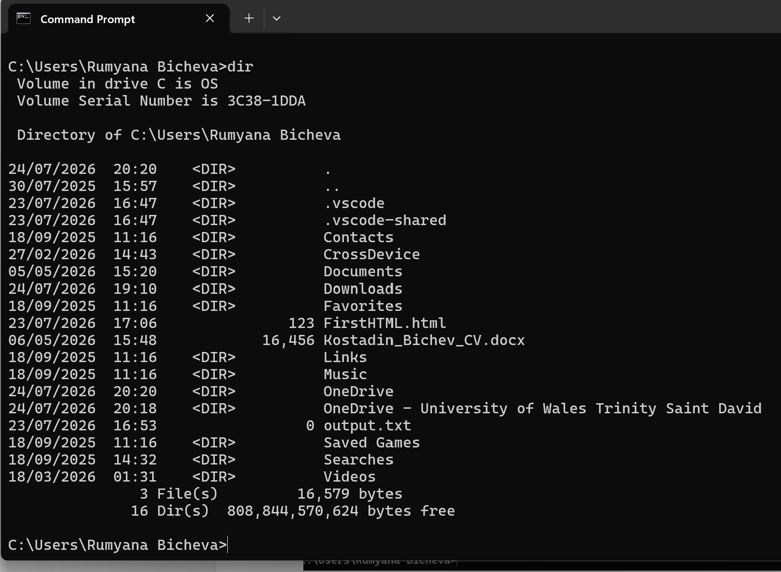
figure 15 Renamed File Kostadin_Bichev_CV

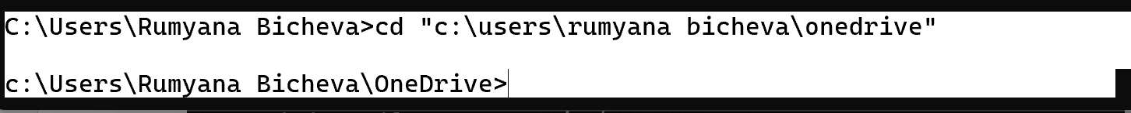
Commands for changing directory, delete file, аnd showing the components inside the directory, Fig.16 and Fig.17. Remove-Item deletes a file or directory. In this example, the command removes the specified file from the current location and get-childItem shows the result.
figure 16 Command CD

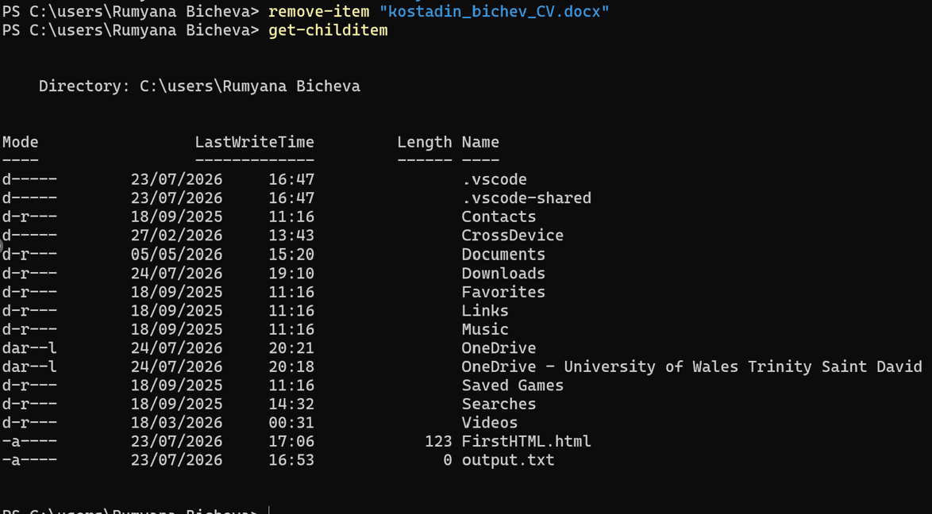
figure 17 Command Remove-item and Get-childitem

User management
Net user command, Fig.18, displays detailed information about a specified local user account. This command is commonly used for user account management and system administration.[6]
In this example, the command retrieves information for the user account "Rumyana Bicheva", including the account status, password settings, last logon time, account expiration, and group memberships.

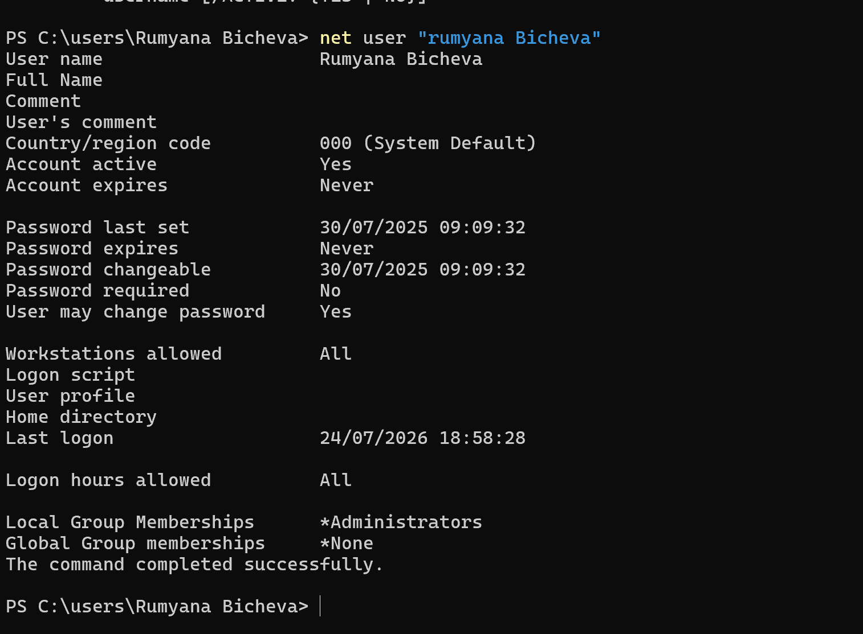
figure 18 Command Net user

Whoami command in CMD displays the name of the currently logged-on user, Fig.19. It is useful for verifying the active user account and security context.

figure 19 Command WhoamI
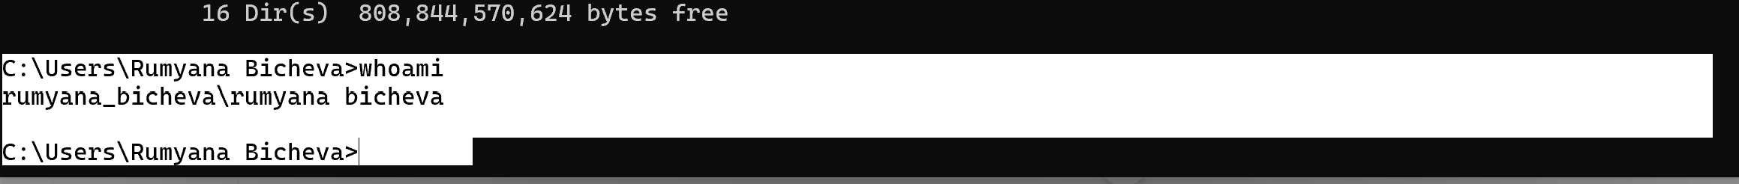

Network testing/monitoring
PING command is used to test network connectivity between the local computer and a remote host. It sends request messages and measures the response time. In example, the command successfully connects to google.com, showing that the network connection is working correctly, Fig.20
figure 20 Command Ping
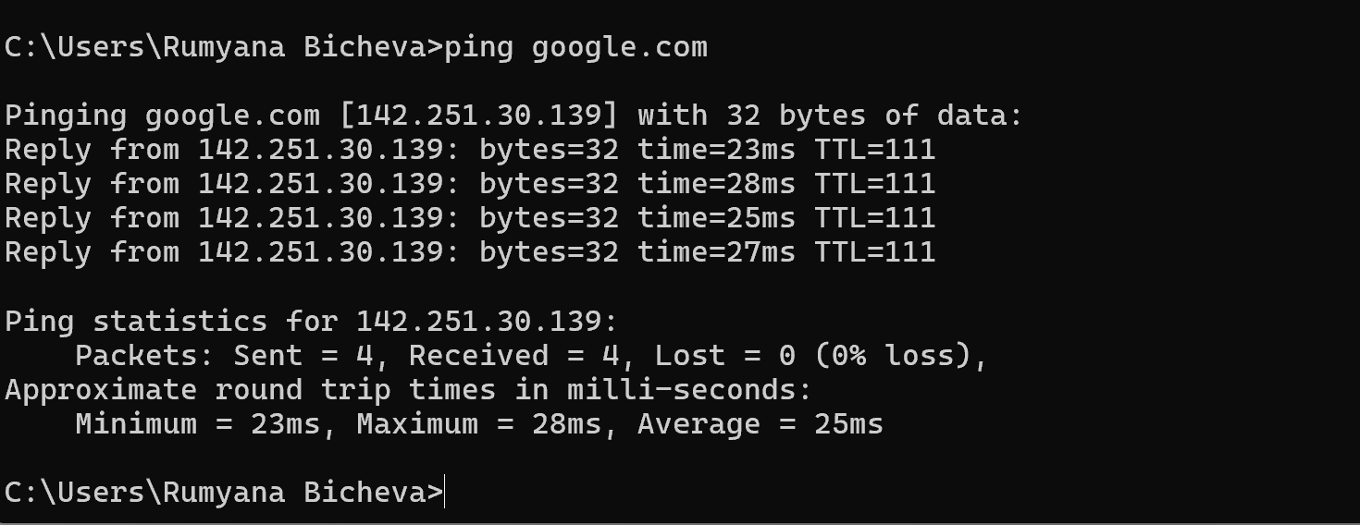

IPconfig displays the IP configuration of all network adapters on the local computer, Fig.21
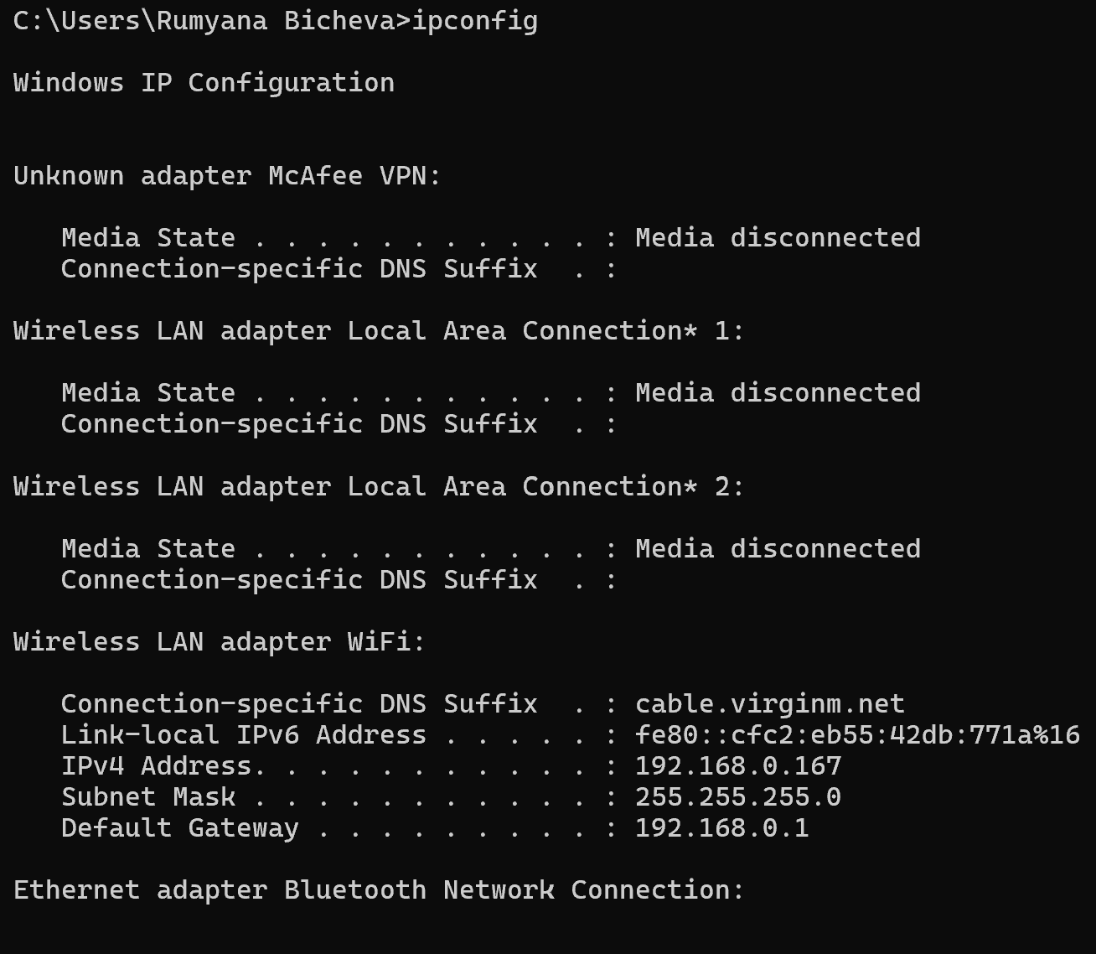
figure 21 Command IPconfig

Task schedule
Get-ScheduledTask cmdlet displays all scheduled tasks configured on the local computer. It provides information such as the task name, task path, and current task state, allowing administrators to monitor and manage scheduled tasks, Fig.22. Select-Object -First 20 limits the output to the first 20 tasks, Fig. 23.
figure 22 Command Get-scheduledtask
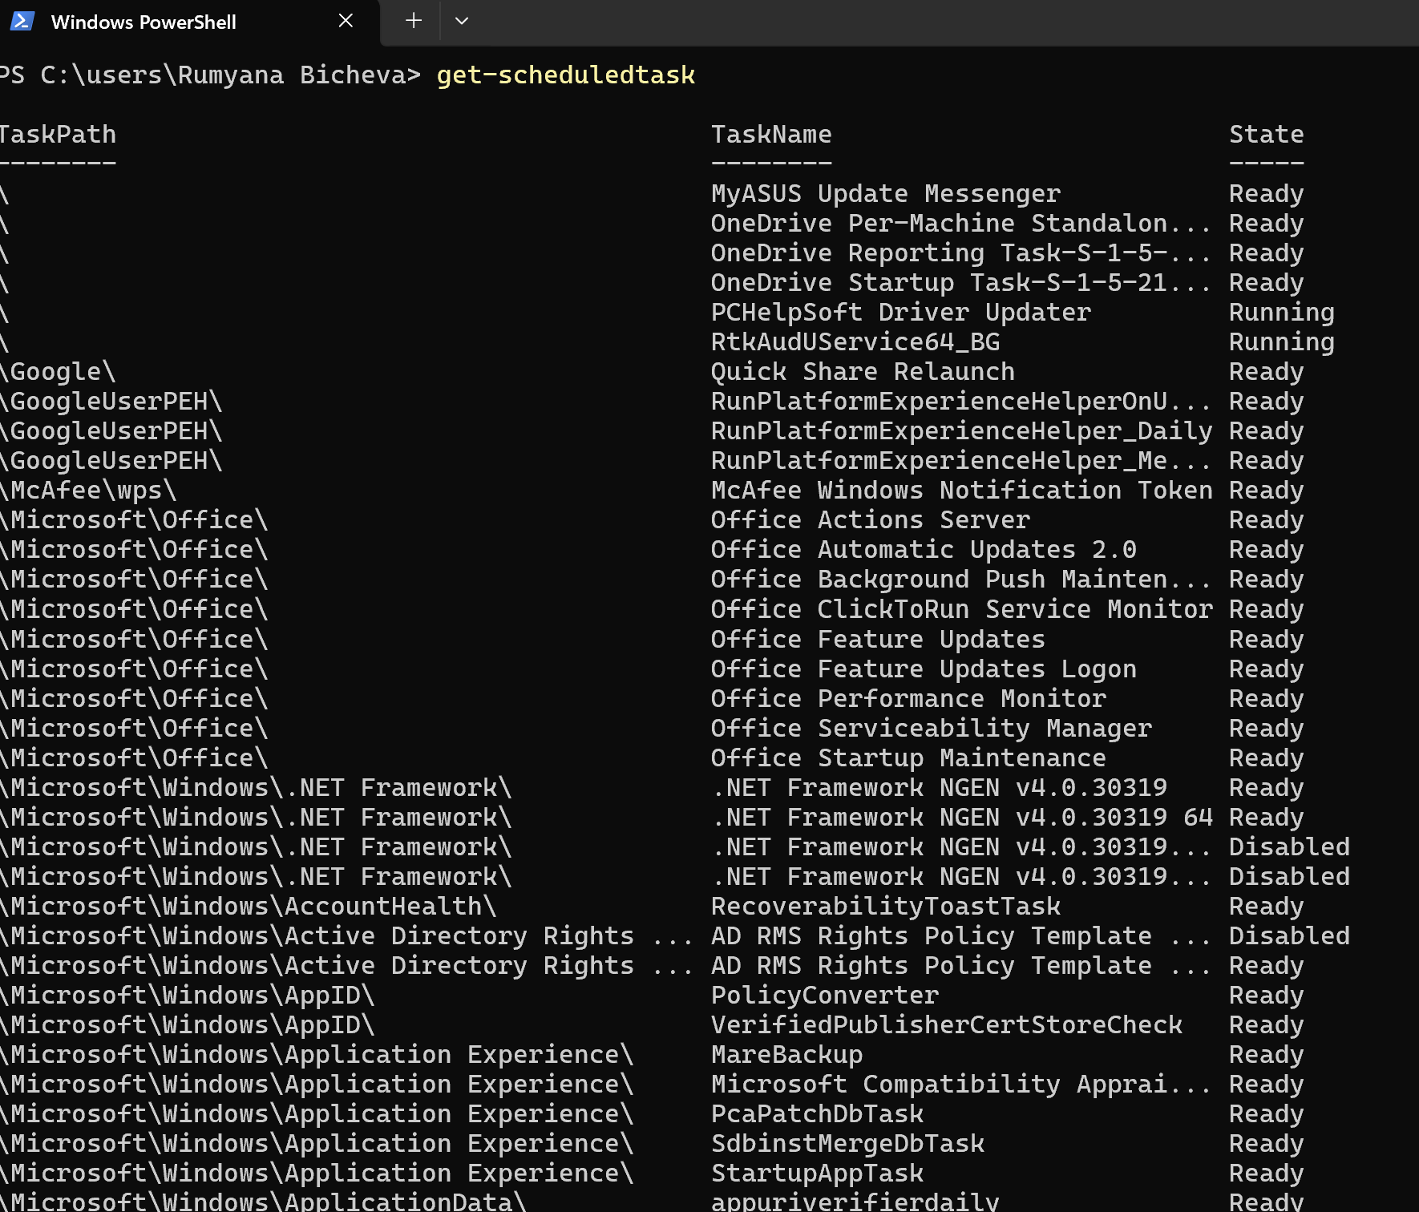

figure 23 Get-scheduledTask with filter
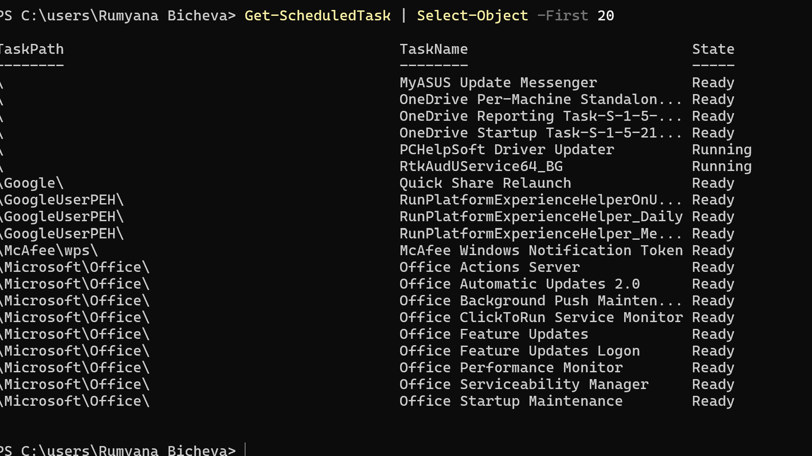

Task 3.Linux OS CLI commands
Linux is created by Linus Torvalds in 1991 and based on Unix that uses a monolithic kernel. It is open-source OS, or its source code is freely available, allowing users and developers to view, modify, and improve. Linux is lightweight, efficient, and portable, running on a wide range of devices from servers and personal computers to smartphones and embedded systems. It is also known for its strong security, stability, and reliability and free, making it a popular choice for developers, businesses, and system administrators.[7]
The command interpreter for Linux is the Bash shell.
Linux commands will be demonstrated using Windows Subsystem for Linux (WSL), launched from Windows PowerShell. This allows Linux Bash commands to run directly within Windows, fig.24.

figure 24 Ubuntu Linux through Windows Subsystem for Linux
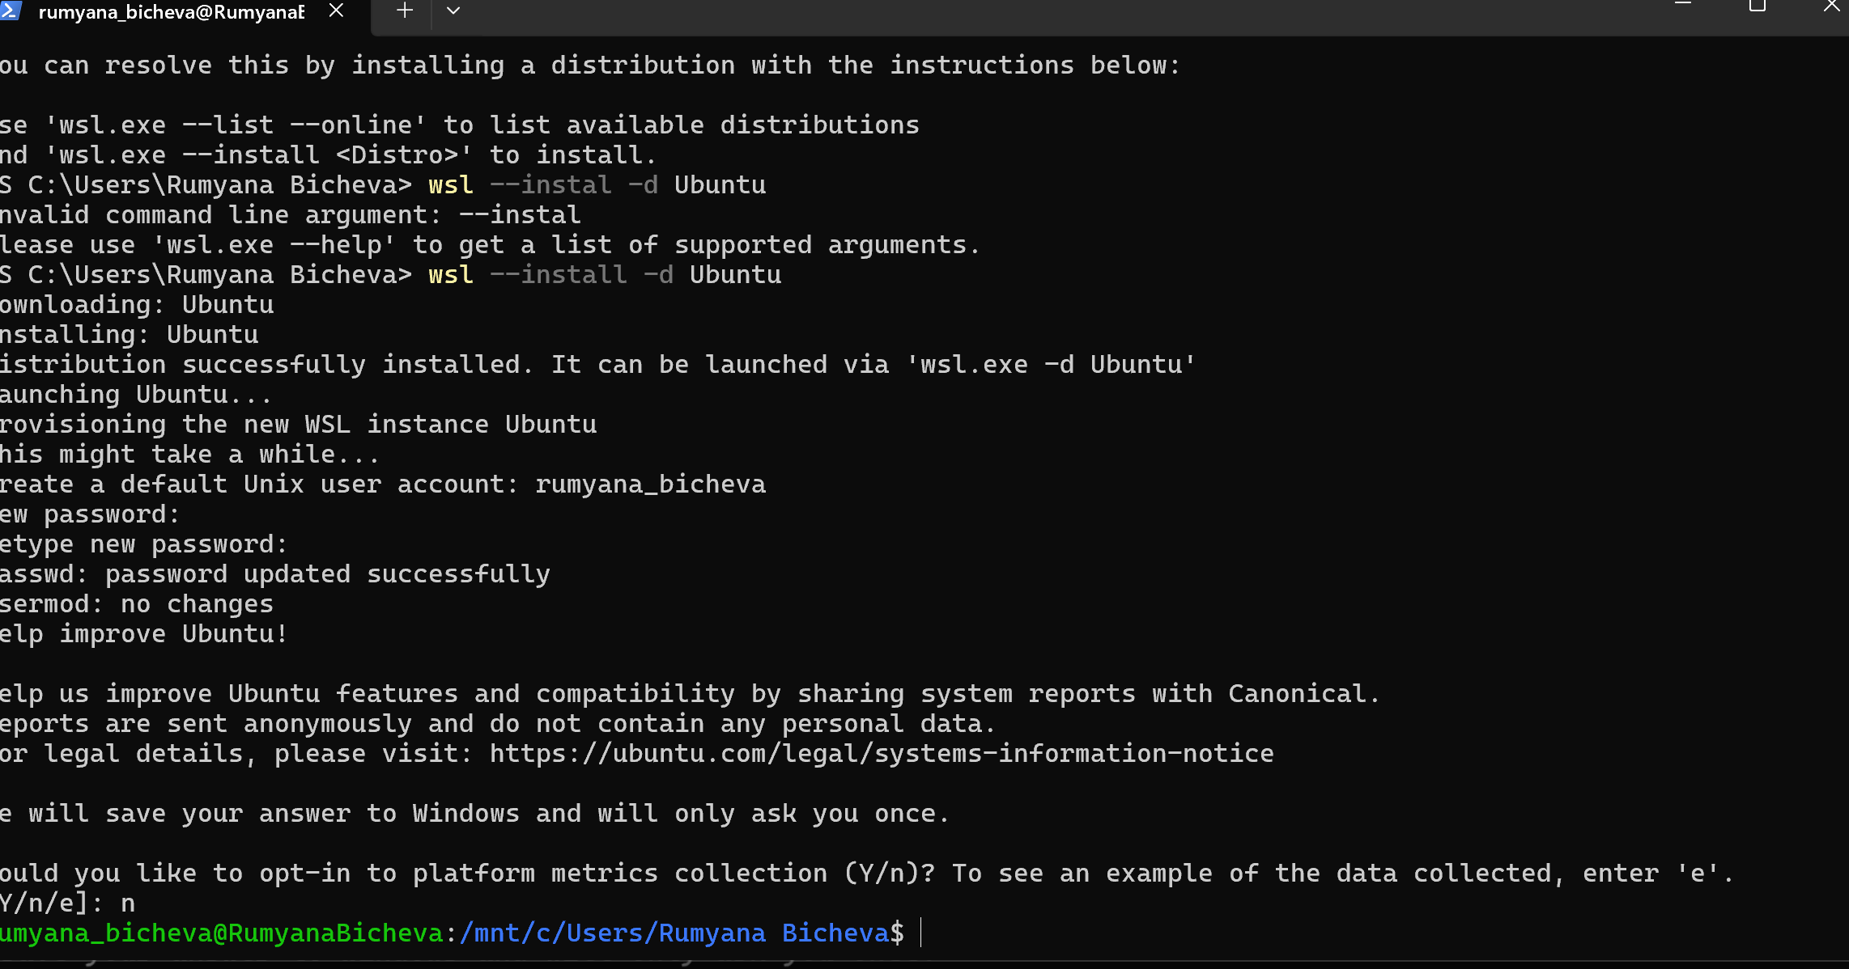

Process management
PS AUX displays all running processes with detailed information. A shows processes for all users, U adds detailed information, and X - also the processes that are not attached to a terminal, Fig.25.
figure 25 Command ps aux
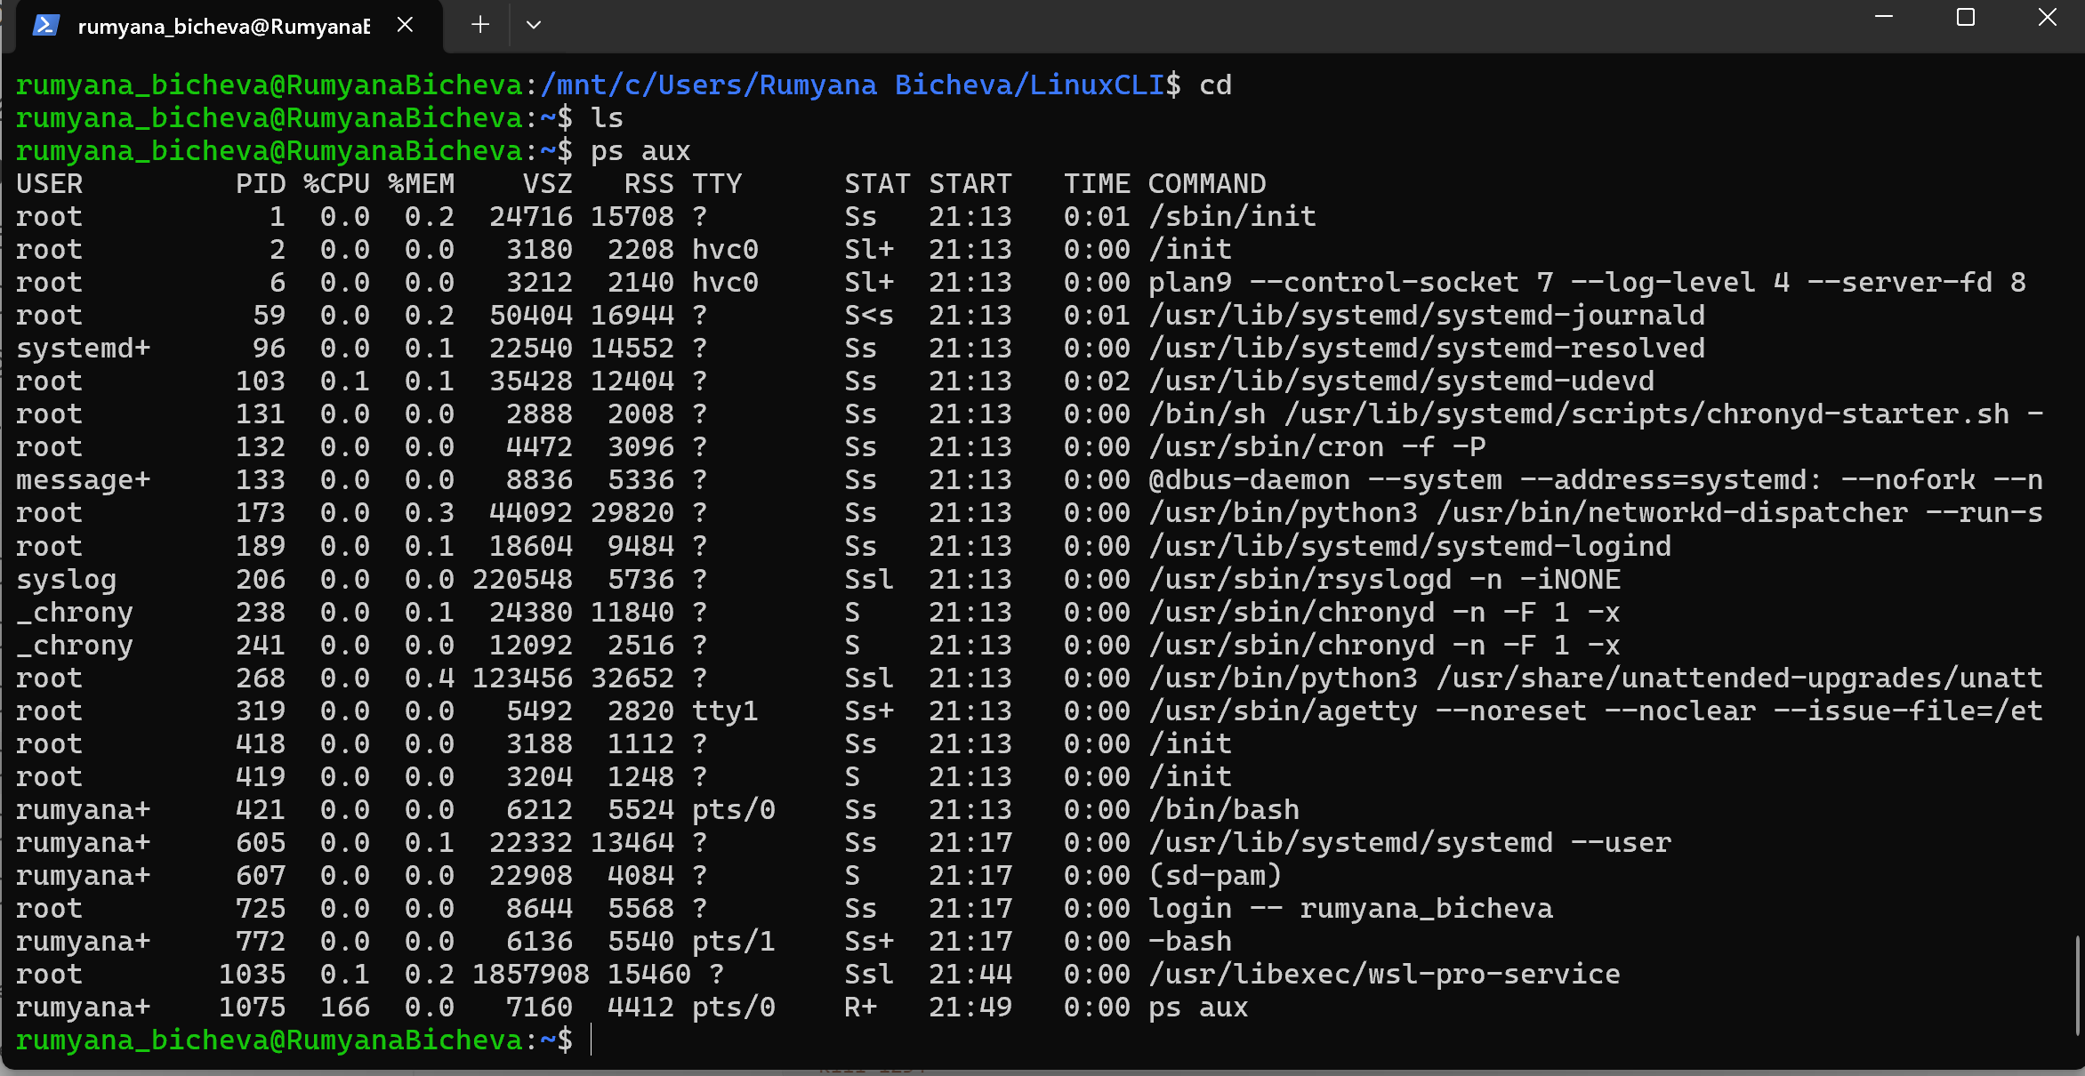
Top - Displays running processes in real time, including CPU and memory usage.
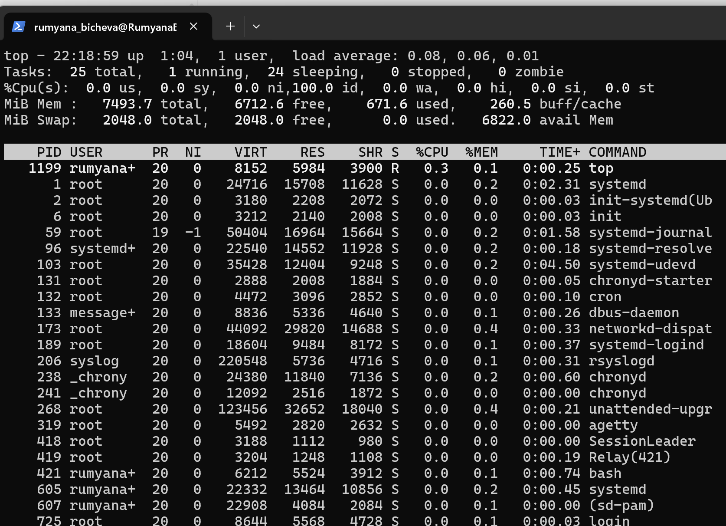
figure 26 Command top

Command df -h, Fig.27 displays available and used disk space in a readable format.
Command free -h, Fig. 27 - RAM and Swap memory usage.

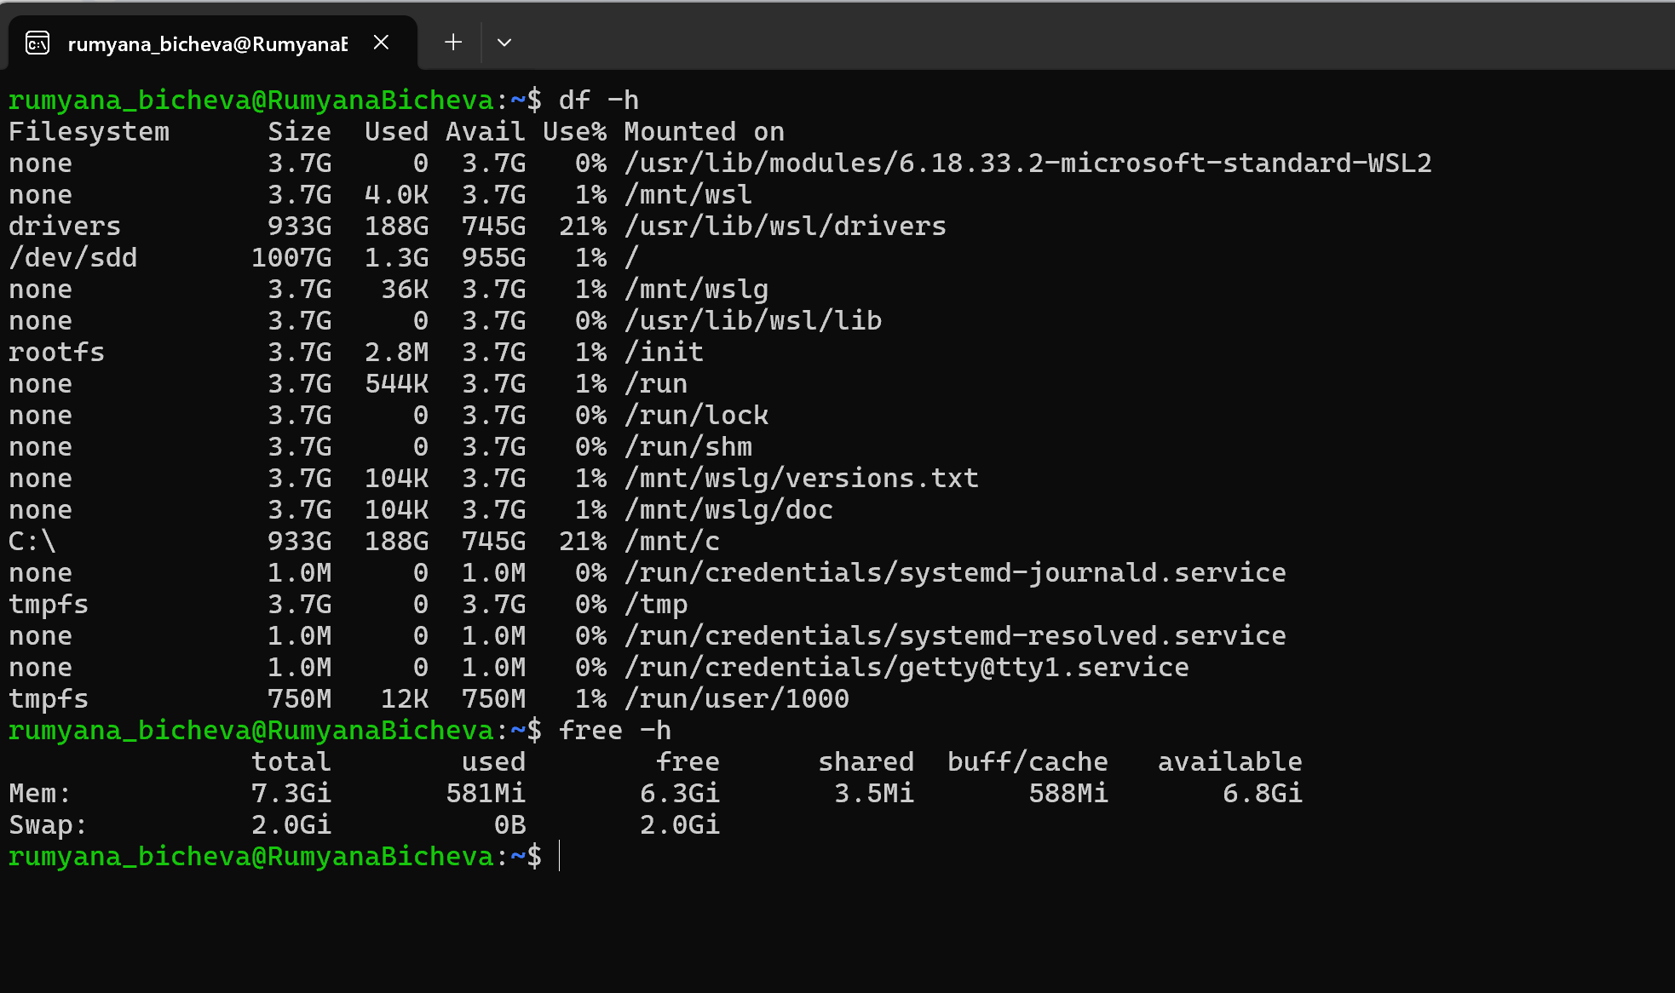
figure 27 Command df -h and free -h

File and directory management
Pwd prints current working directory, Fig.28.
figure 28 Command pwd
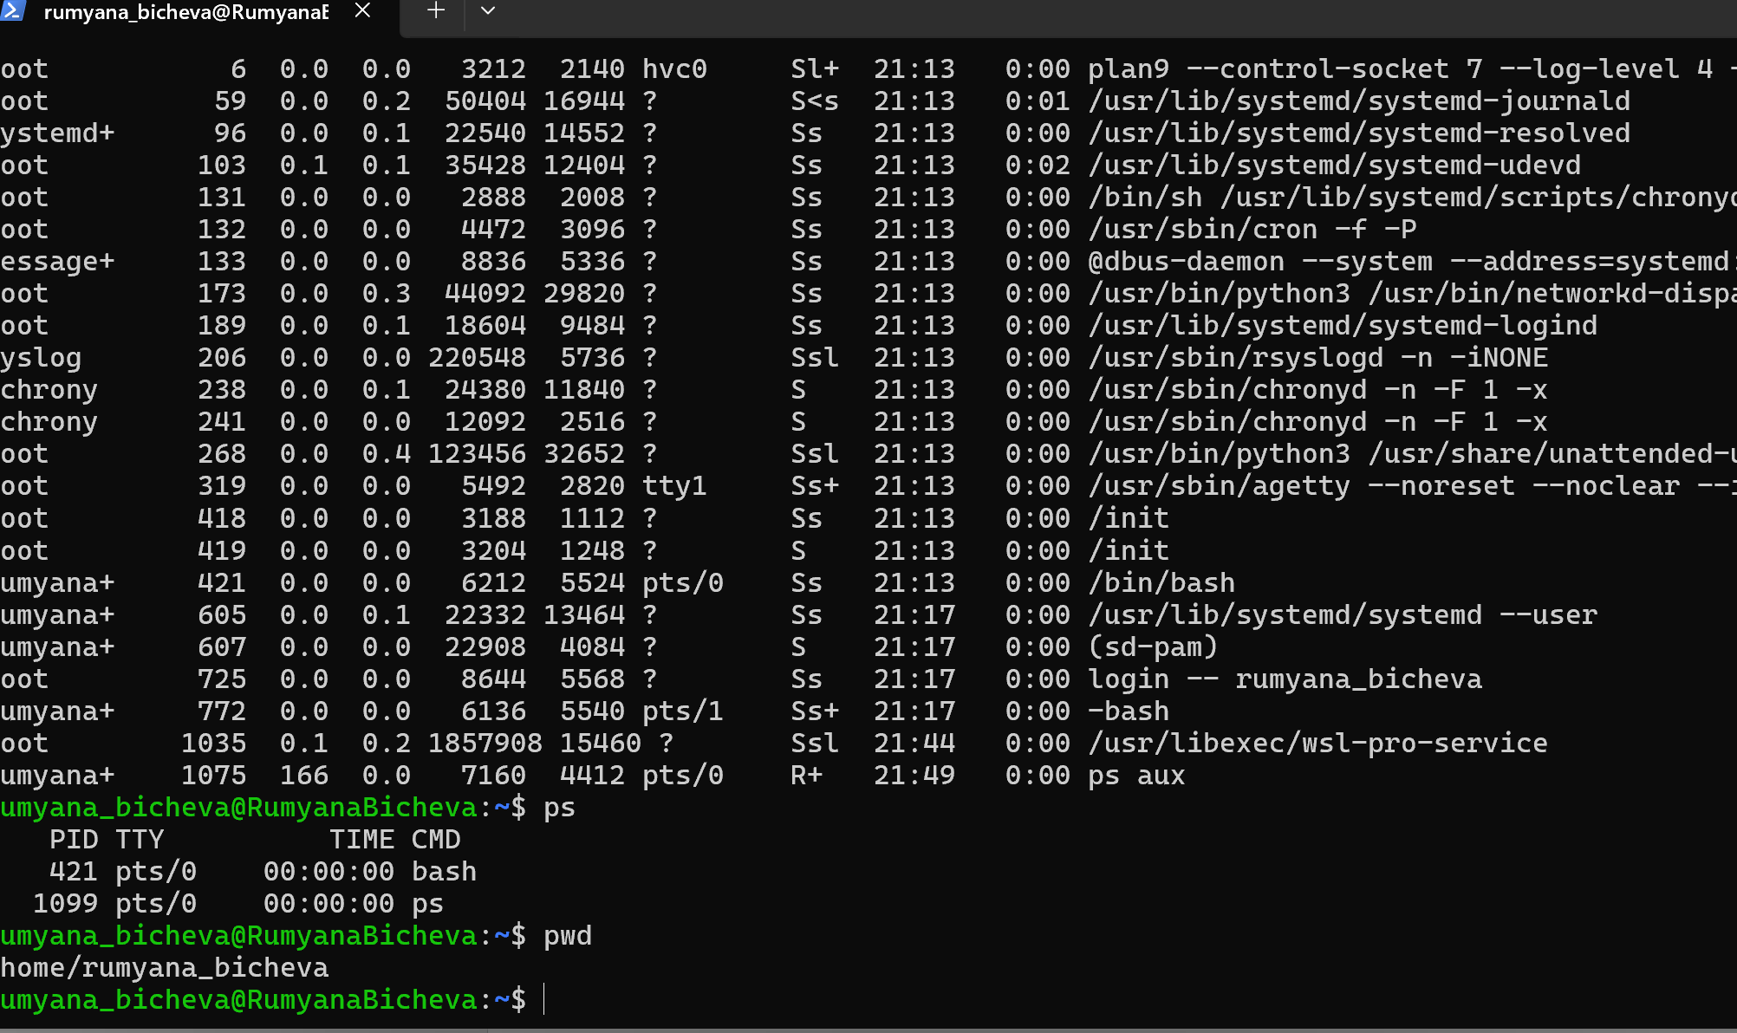
Command ls and mkdir, Fig.29.

figure 29 Command ls and mkdir LinuxCLI
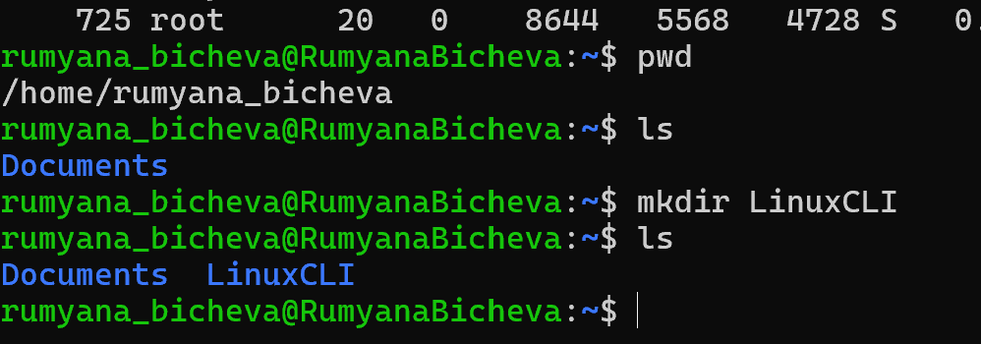

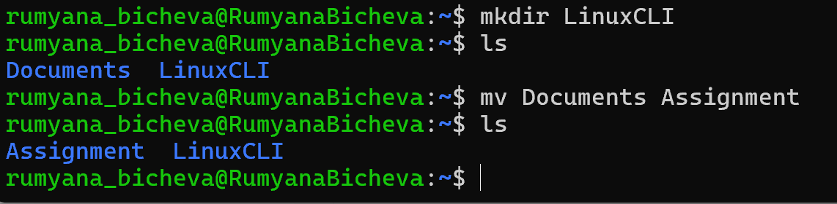
Rename “Documents” to “Assignment”, Fig 30. And rmdir - deleting of Assignment directory only if it is empty, Fig.31.
figure 30 Command mv

figure 31 Command rmdir
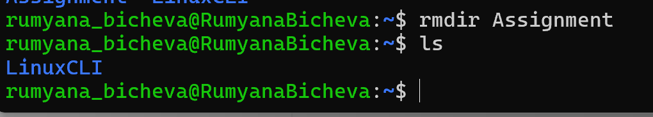

Network testing/monitoring
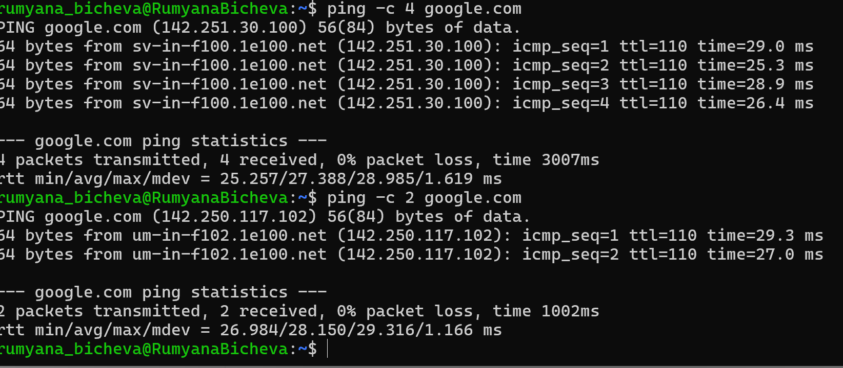
ping tests network connectivity between the local computer and a remote host. It sends Echo Request packets and measures the response time. -c 4 or -c 2 options limit the command to sending four or two packets before it stops automatically, Fig.32.
figure 32 Command ping

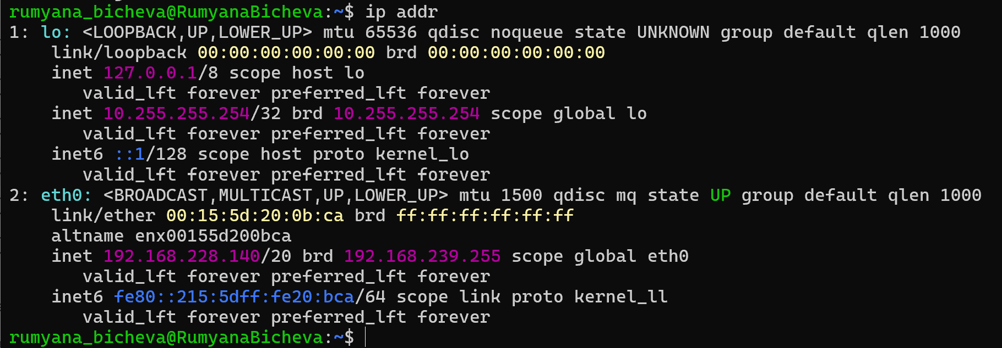
ip displays network interfaces and their assigned IP addresses,Fig.33
figure 33 Command ip

User management
whoami, who, id show user who are currently logged into the system name account and id command displays information about the current user, including the user ID group and ect, Fig.34
figure 34 Command whoami, who, id
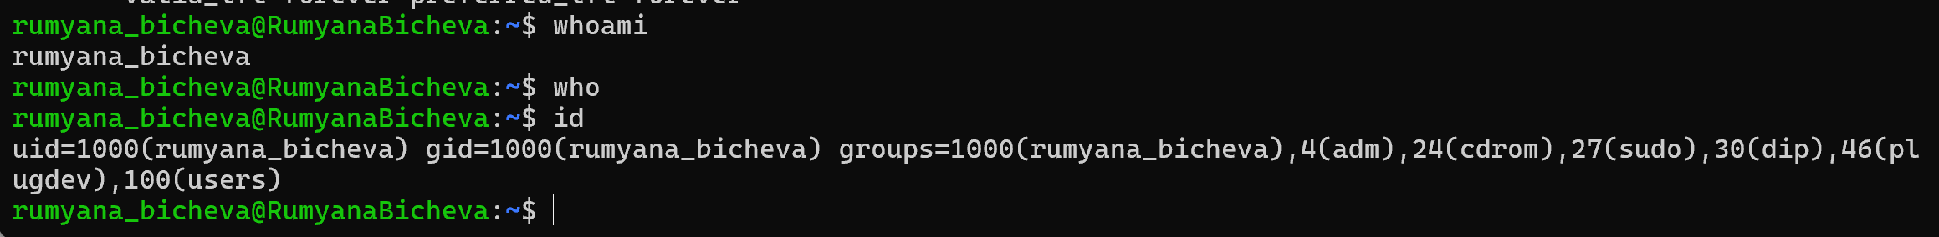

Task scheduling
Fig. 35, 36 – crontab -e
Fig.37 – crontab -l
figure 35 Command crontab for creating or edit task
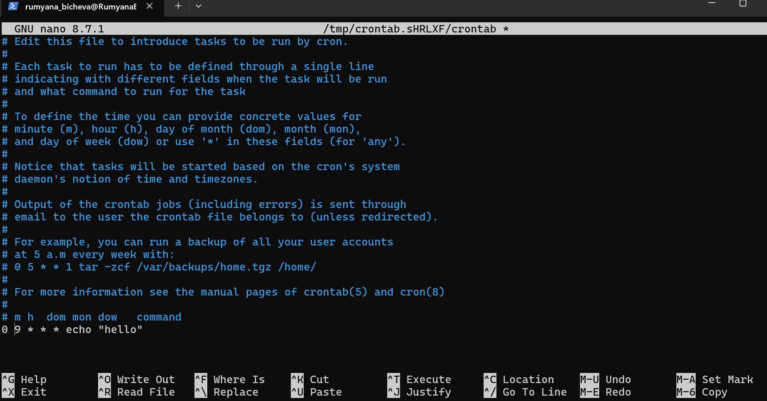

figure 36 saving task
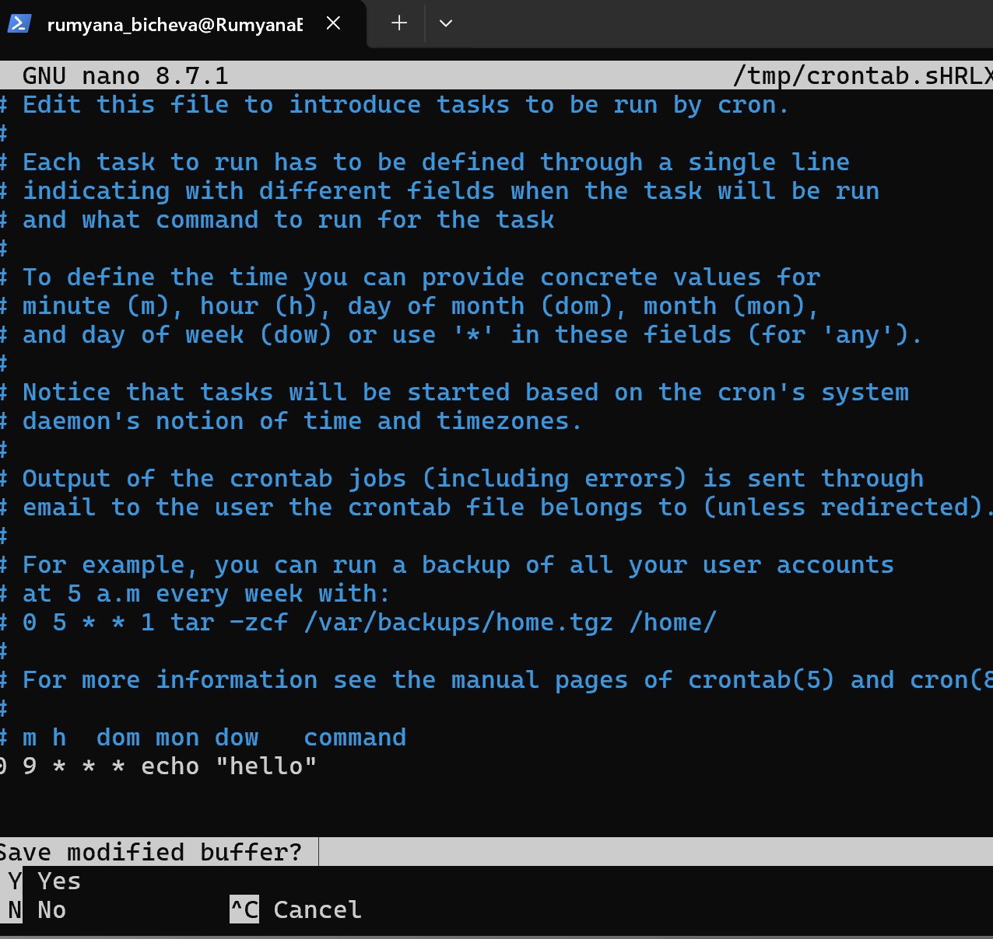

figure 37 Command crontab -l to show the recorded task
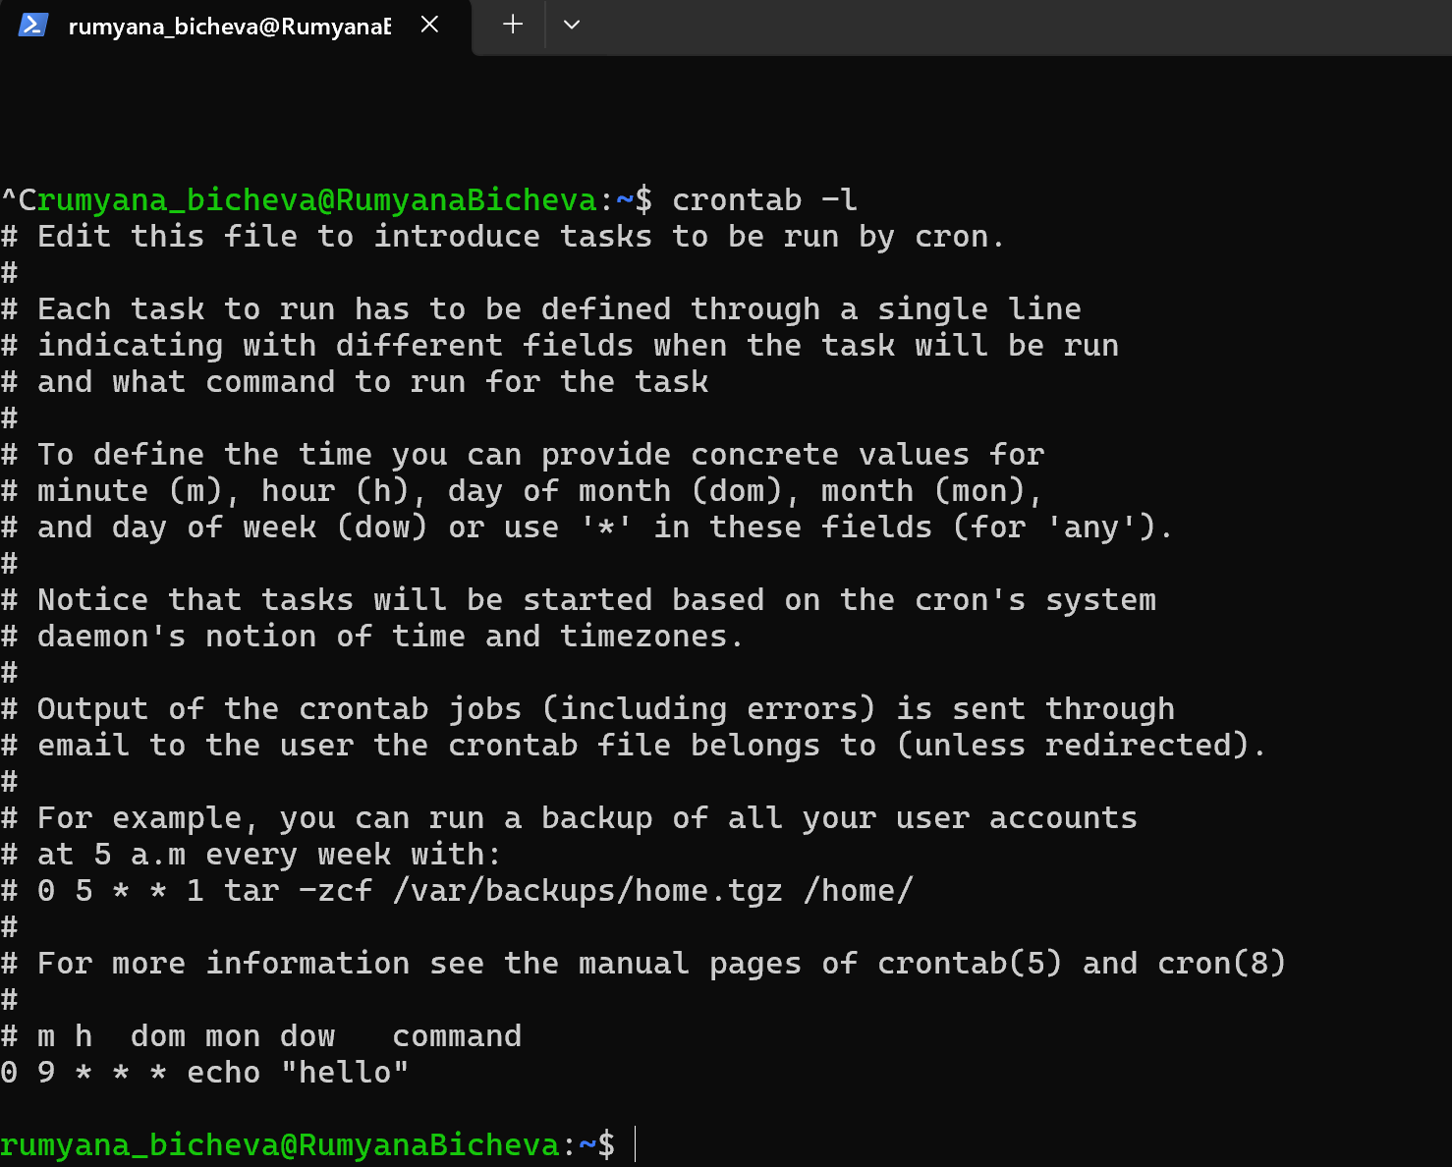

Task 4. Windows OS script
My Batch script in NOTEPAD creates a simple Windows utility menu that automates access to common command-line tools. The user selects an option from the menu, and the script executes the corresponding Windows command. The script demonstrates the use of variables (choice), user input (set /p), conditional statements (if), and a loop (goto menu) to repeatedly display the menu until the user chooses to exit. This simplifies access to common system information without requiring individual commands, Fig.38,39,40,41,42,43,44,45.

figure 38 create interface
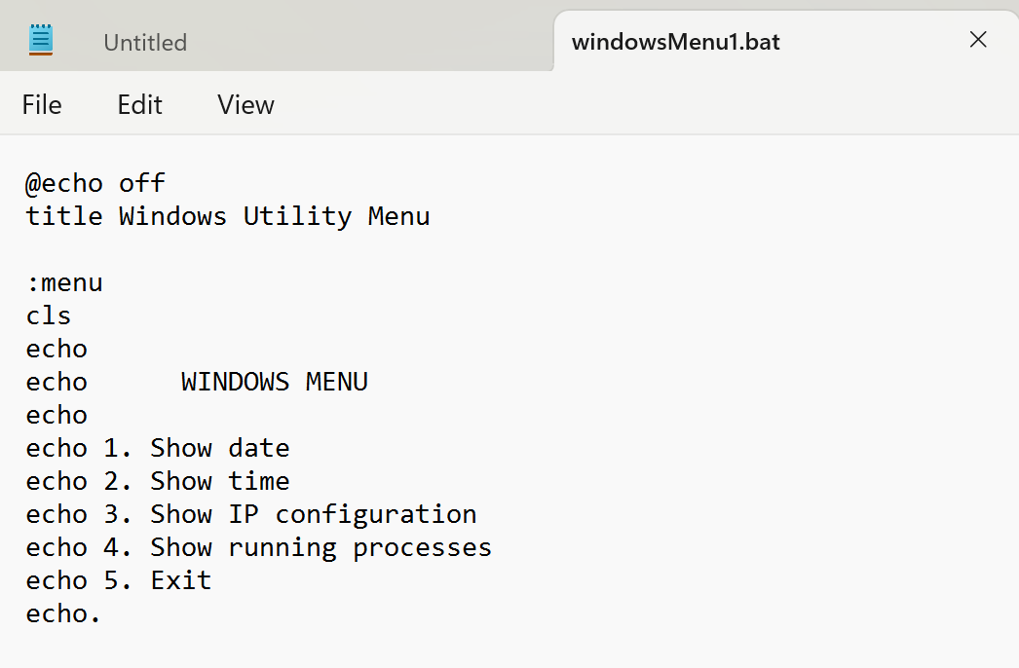

figure 39 put conditions
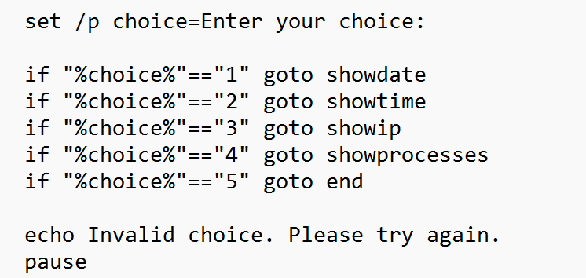
figure 40 transfer to the section of the script
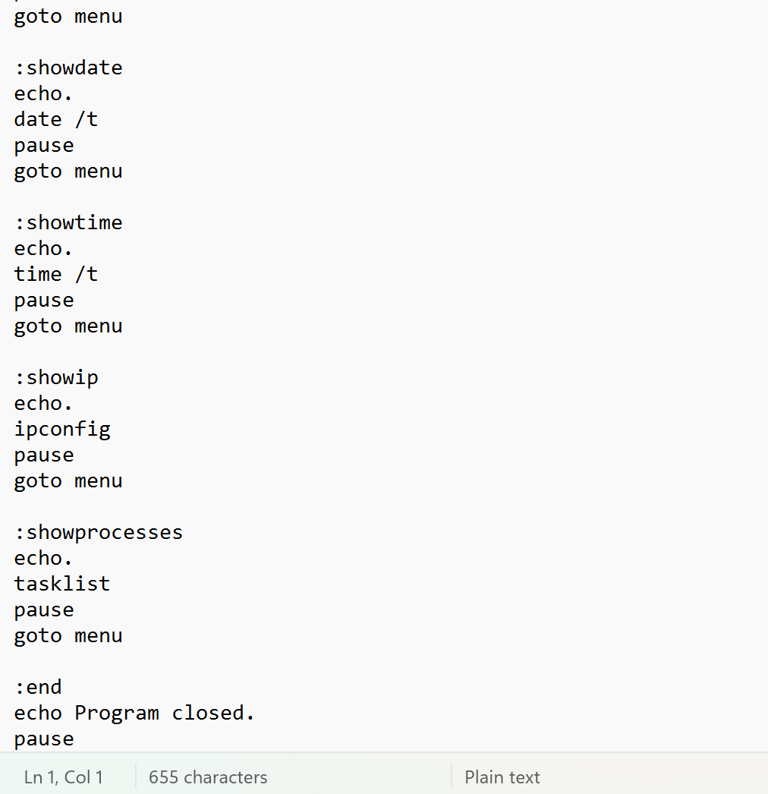
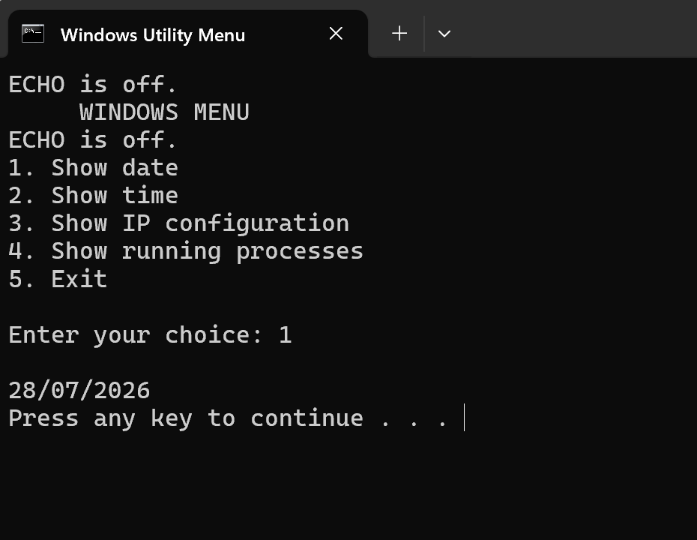
figure 41 execution of choice1

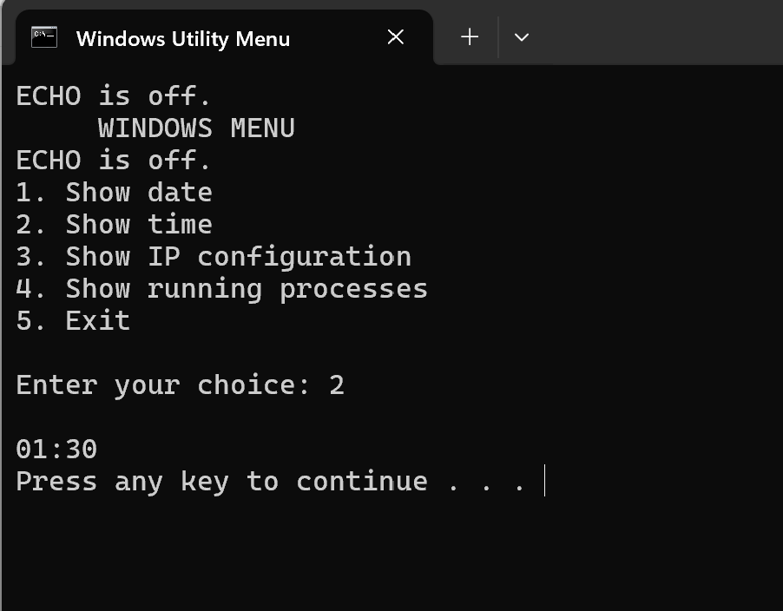
figure 42 execution of choice 2

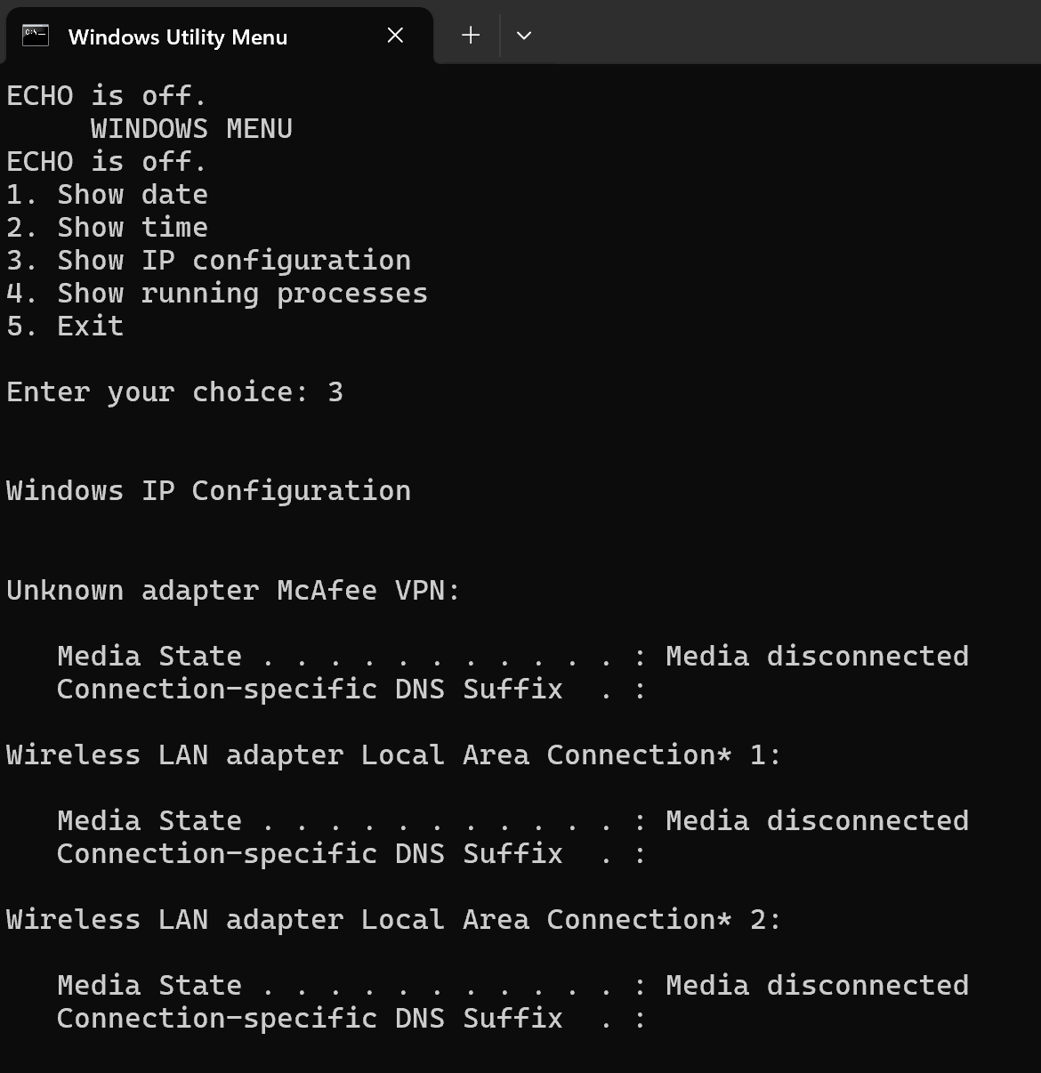
figure 43 Execution of choise 3

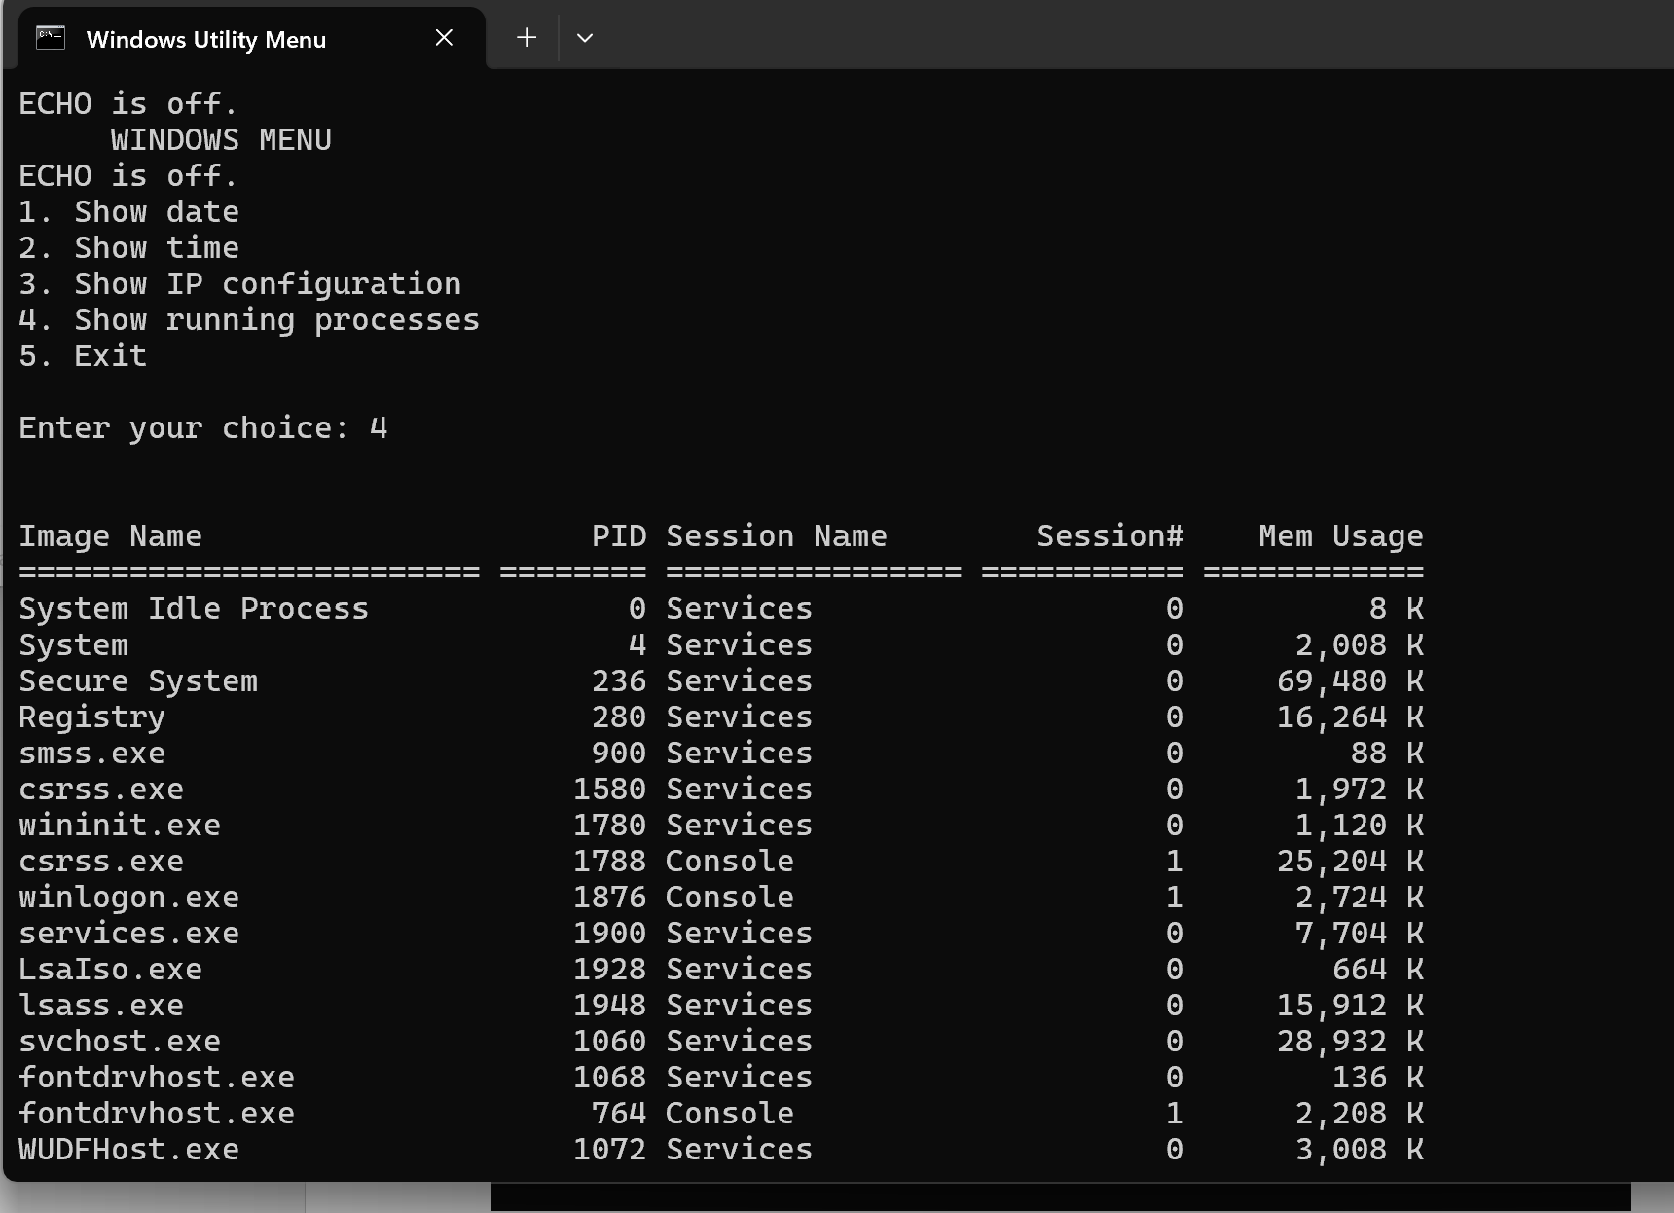
figure 44 Execution of choice 4

figure 45 execution of choice 5
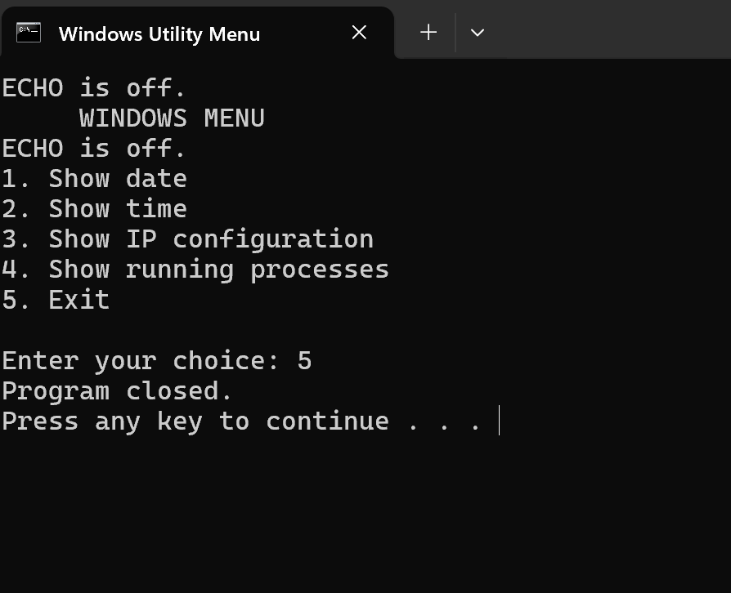

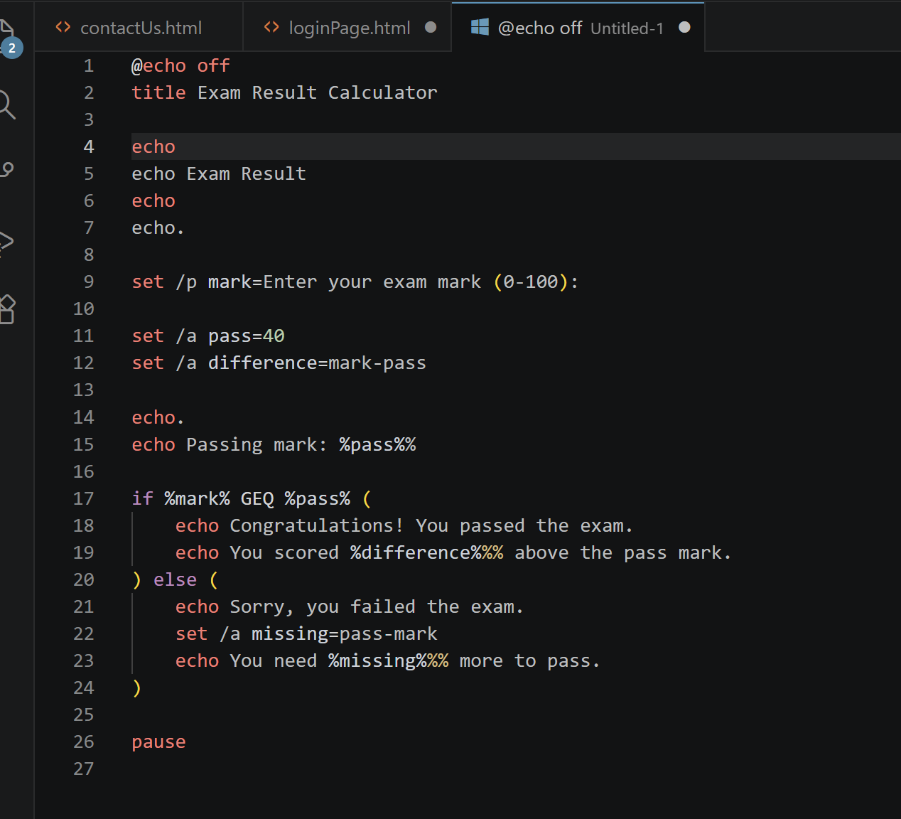
My next Batch script in Visio studio code, determines whether a student has passed or failed an exam using a passing mark of 40%, Fig.46
figure 46 script

figure 47 Demonstration of execution 1
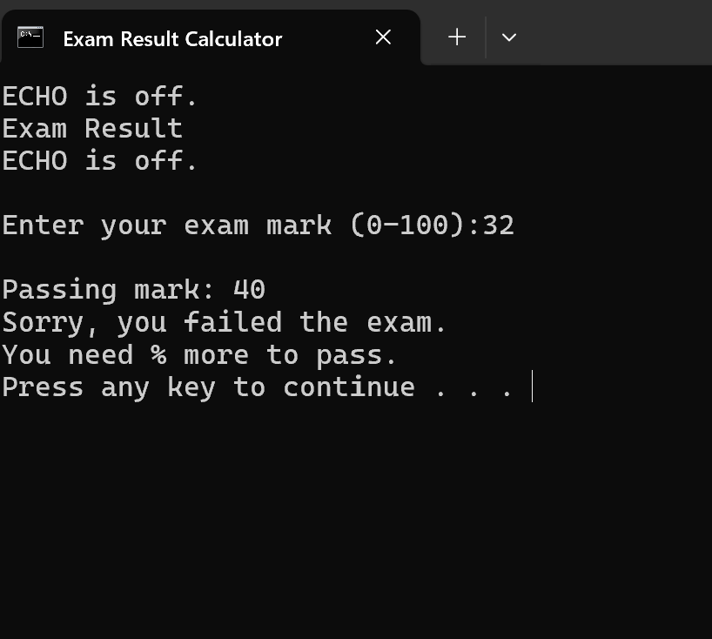

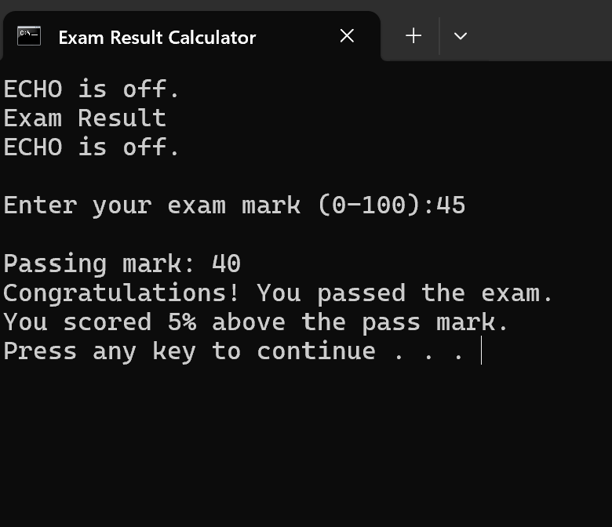
figure 48 Demonstration of execution 2

Task.5 Linux OS script
My Bash script creates a simple Linux menu that allows the user to display the current date or the current user. The script uses a loop to return to the menu after each command until the user chooses to exit, Fig.49,50,51,52,53.
figure 49 Bash script
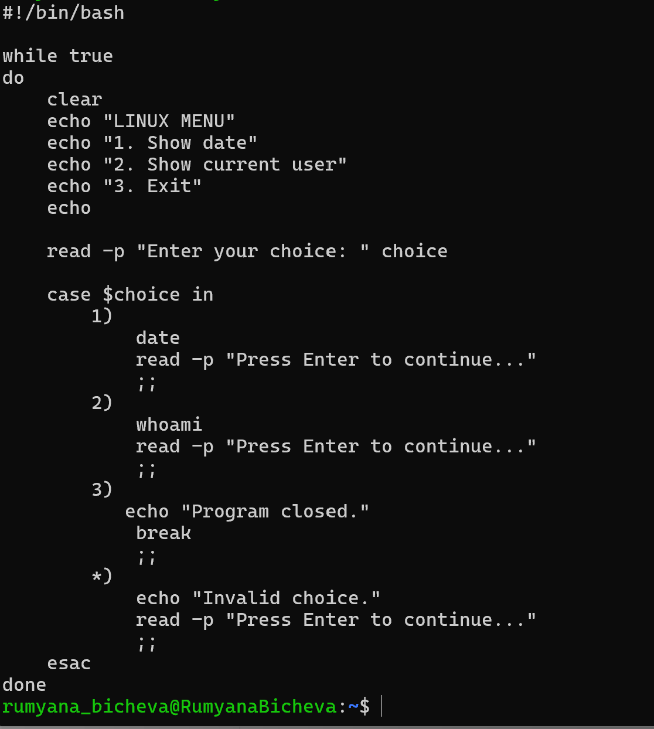

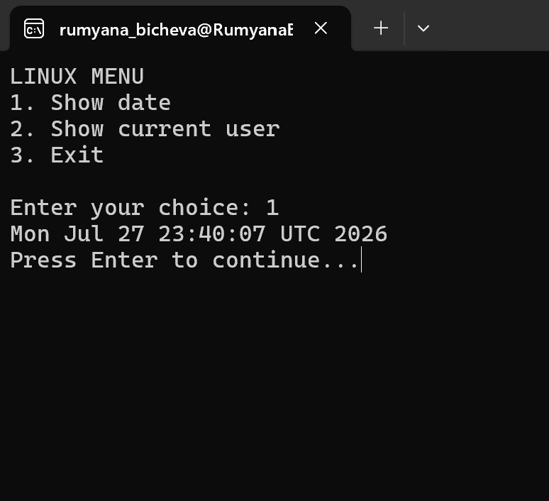
figure 50 Execution of choice 1

figure 51 Execution of choice 2
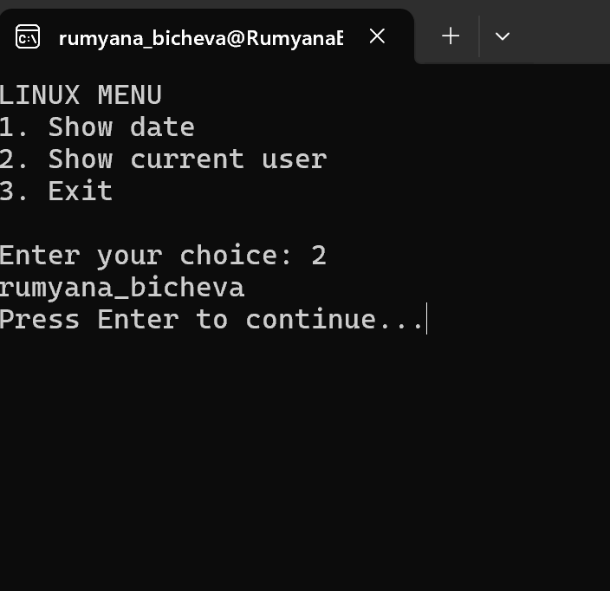

figure 52 Execution choice 3
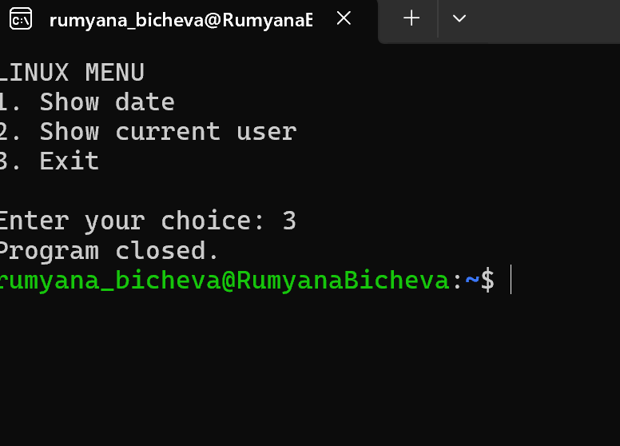

Next Bash script checks whether a student has passed or failed an exam, using a passing mark of 40%, Fig.53,54.

figure 53 Bash script for ExamResult
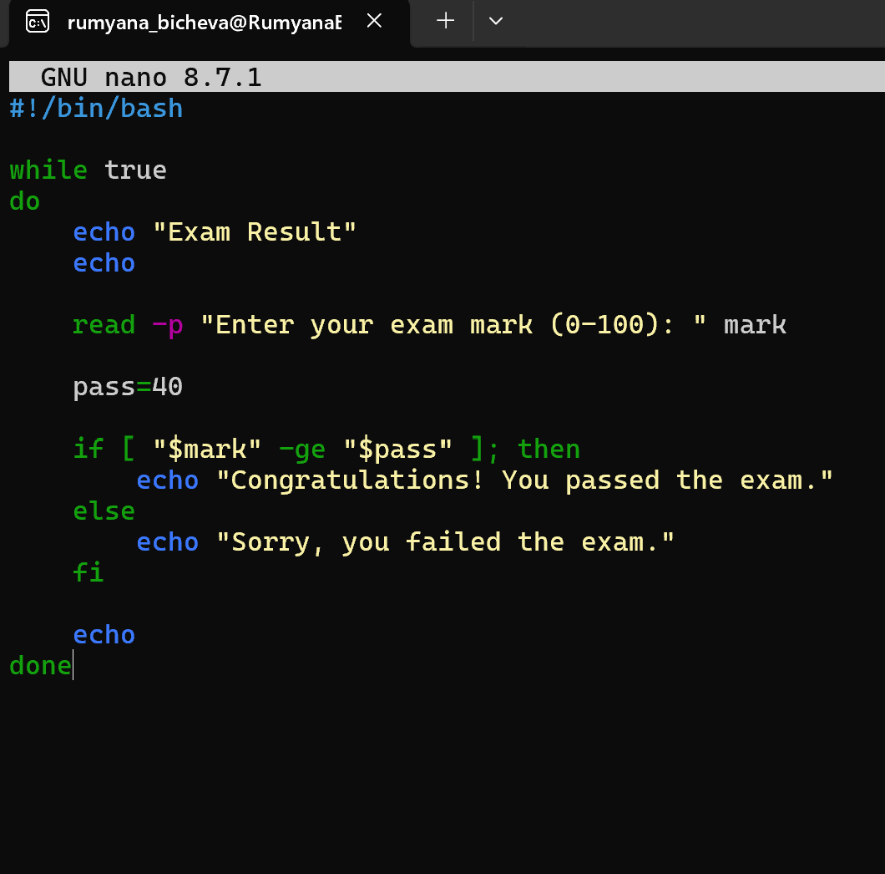
figure 54 Execution of ExamResult script
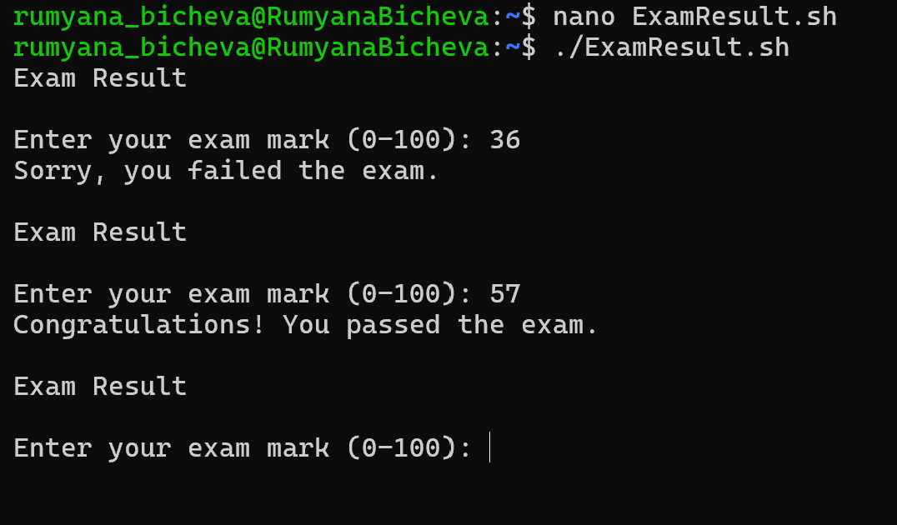

In my opinion, Linux provides faster and more organised command-line environment. I found its commands easier to use and more intuitive for everyday tasks and automation. Although Command Prompt Supports Batch scripting, its scripting capabilities are more limited than those of Bash and PowerShell. Windows PowerShell significantly reduces this gap by providing advanced scripting and automation features, making it well suited for system administration. Both Linux and Windows, effectively perform the essential functions of an operating system, ensuring efficient management of system resources while meeting the diverse requirements of home users, businesses, developers, and system administrators.

CONCLUSION
OS performs several key functions, including process and processor management, memory management, file system management, security, and user management. These functions are essential for the efficient and secure operation of a computer system. They allow the OS to allocate system resources, control running processes, manage memory and stored data, protect the system from unauthorised access, and control user permissions. Different privilege levels allow users to work with standard permissions for everyday tasks or administrative privileges for managing system resources and configuration. This demonstrates the importance of the operating system, which acts as the main link between the user, applications, and computer hardware, providing the foundation for the computer to operate efficiently, securely, and reliably.

REFERENCES
[1] A. S. Tanenbaum, "MODERN OPERATING SYSTEMS FOURTH EDITION," 2015,
[2] A. Silberschatz and P. B. Galvin, "Operating System Concepts," 2013,
[3] J. P. Mueller, Windows Command Line Administration Instant Reference, John Wiley & Sons, 2010.
[4] A. Adekotujo, A. Odumabo, A. Adedokun and O. Aiyeniko, "A comparative study of operating systems: Case of windows, unix, linux, mac, android and ios," vol. 176, no. 39, pp.16–23, 2020,
[5] J. P. Mueller, Windows Administration at the Command Line for Windows 2003, Windows XP, and Windows 2000: In the Field Results, John Wiley & Sons, 2006.
[6] "Windows Server." learn.microsoft.com. [Online]. Available: https://learn.microsoft.com/en-us/windows-server/administration/windows-commands/net-user?utm_source=chatgpt.com
[7] R. Fox, Linux with operating system concepts, Chapman and Hall/CRC, 2021.

