


Management Communication Report:

Management Communication

(BMSK4013)
Daniel Bussell / 2313849


Table of contents:
Page
1.Introduction 3
2. Management Communication 4
2.1 The Communication Cycle 4
2.2 Shannon and Weaver Model 5
2.3 Schramm’s Model of communication 6
2.4 Berlo’s SMCR Model 7
2.5 Comparison of Models 8
2.6 Verbal, Written and Visual Communication 9
2.7 Assessment of Communication Methods 10
2.8 Barriers to Communication and Recommendations 10
3. Motivation, Performance and Conflict 11
3.1 Motivation theories 12
3.2 Application of Herzberg's Theory to the Workplace 14
3.3 Factors Influencing Motivation and Performance 15
3.4 Conflict in the Workplace 15 - 16

4. Conclusion 16
5. Appendix 17
5.1 Peer Feedback Questionnaire 17
5.2 Detailed Gap Analysis 17
5.3 Gap Analysis 18
5.4 Personal Development Plan 18
References 19

Introduction

Communication is widely recognised as the cornerstone of all effective management, with huge influence towards productivity, employee engagement, and the culture of any organisation (Johns & Saks, 2021; CIPD, 2025a). In the United Kingdom (UK), research taken by pumble (2026) has shown that, teams who communicate well can gain an increased 25% in productivity, while poor communication has shown to be responsible for a substantial number of corporate errors (NewZapp, 2024). This report evaluates communication practices within a workplace setting. The report will analyse communication theories including Shannon and Weaver communication Model. The theories will be applied within a workplace example, showing the relevance, strength and limitations. The report will also look into verbal and written communication, levels of formality, barriers of communication and the effectiveness of communication methods used within an organisation.

In addition, the report evaluates motivation theories and their relationship with performance and workplace conflict. Maslow’s Hierarchy of Needs, Herzberg’s Two-Factor Theory, and McGregor’s Theory X and Theory Y are critically analysed before Herzberg’s theory is applied specifically to the workplace example. Finally, the report reflects on personal communication skills, analyses feedback, identifies strengths and weaknesses, and develops a SMART Personal Development Plan (PDP) to improve managerial communication effectiveness.

2.MANAGEMENT COMMUNICATION
2.1 The Communication model offers a foundation understanding towards how communication is a continuous process from sender to receiver (Argyle, 1972). The development of an idea and is processed into an encoded message. The message is then transmitted through a chosen medium such as spoken conversation, email or formal written documentation. The message is then decoded, and an interpretation of the message is formed by the receiver. A handbook by Hargie and Tourish, (2010) is of the impression that with the use of shorthand or slag within the message it may be decoded incorrectly, which can compromise what the message is intended. The feedback stage is the formal element because it offers a minimum confirmation that the message has been received. Noise is any interference that will or can distort the message, this can occur at every stage (Adair, 2009). A report made by Meinam et al, (2023) on the importance of feedback, it can be seen how this model shows that the feedback process of the cycle creates the loop and offers another opportunity to rectify any discrepancies from the message that had been sent and received in its intended purpose, thus highlighting a successful interpersonal collaboration inside any organisation.
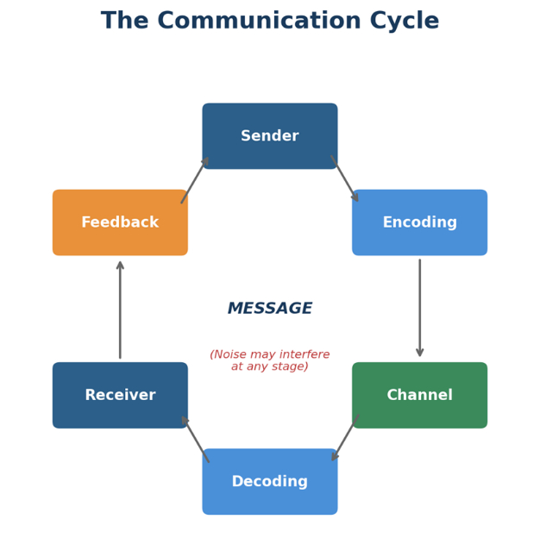
Figure 1: The Communication Cycle (adapted from Eunson, 2012)

2.2 Shannon and Weaver Model of Communication was developed in 1949, considered to be one of the earliest theories of communication, shows that information given from a sender to a receiver has 5 key stages, source, transmitter, channel, receiver and destination. Shannon and Weaver (1949) state that the initial purpose of this model was to improve telecommunications, this was later wildly used in many areas thereafter. The initial message that is created by the sender passes through a channel, these can range from speech, email or a phone call. The model also includes noise, which is anything that interferes with the message, such as background noise, poor internet / signal connection, or misunderstandings. Being a good starting block of understanding communication, it was later described as a linear communication model because of its limitations (Human Focus, 2025 And Bakar et al., 2022). Even with drawbacks, this model will hold a place in time, as it shows the importance of using the right communication structure, as modern studies have shown that poor communication has a negative effect on organisational performance, productivity and teamwork (Baptista, 2023 and Zuzul et al., 2021).
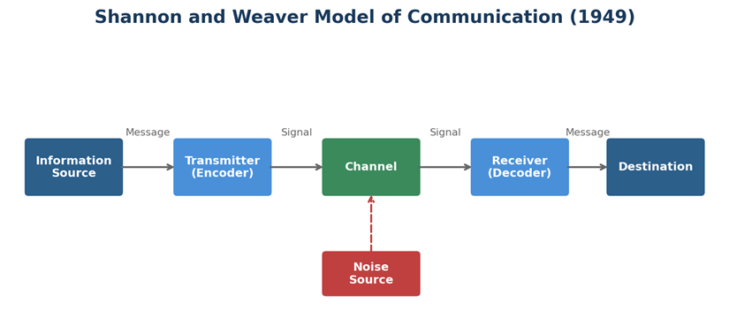

Figure 2: Shannon and Weaver Model of Communication (1949)
2.3 Schramm’s Model of communication ( (1954) represented progressive advancements over its linear models, by offering communication is a two-way process that both parties are in a continuous encoding and decoding spiral. With understanding that both parties “field of experience” this being the total accumulated knowledge, attitudes, and cultural background that each party brings to the interaction (Schramm, 1954). works by McQuail & Windahl, (2015) give reference to how communication is most effective when there is significant overlap during the fields of experience. In the Pendine Sands security context, this is highly relevant. A newly recruited seasonal officer may lack the shared operational wording and site-specific knowledge that permanent staff possess, by reducing the overlap in their fields of experience thus decreasing the risk of miscommunication during critical incidents (Hargie, 2017). As this model’s key direction is through feedback as the main continuous loop, rather than an end-thought, making it suited to be used in an environment as dynamic as security. For the security team, this can be seen with two-way radio exchanges and face-to-face briefings where security would constantly confirm, clarify, and respond. However, Schramm’s model can been criticised for not addressing the interference of noise or channel-specific distortion, which Shannon and Weaver’s model had shown to address.

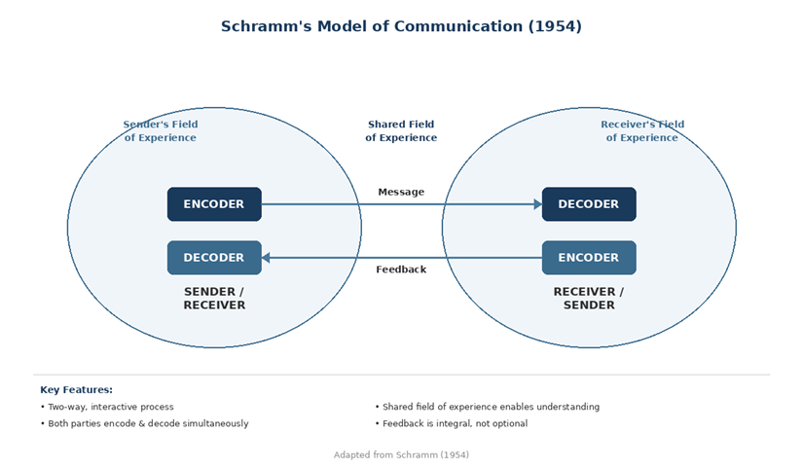
Figure 3: Schramm’s Model of Communication (1954)

2.4 Berlo’s SMCR Model of communication The progression of communication models, Source – Message – Channel – Receiver (SMCR), the communication model similarity and differences toward its predecessors by offering a linear projection but more detailed direction action. The model does not adequately offer any feedback loop or direct encoding and decoding that is characterised in real-time security briefings (Dimbleby & Burton, 2007). Berlo is of the idea that the source and receiver share four attributes: communication skills, attitudes, knowledge, and socio-cultural background (Berlo, 1960). A study in the International Journal of Human Resource Management found that UK organisations with culturally diverse frontline teams like parkdean security team achieved better communication with training (Shen et al., 2009). Within the security team, the Communication model is visible during incident reporting procedures. For example, when a security officer identifies anti-social behaviour, the officer has to communicates details through radio systems to the on-charge supervisor. The supervisor will then interpret the message then respond with instructions and awaits to receive a response from the officer once the issue is resolved. The cycle clearly shows that communication is not fully complete until feedback has been received (Meinam et al., 2023).
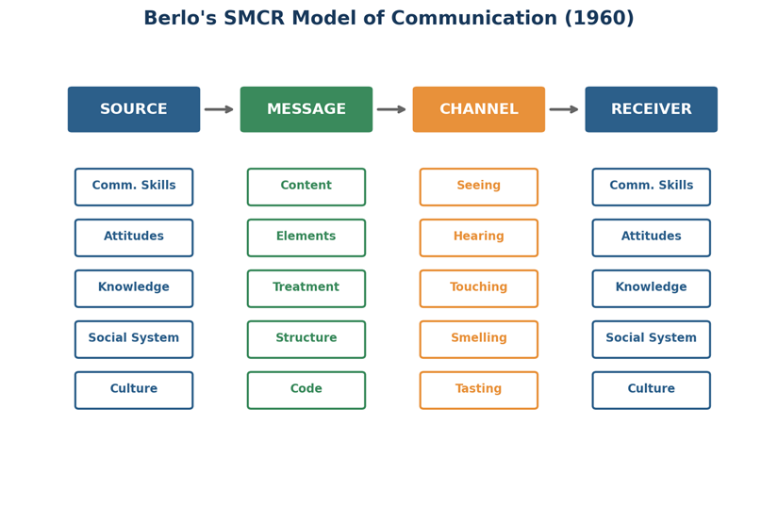

Figure 4: Berlo's SMCR Model (1960)

2.5 Comparison of communication Models

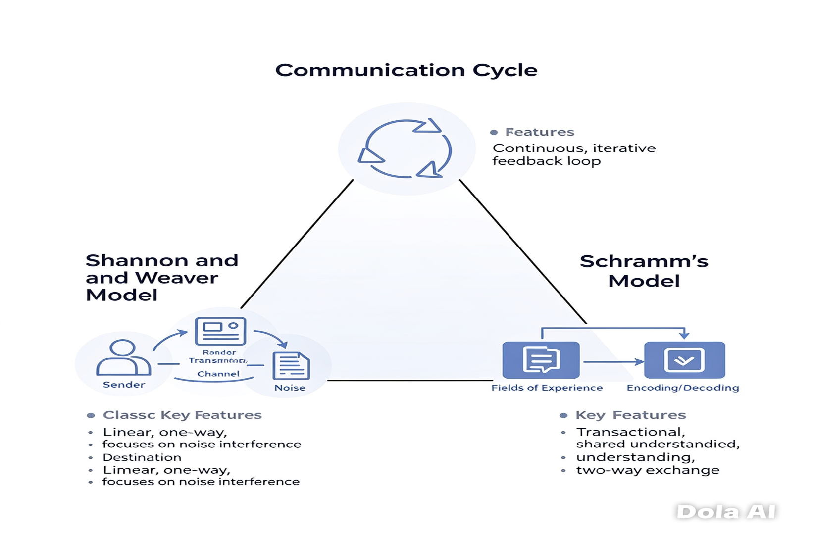
The communication cycle operates on feedback, which is essential for operational environments. While Shannon and Weavers model identifies and combats noise within the structure of communication, makes it relevant to radio dependent teams. Schramm’s model dives into the important field of shared fields of experiences and how they can improve overall communication in a diverse environment. Brelo’s SMCR model has a focus on personal traits and how they have influence over communications integrity. However, no one model focuses on modern workforce’s complexities, as shift patterns, digital communication channels and multilingual limitations create the overlapping processes needed in today’s workplace. Tourish and Hargie (2004), published a paper covering the issues of Communication Management, and offer their perspective that effective organisational communication requires a balance of linear and interactive models. In light if this, the security team would benefit from a blended approach, with the use of the communication cycle for briefings, Shannon and Weaver’s principles for radio protocols and Schramm’s framework for understanding shared context in recruitment team inductions.
Figure 5: Blended trifactor of models (2026)

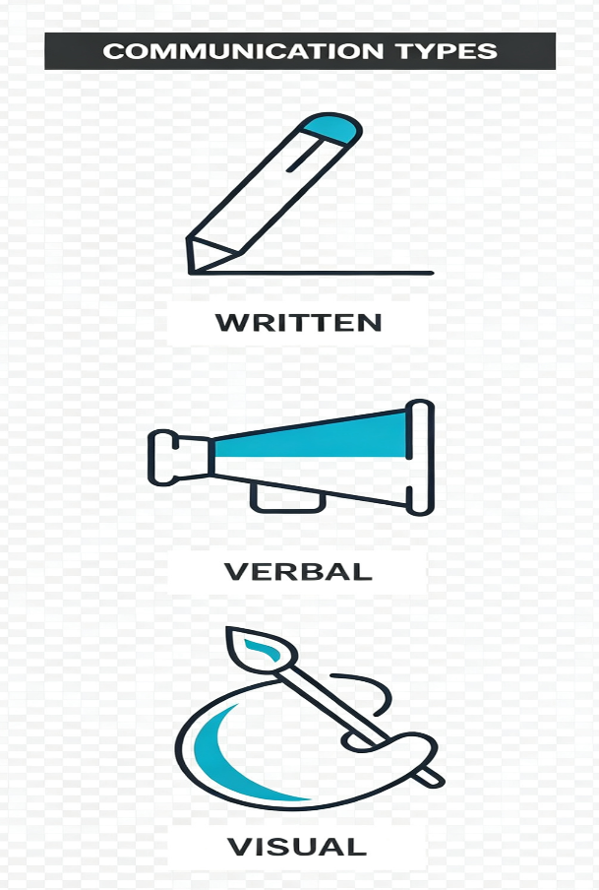
2.6 Verbal, Written and visual Communication are all communication elements that an organisation uses to communicate. Research carried out by Mehrabian suggests that in face-to-face exchanges about feelings, words account for
only 7% of meaning, tone 38%, and body language 55% (Mehrabian, 1971). Although Mehrabian’s findings highlight the importance of written communication, from recent reports and findings from other sources found that these statistics have frequently been overstated (Gurteen, 2026). The 7%-38%-55% rule applies mainly to the communication of feelings and attitudes rather than all workplace interactions (Bekke, 2020). Therefore, in an organisational setting such as security, verbal information remains critical for conveying most instructions, incident details, and safety procedures, while tone and body language support message interpretation. Figure 6: visual representation of communication
A book on body language by Pease & Pease, (2017) offer indication towards security officer's posture, eye contact, and facial expression can de-escalate or inflame a tense situation, directly impacting guest safety. Research by Acuity Training (2023) found that sending an email, is mostly used throughout workplace communication channel across the UK (55.45%), followed by WhatsApp (44.91%) and text messaging (43.10%). However, these channels begin to stray away from non-verbal cues, which lead to misinterpretation, particularly when conveying urgency or emotion (Byron, 2008).


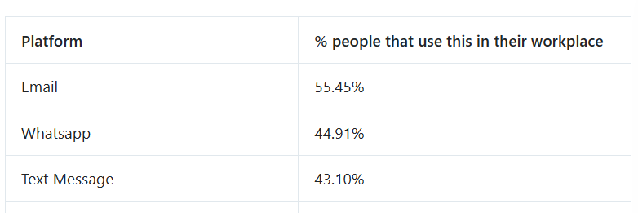

Figure 7: STATS FROM ACUITY TRAINING

2.7 Assessment of Workplace Communication Methods

A security team uses a range of verbal and written communication methods. Verbal methods would include face-to-face briefings at shift handovers, two-way radio communication during patrols, the use of telephone calls to external emergency services, and team meetings with park management. Written methods would include daily incident logs, email correspondence, WhatsApp group messages for an urgent non-sensitive format, and formal reports submitted through the company's reporting system Each method has its advantages and limitations. Communication over radio can offer real-time coordination across a larger area like a resort, but is susceptible to environmental noise (Shannon & Weaver, 1949). Face-to-face staff briefings allow for immediate feedback from written and visual cues but can be limited (Daft & Lengel, 1986). The use of email provides a documented audit ready trail but can be slower process for time-critical communication (Acuity Training, 2023). The effectiveness of each method used depends on the urgency, sensitivity, and audience of the intended communication, which requires officers to exercise quick judgement in selecting the

2.8 Barriers to Communication and Recommendations

Barriers of communication in the workplace can be seen as physical, psychological, linguistic, or organisational (Robbins & Judge, 2023). The physical barriers at Pendine Sands include the geographical spread of the park, radio dead zones caused by land spread, and high ambient noise levels during peak season events. A report made by Health and Safety Executive, (2023) depict psychological barriers to include stress during critical incidents, which can impair both encoding and decoding. The Health and safety board also reported that in 2022/23, approximately 875,000 UK workers are suffering from work-related stress, anxiety, or depression, which in turn can significantly diminish communication effectiveness (Health and Safety Executive, (2023). Linguistic barriers will arise when communicating with international guests or when seasonal staff lack proficiency in Welsh or English. Organisational barriers include hierarchical structures that can discourage any upward communication, CIPD (2023b) found that 24% of UK employees believe challenging issues are swept under the carpet. To overcome any and all of these barriers, the team have implemented standardised radio protocols with confirmation checks, they should provide communication skills training for seasonal recruits and conduct regular audits of communication effectiveness using frameworks such as Tourish's (2010) organisational communication audit. Additionally, investing in repeater equipment would mitigate radio dead zones, which can directly improve response times and guest safety .

3.Motivation, Performance, and Conflict

3.1 Motivation Theories
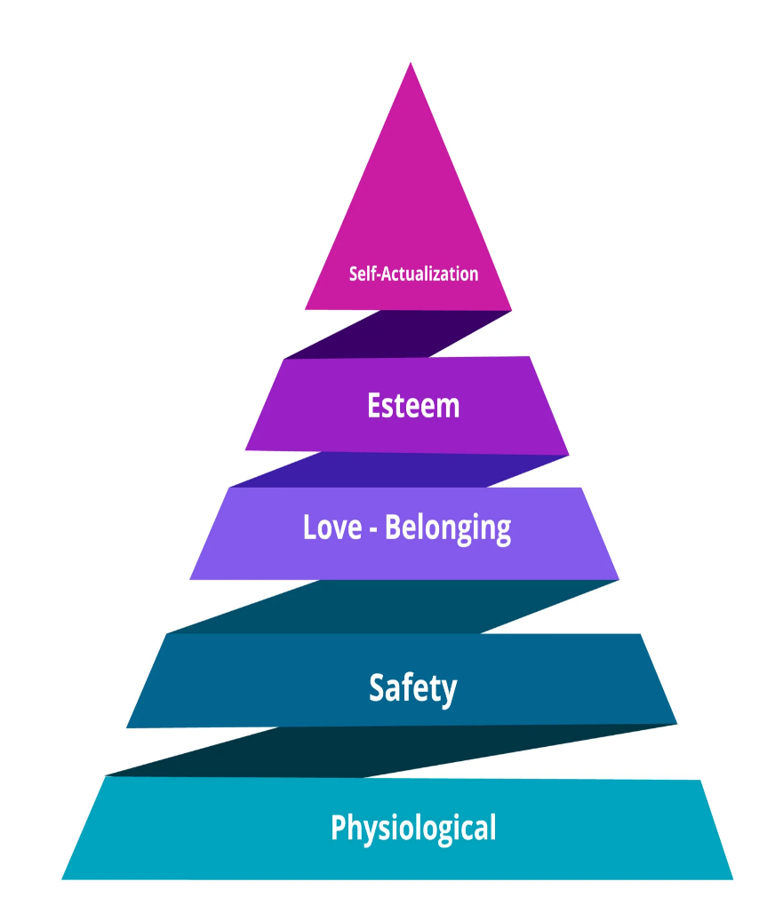
Motivation is a psychological process that guides, promotes, and keeps a person on target towards a goal (Mullins, 2019). To Understand motivation is an essential for managers to preform because it directly influences employee performance, retention, and organisational outcomes (Armstrong, 2020). Several theories offer frameworks for analysing motivation in the workplace.
Maslow's (1943) hierarchy of needs suggests that human needs can be arranged around five levels: physiological, safety, belonging, esteem, and self-actualisation. An individual must first satisfy lower-level needs before higher-level needs become motivating (Maslow, 1943). In a workplace context, this implies that fair wages and safe conditions (physiological and safety) must be addressed before employees are motivated by recognition or personal growth (TSW Training, 2024). However, Maslow's theory has been criticised for its rigid hierarchy; employees may pursue esteem needs even when safety needs are unmet, particularly in high-commitment roles such as security (Wahba & Bridwell, 1976).

Figure 8: Maslow’s hierarchy of needs

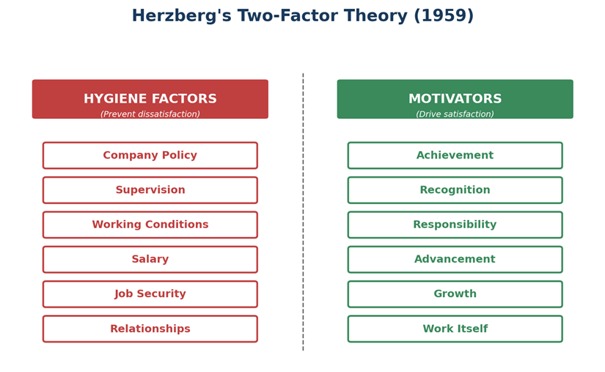
Herzberg's (1959) two-factor theory places itself between hygiene factors, much like pay, working conditions, and supervision, by preventing dissatisfaction, and secondly, motivators, such as achievement, recognition, and responsibility, ultimately driving satisfaction and performance overall positivity (Herzberg, 1959). This definition is significant because it suggests that just by merely improving hygiene factors will not motivate employees, but organisations must also provide opportunities for growth and achievement (Herzberg, 1959). Recent research in the employee feedback (2023) blog highlights the theory's continued relevance in UK organisations, particularly in staff retention and recruitment area. Similarly, a study published in Personnel Review found that employees who experience strong motivator factors, such as meaningful work and career development, reported significantly higher engagement levels (Fletcher, 2019). In summary, Herzberg's theory continues to offer a valuable sight through which organisations can evaluate and strengthen their motivational approaches.

Figure 9: Herzberg’s two factor theory (1959)

McGregor's (1960) Theory X and Theory Y describe different management assumptions.

Theory X gives the idea of employee’s dislike work, they are lazy and require personal supervision, while Theory Y leans towards employees that are self-motivated and thrive under autonomy McGregor (1960).
When theory x is implemented, managers often have strict rules, staff monitoring and show control thus ensuring tasks given are archived (MDT Training, 2024 and Firmbee, 2023). As a workplace example, a security supervisor may monitor staff that require constant updates whilst on shift. In contrast, Theory Y assumes that employees are self-motivated, they enjoy and thrive on responsibility and can work independently when trusted. Managers employing this normally encourage teamwork, utilises staff involvement in decisions, and promotes personal development ( Channell, 2025 and upGrad, 2026). Research suggests that Theory Y management styles correlate with higher employee engagement and performance (Robbins & Judge, 2023).
Offering a advantage of Theory x upGrad, (2026) give reference that environments that the importance of safety, following procedures and discipline. When clear instructions and guidelines give way to a huge
reduction on mistakes and consistency improve. However, the impact of this would be that staff might feel controlled and possibly untrusted.
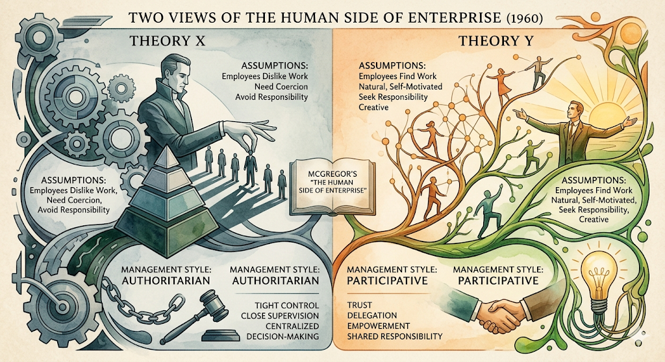
A huge advantage of Theory Y can show increased motivation, creativity and overall job satisfaction, as the feeling of trust and value by staff, boosting teamwork and productivity. This, however, may have an adverse reaction towards staff who lack experience or confidence to work under this amount of freedom and productivity can fall (Mind Tools, 2025).
Figure 10: McGregor's (1960) Theory X and Theory Y

3.2 Application of Herzberg's Two-Factor Theory to the Workplace

Herzberg's two-factor theory is the most relevant to the Pendine Sands security team, mainly because of the clear contrast between hygiene factors and motivators observable in this report (Herzberg, 1959). Security officers operate in conditions where hygiene factors—such as unsociable shift patterns, exposure to adverse weather, and relatively modest pay—are prominent sources of potential dissatisfaction (CIPD, 2024). A guidebook formulated by Armstrong (2020) on human resource management points out that if these factors are miss managed, there would be an increase in staff turnover and absenteeism. Parkdean Resorts seasonal model would suffer at great financial burden. However, according to Herzberg, improving pay alone would not generate genuine motivation. Instead, motivators such as recognition from management for effective incident handling, increased responsibility through designated team-leader roles (Herzberg, 1959). This is supported by CIPD (2024) findings that in UK organisations have been linking recognition to performance-based achievement goals, see measurably higher employee engagement. In practice, a security team leader could implement a monthly recognition scheme for exemplary performance, which would address esteem-related motivators while reinforcing company standards (Mullins, 2019). Having effective communication is front and foremost to the success of this process. Managers have a duty to clearly articulate any and all expectations, provide constructive feedback with recognition of all achievements in team briefings, thereby creating a clear direct link between communication quality and all motivational outcomes (Tourish, 2010). Nevertheless, as Herzberg's theory limitations in this context must be addressed. Seasonal staff may prioritise hygiene factors such as guaranteed hours over intrinsic motivators, which suggests that a mixed approach by combining hygiene improvements and motivational strategies would be most effective (Herzberg, 1959).



Figure 11: Formulating a workforce plan

3.3 Factors Influencing Motivation and Performance

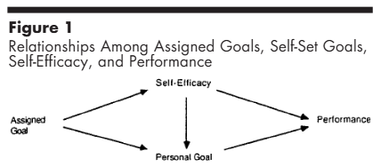
Key factors for influencing motivation and performance within any security team should include top teer leadership quality, full communication transparency, across board team cohesion, and innovative working conditions (Armstrong, 2020). CIPD (2023a) reports that all employee engagement in the UK can be seen as being strongly associated though trust in management and perceived fairness. In a seasonal workforce, where staff turnover is always high, building trust through open communication is especially important for keeping high performance standards (Welch & Jackson, 2007). Moreover, clear communication of role expectations and performance criteria can reduce ambiguity, which Locke and Latham's (2002) goal-setting theory identifies as a critical driver of productivity.

Figure 12: Loke and Latham’s goal-setting theory

3.4 Conflict in the Workplace

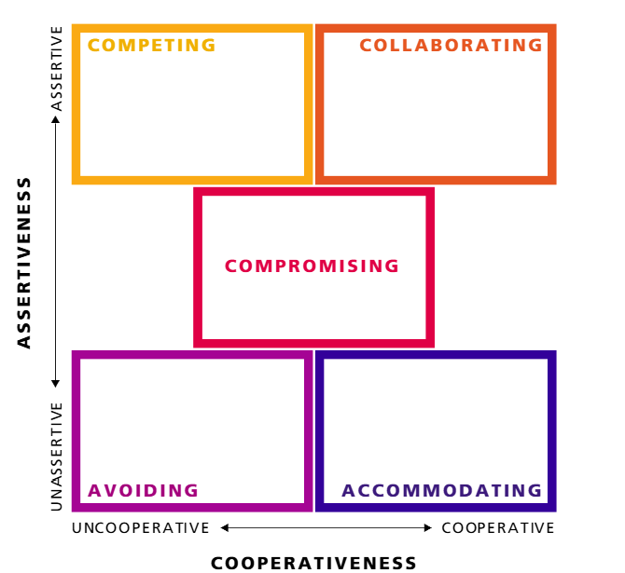
Workplace conflict can be referred to as disagreements or tensions that arise from incompatible goals, values, or expectations between individuals or groups (Thomas, 1992). ACAS (2025) reports that 44% of working-age adults in Great Britain have experienced conflict at work in the past twelve months within 2025, with the annual cost of workplace conflict has been found to estimate at a whopping £28.5 billion (ACAS, 2019). In the security team at Pendine Sands, conflict may arise from scheduling disputes, unclear role boundaries during shift overlaps, or disagreements about incident-handling procedures (Mullins, 2019), Showing that Ineffective communication is a significant contributor to conflict. CIPD (2023b) found that 35% of UK employees had experienced interpersonal conflict in the previous year, with almost a third (31%) reporting that their concern was not taken seriously. When motivation is low, employees may be less willing to engage in collaborative problem-solving, which can escalate minor disagreements into sustained conflict, adversely affecting team cohesion and performance (Robbins & Judge, 2023). The impact of conflict on performance can be both negative and, in limited cases, constructive. Unresolved conflict increases stress, reduces cooperation, and can lead to absenteeism or resignation, all of which compromise the security team's ability to protect guests and staff (Health and Safety Executive, 2023). However, if managed constructively, conflict can surface underlying issues and drive improvement (Tjosvold, 2008). The Thomas-Kilmann Conflict Mode Instrument (Thomas & Kilmann, 1974) identifies five resolution strategies: competing, collaborating, compromising, avoiding, and accommodating. For the security team, a collaborating approach—where parties work together to find a mutually beneficial solution—is most appropriate for recurring operational disputes, as it preserves relationships while addressing the root cause (Thomas & Kilmann, 1974).

Figure 13: Thomas-Kilmann Conflict Mode Instrument (TKI)

4. Conclusion

This report has demonstrated that effective communication is integral to the performance and wellbeing of the security team at Parkdean Resorts, Pendine Sands. By applying the communication cycle, Shannon and Weaver's model, and Berlo's SMCR model, it is evident that communication effectiveness depends on the interaction of personal competencies, channel selection, and feedback mechanisms. Herzberg's two-factor theory provides a practical lens for understanding motivation in the security context, while the Thomas-Kilmann model offers an evidence-based approach to conflict resolution. The self-evaluation and personal development plan identify concrete, measurable steps to enhance my communication skills, which can contribute to improved team performance and guest safety outcomes.



5. appendix

5.1 Peer Feedback Questionnaire
The following questionnaire was distributed to three colleagues to gather feedback on my communication effectiveness. Responses were collected anonymously and used in the self-evaluation.

1. How clearly do I communicate instructions during shift briefings? (1 = Very unclear, 4 = Very clear)
2. How effectively do I listen to your concerns or suggestions? (1 = Very ineffectively, 4 = Very effectively)
3. How appropriate is my tone when communicating with guests? (1 = Very inappropriate, 4 = Very appropriate)
4. How well-structured are my written incident reports? (1 = Very poorly structured, 4 = Very well structured)
5. How approachable am I when you need to raise concern? (1 = Very unapproachable, 4 = Very approachable)
6. How effectively do I manage my body language during stressful situations? (1 = Very ineffectively, 4 = Very effectively)
7. What is my greatest communication strength?
8. What is one area of communication I could improve?

5.2 Detailed Gap Analysis

Skill | Current | Required | Gap | Priority
Verbal clarity in briefings | 4 | 5 | 1 | Low
Written incident reports | 2 | 5 | 3 | High
Active listening | 4 | 5 | 1 | Low
Non-verbal control under pressure | 2 | 4 | 2 | High
Adapting tone to audience | 3 | 5 | 2 | Medium
Digital communication (email) | 3 | 4 | 1 | Low
Giving constructive feedback | 3 | 5 | 2 | Medium

5.3 Gap Analysis
The gap analysis below compares my current communication competency against the expected standard for a security team leader at Parkdean Resorts, identifying specific areas where development is required.
Communication Skill | Current Level  (1–5) | Required Level  (1–5) | Development Action
Verbal clarity in briefings | 4 | 5 | Practise structured briefing formats; seek peer feedback
Written incident reports | 2 | 5 | Complete formal report-writing course; use templates
Active listening | 4 | 5 | Attend active listening workshop; apply reflective techniques
Non-verbal control under pressure | 2 | 4 | Practise mindfulness; role-play high-pressure scenarios
Adapting tone to audience | 3 | 5 | Observe senior colleagues; practise guest de-escalation
Digital communication (email) | 3 | 4 | Use professional email templates; proofread before sending
Giving constructive feedback | 3 | 5 | Study feedback frameworks (e.g., SBI model); practise in 1:1s

5.4 Personal Development Plan
Based on the gap analysis, the following Personal Development Plan (see Appendix C) outlines SMART objectives to address identified weaknesses and build on existing strengths.

Objective | Specific Action | Measurable Target | Achievable Resources | Relevant Justification | Time-Bound Deadline
Improve written report quality | Complete an accredited report-writing course and apply structured templates to all incident reports | Complete course by 31 August 2026; achieve 90% compliance with template use over 3 months | Enrol via Parkdean L&D portal; manager to review sample reports monthly | Essential for accurate record-keeping and legal compliance | Course completion: 31 Aug 2026; Template compliance review: 30 Nov 2026
Enhance non-verbal communication under pressure | Attend a two-day conflict de-escalation and body language workshop | Complete workshop by 30 September 2026; demonstrate improved composure in two observed incident scenarios | Book via SIA-approved provider; request peer observation from team leader | Critical for guest safety and professional credibility during incidents | Workshop: 30 Sep 2026; Observed scenarios: 31 Dec 2026
Develop feedback and coaching skills | Study the SBI (Situation–Behaviour–Impact) feedback model and apply it in monthly one-to-one sessions with team members | Deliver structured feedback in at least 6 one-to-one sessions over 3 months; collect feedback from recipients | Access SBI materials via CIPD online resources; schedule sessions in team calendar | Supports team development and motivation, aligning with Herzberg's motivators | Begin: 1 July 2026; Review: 30 Sep 2026

References

ACAS. (2019). The cost of conflict at work and its impact on productivity. Advisory, Conciliation and Arbitration Service. https://warwick.ac.uk/fac/soc/ier/rewage/news-archive/cost_of_conflict_pb_formatted_final_2.pdf

ACAS. (2025). How prevalent is individual conflict at work in Great Britain? Advisory, Conciliation and Arbitration Service. https://www.acas.org.uk/research-and-commentary/workplace-conflict

Acuity Training. (2023). Communication skills statistics: New research for 2023. https://www.acuitytraining.co.uk/news-tips/communication-skills-statistics/

Adair, J. (2009). Effective communication, The most important management skill of all. Pan books. 87-88. https://books.google.co.uk/books?hl=en&lr=&id=7NAmzag_Q5cC&oi=fnd&pg=PR7&dq=Adair,+J.+(2009).+Effective+communication:+The+most+important+management+skill+of+all.+Pan+Macmillan&ots=L-vCNW4lUz&sig=wf2oQoqwX_LD23SsWQNitEkMRBo#v=onepage&q&f=false

Argyle, M. (1972). The psychology of interpersonal behaviour (3rd ed.). Pelican Books. https://www.scribd.com/document/698493244/Michael-Argyle-the-Psychology-of-Interpersonal-B-BookFi-1-Org

Abu Bakar, A. L., Din, W. A., Ationg, R., & Swanto, S. (2022). Back to basic: Theories and models of communication. International Journal of Law, Government and Communication, 7(30), 78–86. https://www.researchgate.net/publication/367200690_BACK_TO_BASIC_THEORIES_AND_MODELS_OF_COMMUNICATION

Armstrong, M. (2020). Armstrong's handbook of human resource management practice (15th ed.). Kogan Page https://studylib.net/doc/27929236/pdfcoffee.com-armstrong-marmstrongx27s-handbook-of-human-...?p=3

Baptista, A. C. (2023). Communication as an essential strategy in teaching and learning processes. In Perspective Chapter: Communication as an Essential Strategy. IntechOpen.

Bekke, M. (2020, July 6). This is why “93% of communication is nonverbal” is a myth. Donders Wonders. https://blog.donders.ru.nl/this-is-why-93-of-communication-is-nonverbal-is-a-myth/

Berlo, D. K. (1960). The process of communication: An introduction to theory and practice. Holt, Rinehart and Winston. https://www.scribd.com/document/493889048/235577-The-Process-Of-Communication

Byron, K. (2008). Carrying too heavy a load? The communication and miscommunication of emotion by email. Academy of Management Review, 33(2), 309–327. https://doi.org/10.5465/amr.2008.31193163

CIPD. (2023b). Managing conflict in the modern workplace. Chartered Institute of Personnel and Development. https://www.cipd.org/en/knowledge/reports/managing-conflict/

CIPD. (2024). Pay, performance and transparency 2024. Chartered Institute of Personnel and Development https://www.cipd.org/globalassets/media/knowledge/knowledge-hub/reports/2024-pdfs/8551-pay-performance-and-transparency-report-web2.pdf

CIPD. (2025a). Employee engagement and motivation factsheet. Chartered Institute of Personnel and Development. https://www.cipd.org/en/knowledge/factsheets/engagement-factsheet/

Dimbleby, R., & Burton, G. (2007). More than words: An introduction to communication (4th ed.). Routledge. https://api.pageplace.de/preview/DT0400.9781000100822_A40223543/preview-9781000100822_A40223543.pdf

Daft, R. L., & Lengel, R. H. (1986). Organizational information requirements, media richness and structural design. Management Science, 32(5), 554–571. https://doi.org/10.1287/mnsc.32.5.554

Employee Feedback. (2023). Herzberg’s theory – Still relevant today. Employee Feedback. https://www.employee-feedback.co.uk/post/herzbergs-theory-still-relevant-today

Fletcher, L. (2019) 'How can personal development lead to increased engagement?', Personnel Review, 48(1), pp. 100–117. https://www.tandfonline.com/doi/full/10.1080/09585192.2016.1184177#abstract

Firmbee. (2023). McGregor’s Theory X and Theory Y. Firmbee. https://firmbee.com/mcgregors-theory-x-and-theory-y

Gurteen, D. (n.d.). The Mehrabian myth: It is not true that 93% of our communication is nonverbal. Conversational Leadership. https://conversational-leadership.net/mehrabian-myth/

Hargie, O. (2017). Skilled interpersonal communication: Research, theory and practice (6th ed.). https://www.academia.edu/143649826/Skilled_Interpersonal_Communication

Hargie, O. & Tourish, D. (2010). Auditing organizational communication: A handbook of research, theory and practice. Routledge. https://scholar.google.co.uk/scholar?q=Tourish,+D.+(2010).+Auditing+organizational+communication:+A+handbook+of+research,+theory+and+practice.+Routledge.&hl=en&as_sdt=0&as_vis=1&oi=scholart

Health and Safety Executive. (2023). Work-related stress, anxiety and depression statistics in Great Britain, 2023. HSE. https://www.hse.gov.uk/statistics/causdis/stress.pdf

Herzberg, F. (1959). The motivation to work. John Wiley & Sons. https://api.pageplace.de/preview/DT0400.9781351504430_A30546568/preview-9781351504430_A30546568.pdf

Human Focus. (2025, October 14). The Shannon and Weaver model of communication at work. Human Focus. https://humanfocus.co.uk/blog/the-shannon-and-weaver-model-of-communication-at-work/

Johns, G., & Saks, A. (2021). Organizational behaviour: Understanding and managing life at work (12) 392-393. https://studylib.net/doc/27815138/organizational-behaviour--understanding-and-managing-life...

Maslow, A. H. (1943). A theory of human motivation. Psychological Review, 50(4), 370–396. https://www.researchgate.net/publication/385430484_A_Theory_Of_Human_Motivation_A_H_Maslow_1943_Maslow's_Hierarchy_Of_Needs_A_Perspective_Review_Of_Common_Misconceptions_And_Notes_On_The_Revisions

McGregor, D. (1960). The human side of enterprise. McGraw-Hill. https://ia600104.us.archive.org/5/items/in.ernet.dli.2015.459335/2015.459335.The-Human-Side-Of-Enterprise.pdf

McQuail, D., & Windahl, S. (2015). Communication models for the study of mass communications (2nd
ed.). https://api.pageplace.de/preview/DT0400.9781317900689_A26309522/preview-9781317900689_A26309522.pdf

Mehrabian, A. (1971). Silent messages: Implicit communication of emotions and attitudes. https://e-edu.nbu.bg/pluginfile.php/855150/mod_resource/content/1/Albert-Mehrabian%20-%20Silent%20Messages%201971%20-%20red.size.pdf

Meinam. (2023). Feedback in the communication process. ResearchGate. https://www.researchgate.net/publication/373421380_Feedback_in_the_Communication_Process

Mind Tools. (2025). Theory X and Theory Y: Understanding people’s motivations. Mind Tools. https://www.mindtools.com/adi3nc1/theory-x-and-theory-y/

Mullins, L. J. (2019). Management and organisational behaviour (12th ed.). Pearson https://api.pageplace.de/preview/DT0400.9781292245508_A39573206/preview-9781292245508_A39573206.pdf

NewZapp Communications. (2024). The hidden costs of poor communication in the workplace. NewZapp Communications. https://newzapp.co.uk/blog/the-hidden-costs-of-poor-communication-in-the-workplace/

Pease, A., & Pease, B. (2017). The definitive book of body language. Orion. https://e-edu.nbu.bg/pluginfile.php/331752/mod_resource/content/0/Allan_and_Barbara_Pease_-_Body_Language_The_Definitive_Book.pdf

Pumble. (2026). Workplace communication statistics 2021. https://pumble.com/learn/communication/communication-statistics/

Robbins, S. P., & Judge, T. A. (2023). Organizational behavior (19th ed.). Pearson https://api.pageplace.de/preview/DT0400.9781292449968_A46465006/preview-9781292449968_A46465006.pdf

Shannon, C. E., & Weaver, W. (1949). The mathematical theory of communication. University of Illinois Press. https://pure.mpg.de/rest/items/item_2383164_3/component/file_2383163/content

Shen, J., Chanda, A., D'Netto, B., & Monga, M. (2009). Managing diversity through human resource management: An international perspective and conceptual framework. The International Journal of Human Resource Management, 20(2), 235–251. https://doi.org/10.1080/09585190802670516

Thomas, K. W., & Kilmann, R. H. (1974). Thomas-Kilmann Conflict Mode Instrument. https://www.researchgate.net/publication/265565339_Thomas-Kilmann_conflict_MODE_instrument

Thomas, K. W. (1992). Conflict and conflict management: Reflections and update. Journal of Organizational Behavior, 13(3), 265–274. https://doi.org/10.1002/job.4030130307

Tjosvold, D. (2008). The conflict-positive organization: It depends upon us. Journal of Organizational Behavior, 29(1), 19–28. https://www.academia.edu/24592310/Title_The_Conflict_Positive_Organization_It_Depends_Upon_Us

Tourish, D., & Hargie, O. (2004). Key issues in organizational communication. https://dr-zakeri.ir/wp-content/uploads/2017/09/Ref-5.pdf

Tourish, D. (2010). Auditing organizational communication: A handbook of research, theory and practice. Routledge. https://api.pageplace.de/preview/DT0400.9781134122059_A25023503/preview-9781134122059_A25023503.pdf

TSW Training. (2024). Maslow's hierarchy of needs: How leaders and managers can motivate their teams. https://www.tsw.co.uk/blog/leadership-and-management/maslows-hierarchy-of-needs/

Channell, M. (2025). McGregor’s Theory X and Y: How to increase team performance. TSW Training. https://www.tsw.co.uk/insights/mcgregors-theory-x-vs-theory-y/

upGrad. (2025). Theory X and Theory Y by Douglas McGregor. upGrad. https://www.upgrad.com/blog/theory-x-and-theory-y-by-douglas-mcgregor/

Wahba, M. A., & Bridwell, L. G. (1976). Maslow reconsidered: A review of research on the need hierarchy theory. Organizational Behavior and Human Performance, 15(2), 212–240. https://doi.org/10.1016/0030-5073(76)90038-6

Welch, M., & Jackson, P. R. (2007). Rethinking internal communication: A stakeholder approach. Corporate Communications: An International Journal, 12(2), 177–198. https://doi.org/10.1108/13563280710744847

Zuzul, T., Pahnke, E. C., Larson, J., Bourke, P., Caurvina, N., Shah, N. P., Amini, F., Weston, J., Park, Y., Vogelstein, J., White, C., & Priebe, C. (2021). Dynamic silos: Increased modularity in intra-organizational communication networks during the COVID-19 pandemic.

