roxana madalina dranga
89 Birchfield road CV6 2BB Coventry
Roxette.mada23@gmail.com
Tel :07399414235

Personal Statement
I am looking to take on new challenges and more responsibilities as I have a desire to progress and obtain new knowledge in my career. Being dedicated, hardworking team player that can work on my own as well, make key attributers which I can translate to any new role. Naturally I strive to deliver excellent customer service both internally and externally and set high standards which often produces the best out of me and others working with me. Always willing to support others and gain new skills makes me an ideal candidate for the role. I look forward to working towards and achieving all my goals and going beyond what is expected from me within a fast-moving distribution centre.

Employment history
Amazon Associate: July 2018 - Present
Amazon BHX4 Coventry
Amazon is a great place to work and I have fitted in my team well and quickly progressed to new roles over the past 2 years. Amazon matches my desire to achieve high standards and be the best I can be. Until now I had worked and received training for my department Outbound/shipping.
Responsibilities:
- Manual palletize process
- Banding/double banding- banding the pallets to be safe
- Pump track
- Perfect pallet- wrapping the pallets with wrap in a safe way to don’t fall
- Water spider- moving the pallets with the pump truck
- Jack pot- sorting the cases and the totes in the specific destination
- Fluid load-loading the trailers with the items and stack them safely
- Problem solve- solving all the problems with the items
- Indoor marshal-opening and closing a bay door before and after to be loaded and securing the loads
- Instructor- instructing and guiding the new hires
- Process guide- being the voice of team leader, coordinating all the people to do the job properly and safe
- Team leader- coordinating a team of people to do the job required, being responsible for them, recording reports of work
- Ship clerk- taking trailers on the bay to be loaded, making sure all CPT units are loaded in time ,making the paper work for all the products from the trailers
- Fire Marshall- in case of fire alarm we have the responsibility to make sure everyone will exit the building in a safe way.
- Temporary area manager- being responsible with all the team leads, people ,all the team for a good and safe environment, engagements, investigations, holiday, target ,reports, having the correct number of associates working regarding our target, our number of collections .

Warehouse operative: May 2017 – June 2018
PERTEMPS and DHL in JD WETHERSPOON
At DHL I was working on all shifts, morning and Nights and I manage to have good relationships with all my colleagues either full time staff, agency and even managers(DHL/Agency) My role was working in the next chambers.

Responsibilities

- Picking products and packing safely in roll cages for pubs in the Ambient and Freezer
  - Voice picking
  - Drive llop
  - De-kitting vehicles
  - Recycling pubs waste in the recycling area
- Recycling cardboard on the baller
    - -recycling oil
    - -corkscrew machine
    - -green machine
- Identifying/correcting problems with stock
- Housekeeping
- Loading each pub on routes, from various chambers into all vehicles types, ensuring correct temperatures are maintained and loaded in the correct drop order, consolidating cages were needed
- Good in – receive all the products in safe, put them in the system, drive them in the correct location
- 100% checks on certain deliveries

Education
- 2020-present University of Wales Trinity Saint David
Birmingham UK
Business management
Level 4

- 2004-2008 High-school Collegium Technic Mechanic Grivita
Technician and project 3D in AUTO CAD

# 1996-2004 Primary school

- Languages – Romanian-native
-English – speaking/writing/reading
-Greek- speaking/writing/reading
- Spanish- speaking / readying

licenses and certificates
- LLOP driving
- battery changing/charging equipment
- Diploma of technician 3D projects to AUTOCAD
- Car driving license UK provisional L
COMPUTER SKILLS
- Microsoft suite, power point, excel, word
- Design technician Auto CAD
- 3D/2D CAD
KEY SKILLS
- High understanding of Health and Safety in the workplace.
- Experience operating a LLOP safely.
- Trained on how to use the Headset properly.
- Ability to work effectively in a team, in any position.
- Physically fit and able to kneel, lift, push and pull.
- Excellent ability to manage and get the most out of me all the time.
- Working in multi-temperature environment.
- I have great communication skills which often makes me popular with my colleagues.
- Strong communication with others/team
- Good leader
- High standards and very ambitious person
- Perseverant and faster learner

Interests
Socialising, various sporting activities like volleyball, enjoy music, dancing, reading and traveling, learning and having new experiences.

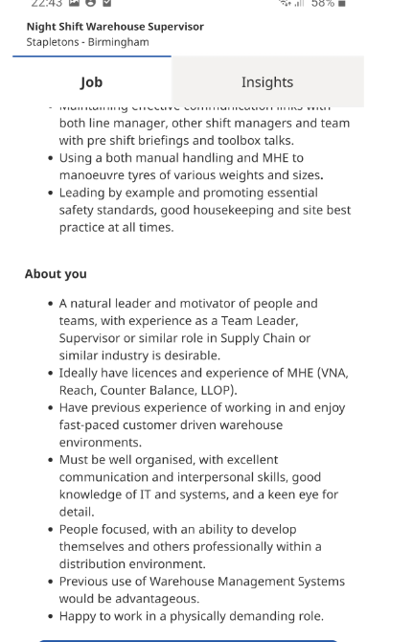

Roxana-Madalina dranga
89 Birchfield road CV62BB
Roxette.mada23@gmail.com
07399414235
14th of October 2020
Stapleton’s Birmingham
Night shift warehouse supervisor
40 hours per week
Sunday to Thursday
Dear Recipient:
I am writing to submit my application for Night shift Supervisor at Stapleton’s Birmingham. It is a great enthusiasm that I ask to contribute with my training, experience and dedication to this new exciting position.
I am confident that my past experience has prepared me for this position. All my experience from past to present made me to be an expert of working with targets and having training and worked to all position in a warehouse and passing all tests. I have the necessary ambition and desire to move to the next level in my career.
Working with Amazon for more than two years, at the beginning as a simple associate in Outbound palletise process and after been promoted to others trainings using the pump truck, banding machines, wrapping machines, trained in Shipping department as an indoor marshal, fire Marshall, Shipping clerk, process guide. All these trainings helped me to have a lot of experience and responsibility to coordinate and working with a big team of associates (70-100) and managing them to reach every day our targets in a nice and safe environment. Working in all the key processes I know how important is every task, departments, as all of them are connected and if one is not working properly all the others departments will struggle. Moreover this allowed me to gain a good understanding of the workflow and the overall process in a crucial point of the customer journey and to understand how important each department is in the overall picture.
After only one year I applied for team leader position where I was successful and excited to learn new things about management, reports in excel, words, projects, team engagements, meetings. It was easy for me to learn everything as I have an eye on each detail, already having strong communication skills, following the leadership principles and Amazon policy.
As a team leader I had more responsibilities regarding my teamwork, targets, numbers, headcount, trainings. All this responsibilities made me to work harder, made me to want to be the best and I started projects to support my drivers ,indoor Marshall’s, Shipping clerks with other trainings, ideas for a better way to do the job over the target and placing my shift every day on top.
I was happy that I build a team like a family, to support each other’s, to help each other’s, the environment was a niece one, a happy team working.
After all this I was promoted to be a Temporary Area Manager for 2 months.
This job was another exciting challenge for me. My team was more than happy to have me as theirs manager. My department was spending the product’s and pellets to our customers. We was loading those pallets with pump truck or PIT (LLop) in the trailers, have to secure the load to be safe, shipping clerks was preparing the paperwork for the trailer with specifics items ,kg , numbers, trailer and tractor, indoor marshal was opening and closing the bay and trailer.
I had all the support from my team and started to take the job very seriously and making changes. I was responsible with department costs, headcount cost, over time, team connect, engagements, meetings with others managers, senior manager and general manager ,investigations, reports of the shift 12 and 24 hours reports ( target, hours, units ,footprint, volume, cost, trailers and collections), trained other team leaders.
I am able to take on the responsibility of this position. I have the enthusiasm and determination to ensure that I will make a success of it.
I encourage you to review my resume which supports my ambition and ability to exceed your expectations and goals by utilizing my talents and my popularity to support your exceptional work.
Thank you for your time and consideration.
Sincerely,
Roxana-Madalina Dranga

