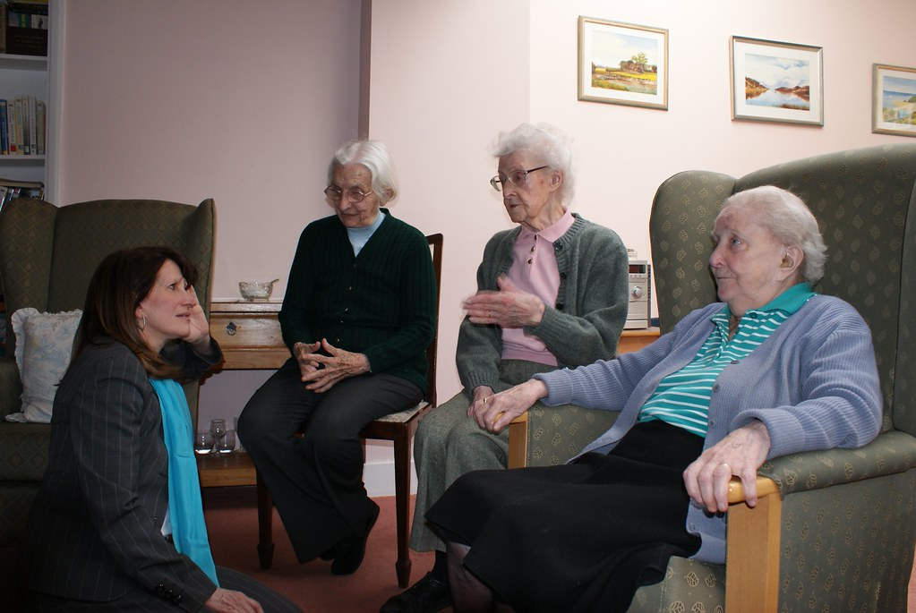  Kineton Manor Care Home  Neayer Sultana (2419538) | Certificate of Higher Education in Health and Social Care| Psychology in Health and Social Care| LCHS4010| Component 2| Neale Haddon. | Abstract  This report looks at a care home and how it uses theories to accommodate the needs of their elderly dementia patients.

Contents
Introduction 2
Care Home 2
Theory 1- PERMA Theory of Wellbeing 2
Relation to Adult Dementia Patients 2
Theory 2- Maslow’s Motivation Theory 3
Relation to Adult Dementia Patients 3
Application to the Health and Social Care Sector (Care Home) 4
Challenges 5
Conclusion 5
Reference List 6

Introduction
This report will discuss how a Care Home supports dementia patients who are 65 years old and over. It will critically evaluate two psychological theories, one being the PERMA theory of wellbeing and the other being Maslow’s motivation theory and explain how these theories can be used to support dementia patients in a practical setting with the use of the theories to support potential improved or new practical practices.

Care Home
Care Homes are experts in nursing care; they opened in 1988 (Kineton Manor, 2025). They cover all your needs whilst allowing residents to live independently (Kineton Manor, 2025). They have state-of-the-art facilities and have a wide range of additional services (Kineton Manor, 2025). They offer 24-hour care, it is the ideal place to support dementia patients (Kineton Manor, 2025). Nurses and workers, learn through shared experience and support each other by sharing best practice (Kineton Manor, 2025). They have an outstanding award from the care quality commission, in 2016, 2019 and 2021 (Kineton Manor, 2025). The main aims of the care home are to, experience, development of learning, new opportunities, and improvement of all nursing home images (Kineton Manor, 2025).

Theory 1- PERMA Theory of Wellbeing
PERMA Theory of wellbeing explains wellbeing through a concept of five pillars (Aastha and Khan, 2023). They are positive, emotion, engagement, relationship, meaning and accomplishment (Aastha and Khan, 2023). Together they make PERMA. Positive emotion shows your feelings, it means happiness, joy, hope and appreciation (Aastha and Khan, 2023). Engagement shows living completely in that moment (Aastha and Khan, 2023). Relationship is when you can build a strong bond between people (Aastha and Khan, 2023). Meaning is when you are feeling involved and needed for and by others, and you can be social in your own way (Aastha and Khan, 2023). Accomplishment is when you learn and complete a skill or project that you desire (Aastha and Khan, 2023).

Relation to Adult Dementia Patients
In relation to adults with dementia, care homes usually encourage positive emotion by encouraging patients and service uses to engage in activities that bring happy emotions like happiness (Seligman, 2011). Some examples of practical activities are craft or music sessions to improve happier emotions (Seligman, 2011). For engagement, they help individuals find activities that they can become attracted to, like gardening or woodwork. It promotes flow and improves mental health. For engagement, they support relationships by helping patients connect with other residents, and care workers. This makes them feel wanted and part of a community (Seligman, 2011). For meaning, they help service users find meaning and purpose by helping them find meaningful work and achievements which help them have a sense of fulfilment. Finally, for accomplishment they encourage individuals to set achievable goals small or big. They celebrate and encourage accomplishment and completion (Seligman, 2011). The theory believes this can boost self-esteem. The PERMA model aims to enhance the quality of life, happiness, and positive outcomes for individuals (Seligman, 2011).
This is particularly important for those with dementia and particularly those aged sixty-five and over as they deteriorate, the quality of life lessens with each symptom. Being able to manage and enjoy the parts of life we can add an addition to within the current and contemporary life span is especially important for those whose mood, energy and mental state is encouraged by the downfall of their lives with the illness of dementia.

Theory 2- Maslow’s Motivation Theory
Maslow theory of motivation says that human motivation is based on people seeking fulfilment and change though personal growth (Care Learning, 2024). Maslow’s hierarchy of needs is created using the following aspects: Self-actualisation which is to achieve full potential (Care Learning, 2024). Aesthetic needs which are described as harmony, order, and beauty. Cognitive needs which is the ability to be curious, understanding of the world and be explorative (Care Learning, 2024). Esteem needs are described as the person being competent and recognised within themselves. Attachment needs are to the ability to love, be loved and to have friends, companions, and foes (Care Learning, 2024). Safety needs are having security, comfort, and the freedom of fear. Finally, physiological needs which are physical necessities like food, water, oxygen, and rest. Maslow puts our diverse needs into a triangle hierarchy, which according to Maslow people up-scale to seek fulfilment once their basic needs are met (Care Learning, 2024). Maslow’s motivation theory sums up as being able to realise one’s full potential through internal drive, by inner motivation, not by approval of external judgement such as fame, status, or awards (Care Learning, 2024). Maslow suggested the following three people who achieved self-actualisation: Eisenstein, Eleanor Rosevelt, and Ghandi as examples of people who have reached the top (Care Learning, 2024).

Relation to Adult Dementia Patients
Maslow’s theory relates to dementia patients by explaining that for an individual to be self-fulfilled they need to be healthy, they need to be well fed, they need to be sleeping well, feeling safe at home and have confidence in themselves (Hayre-Kwan et al., 2021). Maslow’s hierarchy of needs helps practitioners understand how to meet service users’ specific needs. Biological and physiological needs must be met first (Hayre-Kwan et al., 2021). If service users are hungry or tired, they have difficulty concentrating or feeling positive about themselves. Therefore, it is important to meet these needs (Hayre-Kwan et al., 2021).

Application to the Health and Social Care Sector (Care Home)
Using Maslow’s theory in a Care Home can look something like physiological advancements for example is the ability to have basic needs like food, water, warmth, hygiene, and rest (Care Learning, 2024). For safety support it is the idea of feeling secure and protected from physical and emotional harm, to be able to maintain order and stability. Love and belonging are having a social connection, affection through relations with a sense of being a part of a group and community. Esteem needs are the need to have self-worth, and respect from others and self-respect with confidence and independence with a sense of achievement (Care Learning, 2024).
Within a practical setting, the nursing home can make someone feel secure physiologically is having a care home with working heating, healthy and warm food, fresh and clean water, washing facilities and support with it if needed and a good space for sleep and rest (Care Learning, 2024). Care homes can initiate safety by having door locks, bells for emergencies, round the clock care so residents feel safe and secure. They can make residents feel loved by having community groups and a chance to socialise with the other residents and external agencies (Hayre-Kwan et al., 2021). Finally, to promote esteem they can encourage independence and celebrate individual accomplishments like using services or keeping cleaning on their own.
Using PERMAS theory of wellbeing a care home can use the concept of five pillars to encourage positive emotion by being regularly available for service users who need it (Martin, 2017). They can ensure engagement by having routines and community groups (Martin, 2017). They can build relationships with kindness and social settings like a common room (Martin, 2017). They can give people meaning by having them felt heard and in charge of basic jobs (Martin, 2017). They can provide a sense of accomplishment by praising the little achievements (Martin, 2017). Doing this in a care home would make the home feel like a warm and safe place, it can make the environment friendly and family orientated.

Challenges
Some of the challenges care home staff can face is behaviours like, hitting, depression and crying (Hayre-Kwan et al., 2021). There can also be a lack of resources to create and adapt the service for its users. Patients can gradually lose patience due to the dementia becoming more aggressive this can reduce the amount of support nurses can offer in making users feel safe, independent, and motivated (Hayre-Kwan et al., 2021). Elderly patients can also have other underlining issues which can intervene with behaviour and capabilities to do tasks which could cause safety issues for staff trying to create community areas (Hayre-Kwan et al., 2021). Nurses and health care assistants can lack support from managers and as a result be able to provide basic level of care with little space to create fun, mental nurturing environments (Hayre-Kwan et al., 2021).

Conclusion
To conclude, a Care Home provides both basic and advanced care measures which both Maslow’s theory of motivation and PERMA’s wellbeing theory can be used to showcase. Although, both theories provide sense to practical practices within care settings there are some disadvantages and issues which arise for both service users and care professionals in aiming to provide safe, community, motivational and wellbeing groups, care services, and support.

Reference List
Aastha, D & Khan, W. (2023). The PERMA Model of Wellbeing: A Comprehensive Framework for Enhancing Reminiscence in the Elderly. 10.4018/978-1-6684-7630-7.ch005.
Care Learning (2024). Examples Of Maslow’s Hierarchy of Needs in Healthcare - Care Learning. [online] Care Learning. Available at: https://carelearning.org.uk/blog/models/examples-of-maslows-hierarchy-of-needs-in-healthcare/ [Accessed 3 Nov. 2025].
Martin, G.N. (2017). Psychology. 6th ed. Harlow, United Kingdom: Pearson Education Canada.
Hayre-Kwan, S., Quinn, B., Chu, T., Orr, P. and Snoke, J. (2021b). Nursing and Maslow’s Hierarchy. Nurse Leader, [online] 19(6), pp.590–595. doi: https://doi.org/10.1016/j.mnl.2021.08.013.
Kineton Manor (2025). Contact Kineton Manor Nursing Home. [online] Kinetonmanor.co.uk. Available at: https://www.kinetonmanor.co.uk/ [Accessed 3 Nov. 2025].
Seligman, M. E. (2011). Flourish: A new understanding of happiness and well-being and how to achieve them. Nicholas Brealey.

