Introduction to Web and Database Concepts (ACCA4023)
| January 16th 2024
Sharise Jonathan (2306013)
BSC computing (Software engineering)
Level 4
Contents
Introduction 2
Requirements 2
Implementation 2
Home Page 2
Booking Page 3
Offers Page 5

Introduction
This Report consists of information about creating my website and the process using notepad++. The website is about “The Wild Kingdom Experience” a safari park for children and families. To create the website, I used HTML and CSS.

Requirements
My website is for a safari park and zoo that has many animals but offers different experiences such as feeding animals and ongoing shows with sea lions. The purpose of the website was to advertise the zoo and to provide important if they wished to visit. My website targets children, parents, or large families. To accommodate to my target audience, I implemented a simple layout that adults would find easier to use. Additionally, I also implemented a colour scheme that matches the theme of a safari park or zoo including green and beige. Furthermore, for the website to be engaging and captivating to children I included many images that would be exciting. So that they would want to visit the Wild Kingdom Experience. Additionally, the images were useful in order to structure the layout of the website and was able to give the user an idea what the zoo offers and were able to predict what the information would be about. This also makes the website more accessible for adults who have busy lifestyles so do not have much time to research the zoo they want to visit.

Implementation

Home Page

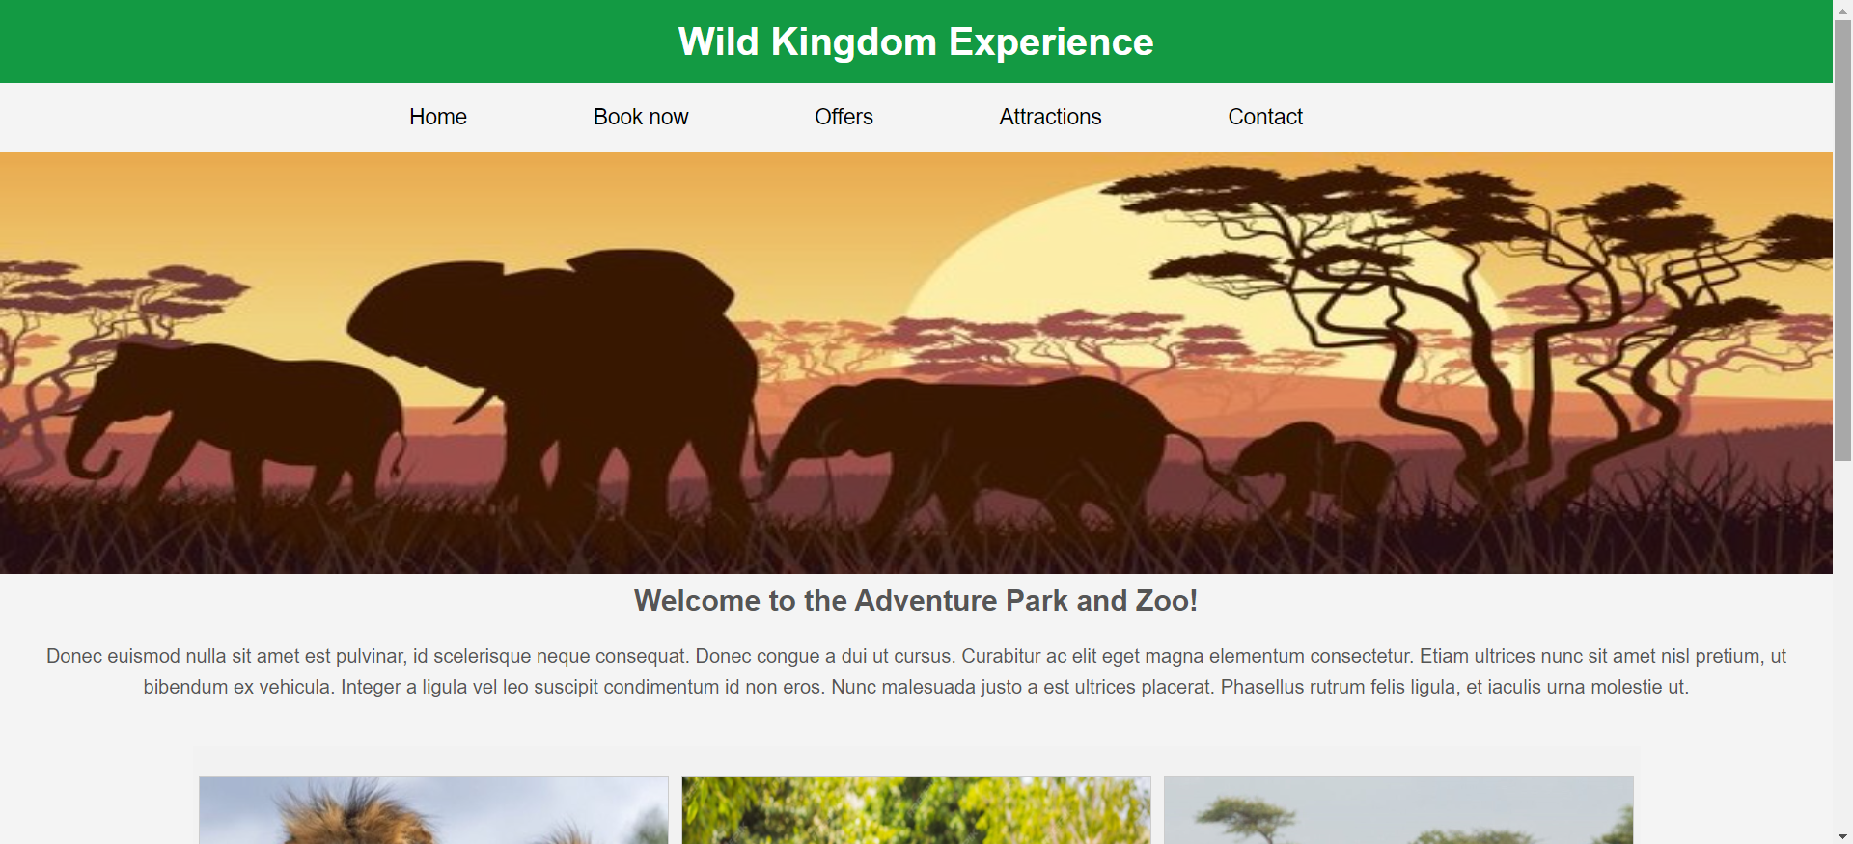

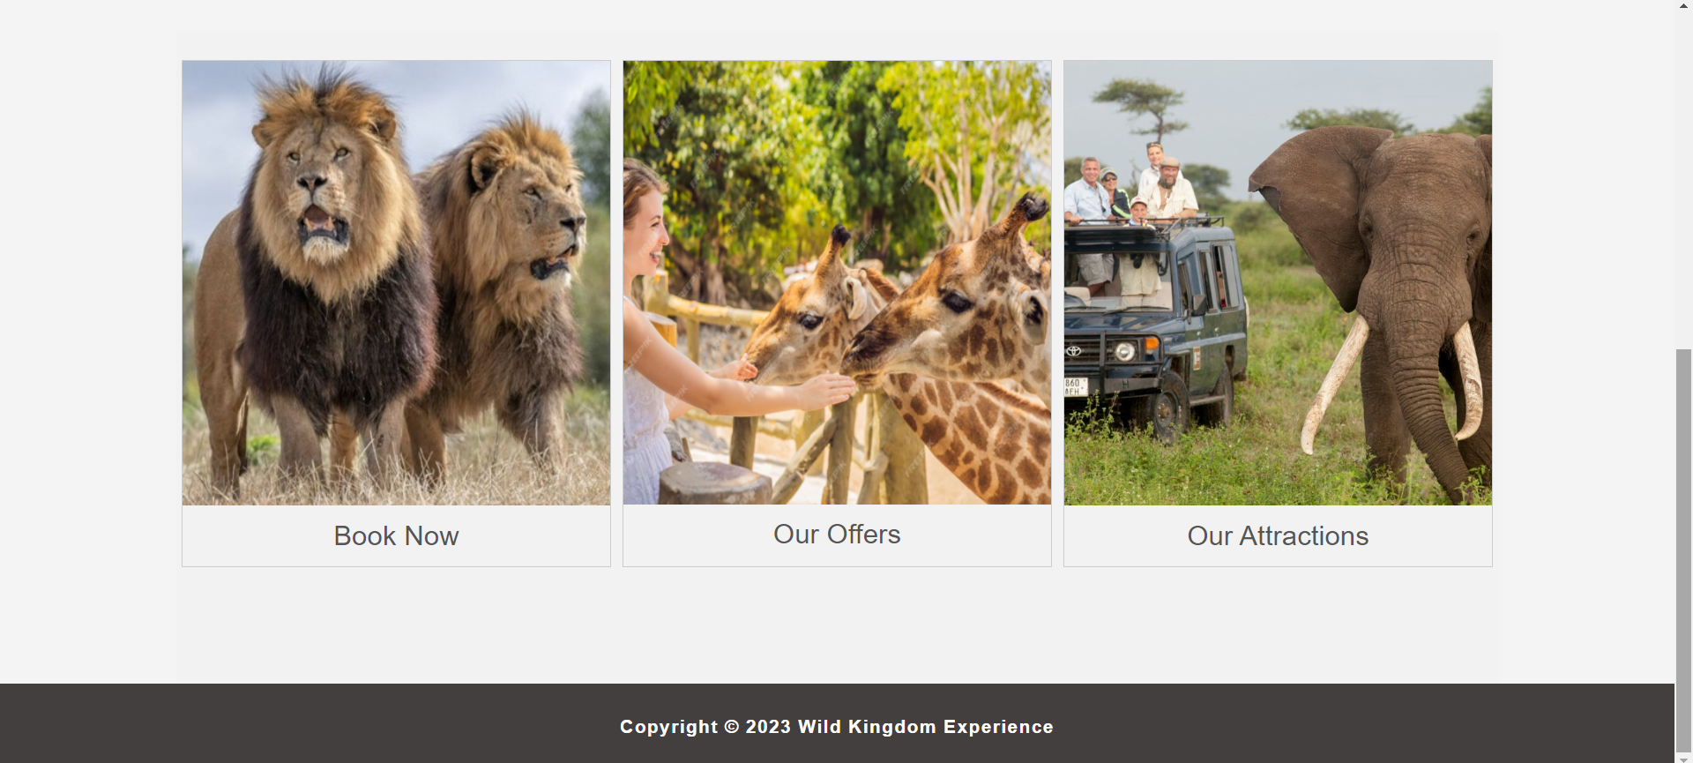

Booking Page

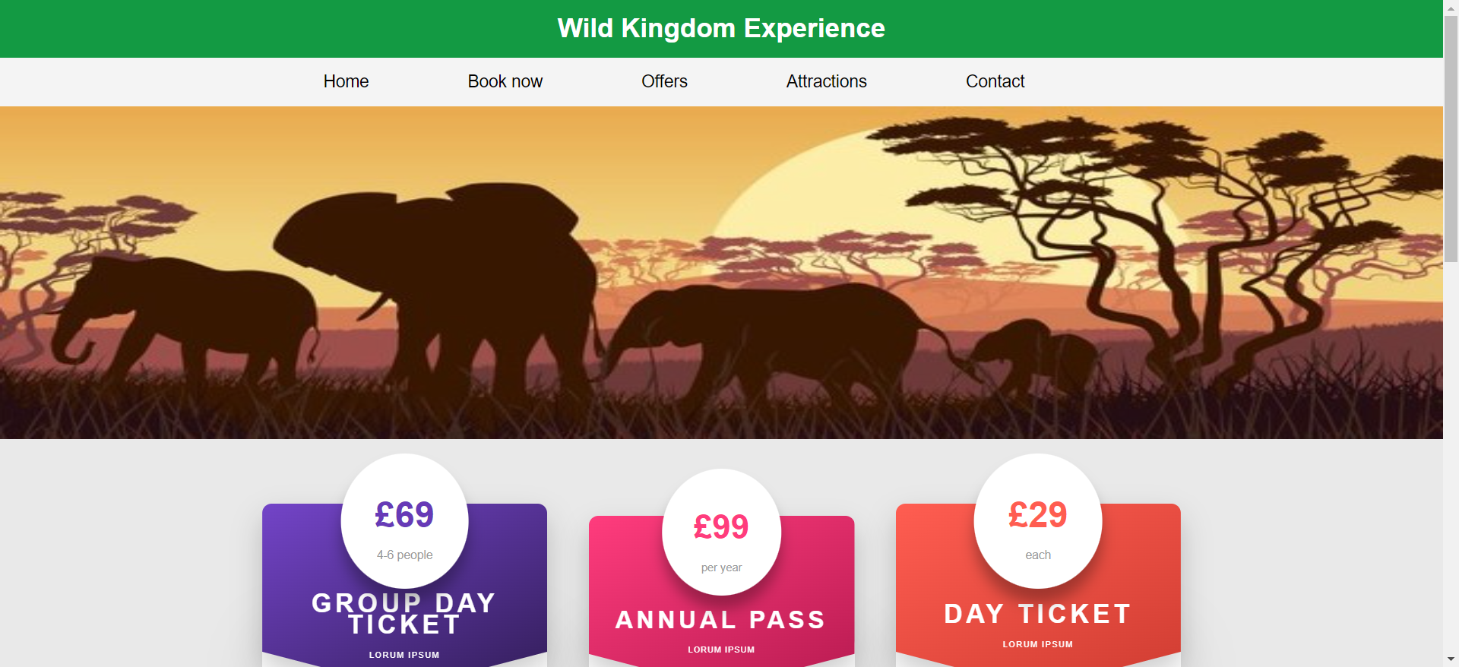

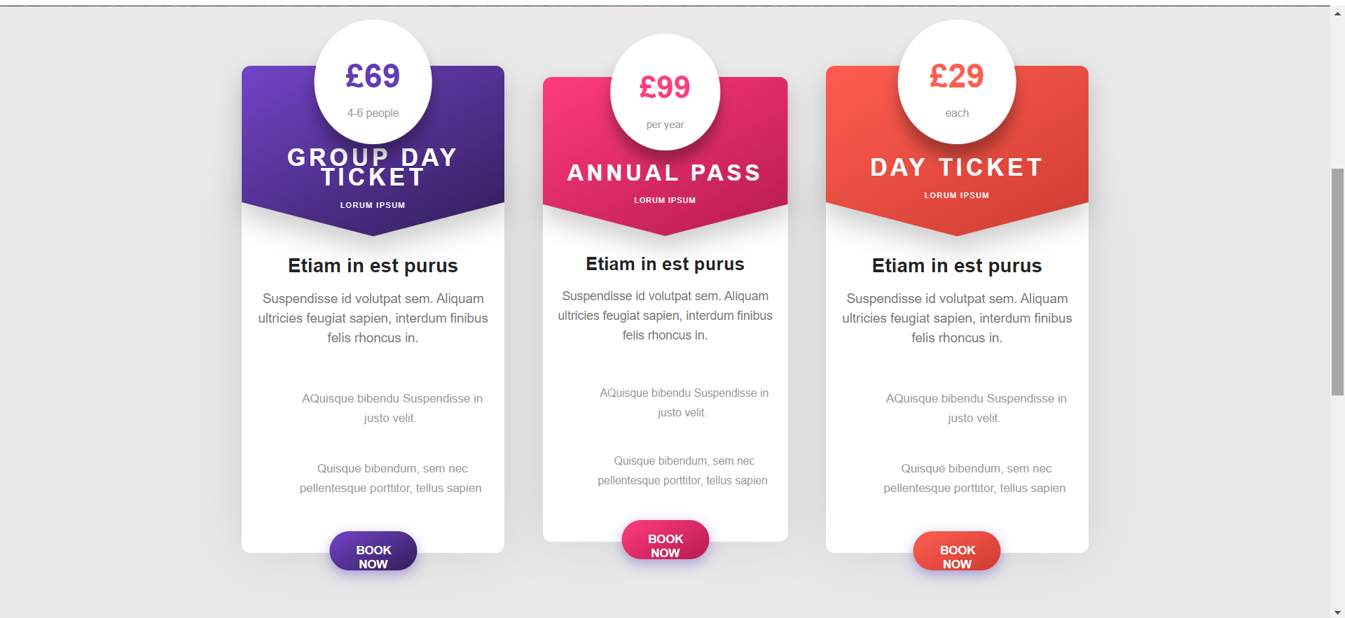
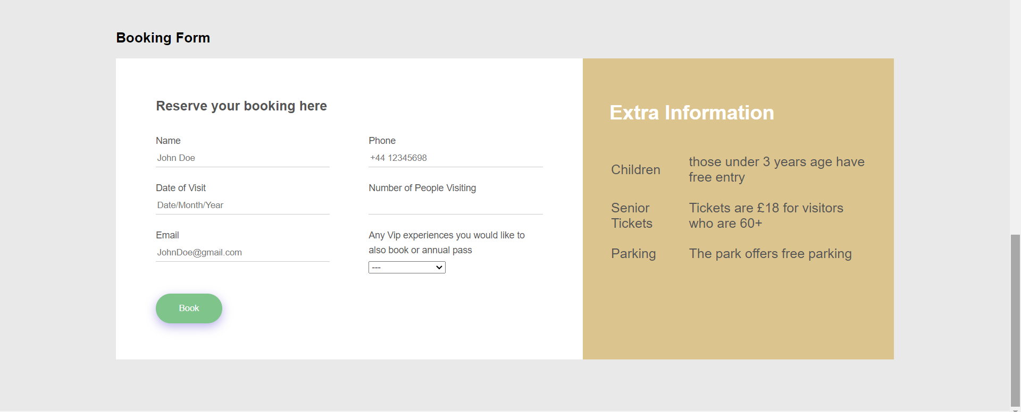

Offers Page

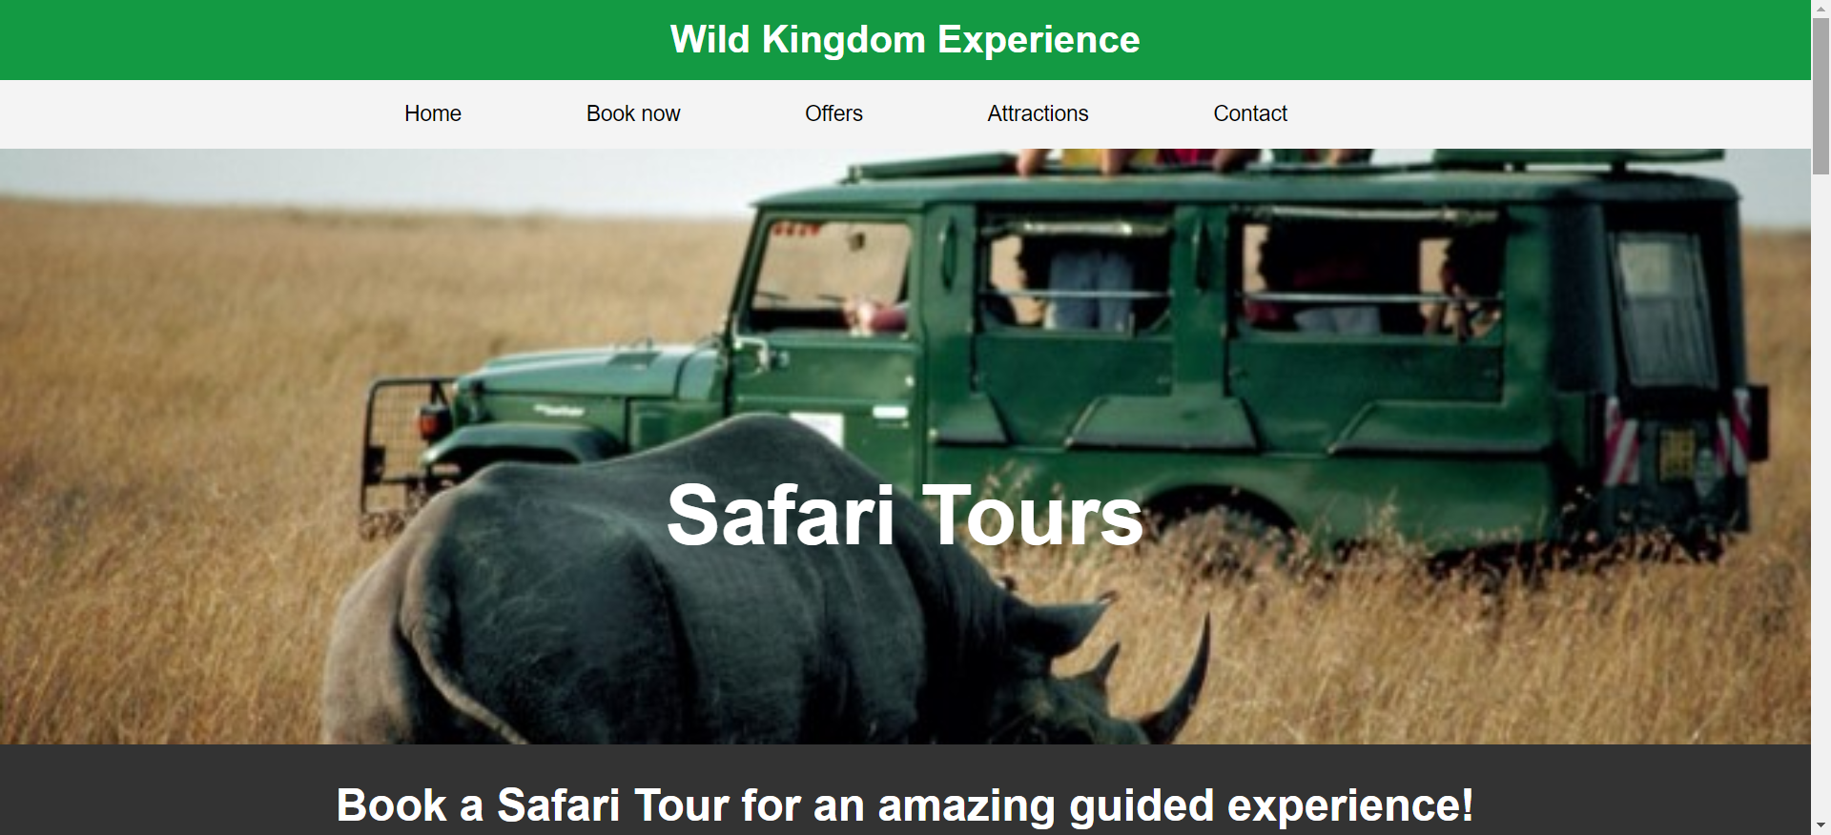

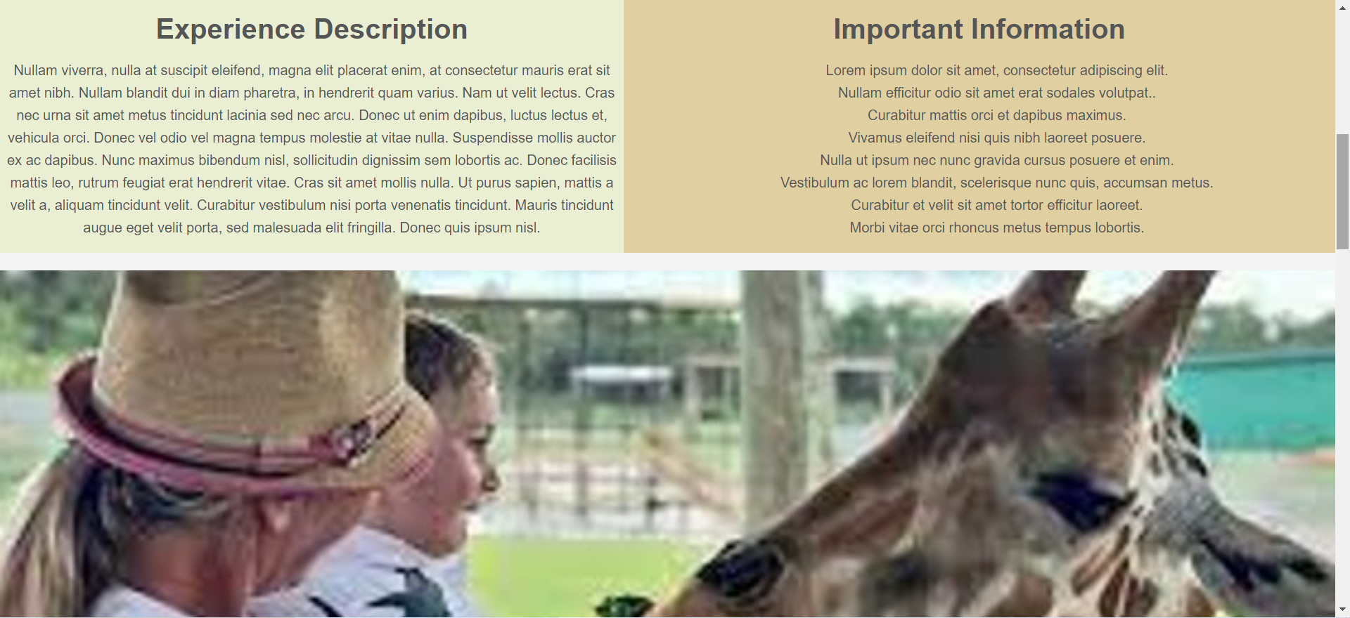
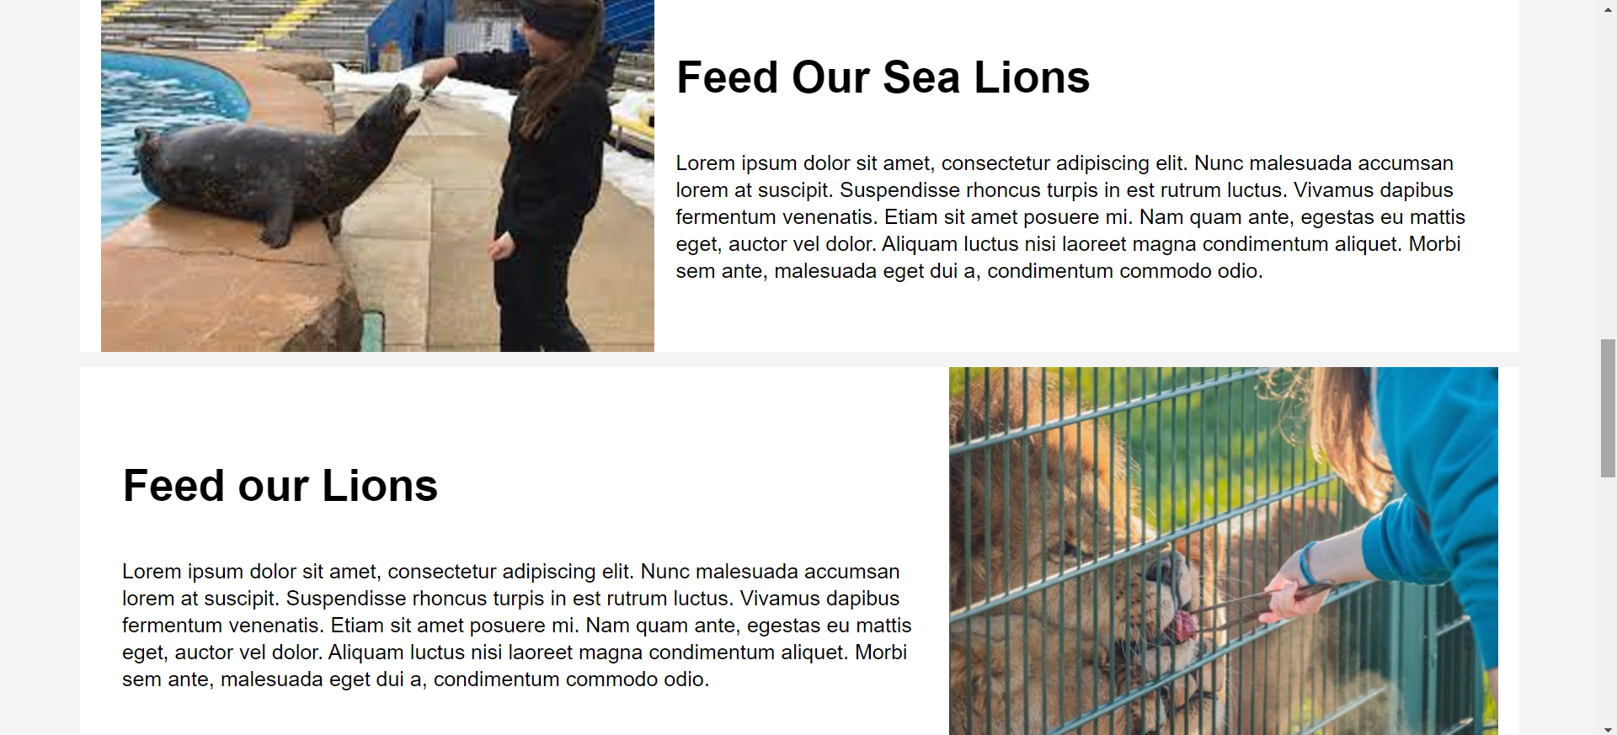
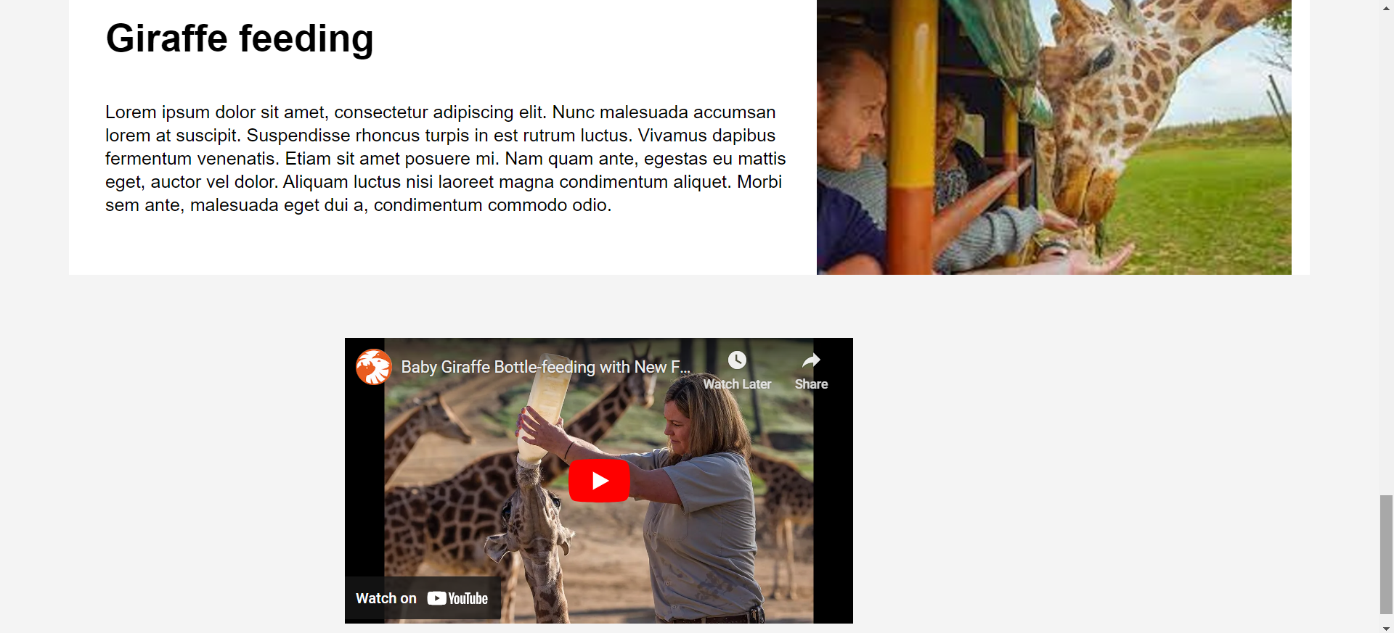

Attractions Page

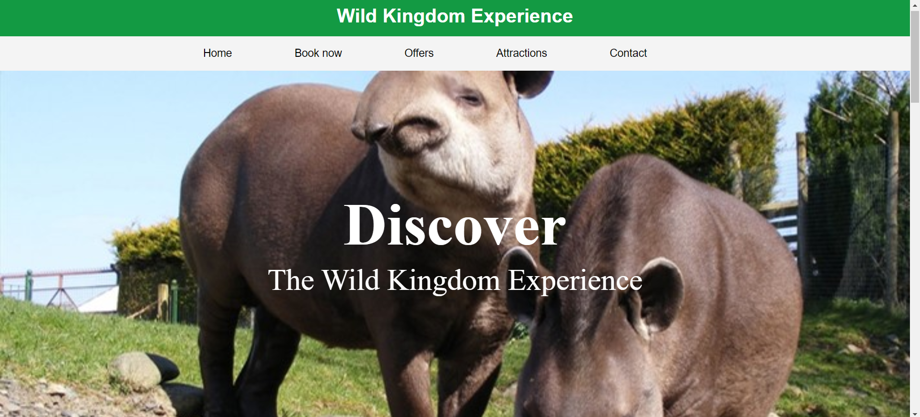
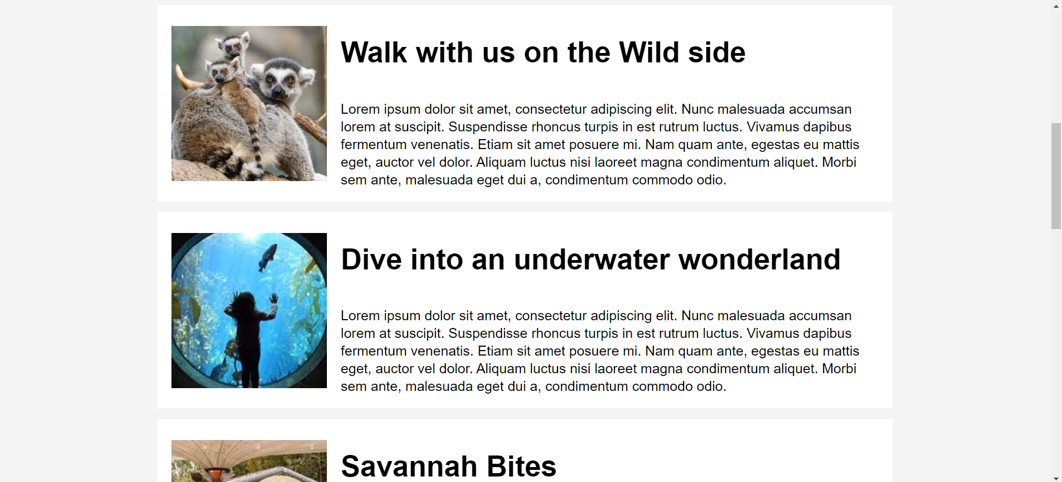

Contact Us Page

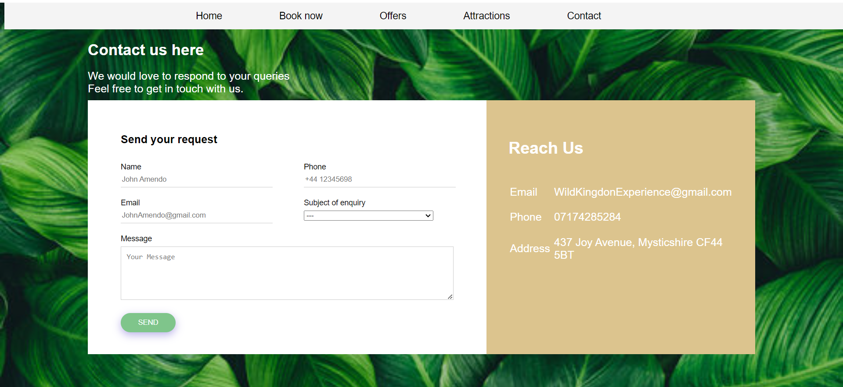

Validation

An error I found in my code is that a start tag was seen before seeing the doc type. When I analysed the code, I realised that there was a mistake when it came to HTML code and CSS code as the link tag was above the doctype. To improve my website, I moved this code so that it is within the header tag. Another mistake I found in my code is that I incorrectly used alt text in the image tag. As the images I used did not provide any information and was mainly for aesthetic purposes the alt text should have been null. Instead I briefly described the image. I also found that I used a div tag for page-container. However, It was not used or altered using css. Because of this, I deleted the class from the HTML file which did not affect how well it functioned or how the website looked.
I also found errors in my code in my CSS file that I was able to change. For example, I float middle which is not a valid value for float. I changed this to text-align center which did not cause any other error messages. Another error was the colour did not work. However, I found that this was caused because the hexadecimal had two hashtags instead of one.

Evaluation
[1] The authors have defined website usability to be “ the perceived ease with which applicants can access desired information from a website”. This relates to how easy the website is to use for the users. The source also states that the usability of a website strongly influences how viewers perceive the business or facility. Thus, for businesses owners or those offering a service, their website’s design is important in getting more people to interact with their facilities.
In addition, [3] it is important that a website is presented well and the information is accessible and that important information is included in the website for the user. This also includes people who have impaired sight and hearing or those with physical disabilities. The source states that functions such as a navigation bar can significantly improve the user’s experience. However, when websites do not work as well as others it hinders the user’s experience and thus, influences they’re opinions on the business and are less motivated to visit the establishment.

In my website I used a simple layout that makes the information easy to understand and what the information consists of. For example, by using large headlines for each section. I also used many images to reach my target audience and to make the website more pleasing to the audience. However, the images can also be indicators what the section discusses. Additionally, I believe it was important that the viewers were able to contact the safari park in case there was information that they wanted to request. Because of this, I believe it was important to create a method where they could contact the zoo as it is important to make the booking process as easy as possible so that people want to visit the safari park. To do this, I created a form that gave the user an opportunity to ask any queries they had. I ensured that the form was clear what it was asking such as giving them options for the subject of enquiry. I ensured that it also was eye catching to my target audience. However, to improve the accessibility of my website I could add footers to all web pages that had links to the other pages and emphasised contact details including email addresses and phone numbers. I could also use the footer to link the ‘contact us’ form so that it is more easily accessed.
In addition, Search Engine Optimisation is important and useful to advertise the zoo and to ensure more people see the website. I have used key phrases such as ‘adventure park’ and ‘zoo’. However, I could improve on this by implementing more key phrases such as stating ‘safari park in Wales’ so that it is more likely going to be seen.

References
[1] Uwtsd.ac.uk, 2024. https://www-sciencedirect-com.ezproxy.uwtsd.ac.uk/science/article/pii/S0747563208001027?via%3Dihub (accessed Jan. 2, 2024).
[2] Uwtsd.ac.uk, 2024. https://www-igi-global-com.ezproxy.uwtsd.ac.uk/gateway/chapter/40501 (accessed Jan. 3, 2024).
[3] P. Teixeira, C. Eusébio, and L. Teixeira, “How diverse is hotel website accessibility? A study in the central region of Portugal using web diagnostic tools,” Tourism and Hospitality Research, vol. 22, no. 2, pp. 180–195, Jun. 2021, doi: https://doi.org/10.1177/14673584211022797.
[4] “YouTube,” www.youtube.com. https://www.youtube.com/embed/KQU-5w8M1YM?si=gcHhacHZHiv4jzk0 (accessed Jan. 16, 2024).
‌

‌

‌

‌

‌

Appendices

Home Page html

<link rel="stylesheet" type="text/css"
href="styling.css">
<!DOCTYPE html>
<html>
<head>
<meta charset="utf-8" />
<title>Wild Kingdom Experience</title>
<link rel="stylesheet" type="text/css"
href="styling.css">
<style>
footer{
padding:10px;
font-size:17px;
font-weight:bold;
text-align:center;
background:#423F3E;
color:white;
font-family:Arial;
letter-spacing:1px;
}
</style>
</head>
<body>
<div class="page-container">
<div id="content-wrap">

<header id="main-header">
<div class="container">
<h1>Wild Kingdom Experience</h1>
</div>
</header>

<nav id="navbar">
<div class="container">
<ul>
<li><a href="website.html">Home</a></li>
<li><a href="book-now.html">Book now</a></li>
<li><a href="Offers.html">Offers</a></li>
<li><a href="Attractions.html">Attractions</a></li>
<li><a href="contact-page.html">Contact</a></li>
</ul>
</div>
</nav>

<section id="showcase">

<img src="savannah.jpg" alt = elephant in field width = 100%; height = 350px;>

</section>

<section id="main">
<h1>Welcome to the Adventure Park and Zoo!</h1>
<p>Donec euismod nulla sit amet est pulvinar, id scelerisque neque consequat. Donec congue a dui ut cursus. Curabitur ac elit eget magna elementum consectetur.
Etiam ultrices nunc sit amet nisl pretium, ut bibendum ex vehicula. Integer a ligula vel leo suscipit condimentum id non eros. Nunc malesuada justo a est ultrices
placerat. Phasellus rutrum felis ligula, et iaculis urna molestie ut.
</p>
</section>

</div>

<div class= "containerg">
<div class = "gallery">
<a href="book-now.html"><img src="lions.jpg" alt="lion"></a>
<div class ="desc"> Book Now</div>
</div>

<div class = "gallery">
<a href="Offers.html"> <img src="Offers-page.png"></a>
<div class ="desc"> Our Offers</div>
</div>

<div class = "gallery">
<a href="Attractions.html"> <img src="Elephant.jpg"></a>
<div class ="desc"> Our Attractions</div>
</div>

</div>

<footer id="footer">
<p> Copyright &copy; 2023 Wild Kingdom Experience</p>
</footer>

</body>
</html>

Home page css
body{
background-color:#f4f4f4;
color:#555;
font-family:Arial, Helvetica, san-serif;
font-size:16px;
line-height:1.6em;
margin:0;
}

.container{
width:80%;
margin:auto;
overflow:hidden;
text-align: center

}

#main-header{
background-color:#139A43;
color:#fff;
}

#navbar{
background-color:#139A43;
color:#fff;
}

#navbar ul{
padding:0;
list-style:none;
}

#navbar li{
display:inline;
}

#navbar a{
font-size:18px;
padding-right:100px;
}

a{
color:black;
text-decoration: none;
}

a:hover{
color:#0DAB76;

}

#main{
float:middle;
width:70%;
padding:10px;
box-sizing: border-box;
padding:10px;
text-align: center
}

.containerg{
padding-top: 20px;
padding-bottom: 100px;
}

.gallery img{
width:100%;
height: auto;
}

#sidebar{
float:right;
width:30%;
background:olive;
color:#fff;
padding:10px;
box-sizing: border-box;
text-align: center;
}

#showcase{
background-size: 1280px;
opacity:1.0;
background-position:center;
height:300px;
min-height:200px;
width: 100%;
margin-bottom:30px;
text-align:center;

}

#showcase h1{
color:#fff;
font-size:30px;
line-height:1.6em;
padding:30px;
}

#main{
width:100%;
float:none;
}

@media(max-width:600px){
#main{
width:100%;
float:none;
}

#sidebar{
width:100%;
float:none;
}

#navbar li{
display:block;
}
}

#page-container {
position: relative;
min-height: 100vh;
}

#main-footer {
position: absolute;
bottom: 0;
width:100%;
background:#333333;
color:#ffffff;
text-align:center;
padding:20px;
margin-top:40px;
height: 50px;

}

.containerg{
max-width:1200px;
/* width: 100%; */
margin:auto;
background:#f2f2f2;
overflow: auto;
display: flex;
/* position: absolute; */
/* align: center; */
}

.gallery{
margin:5px;
border: 1px solid #ccc;
float: left;
/* height: 500px; */
width:400px;
/* above was 400px */
}

.gallery img{
width: 100%;
height:auto;
}
.desc{
padding:15px;
text-align:center;
font-size: 25px;
}

#content-wrap {
padding-bottom: 10px;

<!DOCTYPE html>
<html>
<head>
<meta charset="utf-8" />
<title>Booking</title>
<link rel="stylesheet" type="text/css"
href="book-now.css">
<style>
footer{
padding:10px;
font-size:17px;
font-weight:bold;
text-align:center;
background:#423F3E;
color:white;
font-family:Arial;
letter-spacing:1px;
}
</style>
</head>
<body>
<div class="page-container">
<div id="content-wrap">

<header id="main-header">
<div class="container">
<h1>Wild Kingdom Experience</h1>
</div>
</header>

<nav id="navbar">
<div class="container">
<ul>
<li><a href="website.html">Home</a></li>
<li><a href="book-now.html">Book now</a></li>
<li><a href="Offers.html">Offers</a></li>
<li><a href="Attractions.html">Attractions</a></li>
<li><a href="contact-page.html">Contact</a></li>
</ul>
</div>
</nav>

<section id="showcase">
<img src="savannah.jpg" alt = elephant in field width = 100%; height = 350px;>
</section>

<section class="pricing">
<div class="table">
<div class="price">
<h1>£69</h1>
<small>4-6 people</small>
</div>

<div class="shadow-container">
<div class="table-header">
<div class="title">
<h1>Group Day Ticket</h1>
<p>Lorum ipsum</p>
</div>
</div>
</div>
<div class="table-body">
<div class="body-title">
<h2>Etiam in est purus</h2>
<p>Suspendisse id volutpat sem. Aliquam
ultricies feugiat sapien, interdum finibus felis rhoncus in.</p>
</div>
<ul>
<li>
<i class="fas fa-check"></i>
<span>AQuisque bibendu Suspendisse in justo velit.</span>
</li>
<li>
<i class="fas fa-check"></i>
<span>Quisque bibendum, sem nec pellentesque porttitor, tellus sapien </span>
</li>
</ul>
</div>
<button>Book now</button>
</div>
<div class="table">
<div class="price">
<h1>£99</h1>
<small>per year</small>
</div>
<div class="shadow-container">
<div class="table-header">
<div class="title">
<h1>Annual Pass</h1>
<p>Lorum Ipsum</p>
</div>
</div>
</div>
<div class="table-body">
<div class="body-title">
<h2> Etiam in est purus</h2>
<p>Suspendisse id volutpat sem. Aliquam
ultricies feugiat sapien, interdum finibus felis rhoncus in. </p>
</div>
<ul>
<li>
<i class="fas fa-check"></i>
<span>AQuisque bibendu Suspendisse in justo velit.</span>
</li>
<li>
<i class="fas fa-check"></i>
<span>Quisque bibendum, sem nec pellentesque porttitor, tellus sapien</span>
</li>
</ul>
</div>
<button>Book now</button>
</div>
<div class="table">
<div class="price">
<h1>£29</h1>
<small>each</small>
</div>
<div class="shadow-container">
<div class="table-header">
<div class="title">
<h1>Day Ticket</h1>
<p>Lorum Ipsum</p>
</div>
</div>
</div>
<div class="table-body">
<div class="body-title">
<h2>Etiam in est purus</h2>
<p>Suspendisse id volutpat sem. Aliquam
ultricies feugiat sapien, interdum finibus felis rhoncus in.</p>
</div>
<ul>
<li>
<i class="fas fa-check"></i>
<span>AQuisque bibendu Suspendisse in justo velit.</span>
</li>
<li>
<i class="fas fa-check"></i>
<span>Quisque bibendum, sem nec pellentesque porttitor, tellus sapien</span>
</li>

</ul>
</div>
<button>Book now</button>
</div>

<div class="container1">
<h1>Booking Form </h1>

<div class="contact-box">
<div class="contact-left">
<h3>Reserve your booking here</h3>
<form>

<div class="input-row">
<div class="input-group">
<label>Name</label>
<input type="text" placeholder="John Doe">
</div>
<div class="input-group">
<label>Phone</label>
<input type="text" placeholder="+44 12345698">
</div>
</div>
<div class="input-row">
<div class="input-group">
<label>Date of Visit</label>
<input type="text" placeholder="Date/Month/Year">
</div>
<div class="input-group">
<label>Number of People Visiting</label>
<input type="text" >
</div>
</div>
<div class="input-row">
<div class="input-group">
<label>Email</label>
<input type="email" placeholder="JohnDoe@gmail.com">
</div>
<div class="input-group">
<label>Any Vip experiences you would like to also book or annual pass</label>
<select id="enquiries" name="enquiries">
<option value="---">---</option>
<option value="General-enquiries">Safari tour</option>
<option value="complaint/feedback">Animal Feeding</option>
<option value="Group-Visits">News Letter</option>
<option value="Annual-passes">Annual Passes</option>
</select>

</div>
</div>

<button type="submit">Book</button>

</form>
</div>
<div class="contact-right">
<h3>Extra Information</h3>

<table>
<tr>
<td>Children<td>
<td>those under 3 years age have free entry</td>
</tr>
<tr>
<td>Senior Tickets<td>
<td>Tickets are £18 for visitors who are 60+</td>
</tr>
<tr>
<td>Parking<td>
<td>The park offers free parking</td>
</tr>
</table>
</div>
</div>
</div>

</body>
</HTML>

Booking Css file

body{
font-size: 14px;
font-family:Arial, Helvetica, san-serif;

}

#navbar{

background-color:#f4f4f4;
color:#fff;
}

#navbar ul{
padding:0;
list-style:none;
}

#navbar li{
display:inline;
}

#navbar a{
font-size:18px;
padding-right:100px;
}

a{
color:black;
text-decoration: none;
}

a:hover{
color:#0DAB76;

}

body{
font-size: 14px;
font-family:Arial, Helvetica, san-serif;
}

.table{
margin: 4em 1.5em;
text-align: center;
position: relative;
padding: 0;
}

.pricing{
background: #e9e9e9;
min-height: 100vh;
display: flex;
justify-content: center;
align-items: center;
flex-wrap:wrap;
padding: 2em;
}

.table-header{
width: 20em;
height: 13em;
background: linear-gradient(
331deg, #321d58, #7344c8
);
border-radius: 10px;
display: flex;
justify-content: center;
align-items: center;
clip-path:
polygon(
0 0,
100% 0%,
100% 80%,
50% 100%,
0 80%
);
}

.shadow-container{
filter: drop-shadow(
0 1em 1em rgba(0, 0, 0, 0.2)
);
}

.price{
background: #fff;
width: 7em;
height: 7em;
position: absolute;
top: -3.5em;
left: 50%;
transform: translate(-50%);
padding: 1.5em 1em 1em 1em;
border-radius:50%;
x-index: 2;
z-index: 10;
box-shadow:
0 1em 1em rgba(0, 0, 0, 0.3);

}

.price h1 {
font-size: 2.5em;
color: #673ab7;
}

.price small {
color: #999;
}

.title{
color: #fff;
text-transform: uppercase;
}

.title h1{
padding-top: 70px;
margin: 0.3em;
font-size: 1.8em;
letter-spacing:4px;
}

.title p{
font-size: 0.6em;
letter-spacing: 1px;
}

.table-body{
width: 18em;
margin: -4em auto 0 auto;
padding: 4em 1em 1em 1em;
background: #fff;
border-radius: 10px;
box-shadow:
0 0 4em rgb(0, 0, 0, .1)
}

.body-title h2{
margin: 1em 0 0.2em 0;
color: #222;
}

.body-title p{
color: #777;
}

.table ul{
list-style: none;
margin: 2em 0;
}

.table li{
padding: 1.3em 0;
color: #999;
font-size: 0.9em;
}

.table li:nth-child(odd){
#eee;
}
.table li i {
margin-right: 0.3em;
}

.table li .fa-check{
color: #00ff44;
}

.table button {
background: linear-gradient(
331deg, #321d58, #7344c8
);
color:#fff;
border: none;
border-radius: 5em;
padding: 1.1em 2.3em;
text-transform: uppercase;
font-weight: 600;
position: absolute;
bottom: -1.5em;
left: 50%;
transform: translateX(-50%);
transition: 0.3s;
cursor: pointer;
}

.table button:hover {
background: #fff !important;
color:#111;
}

.table:nth-child(odd){
font-size: 15px;
}

.table:nth-child(2) .table-header,
.table:nth-child(2) button {
background: linear-gradient(
331deg, #b71a50, #ff3c7d
);
}

.table:nth-child(2) .price h1 {
color: #ff3c7d;
}

.table:nth-child(3) .table-header,
.table:nth-child(3) button{
background: linear-gradient(
331deg, #cf3c31, #ff5d51
);
}

.table:nth-child(3) .price h1{
color: #ff5d51;
}

.container1{
width: 80%;
margin: 50px auto;

}
.container1 h1{
color: #000;
padding-top: 20px;
}
.container1 p{
color: #000;
font-size: 20px;
}

.contact-box{
background: #fff;
display: flex;

}
.contact-left{
flex-basis: 60%;
padding: 40px 60px;
}
.contact-right{
flex-basis: 40%;
padding: 40px;
background: #DCC48E;
color: #fff;
}
h1{
margin-bottom: 20px;
}
.container1 p{
margin-bottom: 10px;

}

.input-row{
display: flex;
justify-content: space-between;
margin-bottom: 20px;
}

.input-row .input-group{
flex-basis: 45%;
}
input{
width: 100%;
border: none;
border-bottom: 1px solid #ccc;
outline: none;
padding-bottom:5px;
}

textarea{
width: 100%;
border: 1px solid #ccc;
outline: none;
padding:10px;
box-sizing: border-box;
}
label{
margin-bottom:6px;
display: block;
color: #lc00b5;
}
button{

background: #7FC58B;
width: 100px;
border: none;
outline: none;
color: #fff;
height: 45px;
border-radius: 30px;
margin-top: 10px;
box-shadow: 0px 5px 15px 0px rgba(28,0,181,0.3);
}
button:hover{
background:#ABD9B2;
}

.contact-left h3{
color: #lc00b5;
font-weight:600;
margin-bottom: 30px;
font-size:20px;
}

.contact-right h3{
font-weight:600;
margin-bottom: 30px;
font-size:30px;
}

tr td: first-child{
padding-right: 20px;
}
tr td{
padding-top: 20px;
font-size: 20px;
}

Attractions html
<!DOCTYPE html>
<html>
<head>
<meta charset="utf-8" />
<title>Wild Kingdom Experience</title>
<link rel="stylesheet" type="text/css"
href="Attractions.css">
<style>
#slider {
overflow: hidden;
}
#slider figure {
position: relative;
width: 500%;
margin: 0;
left: 0;
animation: 15s slider infinite;
}
#slider figure img {
float: left;
width: 20%;
}
@keyframes slider {
0% {
left: 0;
}
20% {
left: 0;
}
25% {
left: -100%;
}
45% {
left: -100%;
}
50%{
left: -200%;
}
70% {
left: -200%;
}
75% {
left: -300%;
}
95% (
left: -300%;
)
100% {
left: -400%;
}
}

footer{
padding:10px;
font-size:17px;
font-weight:bold;
text-align:center;
background:#423F3E;
color:white;
font-family:Arial;
letter-spacing:1px;
}
</style>
</head>
<body>
<header id="main-header">
<div class="container">
<h1>Wild Kingdom Experience</h1>
</div>
</header>

<nav id="navbar">
<div class="container">
<ul>
<li><a href="website.html">Home</a></li>
<li><a href="book-now.html">Book now</a></li>
<li><a href="Offers.html">Offers</a></li>
<li><a href="Attractions.html">Attractions</a></li>
<li><a href="contact-page.html">Contact</a></li>
</ul>
</div>
</nav>

<div id="slider">
<figure>
<img src="attractions-tapir.jpg">
<img src="Restaurant.jpg">
<img src="Reptile.jpg">
<img src="Aquarium.jpg">
</figure>
</div>

<div class="hero-text">
<h1>Discover</h1>
<p>The Wild Kingdom Experience</p>
</div>

<div class="wrapper">
<img src="Lemur.jpg" alt="2 lemurs">
<div class="text-box">
<h2>Walk with us on the Wild side</h2>
<p>Lorem ipsum dolor sit amet, consectetur adipiscing elit. Nunc
malesuada accumsan lorem at suscipit. Suspendisse rhoncus turpis in
est rutrum luctus. Vivamus dapibus fermentum venenatis. Etiam sit
amet posuere mi. Nam quam ante, egestas eu mattis eget, auctor vel
dolor. Aliquam luctus nisi laoreet magna condimentum aliquet.
Morbi sem ante, malesuada eget dui a, condimentum commodo odio.</p>
</div>
</div>

<div class="wrapper">
<img src="Aquarium2.jpg" alt="girl looking into aquarium enclosure">
<div class="text-box">
<h2>Dive into an underwater wonderland</h2>
<p>Lorem ipsum dolor sit amet, consectetur adipiscing elit. Nunc
malesuada accumsan lorem at suscipit. Suspendisse rhoncus turpis in
est rutrum luctus. Vivamus dapibus fermentum venenatis. Etiam sit
amet posuere mi. Nam quam ante, egestas eu mattis eget, auctor vel
dolor. Aliquam luctus nisi laoreet magna condimentum aliquet.
Morbi sem ante, malesuada eget dui a, condimentum commodo odio.</p>
</div>
</div>

<div class="wrapper">
<img src="Restaurant2.jpg" alt="restaurant">
<div class="text-box">
<h2>Savannah Bites</h2>
<p>Lorem ipsum dolor sit amet, consectetur adipiscing elit. Nunc
malesuada accumsan lorem at suscipit. Suspendisse rhoncus turpis in
est rutrum luctus. Vivamus dapibus fermentum venenatis. Etiam sit
amet posuere mi. Nam quam ante, egestas eu mattis eget, auctor vel
dolor. Aliquam luctus nisi laoreet magna condimentum aliquet.
Morbi sem ante, malesuada eget dui a, condimentum commodo odio.</p>
</div>
</div>

<div class="wrapper">
<img src="Sea-lion.jpg" alt="sea lion playing with basketball">
<div class="text-box">
<h2>Don't miss our Splash-tastic sea lion show</h2>
<p>Lorem ipsum dolor sit amet, consectetur adipiscing elit. Nunc
malesuada accumsan lorem at suscipit. Suspendisse rhoncus turpis in
est rutrum luctus. Vivamus dapibus fermentum venenatis. Etiam sit
amet posuere mi. Nam quam ante, egestas eu mattis eget, auctor vel
dolor. Aliquam luctus nisi laoreet magna condimentum aliquet.
Morbi sem ante, malesuada eget dui a, condimentum commodo odio.</p>
</div>
</div>

<div class="wrapper">
<img src="Reptile2.jpg" alt="crocodile">
<div class="text-box">
<h2>Reptile Retreat</h2>
<p>Lorem ipsum dolor sit amet, consectetur adipiscing elit. Nunc
malesuada accumsan lorem at suscipit. Suspendisse rhoncus turpis in
est rutrum luctus. Vivamus dapibus fermentum venenatis. Etiam sit
amet posuere mi. Nam quam ante, egestas eu mattis eget, auctor vel
dolor. Aliquam luctus nisi laoreet magna condimentum aliquet.
Morbi sem ante, malesuada eget dui a, condimentum commodo odio.</p>
</div>
</div>

<div class="wrapper">
<img src="Gift-shop.jpg" alt="gift shop items">
<div class="text-box">
<h2>Wildly Wonderful treasures await at our Gift Shop</h2>
<p>Lorem ipsum dolor sit amet, consectetur adipiscing elit. Nunc
malesuada accumsan lorem at suscipit. Suspendisse rhoncus turpis in
est rutrum luctus. Vivamus dapibus fermentum venenatis. Etiam sit
amet posuere mi. Nam quam ante, egestas eu mattis eget, auctor vel
dolor. Aliquam luctus nisi laoreet magna condimentum aliquet.
Morbi sem ante, malesuada eget dui a, condimentum commodo odio.</p>
</div>
</div>

<div class="wrapper">
<img src="Playground.jpg" alt="indoor play area">
<div class="text-box">
<h2>Unleash the fun at our wild play area</h2>
<p>Lorem ipsum dolor sit amet, consectetur adipiscing elit. Nunc
malesuada accumsan lorem at suscipit. Suspendisse rhoncus turpis in
est rutrum luctus. Vivamus dapibus fermentum venenatis. Etiam sit
amet posuere mi. Nam quam ante, egestas eu mattis eget, auctor vel
dolor. Aliquam luctus nisi laoreet magna condimentum aliquet.
Morbi sem ante, malesuada eget dui a, condimentum commodo odio.</p>
</div>
</div>

<footer id="footer">
<p> Copyright &copy; 2023 Wild Kingdom Experience</p>
</footer>

</body>
</html>

body{
background-color:#f4f4f4;
color:#555;
font-family:Arial, Helvetica, san-serif;
font-size:16px;
line-height:1.6em;
margin:0;
}

.container{
width:80%;
margin:auto;
overflow:hidden;
text-align: center

}

#main-header{
background-color:#139A43;
color:#fff;
}

#navbar{
background-color:##139A43;
color:#fff;
}

#navbar ul{
padding:0;
list-style:none;
}

#navbar li{
display:inline;
}

#navbar a{
font-size:18px;
padding-right:100px;
}

a{
color:black;
text-decoration: none;
}

a:hover{
color:#0DAB76;

}

#main{
float:middle;
width:70%;
padding:10px;
box-sizing: border-box;
padding:10px;
text-align: center
}

#sidebar{
float:right;
width:30%;
background:olive;
color:#fff;
padding:10px;
box-sizing: border-box;
text-align: center;
}

#main{
width:100%;
float:none;
}

@media(max-width:600px){

#sidebar{
width:100%;
float:none;
}

#navbar li{
display:block;
}}

#slider{
height: 600ox;;
}
.hero-image {

/* Positions */
background-position: center;
background-repeat: no-repeat;
background-size: cover;
position: relative;
}

/* Place text in the middle of the image */
.hero-text {
text-align: center;
position: absolute;
top: 60%;
left: 50%;
transform: translate(-50%, -50%);
color: white;
font-size: 50px;
font-family: palatino-bold;
}

#main-footer {
background:#333;
color:#fff;
text-align:center;
padding:10px;
margin-top:30px;
width:100%;
}

/* background-position:top right; */
}

.sidebar1{
display: inline-block;
}

@media(max-width:600px){
#main{
width:100%;
float:none;
}

#navbar li{
display:block;
}}

.wrapper{
margin:15px auto;
width: 70%;
padding: 0;
box-sizing: border-box;
display: flex;
justify-content: center;
align-items: center;
min-height: 10vh;
background-color: #fff;
padding-left: 20px;
padding-right: 20px;
}

#wrapper img{
max-width: 500px;
float: left;
border: 3px solid #000;
/* border-radius: 500px; */
margin-right: 15px;
}

.text-box{
color: #000;
padding-left: 20px;
}
.text-box h2{
font-size:42px;
line-height: 1.6
}
.text-box p {
font-size: 20px;
}

#content-wrap {
padding-bottom: 10px;

