Red Bull

Programme Title: Introducing The Modern Workplace
Module Code: LCBB4003
Assignment Title: Red Bull
Student name: Anghel Daniel Claudiu
Student ID: 2022101

In this assignment we will be talking about Red Bull company and making an organisational structure about this company.
I choose this company because is a large company and I can find a lot of advantages and disadvantages that we can talk about them.

Introduction

Red Bull can be called as a pioneer in the energy drink category. The brand came into existence in 1987 founded by Dietrich Mateschitz an Austrian entrepreneur. By 4.6 billion cans sold during 2011 this made Red Bull the most widely held energy drink in the world.
Dietrich Mateschitz got inspired from an energy drink which was made in Thailand and goes by the name Krating Daeng made by Chaleo Yoovidhya. Dietrich Mateschitz with his partner Chaleo Yoovidhya they founded Red Bull with the taste of western. Red Bull is sold in a tall and thin blue-silver can featuring in Thailand and several parts of Asia it is sold in a wider gold cand with the title of Krating Daeng or Red Bull classic.

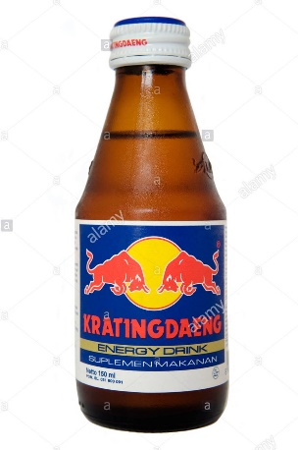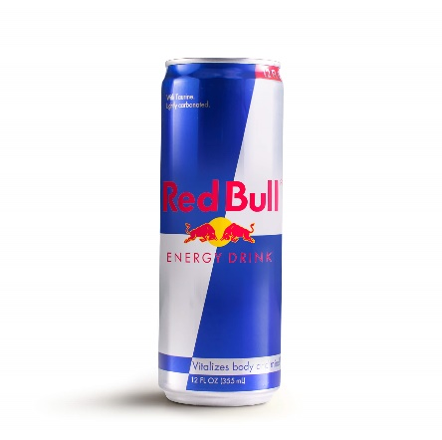
Krating Daeng Reb Bull
R&A Group will carry on arranging Red Bull and Red Bull events as a rare, off the radar subculture. Focusing on the Red Bull vehicle will be an event in itself , making buzz on roads. With using Red Bull to direct drinkers to Red Bull events we will achieve something in rising drinking and awareness in lagging markets and continue reliable across the Egypt. The events will be a put where likeminded people are able to came jointly, enjoy, be inspired, and sense enjoy a part of the special Red Bull family. R&A Group will not modify Red Bulls active tagline, Red Bull “Gives You Wings”, as we believe the company has by now recognized a tag line that numerous people previously familiar with.

Marketing plan

Red Bull marketing plan is to maintain its position as the leader in the energy drinks and the face of extreme sports worldwide, while expanding their reach in U.S. Currently North Dakota, Tennessee and Ohio are lagging in Red Bull awareness and consumption. They want to increase distribution in these states by 5% and increase brand awareness by 85% in the markets while maintaining their national presence.

Marketing Objectives and Strategies

Red Bull marketing objective and strategy is to open local events to grab youth on university grounds and sporting events. These events will present a number of their sponsored sports and players making star appearances.

Product Distribution
With the use of appropriate product distribution channels Red Bull has created a brand image such as extreme events and high profile sports events. Impulsive and high profile sport events have helped Red Bull to establish a unique position in the market. In addition, Red Bull has applied strong marketing and wider distribution tactics that has led increased consumption and influenced to growth of the product. To gat itself identified and maintain this status Red Bull has adopted detailed and effective sales strategy by identifying key areas such as bars and clubs which has helped to increase brand visibility.

Market share

Energy Drinks is a Mature market composed of a few large competitors and many small competitors. The main two competitors have 82% of the energy drink market share. Red Bull market share was 43% of the Energy Drinks market in 2020 followed by Monster with 39%, Rockstar with 10% market share.

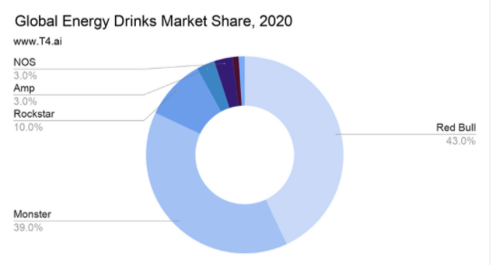

Organisational structure
An organizational structure details how certain activities are delegated toward achieving an organization's goal. It outlines an employee's role and various responsibilities within a company. The more authority employees have, the higher up they will be on the organizational structure. In addition, the more organized a structure is, the more efficiently a company operates. There are four types of organizational structures: functional structures, flat structures, matrix structures and divisional structures.

Differences between an organizational structure and an organizational chart

An organizational structure and an organizational chart can often appear similar on the surface, but there are some profound distinctions:
- Organizational structure is designed around the functions a business performs.
(sales, marketing, finance, engineering etc.)

- An organizational chart is built around people and titles.

- Organizational structure defines the purpose, accountabilities and key performance indicators for each business function and role.

- An organizational chart shows each person job title and may include HR stuff like job requirements.

- Once correctly defined a structure changes infrequently for example, when there is change in strategy like a new product initiative or a move up to a new stage in the execution lifecycle.

- And organizational chart needs to be updated frequently as people come and go. It’s out of date almost the minute it’s created.

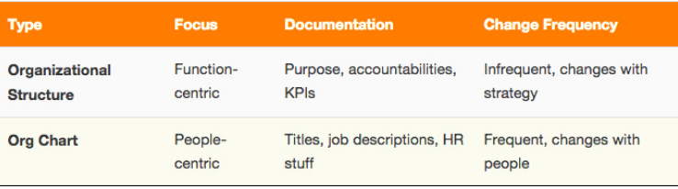

Organizational Culture

Organizational culture includes an organization’s expectations, experiences, philosophy, as well as the values that guide member behavior and is expressed in member self-image, inner workings, interactions with the outside world, and future expectations. Culture is based on shared attitudes, beliefs, customs, and written and unwritten rules that have been developed over time and are considered valid.
Culture also includes the organization’s vision, values, norms, systems, symbols, language, assumptions, beliefs, and habits.

There are 4 types of organizational culture:

- Clan Culture
- Adhocracy Culture
- Market Culture
- Hierarchy Culture

Clan Culture

Clan culture is people-focused in the sense that the company feels like one big happy family. This is a highly collaborative work environment where every individual is valued and communication is a top priority. Clan culture is often paired with a horizontal structure, which helps to break down barriers between the C-suite and employees and encourage mentorship opportunities. These companies are action-oriented and embrace change, a testament to their highly flexible nature.

Adhocracy Culture

Adhocracy cultures are rooted in innovation. These are the companies that are on the cutting-edge of their industry they are looking to develop the next big thing before anyone else has even started asking the right questions. To do so, they need to take risks. Adhocracy cultures value individuality in the sense that employees are encouraged to think creatively and bring their ideas to the table. Because this type of organizational culture falls within the external focus and differentiation category, new ideas need to be tied to market growth and company success.

Market Culture

Market culture prioritizes profitability. Everything is evaluated with the bottom line in mind each position has an objective that aligns with the company’s larger goal, and there are often several degrees of separation between employees and leadership roles. These are results-oriented organizations that focus on external success rather than internal satisfaction. A market culture stresses the importance of meeting quotas, reaching targets and getting results.

Hierarchy Culture

Companies with hierarchy cultures adhere to the traditional corporate structure. These are companies focused on internal organization by way of a clear chain of command and multiple management tiers that separate employees and leadership. In addition to a rigid structure, there is often a dress code for employees to follow. Hierarchy cultures have a set way of doing things which makes them stable and risk averse.

How organisational structure can influence on organisational performances.

Organisational structure defines how people are organised or how their jobs are divided and coordinated. It also refer to a formal configuration between individuals and groups concerning the responsibilities, allocation of tasks and authority in the organisation.
Organisational structure includes nature of formalisation, layers of hierarchy, level of horizontal integration, centralisation of authority and patterns of communication.

Organisational performance is a general consensus that the concept of organisational performance is frequent in the empirical literature. The description of the concept is difficult because it has different connotations.

Organisational structure and performance are recognized as a starting point for organising which include roles and positions, hierarchical levels and spans of accountability and mechanism for problem solving integration. The impact of organisational structure on organisational performance is that effective organisational structure facilitates proper working relationships among various sub-units in the organization. This may definitely improve company efficiency within the organisational units. The finding reveal that organisational structure has an impact on organisational performance and it also indicated that there is a relationship between specialisation of work process and labour productivity which implies that organisational structure affect the behaviour of employees in the organisation. Based on this information it can be concluded that performance of an organisation largely depends on the structure of organisation. When a clear structure exists people perform better, tasks are divided and productivity is increased, indeed, having a suitable organisational structure in place, one that recognize and address various human and business realities of the company in question is definitely going for a long time success.

Examples of organisational performance:

Employee satisfaction:

- Higher productivity
- More creativity and collaboration
- Lower turnover
- Workplace appreciation

Recommendations:

Strategy and mission
- Changes in strategy and mission are often difficult to map out, but, as a business owner, you need to continually monitor how well or if your organization is meeting your mission, and you need to be prepared to change strategies if needed.

Organizational structure
- This concerns the roles, objectives, and responsibilities of individuals, departments, and teams. Structure change, some are relatively minor, while some such as mergers are considered extreme and intense.
People
- Organizational improvements in regards to personnel consist of turnover, hiring, training and other changes that will be beneficial for the organization.

Knowledge
- Changes or improvements to the knowledge of an organization is critical for process, progress and initiative.
- Use training and development strategies.

Different factors which can influence individual behaviour at workplace

- Personal factors
The personal factors which influence the individual behaviour can be classified into two categories:
- Biographic Characteristics
- All the human beings have certain characteristics which are genetic in nature and are inherited. These are the qualities which the human beings are born with. These are the characteristics which cannot be changed; at the most, these can be refined to some extent. If the managers know about the inherited qualities and limitations of the persons, they can use their organisational behaviour techniques more effectively.

- Learned Characteristics

- Learning is defined as, a relatively permanent change in behaviour resulting from interactions with the environment. A person is born with biographical characteristics which are difficult to change or modify. Therefore, the managers lay much stress on studying, learning and predicting the learned characteristics.

- Environmental Factors

- Economic factors
- Socio-cultural factors
- Political factors
- Legal environment

- Organisational Factors

- Physical facilities
- Organisation structure and design
- Leadership
- Reward System

Harvard Reference:
AUEssays.com. 2021. Red Bull strategy. [online] Available at: <https://www.auessays.com/essays/business-strategy/red-bull-strategy.php> [Accessed 8 April 2021].

(Author), F., 2021. GRIN - Investigation of the Marketing of the Red Bull Company in Consideration of Cultural Aspects. [online] Grin.com. Available at: <https://www.grin.com/document/70257> [Accessed 8 April 2021].

Pestleanalysis.com. 2021. [online] Available at: <https://pestleanalysis.com/swot-analysis-of-red-bull/> [Accessed 8 April 2021].

