

Caspar Thurston-Smith

Fault Tree Analysis exercise

University of Wales Trinity St David
Systems engineering

Beng
Academic Year: 2025-2026

Supervisor: Jenni Steen and Dave Holly April 2026

University of Wales Trinity St David
Ordnance Munitions and Explosives

Beng

Academic Year 2025 - 2026

Caspar Thurston-Smith

Fault Tree Analysis Exercise

Supervisor: Jenni Steen and Dave Holly April 2026

This thesis is submitted in partial fulfilment of the requirements for the degree of Ordnance Munitions and Explosives
(NB. Remove if the degree award is based solely on examination of the thesis)

© UWTSD year. All rights reserved. No part of this publication may be reproduced without the written permission of the copyright owner.
Academic integrity declaration
I declare that:
- The thesis submitted has been written by me alone.
- The thesis submitted has not been previously submitted to this university or any other.
- That all content, including primary and/or secondary data, is true to the best of my knowledge.
- That all quotations and references have been duly acknowledged according to the requirements of academic research.
I understand that to knowingly submit work in violation of the above statement will be considered by examiners as academic misconduct.

Contents
Introduction 7
Probabilities 8
Formula 1 8
Formula 2 9
Formula 3 9
Calculations 10
Human Factors 12
Conclusion 13
Bibliography 13
Annex A 14
Annex B 17

Table of Figures:
Figure 1 9
Figure 2- needs changing when I check numbers 11
Figure 3 11
Figure 4 15
Figure 5 15
Figure 6 15
Figure 7 15
Figure 8 16
Figure 9 16
Figure 10 16
Figure 11 16
Figure 12 16
Figure 13 17

Table of Tables:
Table 1 8

Introduction
Fault tree analysis is the systematic method for acquiring information about a system [1] and graphically laying it out in such a way that system failures can be easily identified and traced back to a source. Laying out the possible failures of a system graphically (in a fault tree) also helps to identify how a single failure within the system can lead to a cascade of events that may cause the entire system to fail. Probabilities can be assigned to these events creating a mathematical modelling tool.
Within this graphical tree, there are several key features that simplify the analysis process. Each tree is made up of a series of symbols; these symbols have meanings that enable faster analysis while reducing the chance of human error. Furthermore, these symbols clearly demonstrate how said failure cascades through the system, allowing easy identification of the problem. This is one of the key benefits of fault trees.
There are a total of 10 [2] commonly used logic gates; and, or, not, Nand, nor, exclusive-or, inhibit, priority-and, voting and remarks. Each of these gates has a different symbol and meaning. Annex A depicts all of the symbols and their meanings.
Once a fault tree is drawn using the correct logic gates, probabilities can be used to assess the likelihood that the system might fail. If each basic event is assigned the correct probability of failure, then the probability of the system failing can be calculated accurately. This turns a simple graphic model into a useful mathematical tool. Attaching probabilities to the graph allows for events that are most likely to fail to be easily identifiable, once an event with a high likelihood of failure is identified it can then be changed or mitigated to increase the chance of the system succeeding.

Probabilities
The brief for this task included a fault tree for successfully making a hot drink with milk and sugar. The brief also included a table of probabilities for each event. These probabilities are a mix of success probabilities and failure probabilities. To accurately identify the probability of successfully making a hot drink all of these probabilities needed to be either success or failure probabilities.
As the task was to identify the probability of successfully making a hot drink it was decided that all of the probabilities should be converted into success probabilities.
Table 1 shows the original probabilities and the converted probabilities.
Event | Original Probability | Probability of success
Tea availability | 0.98 | 0.98
Coffee availability | 0.98 | 0.98
Chance of leaky Kettle | 0.001 | 0.999
Chance of water supply failure | 0.01 | 0.99
Kettle reliability | 0.99 | 0.99
Plug in operation reliability | 0.89 | 0.89
Switch on reliability | 0.89 | 0.89
Mains supply failure chance | 0.01 | 0.99
Cup availability | 1 | 1
Cup reliability | 0.99 | 0.99
Milk availability | 0.95 | 0.95
Milk freshness | 0.95 | 0.95
Sugar availability | 0.88 | 0.88
Sweetener Availability | 0.99 | 0.99
Table 1
To convert a probability of failure to a probability of success formula 1 was used:

Formula 1
1 – (probability of failure) = probability of success
Once of all of the probabilities are probabilities of success, the probabilities can be assigned to their events in the fault tree
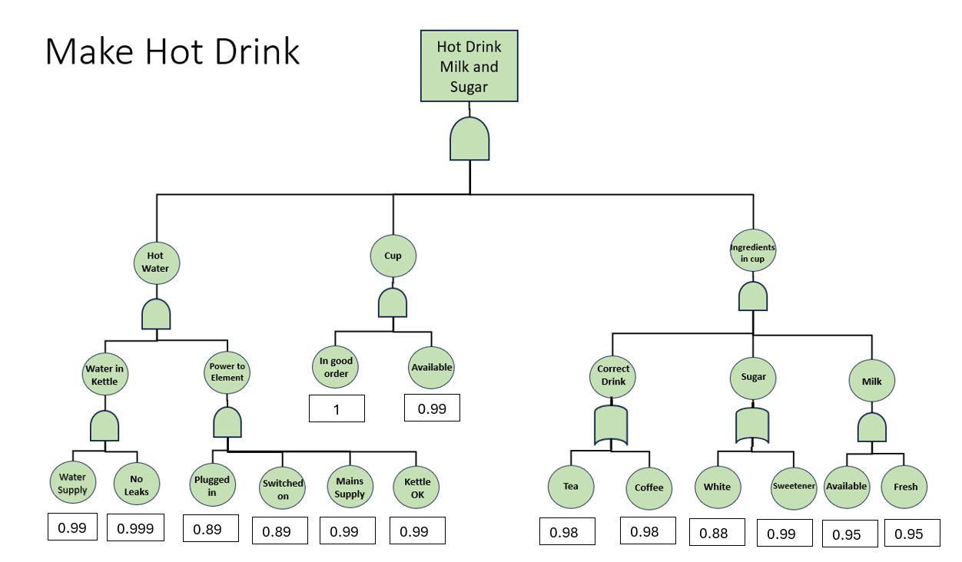
Figure 1 shows the probabilities assigned in the fault tree
Figure 1
Figure
Now that the probabilities have been assigned the probability of success for the follow-on events can be calculated, this is done using two different formulas. Formula 2 is used for And gates and formula 3 is used for OR gates.

Formula 2
Formula 2 shows how the probability of success for an or gate was calculated [1]:
Probability that at least one event occurs = 1 − probability that none occur, OR
Probability(Success) = 1 – (1- successful event A) x (1- successful event B)

Formula 3
Formula 3 shows how the probability of success for an and gate was calculated [2]:
Probability(success at and gate) = Probability(successful event A) x Probability(successful event B) x Probability( (successful event C)

Calculations
As a result, using these formulas the probability of each successful event can now be calculated:
Probability of successful water in kettle:
P(Success) = 0.99 x 0.999 = 0.98901
Probability of successful power to element:
P(Success) = 0.89 x 0.89 x 0.99 x 0.99 = 0.77633721
Probability of successful hot water:
P(Success) = 0.98901 x 0.77633721 = 0.7678052641
Probability of successfully selecting cup:
P(Success) = 1 x 0.99 = 0.99
Probability of successfully selecting correct drink:
P(Success) = 1 – (1- 0.98) x (1- 0.98) = 0.9996
Probability of successfully electing correct sugar:
P(Success) = 1 – (1- 0.88) x (1- 0.99) = 0.9988
Probability of successfully adding milk:
P(Success) = 0.95 x 0.95 = 0.9025
Probability of successfully adding ingredients in cup:
P(Success) = 0.9996 x 0.9988 x 0.9025 = 0.9010564332
Now that all of success probabilities for the completion of the sub steps have been calculated, the probability of successfully creating the desired drink can be calculated:
P(Success) = 0.76780526406 x 0.99 x 0.9010564332 = 0.6849175 rounded to 2dp = 0.68
This means that there is a 68% chance of bill successfully making a hot drink with milk and sugar.
Figure 2 shows the completed chart with all probabilities
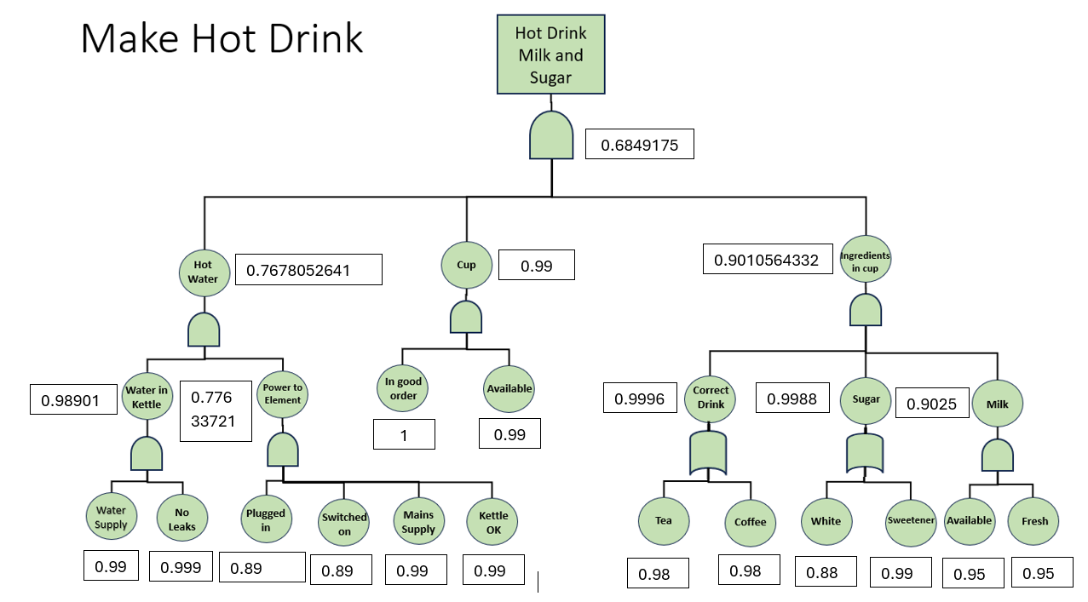
Figure 2
The brief then asks what the probability is of successfully making a drink with specific probabilities of success reduced. The brief requires the probability of success of:
- Plugging in the kettle to drop to 75% of normal
- The ability to select a cup to drop to 90% of normal
Figure 3 shows the fault tree with the new probabilities of success and annex B shows the calculations that produced the new probabilities of success.
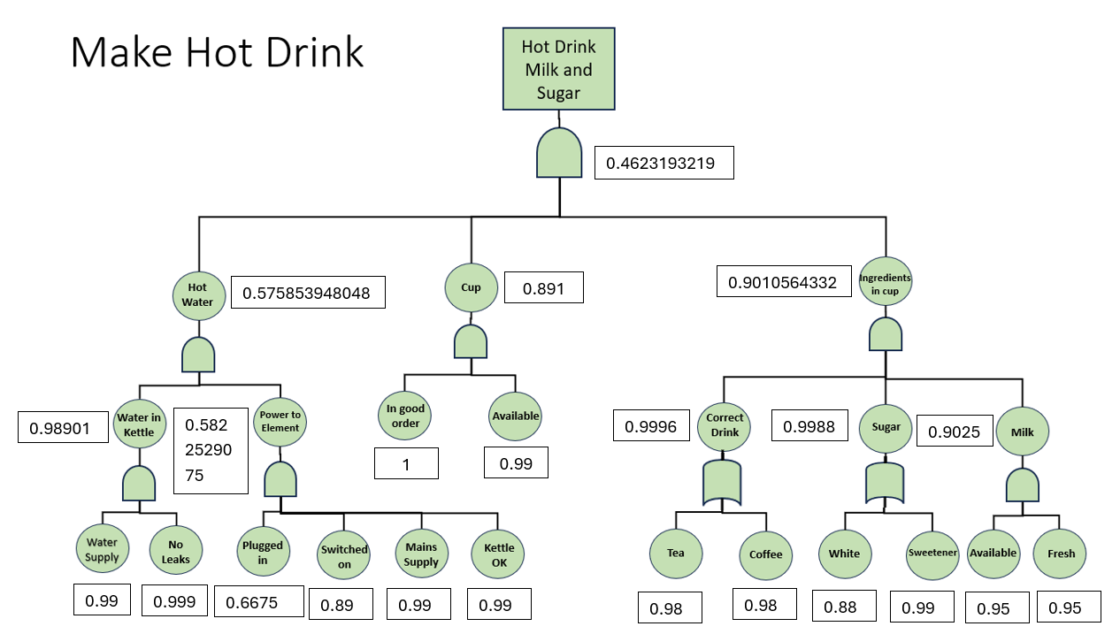
Figure 3
To calculate the overall probability of success formula 2 was used and:
0.575853948047 x 0.891 x 0.9010564332 = 0.462319321884
As a result, the probability of Bill successfully making a drink in the middle of the night is 46% and this is 22% percent lower than his normal probability of success. This is due to a number of human factors impacting his ability to succeed.

Human Factors
When comparing Figure 2 and Figure 3 we can see that there is a significant difference in the probabilities that make up the fault tree. As per the context in the brief, the equipment has not changed or been modified. This means that factors affecting the probability are either environmental or human. One key environmental factor that might impact Bill’s ability to plug in the kettle and select a cup is light level. As Bill is in the middle of the night it is likely to be dark. However, this can be quickly mitigated through turning on the lights, providing a suitable environment.
Human factors also play a significant role in explaining the different success probabilities. One example is human eyes do not respond well to sudden bright lights, when Bill wakes up, and turns on the lights to remove the environmental factor, his eyes will naturally close at the sudden bright light, reducing his ability to carry out the required tasks.
Another key human factor is fatigue, although there is no quantifiable amount for how much fatigue impacts a person’s ability to carry out a task, it is agreed that their cognitive ability, reaction times and coordination will all be reduced due to fatigue [3].
A slower cognitive function increases the length of the task but also increases the chance of mistakes as the consequences of one’s actions are not always considered. A slower reaction time means that any mistakes, such as dropping the mug, will have severe consequences. Where Bill may have been able to catch the mug he dropped in daylight hours, at night his chances of stopping the mug from hitting the floor are reduced.
Finally, coordination is a key part of making a hot cup of tea or coffee. Bill must carry out tasks that require fine motor skills; plugging in the kettle, picking up the mug and pouring the water. It is broadly agreed [3] [4] [5]that sleep loss and operating during hours the body should be asleep reduces all of these abilities.
As a result, it is clear to see why his ability to select a mug was reduced to 75% of normal levels and his ability to plug in the kettle was reduced to 90% of normal levels.

Conclusion
The Fault tree analysis technique is an accurate and useful tool for predicting the probability of an outcome. Not only does it provide an easy-to-understand graphic representation of the system and all subsystems and parts within; by creating a mathematical model it allows for the likelihood of a failure to be fully understood.
Using Bill’s ability to construct a hot drink with milk and sugar is a good example of how small changes to the system, reducing probabilities by 25 and 10% respectively, lead to the overall probability of success being 22% lower.
Human factors cause between 80-90% of workplace accidents [6], as a result understanding how a human factor can cause failure is very important. Fault tree analysis is a simple mathematical tool that can be used to demonstrate the effects of human factors on a system.

Bibliography

[1] | W. Vesely, F. F. Goldberg, N. H. Roberts and D. Hassel, Fault tree handbook, Washington DC: Systems and Reliability Research, Office of nuclear regulatory resarch, US Nuclear regulatory Comission , 1981.
[2] | Relyence corperation, “The Logic Behind Fault Trees: An Explanation of Fault Tree Gates and Events,” Relyence corperation, 4 December 2019. [Online]. Available: https://relyence.com/2019/12/04/. [Accessed 11 April 2026].
[3] | C. Choy, M. Dexter and D. Ghatak, “How Does the Number of Sleep Hours Impact Sustained Attention in Adults?,” OxJournal, 2023.
[4] | M. Engle-Friedman, “The effects of sleep loss on capacity and effort,” Sleep Science , vol. 7, no. 4, pp. 213-224, 2014.
[5] | C. D. Wickens, S. D. Hutchins and A. Sebok, “The Impact of Sleep Disruption on Complex Cognitive Tasks: A Meta-Analysis,” The Journal of the Human Factors and Ergonomics Society, vol. 57, no. 6, 2015.
[6] | You factors, “How many accidents are caused by human error - Statistics,” 20 September 2024. [Online]. Available: https://www.youfactors.com/statistics. [Accessed 12 April 2026].

Annex A
This Annex contains the 10 common logic gates used in fault trees and explains how they can be used:

Figure 4
Figure 4 displays an And gate. This gate is used if the output requires all inputs to occur. [2]

Figure 5
Figure 5 displays an Or gate. This gate is used if the output requires only one of the inputs to occur. [2]

Figure 6
Figure 6 displays a Not gate. This gate is used when the output occurs only if the input does not occur. [2]

Figure

Figure 7 displays a NAND gate. This gate is used if the output occurs when a minimum of one off the inputs does not occur. [2]

Figure 8
Figure 8 displays a NOR gate. This gate is used if the output occurs only if one input does not occur. [2]

Figure 9
Figure 9 shows an Exclusively or (XOR) gate. This gate is used when the output occurs if one input does not occur and one does occur. [2]

Figure 10
Figure 10 displays an Inhibit gate. This gate is used when the output occurs only if all the inputs occur and the input condition is met. [2]

Figure 11
Figure 11 displays a Priority And gate. This gate is used when the output occurs only if all the inputs occur in a particular order. [2]

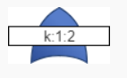
Figure 12
Figure 12 displays a Voting gate. This gate is used when the output occurs only if a set number of inputs occur. [2]

Figure 13
Figure 13 displays a Remarks gate. A remarks gate is for the purposes of adding comments to a diagram or for managing tree layout. [2]

Annex B

Annex B provides evidence of the calculations used to calculate the new probability of plugging in the kettle when Bill wakes up in the middle of the night.
To find 75% of 0.89:
0.89 x 0.75 = 0.6675
To calculate the new probability of selecting a cup
From the initial calculations bills normal probability of selecting a cup is 0.99, therefore 90% of this needs to be found:
0.99 x 0.90 = 0.891
The hot water branch of the fault tree will subsequently be affected and so the success probability needs to be calculated:
Formula 2 was used for the following calculations:
Power in element:
P(Success) = 0.6675 x 0.89 x 0.99 x 0.99 = 0.5822529075
Hot water:
P(Success) = 0.98901 x 0.5822529075 = 0.575853948048
Hot drink with milk and sugar:
0.575853948047 x 0.891 x 0.9010564332 = 0.4623193219
= 46% probability of creating the correct drink

