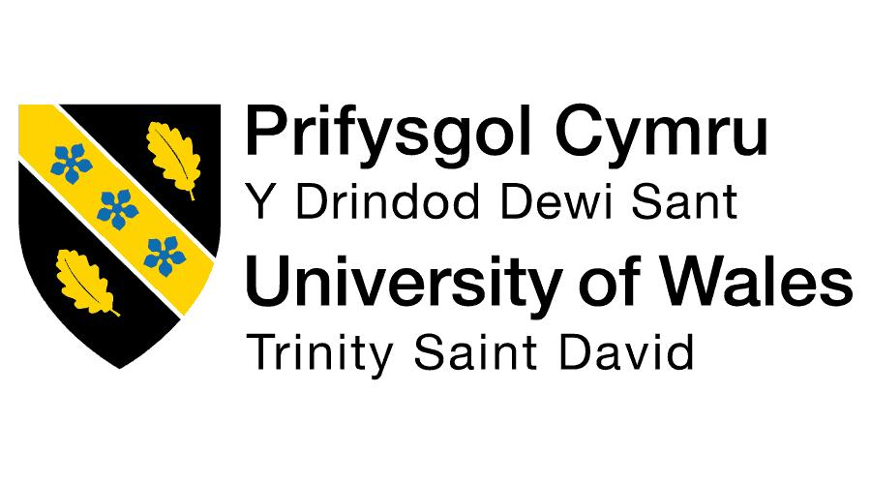
Student Name: Parth Vipulkumar Patel
Student ID: 2532673
Master of Business Administration (MBA)
Module name: Marketing Management
Module code: LCMB7024
Assignment component: Marketing Management
Lecturer's name: Laila Maazouz
Submission Date: 24th july ,2026
Word Count: Approx. 2,500

MARKETING ENVIRONMENT ANALYSIS AND SUSTAINABLE GROWTH STRATEGY: EVALUATING RIO TINTO'S TRANSITION TOWARDS A LOWER-CARBON BUSINESS MODEL
Table of Contents
Introduction 3
Task 1: Marketing Environment Analysis 3
Rio Tinto and the Transition Towards Lower-Carbon Operations 3
Natural Environment as a Key Marketing Environment Actor 4
Climate Change and Carbon Reduction Pressures 4
Resource Scarcity and Environmental Sustainability 4
Critical Analysis 4
Political and Regulatory Environment as the Second Marketing Environment Actor 5
Global Environmental Regulations 5
Government Influence on Mining Activities 6
Critical Evaluation 6
Task 2: Strategic Growth and Competitive Positioning 7
Application of the Ansoff Matrix 7
Recommended Growth Strategy: Product Development Strategy 8
Achieving Competitive Advantage Through Lower-Carbon Innovation 8
Strategic Risks, Challenges and Mitigation Measures 9
Task 3: Critical Reflection on AI Usage 10
Critical Reflection on the Use of Artificial Intelligence in Report Development 10
Tool Disclosure 10
Critical Evaluation of AI Output 10
Contribution Analysis 10
Ethical and Professional Reflection 11
Conclusion 11
References 12

Introduction
The mining industry is experiencing a significant shift, with governments, investors, consumers, and society constantly demanding ecologically conscious business operations. The mining companies are being pushed more and more to reduce greenhouse gas emissions, improve resource efficiency, and join international climate goals without loss to their profitability and competitiveness. Rio Tinto, one of the world's largest mining organisations, has recognised the strategic need to integrate sustainability into its business and operations. The company has invested heavily in decarbonisation technologies, the uptake of renewable energy, and the creation of lower-carbon products to support the transition to a more sustainable industrial economy.
This report aims to critically examine the external marketing environment that has impacted Rio Tinto in its shift to lower-carbon operations and products. The natural environment and political-regulatory environment are given special consideration. This analysis leads the report to propose a proper growth strategy according to the Ansoff Matrix and takes into consideration how Rio Tinto can ensure a sustainable competitive advantage in the context of decarbonisation aims.

Task 1: Marketing Environment Analysis

Rio Tinto and the Transition Towards Lower-Carbon Operations
Rio Tinto has diversified across markets for various commodities, such as iron ore, aluminium, copper, lithium, and critical minerals that are vital to the world's energy transition. The primary themes of business repositioning within the organisation are sustainability and climate responsibility, as environmental issues become central to stakeholders' needs. It has concentrated on key investments in renewable-powered processes, low-carbon manufacturing of aluminium, electrification technologies and carbon-cutting initiatives via mining and processing processes. This strategic change is an indicator of environmental responsibility and the new market potential. Therefore, external environmental forces are becoming increasingly influential on Rio Tinto's future competitiveness, as they shape corporate decision-making and market positioning.

Natural Environment as a Key Marketing Environment Actor

Climate Change and Carbon Reduction Pressures
One of the most effective actors of the external marketing environment that impacts the strategic direction of Rio Tinto is its natural environment. Climate change has increased the level of stakeholder expectations on the environmental responsibility of industries with high carbon emissions. The mining companies are now on the receiving end as a result of the emission of greenhouse gases in the course of extraction, processing, transportation and supply chain activities.
In Rio Tinto, these pressures extend beyond regulatory compliance, and their influence on customer preferences, investor decisions, and corporate reputation is becoming more and more important (Sharkh et al., 2022). One of the competitive differentiators that industrial customers seek from suppliers is the ability to provide raw materials with lower carbon content, which reflects environmental performance. Consequently, sustainability is now a marketing strategic concern that directly impacts customer relationships and business expansion in the long-term.

Resource Scarcity and Environmental Sustainability
Rio Tinto suffers another setback in the form of a lack of resources. Mining consumes a lot of energy, water, and land resources, and the ever-increasing problems of environmental destruction and biodiversity loss place additional pressure on the industry. These aspects influence the efficiency of operations and perceptions of stakeholders.
Meanwhile, environmental issues present innovation opportunities. The performance of operations can be improved by investing in renewable energy, water recycling technologies, and low-emission production systems to solidify the sustainability credentials (Pavloudakis, Roumpos and Spanidis, 2024). These kinds of initiatives assist in the responsible management of resources and enhance the image of the market.

Critical Analysis
The natural environment presents opportunities and challenges to Rio Tinto due to its impact. A growing demand to adopt sustainable materials enables product differentiation and competitive positioning as spending on low-carbon aluminium and on operations powered by renewable energy increases.
However, decarbonisation initiatives are expensive in terms of financial investment and pose technical risks. Reorganisation of major mining operations may affect short-term profitability and flexibility of operations. However, the natural environment is also supposed to be viewed as a source of innovation and strategic renewal even in the face of these challenges (Choi, 2023). Most likely, the organisations that can integrate sustainability into their value propositions will prove more competitive in the evolving mining industry in the long run.
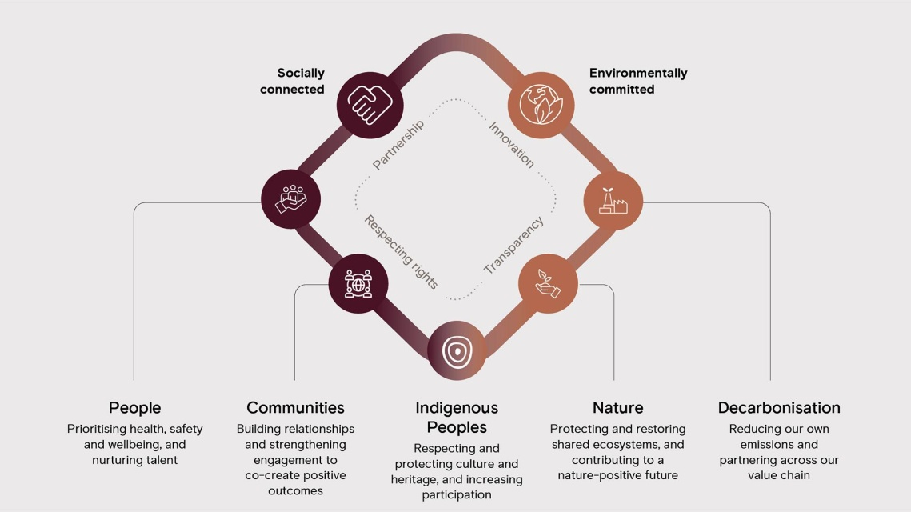
Figure 1: Rio Tinto Sustainability and Decarbonisation Roadmap
(Source: riotinto.com, 2025)

Political and Regulatory Environment as the Second Marketing Environment Actor

Global Environmental Regulations
Rio Tinto has a significant support team in the political and regulatory environment, alongside the natural environment, to help it on its path to lower-carbon products and operations. Governments worldwide have been implementing stricter environmental policies in order to reduce the amount of emissions in industries and to support climate objectives. The laws impact investment decisions, business practices, reporting requirements and competition in the mining sector.
The introduction of carbon pricing, environmental performance goals, and sustainability reporting made voluntary environmental performance a business strategic necessity (Deveci et al., 2022). Therefore, mining organisations have no option but to keep changing to ensure that they are compliant and competitive.

Government Influence on Mining Activities
The influence of government intervention is also on the development of projects, extracting resources, and investing in infrastructure. Political priorities are a major consideration in strategic decision-making because the mining companies must get government approvals for exploration licences, environmental permits and expansions of operations.
Rio Tinto has both opportunities and challenges to the evolving environmental policies. The promotion of renewable energy, clean technologies, and the production of critical minerals by the government stimulates investments in sustainable mining and products with reduced carbon content (Zhou, Lv and Wen, 2023). However, the different environmental laws in jurisdictions make it difficult to comply and may either make it expensive to operate or delay investment decision-making. This uncertainty can affect the planning and resource allocation in the long term.

Critical Evaluation
The relationship between the environmental and political forces is also very influential on the marketing strategy of Rio Tinto. Laws facilitate sustainable innovation and increase complexity in operations. The adoption of cleaner technologies and improved relations with stakeholders early are the competitive advantages that organisations have higher chances of realising when they take initiative in responding to policy developments.
Compliance alone is not enough in marketing. Stakeholders are increasingly demanding organisations to demonstrate environmental leadership, which is not limited to the law. By exceeding regulatory expectations, Rio Tinto can build brand reputation, investor trust, and customer perceptions. These are direct effects that affect the ability to compete in sustainability-based markets.
However, future policy changes and the unpredictability of geopolitics can impact investment results and strategic initiatives. Thus, Rio Tinto needs to strike a balance between regulatory responsiveness and strategic flexibility in the long term. The political and environmental forces are intertwined, underscoring the importance of sustainability as a component of corporate strategy and market development.
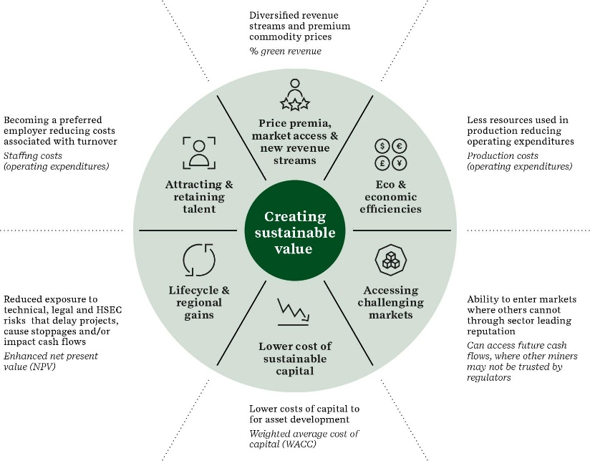
Figure 2: External Marketing Environment Actors Influencing Rio Tinto's Decarbonisation Strategy
(Source: intelligence.sustainability.com, 2025)

Task 2: Strategic Growth and Competitive Positioning

Application of the Ansoff Matrix
Ansoff Matrix offers a strategic tool to analyse growth opportunities based on existing and new products in existing and new markets. The model identifies four strategic choices that comprise market penetration, market development, product development and diversification. All of them have different degrees of risk and resource investments in relation to organisational goals and market factors (Sovacool et al., 2025).
The Ansoff Matrix particularly fits Rio Tinto as the organisation is in an effort to react to the pressure of the environment by changing customer expectations and technological revolution simultaneously. The company's transition to lower carbon will require expansion policies that help fulfil sustainability targets without undermining business feasibility. The most suitable strategic option, considering the existing strategic options, is product development because it would enable Rio Tinto to leverage the already established market relationships and introduce new innovative low-carbon products. This is a strategy that aligns with the trend in the industry, environmental commitment, and long-term competitive differentiation opportunities in the international market in metals and mining.

Recommended Growth Strategy: Product Development Strategy
Product development involves coming up with new or much improved products in the existing markets. This would be a feasible solution to increasing demand for eco-friendly materials and to take advantage of its existing clientele and operational capabilities in the case of Rio Tinto.
The rising switch to low-carbon economies has pushed the demand of sustainable aluminium, copper, and critical minerals (Persakis et al., 2025). Rio Tinto can add more value and enhance its competitiveness by creating products with reduced environmental footprints by relying on renewable energy, cleaner processing technologies, and responsible mining techniques. Product development allows the firm to improve on what it is doing instead of venturing into new markets, minimises market uncertainties, and helps support high prices.
The plan also enables commercial growth to fit Rio Tinto's sustainability goals. The environmental performance is a significant point of supplier selection, making sustainable product innovation a potential way to improve customer relations, market credibility, and long-term profitability. The implementation requires significant investment in technology and process enhancement, yet the payoffs of the strategy are much higher than its risks as it directly reacts to the new demands of the market and allows maintaining the competitive edge.

Achieving Competitive Advantage Through Lower-Carbon Innovation
A good competitive positioning strategy is required to execute the product development strategy effectively. A sustainable competitive advantage will be based on the creation of value that will not be easily acquired by competitors, although the Ansoff Matrix will determine whether growth is viable or not. In this respect, Porter's Generic Strategies can be seen as an excellent guide for how Rio Tinto can centralise its presence in the market when moving towards less-carbon industries.
The most suitable strategic choice that Porter has is differentiation. Rio Tinto could become distinct through high environmental performance, innovative production processes, and sustainable product offerings, rather than making price the primary consideration (Sudirjo, 2023). Following the increased focus on environmental issues in decision-making by industrial purchasers, buyers are placing more emphasis on suppliers who are able to demonstrate measurable reductions in carbon emissions and environmental effects.
Low-carbon aluminium is a good example of such a strategy. Sustainable materials are also being investigated by automotive, construction, renewable energy, and manufacturing customers because they need to meet their environmental targets. Rio Tinto can create value not only through the physical properties of its products by offering lower-carbon credentials. This increases customer loyalty, brand image and long-term competitiveness.
Stakeholder confidence can also be improved to generate competitive advantage. Shareholders, regulators, society, and business associates are all putting organisations to the test based on environmental, social, and governance performance. Leading sustainably can enhance trust, access to capital, and corporate legitimacy (de Oliveira Lima et al., 2024). Long-term commitment, operational capabilities, and technological knowledge can enable Rio Tinto to achieve a sustainable competitive advantage in the evolving global market through sustainability-based differentiation.

Strategic Risks, Challenges and Mitigation Measures
Despite the merits of product development and differentiation that is focused on sustainability, Rio Tinto faces several issues. The technological uncertainty is also not yet low, as the majority of the decarbonisation solutions are still young and are not likely to deliver expected outcomes on a commercial scale and with consistency. In addition, the high cost of investment might be an economic burden during swings in the commodity market.
The markets are also risky, as the willingness of the customers to pay high prices due to sustainable materials may vary across industries and regions. Similar initiatives are also being invested in by competitors, which may diminish differentiation benefits.
To address these challenges, Rio Tinto needs to adopt a slow implementation strategy that would balance innovation and financial discipline. Strategic partnerships with technology partners, research centres, renewable energy organisations, and customers, along with accelerating innovation, can be used to minimise risk (Remondino and Zanin, 2022). Additional research and development, as well as stakeholder engagement, will enhance flexibility and ensure strategic success in the long run.

Task 3: Critical Reflection on AI Usage

Critical Reflection on the Use of Artificial Intelligence in Report Development

Tool Disclosure
The report was developed with the help of artificial intelligence tools, including the investigation of the topic, the initial information search, the structuring, and the preliminary generation of content ideas. Major themes were searched based on analysis of the marketing environment, sustainability, strategic growth, and competitive positioning in the mining industry, using search functions supported by AI. This software simulated efficiency during the early stages of research and planning. Nevertheless, AI output was used as auxiliary material and did not interfere with independent research, critical thinking, or academic judgement.

Critical Evaluation of AI Output
Although the assistance of artificial intelligence tools proved helpful, their results were to be verified before being included in the report. The information produced by AI systems was contrasted with the academic literature, industry reports, and corporate publications to guarantee accuracy and reliability. Certain AI-generated responses contained generalised statements about sustainability efforts and strategic suggestions that lacked organisational context. These limitations highlighted the necessity of performing an autonomous evaluation and checking the sources (Ahmadi-Gh and Bello-Pintado, 2022). The report did not include data that could not be substantiated using credible evidence. Consequently, AI was employed as a starting point for scholarship but not as an end in itself, highlighting the applicability of human control in the process of conducting research.

Contribution Analysis
The last report is the product of AI-enhanced assistance and autonomous intellectual work. The AI helped with the initial brainstorming, organisation of reports and locating relevant strategic frameworks. These functions aided in the planning and drafting phase and the efficiency of research.
Nevertheless, the analysis, evaluation, interpretation and synthesis carried out in the report were done individually. The decision to Rio Tinto, the analysis of environmental processes, the explanation of the proposed growth strategy, and the evaluation of the competitive advantage were based on the essential role of the corresponding literature and personal opinion (Bari, Chimhundu and Chan, 2022). The author, therefore, was left in charge of the report arguments, findings and conclusions.

Ethical and Professional Reflection
The use of Artificial Intelligence in academics elicits important issues of transparency, accountability, and academic integrity. Responsible use needs to be explicitly recognised in the use of AI, and its outputs should be critically assessed. The overreliance on AI may be an obstacle to independent learning and critical development. Professionally, AI needs to be seen as an assistant and not as a substitute for human knowledge.

Conclusion
This report has revealed that both the natural environment and political-regulatory environment have a strong impact on Rio Tinto to shift to lower-carbon operations and products. The environmental forces and shifts in the regulatory requirements pose some challenges as well as opportunities, which are also becoming more dominant in the strategic decision-making of the mining industry. The environmental analysis indicates that the most suitable strategy of growth in the Ansoff Matrix framework is product development. The differentiation strategy allows Rio Tinto to build a competitive advantage by supporting long-term sustainability by developing sustainable and lower-carbon products.
This ability to balance innovation, environmental responsibility, and commercial performance will remain critical in enhancing development in the future. Furthermore, the capability to respond to the growing needs of the market will be attained through additional investments in clean technologies, stakeholder engagement, and sustainable control of resources. Proactive reaction to new trends in environmental regulations can help Rio Tinto emerge as a leading participant in the global transition to a more sustainable mining industry.

References
Journals
Ahmadi-Gh, Z. and Bello-Pintado, A., 2022. Why is manufacturing not more sustainable? The effects of different sustainability practices on sustainability outcomes and competitive advantage. Journal of Cleaner Production, 337, p.130392.
Bari, N., Chimhundu, R. and Chan, K.C., 2022. Dynamic capabilities to achieve corporate sustainability: a roadmap to sustained competitive advantage. Sustainability, 14(3), p.1531.
Choi, Y., 2023. Interdisciplinary studies for sustainable mining. Applied Sciences, 13(7), p.4621.
de Oliveira Lima, L.A., dos Santos, A.F., Nunes, M.M., da Silva, I.B., da Silva Gomes, V.M.M., de Oliveira Busto, M., de Oliveira, M.A.M.L. and do Nascimento João, B., 2024. Sustainable management practices: green marketing as a source for organizational competitive advantage. Revista de Gestão Social e Ambiental, 18(4), pp.1-11.
Deveci, M., Brito-Parada, P.R., Pamucar, D. and Varouchakis, E.A., 2022. Rough sets based Ordinal Priority Approach to evaluate sustainable development goals (SDGs) for sustainable mining. Resources Policy, 79, p.103049.
Pavloudakis, F., Roumpos, C. and Spanidis, P.M., 2024. Sustainable mining and processing of mineral resources. Sustainability, 16(19), p.8393.
Persakis, A., Nikolopoulos, T., Negkakis, I.C. and Pavlopoulos, A., 2025. Greenwashing in marketing: a systematic literature review and bibliometric analysis. International Review on Public and Nonprofit Marketing, 22(4), pp.957-992.
Remondino, M. and Zanin, A., 2022. Logistics and agri-food: Digitization to increase competitive advantage and sustainability. Literature review and the case of Italy. Sustainability, 14(2), p.787.
Sharkh, B.A., Al-Amoudi, A.A., Farooque, M., Fellows, C.M., Ihm, S., Lee, S., Li, S. and Voutchkov, N., 2022. Seawater desalination concentrate—a new frontier for sustainable mining of valuable minerals. npj Clean Water, 5(1), p.9.
Sovacool, B.K., Geels, F.W., Andersen, A.D., Grubb, M., Jordan, A.J., Kern, F., Kivimaa, P., Lockwood, M., Markard, J., Meadowcroft, J. and Meckling, J., 2025. The acceleration of low-carbon transitions: Insights, concepts, challenges, and new directions for research. Energy research & social science, 121, p.103948.
Sudirjo, F., 2023. Marketing strategy in improving product competitiveness in the global market. Journal of Contemporary Administration and Management (ADMAN), 1(2), pp.63-69.
Zhou, P., Lv, Y. and Wen, W., 2023. The low-carbon transition of energy systems: A bibliometric review from an engineering management perspective. Engineering, 29, pp.147-158.
Websites
intelligence.sustainability.com, 2025. External Marketing Environment Actors Influencing Rio Tinto's Decarbonisation. Available at: https://intelligence.sustainability.com/insights/sustainability-that-pays-defining-a-credible-business-case-for-investing-in-sustainability-in-mining-and-metals [Accessed on: 30/06/2026]
riotinto.com, 2025. Rio Tinto Sustainability and Decarbonisation Roadmap. Available at: https://www.riotinto.com/en/sustainability/our-approach [Accessed on: 30/06/2026]

