

PROGRAMME: MBA – International Business
Term 3

STUDENT NAME: YASHKUMAR DHOLAKIYA
STUDENT ID: 2505243

MASTER OF BUSINESS ADMINISTRATION

LCMB7035 - DISSERTATION

DISSERTATION PROPOSAL

ANALYSING FACTORS THAT TRIGGER CHANNEL-SWITCHING BEHAVIOR OF CONSUMERS FROM BRICK-AND-MORTAR GROCERY RETAIL TO QUICK-COMMERCE APPS IN THE CASE OF CONSUMERPACKAGED GOODS (CPG)

Table of Contents
1. Introduction 4
1.1 Background of the Study 4
1.2 Research Problem 4
1.3 Research Aim 4
1.4 Research Objectives 4
1.5 Research Questions 5
1.6 Significance of the Study 5
2. Literature Review 5
2.1 Understanding Channel-Switching Behaviour in Grocery Retailing 5
2.2 Functional Drivers of Consumer Channel-Switching 5
2.3 Psychological Drivers, Theoretical Perspectives, and Research Gap 6
3. Methodology 7
3.1 Research Onion Diagram 7
3.2 Research Philosophy 7
3.3 Research Approach 8
3.4 Research Strategy 8
3.5 Research Design 8
3.6 Data Collection method 8
3.7 Data Analysis 9
3.8 Ethical Considerations 9
4. Expected Findings 9
5. Limitations 10
6. Timeframe 10
7. Conclusion 11
References 12

1. Introduction

1.1 Background of the Study

The tendency of consumers to shift their focus between different retail platforms, such as physical stores, websites, and mobile apps, during a shopping journey is referred to as the channel-switching behavior. In recent times, increased demand of Consumer-Packaged Goods (CPG) is causing consumers to move from traditional bulk buying to frequent, and intent-driven daily replenishment. Such a type of behavior is dependent on the pursuit of convenience, competitive pricing or offerings, detailed product information, and even gratification.

UK grocery retail is undergoing a rapid digital transformation with a growing e-grocery and quick-commerce penetration. UK online grocery sales are expected to rise by 19.2% per annum from 2026 to 2034, foreshadowing a surge in consumer demand for online grocery channels (IMARC, 2026). Quick-commerce has also gained significant momentum, with the market anticipated to hit about USD 4.71 billion by 2029, thanks to retailers improving their partnerships and delivery capabilities (YF, 2026). Generation Z is driving the increase in the use of quick commerce as 37% of young consumers are regularly using rapid delivery grocery services, a figure that is helping to divide and spread the UK's online grocery market (IGD, 2026).

1.2 Research Problem
Even as quick-commerce businesses have rapidly expanded, there are gaps in the understanding of why and in which situations online grocery shopping is preferred over in-store shopping. Between 2026 and 2031, the UK quick commerce market is expected to grow at a compound annual growth rate (CAGR) of 18.7% due to the rising demand for convenience, ultra-quick deliveries, and mobile shopping platforms (MI, 2026). The current research, however, concentrates on online grocery adoption instead of the online channel adoption determinants of consumer-packaged goods (CPG) in adopting behaviour. This represents a big research opportunity, as retailers need to better understand what triggers a switch to be able to build great customer retention and omnichannel strategies.

1.3 Research Aim
This research will aim to understand the factors that can influence consumers' process to switch from offline grocery shops to quick-commerce apps while shopping for CPG. The study aims to analyse the important switching drivers and offer strategic recommendations for retailers in an ever more digital retail landscape.

1.4 Research Objectives
- To understand the most important factors that impact consumers when switching between brick-and-mortar grocery stores and quick-commerce apps
- To investigate ways in which speed of delivery and convenience of purchase affect consumers' preference to change their purchasing channels
- To understand the impact of price incentives, loyalty programs, trust and perceived value on quick-commerce adoption
- To recommend actionable effective measures that traditional brick-and-mortar grocery retailers can take to improve their competitiveness and customer retention

1.5 Research Questions
- What are the compelling reasons that make consumers deviate from offline grocery retailers to fast grocery mobile apps for CPG product buying?
- What is the importance of convenience and speed of delivery on customers' channel switching behaviour?
- How important are price incentives, loyalty programmes, trust and perceived value relating to consumer switching?
- What are the recommended actionable effective measures that traditional brick-and-mortar grocery can adopt to combat switching in the quick commerce era and enhance customer retention strategies?

1.6 Significance of the Study
The study is relevant because it adds to the understanding of consumer channel-switching behaviour in the much-needed-to-be-understood quick-commerce sector. The increasing use of app-based grocery retail channels makes it all the more critical for research and practice to understand the motivation for digital transformation in grocery retail. Alkhiyami et al. (2025) highlighted behavioural, convenience, and accessibility limitations as key factors in channel choice. Hence, this study is a journey through the switching triggers in the CPG market related to customer retention and omnichannel strategies.

2. Literature Review

2.1 Understanding Channel-Switching Behaviour in Grocery Retailing
Channel switching behaviour is the behaviour of moving from one channel to another shopping channel due to preference fulfilment, technological advancements, and/or expectations of other services. Quick Commerce has revolutionized grocery retail in today's world and revolutionized the process of buying groceries, as it provides fast and convenient ways to buy. According to Kuppili (2025), the surveyed consumers' preference for using quick commerce platforms for their daily grocery purchases is based on factors such as accessibility and the effortlessness of shopping. The study also identified significant shifts in consumer behaviour, with urban consumers using digital grocery platforms more to purchase frequently purchased CPG.

2.2 Functional Drivers of Consumer Channel-Switching
One of the top reasons why consumers choose to switch from a traditional grocery store to a quick-commerce store is functional. Some of the main factors are convenience, product availability, promotional offers that make it easy to shop, and delivery speed. As revealed by Pillay (2025), service efficiency and perceived service value had a significant role on brand-switching behaviour for same-day grocery delivery service, especially for higher income consumers. Grocery shopping via apps is being promoted more because of these benefits. Similarly, Prasad et al. (2026) observed that quick-commerce platforms achieved approximately 40% faster order fulfilment than traditional e-commerce channels, enhancing customer satisfaction and encouraging repeated usage. These benefits have empowered consumers to favour solutions to buy groceries using an app.

2.3 Psychological Drivers, Theoretical Perspectives, and Research Gap
The attitudes of customers to change their channels are greatly influenced by psychological aspects like Trust, Perceived value, satisfaction, and Loyalty. Consumers' thinking about using quick-commerce platforms in the future may be amplified with positive experiences on their end, such as fast delivery, trust in service and product quality. Saeed and Sharma (2026) added that customers were about 18% more satisfied with the quick-commerce FMCG application as compared to conventional e-commerce applications, leading to higher levels of loyalty intentions. Although there has been increasing research into the adoption and satisfaction with quick-commerce delivery channels, insufficient studies have looked into the joint effect of functional and psychological influences on channel-switching behaviour in the CPC industry, presenting a key research gap.

3. Methodology

3.1 Research Onion Diagram
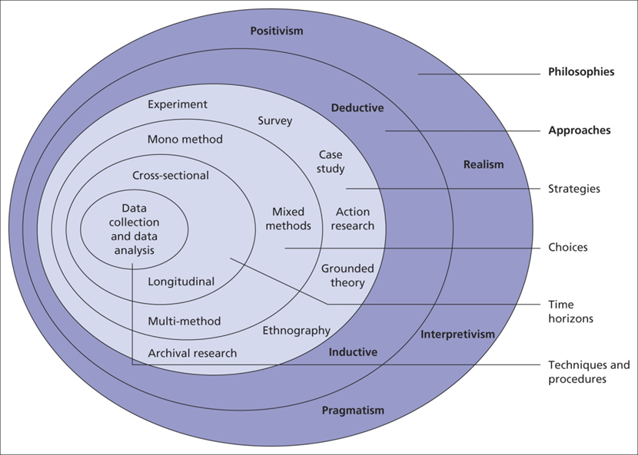
Figure 1: Research Onion Diagram
(Source: GE, 2025)
Extremely popular and still used in business research today, Saunders' research onion is one of the most applied models available. The research onion is a structure that enables the methodological decisions made in the study and coherence throughout the study to be presented in a structured way (GE, 2025). The outer layer of the onion presents the interpretivist philosophy, and later on in the onion is the inductive research approach. The methodological approach will be secondary qualitative research, and the research approach to be used will be in the form of literature. The research design will be an exploratory type, and the analysis will favour the use of thematic analysis. Graham et al. (2025) highlighted the importance of systematic methodological structures in enhancing research transparency and credibility.

3.2 Research Philosophy
This study will use an interpretivist research philosophy, as the main aim here will be to understand and interpret consumers' channel-switching preferences in the context of the grocery retail environment and the adoption of quick-commerce. Using interpretivism will help to gain insight into meaning, perception, experiences and behavioural intentions in the context of available scholarly work. Such a philosophy allows looking at subjective interpretations of data, instead of the data being measurable, and is therefore very appropriate for a qualitative investigation. Denscombe (2025) stated that it has now become equally important to understand social reality in an interpretive and context-specific approach.

3.3 Research Approach
This study will employ an inductive approach that enables gaining insights from peer-reviewed literature and generate recurring patterns that relate to the channel switching behaviour. The use of an inductive method will allow preparation of meaningful themes and explanations to arise from the evidence collected and is not seen as a way to test predetermined hypotheses. It will be especially appropriate for the initial exploration of new retailing contexts and the changing consumption practices it entails. Susilawati et al. (2025) stated that inductive reasoning helps in knowledge construction that is through systematic examination, synthesis, and interpretation of the available evidence.

3.4 Research Strategy
The research strategy to be used for the investigation of the channel switching behaviour is a secondary qualitative approach wherein academic literature as well as industrial information (available over the internet) will be examined. The strategy will make it easy to gather a lot of evidence from peer-reviewed journal articles, reports, and scholarly publications in relation to grocery retailing and quick-commerce. Secondly, conducting qualitative research will be beneficial because it enables a researcher to take a look at various opinions at the same time and also save them time and resources. Qualitative methodologies do not seek to numerically measure a phenomenon, but interpret it and provide a deeper understanding of behavioural and social phenomena (Makateng and Mokala, 2025). Therefore, this strategy will be suitable for addressing the research objectives and questions.

3.5 Research Design
The study will use an exploratory research design for investigating the underlying factors of consumers' channel switching behaviour. Exploratory designs are expected to fit when phenomena are relatively new and/or changing quickly, with theory developing slowly. Quick commerce has presented new grocery purchasing behaviour dimensions which need to be investigated academically further. Graham et al. (2025) added that exploratory research designs can be beneficial for providing insights and exploring relationships in new research fields.

3.6 Data Collection method
The data sources to be used in this secondary qualitative research will be academic sources, mainly from peer-reviewed journals, academic databases, industry publications and market research sources. This research will rely on the use of updated information while obtaining required information sources from secondary (already published) literature. Relevant literature will be identified from major databases like Google Scholar ScienceDirect, Emerald Insight, Google Scholar and SpringerLink. The selection of articles to be included will be done with a predetermined search strategy using a search engine with keywords and inclusion criteria. Mokka and Makateng (2025) stated that systematic collection of secondary qualitative data serves to reassure that the sources were adequately selected, which will guarantee research credibility, transparency and consistency.
Inclusion and exclusion criteria
Reliance on the use of secondary data will include studies that are directly related to channel-switching behaviour and grocery retail, quick-commerce adoption, consumer behaviour, and digital retail transformation. Only peer-reviewed articles published in journals, academic books, and conference papers will be considered, and within the timeframe of 2020-2026. Sources that are published in languages other than English or are not available with free access over the internet will be excluded.

3.7 Data Analysis
Collected literature will be analysed in thematic analysis that will make it possible to identify, categorise, and interpret emerging patterns across studies. The thematic analysis process will include familiarisation with the literature, coding important findings, initial development of themes, theme review of theme relationships and refinement of the preliminary and final themes. Thematic analysis approach is a type of qualitative approach commonly used in qualitative research, which allows systematic interpretation of complex data sets. Thematic analysis helps to structure qualitative evidence into new categories that contribute to the understanding of the research phenomenon (Susilawati et al. 2025).

3.8 Ethical Considerations
The study being only secondary, the issues of participants' consent and confidentiality do not arise. However, there is an expected ethical responsibility involved, which includes accurate citation, acknowledging the original authors, and not engaging in plagiarism. According to Denscombe (2025), ethical research practice does not stop after collecting data but goes to transparency, accountability and respecting someone's intellectual contributions. As a result, all the sources cited in this study will be duly cited, ed and all findings reported objectively to ensure academic integrity and adhere to accepted research ethics requirements.

4. Expected Findings
The key findings of the study are believed to be convenience, quick delivery, promotional offers, trust and perceived value, which are assumed to be the main drivers causing consumers to shift from offline grocery stores to the quick-commerce apps. People will strongly prefer channels that save effort and will deliver fulfilment directly. Cunningham et al. (2025) proposed that if superior service value and convenience actions are experienced consistently, then omnichannel channel migration can be a long-term consumer behaviour change.

5. Limitations
Some constraints of secondary qualitative research may apply to the study. The results will be influenced by the availability, quality, and scope of literature to limit the depth of analysis in some areas. Additionally, geographical differences and customer and store specifications in the studied papers can impact generalisability. Ramolobeli and Nel (2026) showed that there are significant differences in consumers' reactions to grocery retail services based on different service formats and preferences.

6. Timeframe
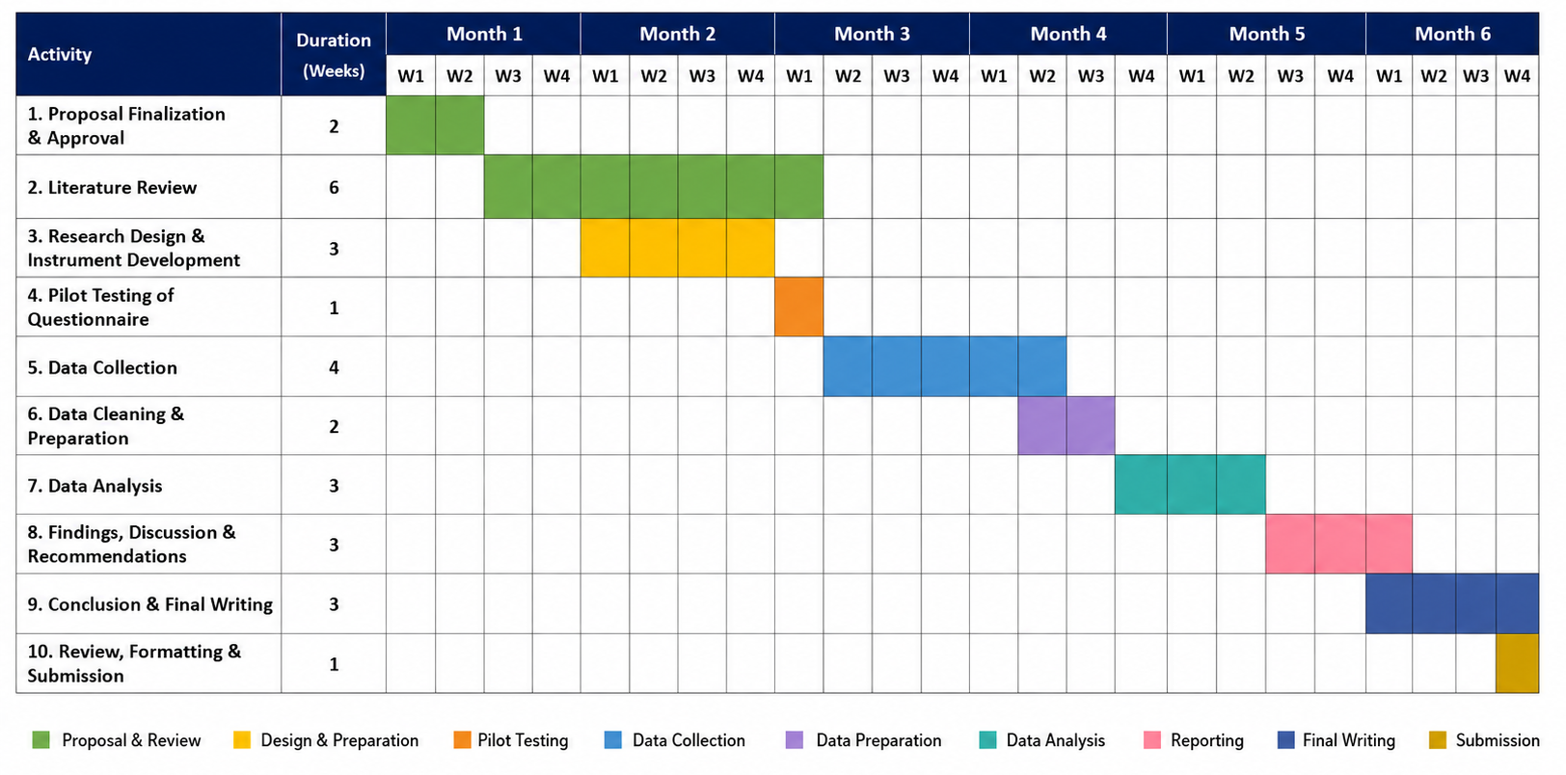
Figure 2: Gantt Chart Framework
(Source: Self-Developed)
The timeframe provides a framework of steps to be taken over the six months to carry out the research project. The first step is to finalise the proposal, and through an in-depth literature search, the next step is the development of the research design and pilot testing of the questionnaire. Data collection will take place in the mid-phases of the project, and then data will be cleaned, prepared and analysed. The final stages involve interpretation of findings, discussion and recommendations, dissertation write-up and final review and formatting for submission. This timeline will help to maintain continuity and orderly movement in the research process during the time frame.

7. Conclusion
This proposal aims to find out which are the factors that affect the channel switching behaviour of consumers from traditional grocery stores to quick commerce apps in the CPG sector. The secondary qualitative method investigates the functional and psychological aspects to provide a foundation for an important gap in the literature. Insights and recommendations in the study will be used to help retailers plan effective customer retention and omnichannel strategies.

References
Alkhiyami, H., Padmanabhan, R., Hadid, M. and Kerbache, L. (2025). Drivers of change to e-grocery: an investigation of consumers’ channel choice. Electronic Commerce Research, pp.1-33. https://link.springer.com/article/10.1007/s10660-025-10001-7
Cunningham, C., Hwang, E.H., Nageswaran, L. and Cho, S.H. (2025). Channel Stickiness in Omnichannel Retail: Temporary Shifts or Lasting Changes?. Available at SSRN 5372696. https://papers.ssrn.com/sol3/papers.cfm?abstract_id=5372696
Denscombe, M. (2025). Decolonial research methodology: an assessment of the challenge to established practice. International Journal of Social Research Methodology, 28(2), pp.231-240. https://www.tandfonline.com/doi/abs/10.1080/13645579.2024.2357558
GE. (2025). The Research Onion Explained: Layers, Methodology, and Application. https://getitdoneex.com/the-research-onion-explained-layers-methodology-and-application/
Graham, M., Alyanak, O., Bertolini, A., Feuerstein, P., Kuttler, T., Ustek Spilda, F. and Valente, J. (2025). Pressure and praise as an action research methodology: The case of Fairwork. Environment and Planning A: Economy and Space, p.0308518X251336893. https://journals.sagepub.com/doi/abs/10.1177/0308518X251336893
IGD. (2026). Gen Z pushes quick commerce into mainstream as online grocery fragments. Available at: https://www.igd.com/about-us/press-centre/articles/gen-z-pushes-quick-commerce-into-mainstream-as-online-grocery-fragments/73135
IMARC. (2026). UK Online Grocery Market Size, Share, Trends and Forecast by Product Type, Business Model, Platform, Purchase Type, and Region, 2026-2034. Available at: https://www.imarcgroup.com/uk-online-grocery-market
Kuppili, B.S. (2025). Quick Commerce Adoption in India: Consumer Perceptions, Behavioral Changes and Sustainability Expectations. Available at: https://www.theseus.fi/handle/10024/909800
Makateng, D.S. and Mokala, N.T. (2025). Understanding qualitative research methodology: A systematic review. E-Journal of Humanities Arts and Social Sciences, 6(3), pp.327-335. https://noyam.org/wp-content/uploads/2025/03/EHASS2025637.pdf
MI. (2026). UNITED KINGDOM QUICK COMMERCE MARKET SIZE & SHARE ANALYSIS - GROWTH TRENDS AND FORECAST (2026 - 2031). Available at: https://www.mordorintelligence.com/industry-reports/united-kingdom-quick-commerce-market
Pillay, S. (2025). Investigating brand switching in same-day-grocery-delivery mobile sector: the moderating role of income in an emerging market. Cogent business & management, 12(1), p.2552920. https://www.tandfonline.com/doi/abs/10.1080/23311975.2025.2552920
Prasad, A., Sinha, A.K. and Tripathi, A. (2026). The impact of quick commerce on consumer purchase behavior: A comparative analysis with traditional e-commerce. Int. J. Res. Mark. Manag. Sales, 8(1), pp.11-20. https://www.researchgate.net/profile/Adarsh-Prasad-5/publication/399871230_The_impact_of_quick_commerce_on_consumer_purchase_behavior_A_comparative_analysis_with_traditional_e-commerce/links/697d9c80ca66ef6ab98ee29c/The-impact-of-quick-commerce-on-consumer-purchase-behavior-A-comparative-analysis-with-traditional-e-commerce.pdf
Ramolobeli, T. and Nel, J. (2026). Exploring “buy online and pick-up in-store”(BOPIS) service rejection in grocery retail. European Business Review, 38(2), pp.133-150. https://www.emerald.com/ebr/article/38/2/133/1276791
Saeed, S. and Sharma, R. (2026). Customer Satisfaction and Loyalty in Quick Commerce Vs Traditional E-Commerce FMCG Platforms. AIJFR-Advanced International Journal for Research, 7(1). https://www.aijfr.com/papers/2026/1/3646.pdf
Susilawati, A., Al-Obaidi, A.S.M., Abduh, A., Irwansyah, F.S. and Nandiyanto, A.B.D. (2025). How to do research methodology: From literature review, bibliometric, step-by-step research stages, to practical examples in science and engineering education. Indonesian Journal of Science and Technology, 10(1), pp.1-40. https://ijost.upi.edu/index.php/ijost/article/view/439
YF. (2026). United Kingdom Quick Commerce Databook Report 2026: Market to Reach $4.71 Trillion by 2029 - Tesco, Ocado, and Deliveroo Spearhead Growth as Strategic Grocery Alliances Redefine the Retail Landscape. Available at: https://finance.yahoo.com/markets/stocks/articles/united-kingdom-quick-commerce-databook-104000842.html

