

Module name: Health, Wellbeing and Sustainable Development

Module code: BMHP6021

Assessment Component 1: Written Report

Lecturer name: Student Name:
Rita Ukachi Lois Margareta Nicoleta Dragoi
Student ID: 2019145

Date: 30 August 2023

Table of Contents

Introduction 3
Identify the reasons behind UK’s success in meeting the SD Goals 4
Policies or initiatives the UK government has adopted in meeting these goals 7
Reflecting to what extent people living in the city or borough I have identified for this project have benefited from these three goals of sustainable development initiatives 11
Recommendation 15
Conclusion 17
Reference 18

Introduction
Health and social care is regarded as the term which is associated with the services that are provided and health and social care providers. The main purpose of such a provider is to maintain the quality of life by delivering the right medical and personalised care services to the public in order to improve their health outcomes (‌Moudatsou et al., 2020). Healthcare is related to the services that are focused more on the prevention, diagnosis and treatment of diseases and illnesses. At the same time, social care is tied to healthcare care services which are focused more on providing personal and practical care and assistance to the patient and the vulnerable groups. The following report is created to deliver information on the various aspects of health and social care. The key focus of the report is on identifying the methods that will bring sustainable development in the health and social care organisation. The study will provide a discussion of the SD goals that are developed by the United Nations (UN). It will also provide information on the policies that are initiated by the government in fulfilling the SDGs and will measure the performance of it in the local borough of the UK. Further, the study will also provide information on the benefits that is provided by the SDGs and the recommendations for bringing better development. Lastly, the study will include information from the various councils of London to aid the discussion placed in the report.

Identify the reasons behind UK’s success in meeting the SD Goals
The health and wellbeing consultant is the professional body that provides the client with education on maintaining their health outcomes. It is an institution that is focused on helping individuals to bring improvement in their overall health and well-being. The Sustainable Development Goals (SDGs) were developed by the United Nations (UN) in 2016. The SDGs are also known as Global Goals and the universal call to improve the well-being of the public and the regions that are present in the global field. The goal is developed with the aim of ending poverty, protecting the planet and making sure that every human present in the global field will take advantage of peace and prosperity (Alamoush et al., 2021). The SDGs consist of 17 goals which are integrated as one action to balance social, economic and environmental sustainability. Such goals include goal 1-removing poverty, goal 2-ending all forms of hunger and malnutrition, goal 3-maintaining good health and well-being, goal 4-providing quality education, goal -5 bringing gender equality, goal 6-improving clean water and sanitation, goal 7-bringing affordable and clean energy, goal 8-decent work and economic growth, goal 9-industry, innovation and infrastructure, goal 10-reduce inequalities, goal 11-build sustainable cities and communities, goal 12-foster responsible consumption, goal-13 fight back climate action, goal 14- maintain life below water, goal 15-maintain life on land, goal 16-bring peace, justice and strong institution and goal 17- partnership for the goals (Alamoush et al., 2021).
The SDGs which is applicable to health and social care include the following:
SDG 3: Good health and wellbeing
The UN provided that good health is the key component of bringing sustainable development to the community (UNDP, 2023). The SDG-3 developed by the UN is focused on making progress towards reducing the leading causes of death and diseases. The main purpose of the goal is to prevent preventable diseases, reduce premature death, provide support to mental health, reduce road traffic deaths and reduce the overall global health crises. The goal addresses all the health priorities, health inequalities and more so that health and well-being can be maintained in the various regions of the world.
In the UK the SDG-3 has been adopted to promote better public health and well-being for all ages. The main reason behind gaining the success of implementing SDG 3 is the dedication of the government to providing the finest healthcare home to the public. The UK government has invested a huge amount in combating global health problems like Ebola where 70 million children were immunised by 2020 (ICAI, 2021). In the year between 2020 to 2022, the government of the UK has provided a fund of around £37 billion for improving health and wellbeing (BMA, 2022). The healthcare organisation in the UK has also provided life-saving antiretroviral therapy to around 1.3 million people who were living with HIV. The health and social care services provider of the UK has also been successful in providing safe and higher quality care services which is evident in the reduced mortality rate. In 2021 the data rate in the UK was around 667,479 as compared to 689,629 deaths in the previous year (Statista, 2023). The full support from the UK government is the main factor which is bringing better improvement in the health and well-being of the public.
SDG 4: Quality Education
SD Goal 4 of the UN is focused on providing quality education to the children and youths that are present in various parts of the global regions (Boeren, 2019). The goal is to ensure that every individual achieves the knowledge and education on the development of sustainable lifestyles, human rights and more. The purpose of this goal is to “ensure inclusive, equitable quality education” and “promote lifelong learning chances for everyone” (Ferguson and Roofe, 2020). One study has found that formal education helps every individual to gain knowledge on the various health options and choose the best one (IFAS, 2022). In the UK the SDG-4 has been implemented to provide equal access to “fair, impartial and quality education” through all the stages of life. It is also aimed at helping young people to gain adequate knowledge and skills so that they can gain employment opportunities and decent jobs. Also, the goal has been implemented to reduce income disparities and eliminate gender inequalities in relation to educational access. The reason behind the success of providing quality education is student-friendly services. The students in the UK are provided with extensive student-focused amenities like accommodation, working opportunities, healthcare facilities and more. Another reason is the support from the government where the students are provided with scholarships, full or partial tuition fees and more which is improving the delivery of quality education in the UK (Biswas, 2023). Moreover, SDG-4 is also reflected in the health and social care institutions where quality education is provided to the patients. For instance, in the NHS the healthcare practitioner provides the patient with self-management healthcare practices (NHS, 2023). The self-management practices include information on the action that can be taken by people to recognise, treat and manage their own health. In this way, the UK has been successful in reaching the set SD goals.
SDG 17: Partnership for goals
This goal of the UN is concentrated on the development of a strong partnership to foster sustainable development (Leal Filho et al., 2022). It is found that forming partnerships will help every institution or organisation to gain access to many information and ideas, technologies and even financial resources which is essential for bringing effective development and reaching the set goals. The UK has always been at the forefront of establishing an effective international partnership. The UK has attained the name of becoming the top five bilateral donors for funding world food programs, fencing humanitarian crises and more. In 2021, the UK provided around £1,334mn as a part of bilateral ODA to America (Taylor, 2022). The donation which is provided by the UK is the main reason that has made it successful in meeting SDG-17. For instance, the NHS is the largest health and social care provider in the UK and has partnered with the local government and other system partners which is helping the institution in providing quality healthcare services to the public (NHS, 2022).

Policies or initiatives the UK government has adopted in meeting these goals
The government of the UK has taken major steps in meeting the three SDGs which are developed by the UN. The main initiative which is taken by the UK government to meet the SDG-3 and SDG 17 includes the initiative known as “Build Back Better” to support healthcare services. The aim of this initiative is to improve the public health outcome so that everyone can gain the needed and adequate care services. In the year 2021, the UK government initiated the fund of £35 billion to assist the health care services, £500 million for health care recovery and £260 million for increasing the workforce growth in the NHS (GOV.UK, 2021). The government of the UK has taken this initiative to form partnerships and improve the performance level of the health care services where the quality of public health and well-being. The government has also developed the law known as the “Health and Safety Act” which is the main requirement of every health and social care service. The main aim of the law is to reduce and prevent medical errors which can harm the health of the patients, improve the quality of care and more (Department of Health, 2023).
Another initiative of the UK government to meet SDG-4 includes the development of an Educational Policy. The policy is integrated with the SDG-4 of the UN that is focused on providing fair, equitable and accessible education and lifelong educational opportunities to every individual. The priority of the policy includes the investment in good teaching, supporting educational reform and providing targeted support to the poor and marginalised children. In the year 2022 to 2023, the government has provided educational spending of around £53.8 billion and will provide the fund of around £58.8 billion by 2024 to 2025 (GOV.UK, 2023). This initiative taken by the government will provide a huge benefit to the educational institution to provide quality education to the people.
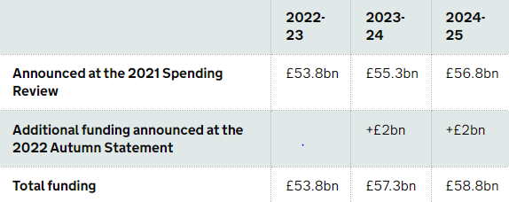
Fig 1: “Educational funding of the UK government”
Source (GOV.UK, 2023)
London City is a well-known region of the UK and has been successful in improving health and well-being, providing quality education and even forming effective partnerships to bring sustainable development. The city of London has been attaining the SDG-3 by bringing effective initiative. The “Build Back Better Plan” is the key initiative taken by the UK government to improve health and well-being. The fund which has been provided by the government is around £35 billion which is providing a huge help to the various boroughs of the country including London City. The London city council has always prioritised the “Health and Safety Act” and has taken the full opportunity placed by the funds. The council has been focused on fighting the health crises in the community through the development of the “Hub Implementation Plan”. The plan provides 24/7 services where 15 health hubs will be created for Londoners who are from the vulnerable group and homeless people (Richmond, 2023). This initiative which is taken in London City is playing a huge role in improving public health and well-being which is evident in the growing life expectancy. For example, in the borough of the London city known as Kensington and Chelsea the life expectancy for women was 87.9 years and for men was 84.7 years. The lowest life expectancy was found in Barking and Dagenham of London city which was 77 years (Men) and 81.7 years (female) (Trust for London, 2021).
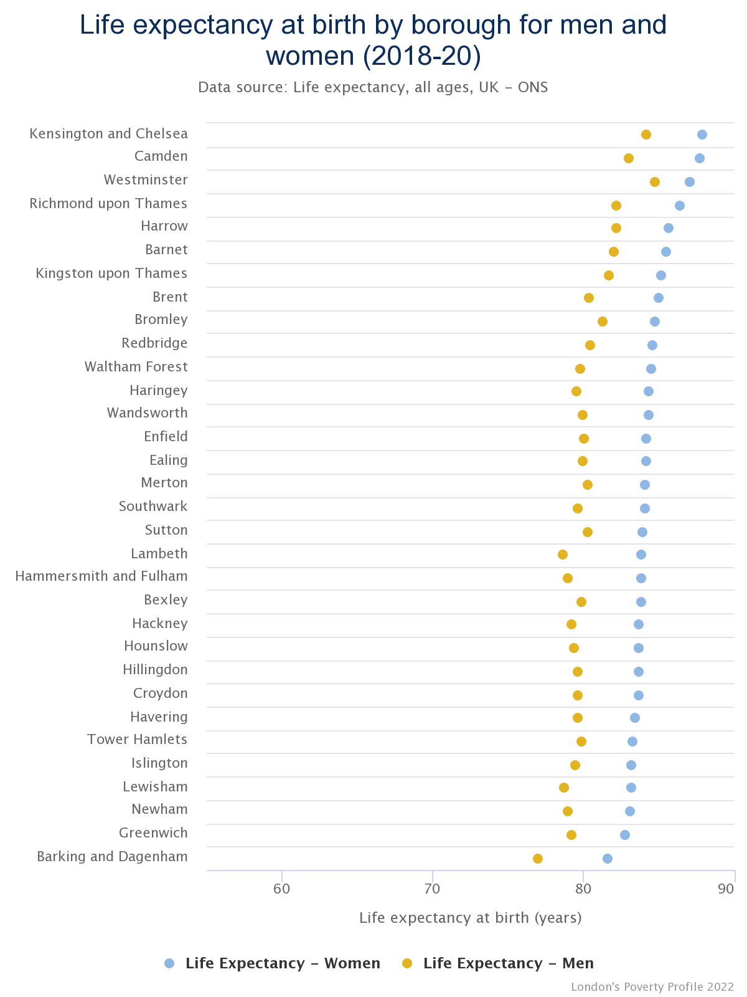
Fig 3: “Life expectancy growth of men and female in the London Borough”
Source (Trust for London, 2021)
The London city has also been successful in providing quality education to the students which is part of the SDG-4 plan. The city has around 400,000 university students who are from different nations (London, 2021). The city has integrated the Educational policy to deliver the highest possible education to every student that is present in the city. The student can gain the scholarship for around 50% who are pursuing undergraduate courses (City. uk, 2023). The student in London city is also provided with the full funding which is based on programme feed, living expenses and transportation facilities (British Council, 2023). In the education institution of London City, there is a presence of a competent teaching force.

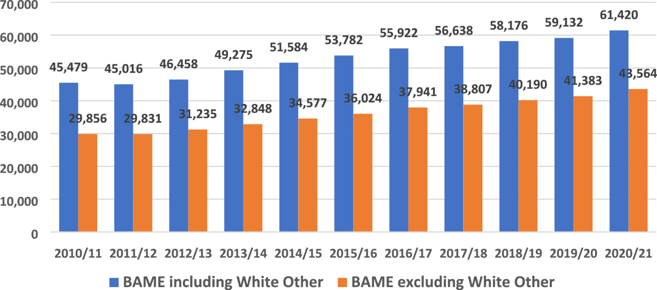
Fig 3: “Teaching workforce in the London city”
Source (Sage Journals, 2023).
In the above graph, it can be seen that there were around 61420 teaching professionals in the year between 2020 to 2021 (Sage Journals, 2023). The presence of a wider teaching force is also the main reason that is helping London City to provide quality education to the students. The quality educational system in London City is evident in the successful academic performance of the student where more than a third of students in the city received an A or A* IN 2022 (Davis Miriam, 2023). The support and the initiative are increasing the educational performance of every student present in London City.
London City has also been successful in forming better partnerships which are based on SDGs-17 of the UN. NHS England is the key health and social care provider of London City. The organisation has partnered with 38 trusts, local government and the five “Integrated Care Boards” with the goal of providing the best health and social care services to its patients in the city (NHS England, 2023). The NHS England has utilised the fund of the government which was provided in the initiative known as the “Build Back Better Plan” for implementing electricity recovery technology, increasing bed capacity and bringing necessary development in its care services (NHS, 2021). With effective development, the NHS has been successful in serving around 320 million patients every year (NHS England, 2023). This goal is to help the NHS of London City to provide better healthcare services to Londoners.

Reflecting to what extent people living in the city or borough I have identified for this project have benefited from these three goals of sustainable development initiatives.
Goal 3 Good Health & Well-being: London City provides all kinds of health and wellbeing care to its people to ensure that they are free from any kind of health issues. They are counselling the disability, well-being team and mental health to understand the requirement of people. Professional staffs in health and wealth support are providing all the required support. According to sources in London more than 4,000 people have been supported by Hestia charity (Hestia, 2023‌). Their NHS organisation is providing health and wellbeing support to the people. UK residents are able to access all kinds of support from the organisation. People in the UK are also getting training which helps in boosting their confidence level and skills to deal with health issues and improve their well-being. For example, “ZeroSucideLDN” is providing with all kinds of support for the well-being of people (London, 2023).
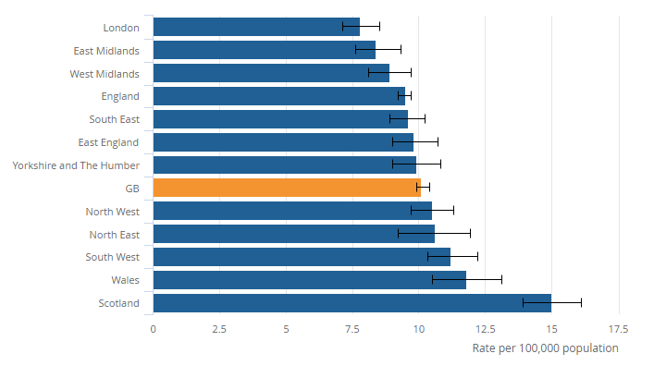
Figure No.4: Ranking of suicide rate
(Source: Osborn, and Osborn, 2023)
With the help of this goal, London City is able to reduce the rate of suicide as compared to other reasons in UK. It is estimated that in London “6.6 deaths out of 100,000” in 2023 whereas in 2021 was about 14.1 deaths per every 100,000 (Osborn, and Osborn, 2023). London is also giving priority to the health and well-being of the state and follows the “Health and Social Care Act 2012” (City of London, 2023). Such kind of initiative has helped the city to set higher standards of well-being and health. London has formulated a strategy called the “Join Strategic Needs Assessment” (JSNA) to provide all kinds of well-being and health to the local people. People in London easily access NHS care from “high street pharmacy”. A person can easily get the entire prescribed medical from the NHS store without any GP appointments for more than seven different common conditions which also include sore throat, “urinary tract infection” and earache.
Overall it shows that London is able to achieve the goal of providing proper health and support to the people in the city.
Goal 4-Quality Education: London is an education hub, which provides education to a large number of people. According to sources, it is estimated that in London there is about 40 different educational institutes which provides quality education to its people (StackPath, 2023). The city is also providing their student with different scholarships so that learners can get a better education without spending much. Such kind of practices has encouraged the student to try hard to get a scholarship and get a better education. It is estimated that in London every year more than 800 students are provided with scholarships. London is trying every possible way to ensure equitable and inclusive quality education and also promote lifelong opportunities for learning. The City of London has also committed to providing boys and girls with complete equitable, free and quality primary and secondary education.
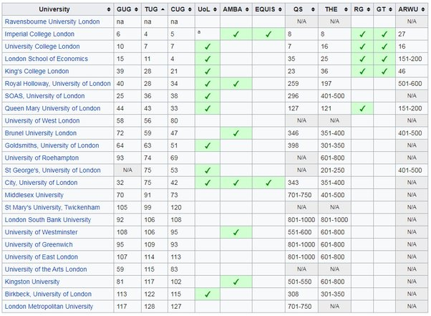
Figure No.5: London Universities ranking in the world
(Source: ‌Quora, 2023)
Learners in London are able to get quality education in science, medicine and others. Therefore, the learner in London is also given free online taster courses opportunity of getting an education online. “Massive Open Online Courses” (MOOCS) is one of the online platforms that provide education to people all around the UK (MOOC, 2023). People in the city are able to work plus study at the same time or learn as per their suitability. In such a way, no individual learner is left out and education is researched for every individual in the city. Further, the city is also providing online support to the teacher so that they can perform their respective duties effectively. It has benefited the learner in the city to get quality education.
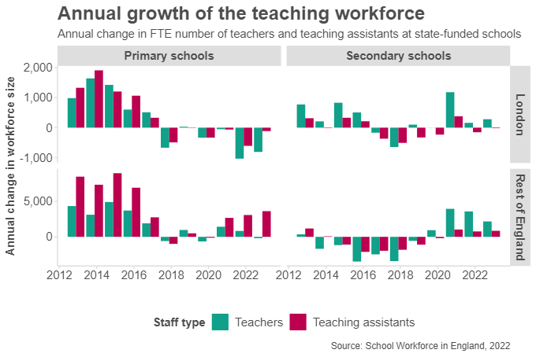
Figure No.6: Growth rate of the teaching workforce
(Source: Institute, 2023)
The above graph shows that the current ratio between the teacher and pupil is about 20.7:1 (Institute, 2023). There are more than 450,000 teachers in the city who provide education to learners (the Guardian, 2023). Over all London is able to provide quality education to the people but it is also facing some problems with teacher retention. London City needs to improve their teacher retention. Educational centres can provide attractive salaries, a reward system and learning opportunities.
Goal 17: Partnering for goals: London is partnering with different international organisations to meet the sustainable goal. NHS is partnering with the local organisation to provide better services to the people in the city. According to sources, it is estimated that the “NHS London Procurement Partnership” (NHS LLP) is one of the procurement hubs in the country (Lpp, 2023). People in the city are being benefited from a variety of services provided by the NHS. London is also funding different departments for sustainable development. Therefore, London is also encouraging foreign brands to invest in the city which has helped the local people in the city. It is estimated that in London more than 5.8 million people are employed (Data, 2023).
SMEs in London are also getting all the required support from the government. Businesses are getting loans to survive in the market which benefits the local people to do business and improve their lifestyle. London is trying every possible way to mobilise the financial resources in the city and support the local people. London councils are working together with the borough to provide better advice and support the SMEs and perform their respective duties properly. The small firms in London are growing and play a crucial role in the development of cities. It is estimated that they account for almost 99% of total London Business and about 50% of the capital's employment (Londoncouncils, 2023).
Overall it seems that London is benefiting its local people and is properly achieving the SDG 17 Goal.

Recommendations
London is one of the leading cities in the country, they are following the mentioned SDG goal. They can improve more and continuously implement practices for meeting the set goals of SDG.
Goal 3: Good Health & Wellbeing
- Health and well-being is one of the important factors because it is the backbone of the economy in the city. When the people in the city are healthy they tend to perform in a much more effective manner. The city can council on a regular basis which will help in understanding the health and well-being of an individual person in the city. London City can promote a healthy lifestyle or diet, which will help the people in the city to maintain their activities which will lead to a healthy life. For example, promote a Vegan diet because it helps in weight loss, reduces the risk of heart disease, and lowers the chances of colon cancer and various different diseases. A vegan diet will also help in managing the diabetes level by lowering the A1c levels, such kinds of practices can help the London city to deal with the growing diabetes level. According to the survey, it is estimated that in London more than 600,000 people are dealing with type 2 Diabetes (Diabetes, 2023).
- London City can also ensure that there is proper water and sanitation. When there is a proper disposal system and pollution management, it helps in lowering the chance of growing any kind of disease. Further, the city can also practice a zero hunger strategy, they can ensure safety and sufficient and nutritious food. London can adopt necessary policies and measures to improve food environments. Increased the access to a healthy option is also one of the effective strategies that can help in managing a healthy environment in the city because people get an opportunity to improve their health. Therefore, London can also put some restrictions on the unhealthy food and practices which will help people in managing healthy diets. These are certain recommendations that can be used by London in managing SDG goal 3.

Goal 4 :Quality Education:
- Education is one of the important factors because it helps in increasing the knowledge base of an individual person. London can maintain the infrastructure of their educational centre because it will help attract learners and provide quality education to the learners. The school structure needs to fulfil the basic requirement of learners which will help in developing a supportive teaching and learning environment. It should have a proper classroom for the learners so that learners can sit in a classroom and get information directly from the lecturer. Further educational centres should also have proper electrical fitting so that there will not be any kind of electrical issues.
- London can also encourage the education hub to use pedagogy skills to provide quality education to the learner. Pedagogical skills refer to those skills which increase the ability of the teacher to instruct their learner and manage the classroom properly (Shavkatovna, 2021). Teachers will be learning the uses of different materials and also understand the requirement of learners. The city can partner with other organisations which will help in increasing the quality of teachers. When the teachers in the city are highly qualified then they will be able to provide quality education to the learners.
Goal 17: Partnership to achieve the goals
- London can encourage different projects which will help in increasing more employment for the local people. When there is a new project in the city it not only provides employment but also helps the local people to get access to a different source. Encourage local businesses to export and import which will help the people in the city to be financially strong and lead a healthy lifestyle.
- London can also partner with different environmental organisations which will help in managing proper sustainability. Sustainability is one of the major concerns, the city can promote sustainable practices through different social media platforms. It is estimated that in the UK more than 57 million people are using social media which will help in reaching a larger audience in less time (Statista, 2023).

Conclusion
The above report shows that London is managing every activity in the city to achieve the SDG goals. It shows that London is taking necessary action or initiatives to improve the health and well-being system in the city. The city provides good quality health and social care to the people in the city. They are also providing proper education to the people and also partnering for the development of the city. People in the city have benefited from the strategy used by London for managing the SDG goals. SDG goals are one of the effective strategies because the cities or countries are getting proper direction and competing with each other to reach sustainability. Every city needs to use or follow the SDG objectives because it will help in managing proper sustainability. Lastly, it has also provided with appropriate recommendations that can be used by London cities in meeting SDG goals.

Reference
‌Alamoush, A.S., Ballini, F. and Ölçer, A.I., (2021). Revisiting port sustainability as a foundation for the implementation of the United Nations Sustainable Development Goals (UN SDGs). Journal of Shipping and Trade, 6(1), pp.1-40.
Biswas, S. (2023). Is the UK still a viable destination for higher education despite inflation? [online] The Economic Times. Available at: https://economictimes.indiatimes.com/nri/study/is-the-uk-still-a-viable-destination-for-higher-education-despite-inflation/articleshow/99927410.cms?from=mdr [Accessed 23 Aug. 2023].
BMA. (2022). Health funding data analysis. [online] Available at: https://www.bma.org.uk/advice-and-support/nhs-delivery-and-workforce/funding/health-funding-data-analysis#:~:text=During%20the%20pandemic%2C%20the%20Government,around%20%C2%A337bn%20was%20provided. [Accessed 23 Aug. 2023].
Boeren, E., (2019). Understanding Sustainable Development Goal (SDG) 4 on “quality education” from micro, meso and macro perspectives. International review of education, 65, pp.277-294.
City.uk. (2023). President’s International Scholarship | City, University of London. [online] Available at: https://www.city.ac.uk/prospective-students/finance/funding/presidents-international-scholarship [Accessed 23 Aug. 2023].\Britishcouncil.org. (2023). Scholarships and funding | Study UK. [online] Available at: https://study-uk.britishcouncil.org/scholarships-funding [Accessed 23 Aug. 2023].
Cityoflondon (2023) Cityoflondon.gov.uk. Available at: https://www.cityoflondon.gov.uk/assets/Services-DCCS/health-wellbeing-strategy.pdf (Accessed: 23 August 2023).
Data (2023). Labour market update for London – June 2021 – London Datastore (2021). Available at: https://data.london.gov.uk/briefings/labour-market-update-for-london-june-2021/#:~:text=The%20total%20number%20of%20workforce,or%201%25%20from%20December%202020 (Accessed: 23 August 2023).
‌Davis Miriam, A. (2023). A-level results 2023 LIVE: London students get highest A* rate in the country as attainment gap widens. [online] Yahoo Sports. Available at: https://sports.yahoo.com/level-results-2023-live-students-053734947.html [Accessed 23 Aug. 2023].
Department of Health (2023). Health and Social Care Act 2012 - Explanatory Notes. [online] Legislation.gov.uk. Available at: https://www.legislation.gov.uk/ukpga/2012/7/notes#:~:text=The%20main%20aims%20of%20the,provider%20regulator%20to%20promote%20economic%2C [Accessed 23 Aug. 2023].
Diabetes (2023) Diabetes hits almost 600,000 in London, Diabetes UK. Available at: https://www.diabetes.org.uk/in_your_area/london/london-region-news-/prevalance#:~:text=New%20analysis%20shows%20that%20the,%E2%80%93%206.7%25%20of%20the%20population. (Accessed: 23 August 2023).
England, N. (2023). NHS England — London. [online] England.nhs.uk. Available at: https://www.england.nhs.uk/london/#:~:text=Welcome%20to%20the%20NHS%20in,meet%20the%20needs%20of%20patients. [Accessed 23 Aug. 2023].
Ferguson, T. and Roofe, C.G., (2020). SDG 4 in higher education: Challenges and opportunities. International Journal of Sustainability in Higher Education, 21(5), pp.959-975.
GOV.UK (2023). School funding: Everything you need to know - The Education Hub. [online] Blog.gov.uk. Available at: https://educationhub.blog.gov.uk/2023/04/26/school-funding-everything-you-need-to-know/ [Accessed 23 Aug. 2023].
GOV.UK. (2021). Build Back Better: Our Plan for Health and Social Care. [online] GOV.UK. Available at: https://www.gov.uk/government/publications/build-back-better-our-plan-for-health-and-social-care/build-back-better-our-plan-for-health-and-social-care#:~:text=While%20the%20immediate%20focus%20must,year%20to%20support%20health%20services. [Accessed 23 Aug. 2023].
Hestia 2023‌. Over 4.5 million Londoners are now struggling with their mental health, new research shows (2022). Available at: https://www.hestia.org/news/news-over-45-million-londoners-are-now-struggling-with-their-mental-health-new-research-shows (Accessed: 23 August 2023).
ICAI. (2021). The UK aid response to global health threats - ICAI. [online] Available at: https://icai.independent.gov.uk/html-version/global-health-threats/ [Accessed 23 Aug. 2023].
IFAS. (2022). Sustainable Development Goals And One Health: SDG 4 - UF/IFAS One Health. [online] UF/IFAS One Health. Available at: https://blogs.ifas.ufl.edu/onehealth/2022/10/13/sustainable-development-goals-and-one-health-sdg-4/ [Accessed 23 Aug. 2023].
Institute, E. (2023) Six charts that explain the state of the teaching workforce in England - Education Policy Institute, Education Policy Institute. Available at: https://epi.org.uk/publications-and-research/six-charts-that-explain-the-state-of-the-teaching-workforce-in-england/ (Accessed: 23 August 2023).
Leal Filho, W., Wall, T., Barbir, J., Alverio, G.N., Dinis, M.A.P. and Ramirez, J., (2022). Relevance of international partnerships in the implementation of the UN Sustainable Development Goals. Nature Communications, 13(1), p.613.
‌London (2021). A student city. [online] London School of Economics and Political Science. Available at: https://www.lse.ac.uk/student-life/London-life/A-student-city#:~:text=London%20is%20incredibly%20diverse%20and,200%20different%20nations%20study%20here. [Accessed 23 Aug. 2023].
London (2023). Mental health and wellbeing support in London | London City Hall. [online] Available at: https://www.london.gov.uk/programmes-strategies/health-and-wellbeing/health-inequalities/mental-health-and-wellbeing-support-london.
Londoncouncils(2023). Small businesses | London Councils. [online] Available at: https://www.londoncouncils.gov.uk/our-key-themes/economic-development/small-businesses#:~:text=London%20Councils%20works%20with%20the [Accessed 23 Aug. 2023].
Lpp (2023). About NHS London Procurement Partnership (2023). Available at: https://www.lpp.nhs.uk/about-nhs-london-procurement-partnership/ (Accessed: 23 August 2023).
MOOC (2023). | Massive Open Online Courses | An edX Site (2023). Available at: https://www.mooc.org/ (Accessed: 23 August 2023).
‌Moudatsou, M., Stavropoulou, A., Philalithis, A. and Koukouli, S., (2020), January. The role of empathy in health and social care professionals. In Healthcare (Vol. 8, No. 1, p. 26). MDPI.
‌NHS England (2013). Transforming primary care in London HOW CAN WE IMPRO VE THE QUAL ITY OF NHS CARE? HO W CA N WE MA IN TA IN FIN AN CI AL SU ST AI NA BI LIT Y? London GENERAL PRACTICE A CALL TO. [online] Available at: https://www.england.nhs.uk/london/wp-content/uploads/sites/8/2013/11/Call-Action-ACCESSIBLE.pdf.
NHS Transformation Directorate. (2021). Building back better with a new fund for elective recovery tech. [online] Available at: https://transform.england.nhs.uk/blogs/building-back-better-with-a-new-fund-for-elective-recovery-tech/ [Accessed 23 Aug. 2023].
NHS. (2022). NHS England» Working in partnership with people and communities: Statutory guidance. [online] England.nhs.uk. Available at: https://www.england.nhs.uk/long-read/working-in-partnership-with-people-and-communities-statutory-guidance/#:~:text=Role%3A%20Partnerships%20between%20the%20NHS,plan%2C%20deliver%20and%20monitor%20services [Accessed 23 Aug. 2023].
NHS. (2023). NHS England» Self-management education. [online] England.nhs.uk. Available at: https://www.england.nhs.uk/personalisedcare/supported-self-management/self-management-education/ [Accessed 23 Aug. 2023].
Osborn, E. and Osborn, E. (2023) Suicides in Great Britain - Office for National Statistics, Ons.gov.uk. Available at: https://www.ons.gov.uk/peoplepopulationandcommunity/birthsdeathsandmarriages/deaths/bulletins/suicidesintheunitedkingdom/2016registration/previous/v1 (Accessed: 23 August 2023).
‌Quora (2023). What is the University of London ranking in the world? (2023). Available at: https://www.quora.com/What-is-the-University-of-London-ranking-in-the-world (Accessed: 23 August 2023).
Richmond, R. (2023). Everything you need to know about London’s homeless hubs plan. [online] lfpress. Available at: https://lfpress.com/news/local-news/everything-you-need-to-know-about-londons-homeless-hubs-plan [Accessed 23 Aug. 2023].
Sage Journals. (2023). Ethnic disproportionality in the school teaching workforce in England - Feyisa Demie, Beng Huat See, 2023. [online] Equity in Education & Society. Available at: https://journals.sagepub.com/doi/full/10.1177/27526461221134291 [Accessed 23 Aug. 2023].
Shavkatovna, S.R., (2021). Improvement of methodological pedagogical skills of developing creative activity of primary school students. ACADEMICIA: An International Multidisciplinary Research Journal, 11(10), pp.289-292.
StackPath (2023). Available at: https://www.edarabia.com/universities/london/#:~:text=With%20a%20population%20of%208.5,the%20best%20in%20the%20world. (Accessed: 23 August 2023).
Statista (2023). Social media penetration UK 2023 | Statista (2023). Available at: https://www.statista.com/statistics/507405/uk-active-social-media-and-mobile-social-media-users/ (Accessed: 23 August 2023).
Statista. (2023). Topic: Death in the UK. [online] Available at: https://www.statista.com/topics/6656/death-in-the-uk/#topicOverview [Accessed 23 Aug. 2023].
‌Taylor, R. (2022). UK aid spending: Statistics and recent developments. [online] House of Lords Library. Available at: https://lordslibrary.parliament.uk/uk-aid-spending-statistics-and-recent-developments/ [Accessed 23 Aug. 2023].
Theguardian (2023). Teacher crisis hits London as nearly half quit within five years (2018). Available at: https://www.theguardian.com/education/2018/oct/04/teacher-crisis-hits-london-as-nearly-half-quit-within-five-years#:~:text=There%20are%20more%20than%20450%2C000,numbers%20returning%20to%20the%20profession (Accessed: 23 August 2023).
‌Trust for London. (2021). Life expectancy by London borough. [online] Available at: https://trustforlondon.org.uk/data/life-expectancy-borough/ [Accessed 23 Aug. 2023].
UNDP. (2023). Sustainable Development Goals | United Nations Development Programme. [online] Available at: https://www.undp.org/sustainable-development-goals/good-health [Accessed 23 Aug. 2023].
‌

‌
‌
‌

‌

‌
‌
‌
‌
‌

