WRITTEN ASSIGNMENT

POSTER AND PITCH

BridgeCare UK: Breaking Barriers to Better Healthcare
Proposed Multilingual Digital Health and Social Care Innovation
Student Name: Sarah Birabwa
Student Number: 2430883
Module Code: BMHP5014
Module Title: Creativity and Value Creation.

Lecturer: Brian Mashumba
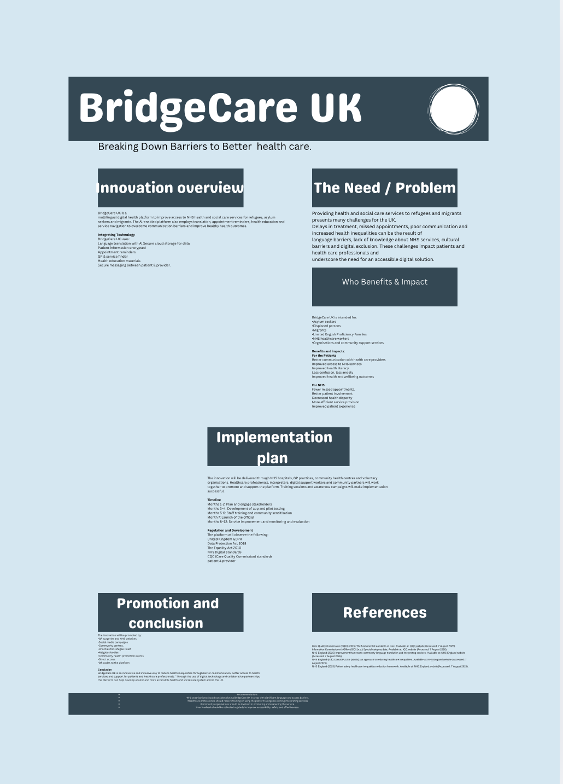

BridgeCare UK: Overcoming barriers to better healthcare
Introduction
BridgeCare UK is a digital health and social care platform designed to make healthcare more accessible for refugees, asylum seekers and migrants who have language, cultural and digital barriers. The platform needs to be multi-lingual. The innovation would provide a mobile app and web platform to deliver multilingual health information, healthcareservice navigation, appointment reminders, interpreting support and signposting to relevant health and community services. BridgeCare UK would afocus on assisting current services, helping users understand and find their way through the health and social care system, instead of taking the place ofNHS services or professional interpreters.
The proposal is supportive of the NHS’s commitment to reducing health inequalities and improving access for inclusive health groups. NHS England (2023) states that refugees, asylum seekers and other vulnerable migrants may face barriers to healthcare. Refugees, asylum seekers and undocumented migrants may also struggle to access health care in the UK, for example because of language barriers and lack of understanding of how services operate (Asif and Kienzler, 2022). BridgeCare UUK, therefore,seeks to provide a more person-centred and inclusive healthcare experience.

The social and health-care challenge
Barriers in language and communication have adverse effects on access and experiences of health care. If you don’t speak English well, you may find it difficult to understand about your appointment, describe your symptoms, follow health advice or use NHS services online. Research in the UK on the experiences of refugees, migrants and asylum seekers in relation to their access to primary health care has shown that there can be significant barriers to the provision and receipt of healthcare (Scott, Forde and Wedderburn, 2022).
The services of interpreters are very important to overcome the communication barriers, but it is not easy to get them. Barriers included limited availability of interpreters, lack of awareness, and difficulty in accessing appropriate interpreting services (Vange et al., 2024). In the absence of intervention, language barriers pose a threat to patient safety and the quality of the healthcare encounter. The change would allow BridgeCare UK to offer guidance and advice to professional interpreting services and to support users to understand healthcare processes.
Then there’s digital exclusion. The digital transformation should be inclusive and should not leave behind those with low digital skills, poor access to the internet or low confidence (NHS England, 2023). BridgeCare UK will be easy to use and will complement non-digital support, not substitute it.

The Proposed Innovation
BridgeCare UK would provide a simple, accessible platform in which users select their preferred language and accessibility requirements. Key features would include the following:
multilingual health and social care information;
GP and NHS service navigation;
appointment reminders;
information about routine and urgent healthcare;
signposting to professional interpreting services;
simple explanations of healthcare terminology;
links to community and voluntary organisations; and
secure communication features where appropriate.
For example, a user who receives an appointment message in English could use BridgeCare UK to understand the information in their preferred language, receive a reminder and access directions to the relevant healthcare service.
The innovation would use translation technology carefully. Automated translation would support general information and navigation but would not replace qualified interpreters during clinical consultations. This distinction is important because clinical communication requires accuracy and appropriate professional judgement.

Target Audience and Expected Impact
The key audience would be refugees, asylum seekers and migrants with language, cultural or digital barriers accessing UK health and social care services. This could be of great benefit to LEP families and individuals.
Benefits expected are increased health literacy and confidence in accessing services, improved understanding of health information and a possible reduction in missed appointments that could have been avoided. This would be helpful to healthcare professionals, and patients could be better informed about appointments and available services.
We believe BridgeCare UK has the potential to reduce health inequalities by providing service users with bespoke support. Asif and Kienzler (2022) highlight structural barriers to accessing healthcare in the UK for refugees, asylum seekers and undocumented migrants. The innovation is therefore aimed at overcoming barriers at the point of engagement of service users with the health care system.

Safety and Regulation of Technology
At the core of BridgeCare UK’s operation would be technology,, but patient safety and confidentiality would be key. Matlin et al. (2025) acknowledge the potential of digital technologies to support migrant and refugee health and raise severalconcerns,s, including privacy, security, informed consent, digital inequality, and meaningful involvement of migrants in the design of digital resources. Such concerns would have a direct bearing on the development of BridgeCare UK.
Health information is considered a special category of data under the UK GDPR and requires additional protection (Information Commissioner’s Office, n.d.). The platform would therefore employ secure authentication, encryption, data minimisation and appropriate control over access. Prior to deployment, data protection impact assessmentnt should be performed.
BridgeCare UK would also have to comply with the Data Protection Act 2018, UK GDPR and relevant NHS requirements. The Equality Act 2010 would be relevant as the innovation seeks to reduce barriers and promote equal access to healthcare.
The platform would complement NHS interpreting services. NHS England (2025) points out the importance of efficient community languagtranslation/interpretation services.ervices. serviBridgeCare UK would aim to help users to identify and use the appropriate interpreting support rather than providing automated translation as a substitute for professional interpretation. tion.

Execution
Implementation would involve co-designing with refugees, asylum seekers, migrants, healthcare professionals, interpreters, community organisations and digital specialists. The pilot would make sure the platform is responsive to lived experiences anddoesn't create more barriers.
"Selected GP practices, community health services, and voluntary organisations could initially introduce a small pilot.Months 1-2: Consultation, planning and co-creation
Months 3-4: Platform development and testing.
Months 5–6: Staff training and community awareness.
Month 7: Pilot roll-out.
Months 8-12: Monitoring, evaluation and improvement
Evaluation would involve user satisfaction, accessibility, engagement, understanding of health information, and missed appointment rates. The platform would be refined following feedback from service users and pprofessionals beforeurther implementation.

References
Asif, Z. and Kienzler, H. (2022) ‘Structural barriers to refugee, asylum seeker and undocumented migrant healthcare access. Perceptions of Doctors of the World caseworkers in the UK’, SSM – Mental Health, 2, 100088. doi: 10.1016/j.ssmmh.2022.100088.
Information Commissioner’s Office (n.d.) Special category data. Available at: https://ico.org.uk/for-organisations/uk-gdpr-guidance-and-resources/lawful-basis/special-category-data/ (Accessed: 7 August 2026).
Matlin, S.A., Hanefeld, J., Corte-Real, A., da Cunha, P.R., de Gruchy, T., Manji, K.N., Netto, G., Nunes, T., Şanlıer, İ., Takian, A., Zaman, M.H. and Saso, L. (2025) ‘Digital solutions for migrant and refugee health: a framework for analysis and action’, The Lancet Regional Health – Europe, 50, 101190. doi: 10.1016/j.lanepe.2024.101190.
NHS England (2023) A national framework for NHS – action on inclusion health. Available at: https://www.england.nhs.uk/long-read/a-national-framework-for-nhs-action-on-inclusion-health/ (Accessed: 7 August 2026).
NHS England (2023) Inclusive digital healthcare: a framework for NHS action on digital inclusion. Available at: https://www.england.nhs.uk/long-read/inclusive-digital-healthcare-a-framework-for-nhs-action-on-digital-inclusion/(Accessed: 7 August 2026).
NHS England (2025) Improvement framework: community language translation and interpreting services. Available at: https://www.england.nhs.uk/publication/improvement-framework-community-language-translation-interpreting-services/(Accessed: 7 August 2026).
Scott, R., Forde, E. and Wedderburn, C. (2022) ‘Refugee, Migrant and Asylum Seekers’ Experience of Accessing and Receiving Primary Healthcare in a UK City of Sanctuary’, Journal of Immigrant and Minority Health, 24, pp. 304–307.
Vange, S.S.P., Nielsen, M.R., Michaëlis, C. and Jervelund, S.S. (2024) ‘Interpreter services for immigrants in European healthcare systems: a systematic review of access barriers and facilitators’, Scandinavian Journal of Public Health, 52(7), pp. 893–906. doi: 10.1177/14034948231179279.

