Book Review
This essay is a book review of Lyn Macdonald’s work The Roses of No Man’s Land, which puts a new perspective on the Great War and tells the story of the war through the women who were affected by it, such as the British nurses who volunteered to treat the men who were injured fighting in the war. The book is not specifically about women but rather the war itself through the recollections and diaries of those women who experienced it first-hand. Many of the accounts Macdonald uses in her book are from the nurses who saw the horrors that were afflicted upon the soldiers and who, Macdonald states is ‘on active service, and as much a part of the war as Tommy Atkins’ which after reading the book, is easy to agree with.
Lyn Macdonald has been described as ‘one of the most highly regarded historians of the First World War’ and indeed, she has written many other notable works such as They Call it Passchendaele, Somme, and 1915: The Death Of Innocence. This suggests that she is a historian who knows the Great War well as she has written numerous works on the subject. She is a social historian who focuses on using direct accounts from eyewitnesses. Indeed, for this book Macdonald collected accounts from diaries of women, however, she also was able to interview many of them. As a social historian Macdonald focuses on the experiences of people and uses them, especially in this book, to tell the wider story through the perspective of the people who lived it.
The Roses of No Man’s Land was published in 1980, however the paperback edition that I am reviewing was published in 1984. According to Macdonald she spent over two years on researching and preparation for the book as well as ‘hundreds of hours talking to octogenarians who were nurses, soldiers, orderlies and doctors.’ Due to the dates in which Macdonald was participating in information gathering many participants would have still been alive, as they would have been in their 80’s. This meant that she could interview these women who lived through the events, which is a rare occurrence in many historians works, and in this case is very valuable as interviewing eyewitnesses from World War One is not possible now.
Macdonald states in her preface that the book is about ‘an aspect of the war which, until now, has been sparsely documented.’ In the time that the work was published this would have been true but with ever evolving focuses more historians have been directing their attention to less covered facets of the war, which has resulted in a lot more historiography about women. However, these would not have benefitted the same way Macdonald’s did as they were not able to conduct interviews. Kate Adie’s book Fighting On The Home Front which was published in 2014 is a recent example that adds to the historiography of women in World War One. Adie discusses the legacy of the women that were left back in Britain. Another example is Stephen and Tanya Wynn’s book Women in the Great War which similarly deals with the women of the Home Front but which also goes into detail about notable individuals such as Dorothy Lawrence who ended up as a soldier in the trenches. These two books go further than Macdonald’s as they discuss the women who were working back in Britain and not just the nurses in the Western Front. However, they do not benefit from personal interviews like Macdonald’s does. In any case, it is clear to see that in recent times the writing of women during the war has become more popular.
Recently there have been more works adding to the historiography of other less discussed minorities of World War One, one of these being boy soldiers. Richard Van Emden’s work Boy soldiers of the Great War discusses them in detail and talks about how young teenagers lied about their age in order to enlist in the Army and the trials they had to face on the front. In the book, Emden uses the boy’s own stories in a similar way to Macdonald. Indeed, his book is in a similar vein as he uses his primary sources in conjunction with his own writing in order to move the discussion forwards. As Emden’s book was first published in 2005 it could be possible that he emulated Macdonald and how she structures her work this way.
The main strength of this book lies in Macdonald’s ability to gather first hand accounts in order to supplement her narrative. However, she does omit potentially important facets of this time such as khaki fever, which many other important works discuss. Angela Woollacot writes ‘women, it seemed, were so attracted to men in military uniform that they behaved in immodest and even dangerous ways.’ There seemed to be general animosity towards these women from the public. If Macdonald had included a discussion of khaki fever that she conducted in her interviews in her book would have been an interesting discussion point and would have enriched her work as well as the historiography of the subject.
The Roses of No Man’s Land is split into three sections which are then split again into chapters. The first section deals with time period between 1914 and 1915 which is the early days of the war. The first chapter discusses the British Expeditionary Force and the Battle of Mons which they had to retreat from, and it uses an account of a Frenchwoman named Germaine Lauryssen to supplement the information. This chapter is used in order to set the story for the rest of the book. Macdonald discusses the events leading up to November 1914 where each side ‘was entrenched in a fixed position which…would hardly alter for the next three years and a half’. Macdonald’s use of this chapter to set the stage is valuable as it provides a lot of context for what is to come as well as providing an informative account of the early stages of the war.
The section discusses various aspects of women’s lives during the war. This ranges from how ordinary women lived during the pre-war of summer 1914 and how the war affected them, such as Hilda and Gladys Pole who after finishing school in Stuttgart returned to their home in Chislehurst and joined the Red Cross. It also discusses what they had to go through when joining the Voluntary Aid Detachment and how women viewed the war such as Mary Ludlum who described it as ‘thrilling’. Macdonald goes into great detail using Millicent the Duchess of Sutherlands experience as Red Cross worker. Macdonald here paints a vivid picture using her account of the siege of Namur and shows what women like her would have gone through. Macdonald ends the section discussing the women who were stationed in the Middle East during the Gallipoli campaign and talks extensively about the nurses treating the patients suffering with dysentery, such as Cathy Mellor who writes ‘I had never nursed such cases before’ giving the impression that many of these women were inexperienced nurses. Macdonald also provides evidence that the women were directly affected by these battles, as, for example, one of the ships the nurses were on was struck by a torpedo.
The second section details the events from 1916 up until the end of 1917, beginning with the battle of Verdun, further suggesting that the women were very close to the fighting as Winifred Kenyon, a voluntary nurse, describes seeing gunners shooting down a zeppelin near Revigny when she was working nearby. This suggests that the women were in a lot more danger than many people believe as they were working very near to the front lines. Macdonald ends the section with an account of a nurse whose brother had been killed at Ypres, but who you can tell the war took a toll on, and you can imagine this happened to many other women as well. The nurse went out to try to forget about the war but another woman approached her who was selling flags for the red cross at which point she states ‘It was more than I could bear. I just ran from her.’ You can see from this that as well as the war affecting men mentally, it also affected women in the same way.
The last section before Macdonald concludes her book, deals with the events of 1918 where she discusses much of the America’s involvement in the war. However, Macdonald uses an account which shows that women still did not have it easy. Peggy Marten writes ‘Armistice Day was the most appalling day I’ve ever lived through’ as she saw two parents being escorted to see her son’s body and she writes ‘here we are at the end of the war- but we’re not at the end of the grief’. Macdonald uses this to show that even though the war was effectively over, people were still being affected by it.
To conclude, MacDonald’s book has its strengths and its weaknesses and could easily be used as either an academic aid or for casual reading as it provides a wealth of information on a subject which is not overly discussed. As well as this she also writes it in a way that is easy to understand. However, although it is a very good and informative work it should be said that this is not an analytical book, as it is very descriptive. This lets it down somewhat as you are getting a history of the war but without the thoughts and views of an established historian. One way it can be summed up is that it is the narrative of the war, told through the perspective of women’s accounts.
Word Count: 1632

Document Analysis
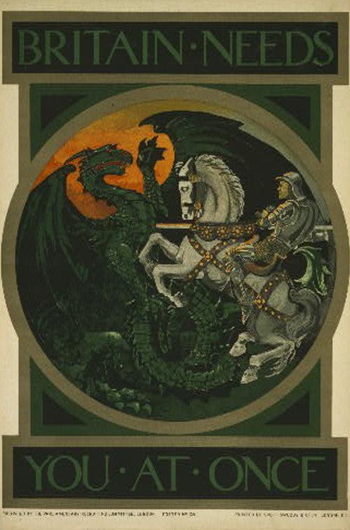

The image above is a British propaganda poster that dates from 1915. It is a depiction of a famous myth from British culture and shows St. George slaying the dragon from horseback with writing above and below saying ‘Britain needs you at once’. It was published by the Parliamentary Recruiting Committee with the aim of enticing the young men of Britain into joining the Army in order to fight in the Great War. This poster will help to gain insight into how Britain viewed themselves as well as the enemy, but also to gauge the general feelings behind the war.
The Parliamentary Recruiting committee or PRC, who published this poster, were formed just after World War One had started on the 27th August 1914. This was primarily due to the fact that the British Army were not at this point using conscription as a method of acquiring manpower, but were instead reliant on people volunteering to join. Herbert Asquith, the Prime minister, had thought in the early stages of the war, that there needed to be an active recruiting campaign in order to persuade the British civilians to join the Army, and that parliament would be best choice to run this campaign. The formation of the PRC occurred very early on in the war’s lifespan, and as such the enthusiasm surrounding the war was still at a high point and had not died down. However, the poster in question was published in 1915 when unsurprisingly the number of people joining up would have been slightly declining a year into the war.
When initially viewing the poster, your eyes are drawn to the image depicted in the centre of the piece rather than the writing above and below. This would have been done deliberately as people are more likely to take notice of an image or a picture instead of writing, so posters like these would have garnered more attention than if the poster was made up of text. The first part of the image people would look at would be St George as he is in the foreground, which would instil in the viewers as sense of patriotic duty as the legend of St. George is well known. It would evoke a sense of pride in the person as well as in a national sense for potential volunteers, as they would feel, if they joined the Army, that they would be as heroic as St. George and would be compared to him in future generations. The dragon here is taking the place of the Germans who are being compared to a beast or a monster that must be slain. It was common for the enemy to be portrayed in such a way, as many posters in this vein depicted them like this, such as the destroy this brute poster (see Figure Two). The fact that the British are portrayed as a chivalrous Knight and the Germans as a beast tells the viewer that if they join the Army they would be on the side of good and that they would be helping to defeat evil. This theme is common in literary works as well, as Leslie Walkinton writes ‘Our real need was to rescue beautiful maidens from terrible dragons…so that when the Daily Mail told us that beautiful Belgium had been violated and France was in distress, we all rushed to the rescue’. Here Leslie is also comparing Germany to the dragons, and France and Belgium as the maidens that need saving.
A lot can be gleaned from the colours employed in the poster as it gives us further information as to how the various facets of the war were viewed. Firstly, the dragon is made up of dark green for the body and the top part of its wings and black for the bottom of the wings. St George and his horse are depicted in different shades of white evoking a feeling of purity or innocence. The dark colours used for the dragon are in stark contrast to the white of St. George which clearly demonstrates which side can be considered “good” and which can be considered “bad”. The dark colours tell us that the dragon is evil, as most things in British culture correlate darkness and evil together. The purity of the white of St. George implies that the British thought of themselves as the morally superior participant in the war and that what they were doing was for the greater good, whereas the dragon or Germany were the antagonists and that their cause was unjust. Not only this but the background colour behind the dragon is reminiscent of fire and devastation implying that the dragon or the Germans, had just torched an area in the distance, possibly a settlement, further reinforcing the idea that they are the antagonists.
The postures of the figures are also worth discussing. St George is depicted impaling the dragon with his lance which gives the impression that the PRC’s recruiting tactic is to imply that the British are in the process of killing the dragon. Perhaps they wanted to get across to the public that anyone enlisting now would be helping in delivering the killing blow to the German’s, thus getting labelled as heroes by vanquishing the “dragon”.
There were many posters of a similar type to this that were employed by the British at this time such as the one depicting Lord Kitchener pointing a finger at the person viewing it with the phrase 'Your country needs you' (see figure three) underneath the image. It is easy to see the similarities here as they both use a similar phrase to try and get people to join the Army, by saying that their country needs them to enlist. As well as this both employ the use of a notable figure that most British people would recognise.
To conclude, the poster shows us how the British and the PRC viewed themselves and the enemy and that they were the protagonists of the war vanquishing the enemy who they thought of as being evil and clearly antagonists. They used that as a recruiting tactic in order to get more British men to enlist in the Army. It also allows you to get a good insight into what British propaganda was like during this time as it plays upon British culture in order to inspire the ordinary person to enlist. As well as this, it could be viewed by the British public that the Army was winning the war.
Word Count: 1083

Bibliography
Primary Sources
British Library, Your country needs you, a British advertisement, <https://www.bl.uk/collection-items/your-country-needs-you> [Accessed 6th November 2019].
Imperial War Museums, DESTROY THIS MAD BRUTE – ENLIST <https://www.iwm.org.uk/collections/item/object/13610> [Accessed 6th November 2019].
Imperial War Museums, BRITAIN NEEDS YOU AT ONCE <https://www.iwm.org.uk/collections/item/object/27762> [Accessed 6 November 2019].

Secondary Sources
Adie Kate, Fighting On The Home Front, (London: Hodder & Stoughton 2014).
British Library, Voluntary recruiting in Britain, 1914-1915, < https://www.bl.uk/world-war-one/articles/voluntary-recruiting > [Accessed 7th November 2019].
Douglas, Roy, ‘Voluntary Enlistment in the First World War and the Work of the Parliamentary Recruiting Committee’, The Journal of Modern History, 42(4) (1970), 564-585.
Macdonald Lyn, The Roses Of No Man’s Land (London, Papermac 1984).
Penguin Books UK, Lyn Macdonald () <https://www.penguin.co.uk/authors/21626/lyn-macdonald.html?tab=penguin-biography> [accessed 8 November 2019].
van Emden, Richard, Boy Soldiers of the Great War. (London: Headline, 2005).
Walkinton, Leslie, ‘The Melting Pot’ In Account of Enlistment, ed. R. van Emden (London: Headline, 2005).
Woollacott Angela, ''Khaki Fever' and Its Control: Gender, Class, Age and Sexual Morality on the British Homefront in the First World War', Journal of Contemporary History, 29(2), ( 1994), 325-347.
Wynn, Stephen and Wynn, Tanya, Women In The Great War (Barnsley: Pen & Sword Military, 2017).

Appendix
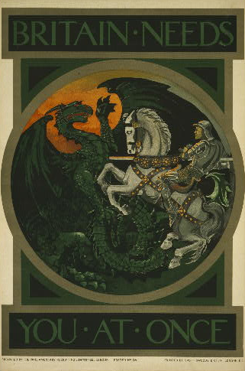

Figure 1: Imperial War Museums, BRITAIN NEEDS YOU AT ONCE <https://www.iwm.org.uk/collections/item/object/27762> [Accessed 6 November 2019].

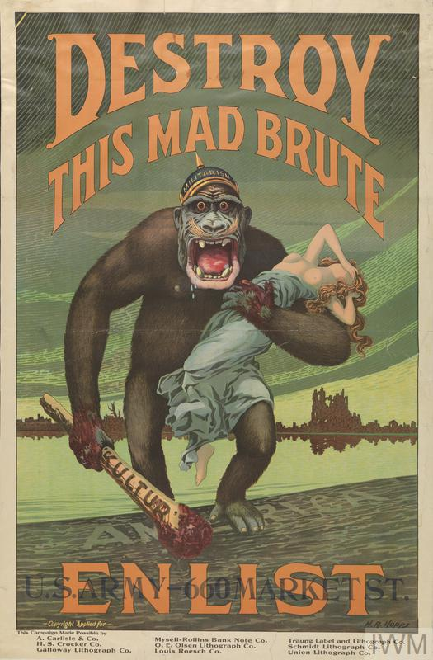
Figure 2: Imperial War Museums, DESTROY THIS MAD BRUTE – ENLIST <https://www.iwm.org.uk/collections/item/object/13610> [Accessed 6th November 2019].

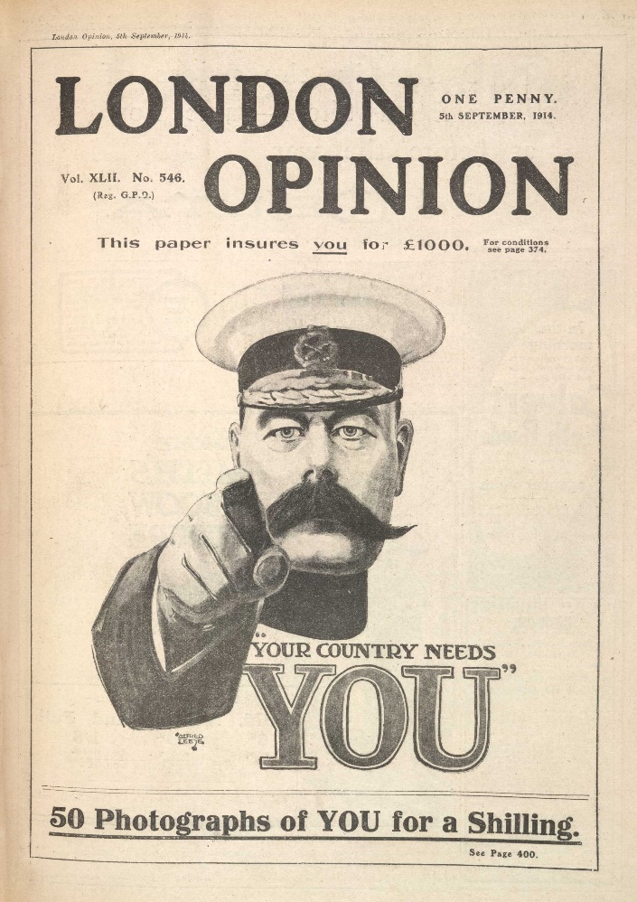
Figure 3: British Library, Your country needs you, a British advertisement, <https://www.bl.uk/collection-items/your-country-needs-you> [Accessed 6th November 2019].

Lyn Macdonald, ‘Author’s Foreword and Acknowledgements’ In The Roses Of No Man’s Land (London, Papermac 1984), p.11.
Penguin Books UK, Lyn Macdonald () <https://www.penguin.co.uk/authors/21626/lyn-macdonald.html?tab=penguin-biography> [accessed 8 November 2019].
Ibid.
Macdonald, The Roses Of No Man’s Land, p.12.
Ibid., p.9.
Kate Adie, Fighting On The Home Front, (London: Hodder & Stoughton 2014).
Stephen Wynn and Tanya Wynn, ‘Individual Women Of The Great War’ In Women In The Great War (Barnsley: Pen & Sword Military, 2017), p.58.
Richard van Emden, Boy Soldiers of the Great War. (London: Headline, 2005).
Angela Woollacott, ''Khaki Fever' and Its Control: Gender, Class, Age and Sexual Morality on the British Homefront in the First World War', Journal of Contemporary History, 29(2), ( 1994), 325-347 (p. 325).
Macdonald, The Roses Of No Man’s Land, p.20.
Ibid., p.35.
Ibid., p.27.
Ibid., p.33.
Ibid., p.40
Ibid., p.120.
Ibid., p.122.
Ibid., p.130-131.
Ibid., p.226-227.
Ibid., p.297-298.
Imperial War Museums, BRITAIN NEEDS YOU AT ONCE <https://www.iwm.org.uk/collections/item/object/27762> [Accessed 6 November 2019].
Ibid.
Roy Douglas, ‘Voluntary Enlistment in the First World War and the Work of the Parliamentary Recruiting Committee’, The Journal of Modern History, 42(4) (1970), 564-585, (p.566).
Ibid. p.566.
Imperial War Museums, BRITAIN NEEDS YOU AT ONCE.
Imperial War Museums, DESTROY THIS MAD BRUTE – ENLIST <https://www.iwm.org.uk/collections/item/object/13610> [Accessed 6th November 2019].
Leslie Walkinton, ‘The Melting Pot’ In Account of Enlistment, ed. R. van Emden (London: Headline, 2005) p.37.
British Library, Your country needs you, a British advertisement, <https://www.bl.uk/collection-items/your-country-needs-you> [Accessed 6th November 2019].
British Library, Voluntary recruiting in Britain, 1914-1915, < https://www.bl.uk/world-war-one/articles/voluntary-recruiting > [Accessed 7th November 2019].

