Hotel Trinity  kbhb |  |  |  |  |  |  | MAIN COURSE  Chicken tikka biryani  layers of chicken, rice, and aromatics that are steamed together. The bottom layer of rice absorbs all the chicken juices as it cooks, giving it a tender texture and rich flavor, while the top layer of rice turns out white and fluff  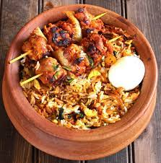  DESSERT  Homemade special fruit cocktail made with freshly cut fruits covered in a yogurt  Fruit cocktail  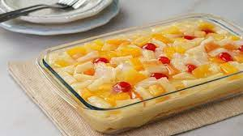  Champagne  Pol roger  Salon  Crug Nasima khatun
  - takeaway MENU

APPETIZER

Vegetable samosas
Chicken pakoras

FIRST COURSE
A salad of sliced cucumbers, red onions , red bell pepper , olives and crumbled feta with freshly cut lettuce served with (optional)lemon and honey sesame chicken
Greek chicken salad
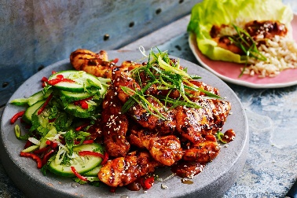

DESSERT
List or describe dessert(s)
Dessert item

