Lauren Rose McGree
P150235
Illustration

Contextual Studies
Dissertation Proposal

Existential influence on the abstract art movement in modern art.

Key words: Reality, Authenticity and Meaning

Word count: 2034

Throughout this dissertation proposal the philosophical theory of existentialism and its influence on abstract art will be explored, concentrating on the keywords of reality, authenticity, and meaning which are some of the key terms within existential beliefs. there will also be a focus on the work of Jackson Pollock, an abstract expressionistic painter, The work of Jean- Paul Sartre, a philosopher who is thought of as one of the main thinkers behind existentialism, and the artwork of Jean Dubuffet, an existential artist, all in regards to the title.

Beginning with the keyword of reality, in respects to the truth of the world we live in and experience, in ‘Movements in Modern Art’, Mel Gooding (2011: 6) stated that all art is abstract and continues to explain that all art engages with the world by existing in it and that it abstracts aspects of it by creating pieces that resemble objects or experiences, because they are always variations of it simply by being a copy inspired by the original. Also, Mel Gooding (2011: 7) expressed that the abstraction of the world through art enlivens and enlightens our appreciation of it by communicating our personal and unique interpretations of it. Gooding (2011: 7) This relates to the existential belief that that people spend their life constantly trying to figure out who they are and those who are closer to understanding that make personal decisions that become unique through not needing an objective form of truth. Cannon,(1996)

Figure 1: Jean Dubuffet, Soul of the underground, 1959, oil paint and aluminium foil on composition board 1.5 m x 1.95 m

Figure one is a piece by Jean Dubuffet, created with aluminium foil and oil paint to exemplify his fascination with texture that features in all his artwork. Another interest of his was creating pieces that depart from representational paintings. Borteh, (2018) He believed that abstraction and ‘style evoked the manner in which objects appear in the mind’ and explored the contrast between physical and mental representations of reality. Radford (2016)
‘The progress of art from representation to abstraction is in some ways paralleled with that quintessential modern quest for a new kind of truth’ was quoted by Mel Gooding (2011: 123), expressing that abstraction captures a new way of observing reality and are in no way inferior to figurative representations, simply a ‘new kind of truth’. This could be considered to be an existential viewpoint as Kierkegaard, thought to be the first existential philosopher and widely referred to as the “father of existentialism”, claimed that all truth is subjective. Wolf, J (2018) Ludwig Wittgenstein wrote ‘the world is everything in the case’ at the beginning of a philosophical project that he continued throughout his lifetime, where he began by attempting to describe and explain the world in a logical way but ended up realising the problematic nature of the limited language that we have to describe anything at all. Gooding (2011: 96) This could also be true in regard to how limited art would be if one could only create art representing objects and effects that can be seen, and by embodying them only exactly as they are seen. Gooding (2011: 114) Which is why abstract artists consciously sought drastically new ways to symbolise their reality, aiming to create an art form that could communicate qualities of reality that seemed to be unreachable to figurative art techniques and practices. Mosworthy (1990 : 128) Mel Gooding (2011: 122) also conveyed this by stating ‘Objects are objects, they can be pictures; but to represent the dynamic relations between objects required an abstract visual language.’

The second key word is authenticity which is a largely covered topic within existentialism. Outlaw, G (2002) Abstract art paired well with this as they shared the same interest in their desire for both personal expression and for the freedom that breaking away from past traditions of figurative art gave them Mosworthy (1990 : 155)
Jackson Pollock is considered an existential and abstract artist. This is because an existentialist theory is that life’s meaning is to be authentic, which comes from a series of personal choices that you have to take responsibility for by accepting the consequences of you decisions, which Jackson pollock has done throughout his career. Wolf, J (2018) On many occasions he has accepted criticism well and has even stated that he is not worried about making changes to a piece and possibly ruining it as it is his decision based on his connection with the painting. Jackson Pollock also mentioned how ‘painting is self discovery’ and that ‘every good artist paints what he is’, which could be related to the existential view of personal experiences influence on leading an authentic life, along with how he was constantly creating artwork that required him to make conscious decisions to create work that broke the mould of traditional art. Wolf, J (2018)
Jackson pollock was quoted stating how he had thought about death often, and although he was frightened ‘as we all are’ of the unknown, he goes on to describe death in a positive way, expressing that death is earnt by those living on the edge. This also closely relates to the existential view on death, which is also a positive perspective, where it is believed that it is important to be aware of death because although it is natural for humans to be scared of the prospect of morality, it gives significance to life. Outlaw, G (2002)
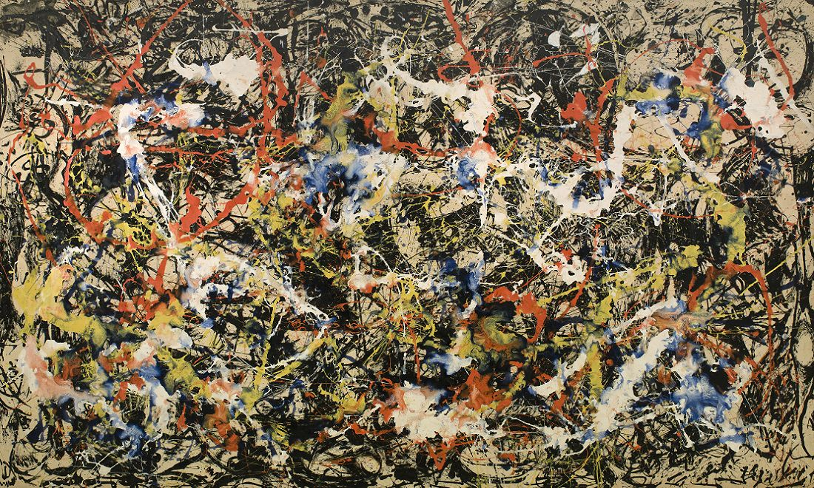

Figure 2: Convergence, Jackson Pollock. Oil painting on canvas 237 cm × 390 cm (93.5 in × 155 in)

Figure two is a large scale oil painting on canvas by Jackson Pollock entitled ‘Convergence’. This piece is considered one of his most infamous pieces featuring one of his most recognisable methods of splattering colourful paint of the canvas creating a dynamic piece consisting of contrasting shapes and textures. Tate (2018) Combined with this the large scale of the painting makes a very profound impact on the observer which can only be truly appreciated in person. It was a strong contribution to the progression of the abstract art movement making a strong statement about the importance of freedom of expression, linking to the existential theory of leading an authentic life. Wolf, J (2018) He did this by rebelling against the socially accepted forms of traditional figurative art and the constraints of society’s oppressions, and although viewers found it difficult to untangle the meaning behind his works, the defiant nature and freedom of expression was clearly apparent. Fer (1997: 105)
Clyfford Stil (1952), an abstract expressionist painter, believed ‘One must accept total responsibility for what he executes. And the measure of his greatness will be in the depth of his insight and his courage in realizing his own vision’ and it was widely claimed that the artists emotions and commitment would translate directly into every brush stoke of an abstract artist. Furthermore, that every unpremeditated touch signified the artists engagement and the consequential mark making of this was evidence of authenticity within their contact with the materials used. Mosworthy (1990 : 122) This was imperative to existentialists; developed by Jean Paul Sartre and Albert Camus, individuality was considered the source of all moral value therefore the conscious decision that abstract artist made to recognise their freedom and make choices without direct reference to eternal sources or objective standards was seen by existentialists as leading and authentic existence. Wolf, J (2018) Outlaw, G (2002)
Likewise, it was equally important to the modern artist of the abstract movement to be authentic through creative originality. They achieved this by ensuring that they created a depiction of their truthful engagement with reality, with emphasis on their personal experience. made their work more original as everyone has a different outlook on all aspects of reality, therefor their outcomes would be diverse in their view of the meaning and purpose of their outcomes and the aesthetic of said piece of art. Mosworthy (1990 : 210) Furthermore, they expected the viewer to construe a separate interpretation of that piece of art based on their personal experiences of reality. As Mel Gooding wrote ‘it is for the spectator to create meanings, not for the artist to dictate them’ while referring to abstract act.

This leads on to the third key word of meaning. Curator Paul Tillich wrote "in abstract or non-objective painting and sculpture, the figure disappears completely ... [because man] is losing his humanity and becoming a thing amongst the things he produces." Which is an existentially influenced viewpoint of the abstract art exhibition he was commenting on. This is shown through his interpretation of the meaning of the piece by referencing existentialists term for the abstract and authentic version of a figure as non objective. By doing this he is giving recognition to the existential philosophy that placed stress on freedom of choice based on personal subjective experience of the individual. Wolf, J (2018)
The focus that existentialism has on personal experience made it the ideal tool for reading most of the late 1940’s modern art from Europe, in particular the more individualistic and expressive post war abstract art. It also helped in interoperating the meaning of some abstract expressionist art, particularly the notion of ‘action painting’, that recognised the importance of an artists need of self assertion through expressing their freedom and authenticity. This notion was created by an American writer and art critic, Harold Rosenberg.
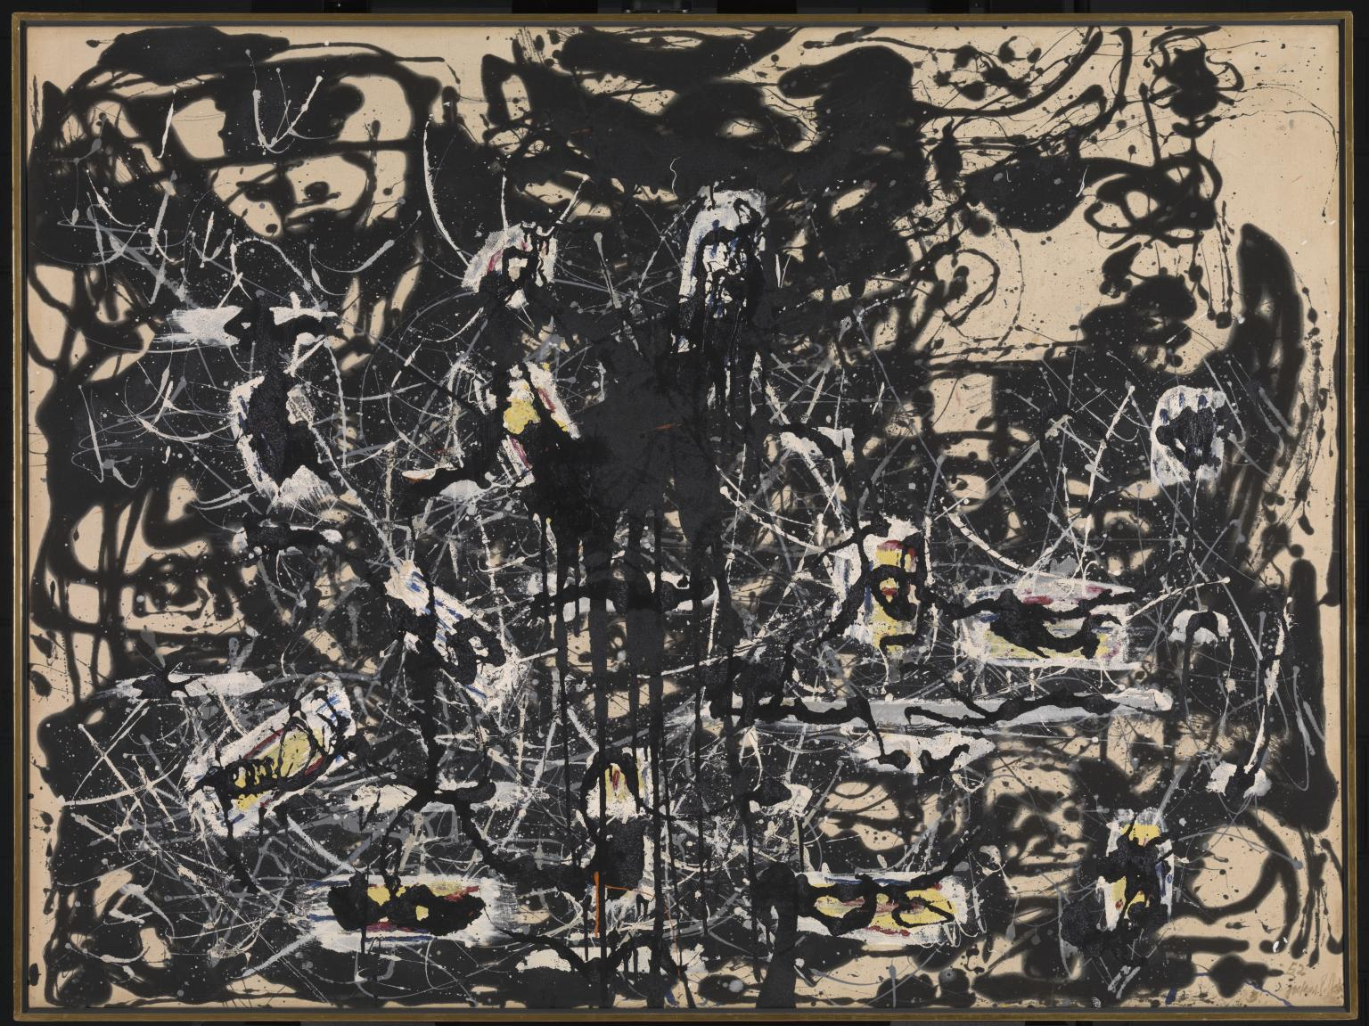

Figure 3: Jackson Pollock ‘Yellow islands’ 1952 oil painting on canvas 1435 x 1854 mm

Figure three is another Jackson pollock pieces that consists of oil paint on canvas. While talking about this piece Jackson Pollock stated that ‘when I am painting I am not much aware what is taking place’ referring to his process of pouring and dripping the paint to work in a free and intuitive way, he also mentioned how his would give meaning by directly expressing his thoughts and feelings through the rhythmic patterns he created. Tate (1028)
This piece was created when Pollock experimented in applying a amore deliberate and unambiguously monochromatic method which art critic Laurence Alloway (1969: 41) commented that this technique created a better sense of movement in Pollocks work through the added texture of the monochromatic layers. Laurence Alloway also stated that ‘The destruction of a known kind of painting, produced by a learned means, characterises Pollock at all periods of his life.’ Inferring that Jackson Pollocks work developed with his personal development in life, he continued to observe that Pollock had a constant desire to move from the known which in this case even considered his previous work as it became more commonly recognised and accepted. This implied that the most common interpretation of the meaning behind Jackson pollocks work revolved around authenticity. Fer (1997: 105)
Jean Paul Sartre, who is considered the most prominent advocate of existentialism in the post war period stated that existentialism stressed the importance of personal subjective experience and how this added meaning to life through the freedom and autonomy of the individual, which directly related to the interpretation Jackson Pollock and others, such as art critics, had on the meaning behind Pollocks work. Mel Gooding states that many other artists also ‘responded to the unpreceded freedom of expression that was necessary condition of abstraction by extending the expressive possibilities of figurative art.’ Gooding (2011: 122)

To conclude there is an undeniable influence of the existential philosophical theories on abstract art. This can be seen from the link between thoughts behind how abstraction developed and the existential theory of authenticity, the personally expressive nature of abstract art that links with the existentialist theory of subjective truth in experiencing reality and that the meaning behind the pieces covered in this dissertation proposal revolved around these key existential topics. They also both arose around the same post war period and developed together at that time, so the possibility of them impacting each other was high, but this arises the question of whether all abstract art is actually existential art and whether those terms are for the same artwork, or artwork that share the same views and key topics. This is what would be researched and discussed further in more depth through the final dissertation.

Bibliography

Borteh, L (2018) Jean Dubuffet Artist Overview and Analysis Available at: http://www.theartstory.org/artist-dubuffet-jean.htm (Accesed April 25 2018)

Cannon, D(1996) An Existential Theory of Truth Vol 12 New York: University of illanois Press

Fer, B (1997) On Abstract Art London: Yale University Press

Gooding, M (2001) Movements In Modern Art, Abstract Art London: Tate Publishing

Karamel, P (2000) Pollock, Jackson: Interviews, Articles and Reviews(1943-1933) New York: Museum of Modern Art

Mosworthy, A (1990) Abstract art London: Thanes and Hudson Ltd

O’Donohoe, B (2014) Severally Seeking Satre Newcastle: Cambridge Scollars Publishing

Outlaw, G (2002) Existentialism Available at https://www.allaboutphilosophy.org/existentialism.htm (Accessed April 22 2018)

Radford, E (2016) The Return of the "Repressed": Dubuffet, l'Art Informel, and Giacometti Available at: http://www.radford.edu/rbarris/art428/thefiguresreturn.html (Accesed 28 April 2018)

Remer, A (2018) Jackson Pollock Artist Overview and Analysis Available at: http://www.theartstory.org/artist-pollock-jackson.htm (Accesed 22 Apri 2018)

Smith, J (2011) Jackson Pollock Convergence Available at: https://www.jackson-pollock.org/convergence.jsp ( Accessed 22 April 2018)

Wolf, J (2018) Existentialism in Modern Art Definition Overview and Analysis Available at: http://www.theartstory.org/definition-existentialism.htm (Accessed: 28 April 2018)

Tate (2017) Available at: http://www.tate.org.uk/art/artworks/pollock-yellow-islands-t00436 (accessed 22 April 2018)

Wolf J (2018) Harold Rosenberg Critic Overview and Analysis Available at: http://www.theartstory.org/critic-rosenberg-harold.htm (Accessed April 22 2018)

Art Since 1940 (Laurence King Publishing, 2000)

Webber, J (2009) The Existentialism of Jean-Paul Sartre London: Routlegde

Zalabardo, J (2014) The world is all that is the case Available at: https://philosophynow.org/issues/103/The_world_is_all_that_is_the_case (Accessed: 28 April 2018)

