
Ux design analysis
User Experience Design

2220233
Acca6034
Andrew Davis
Contents
Table of Contents 1
1.0 Introduction 2
2.0 Product Selection 2
3.0 UX Design Principles 2
3.1 User-centric focus 3
3.2 Consistency 3
3.3 Hierarchy 4
3.4 Context 4-5
3.5 User Control 5-6
3.6 Accessibility 7
3.7 Usability 7
4.0 Initial Review 8-13
5.0 UX Analysis 14-23
5.1 User-centric focus 14-15
5.2 User Control 16-17
5.3 Consistency 18-19
5.4 Hierarchy 20-21
5.5 Usability 22-23
6.0 Conclusion 24
7.0 References & Bibliography 25--31

1.0 Introduction
This report aims to highlight user experience (UX) in digital applications, showing an understanding of the design principles and how they are important to UX. Choosing an application to give an initial review applying UX principles to make an analysis, and finally, seeing where improvements could be made.
2.0 Product Selection.
Amazon, as the world’s leading e-commerce platform, attracts millions of users daily. Its shopping app and website are crucial for facilitating the buying experience for this massive user base. While Amazon has successfully built a streamlined e-commerce experience, there is always room for improvement. This report analyses the UX of the Amazon Shopping app and website based on several UX design principles. The goal is to evaluate its strengths, identify areas for improvement, and suggest practical solutions.
3.0 UX Design Principles.
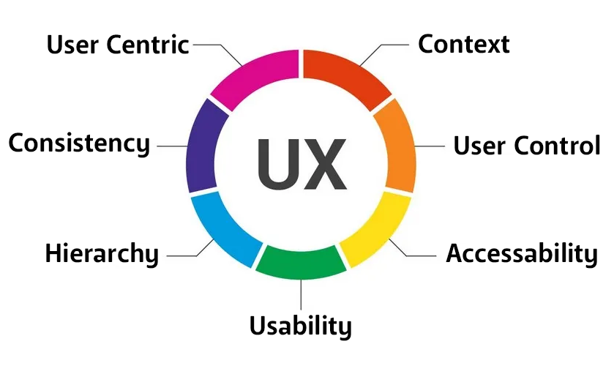
There are several basic principles to follow when creating a great user experience. Below are UX principles with detailed explanations for the best user experience.

Figure 1. seven of the User Experience design principles.

3.1 User-centric focus.
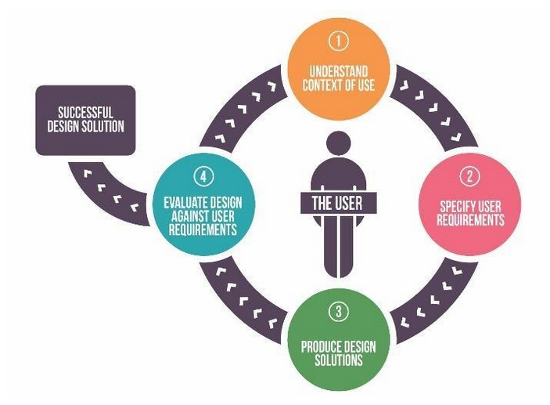
User experience (UX) design, user-centricity, is to create and design digital products and services to solve user problems [1][2]. This means putting the user’s needs first and making decisions based on knowledge of your target demographic and what they want and need from the product [3][4].

Figure 2. Image showing user centricity in the design process.

3.2 Consistency.
The second principle of UX design, is consistency, creating products that solve user-specific issues. Keeping designs consistent regarding functionality and aesthetics across all pages/screens [3]. Whether that is an app or website consistency with visuals such as buttons, links, and socials will help with users’ expectations of how the product should function, this lowers the learning curve for users allowing smoother user experiences [2][5][6].

3.3 Hierarchy.
Hierarchy is another important principle of UX design as it shapes the user’s navigation of the product. Here, hierarchy relates to both information architecture as well as visual hierarchy of pages/screens, with more essential elements at the ‘top’ of the hierarchy. Information architecture refers to the sitemap which is the overall layout of the product with how the user navigates from page to page, whilst visual hierarchy emphasizes how elements are laid out on the page/screen [2][5][6][7].
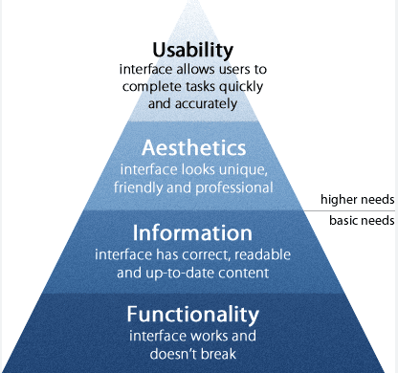

Figure 3. shows the hierarchy of information and visual architecture.

3.4 Context.
When designing a solution to a user problem understand who your users are, what context and circumstance your product is being used in, or how certain factors can impact the user experience. This would include what devices a user might use to interact with a product, where the user might be located or are there any other factors that might interfere with the experience such as noise or lighting [1][3][5].
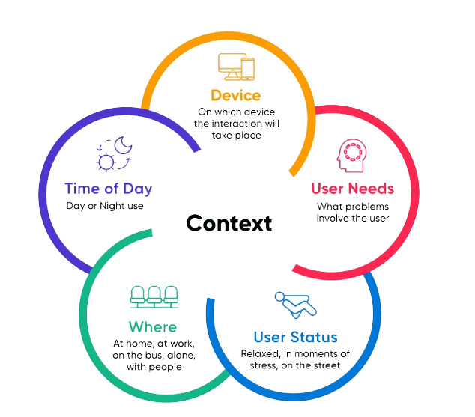
Mobile browsing is now a primary way users access a website, so ensuring a website can function as it should when browsing via both web browsing and mobile browsing is important. Having a better understanding of the context of interaction between the end user and the product will help factor in potential limitations such as background noise and lighting [1][8].

Figure 4. shows different context the end user can engage a product.

3.5 User Control.
A core mechanic in UX design principles focuses on the amount of control the user can interact with the product. Jakob Nielson co-founder of Nielson Norman Group cites user control as one of the ten most important usability heuristics for web design [5], as explained on the NNG website “Users often perform actions by mistake. They need a clearly marked ‘emergency exit’ to leave the unwanted action without having to go through an extended process.”
This is particularly true with AI Automation. Finding the balance between AI and user control, to allow users the ability to reverse an AI decision. An example of this would be the predictive text where you have sent a message in error but have hit send before realizing an error [10].

Figure 6 below. WhatsApp function to delete messages but still shows a message has been deleted.



Figure 5 to the left. An example of A.I automation causing a preventable error.

The principle of user control is to allow the user to correct or amend an error without ruining the entire user experience. Building in controls by incorporating ‘Redo’ or ‘Undo’ and ‘cancel’ buttons whilst clearly labelling alternative routes the user can take to reverse certain actions [11].

3.6 Accessibility.

Accessibility is critical to good UX design, as this ensures the product will reach as many people as possible [6]. This includes people with disabilities, such as visual, auditory, motor, cognitive, and speech, as well as comprehending how different situations or environmental factors may impact the user experience [11]. An example of this would be for visually impaired users, setting high colour contrast or having options to scale the text size [6].
Figure 7. shows an example of contrast used effectively.

3.7 Usability.

Usability, simply put is a measure of how easy a product is to use. Interfaces with a high level of usability allow users to complete tasks quickly and accurately increasing user productivity. Whilst continued analysis on accuracy and speed of user’s ability to complete all tasks within the interface. When users consistently complete each task without mistakes, that is when usability needs have been met [2][5][9].

Figure 8. Image of all UX functions to increase usability.

4.0 Initial Review
Website: Amazon’s website is comprehensive and well-established, offering a wide range of features that cater to experienced users familiar with the platform. However, new users may find it overwhelming due to the complexity and clutter. The homepage could benefit from a cleaner, more focused design, while the navigation structure needs to be more intuitive to reduce cognitive load [13][14][15].
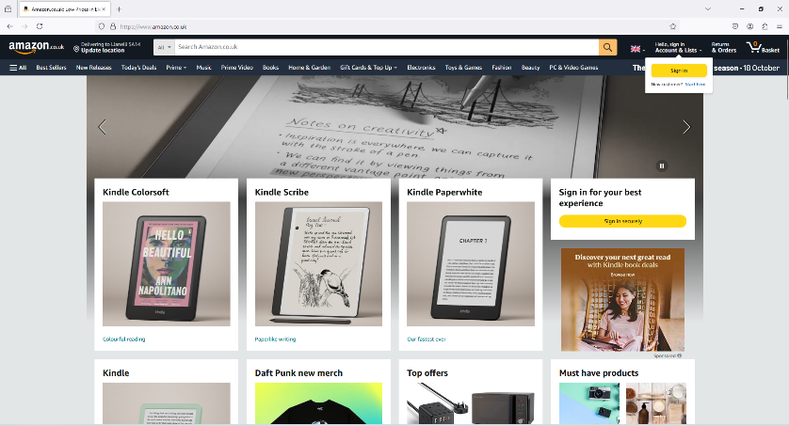

Figure 9: Amazon website Home page

Strengths:
Wide Product Range: Amazon’s website provides access to a vast selection of products, with detailed descriptions, multiple images, and customer reviews, allowing users to make informed decisions.
Robust Search Function: The search feature is powerful, offering filters by category, price, rating, and more. Users can easily find products across various departments.
Personalized Recommendations: The website uses user data to provide personalized recommendations based on browsing history and past purchases, enhancing user engagement.
Fast Loading Times: Despite being content-heavy, the Amazon website loads quickly and maintains reliable performance, which is critical for user satisfaction.
Efficient Checkout Process: The one-click checkout and streamlined payment system reduce friction, especially for returning customers with saved payment details.

Weaknesses:
- Cluttered Homepage: The homepage is overcrowded with ads, promotions, and suggestions, which can be overwhelming, especially for new or less frequent users. This design can contribute to decision fatigue.
- Inconsistent Design: Some areas of the site, such as the placement of buttons or the appearance of product pages, lack visual consistency, creating a disjointed experience.
- Overloaded Navigation: The website offers too many options and links in its navigation, which can confuse users. New visitors might find it difficult to locate specific departments or features.
- Overemphasis on Sponsored Products: Frequently, search results prioritize sponsored listings, which can sometimes reduce the relevance and trustworthiness of the recommendations for users looking for unbiased results.
- Complex Return Process: While purchasing is streamlined, the return process is more complex and less intuitive than expected, with multiple steps and options that may confuse users.
- Shipping Issues: Many of the ‘One Star’ reviews complain about issues with shipping, issues ranging from next day delivery and delivery quality to products being shipped to the wrong location.

Mobile App: The app is convenient for on-the-go shopping and offers useful features like barcode scanning and voice search. However, it suffers from some of the same issues as the website—cluttered design, complex navigation, and a checkout process that could be simplified. Despite these flaws, the app remains functional and is ideal for repeat users who are familiar with its layout [13][14][15].

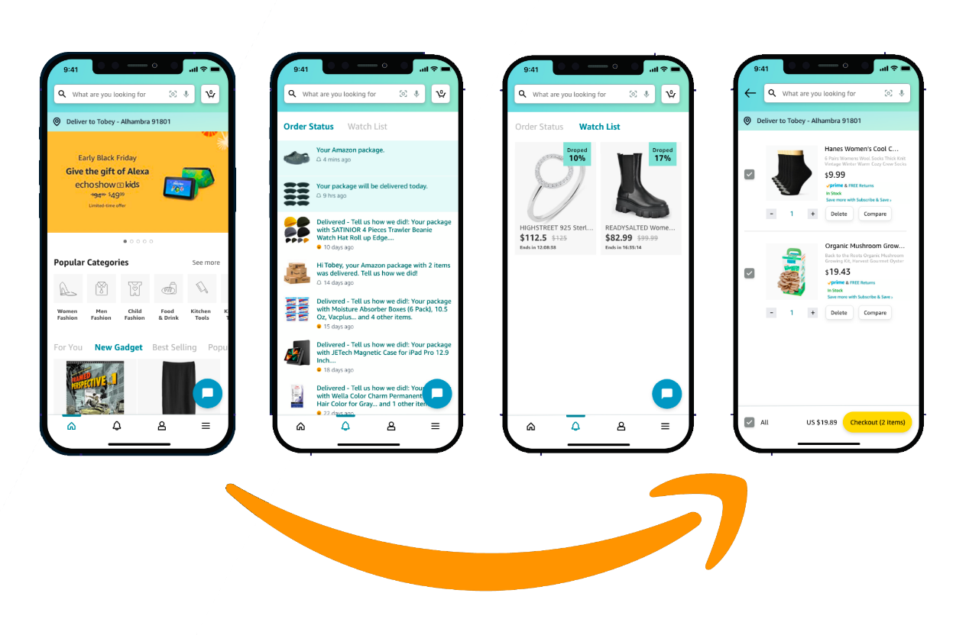

Figure 10: Amazon App Homepage, order status, watchlist, and checkout.

Strengths:
- Mobile Optimization: The app is well-optimized for mobile, providing a faster, more responsive experience compared to mobile web browsing. The layout is adapted to small screens, making product browsing easier.
- Push Notifications: Users can receive updates about deals, shipping status, and personalized offers, keeping them engaged without needing to open the app.
- Barcode Scanning: The app offers a barcode scanning feature, which allows users to compare prices or quickly find products on Amazon by scanning physical items in stores.
- Voice Search Integration: Amazon integrates voice search within its app, allowing users to quickly search for products using Alexa for example, which enhances accessibility.
- Saved Shopping Lists: Users can easily create, save, and manage shopping lists across devices, making it convenient for repeat purchases or Wishlist management.

Weaknesses:
- Interface Congestion: The mobile app is crowded with too many options in a limited space, especially on smaller devices. This can lead to a cluttered feel, where valuable information or features are difficult to locate.
- Navigation Complexity: Like the website, the mobile app’s navigation can be confusing due to the high number of icons, menus, and product categories. First-time users may struggle to intuitively understand the interface.
- Lengthy Checkout: Although the app aims to provide convenience, the mobile checkout process can feel longer than expected, with unnecessary steps that could be simplified, especially for returning users.
- Limited Customization: The app does not allow for much customization in terms of the interface layout or the filtering of recommended products, which could enhance the user experience.
- Occasional Performance Lag: Although the app is optimized for performance, some users report occasional lags when browsing through product categories or during the checkout process.

5.0 UX Analysis
5.1 User-Centric Focus
Strengths:
- Personalization: Amazon excels in offering personalized product recommendations based on user history, searches, and preferences. This personalization helps create a more relevant shopping experience [5].
- Wide Range of Options: The platform offers users access to millions of products across many categories, providing extensive choice, which caters to diverse needs.
- Accessibility: The platform has accessibility features, such as voice search and compatibility with screen readers [6][11].
Weaknesses:
- Mental Overload: Despite personalization, the homepage and search results often feel overwhelming, with too many options, ads, and sections competing for attention. This overload can make it difficult for users to focus on their immediate goals [6].
- Onboarding for New Users: The complexity of the website and app can be intimidating for new users who may struggle to navigate effectively due to a lack of introductory guidance or streamlined pathways [9].
Recommendations:
- Reduce Cognitive Load: Simplify the homepage by reducing the number of promotional banners and ads. Use AI to prioritize content based on the user's immediate behaviour and preferences, showing fewer but more relevant product categories [2][5][7][8].
- Improved Onboarding: Introduce a brief onboarding process for new users, walking them through key features of the website or app. A guided tour of the navigation, product search, and checkout process would greatly enhance the first-time experience [7][8].
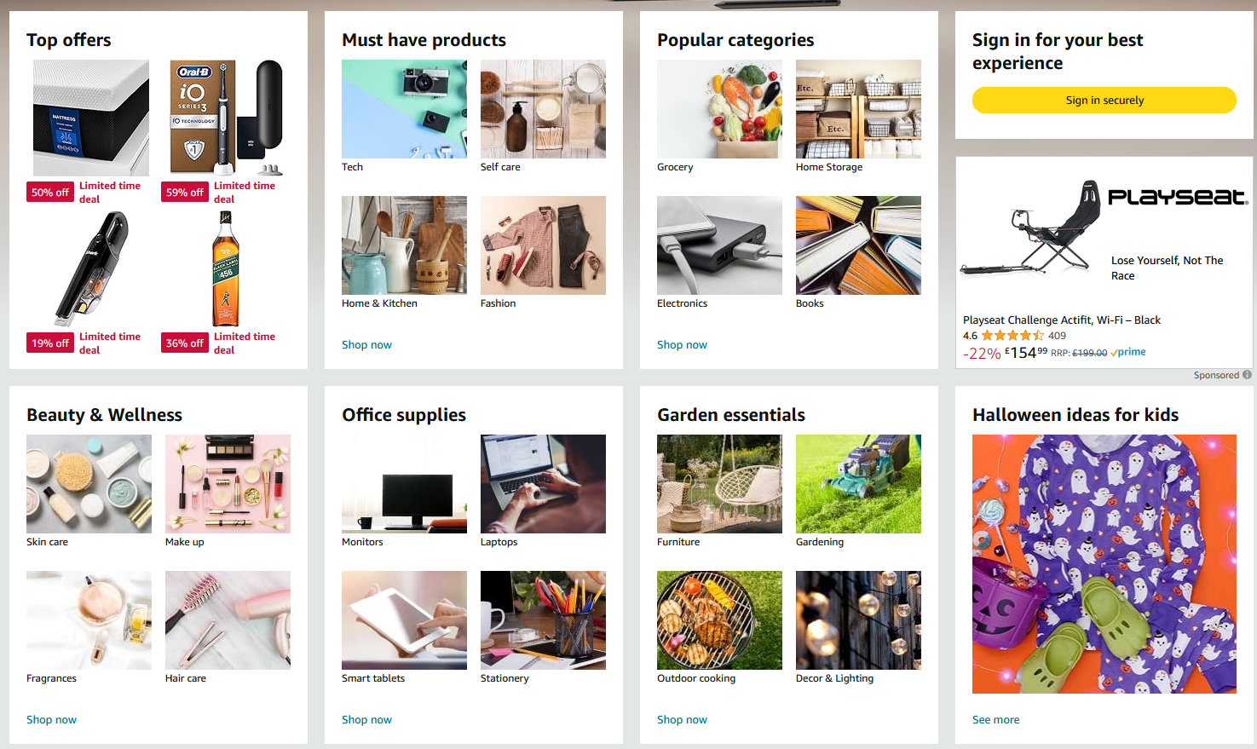

Figure 11: Home-page clutter leading to cognitive overload for new users.

5.2 User Control
Strengths:
- Advanced Filters: Both the website and app offer users control over their searches with various filtering options (price range, product categories, reviews, etc.), helping them refine their results [1][5].
- One-Click Checkout: Amazon's "One-Click" ordering gives users a fast and simplified checkout process, providing control over purchases and reducing friction [1][3].
Weaknesses:
- Overwhelming Control Options: While advanced filters are available, they can be overwhelming for users unfamiliar with Amazon’s structure. The sheer volume of options sometimes makes the platform feel chaotic [6].
- Lack of Customization: Although users can control their filters and search terms, there is little ability to personalize the layout of their browsing experience. For example, users cannot easily customize the homepage to prioritize their favourite categories or reorder sections based on their preferences [5].
Recommendations:
- Improve Filter Simplicity: Implement progressive filtering that shows only the most relevant filters based on the current search query or product category. This could reduce the complexity and help users make quicker decisions [5].
- Introduce Customization Features: Offer users more control over the homepage layout, allowing them to hide, reorder, or customize sections like recommendations, deals, or recently viewed items. This would make the experience more personal and efficient [5][6].
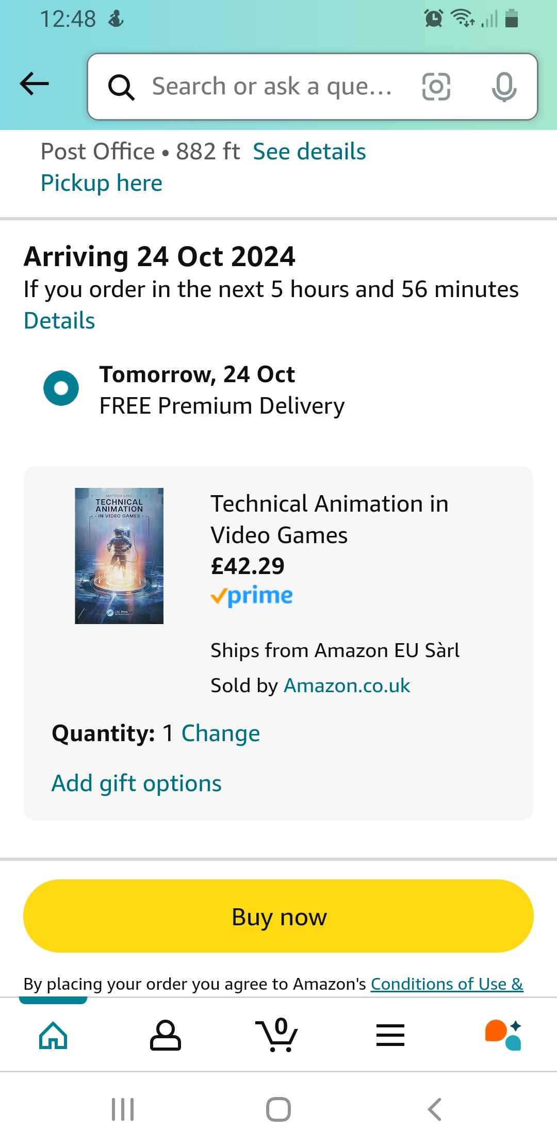

Figure 12: Streamline One Click purchasing options

5.3 Consistency
Strengths:
- Cross-Platform Design: Amazon maintains a relatively consistent look and feel across its website and app, helping users transition smoothly between the two [1][2][3][4][8].
- Layout Familiarity: Users who used to Amazon’s structure appreciate the consistency of the shopping experience, with a predictable design across product pages, shopping trollies, and checkouts [6].
Weaknesses:
- Visual Inconsistencies: Some areas of Amazon’s platform lack visual consistency, especially in the use of font sizes, button styles, and colours across different pages. This makes the design feel less cohesive [6][10].
- Ad Placement: Sponsored products and advertisements are often placed inconsistently within product searches, sometimes disrupting the natural flow of the user experience, and making the site appear cluttered [6][8].
Recommendations:
- Adopt a Unified Design Language: Standardize the appearance of buttons, text, and interactive elements throughout the platform to create a more cohesive visual identity. Consistency in these elements will improve the user experience and reduce cognitive strain [1][2][3][4][8].
- More Predictable Ad Placement: Place sponsored products in consistent and clearly labelled positions across search results. This will help users easily identify sponsored content without disrupting their experience [2][6].
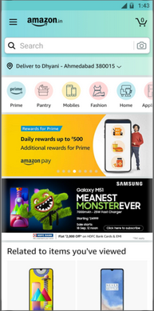

Figure 13: Amazon App Home Page like the website for layout familiarity but also with high amount sponsored adverts

5.4 Hierarchy
Strengths:
- Clear Product Pages: Amazon’s product pages are well-structured, with clear placement of images, product descriptions, ratings, and reviews. This hierarchy allows users to focus on the most critical information first [2][7][8].
- Emphasized Checkout Process: The shopping trolley and checkout process are designed with a clear hierarchy, guiding users step-by-step to complete their purchase [2][7][8].
Weaknesses:
- Homepage Overload: The homepage suffers from poor visual hierarchy, with too many competing elements (ads, recommendations, promotions) placed on the same level of importance, making it difficult to focus [1][3].
- Search Results Confusion: Search results sometimes present items without a clear hierarchy. Sponsored items, organic results, and irrelevant suggestions can appear mixed together, which disrupts the user's flow [1][7][8].
Recommendations:
- Enhance Homepage Visual Hierarchy: Use larger fonts, more whitespace, and defined sections to highlight essential elements like recent purchases, personalized deals, or main product categories. De-prioritize less relevant content (e.g., ads) [6].
- Improve Search Result Structure: Organize search results with a clearer distinction between organic and sponsored items. Use visual indicators to emphasize relevance and ensure that users can quickly scan results [2][7][8].
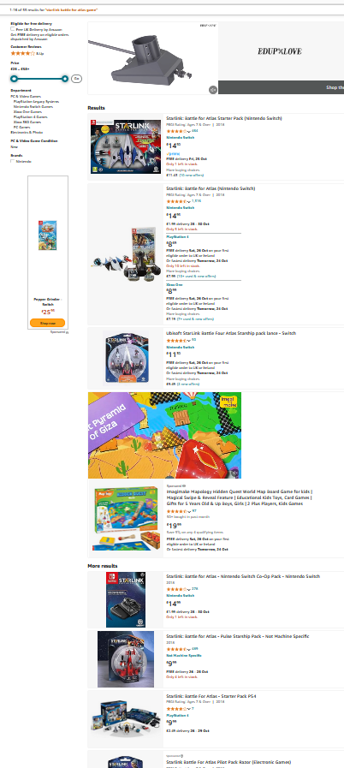

Figure 14: Image of search results that do not match the search criteria

5.5 Usability
Strengths:
- Efficient Shopping Process: Amazon’s "One-Click" purchase feature makes usability a strong point, allowing users to complete purchases with minimal effort [7][8].
- Search Functionality: The search tool, coupled with powerful filters, provides a functional experience, helping users find products effectively [1][2][3][4].
- Responsive Design: Both the website and mobile app are responsive, adapting to various screen sizes and devices without significant issues in functionality [7][8].
Weaknesses:
- Mobile App Navigation: The mobile app’s navigation can feel cramped, especially on smaller devices. The considerable number of icons and options creates a cluttered interface [1][3].
- Complex Returns: While making purchases is easy, the return process is cumbersome, with too many steps and unclear options, impacting the overall usability [13]14][15].
Recommendations:
- Simplify Mobile Interface: Redesign the mobile app with a more minimalist approach. Streamline the menu structure and reduce the number of visible icons to improve navigation and usability [7][8].
- Streamline Returns: Simplify the return process by creating a clear, step-by-step guide with fewer options to reduce confusion and improve usability [13][14][15].
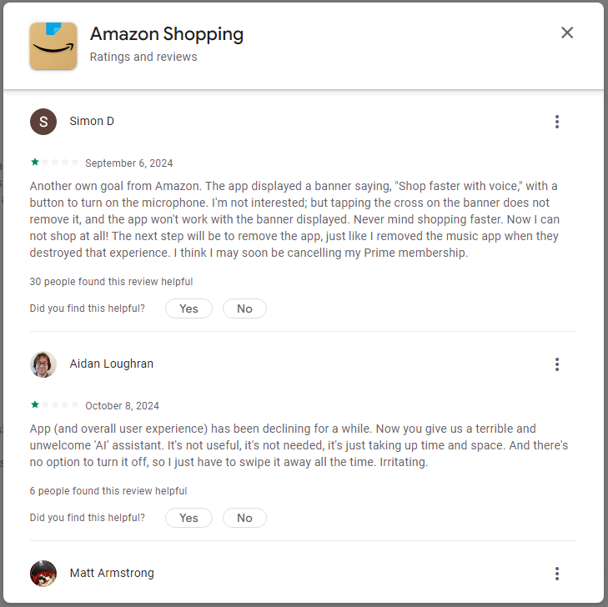

Figure 15: Reviews of Amazon shopping experience

6.0 Conclusion & Importance of UX Design
Amazon’s UX design has many strengths, especially when it comes to product accessibility, speed, and navigation [1][2][7]. However, the platform also suffers from a crowded interface, inconsistent visual elements, and some inefficiencies in personalization and mobile design [6][11]. The complexity of the site may be beneficial to experienced users, but for new users, it can be overwhelming.
To remain competitive and improve user satisfaction, Amazon should focus on simplifying its design, enhancing personalization, and modernizing its visual aesthetic. User-friendly interfaces help convert visitors into buyers, and a clean, efficient UX design leads to higher retention, trust, and customer satisfaction [4].

7.0 References
[1] P. J. Lynch, Web style guide, 4th edition. Yale Univ Press, 2016. Pages 2-36,105-135,135-173,285-300.
[2] D. Norman, The Design of Everyday Things: Revised and Expanded Edition. New York: Basic Books, 2013. Pages 4-31,78-105,132-176,245-288.
[3] J. Nielsen and H. Loranger, Prioritizing Web Usability. New Riders Publishing, 2006.
[4] S. King and K. Chang, Understanding Industrial Design. “O’Reilly Media, Inc.,” 2016.
[5] R. Singh, “11 Important UX Design Principles for a Great User Experience,” Net Solutions, Apr. 26, 2022. https://www.netsolutions.com/insights/ux-design-principles/#5-maintain-consistency (accessed Oct. 08, 2024).
[6] R. Krause, “Maintain Consistency and Adhere to Standards (Usability Heuristic #4),” Nielsen Norman Group, Jan. 10, 2021. https://www.nngroup.com/articles/consistency-and-standards/
[7] W. Akbar, “26 points of UI/UX Design Principles - W. Akbar Putra N - Medium,” Medium, Jun. 08, 2024. https://medium.com/@akbarputra37/25-points-of-ui-ux-design-principles-5e4e4353ae79
[8] E. Stevens, “7 fundamental UX design principles all designers should know - UX Design Institute,” UX Design Institute, Jun. 22, 2022. https://www.uxdesigninstitute.com/blog/ux-design-principles/
[9] N. Hamidli, “Introduction to UI/UX Design: Key Concepts and Principles,” Accessed: Oct. 02, 2024. [Online]. Available: https://scholar.google.com/scholar?hl=en&as_sdt=0%2C5&q=UX+DEsign+Principles&btnG=
[10] M. Gualtieri, “Making Leaders Successful Every Day Best Practices in User Experience (UX) Design by Mike Gualtieri for Application Development & Program Management Professionals,” Sep. 2009. Available: http://web.uchile.cl/DctosIntranet/05UsabilidadExperienciaUsuario/BuenasPracticas/BestPracticesUserExperience.pdf
[11] Hannah, J. et al. (2023) 10 bad ux design fails we’ve seen in Tech, CareerFoundry. Available at: https://careerfoundry.com/en/blog/ux-design/10-classic-ux-design-fails/ (Accessed: 01 October 2024).
[12] W. Grant, 101 UX principles: a definitive design guide. Birmingham: Packt Publishing Ltd, 2018.
[13] Amazon, “Amazon.co.uk,” Amazon.co.uk, 2024.https://www.amazon.co.uk/
[14] “Top 5,019 Reviews about Amazon.com,” ConsumerAffairs, Jan. 10, 2020. https://www.consumeraffairs.com/online/amazon.html
[15] “Amazon is rated ‘Poor’ with 2.1 / 5 on Trustpilot,” Trustpilot. https://uk.trustpilot.com/review/www.amazon.com
‌Image References
[Figure 1] UX Design Principles created in photoshop based on J. Nielsons 10 principles.
[Figure 2] “The User-Centred Design Approach (adapted from ISO, 2010).,” ResearchGate, 2017. https://www.researchgate.net/figure/The-User-Centred-Design-Approach-adapted-from-ISO-2010_fig3_316680273 (accessed Oct. 02, 2024).
[Figure 3] “Are You Meeting the User Experience Hierarchy of Needs?” Nov. 30, 2011. https://uxmovement.com/thinking/are-you-meeting-the-user-experience-hierarchy-of-needs/
[Figure 4] R. Singh, “11 Important UX Design Principles for a Great User Experience,” Insights - Web and Mobile Development Services and Solutions, Apr. 26, 2022. https://www.netsolutions.com/insights/ux-design-principles/
[Figure 5] “Autocorrect...seriously sometimes I cry because I laugh so hard at these! | Funny text messages, Funny text fails, Funny texts,” Pinterest, 2024. https://www.pinterest.com/pin/163114817723413979/ (accessed Oct. 02, 2024).
[Figure 6] Kenn Abuya, “How to Read ‘Deleted for Everyone’ Messages on WhatsApp, Telegram,” Techweez | Tech News, Reviews, Deals, Tips and How To, Nov. 07, 2021. https://techweez.com/2021/11/07/whatsapp-read-deleted-for-everyone/ (accessed Oct. 02, 2024).
‌[Figure 7] “Built by Silo - Digital Studio,” Builtbysilo.com, 2024.
https://builtbysilo.com/ (accessed Oct. 02, 2024).
‌ [Figure 8] A. Komninos, “An Introduction to Usability,” The Interaction Design Foundation, Sep. 24, 2019. https://www.interaction-design.org/literature/article/an-introduction-to-usability
[Figure 9] Amazon, “Amazon.co.uk,” Amazon.co.uk, 2024.https://www.amazon.co.uk/
[Figure 10] “Amazon.co.uk,” Amazon.co.uk, 2015. https://www.amazon.co.uk/?tag=admpdesktopuk-21&ref=pd_sl_33684bbbc54f083f32da54de36bff7f7dcef1c41f1c8a71d4cba3276&mfadid=adm (accessed Oct. 23, 2024).
‌[Figure 11] Amazon Mobile LLC, “Amazon Shopping,” Google.com, 2021. https://play.google.com/store/apps/details?id=com.amazon.mShop.android.shopping&hl=enus
[Figure 12] “Amazon.co.uk,” Amazon.co.uk, 2015. https://www.amazon.co.uk/?tag=admpdesktopuk-21&ref=pd_sl_33684bbbc54f083f32da54de36bff7f7dcef1c41f1c8a71d4cba3276&mfadid=adm (accessed Oct. 19, 2024).
[Figure 13] “Amazon.co.uk,” Amazon.co.uk, 2015. https://www.amazon.co.uk/?tag=admpdesktopuk-21&ref=pd_sl_33684bbbc54f083f32da54de36bff7f7dcef1c41f1c8a71d4cba3276&mfadid=adm (accessed Oct. 17, 2024).
[Figure14] ‘‘Amazon.co.uk’’ Search Results https://www.amazon.co.uk/s?k=starlink+battle+for+atlas+game&crid=23QFIZUR0MMUM&sprefix=starlink+battle+for+atlas+game%2Caps%2C83&ref=nb_sb_noss_2
[Figure 15] Amazon Mobile LLC, “Amazon Shopping,” Google.com, 2021. https://play.google.com/store/apps/details?id=com.amazon.mShop.android.shopping&hl=en-us (accessed Oct. 17, 2024).
Bibliography
[1] S. King and K. Chang, Understanding Industrial Design. “O’Reilly Media, Inc.,” 2016.
[2] P. J. Lynch, Web style guide, 4th edition. Yale Univ Press, 2016.
[3] Hannah, J. et al. (2023) 10 bad ux design fails we’ve seen in Tech, CareerFoundry. Available at: https://careerfoundry.com/en/blog/ux-design/10-classic-ux-design-fails/ (Accessed: 01 October 2024).
[4] R. Krause, “Maintain Consistency and Adhere to Standards (Usability Heuristic #4),” Nielsen Norman Group, Jan. 10, 2021. https://www.nngroup.com/articles/consistency-and-standards/
[5] E. Stevens, “7 fundamental UX design principles all designers should know - UX Design Institute,” UX Design Institute, Jun. 22, 2022. https://www.uxdesigninstitute.com/blog/ux-design-principles/
[6] W. Grant, 101 UX principles: a definitive design guide. Birmingham: Packt Publishing Ltd, 2018.
[7] T. Cromwell, “14 Accessible Website Examples to Inspire Yours,” Hubspot.com, Jul. 25, 2024. https://blog.hubspot.com/website/accessible-website-examples?__hstc=129072723.e1e3c6b5c240388ae6b6b4c14125abab.1727808732249.1727808732249.1727808732249.1&__hssc=129072723.1.1727808732249&__hsfp=2184880705 (accessed Oct. 02, 2024).
[8] “Amazon is rated ‘Poor’ with 2.1 / 5 on Trustpilot,” Trustpilot. https://uk.trustpilot.com/review/www.amazon.com
[9] M. Gualtieri, “Making Leaders Successful Every Day Best Practices In User Experience (UX) Design by Mike Gualtieri for Application Development & Program Management Professionals,” Sep. 2009. Available: http://web.uchile.cl/DctosIntranet/05UsabilidadExperienciaUsuario/BuenasPracticas/BestPracticesUserExperience.pdf
[10] Amazon, “Amazon.co.uk,” Amazon.co.uk, 2024.https://www.amazon.co.uk/
[11] “Top 5,019 Reviews about Amazon.com,” ConsumerAffairs, Jan. 10, 2020. https://www.consumeraffairs.com/online/amazon.html
[12] D. Norman, The Design of Everyday Things: Revised and Expanded Edition. New York: Basic Books, 2013.
[13] J. Nielsen and H. Loranger, Prioritizing Web Usability. New Riders Publishing, 2006.
[14] “Search | Mendeley,” www.mendeley.com. https://www.mendeley.com/search/
[15] Internet Archive, “Internet Archive,” Archive.org, 2016. https://archive.org/
[16] N. Hamidli, “Introduction to UI/UX Design: Key Concepts and Principles,” Accessed: Oct. 02, 2024. [Online]. Available: https://scholar.google.com/scholar?hl=en&as_sdt=0%2C5&q=UX+DEsign+Principles&btnG=
[17] R. Singh, “11 Important UX Design Principles for a Great User Experience,” Net Solutions, Apr. 26, 2022. https://www.netsolutions.com/insights/ux-design-principles/#5-maintain-consistency (accessed Oct. 08, 2024)
[18] “Official Adobe Photoshop - Photo & Design Software | Buy Now,” Adobe.com,2024. (accessed Oct. 17, 2024).
[19] “Free Online Document Editing with Microsoft Word | Microsoft 365,” Microsoft.com, 2024. https://www.microsoft.com/en-us/microsoft-365/word?ocid=ORSEARCH_Bing&msockid=14a070797b646a753f3a63a97a646b70 (accessed Oct. 17, 2024).
[20] Amazon Mobile LLC, “Amazon Shopping,” Google.com, 2021. https://play.google.com/store/apps/details?id=com.amazon.mShop.android.shopping&hl=en-us (accessed Oct. 17, 2024).
‌

