1702357-ECAD6052
Welsh Reflection
To reflect on my lesson, I am going to use Gibbs reflective cycle which is a six-stage reflective model which helps individuals to reflect on an experience by focusing on the description of the event, feelings, evaluation, analysis, conclusion, and an action plan (Main,2023).
The primary focus of the lesson was to develop pupils understanding of “Wyt ti eisiau chwarae”. by implementing different learning strategies within the lesson. To promote active participation and to encourage oral fluency I used a variety of practical strategies. Strategies that were used consisted of: a quick call and response, walk and talk and opportunities were given to the children to develop their writing skills. Prior to delivering the lesson I felt a bit nervous as speaking Welsh is not something that I felt very confident about, but I ensured that I familiarised myself with the planning and key words and question of the session.
The first activity of the lesson was the call and response. To ensure that the Helpwr Heddiw session was both adult and child led, I asked the Helpwr Heddiw to point to a hobby from the vocabulary sheet on the IWB (interactive whiteboard). This ensured that all children were engaged as they looking to see what Hobby was chosen. I modelled the pronunciation of the chosen word to the children, and they have to repeat it back to me. To ensure the children remained engaged I set them a challenge to see if they could respond quicker the next time around. We carried this quick response strategy out a couple of times to ensure that everyone was feeling confident with the vocabulary. The use of pictures on the vocabulary sheet on the IWB supported the children with knowing what each sport was and was accessible to all children throughout the lesson.
The next activity of the lesson was walk and talk. This required the children to walk around the classroom asking the focus question of the day and answer it when their peers asked them. Facilitating walk and talk was an effective strategy as it provided the learners with a practical approach in which provided the children with opportunities to verbally practice asking the question. Additionally, it allowed the children to work collaboratively which enabled more confident children to support children who were less confident. Furthermore, the use of repetition would support the children in remembering the question and how to answer it. During the walk and talk session I was able to identify that the majority of students were able to respond confidently with “Ydw, dw i eisiau...” or “Nag ydw, dw i ddim eisiau...” by the end of the walk and talk session.
To give opportunities for the children to practice their Welsh writing skills, I asked the children to write the question and to choose a hobby and to then ask the question to their learning partner. This consolidated further knowledge of ‘wyt ti eisiau’ as it gave the children a visual approach of how we answer and write the question. Once the children completed the whiteboard task, I asked some children to demonstrate a WAGOLL (what a good one looks like) to the rest of the class. This supported other children in the class to develop their Welsh language skills as they might have been unsure or lacked confidence.
During the lesson, I felt relieved that the activities that I had planned were able to support the children with developing their Welsh skills and that the children were engaged throughout the lesson.
I was able to work collaboratively at all times during the lesson with both the pupils and other staff within the classroom to ensure that everyone was aware of the task and that they felt confident to take part in the task.
Reflecting on the lesson has enabled me to identify next steps of how to improve the lesson. Moving forward, to consolidate learning I will revisit the question as a quick recap and then move on to introducing more vocabulary to allow the pupils to extend their conversational skills.
One area of improvement is the focus differentiation to support the different needs of pupils. Despite most of the children being able to ask and answer the focus question, different strategies could be in place to ensure that all children are supported. For example, scaffold and model the sentences to the children.
The children were given opportunities to develop their speaking and writing skills, but the lesson had no focus on the reading aspect. For future lessons I will ensure that I plan to give the children opportunities to develop their Welsh reading skills by providing them with a task where they match the phrase to the correct image.
Overall, the strategies which were used had a positive impact on developing the children’s knowledge of ‘wyt ti eisiau chwarae’. The children were engaged throughout the lesson as the activities were practical which enabled the children to be active participants within their own learning.
Based on this reflection, I will ensure that when I am planning for future Welsh lessons that I provide opportunities for the children to develop all skills such as reading and listening and not just oral and writing skills. Even though the children were provided with opportunities to listen to Welsh being spoken I also need to give them opportunities to I need to ensure they understand what has been spoken. This will be implemented by given them a simple listening task and they write the answers in the correct box. Furthermore, I will ensure that I enhance differentiation further by challenging the children who are confident with the Welsh focus to enhance their sentences with a wider range of vocabulary to develop conversational sentence patterns. To support those who might feel less confident, continue to provide them with visual aids e.g. vocabulary sheets to build up the individuals confidence.

References
Main, P (2023) Gibbs' Reflective Cycle. ‘Delve into Gibbs' Reflective Cycle, a powerful tool fostering critical thinking, deep learning, and professional growth through reflection’. Available at: https://www.structural-learning.com/post/gibbs-reflective-cycle (Accessed: 15th March 2025)

Blwyddyn:  Year: 3 | Maes Dysgu a Phrofiad:  Area of Learning and Experience: LLC-Welsh | Amcan y wers:  Aims of the lesson: To develop the understanding and use of ‘Wyt ti eisiau chwarae..?’.
Gwybodaeth flaenorol:  Previous knowledge:  The children have been using ‘Wyt ti eisiau’ in different contexts such as  ‘Wyt ti eisiau bwyta..?’, ”Beth wyt ti eisiau wneud..?’. | Geirfa allweddol / Ffocws iaith:  Key vocabulary / Language focus:  Children to ask and answer ‘Wyt ti eisiau chwarae..?’ – Do you want to play….?  Children to answer using ‘Ydw, dw I eisiau chwarae…’ –Yes I want to play or Nag Ydw, dw I ddim eisiau chwarae…’- No I don’t want to.  Hobbies:  Nofio, Tennis, Rhedeg, Gymasteg, Criced, Seiclo, Pel-droed, Rygbi, Pel-Fasged, Marchogaeth. | Gweithgareddau Addysgu a Dysgu:  Teaching and Learning Activities:  To Recap Hobbies sports vocabuluary use the Helpwr Heddiw to point at a hobby, teacher to model how to pronounce it and the children to repeat the word Call and response. Repeat this a few times to ensure children are  Walk and Talk- Teacher to facilitate Walk and Talk where children are required to go around the classroom and ask/answer the question.  Whiteboards: Children to practice writing the question by writing it down three times. In learning partners children to then ask each other their questions. Children to take turns so both children get a chance of having a go.
Adnoddau:
Resources:
Vocabulary sheet on the IWB (Interactive Whiteboard).
showing the children the Hobbies: Pictures and words.
Whiteboards and pens
Lesson Plan

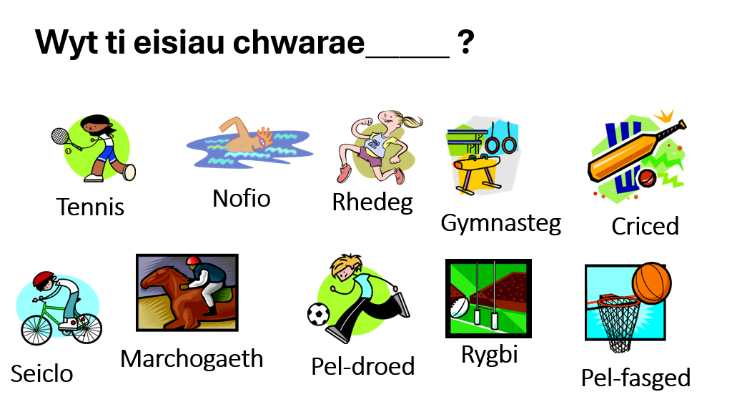
Hobbies Vocabulary Sheet

