Student Name: Eleisha Katherine Price

Student Number: 2005610

BA Course Title: Surface Pattern Design

Module: ADAD4018

Ways of Thinking Lecturer’s Name: Julia Lockheart

Tasks in the order I received them:

Task 1: Manifesto Writing = 492

Task 2: Observational Writing =

Task 3: Practise-based Writing =

Task 1: Manifesto Writing

- Focusing on the industry of the mind; understanding and accepting oneself to partner with the processes of our artistic practice.
- Being aware that the greatest knowledge is in knowing that we know nothing. There is always something to learn, to understand and to easily forget.
- In literature there is stillness and silence, in imagery there are explosions and tears of all colours.
- Courage and rebellion will be the essential elements to a successful practice.
- Do not worry, overanalyse, discuss or compare; remain quiet, have respect and be calm.
- We all must return to craftsmanship, there is no soul in mass production.
- Traditional mediums are those of self-discovery.
- Striving for artistic fame is a selfish man’s game.

3 Areas of Exploration:

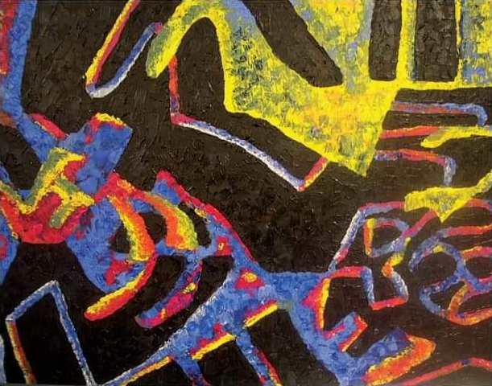
Focusing on the industry of the mind; understanding and accepting oneself to partner with the processes of our artistic practice.
Fig 1. Olivia’s finished piece. 2013.

To understand our cognitive processes when undertaking artistic practices, one must first understand themselves. This is vital to improving artwork. Perception through observational studies aids in this development. A case study through a phenomenological approach features the cognitive processes of creative students during an art session. The reflective nature of the observations would provide the students with the benefit of developing their abilities in their art-making processes through their personal cognitive understanding. As Hickman and Kiss (2013) write, “Making decisions through recognition and exploration transforms perception into an important consideration: a fundamental concern for those working in the arts is to create satisfying and expressive relationships with their work”. From the abstract image above, it is easy to comment that the thought process of this piece is difficult to explain. Olivia - a student from the case study - justifies from her piece that making assumptions is easy and the ‘gut feeling’ of knowing if something will work or not is common through practice. Representing yourself through your work takes a certain level of self-awareness. By understanding yourself, your work will embody aspects of your personality.
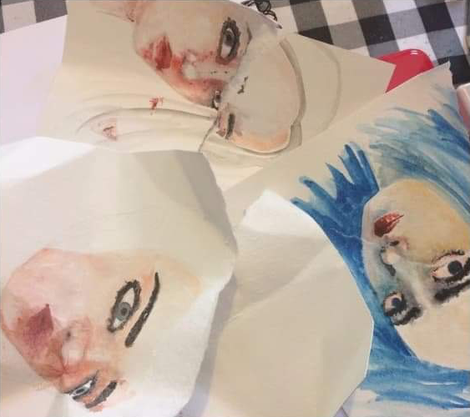
Courage and rebellion will be the essential elements to a successful practice.
Fig 2. Failed attempts at watercolour portraits. 2016. Erika Lancaster.
These two heavy traits play a part in our ability to decide what elements are crucial to our artistic practice. Rebellion - otherwise known as ruthlessness – is a disregard of others opinions and walking over the normalities of society in pursuit of creating successful artwork. To be ruthless as a dedicated and ambitious artist is to lack guilt about one’s own callous behaviour. The discussion of whether artists need some of this to make art (Smith, 2012), is determined by the right amount of appropriate aggression, and syncing this with justice, fondness, and remorse against religious and moral pondering. Having courage is a prior step to enabling our rebellious nature. Artistic practice requires courage to overcome guaranteed failure (Lancaster, 2016). It is courage that helps us push through our psychological conundrums – to show or tell what others may not want to know, to challenge, or to reveal bold indifference. Courage is to accept, adapt and see beyond what is required of our studies, and put these into immediate practice.

We all must return to craftsmanship, there is no soul in mass production.

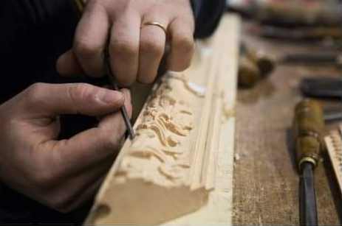
Fig 3. Wood carving wonders. Photo: ©️fuorisalone. 2019.

Craftsmanship is the artistry of a hands-on approach to producing artwork. Production through modernity often refers to the use of technology, which mediates most of our interaction with the world (Openshaw, 2015, p. 4). There are things that technology can not satisfy in artistic practices that traditional methods can, such as the satisfaction of making something yourself – as seen in the above image. Digital media will undoubtedly dominate our future, but there will always be waves of resistance from traditional artists. The term for this is a post-digital mindset: a use of tactile materials often in metal, glass or wood. Hand-crafted items retain the spirit and compassion of the artist. Machines take these feelings away from the end product, making it something that can be bought and replaced regularly with little to no thought about its worth.

Bibliography
Baker, H., 2015. 10 Game-Changing Art Manifestos | Blog | Royal Academy of Arts. [online] Royalacademy.org.uk. Available at: https://www.royalacademy.org.uk/article/ten-game-changing-manifestos [Accessed 5 November 2020].

Hickman, R. and Kiss, L., 2013. Investigating Cognitive Processes within a Practical Art Context: A Phenomenological Case Study Focusing on Three Adolescents. The international journal of art & design education, pp. 99-103.

Homedecorideas.eu. 2019. The Wonders of The Italian Craftsmanship: Behind the Scenes | Home Decor Ideas. [online] Available at: https://www.homedecorideas.eu/inspirations/wonders-italian-craftsmanship-scenes/ [Accessed 7 November 2020].

Lancaster, E., 2017. Self-Doubt an Artist: How to Stay Confident and Keep Going. [online] Erika Lancaster-Artist, Content Creator & Online Art Tutor. Available at: https://www.erikalancaster.com/art-blog/self-doubt-as-an-artist-how-to-stay-confident-and-keep-going [Accessed 6 November 2020].
Openshaw, J., 2015. Postdigital artisans: craftsmanship with a new aesthetic in fashion, art, design and architecture. Amsterdam: Frame Publishers, p. 4.

Smith, J.M., 2012. Ruthlessness and Art-Making. The Virginia Quarterly Review, pp. 145-159.

List of Figures:

Figure 1. Olivia’s finished piece. (2013) Hickman, R. and Kiss, L., 2013. Investigating Cognitive Processes within a Practical Art Context: A Phenomenological Case Study Focusing on Three Adolescents. The international journal of art & design education.

Figure 2. Failed attempts at watercolour portraits. 2016. Erika Lancaster. Accessed from: https://www.erikalancaster.com/art-blog/self-doubt-as-an-artist-how-to-stay-confident-and-keep-going [Accessed 6 November 2020].

Figure 3. Wood carving wonders. Photo: ©️fuorisalone. 2019. Accessed from: https://www.homedecorideas.eu/inspirations/wonders-italian-craftsmanship-scenes/ [Accessed 7 November 2020].

Observational Writing

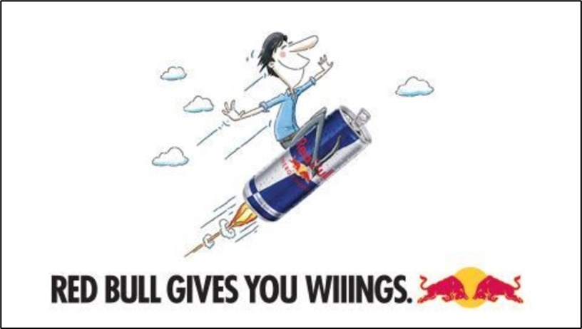

Fig 1. Red Bull Gives You Wings Advert (2012) by Kastner, Los Angeles.

Semiotics is the study of signs and symbols, providing a formalised interpretive structure for disseminating hidden or obvious meanings. It can also be the deconstruction of an image as theorised by Gillian Rose (2016). They communicate things spoken or unspoken, using such methodology for analysing and evaluating visual contents. Adverts are an effective way of training our brains to interpret hidden meanings. They narrate a relevant story and play on the emotions of an audience through subject relativity.

There are three stages of meaning in semiosis as described by Charles Sanders Peirce (1839-1914) as the laws of signs, where there is first the critical study of the relationships of signs to their objects, a speculative vision where one studies the meaning of the signs, and a methodical study of the relationships of the signs to their interpretants. In the Red Bull advert above, we can summarise that the activities of the brand revolve around high energy, insinuating that the drink provides an increase in concentration and reaction speed (a polysemic meaning illustrating that the drink stimulates both the mind and the body). This directs its attention between two personalities: one being serious athletes – that with this drink – will excel in high risk adventures, and a more common, fun personality as represented in their hand-drawn cartoon advertisements, whereby suggests that anyone can consume this beverage. The success strategy of Red Bull is highlighted through consumer engagement, videos featuring athleticism and bravery, and a catchy slogan for brand recognition. The difference between the animated adverts and realistic imagery relates to the type of audience the brand is trying to persuade, and the recognition efforts for the product.

Similarly, Ferdinand de Saussure (1857-1913) produced a semiotic theory that stated that the sign is made up of two parts: the signifier and the signified. The signifier was the object that conveyed or communicated meaning, and the signified is the concept that the signifier refers to; as such, are also represented as ‘connotation’, where cultural or idealistic meanings associate with the object, and ‘denotation’ where the object is described through its primary meaning. In the above advert, the denotation refers to the blue, silver, red and yellow can that visualises the design of Red Bull’s product and logo. The product has been portrayed as a type of aircraft (the anchorage between the flames and the sky suggests this), featuring a man sitting on the can with his arms spread out. The connotation – or otherwise arbitrary meaning - in this pose refers to metaphorical wings, as suggested through Red Bull’s slogan, ‘Red Bull Gives You Wiiings’.

The sociologies of this advert can be better described through Roland Barthes’ (1915-1980) book on Mythologies. Red Bull’s claim of universality can be seen through its social code; these are bodily, commodity, and behavioural: the figure in the ad suggests a target audience that is not limited to athletes, and the can is situated in place of an aircraft - symbolising flight. Therefore, the belief or ‘myth’ of this product is that it will pick you up and give you the energy to succeed, surpass and climb higher. Another hidden code is featured in the ad’s slogan. The triple ‘I’ in ‘wings’ was an outcome of a lawsuit that caused a change in this word so that it no longer proved to be defined in a dictionary or be used to provide an exact relation to the word ‘wings’, but sound similar, so in that it wouldn’t give its audience the wrong idea.

The colours of the product have a psychological effect on the audience. The logo of the two red bulls charging at one another signifies strength, speed, power, risk taking and aggressiveness. The yellow centre spot characterises emotion as it associates with vibrancy and happiness. The primary colours of the can represent intellect and stability. Red symbolises energy, and stimulates people to make quick decisions. It can also be directed towards low battery, a hint towards people with low energy.

Note: I’m not sure about the structure at the moment, and I have exceeded the word count – any way of limiting this? (662 words).

Bibliography:

Archive for Research in Archetypal Symbolism. (2010) The Book of Symbols. Hohenzollernring, Latvia: TASCHEN GmbH, pp. 6-7.

Agency Spotter. 2012. Red Bull Gives You Wiiings. By Kastner Los Angeles. [online] Available at: <https://www.agencyspotter.com/agency_projects/red-bull-gives-you-wiiings> [Accessed 2 December 2020].
Bmmguru.in. 2019. Ever Thought Why Red Bull Has 3 I’Es In Their Tagline? Its $13 Million US Story. | Bmmguru. [online] Available at: <http://www.bmmguru.in/ever-thought-red-bull-3-ies-tagline-13-million-us-story/> [Accessed 2 December 2020].

Hammouri, S., 2018. Roland Barthes: Myth. [online] Critical Legal Thinking. Available at: <https://criticallegalthinking.com/2020/06/12/roland-barthes-myth/> [Accessed 2 December 2020].

Nöth, W. (1990) Handbook of semiotics, Bloomington: Indiana University Press, pp. 39-47.

Stawarska, B. (2015) Saussure’s Philosophy of Language as Phenomenology: Undoing the Doctrine of the Course in General Linguistics, Oxford Scholarship Online: Oxford University Press, p. 23.

Theories of Viscom Blog. n.d. Semiotics - Theories of Visual Communication. [online] Available at: <https://theoriesofviscomblog.wordpress.com/semiotics/> [Accessed 2 December 2020].

Design Writing notes:

Meta-design tools: about business and collaboration, how we can redesign what is already in existence.
Hierarchy of the text – design tools & skills to create writing.
Readability – degree to which prose can be understood.
Visual Hierarchy – increasing visibility of the relationships within a system (with diagrams, images, mapping).
Trees, Nests & Stairs structure – Objective Tree Analysis.
Concept grouping – making up paragraphs from combined information.
Framing – manipulating the way information is presented. (George Lakoff – Simple Framing). Example: Fake News.
Stickiness – increasing recognition of an idea (example: memes).

Universal principles of design book.
Maslow’s hierarchy of needs vs Hierarchy Needs: Functionality (design requirements) > Reliability (Stability and consistency) > Usability (Easy and forgiving?) > Proficiency (doing things better than before – develop/improve) > Creativity (when all needs have been satisfied and there is an additional uniqueness).
Sciences of the artificial text.
Metaphors we live by – Lakoff and Johnson.
Buckminster Fuller structure.

I’ll need to go through these books and find links for situating them in my structure.

Ending sentence: What I have learnt about design writing & relationships.

https://www.britannica.com/art/mask-face-covering

https://www.bbc.com/culture/article/20200512-how-masks-have-appeared-in-art

https://www.insider.com/most-creative-face-masks-people-have-designed-2020-5#an-engineer-turned-a-snorkeling-mask-into-one-that-could-be-worn-on-the-streets-1

https://www.pixartprinting.co.uk/blog/face-mask-types-differences/

Personal Viewpoint:
I am required to wear a mask outdoors/indoors when going places because of the pandemic – they keep me safe and allow me to help others.
I have created masks for cosplaying.
I am interested in the history of masks because they have different properties, materials, designs and uses.
I create masks through character illustrations.
‘Masking’ or otherwise concealing parts of myself.
I have to wear masks around dangerous equipment and materials.
I find that masks can sometimes become hard to wear because of heat or breathability.

Is a personal standpoint required for this writing? As if I were to include this, I would exceed the word limit by a substantial amount.

Design Writing

Masks have an interesting link to history that not everyone is aware of. In this extract on design writing, I will analyse the use of masks in history and explore the relationships between these key elements in regards to my discipline of study, a student audience, personal opinions and how these link to principles of designs in other contexts.
Note: Is there a better way I could word this introduction in regards to design writing?


Fig 1. Medical Masks, Public Domain Image.

Medical masks are widely used in the contemporary scene as a safeguard against COVID-19. These masks are typically blue in colour, have a pleated design for coverage, inhibit straps that go around the head or ears, and are mostly worn by doctors and dentists. These masks filter the air exhaled through the nose and mouth, preventing others from coming into contact with bacteria and viruses the wearer may carry. However, these masks are not as effective at filtering air inhaled by the wearer. These masks are single use and are usually thrown away after 4 hours. Another popular mask is the fabric mask. Compared to medical masks, these are intended for non-medical hygiene use and have been produced through high demand for public safety. These masks are a fabric barrier that allow the wearer to breathe easily and prevent the spread of contagious droplets expelled from the nose and mouth. For both of these products, the 2-metre rule still applies while wearing. In contrast to the medical mask, fabric masks can be washed and reused, and they also reduce the amount of waste associated with the disposable medical masks.

In history, masks have a wider range of uses. History refers to the analysis of past events, particularly those in human affairs. Some masks are used as a form of disguise, or to conceal the wearers identity. Some are worn to establish ‘another being’, such as an animal or mythical creature. The juxtaposition of hiding and revealing personalities is related to all types of masks. “As cultural objects they have been used throughout the world in all periods since the Stone Age.” (Wingert, P.S., 2020). They vary in appearance according to their use and symbolism.

The masks that students encounter within their educational units are commonly safety masks, hygiene masks, masks studied in artwork and the primary study of masks within the context of textiles. Fabric masks appeal more so to creative students because of their unique pattern designs. In creative disciplines, students may observe and draw different forms of masks, whether that be for fine art, fashion or illustration. You will see them in character illustrations, mock-ups, paintings and 3D artworks. Within certain workshops, masks are a requirement when working with certain chemicals and machinery as to protect the wearer. The same applies for masks worn to protect students from the spread of COVID-19.

Not only do masks protect students, but they also provide them with a level of selflessness. Sharing this trait could easily be approached through a new design idea; something that combines all of the important elements and appeals to a wider audience. A mask that inherits elements such as protection, a one-off identity, but could also be reused as a costume mask may appeal to cosplayers, and an audience that wants to both feel unique and safe.

