A research report on Data Centre

Student: Liliana Guraliuc
BSc Cloud Computing
University of Wales Trinity Saint David
London, United Kingdom
ACUA6000 - Data Centre Technologies
Student ID: 1811989
Lecturer: Koushik Modak

Abstract— The University of Manchester has decided to combine its IT operations following the merger. To centralize the Institution of Manchester's IT equipment and activities, they want to construct a Data Centre where they can manage and maintain the ICT infrastructure. In its capacity as an expert, it has been asked to create a Data Centre to support the company's daily operations. Data centre strategy includes planning, crucial implementation, producing a system idea, identifying limitations and user preferences and, lastly, defining the requirements for system implementation and operation. This study's conclusions and recommendations are supported by evidence. The research looks at security, scaling, architecture, fault tolerance, energy usage, management, and performance. The data centres chosen for the case scenario, on the other hand, were thoroughly examined. According to the company, four levels of data centre infrastructure standards will be investigated in the near future.
Keywords—Data centre, architectures, operations, research, cloud services.

Introduction
The study is based on the collaboration of two UK research-led institutions to turn into the country's largest "super-university." The Manchester Institute of Science and Technology (UMIST) and the Victoria University of Manchester merged to form the University of Manchester. It will educate 34,000 students annually and will have more academic departments and disciplines than any other university in the United Kingdom. The University of Manchester has chosen to consolidate its IT operations following the merger. They intend to establish a Data Centre as part of this effort to centralize the Institution of Manchester's IT equipment and operations, as well as a place where the university can manage and maintain the infrastructure of ICT. It has been assigned as an expert to build a Data Centre to support its day-to-day operations.
The paper contains studies on architecture and recommendations for the same, all of which are supported by evidence. Security, scalability, design, fault tolerance, energy use, management, and performance are all topics covered in the research. The data centres were reviewed in length, including basic components such as computing resources, storage, and network infrastructure, kinds of data centres (such as managed services, colocation, cloud, and enterprise data centres), and the type of data centre chosen for the case scenario. Moving forward, four layers of data centre infrastructure standards are being explored. The study concludes with a discussion of data centre facilities. Following the completion of the first phase, the super university's data centre will be designed in the second phase.
It comprises a suitable strategy to creating the data centre, which will include first and foremost planning, which will include critical implementation, generating a system concept, constraints, and user preferences, and finally defining the requirements for system implementation. Following the cost analysis of the system and the design of the system, the reference design is addressed. The architecture utilized is also described in the study paper, which covers the design component of a three-layered or multi-tier architecture that contains the core layer, aggregate layer, and access layer. After that, scalability, security, performance, fault tolerance, energy use and management, as well as network scheme management, are all addressed in this report with suitable images.

Data Centre design to support day-to-day operations
At its most basic level, a data centre is a corporeal location where businesses keep their mission-critical data and programs. The strategy of a data centre is built on a system of storage properties and computers that allow common data and applications to be delivered. Systems for storage, switches, firewalls, application delivery controllers, routers, and servers are all important constituents of the design of the data centre.
Data hubs nowadays are vastly dissimilar than they were only a few years ago. Networks that are virtual and enable a load of work and applications through groups of physical infrastructure and into the environment of multi-cloud have replaced outdated physical servers that are on-premises.

Core components
Application delivery controllers, storage systems, switches, firewalls, servers, and routers are all part of the design of the data centre. Security of data centre is essential in the architecture of data centre since these constituents handle and hold business-critical applications and data. All the core components can provide different resources and infrastructure to be implemented –
- Computing Resources – Engines of the data centres are applications. Local storage, memory, processors, and connection of the network are all provided by these servers.
- Network Infrastructure – The location of this link of end-user to virtualized and real servers, storage, data centre services, and external connection.
- Storage Infrastructure – Data is the contemporary data centre's essence. This precious commodity is kept in the system of storage.

Types of data centre and selected type
When businesses move their workloads and their data to cloud centers, they do on physical substructures that are identical to those found in on-premises data centers that are best-of-breed. The cloud client is no longer responsible for the staffing, construction, design, maintenance, power, or security of the physical structure.
There are several different types of service models and data centers. Their categorization is determined by whether controlled by a single company or a group of companies, fitting into other data center's topologies, the storage and computing technology employed, and even their efficiency of the energy.
Managed services DC – On the corporation's behalf, these are maintained by an external party. As a substitute for purchasing the infrastructure and equipment, the firm rents it.
Cloud DC –IBM Cloud, Microsoft (Azure), Amazon Web Services (AWS), or another public cloud provider hosts applications and data.
Enterprise DC – Companies build, and manage these, which are improved for their target customers. The majority of the time, they are located on the company campus.
Colocation DC – A firm rents in a data center and is not owned by the organization and is situated off-site. The structure is hosted by the data centre of colocation, which includes the bandwidth, building, security, cooling, and more while the firm controls and provides the modules, such as firewalls, storage, and servers.
As per the case scenario of UK research-led universities collaborated for super-university, they will use Manager Service data centers which will be managed by an external party on the behalf of the super university.

Datacenter infrastructure standards
Most data centres correspond to ANSI/TIA-942, the most widely used standard for data centre architecture as well as infrastructure. According to accountability or severity levels, it comprises permission requirements that comply with ANSI/TIA-942. A standard for telecommunications infrastructure for data centres, ANSI/TIA-942, is available. The TIA TR- 42.1.1 Network Distribution Nodes subcommittee is responsible for its development . The goal is to encourage telecom firms to become part as early in the process as possible. The data center's design process should include early participation by the data center's designers.
Tier of data center standards are –
- Tier 1 Basic infrastructure of the site provides a very simple guard from physical harm. It features a single, non-dismissed circulation route and components of single capacity.
- Tier 2 Component site infrastructure with high redundancy.
- Tier 3 Infrastructure that can be maintained at the same time.
- Tier 4 Site infrastructure that is fault tolerant.

Data centre facility
Big data centres are housed in structures that are built for the purpose. Data centres that are small might be housed in specifically built quarters within structures that serve several purposes. Because data centres use a lot of energy, it's critical that facilities that are physical contain them are designed well and insulated properly to exploit control of the temperature and energy effectiveness. Data centres should be close to dependable sources of power and high-speed connections of the network. The location must not be near a plain of the flood, nor exposed to other conservational dangers. The load-bearing of floors and walls of the building must be capable of supporting the weight of the racks, hardware, and other supportive materials it will host. Sufficient fire suppression equipment and security, as well as adequate systems for monitoring, should be installed [2].
To provision the software and hardware of the data center, constituents necessitate a substantial infrastructure. Systems for cooling, generators for backup, uninterruptible power supply (UPS), fire suppression, aeration, connections to networks that are external, and subsystems of the power are among these components [1].

Design
The process of developing and modeling the IT resources of a data center, architectural design, and complete structure is termed as data center design. It allows for the data centers’ logical design before it is developed or implemented in an enterprise or environment of IT [3]. The designing of the data centers may include several different phases like– Planning, designing, and then best practices. Following the same series –

Plan
Appropriate planning transforms imprecise or devastating needs into full blueprints, rather than giving unbearable detail or an unclear sketch with insufficient information. The planning contains some necessary steps –
Set critical limitations – Setting the boundary of the project to preserve the architecture of the system and economy under control.
Develop a system conception – The selection of an orientation design is the most important aspect of this process. While there are many alternative designs for orientation, essential project six characteristics will speedily eliminate the majority of them. Once reduced down to a handful, look through them for other factors like logistics.
User preferences & restrictions should be taken into account – This includes technical plan needs that aren't covered by the project's main criteria. However, rather than collecting these data and using them to guide the complete strategy, it's far more effective to adjust the likings of the user and limitations once the design idea has been decided.
Determine prerequisites for implementation – Codes, resource assignments, collecting standards, and requirements of the process are all part of this procedure. Compatibility of subsystem, standards regulatory of compliance, and best practices are all standard criteria.

Reference design
Implementing a well-thought-out reference design may have a favorable influence on both the data centers and the project's long-term functioning. These high-level theoretical blueprints make planning easier by allowing one to focus on the important things. Key parameters of the project are promptly determined by project teams, giving them a start point on the process of comprehensive design.
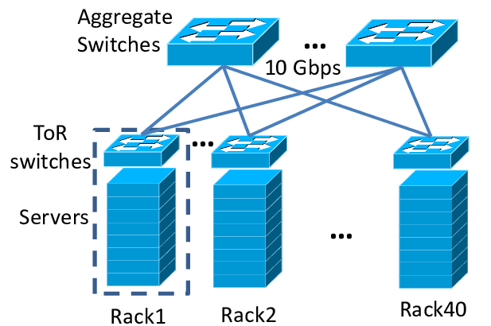

Source: [4]

Cost analysis
Funds, like the demands of a data center, contrast, which can be one of the most difficult barriers to overcome when establishing or updating data centers. Primary in the stages of planning, developed various techniques to ensure that requirements of the data center fit with modest of the project.
Cost analysis can project space of the floor, racks number, and the conserving and power needs by detecting load, compactness, severance, and critical power and cooling requirements. The amount of space needed, as well as the total cost of wealth. Higher severance, for example, is frequently a high objective, but economic constraints limit the amount of severance that can be implemented.
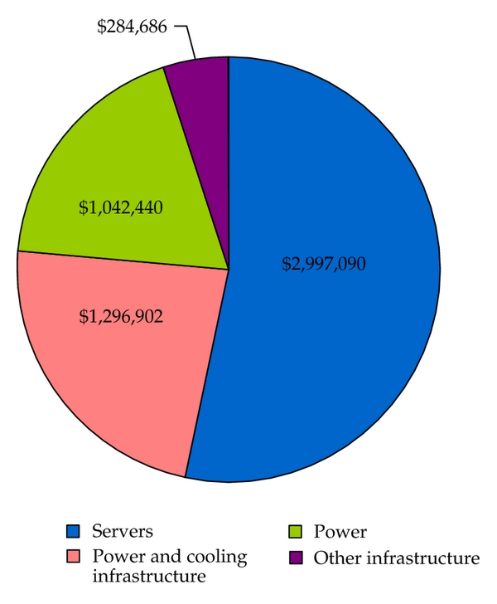
Source: [5]

System Design
The amount of space needed, as well as the total cost of capital. Basic severance, as an example, is frequently a high objective, but budget constraints limit the amount of severance that can be implemented. The agreement should express and system key sponsors' accountabilities and roles by phase, define assurance and benefit requirements, describe the charge effort, change order process and dispute resolution methods, margins, and conclusion processes and grounds. The system design may keep some points –
- Regular and artificial dangers, as well as natural disasters, are important obtainability threats.
- The hazards posed by the local atmosphere, community structure, local regulation, and personnel are referred to as local risks.
- Structure restrictions and features, such as the types of workloads operating, and the quality and form of the capability, all influence building hazards.
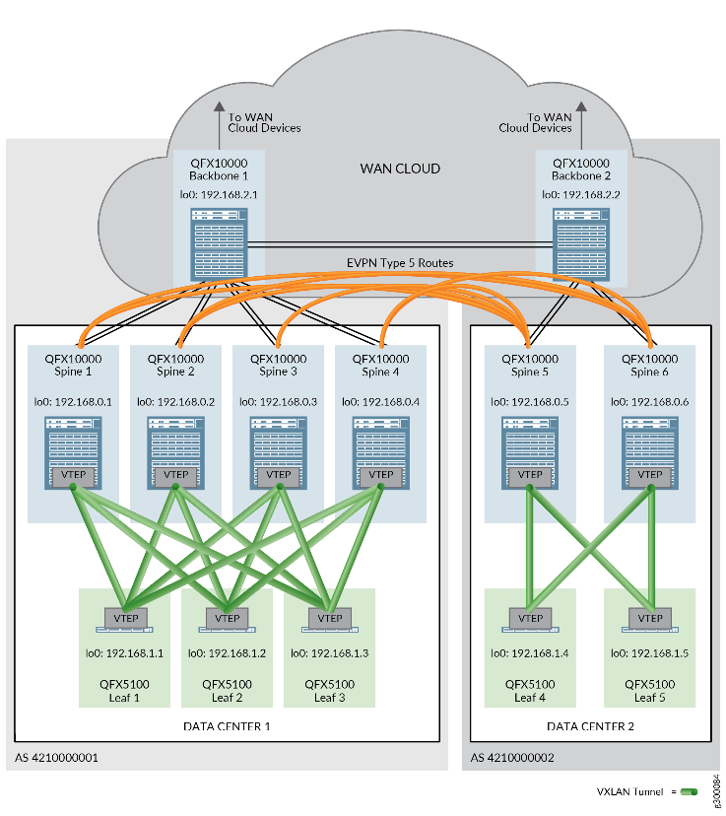
Source: [5]
As per the case scenario of the Super University, the architecture type used for the data center is multi-tier architecture or three-tier architecture.
The edge of user or tier of presentation, the application layer, where data is handled, and the data layer, where the information linked with the presentation is accomplished and deposited, is a well-established application structural design of the software that categorizes applications into three physical and logical dividing tiers [6]. The reasonable and physical organization of the equipment and properties surrounded by a data center capability is known as the architecture of the data center. It acts as a guide for constructing and planning a data center. It's a multi-tiered approach to the design of a data center that includes architectural standards. Because each layer runs on its individual substructure, the architecture of three layers has the advantage of allowing each layer to be created concurrently by a different improvement team and scaled or upgraded as needed without affecting the additional levels [7].

Data Centre Design
In the data center, the architecture of multi-tier has been the most frequently used method. The server of database, application, and web tiers route on a variation of platforms, together with mainframes, 1RU servers, and blade servers in this conformation. Before, networks of the three-tier data center were the most often suggested network design for data. When the widespread traffic flowed (from the external data center into the internal data center) or vice versa, they performed admirably. A package streams to the core is directed to the right switch of supply and then sent to the switch of access where the server is attached; the packet travels only in three physical stages, reducing the quantity of delay added per-flow of the packet.
The problem with this architecture of the data center is that significantly more traffic that is intra-DC is becoming the standard. Due to traffic from the server to server, three stages have soon become four, or more, resulting in considerable delay in each flow and increased chances of packet loss, buffer overruns, and bottlenecks. Loops were introduced by networks of the data center of three-tier, this necessitates proper protocol setup of the spanning tree. Because a failure of spanning-tree produces continual winding, spanning-tree difficulties are renowned for creating disruptions of the network [8].
This architecture is extremely adaptable, but it is also quite costly. The three main levels of this design that is multilayer are Core, Aggregation, & Access:
The multi-tier architecture or three-tier architecture includes several different layers in it. The included layers in this architecture are –
- Core layer – This level is known as the support because it guarantees that packages are delivered reliably at a high transfer rate of the data.
- Aggregation layer: This level is also known as the layer of Workgroup because it guarantees that packets are routed correctly across the VLANs and subnets of the organization. Quality of Service (QoS), firewalling, and a variety of network connectivity that is additional policy-based may be included.
- Access layer: This level is accountable for the joining of the endpoints [9].
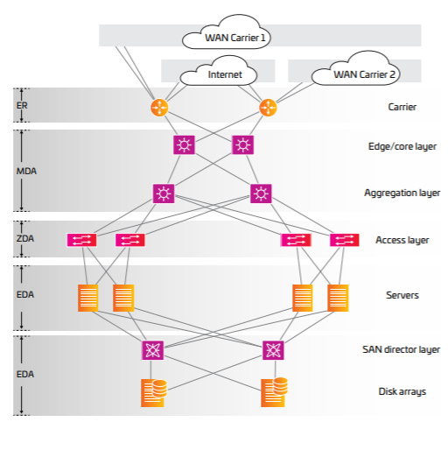
Source: [10]

Scalability
It prepares more than increase e-Business quickness when the design of N-tier is utilized in aggregation with proper middleware. It also allows organizations to use RAIS (Redundant Arrays of Inexpensive Servers) at the middle tiers and front-end to achieve extremely high levels of accessibility and performance. Requests of service are controlled by a group of servers with parallel configurations that all provide the same facilities to all customers. Requests that are incoming are distributed across the farm of the server via load-balancing or router tools. There is no only socket of disappointment thanks to terminated connections of ISP and a capacity balancing appliance that is the hot fallback. If one of the structures fails, the load is mechanically divided transversely to the other systems, and a server of backup is carried up to reinstate the routine.
It overcomes problems by distributing data access among many servers. Multi-tier architecture All resources are distributed over a large number of servers, which improves the performance of the distribution. Separate data isolation is also required when consuming several layers for different characteristics. The base data of programmes that allow duplication can be replicated among many servers, eliminating data loss in the case of a cluster failure [10].

Security
The mainstream of an organizations’ logical stuff and assets of the information is stored in data centers. These are the major targets of directed assaults, and securing them necessitates the highest degree of effort. There are mainly some threats from which it is being protected –
- Botnet cultivation - A server properties are a great mark for the refinement of a botnet. Botnets are networks of the computer that may be organized remotely. They're used to take information, spread spam, and ca”87rrry out various types of assaults.
- Unauthorized access of network - Unapproved access allows hackers to do things like delete confidential or complex data from a cloud, virus injection, and slow down the performance of the network by flooding it with fake traffic.
- Data extraction - Stealing organizations’ logical assets, revolution, and private data without permission.
- Distribution of malware - Resources in the data center are vulnerable to infection from servers, as well as infection from partners, clients, or workers' strategies connected to the link. The common goals are applications that accept transactions of credit cards and devices of the Internet of Things (IoT).
The occupational flows define the attack surface of the data centers, which includes the technology and individuals present.
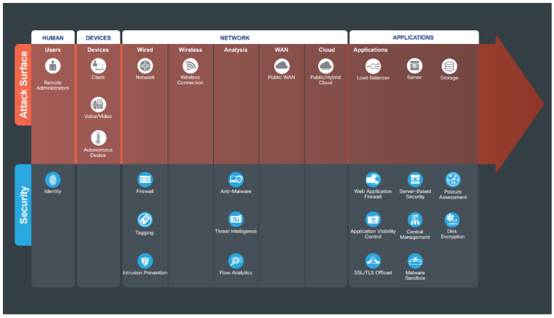
Source: [11]

Fault tolerance and performance
When one or more than one of the components of the system flop, fault tolerance states to the capability of the system (cloud cluster, network, computer, etc.) to endure working without disruption. The goal of designing a system of fault-tolerant is to avoid interruptions caused by a only fact of failure while also maintaining the availability high and endurance of business of mission-critical systems or requests. Components of backup are used in systems of fault-tolerant to repeatedly take habitation of components that are failing, confirming that no facility is lost. This will include –
- Hardware systems are supported up by structures that are comparable or similar. A server, for example, can be error-tolerant by functioning two servers that are identical in reflecting and equivalent all activities to the server of backup.
- Supported by other software instances. On a regular basis, for example, a database holding client information can be copied to the additional system. Actions could be automatically moved to a backup database if the original database crashes.
- Error-tolerant power sources should be used instead. Backup generators are used by many organisations in case of power outages.
In terms of performance, the ability of a structure to minimize service interruptions by reducing interruption is referred to as high availability. It's represented as a ratio of the total time of running in terms of the uptime of the system. In most situations, a strategy of business steadiness would incorporate both fault easiness and high availability to ensure that super-university critical services are maintained during disasters and small outages. While high availability and fault tolerance both relate to the capacity of the system to a task beyond normal time, there are certain distinctions that emphasize their respective relevance in the continuity planning of the organization.
When designing high-availability and fault-tolerant systems for the suer-university, keep the following in mind:
- Downtime - The amount of service disruption allowed in a system that is highly available is kept to a basic. A system of fault-tolerant is intended to operate without disruption for an extended period of time.
- Scope - High accessibility is based on a pooled resources set that are shared to decrease downtime and accomplish failures. Error tolerance is based on terminated power supplies and software or hardware that can change and identify dismissed components in the event of a breakdown.
- Cost - Because it necessitates the ongoing preservation and operation of extra, terminated components, a system of error-tolerant can be exclusive. High availability is usually included as part of the entire package of the provider of the service (example, provider of load balancer).
- Some of the arrangements require error tolerance, while others only demand high accessibility. Each tolerance of the system for service disturbances, the charge of such breaks, and the difficulty and charge of adopting full error tolerance should all be considered [12].

Energy usage and management
The demand for effective and safe storage of information that is digital on joined networks has sped up the data centers development throughout the world. A data center is a building that houses computer properties in a nexus of application message substructure and data storage. The capital investment (CAPEX) required to set up a data center is substantial, but not always equivalent to the expense in terms of operational things (OPEX).
The super-university design framework of the data center has prioritized the implementation of an accessible, extensible, effective, as well as cost-effective DCN architecture. The traditional 3T tree-based system appeared to meet the said super-university criteria.
It is important to use measures that are related to power to evaluate the efficiency of energy in DCNs in order to achieve optimal energy effectiveness and a small ecological impact, as proposed by the super-university project. This will include –
- NPUE (Network Power Usage Effectiveness), is the ratio of the total power of IT to the power of the network module.
- CNEE (Communication Network Energy Efficiency), is the energy required to convey information of one bit.

Network management scheme
Two network topologies that are switch-centric are taken into account in the system. 3T is tree-based several layered designs, while FT is a three-layered architecture that is Clos-based, with the spine or main, collective, and edge covers forming the design.
Severance is included in the design to prevent failure points in the joining. The two data centre networks to be demonstrated are set up as follows:
Computational burden, execution of the task, and consumption of energy are all compared using a similar number of processing servers.
In each of the classified topologies of the tree- and Clos-based are studied, it provides for server and network load partnership.
Sometimes topology was termed as a system of spine-leaf with two covers, and switches of the commodity were installed in the higher levels of the design.
All networks that are synchronized from a switch of admittance participate for the similar cluster of the central switch while creating routes of the connection, putting more strain on the switches of the core if overcrowding arises at the switch of access.

Conclusion
Following the conclusion of the entire cloud computing and data centre technologies study, a thorough approach to data centre design and execution of various organizations was explored. To begin, let us define a data centre. A data centre is a physical location where corporations or organizations keep their important data and applications. The entire study is based on the design and suggestion of a data centre for the super university program, which is a cooperation of two UK institutions that have come together to form the country's largest "super-university." This will bring together the Manchester Institute of Science and Technology and Victoria University of Manchester, educating approx. 35,000 students each year and offering more academic topics and academic departments than other UK institutions.
The report has described in detail the introduction of data centres across their core components that are switches, routers, and many other components with the storage and network infrastructures. Different types of the data centre are discussed in the report that has included several types – colocation, cloud, enterprise, and managed services data centres along with the infrastructure of data centres. This report also describes the data centres facility.
Coming to the designing phase, the design of data centres is described with the plan, reference design, and cost analysis of the system. This design part describes, designing, security and scalability, performance and tolerance of fault, management, and the usage of energy in context to the data centre model for the super university.

References
- Cisco, “What Is a Data Center,” cisco.com, para. 1-6, 2021. [Online].Available:https://www.cisco.com/c/en_in/solutions/data-center-virtualization/what-is-a-data-center.html.
- IBM, “Data Centers” ibm.com, para. 1-8, Jan. 24, 2020. [Online].Available:https://www.ibm.com/in-en/cloud/learn/data-centers.
- Techopedia “Data Center Design” techopedia.com, para 1-4,Jan.17,2017.[Online].Available:https://www.techopedia.com/definition/29712/data-center-design.
- Juniper, “Data Center Fabric Reference Design Overview and Validated Topology” juniper.com, para. 1-6, Nov. 09, 2020.[Online].Available:https://www.juniper.net/documentation/en_US/release independent/solutions/topics/concept/solution-cloud-data-center-topology-overview.html.
- Juniper, “Data Center Interconnect Design and Implementation Using Type 5 Routes” juniper.com, para. 1-6,Nov.09,2020.[Online].Available: https://www.juniper.net/documentation/en_US/release-independent/solutions/topics/topic-map/data-center-interconnect-fabric-architecture.html.
- Techopedia, “What Does Data Center Architecture Mean?” techopedia.com, para. 1-3, 2021. [Online]. Available: https://www.techopedia.com/definition/29867/data-center-architecture.
- IBM, “Three-Tier Architecture” ibm.com, para. 1-7, Oct. 28, 2020. [Online]. Available: https://www.ibm.com/in-en/cloud/learn/three-tier-architecture.
- D. Sheldon & R. Younger, “Three-Tier Architecture” wwt.com, para. 1-7, Jan. 29, 2020. [Online]. Available: https://www.wwt.com/article/comparing-two-tier-three-tier-data-center-networks/.
- OREILLY, “Data center multi-tier model design” oreilly.com, para. 1-3, 2020. [Online]. Available: https://www.oreilly.com/library/view/advanced-infrastructure-penetration.xhtml.
- Bitnami,“Single-Tier Vs. Multi-Tier Architecture: Choosing The Right Bitnami Package” docs.bitnami.com, para.5-9,2021.[Online].Available: https://docs.bitnami.com/google-templates/singletier-vs-multitier/.
- Cisco, “SAFE Architecture Guide” cisco.com, para. 1-30, 2018.[Online].Available:https://www.cisco.com/c/dam/en/us/solutions/collateral/enterprise/design-zone-security/safe-secure-dc-architecture-guide.pdf.
- Imperva, “Fault Tolerance” imperva.com, para. 1-8, 2021. [Online].Available:https://www.imperva.com/learn/availability/fault-tolerance/.

