Data Handling and Business Intelligence
Student’s Name: Natalia Dimitrova
Student’s ID: 2123042
Institution:UWTSD

PART 1
Hotel Reservation Dataset
The hotel reservation dataset, available in spreadsheet format, includes reservation data for visitors who check into hotels between 2017 and 2022. The features in the dataset are Booking ID, Demography, Room Type, Meal Type, Parking Required, Arrival, Market Type, Repetition, Lead Time, Special Requests, Average Price, and Booking Status. The data must be pre-processed using Microsoft Excel to analyse and determine the average price change from 2017 to 2021.
Pre-processing the data using Excel
Pre-processing data is the process that converts raw data into something that can be examined. The steps involved in data pre-processing include cleaning, integration, transforming, reducing, discretizing, and normalising data. Since the raw data must be cleansed up and error-free before analysis, data preparation is necessary for all types of analysis.
Step 1: Original dataset establishment
The initial step entails collecting and storing the original dataset, which includes the unprocessed raw data.
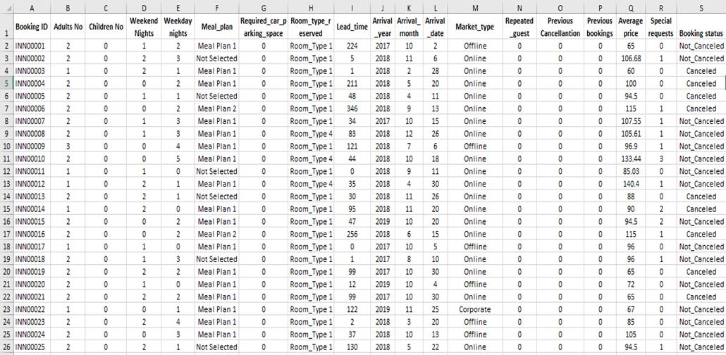
Figure 1: The hotel reservation dataset
Source: Course Material
Step 2: Eliminating unnecessary cell formatting
To prepare the data for analysis, unnecessary cell formatting is removed in this stage. The "Autofit Row Height" and "Autofit Column Width" settings are used on the entire data set. Specific rows and columns can be retrieved using this process and placed in different sheets for additional analysis.
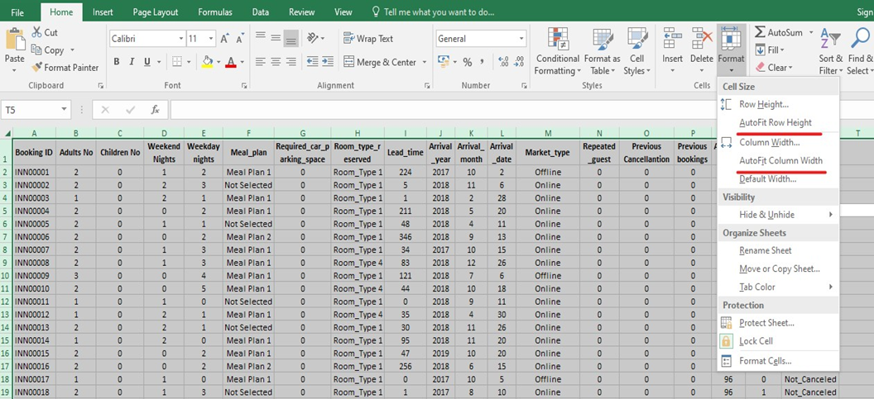
Figure 2: Format Cells
Source: (Author)
Step 3: Sorting and filtering
In Excel, the "Sort and Filter" option is found in the Home tab. Inconsistencies in the data within particular columns can be found by selecting the header row. The relevant columns for analysis are "Arrival_Year" and "Average Price."
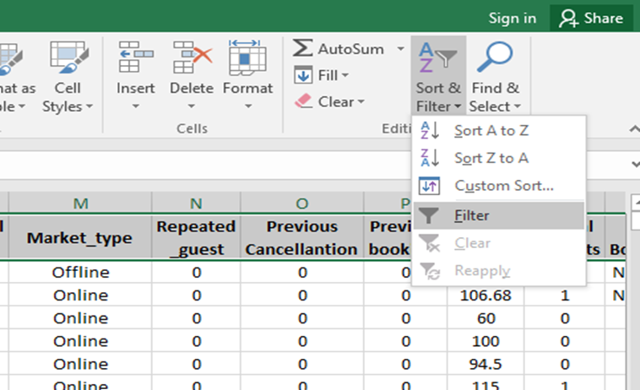
Figure 3: Sort and Filter
Source: (Author)
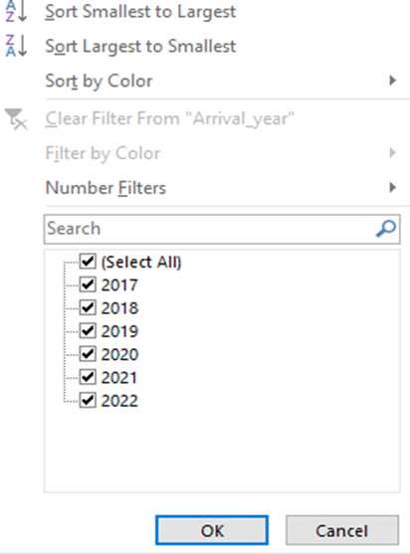
Figure 4: Filtering the Arrival year column
Source: (Author)
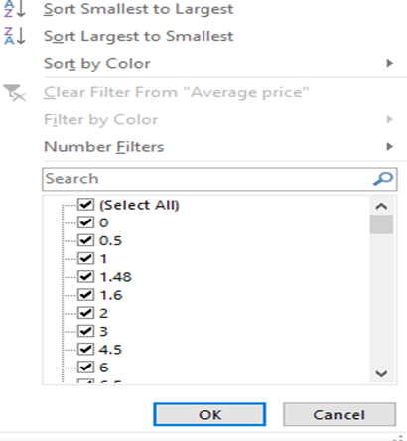
Figure 5: Filtering the Average Price column
Source: (Author)
Step 4: Handling Missing Values
Inspection reveals that the "Average Price" column has missing values, represented by null values. To continue with the analysis, these values must be taken into account. Using the dropdown option for the "Price" column, the rows where the average price is 0 (null values) are chosen and eliminated from the dataset.
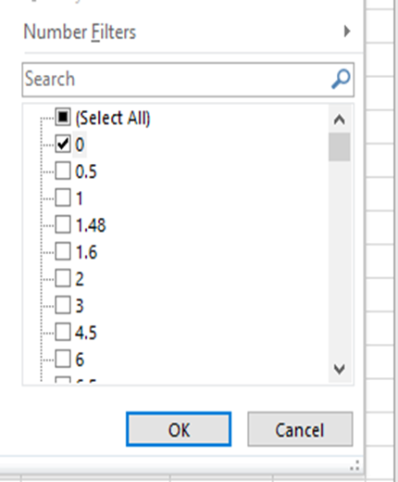
Figure 6: Selecting the null values using the dropdown list for the price column
Source: (Author)
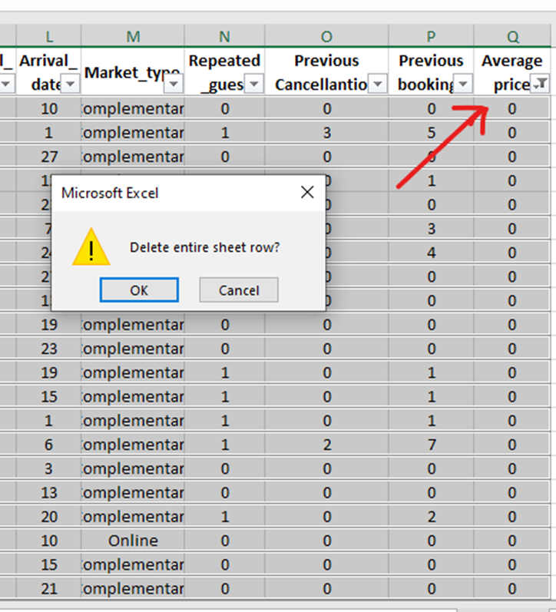
Figure 7: Deleting the average price rows containing null values.
Source: Author
By completing these pre-processing steps, the Hotel Reservation dataset is now readily accessible for analysis to determine the average price trends from 2017 to 2021.
Data Analysis using Excel
IF formula
In the initial stages of the analysis process, the evaluation-required data elements are extracted and structured for further analysis. This entails extracting the Average Price and Arrival Year data points from the complete dataset and inserting them into a new table. For this purpose, the Excel IF formula is employed.
Excel's IF formula is a powerful conditional function that enables users to specify criteria and conduct different calculations based on whether or not those criteria are met. In this instance, the SUMIF() function was utilised, an extension of the IF formula designed particularly for summing values that satisfy a specified condition.
In this analysis, the syntax of the SUMIF() formula is as follows:
SUMIF(A:A, "2017", B:B)
Here's what each part of the formula represents:
- A:A: This denotes the "lookup range" and refers to the column where the condition will be checked (Arrival Year in this case).
- "2017" is the criteria or condition the formula checks for in the lookup range. It looks for the value "2017" in the Arrival Year column.
- B:B: This represents the "return range" and specifies the column from which the values will be summed if the condition is met (Average Price in this case).
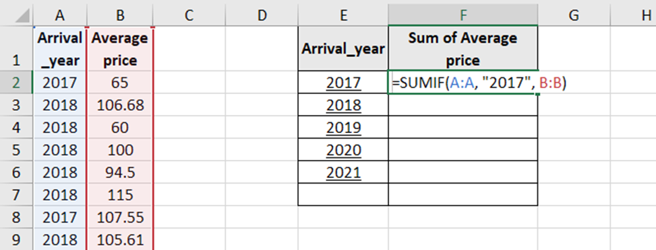
Figure 8: Extraction of required fields
Source: (Author)
Figure 9 shows a new dataset created by applying the SUMIF() formula. This dataset includes the Arrival Year and the Average Price Sum, enabling a more organised and focused analysis.
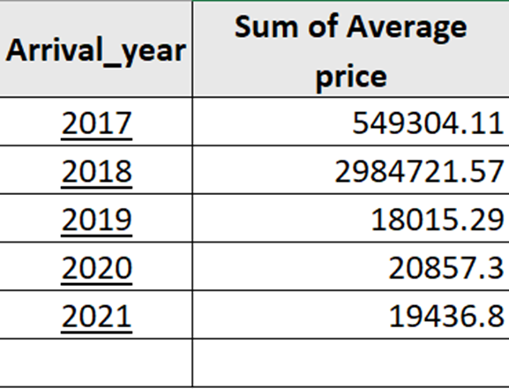
Figure 9: Analysis dataset using the conditional formula
Source: (Author)
Using Pivot Tables for Data Summarization
Excel's Pivot table is a dynamic table that allows for flexible organisation and summarization of large datasets. It permits analysts to generate customised reports and obtain compiled information without modifying the original data (Domino et al., 2021).
The steps involved in creating a Pivot table are as follows:
- Selecting the Dataset: The first step is to select the entire dataset that needs to be summarized or condensed.
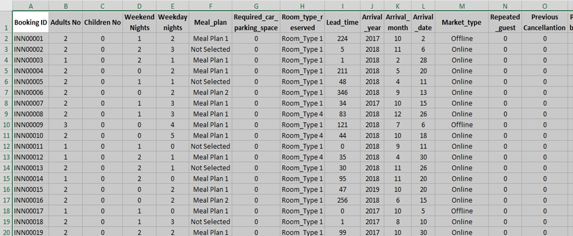
Figure 10: Selection of all the rows and columns of the required dataset
Source: (Author)
- Inserting a pivot table: The "Pivot table" option is selected in the "Insert" section in the Excel framework.

Figure 11: Inserting the pivot table
Source: (Author)
- Creating the Pivot Table: A new "Create Pivot Table" window appears after selecting the "Pivot Table" option. The table range and whether the pivot table should be added to an existing worksheet or a new one must be specified in this window.
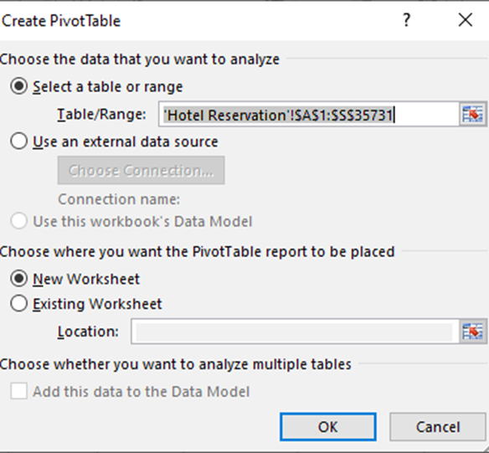
Figure 12: Create Pivot Table
Source: (Author)
- Selecting Required Fields: A new worksheet with the Pivot table window displays after the Pivot table has been generated. Using the checklist next to each column name, choose the necessary fields for analysis, such as Arrival Year and Average Price. Additionally, filters and conditions can be used as necessary. To produce a structured table resembling that in Figure 9, the Arrival Year and Average Price columns are chosen for this specific analysis.
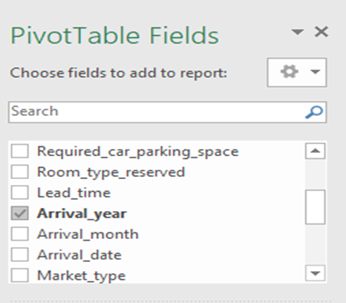
Figure 13: Inserting Arrival Year field
Source: (Author)
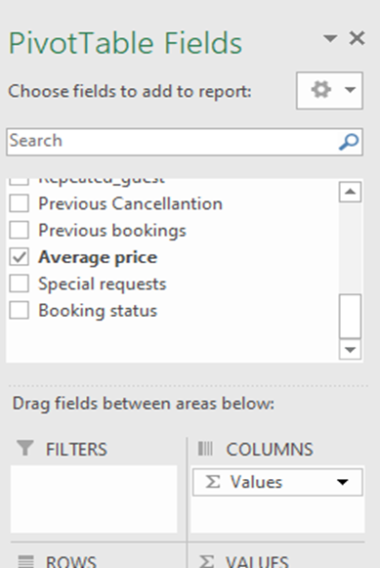
Figure 14: Inserting Average price field
Source: (Author)
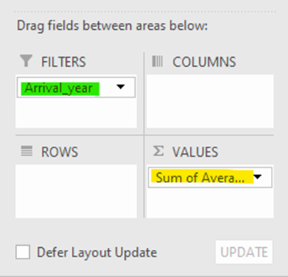
Figure 15: Dragging values in the required panes
Source: (Author)
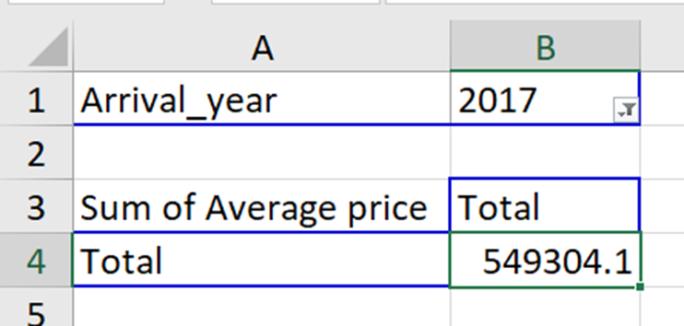
Figure 16: Extracting values using Pivot tables
Source: (Author)
Data Visualization and Interpretation using a Line Chart
After the data has been correctly organised and summarised using the pivot table, the next step is visually depicting the trends and patterns across time. A line graph is created for this purpose. The line chart makes the data easier to interpret graphically by displaying the average price trend from 2017 to 2021. The chart determines whether the aggregate average price increased or decreased during this period.
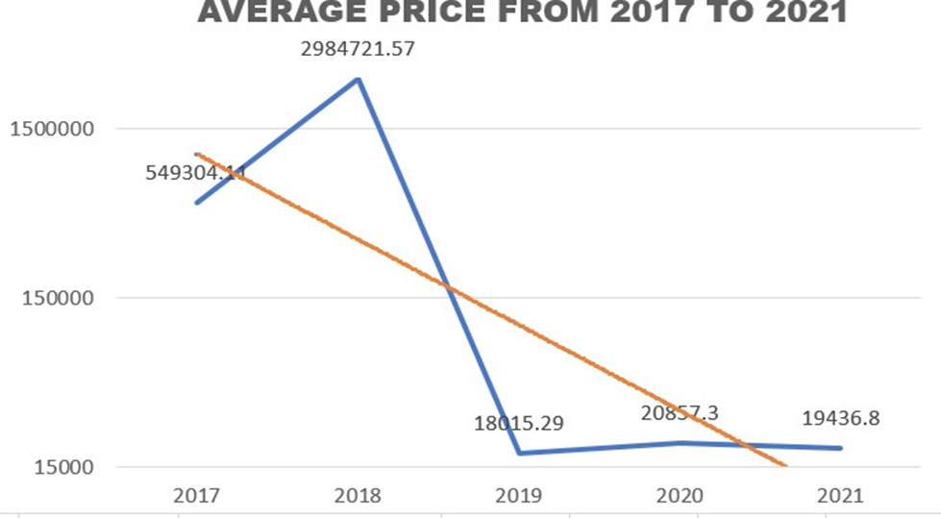
Chart 1: Line depiction of the average price trend from 2017 to 2021
Source: (Author)
Interpretation of the Line Chart
The interpretations drawn from the line chart are as follows:
- Initial Upward Trend: From 2017 to 2018, the graph shows an initial upward trend in the total average price. During this period, the aggregate average price increased by more than four times its initial value, representing a substantial increase.
- Downward Trend: From 2018 until 2021, the total average price has a distinct downward trend. From 2018 to 2019, the overall average price decreased by nearly 99.3 percent, a significant decline. From 2019 to 2021, there was minimal growth, showing a lack of a substantial recovery.
- Peak and Trough: The maximum average price for hotel bookings was observed in 2018 (£ 2984k), while the minimum average price was observed in 2019 (£18k).
- Overall Decline: From 2017 to 2021, the hotel industry's average price value decreased by approximately 96%, according to a comprehensive analysis.
PART 2
The "Student_Score.csv" database consists of 2133 records and 14 fields.
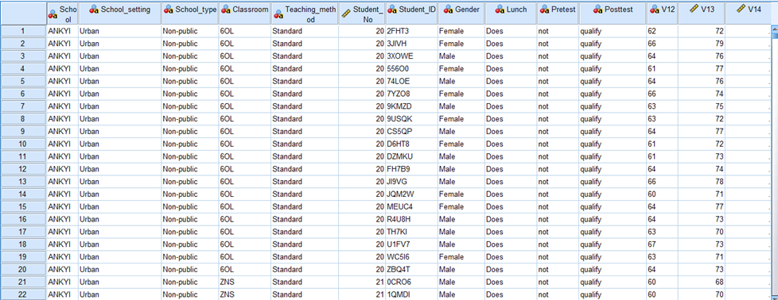
Figure 1: Demonstration of the student_score.csv dataset
Source: Course material
2.1. How many students are male and female?
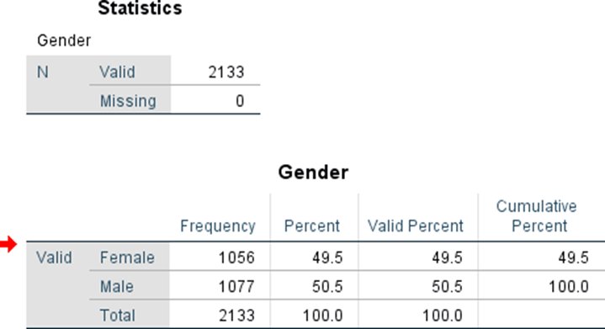
Table 1: Frequency distribution of the gender of students
Source: Author
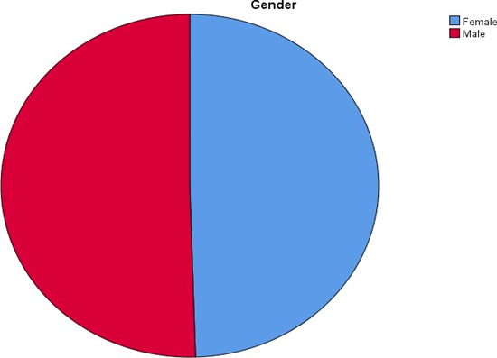
Chart 1: Gender Distribution
Source: Author
According to "Chart 1: Gender Distribution," the proportion of male students was 49.5%, and the proportion of female students was 50.5%. Although the number of male students was slightly greater than the number of female students, the overall distribution of each gender was nearly equal, with each gender accounting for nearly half of the total percentage of students.
2.2 Qualification Statistics for Reduced/Free Lunch
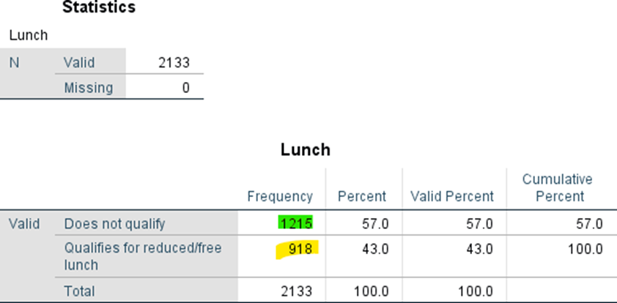
Table 2: Distribution of qualified and disqualified students for reduced/free lunch
Source: Author
Out of the 2133 students, 918 (43%) qualified for the reduced/free lunch, while 1215 (57%) did not qualify.
2.3 Mean and Median Value for Qualification Statistics
The mean value:
The median value:

2.4 Mean and Median Value of Pre-test and Post-test Scores
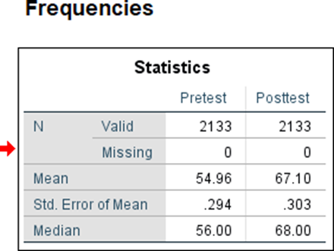
Table 4: Mean and Median differences between pre-test and post-test scores
Source: (Author)
Table 4 summarizes the pre-and post-test scores of 2133 students. The calculated mean pre-test score was 54.96, while the median pre-test score was 56. This indicates that fifty percent of the students' grades fell on either side of the value 56. In contrast, the median post-test score was 68, and the average post-test score was 67. This indicates that pupils performed better on the post-test than on the pre-test.
2.5 Clustering
K Means Clustering
The analysis used the K-means clustering method, an unsupervised clustering technique, to divide the students into clusters based on shared characteristics and significant differences (Nainggolan et al., 2019). Using both the pre-test and post-test Z Scores, two clusters were generated. Cluster 1 consisted of 993 students, whereas Cluster 2 had 1,140 students.
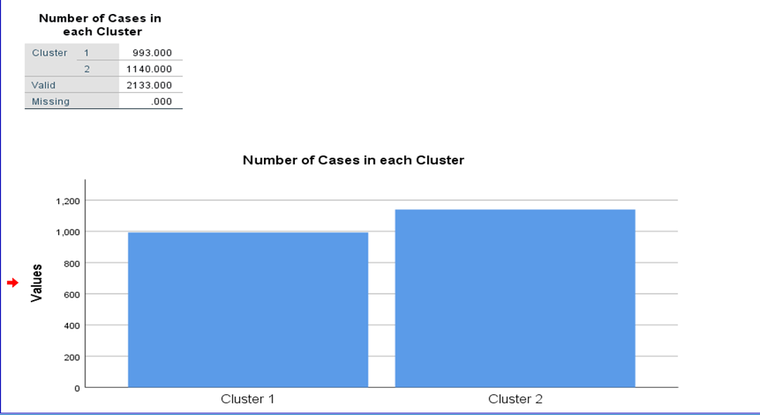
Chart 2: Segmentation of clusters
Source: (Author)
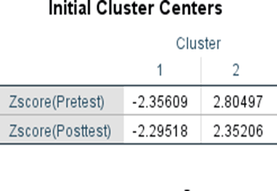
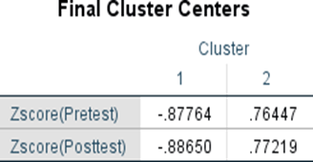
Table 5: Initial Cluster Centres and Final cluster centres
Source: (Author)
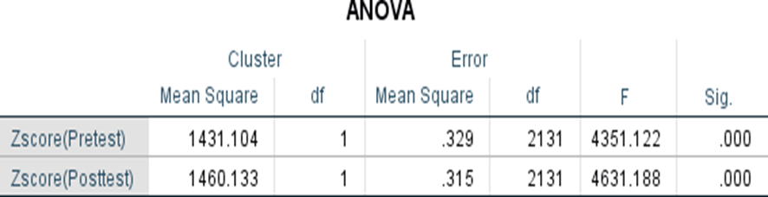
Table 6: ANOVA table and statistical significance
Source: (Author)
The initial and final cluster centres for the pre-test and post-test results are shown in Table 5. The cluster centres represent the mean value of the points situated within each cluster. The statistical significance between the cluster centres for both variables was then assessed using the ANOVA (Analysis of Variance) test.
Table 6 shows that the mean values for clusters 1 and 2 are 0.87 and 0.76 for pre-test results and 0.88 and 0.77 for post-test results. The statistical significance in Table 6 shows a significant difference between the mean values. The pre-test and post-test scores show a stronger dependence on Cluster 1 than Cluster 2.
2.6 Data Mining and Text Mining Methods
Data is more readily available in today's data-driven world, making efficient data management and analysis crucial for enterprises. As the amount of data becomes overwhelming, businesses try to find relevance and relevant insights in the enormous datasets they collect. Data mining is essential because it entails gathering useful information and patterns from readily accessible data (Ernawati et al., 2021). Businesses can stop relying on intuition when using data mining technology and instead focus on making well-informed judgements based on numerical techniques and statistical analysis.
Data mining has a variety of applications that can help organisations in many ways. One of the main applications of data mining is forecasting future values to avoid risks and dangers and take advantage of opportunities to succeed in a competitive market. Data mining may also assist with the maintaining and updating of data warehouses, ensuring that the data is accurate and current for analysis. Another important use of data mining is customer segmentation, which enables organisations to better categorise clients according to specific traits to understand their behaviours and preferences.
Clustering in Data Mining
Clustering is a key data mining approach for dividing data points based on important characteristics (Hossain, 2019). Clustering enables businesses to properly target particular client segments by integrating pertinent data components. Retailers, for example, might use clustering to classify products based on brand, customer choice, price, or geographic preferences, allowing them to tailor marketing campaigns to the unique qualities of each cluster. Numerous clustering methods may be used, each best suited for a particular situation and data type. Some examples include partition-based, density-based, grid-based, and hierarchical clustering.
Association in Data Mining
The goal of association mining, as suggested by its name, is to find relationships or correlations between different data points (Surya Narayana et al., 2021). Finding hidden notions that might go unnoticed but could provide crucial information with this technique is helpful. Associations can be mined in marketing to assess transaction data and identify trends like commonly occurring items to build effective cross-selling tactics. Association mining can be multidimensional or single-dimensional, focusing on the connections between many variables, depending on the methodology used.
Visualization in Data Mining
The effective data mining method called data visualisation converts data points into graphical formats (Inusah et al., 2022). Data visualisation is crucial for firms of all sizes to interact with stakeholders effectively. Visual reports can be made using various tools, such as comparisons, histograms, heat maps, density plots, correlation plots, and more, depending on the type of information that must be displayed. Businesses may make better decisions when data is presented visually because they can more immediately see patterns, trends, and outliers.
Text Mining
Businesses routinely deal with enormous amounts of unstructured text data and numerical data. The goal of text mining, a subset of data mining, is to extract useful insights from unstructured textual data stored in databases. Natural language processing (NLP) techniques are related to text mining, which is particularly helpful for assessing text-based sources like customer reviews, papers, journals, social media posts, or news.
Methods of Text Mining
Text mining offers several techniques for drawing important conclusions from textual data, including:
Automatic Document Classification: This method involves classifying many text-based forms and online documents according to predetermined criteria. Rules-based techniques like sentiment analysis, unsupervised techniques like clustering, and supervised techniques like labelling can all be used to classify documents automatically. This makes it easier to extract critical information for organisations to manage and organise massive amounts of textual data.
Keyword-Based Association: Keyword-based association mining aims to discover correlations and connections between certain keywords in textual data. After pre-processing the data to remove noise and unimportant information, the approach assesses the co-occurrence and behaviour of keywords. This approach saves time by not requiring human work while assisting organisations in identifying relevant patterns and relationships in textual data.
Advantages and Disadvantages of SPSS and Excel
SPSS
"Statistical Package for the Social Sciences," or SPSS, refers to a comprehensive statistical software widely used in various industries but is most frequently used in education, economics, and healthcare. Its important characteristic is its simplicity of use, which enables researchers and analysts of all statistical expertise levels to use and utilise it effectively (Rahman and Muktadir, 2021).
Advantages | Disadvantages
- Graphical User Interface (GUI) with maximum capabilities, making it accessible to users with differing degrees of statistical expertise.  - Advanced statistical capabilities that enable smarter data analysis and the formulation of variables based on data-read information.  - Supports various file formats, including Stata and SAS, and runs on multiple platforms, including Windows, LINUX, and Mac OS.  - Accurate predictive analysis suits social science, education, economics, and healthcare researchers and analysts. | - Commercial licences can be costly, particularly for specific sectors or industries, rendering them inaccessible to smaller businesses or individuals.  - Visual graphs in the output are less adaptable than other tools, such as Excel, which may restrict data visualisation customization options.  - Some modules and add-ons could have usability issues, and the software's performance could be sluggish when dealing with large datasets or intricate analyses.

Excel
Microsoft Excel is a popular spreadsheet programme that offers a variety of environments for data management, analysis, and visualisation (Rouse, 2019). Users may quickly clean, save, and analyse data using its comprehensive tools, including equations, functions, and chart options. Due to its compatibility with both the "Microsoft Windows" and "Mac OS" operating systems, Excel may be used by various people.
Advantages | Disadvantages
- It allows for unlimited data insertion, making it a versatile instrument for various applications and datasets.  - Calculating and retrieving data using formulas and functions provides a quick and uncomplicated method for data analysis.  - The spreadsheet feature enables the organisation of multiple sheets within a single workbook, facilitating data administration and accessibility.  - Because of its user-friendly interface and conventional use for spreadsheets, it is extensively adopted in various industries and professions. | - With larger datasets and numerous add-ons and extensions, the software's performance may slow down, limiting its scalability for extensive data analysis.  - Some advanced formulas and functions may be unfamiliar to users, resulting in a learning curve and possible reporting and analysis difficulties.  - Excel may lack certain statistical features compared to SPSS, and certain add-ons must be manually downloaded to conduct specific tasks. Consequently, Excel may better suit simple spreadsheets than advanced statistical analyses.  - Excel is prone to errors, especially when performing intensive calculations such as predictive analysis, which can affect the dependability of certain results.

As a result, SPSS and Excel are suitable for various types of data analysis tasks due to their advantages and weaknesses. Because of its well-known precision in predictive analysis and strong statistical capabilities, SPSS is a valuable tool for academics and professionals in some sectors. However, some customers might be put off by its commercial licence and several usability issues. The user-friendly interface, effective algorithms, and broad industry acceptance of Excel, on the other hand, make it an essential tool for basic spreadsheet operations and data analysis. Its statistical qualities and scalability might, however, fall short of what is offered by dedicated statistical software like SPSS. The precise requirements, the complexity of the analysis needed, the organization's or person's budget, and other factors all come into play when choosing between SPSS and Excel.

References
Bryant, L.A., (2021). Statistical skills for the workplace: A practical approach to teaching methods with Excel. The Palgrave Handbook of Political Research Pedagogy, pp.289-300.
Domino, M.A., Schrag, D., Webinger, M. and Troy, C., (2021). Linking data analytics to real- world business issues: The power of the pivot table. Journal of Accounting Education, 57, p.100744.
Ernawati, E., Baharin, S.S.K. and Kasmin, F., (2021). A review of data mining methods in RFM- based customer segmentation. In Journal of Physics: Conference Series (Vol. 1869, No. 1, p. 012085). IOP Publishing.
Hossain, M.Z., Akhtar, M.N., Ahmad, R.B. and Rahman, M., (2019). A dynamic K-means clustering for data mining. Indonesian Journal of Electrical Engineering and computer science, 13(2), pp.521-526.
Inusah, F., Missah, Y.M., Najim, U. and Twum, F., (2022). Data mining and visualisation of basic educational resources for quality education. International Journal of Engineering Trends and Technology, 70(12), pp.296-307.
Nainggolan, R., Perangin-angin, R., Simarmata, E. and Tarigan, A.F., (2019), November. Improved the performance of the K-means cluster using the sum of squared error (SSE) optimized by using the Elbow method. In Journal of Physics: Conference Series (Vol. 1361, No. 1, p. 012015). IOP Publishing.
Rahman, A. and Muktadir, M.G., (2021). SPSS: An imperative quantitative data analysis tool for social science research. International Journal of Research and Innovation in Social Science, 5(10), pp.300-302.
Rouse, M. (2019). What is Microsoft Excel? - Definition from Techopedia. [online] Techopedia.com. Available at: https://www.techopedia.com/definition/5430/microsoft-excel.
SuryaNarayana, G., Kolli, K., Ansari, M.D. and Gunjan, V.K., (2021). A traditional analysis for efficient data mining with integrated association mining into regression techniques. In ICE 2020: Proceedings of the 3rd International Conference on Communications and Cyber Physical Engineering (pp. 1393-1404). Springer Singapore.

