Literature Research of Gig Economy

LCDB7007
Name: Liu xueying
Date: May.14.2022

1. Overview of literature review
1.1 Purpose of literature research
As a doctoral researcher, literature research is the first step of research work. Literature research can help researchers to understand the overall situation of the research field, find the starting point and basis of the research, systematically discover the cutting-edge and latest problems in the specific research field or topic, find a way to learn to acquire new knowledge and new theories, find the research basis, obtain research materials, and train the ability of writing papers.

1.1.1 Discover the research depth
Literature research can comprehensively analyze the existing research results, which is helpful for scholars to find the problems existing in the existing research field and broaden their research horizon. Therefore, it is necessary to understand what has been solved by predecessors and to what extent, grasp the history and future development trend of research in relevant fields, and conduct further research on the basis of existing research. At the same time, as a later researcher, it is unnecessary to conduct research on the already clear research field, avoid repeated reference to the literature, and directly explain the problem.

1.1.2 Identify the research gaps
The study of literature review to find out the problems that have not been solved by the predecessors is an important issue that needs to be derived when researching the literature to find the aspects and contents of a research topic that have not been studied by the predecessors as a basis for the research of the paper. The fact that certain problems have not been solved by previous authors means that they are difficult and not so easily solved. It is necessary to explore what problems can be solved, to form a clearer idea of the research, and to conceptualize how to conduct the research in conjunction with the previous research ideas.

1.1.3 Definition of core concepts
Define, assume, and limit the core terms of the research topic. Literature research can help researchers to clarify the meaning of core concepts, identify the assumptions between concepts, and understand and learn how others define and measure key concepts. Have a comprehensive understanding of the connotation, denotation, classification and actual use of the core concept. In my own research, after the concept is clearly defined through literature research, the research object is clearly defined and the research scope is limited, so as to obtain higher validity research results.

1.2 Content of the literature study
1.2.1 Research background
Analyze the research background and environment, pay attention to the development process of the research in this field, when the problems involved in the research started, what stages have been experienced so far, and why this research is carried out. From this, the significance of this study can be developed, such as novel perspective, novel practice, novel theoretical background, novel research methods, highlighting the problem situation and so on.

1.2.2 Identify research topics
Determining the research topic is the primary task of the research. Understand what questions and viewpoints have been raised by predecessors in the research topic, and provide inspiration for paper writing or research. By carefully understanding the research problems, research gaps and Disscussion of existing research literature, we can inspire our thinking on research problems and adjust or revise our topic selection. Analyze the research orientation of others, scientifically construct my own research program, and find innovative points at the method level for research.

Properly delineate the scope of the review. In the age of knowledge explosion, your research topic can be found in a huge amount of research literature. To complete the research work with high quality in limited time, the scope of literature review needs to be delineated and the time and space definition of the research topic should be minimized. Researchers need to work intensively in a smaller direction, small and precise, to make new advances and fill empty tables. If we blindly seek to be big and complete, we will find it difficult to produce high-quality research results even though we have done a lot of work.

1.2.3 Select research methods
When preparing to do a study, it can be difficult to determine the method. Even though there are many research ideas, it is difficult to choose which method to adopt. Study the specific technical issues such as previous research topics, selected research methods, methods of data collection and data analysis, measurement tools and statistical analysis methods, and find the adaptive relationship between research topics and research methods. Summarize and integrate different research methods, which can be used for reference and inspiration for my own research. Under the same background, they can try to imitate other researchers' research methods, design methods and data collection methods to design their own research plans and finally solve the problems they want to solve.

1.2.4 Research findings and results
The key point of literature reading is to pay attention to scholars' research findings and achievements, which is the main part of literature review. Pay attention to what propositions, ideas, models, theories and frameworks are put forward by scholars. For those who fully and deeply understand the research literature, the new findings and conclusions, newly obtained data and materials of the literature research shall be clearly introduced and interpreted. Critical analysis should be made on the findings and conclusions of previous studies, comparative analysis should be made on the literature of the same study, and whether there are the same findings and results for each topic and how different findings and results are generated.

1.2.5 Discussion
By raising questions on the literature, especially by analyzing the content of the discussion section, I put forward my own thinking. Is there a problem that has been studied but not in-depth enough? Why do we need further study and in-depth discussion? Whether there is valuable research that has not been done. Is there a single research method that requires multiple research methods to get more real conclusions? These questions and discussions are of specific guiding significance for my research to expand my thinking, find the research direction and choose appropriate research methods.

1.3 Structure of the literature study
In the opinion of Ray Pawson, a professor in the School of Sociology and Social Policy at the University of Leeds in the United Kingdom, while it can be challenging for researchers to choose the right research method for a literature review, they can develop a detailed research plan based on their goals and ensure that the research process is transparent, and the texts are covered precisely so that the research task can be finalized. Richard Torraco, a professor in the College of Education at the University of Nebraska-Lincoln, mentioned that the three main factors, published in the last five years, with strong professional relevance, and published in prestigious journals, encapsulate the timeliness, professionalism and authority of the literature. According to Posen, completing a full literature review requires four steps: designing the review topic, selecting texts and theories relevant to the review, analyzing, and writing the review report. During the design phase, it is important to select the topics of interest to scholars and readers and to determine the scope of the study. The text selection stage also requires the development of necessary search strategies, such as appropriate databases, suitable keywords or phrases, appropriate time frame, and whether to add other terms related to the topic are factors that can affect the final outcome of the study. Whether the researcher needs to read all relevant literature texts during the analysis process or only perform a staged review is related to the speed and quality of the literature review study. Overall, a high-quality literature review must have depth and rigor and yield unique insights that distinguish it from previous ones. It also needs to be replicable, meaning that it allows the reader to obtain similar findings by replicating the study.

The study will be completed by dividing the literature research into eight main areas:
1. Introduction to the subject of the study and its development
2. The research topic
3. The research questions
4. The research method
5. Data collection and analysis
6. Research findings and results
7. Research discussion
8. Research progress and problems

2. Notes of my literature review

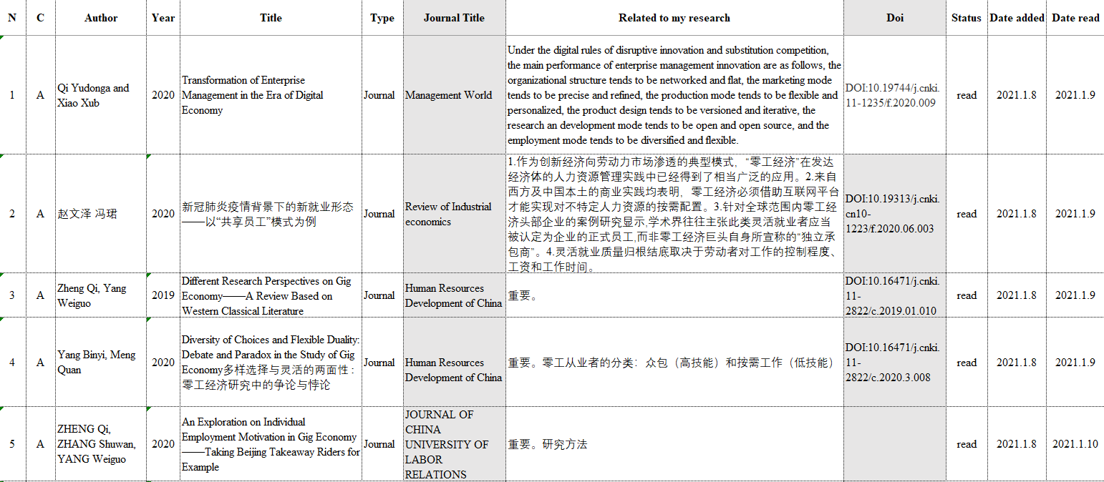
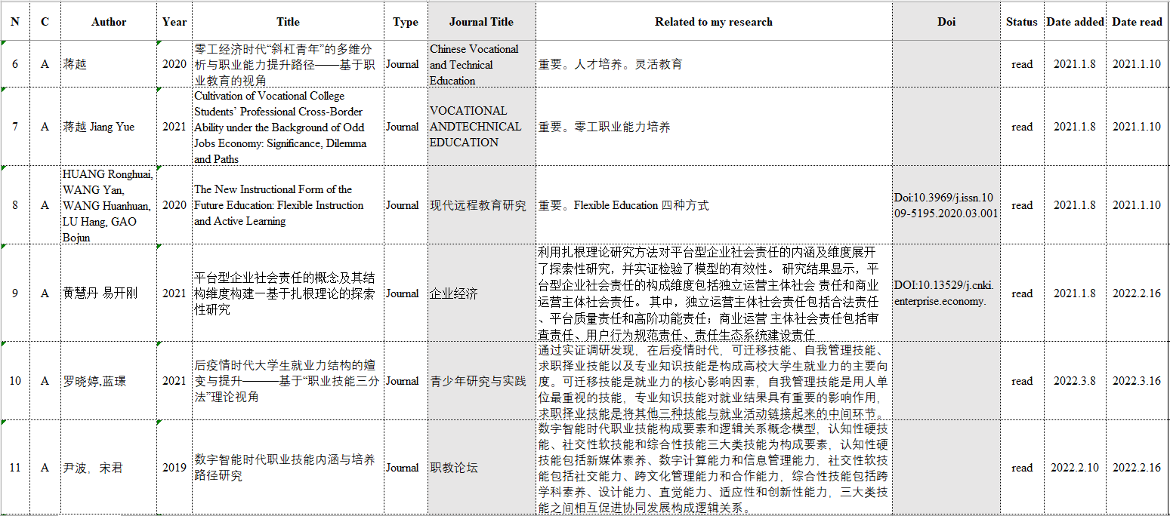
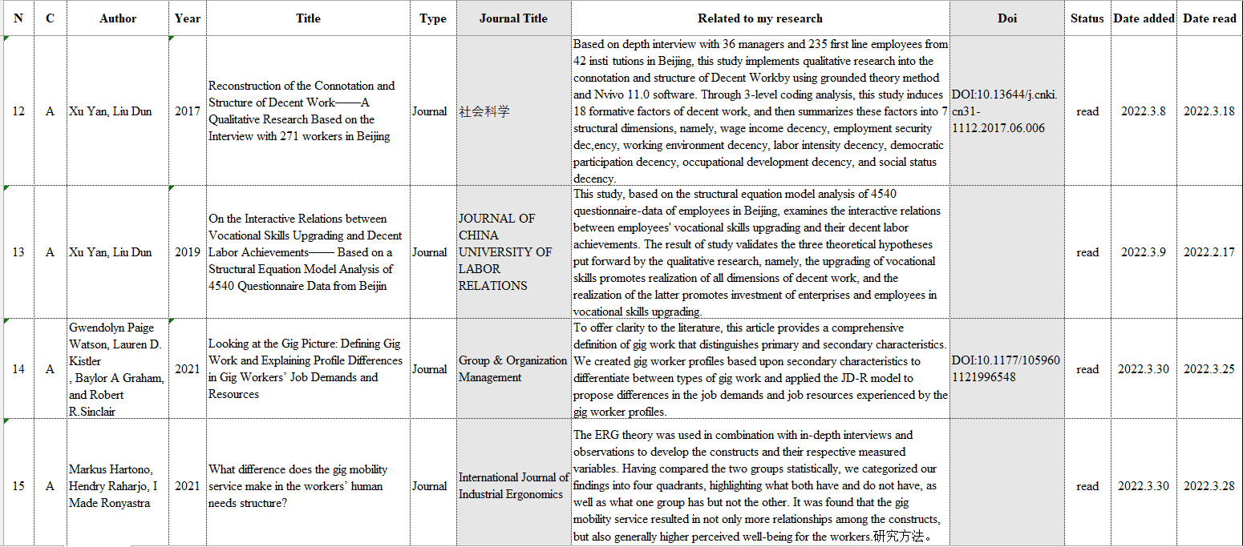

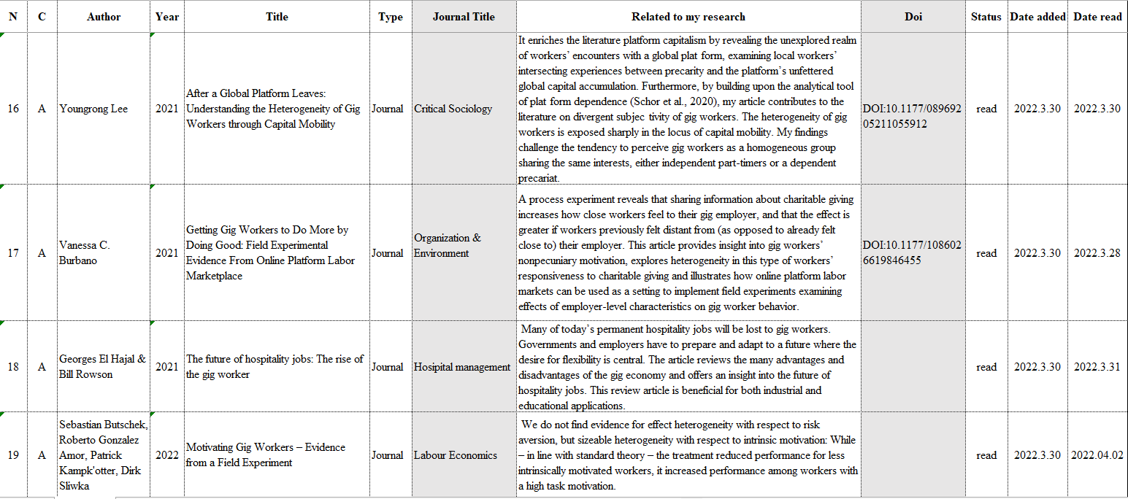
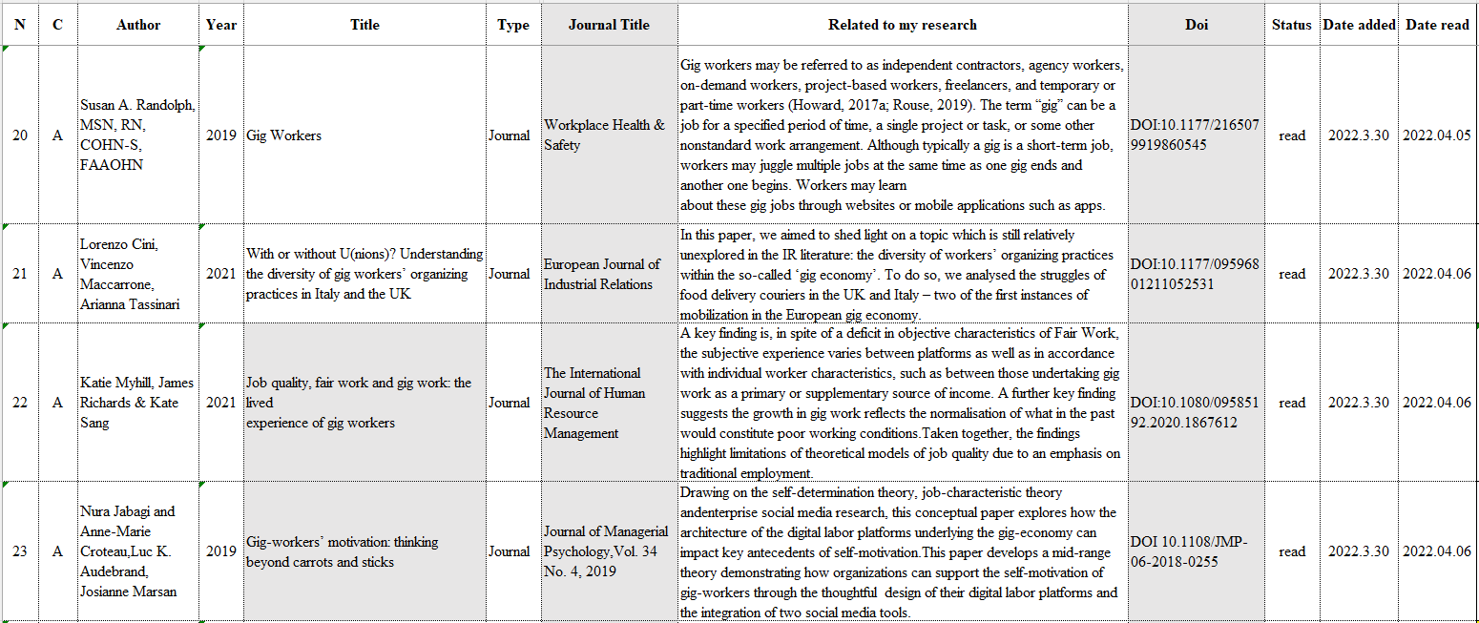
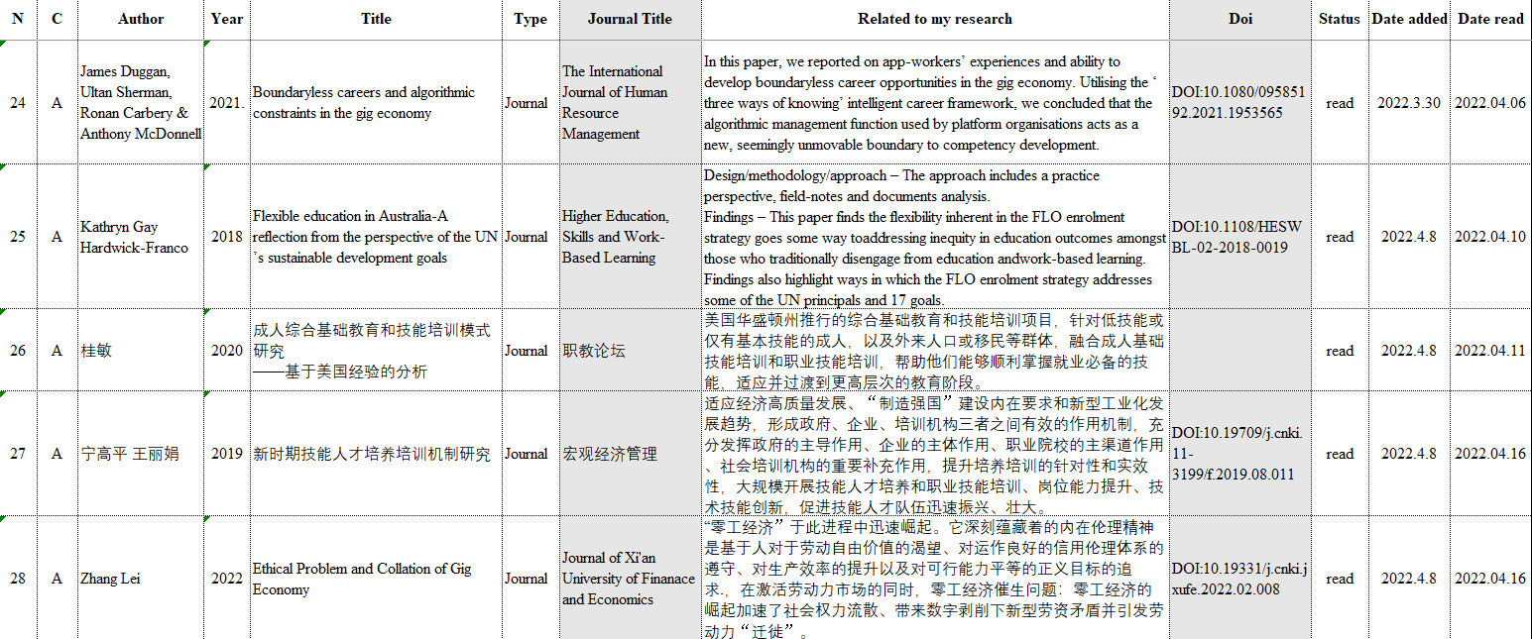
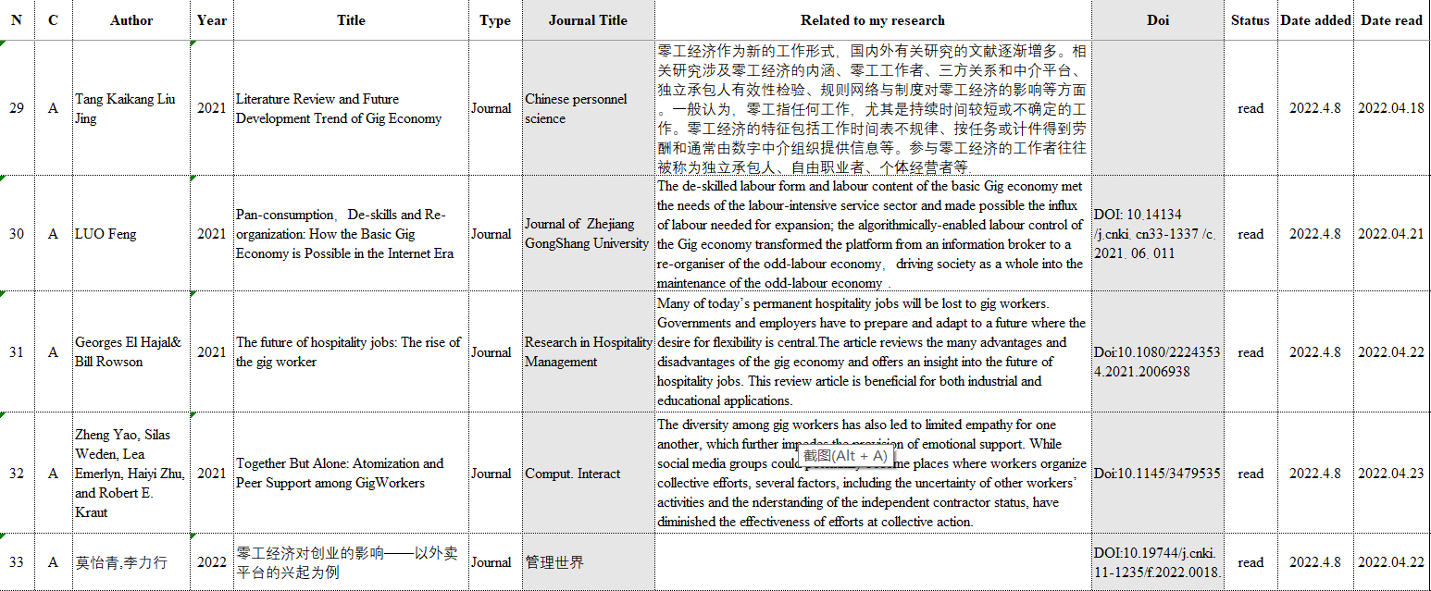
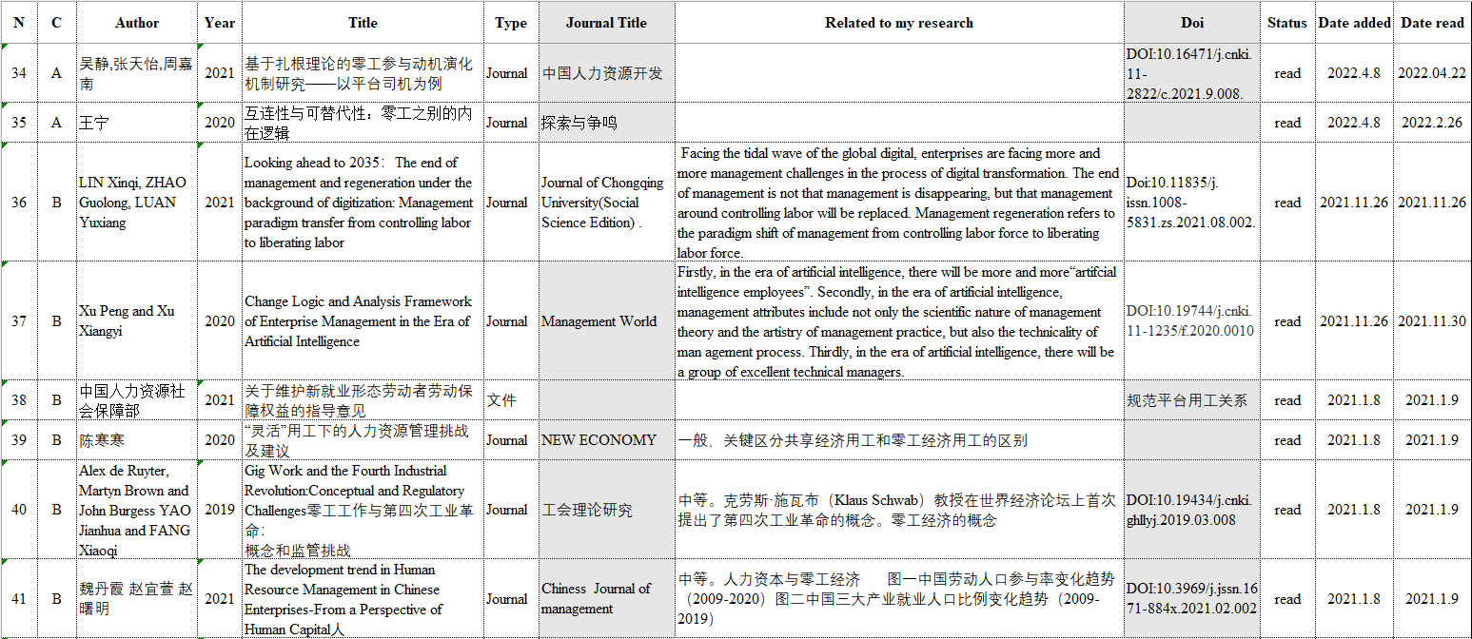
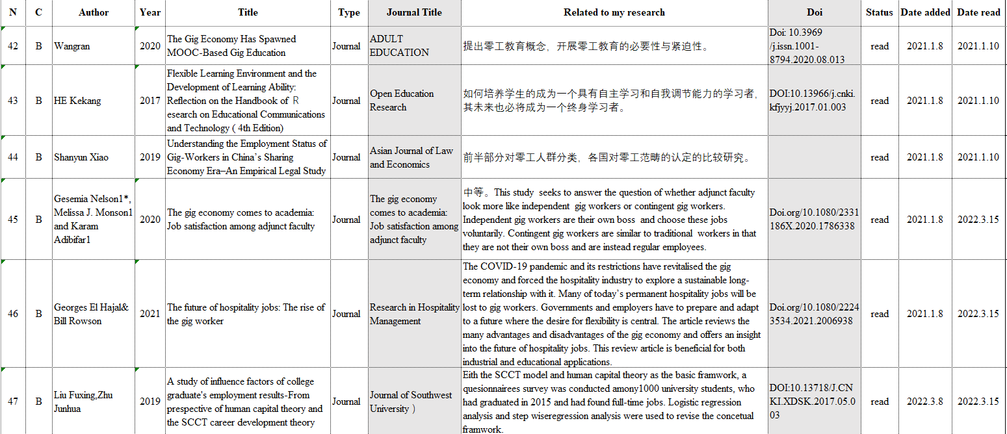
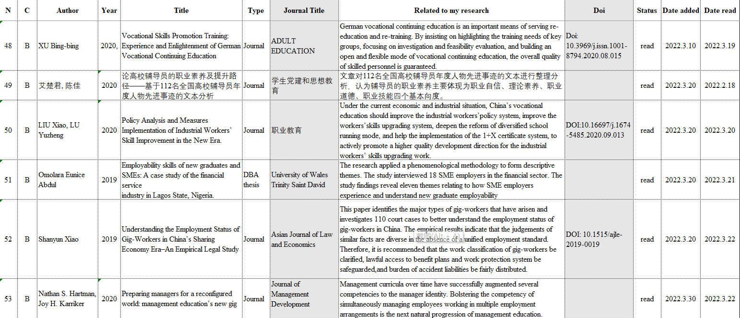
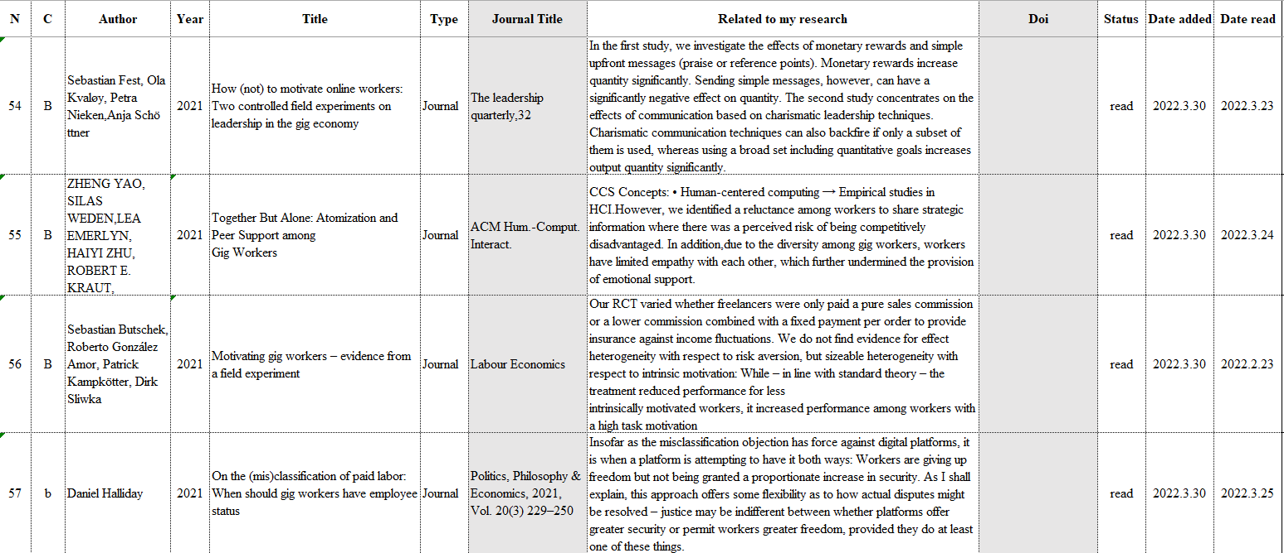
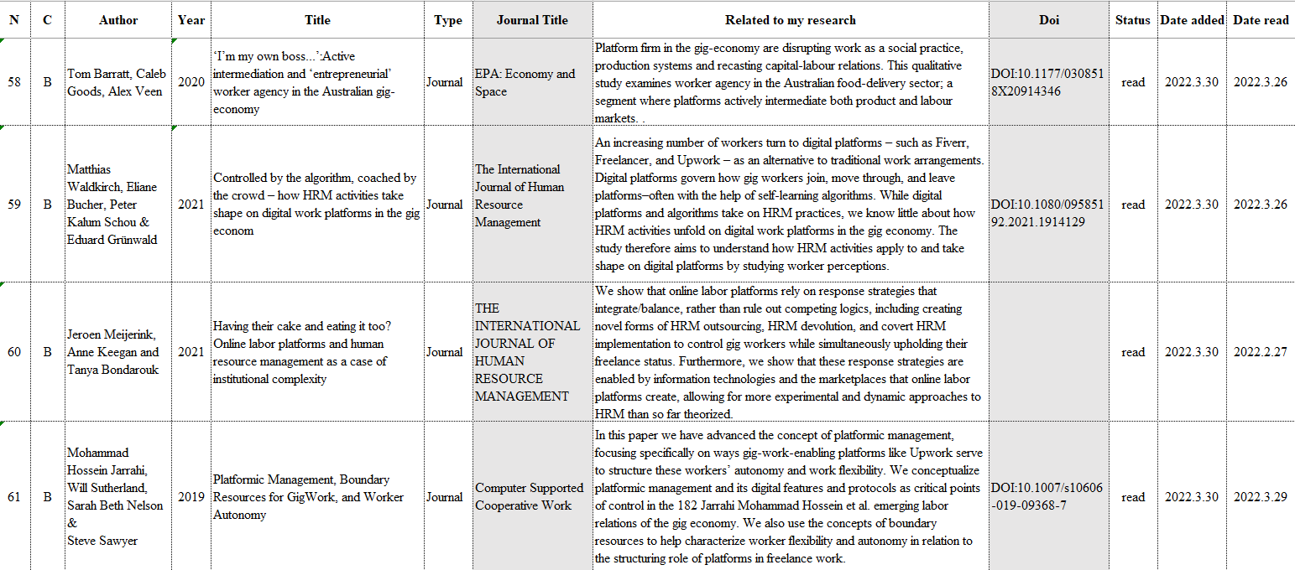
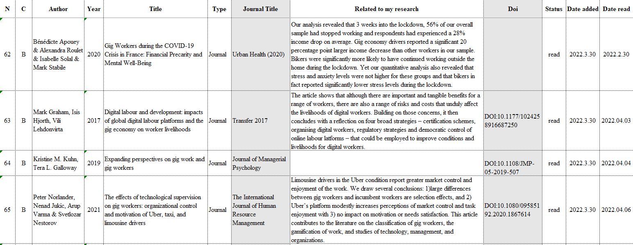
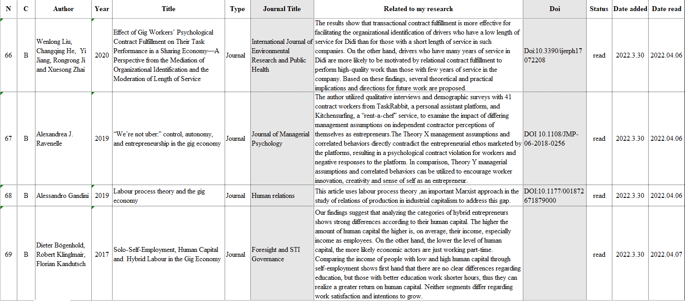
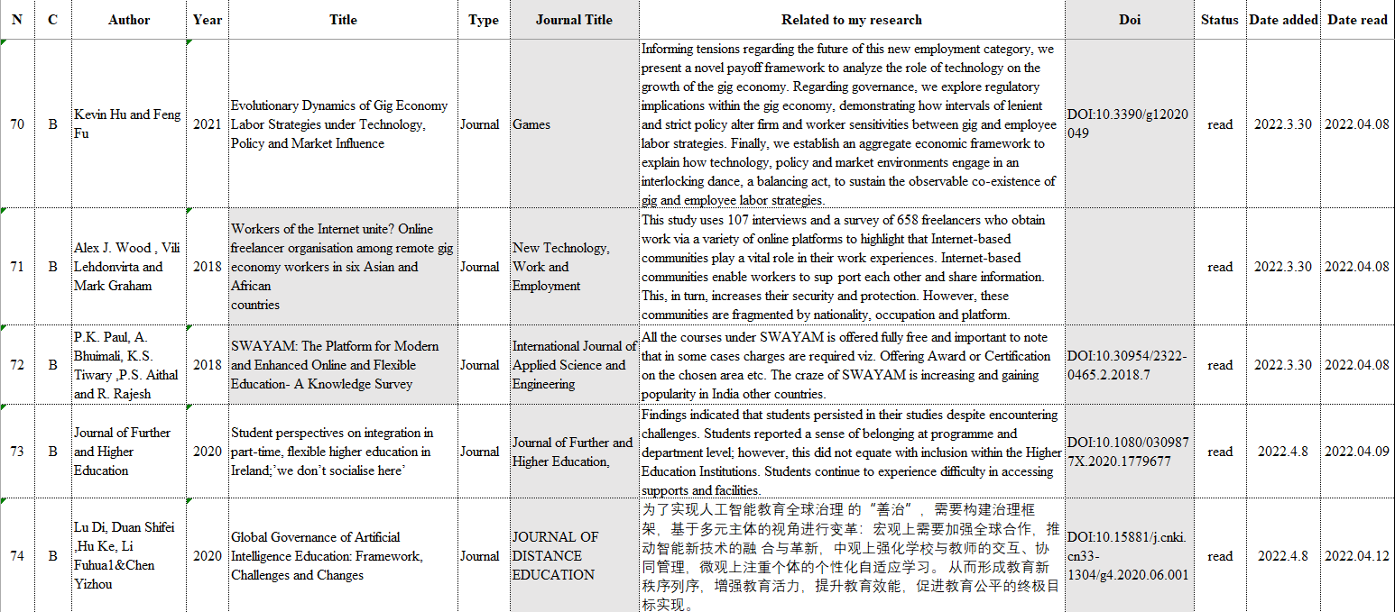
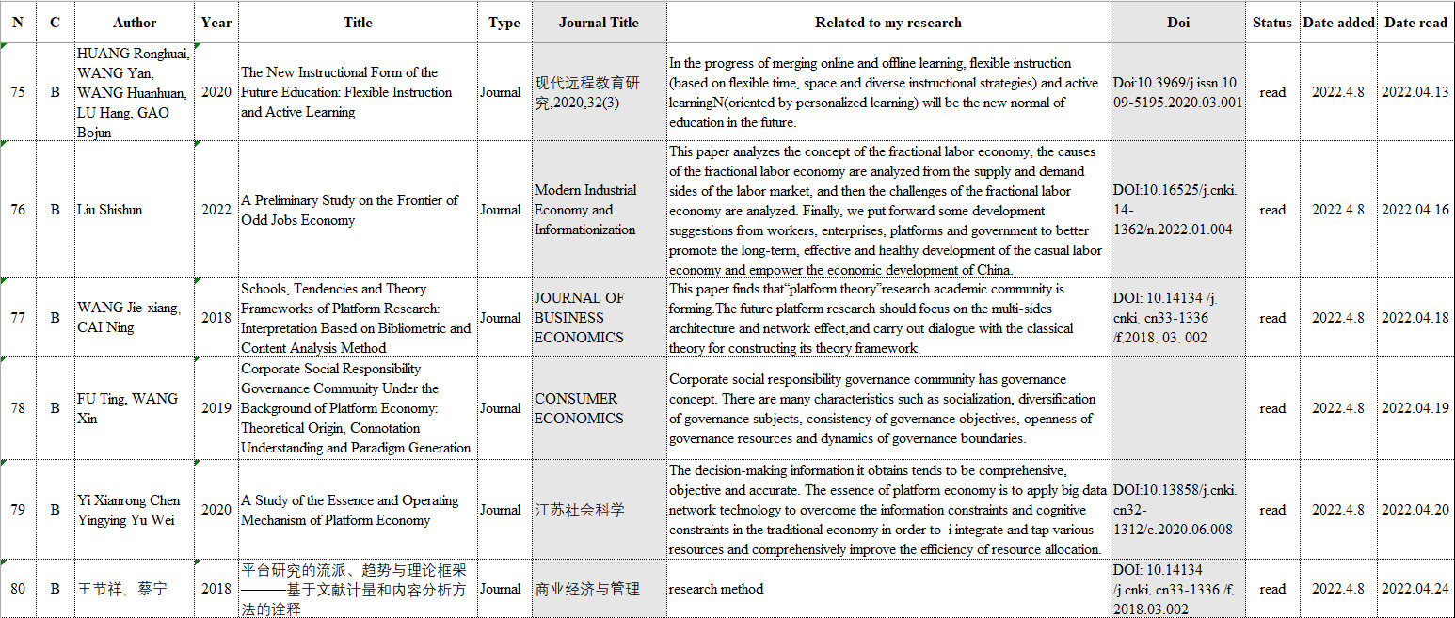
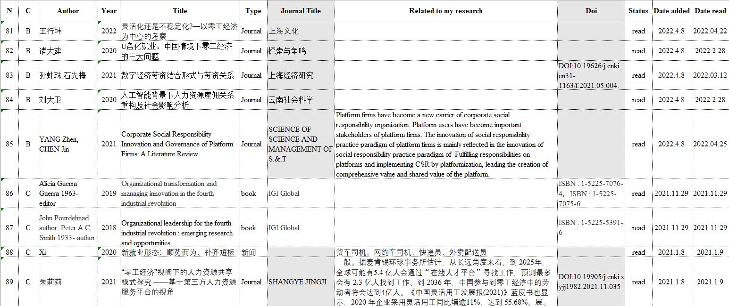
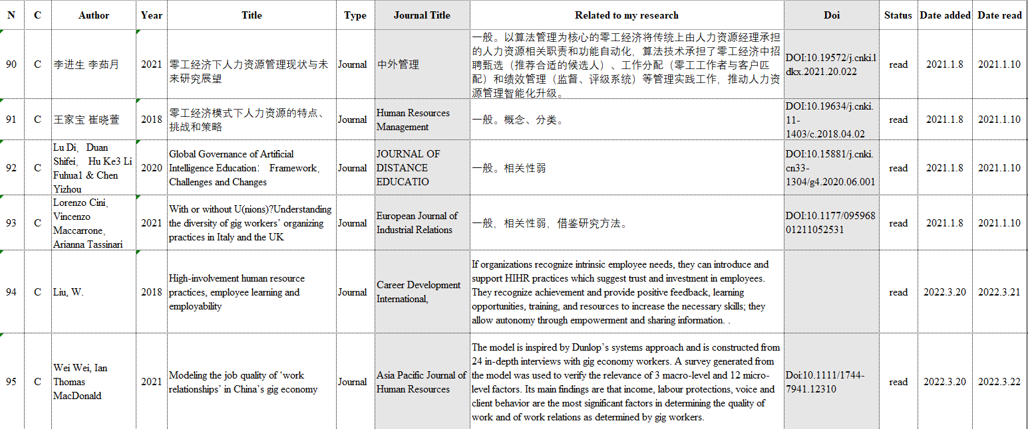
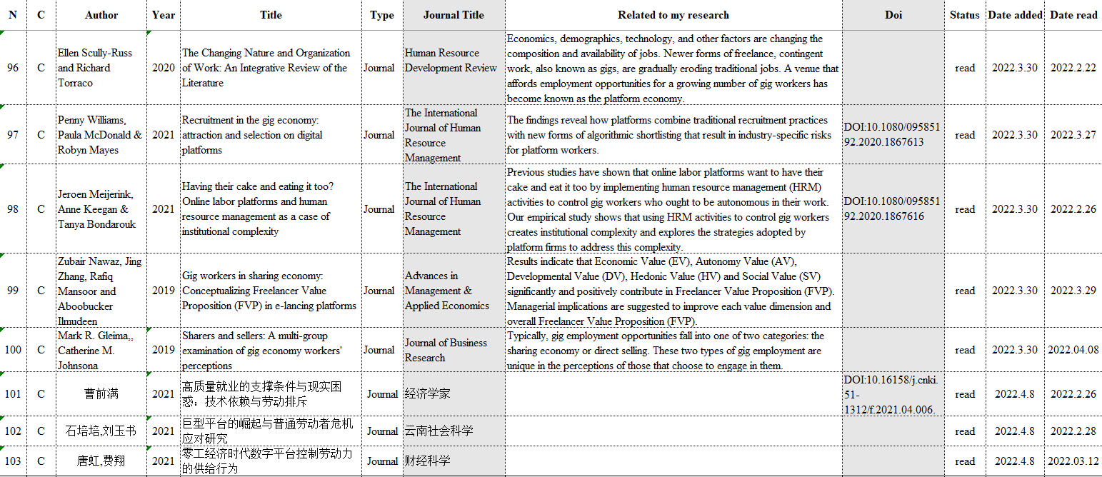

3. Literature Review of Gig Economy
3.1 Produce of gig economy
In the digital era, the gig economy is growing rapidly across the globe. As financial Times 2021 research findings, in England and Wales, the labor in gig economy has tripled in the past five years, with nearly 4.5m people regularly finding jobs through online platforms. The Bureau of Labor Statistics reports that 55 million Americans (34% of the U.S. workforce) participated in the gig economy in 2017. By 2023, 52% of Americans are expected to choose gig jobs. According to data released by the Ministry of Human Resources and Social Security of China in 2021, the number of gig workers has reached about 200 million (20% of China's workforce), and it is expected that by 2036, about 400 million Chinese will participate in the gig economy.

By analyzing the search of management-related literature on CNKI from 2015-2022 through the keywords of gig economy, sharing economy, and platform economy, it can be seen that literatures of the gig economy has seen a rapid increase since 2019 (Figure 1), especially after COVID-19 in 2020. Gig economy has become the focus and hot issue concerned by governments, academia, enterprises and non-profit organizations

3.1.1 The digital economy has spurred the generation of gig economy
Gig economy is the product of digital economy, rapid development of Internet and economic globalization. The new generation of digital technologies represented by artificial intelligence, big data, cloud computing and blockchain are disrupting the production and lifestyle of human beings, and the global Internet penetration rate continues to rise. According to the data published by the World Bank and IWS, from 2009-2021, with the number of global Internet users reaching 5.169 billion and the global Internet penetration rate reaching 65.6%. Among the “invasion” of the digital economy into the labor field, the most typical and popular phenomenon is the rise of gig economy. This new mode of employment provides a platform for people with skills to realize their own value and give full play to their advantages (Zheng and Yang, 2019). Science and technology create platforms, expand the scope of labor market, work presents the characteristics of task fragmentation, specialization and so on. The platform develops rapidly, and the employment opportunities for workers increase (Rozzi, 2018). The popularity of the Internet has further provided technology for the development of the gig economy, thus moving more types of jobs online and creating many new industries and a large number of employment opportunities (Chen and Zhang, 2021). The development of the gig economy has given rise to a new class of workers. What used to be secure and financially stable permanent employment has been replaced by an increasing number of gig work, which are available on an Internet platform with just a smartphone. While the rise of the gig economy is dependent on the growth of the digital economy, attributing the rapid growth of the gig economy to Internet technology is clearly only scratching the surface. Because technology itself has not changed the demand for labor in the market, whether in the industrial or information age. (Yang and Meng, 2020).

3.1.2 The consumer society is fueling the development of gig economy
With the improvement of people's living standard and the demand of consumption upgrading, gig economy has gradually become a new economic phenomenon. According to the famous sociologist Bauman, contemporary society has changed from a “producer society” to a “consumer society”. An unprecedented number and variety of consumer goods and forms of consumption have emerged and are accepted by society at large. The daily consumption needs of the masses have been stimulated as never before, and consumption has begun to replace production as the center of social and economic life. The advent of the Internet era has further reshaped the pan-consumption ideology of society based on material abundance, successfully reshaping the consumption habits of the masses and enriching the content and forms of consumption. It is in such a pan-consumption social wave that the basic gig economy oriented to daily consumption has been given a realistic ground for growth (Luo, 2021). In a consumer society, mass production no longer requires mass labor, many workers have lost their useful social functions (actual or potential), and most people no longer have direct access to the experience of “work” as a career; they can only experience it virtually by watching novels or television. “work” by watching novels or television. The mobile nature of consumer society has, to some extent, determined the immediacy of individual work; there is no longer a concept of professionalism, and traditional jobs that were fixed for long periods of time no longer exist. Flexibility leaves us in a world of uncertainty, where workers no longer feel secure, and everything becomes elusive and unpredictable.

3.1.3 Pursue the freedom of labor
Labor plays a conclusive role in the creation and evolution of human beings as a source of motivation. The self-realization of man is a process of self-birth, self-creation and self-development through labor. It can be said that labor is the demonstration of the essential power of human being, the purpose of human existence, and an important way for individuals to pursue interests, satisfy needs and obtain a happy life (Chu, 2020). The booming gig economy in the Internet era allows workers to choose their own labor time and labor methods relatively freely, and have more flexible employment opportunities, thus gaining a relatively free status and personality. The gig economy has its own obvious advantages, with the separation of work and workplace, people can work at any location or have multiple jobs at the same time or stay out of work for a long time (Wang and Cui, 2020). For workers, gig work can give them job opportunities with high freedom, autonomy, satisfaction and their wide work boundaries that are not available in traditional workplaces (Liu, 2022). Individual workers' pursuit of freedom and profit is combined in this form of short-term work, which liberates the labor force as never before, activates the labor market, and stimulates human potential and labor enthusiasm (Zhang, 2022). As millennials enter the workforce, they seek individuality and adventure, viewing work not just as a means to make a living, but as a means to fulfill their social needs and self-actualization. Stability and a permanent job are no longer what they pursue, and a diversified job with career development is what they value most (Chen, 2019). As seen in the “low desire society” in Japan and the “lay flat generation” in China, the values and behaviors of the new generation of employees differ significantly from those of their parents, and they attach great importance to the realization of self-worth and want to work in jobs that are flexible, have a relaxed and egalitarian organizational climate, and bring them a sense of well-being (Zhao et al., 2016). There are also workers who choose gig work in order to obtain a balance between family and work, gig work represent a new way of life that satisfies their own expectations of a reasonable distribution of leisure and labor time, and most of these people are well educated and can take advantage of their resources to obtain high income and high pay. (Berger et al., 2018).

3.1.4 Companies chasing profits
The boom of gig economy precisely caters to enterprises' preference for cost saving and risk management. For enterprises, they have a strong demand for cost reduction. Targeted employment of gig workers according to their needs can help them reduce the cost of hiring labor and also meet various development needs of enterprises. In the process of production and operation of enterprises, they inevitably face two problems, namely cost and risk. Most of the gig economy is run and managed through a platform, which is essentially a form of enterprise as well. Under the zero-labor economy, workers achieve autonomous management and enterprises do not need to conduct traditional enterprise human resource management, which undoubtedly saves enterprises a lot of operation and management costs (Zheng and Yang, 2019). Platform companies no longer need to supervise the labor process of their employees, instead, they are replaced by an algorithm-based online platform supervision model, which greatly reduces his supervision costs; platform companies no longer need to bear the costs that they need to bear in traditional employment relationships, such as fixed wages, social security insurance and other social responsibility exemptions, due to flexible and mobile employment relationships, and also compressed to reduce legal risks and default costs (Liu, 2022). With the help of gig workers, companies can expand their own business space more effectively and respond more quickly and accurately to the impact from competitors and the market. The continued Newcastle pneumonia epidemic makes the world economic growth weak, and the survival of many enterprises is severely tested, and their own business cannot be carried out normally. According to the Blue Book of China Flexible Employment Development Report (2022), 61.14% of enterprises in China are using flexible employment in 2021, and enterprises prefer to expand rather than reduce the scale of flexible employment. The main motive for enterprises to adopt flexible employment is to reduce labor cost (49.66%), followed by reducing the pressure of self-recruitment (30.26%), and 28.75% of enterprises adopt flexible employment due to short-term projects or seasonal labor demand. Meanwhile, during the epidemic, the catering and take-out industry developed rapidly, and enterprises and platforms opened the mode of “sharing employees”, which effectively solved the problem of labor shortage and showed the new form of gig economy.

3.2 Gig Economy Concept
3.2.1 Gig economy from historical development
There is no unified conclusion on the definition and category of “gig economy” in the academic circle. The U.S. Congressional Research Service Center defines “gig economy” as A labor mode that matches the needs of resource providers and consumers with mobile software or Internet platforms for the purpose of on-demand business (Donovans et al., 2016]. Some scholars pay attention to the gig economy in the digital era and divide the “gig economy” into “traditional gig economy” and “new gig economy”. The traditional gig economy emphasizes the temporary and project nature of labor, while the new gig economy highlights the application of the Internet and emerging scientific and technological media [Zheng and Yang, 2019]. Focusing on the nature of “temporary work” in gig-works, the gig economy is defined as a job of indefinite duration in any field, and the gig economy is the company and business system that has evolved to support the form of temporary work. Focusing on the nature of the digital era and the role of the Internet, the gig economy is defined as “labor transaction” relying on the digital technology platform (Wang, 2022). The gig economy is now widely considered by academics as the “new gig economy”, which is an on-demand employment model (Lobel, 2017; Horney, 2016). Gig economy relies on the Internet and the application of new technologies, under which the traditional employment mode is slowly being replaced by flexible time, place and forms of work (Mulcahy, 2017). It reflects the emerging economic model of supply and demand matching based on network platform, with independent and capable workers as the main body and fragmented tasks as the work content (Zhang, 2022). It reflects the emerging economic model of supply and demand matching based on network platform, with independent and capable workers as the main body and fragmented tasks as the work content (Zhang, 2022). T New gig economy is a kind of digital economy, which takes the application of digital knowledge and information as an important factor of production. With network and information technology as the carrier, the use of efficient communication technology to improve the efficiency and effect of economic operation (Li et al., 2018).

3.2.2 Look at gig economy from connotation
The general academic circle has three aspects about the connotation of gig economy, including the joint participation of workers producing or performing services, end users of services (enterprises or individuals) and digital intermediaries (Tang and Liu,2021). One is gig workers, who are independent workers paid for a task or a project. The second is consumers who need specific services. Services refer to personalized services that are specified to be delivered. The third is the gig economy platform organization, which connects gig workers to the platform. The biggest difference between gig work and traditional work is that gig work is a temporary work arrangement in which workers are paid only for specific work (Georges and Rowsont, 2021). All age groups are participating in the gig economy. According to a nationwide survey conducted by Wonolo in 2021, 20% of baby boomers (those born between 1941 and 1964) work on Wonolo more than twice a week. Similarly, 20 percent of Gen Xers (those born between the mid-1960s and late 1970s) work on Wonolo more than twice a week. By comparison, only 11% of millennials finish work more than twice a week, and only 6% of Gen Z workers finish work more than twice a week. Baby boomers, as well as Gen Xers, work more in the gig economy than any other age group, taking home more money from gig-works each month on average than any other generation. Workers in the gig economy are often referred to as Independent Contractors, also known as free-lancers, self-employed, Consultants and e-lancing workers (Chadwick and Flinchbaugh, 2016). Gig workers are also divided into high-skilled gig workers, low-skilled gig workers and sideline gig workers (Zhang, 2022). High-skilled gig workers and sideline gig workers are mostly gig work with active participation, while low-skilled gig workers are mostly full-time jobs with basic living wage. Gig economy consumers show a preference for online purchases and personalized services, such as takeout, where each order is a designated delivery service. Gig economy platforms can be divided into “Labour Platforms” and “Capital Platforms”, which organize the execution of production tasks and facilitates asset sales or leasing (Stefano, 2015). “Work-on-demand” system platforms, which often offer more traditional, physical, “real world” jobs organized by company-managed online platforms, they can have a greater say in the standard, pricing, retention and selection of labor force (Farrell et al., 2016).

3.2.3 Gig economy from features
Exploring the characteristics of the fractional work economy is the main method used by scholars to define the fractional work economy. In a study of 2558 papers on the gig economy, Watson et al. classified the characteristics of the gig economy into primary and secondary characteristics and distinguished them from other types of non-standard jobs. Among the primary characteristics, “temporary” accounts for 73.08%, “project-based compensation” accounts for 84.62%, “it involves some level of flexibility in when/how/where the work is performed” accounted for 80.77%. Among the secondary characteristics, “the work is facilitated using a technologically enabled network” accounts for 76.92%, “crowd work” accounts for 30.77%, “remote work” accounts for 26.92%, “intermediary or agency-based work” accounts for 11.54% (Watson, et al., 2021). Other scholars characterize the gig economy in five ways: First, the fluctuating demand for services generates irregular working hours. Second, workers in most positions provide some or all of the capital and equipment needed to do the job. Third, most gig workers own their own workplaces. Fourth, gig workers are paid for specific tasks rather than unit hours worked. Five, gig work is usually provided by digital intermediary organizations (Stanford et al., 2021). Based on the research of scholars, this paper believes that the gig economy is more concerned with the field of new gig economy, and the main features are reflected in three aspects. The first one is based on digital technology and Internet platform, which is the most important feature that distinguishes the gig economy from the traditional labor mode. This is the most important feature of the gig economy that distinguishes it from the traditional labor mode. The gig economy is formed through the platform based on mobile communication and Internet technology to complete the resource pooling and demand matching between supply and demand. The second one is demand matching, which is the biggest advantage of the gig economy. The support of technology makes the matching of supply and demand across time and space constraints, and the process of matching supply and demand is more efficient and commercially sustainable in terms of cost and benefit. The third one is flexible working hours and places, which is the main reason for both supply and demand sides of gig work to choose gig economy. Traditional work is basically a centralized or verticalized model, centered on enterprises. The fractional work economy has enabled a breakthrough in traditional production methods, expanding new areas of labor and allowing people to be employed frequently and freely.

3.3 Skills upgrading of Gig workers in gig economy
After searched and reviewed more than100 pieces of literature related to gig economy by searching keywords such as “gig economy”, “sharing economy”, “platform economy”, and especially screened the content of CSSCI literature from 2020 to 2022 on CNKI database, it shows the main research area in gig economy(Figure 2). The main research fields of gig economy are increasingly focused on labor employment, workers’ behavior, workers’ legal protection, labor relations and corporate social responsibility. Existing studies mainly focus on phenomenon description, historical review, data statistics, and case analysis, and there are not many relevant empirical studies yet.

Through literature review, it is perceived that the gig economy is a double-edged sword that plays a positive role in urban employment creation, residents' income increase, and social governance (Zhang and Cai, 2020), while raising many new issues of social ethics and modern enterprise management. From the perspective of the problem, we specifically discuss the impact of platform algorithm management on casual workers, the problem of de-skilling of casual workers, and the social responsibility of enterprises in the skills upgrading of casual workers.

3.3.1 Impact of platform management on gig workers
The platform, the fractional worker and the customer are three important components of the fractional economy. The platform plays a key role and determines the main attributes of the fractional work economy, autonomy, control and dependency of the platform worker, operational capacity and efficiency, privacy and data security. Platforms act as intermediaries and are able to fully control the implementation of work data, processes and rules (Kuhn and Maleki, 2017; Schmidt, 2017). Platform providers offer a completely virtual service where gig workers do not have a formal human supervisor (Kuhn and Maleki, 2017; Schmidt, 2017), and managing the platform is a very complex task. There are two key questions that platforms critically address: first, whether the platform can attract and retain enough workers and whether the platform has long-term viability (Jabagi et al., 2018). The second is the problem of the platform's regulation of the labor process of workers.

At this stage, the platform manages and controls the workers through algorithmic management, and the task release, salary setting, and performance evaluation are measured by the platform algorithm (Aloisi, 2015). The algorithm-enhanced platform is just another projection of the Colling ridge Dilemma caused by technological development in the real society (Chen and Jia, 2016). Through algorithmic control, platform companies squeeze the space of applicability of skilled labor, reduce the value of their skills, and create organizational dilemmas for the workers, which shape all workers into individualized “primitive labor” with low skills and disorganization. Workers are turned into robots that merely respond to signals expressed in step-by-step instructions (Beigi et al., 2020). As workers are completely digitally detected and statistically analyzed by machines, the gig economy may become the “Taylorism of the digital age” (Chen, 2016), not knowing why, how, and with whom they work. Numerous empirical field studies point out that instead of promoting a “de-hierarchical and egalitarian” labor-management relationship and substantial freedom for workers, the gig economy under the control of Internet platforms has brought about “illegible and inscrutable work, and manipulative and false teamwork resulting in The new problems of “illegible and inscrutable work, as well as manipulative and false teamwork, have led to organizational 'flexibility' and the erosion of workers' human identity” (Dou, 2020). Thus, casual work does not empower workers, but rather accelerates the commodification of labor and undermines existing labor standards.

3.3.2 Exploring the issue of de-skilling in gig economy
According to research data, gig workers earn significantly less than regular workers in similar jobs (Farrell and Greig, 2016). Gig workers employed at the lower end of the labor market, with lower income levels and skill levels (Healy et al., 2017). Gig workers in the labor market are also often synonymous with lower quality of employment and vulnerable groups (Zhao, 2021). While high-skilled and gig workers are able to obtain more flexible work opportunities and higher total income, low-skilled gig workers are forced to work longer hours and more intensely due to the pressure of life and competition, and increasingly face income and job instability (Xie and Wu, 2019). The extremely low entry barrier for low-skilled gig workers and the single form and content of labor meets the essential needs of the labor-intensive service industry, making the influx of labor possible in the post-epidemic era when unemployment rates are increasing. The large number of low-end service jobs in the gig economy only extends the convenience of consumers' daily life, and there is no need to train low-skilled gig workers to obtain the space and opportunities for practical training from “rusty” to “skilled” labor provided by traditional industries, thus leading to the high number of low-skilled gig workers. This leads to high mobility and competition for low-skilled gig workers (Luo, 2021). For low-skilled gig workers, the low level of repetitive labor also means that they can rarely obtain long-term employment contracts and stable promotion paths, and their fungibility is greatly increased (Wang, 2020).

Although gig workers have a relatively high degree of flexibility in their job choices in platform organizations, the existence of interorganizational boundaries prevents low-skilled gig workers from using their experience to transition to more traditional and secure forms of employment (Kost et al., 2020). As a result, opportunities for career competency development appear limited. Due to the increasing flexibility of application work, employees appear to be more likely to experience transient work and lack a clear career path (James et al., 2018). The vocational skills of casual economy workers are just as important as those of traditional workers. Having the skills to adapt to the market demand is the way to survive for the gig workers (Mulcahy, 2017). Enhancing vocational skills training for gig workers, specifically developing their business skills, training them to better explore and utilize their existing skills, helping them to build links to jobs and resources, and strengthening related infrastructure (Tepper, 2016). Therefore, it is necessary to advocate the return of the correlation between labor value and labor skills as a whole, and to construct feasible paths for the advancement of labor skills and social status for gig workers.

3.3.3 Research Gaps
Most of the existing research in the gig economy focus on the labor relations and labor protection of gig workers, algorithm management, etc., while the research on the ways for workers to maintain decent labor, career development opportunities, and vocational skills improvement is in a gap. In the future, knowledge-intensive industries that highly value elements such as knowledge, skills and innovation will become dominant in gig economy. For workers, skillfulness is an inevitable trend, and high-skilled gig workers will occupy the mainstream position. The cultivation of high-skilled gig workers is also a reflection of corporate social responsibility. How to improve the skills of gig workers and how the platform can take up the responsibility of cultivating gig workers will be the focus of the next research.

References

Cheng, X. and Li, P. (2016) A Study of Human Resource Management Patterns in Sharing Economy- Taking Airbnb as an Example, Human Resources Development of China (Vol.06).

Chen, X.G. and Zhang, F. (2020), The reconstruction and promotion of labor by gig economy and sharing economy, Chinese soft science.

Chadwick, C. and Flinchbaugh, C. (2016), The effects of gig workers on establishment financial performance, Journal of Management

Duggan, J., Sherman, U., Carbery, R. and McDonnell, A. (2021), Boundaryless careers and algorithmic constraints in the gig economy, The International Journal of Human Resource Management

Donovans, A. and Bradleyd, S. (2016), What does the gig economy mean for workers, Congressional Research Service

Dou, X.W. (2018), The impact of sharing economy on labor relations, Modern economic information

Finkin, M. (2016), Beclouded work in historical perspective, Comparative Labor Law & Policy Journal

Farrell, D. and Greig, F. (2016), Paychecks, paydays, and the online platform economy: Big data on income volatility, JP Morgan Chase Institute,

Jabagi, N., Audebrand, L.K., Croteau, A.M. and Marsan, J. (2018), Connecting with gig-workers: an exploratory study of organizational identification in the gig-economy, HRM and Labour Market Institutions

Jiang, Y. (2021). Cultivation of vocational college students’ professional cross-border ability under the background of gig economy, Vocational and Technical Education.

Jiang, Y. (2020). Multidimensional analysis of “Slash Youth” in the era of gig economy and the path to vocational ability improvement-Based on the perspective of vocational education, Chinese Vocational and Technical Education.

Kuhn, K.M. and Maleki, A., (2017), Micro-entrepreneurs, dependent contractors, and instaserfs: understanding online labor platform workforces, The Academy of Management Perspectives, pp. 183-200

Lobel. (2017), The gig economy & the future of employment and labor law. University of San Francisco Law Review,

Lin, X. and Zhao, G. (2021) Looking ahead to 2035: The end of management and regeneration under the background of digitization: Management paradigm transfer from controlling labor to liberating labor, Journal of Chongqing University.

Lee, Y. (2021) After a Global Platform Leaves: Understanding the Heterogeneity of Gig Workers through Capital Mobility, Critical Sociology

Li, J. and Li, Y. (2021) Current situation and future research prospect of human resource management in gig economy, Leadership Science.

Luo, F. (2021), Pan-consumption, De-skills and Re-organization: How the Basic Gig Economy is Possible in the Internet Era, Journal of Zhejiang GongShang University.

Marion, M. (2017), Thriving in the GIG Economy-How to Capitalize and Compete in the New World of Work, CITIC Press

Mulcahy, D. (2017), The gig economy, American Management Association

Mulcahy, D. (2017), Will the gig economy make the office obsolete? Harvard Business Review

Rozzi, F. (2018). The Impact of the gig-economy on US labor markets: Understanding the role of non-employer firms using econometric models and the example of Uber, Junior Management Science

Stefano, V.D. (2016). Introduction: Crowdsourcing, the gig-economy and the law, Comparative Labor Law & Policy Journal, Vol.37, No.3.

Schmidt, F.A. (2018), Digital labour markets in the platform economy mapping the political challenges of crowd work and gig work, available at: http://library.fes.de/pdf-files/wiso/13164.pdf

Stefano, V. (2015), The rise of the just-in-time workforce: On-demand work, crowdwork, and labor protection in the gigeconomy,

Stanford, J. (2017), The resurgence of gig work: Historical and theoretical perspectives, The Economic and Labour Relations Review

Tassinari, A. and Maccarrone, V. (2020). Riders on the storm: Workplace solidarity among gig economy couriers in Italy and the UK, Work, Employment & Society, Vol. 34.
Stewart, A. and Stanford, J. (2017), Regulating work in the gig economy: What are the options, The Economic and Labour Relations Review

Valenduc, G. and Vendramin, P. (2016), Work in the digital economy: sorting the old from the new, European Trade Union Institute

Wang, S. and Li, Z. (2019) Research on Value Creation Process Model of Shared Economic Platform-A Case Study of Didi, Airbnd and Douyin, Management Review (Vol.21, No.7).

Wang, N. (2020), The nature, problems and employment potential of the gig economy, People's BBS.

Wang, J.B. and Cui, X.T. (2018). Trait, challenge and strategy of human resource in gig economy, Human Resources Management.

Wang, R. (2020). The gig economy has spawned MOOC-based gig education, Adult Education, No.8.

Wang, N. (2020), Interconnectedness and fungibility: The internal logic of gig-works, Exploration and contention.

Xie, F.S. and Wu, Y. (2019). Is the gig economy a new type of win-win employment relationship between labor and capital, Economists, Vol.6.

Xiao, S.Y. (2019). Understanding the employment status of gig-workers in China’s sharing economy era: An empirical legal study, Asian Journal of Law and Economics.

Xu, H.Z. (2020), Labor and Laborers in risk Society: The Vanishing “Stability”, Chinese Book Review

Yang, B.Y. and Meng, Q. (2020). Diversity of choices and flexible duality: Debate and paradox in the study of gig economy, Human Resource Development of China, Vol.3.

Yang, W.G., Zhang, C.G. and Xin, Q.L. (2018), Digital Economy paradigm and work relationship transformation, Chinese Journal of Labor Relations.

Yu, X. and Liu, R. (2016) Human Resource Policies in “Internet+” , A Case Study Based on Didi, Human Resources Development of China, (No.6).

Zhu, L.L. (2021). Study on sharing model of human resource in gig economy: Based on 3rd party platform of human resources service, SHANGYE JINGJI, No.11.

Zheng, Q. and Zhang, S. (2020) An exploration on individual employment motivation in gig economy-Taking Beijing takeaway riders for example, Journal of China University of Labor Relations.

Zheng, Q., Zhang, S.W. and Yang, W.G. (2020). An Exploration on individual employment motivation in gig economy: Taking Beijing takeaway riders for example, Journal of China University of Labor Relations, Vol.34, No.5.

Zheng, Q. and Yang, W.G. (2019), Different Research Perspectives on Gig Economy-A Review Based on Western Classical Literature, Human Resources Development of China.

Zhao, W.Z. and Feng, J. (2021). New forms of employment under the COVID-19 Epidemic: Take sharing employee as example, Review of Industrial economics.

Zhang, C.Y. and Cai, Q.M. (2021), City size, digital financial inclusion development and the gig economy, Journal of Shanghai University of Finance and Economics

Zygmunt, B. (2005), Work, Consumerism and the New Poor, McGrawHill

