Business Skills Reflective Report

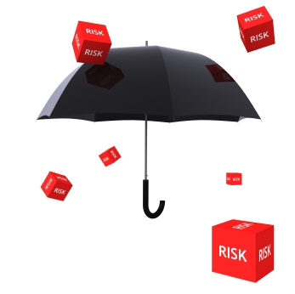

Module Title: M4X01917
Assignment Title: Business Skills
Module Lecture’s Name: Dale Clark
Student Number: 1815430
Student Name: Elza Soares

1
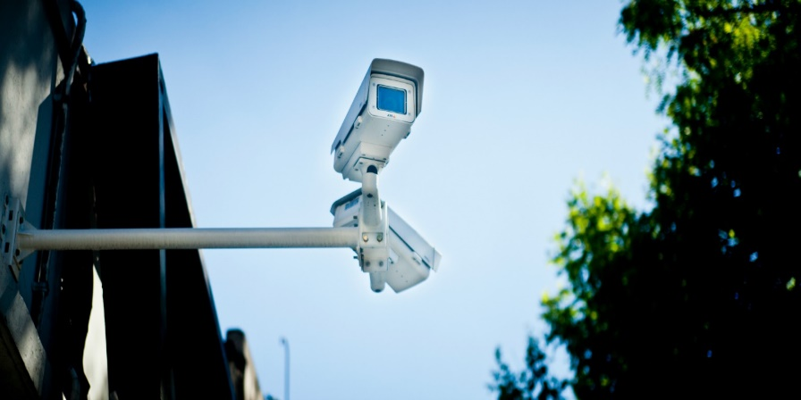

Table of Contents:
Introduction
Data protection
Healt and safety
Food hygiene
Risk management
Licensing and Registration
Hotel proprietors Act 1956
Conclusion
References

2
Introduction
In this task, I will examine possible legal legislative risks within the hotel industry.
Legal responsibility and risk of data protection, staff, guests, hygiene required within the hotel industry, including licensing and Hotel Proprietors Act (1956).
For all these goals, I will have to make use of the materials given in the classroom and use the internet to be able to successful complete the desired work.
This task is a practical introduction to the main concept to Hotel industry.
In this task we will analyze responsibilities and risks within an organization, evaluate the responsibilities and legal risks, safety and health of all, hygiene of space, employees, food, protection of the database.
Assessing these risks is the work that the Product Manager must perform to ensure that the product or functionality can add value to the enterprise. It is a very common mistake to think that only internal opinions are enough to guarantee the value of the final product, or to underestimate technical or legal obstacles and, in the end, have a major headache.
Data Protection
The hotel industry faces the highest number of data traffic security risks, a large volume of customer data including card details, address, names, even when companies offering security are never trusted, there are always risks from the moment in which personal information is collected. (Carey, 2008)
It is true that in many industries data collection becomes important because it allows managers and officials to customize each guest's preferences, thereby protecting card data, personal data, and numbers.
There are global, European data protection laws and in the UK the first approval was in 1984
Over the years some adjustments have been made
(Law 1998), but the GPDR (General Data Protection Regulation) of the EU came into force in May 2018. The amendment is important because it has allowed people to gain control over their data and regulate the exchange of information outside the EU and EE.
In charge of Data Protection, there will be an obligation for organizations to appoint one who should be responsible for ensuring the new legislation and has Data Privacy Impact assessment to better assess the privacy of private individuals, the need to provide data processing and help assess the risks, rights and freedoms of individuals. (Alojamento, Business, 2018)

3
Health and Safety
In the hotel industry the Health and safety of all staff and clients and very important therefore have a list of rules obligatory for all to know how to act in any inconvenience. In all sectors there is a map to know the emergency exits, own shoe for each department, how to act in case of robbery, fainting, falling, fire, chemical spill, elevator failure, fire, emergency phone number etc. All precautions make companies more effective. (www.hse.gov.uk)
There are international laws that must be followed to ensure the safety and good safety practices of everyone, everything has to be checked first of all the electrical system, spaces reserved for protective clothing, food in its proper places, all this so as not to cause damage to civil servants , clients and by reason of the reputation of the hotel.
I will mention some health and safety rules for different jobs: always uniform clean and flawless, shoes, protect hair if you work directly with food, gloves, ladder, emergency exits indicated by everyone's vision, well-relief extinguishers, cameras of surveillance.

Food and Hygiene
It is of vital importance the training of all people on how to handle preparing and knowing how to prepare food in this way prevent foodborne diseases. It is very important to wash hands before touching food, not having wounds, keeping food at the ideal temperature, keeping food separate (ex: fish, meat, milk, salad) Food safety practices analyse the entire food process (production, transportation, storage, handling and service). there are several types of contamination being the most common: crossbreeding can occur through equipment and utensils used during food handling but also through handlers (hands and protective clothing)
Biological: it is represented, mainly, by bacteria, fungi, parasites and viruses, besides its possible toxins produced.
Physical: food that has been contaminated by some object throughout its production process or by the product of a physical reaction with other compounds.
(www.neoprospecta, 2017)
There is a lot of care to take with the cleanliness of the hotel for have success and need to keep super clean, without dust mites, panties, pet hair keeping a daily clean.

4


Risk Management
In the hotel industry, like any other industry, it is subject to success and failures, and the speed of information exchange can be a factor that favours the good business image or be a negative multiplier. Every business has risks that must be known to know how to minimize. The hotel industry has risks directly related to its product that can have direct affection to the client.
All establishment has to offer protection to its guests to try to prevent against losses. Responsibility for safety must be shared by all, the drop-in reservations can be very significant, and the reputation of the hotel is hampered by safety issues.
the security problem causes damage to the hotel's own image as well. (Chon and Sparrowe 2003)
In any business, it is extremely important to know how to identify the risks and to analyse the origin or the problem that may have unchained. evaluate the negative impact so you can act and create a plan to avoid the problem. (Hopkin,2018).
Can measure the level of a hotel through the amount of attention and reasonable consideration with which it is hosted and received, comparing the hotel together with others can then create your reputation for the expectation of the host and very important. The core business is based on the creation of memorable experiences to satisfy the client as opposed to satisfying the business. (Ismail 2004)
risk is not a desire or choice! but it exists in every decision taken daily, planning can be perfect, and something go wrong. (Vaughan 1997)

5

Licensing and Registration
There are many laws, regulations and codes to consider before becoming a hotelier. It is necessary to take all necessary and obligatory measures so that it is protected before the law. Because the name in the hotel has regulatory implications. Under the Commercial Names Act of 1985, hotel owners must display a notice showing the owner's name, which should not be the same as the name of the hotel. The Trade Description Act of 1968 when conducting the marketing activities had to provide true information, hotel name, price, location.
If the hotel is going to serve food, it has legal duties to ensure that food is prepared with hygiene and in a manner appropriate for the safety of customers.
There is a great offer of short-term courses for those with little experience.
For everything must have a respective license to ensure the security of the proper functioning of the hotel.
some examples of License:
Form the police to the hotel | Farewell
Health trade license or commercial license | TV License
Business registration | Bar License
(www.assetsure.com)
Hotel proprietors Act 1956
The Hotel Owners Act of 1956 and the Local Authorities Act of 2004, the owner of a hotel may, under certain circumstances, be held liable for any loss or damage to the property of the guest, even if it is not for lack of owner or employee. of the hotel.
Under the Hotel Proprietors Act of 1956, a hotel owner may, in certain circumstances, be liable for any loss or damage to a guest's property, even if it is not due to any failure of the owner or hotel staff. This liability: does not apply to any pet, vehicles this law covers only damage to the room with the amount already defined by the law £ 50 for any item and a total of £ 100. (legislation.gov.UK)
Many hotels to protect themselves offer their clients safes so they can have their belongings safely.
Before this law when registering the Hotel, it cannot be anything other than Hotel.
In this law the word Hotel means that the establishment has the conditions to offer food, drink, sleeping accommodation without compulsory contract, anyone willing to pay what is in the table must be accepted.

6

conclusion
In analyzing my work, I realized that there are many things that are fundamental to the good functioning of an organization, such as: safety, although expensive, but indispensable for the trust of clients, to have a high standard of hygiene, to have the maps showing the emergency exits in case of danger,
Have up-to-date data protection, keep up to date, updated marketing with location, price and actual photos.
The manager must know how to organize the work to better assess the risks, to know beforehand to better protect, execute and guarantee the functionality of the real value of the company.
Internal oppression is never enough to guarantee the final value and never substitute technical or legal obstacles.

References
Alojamento, business, (2018)
www.assetsure.com
Chon and sparrow, (2003)
Carey, (2018)
www.legistation.gov.uk
www.neoprospecta,( 2017)
Hopkin,( 2018)
www.hse.gov.uk
Ismail, (2004)
Vaughn, (1997)

7

