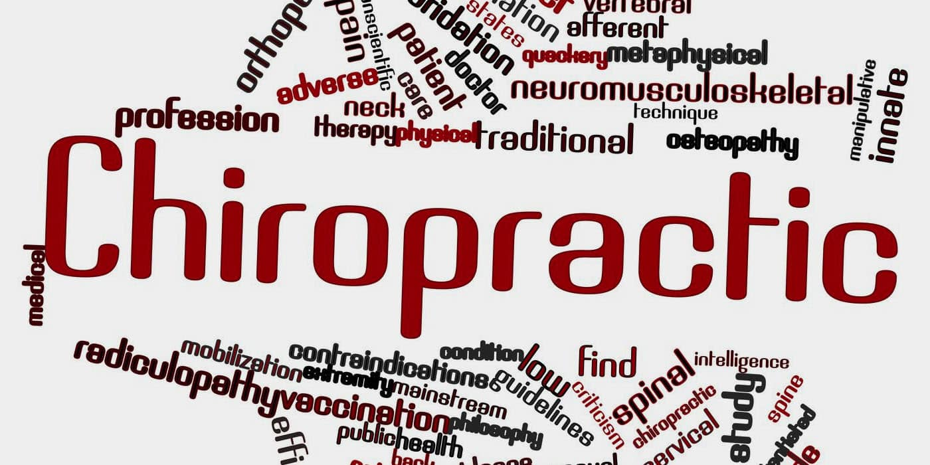

Chiropractic Therapy

Module: | Complementary Therapies
Assignment: | Assessment 2: Written Assignment
Module Code: | BMHP5001_LON
Lecturer: | Mentesnot Mengesha
Student: | Fatimah Choudhry
Student ID: | 2012893
Submission Date: | 5th January 2022
Wordcount: | 2,622

Contents Page

Chiropractic Therapy 1
Contents Page 2
Introduction 2
Complementary Therapies and the Current Self-Regulatory Systems 3
History of Chiropractic 5
Uses of Chiropractic 6
Efficacy of Chiropractic in Comparison to Traditional Treatments 6
Policies, Guidelines and Regulations of Chiropractic 10
Ethical Considerations 10
Recommendations 12
Conclusion 12
References 13

Introduction
The National Center for Complementary and Alternative Medicine (NCCAM) explains Complementary Alternative Medicine to be a group of different health care practices and is not thought to be used as part of conventional medicine. Complementary therapies are promoted to help for recovery of illnesses, to treat and prevent illnesses, all to emotionally and spiritually uplift an individual using natural practices to relax the body and mind.
The use of complementary therapies has grown considerably and become highly recognised to be used globally over the past thirty years (Lopez-Junior, et al., 2020). Research shows, in 2005, 12% of the British population were using practitioner led complementary therapies. By 2015, the population had increased to 16% of usage (Sharp, et al., 2018).
Even though practitioners in complementary therapies are well trained and experienced, it is important they are regulated by governing bodies to aim to ensure patients are kept safe according to set standards of conduct, training and practice and to protect the healthcare practitioners as well (IDB, 2021)
The aim of this assignment is to critically evaluate the current legislative and policy requirements for the use of chiropractic therapy in healthcare, including its effectiveness of it compared to traditional treatments.

Complementary Therapies and the Current Self-Regulatory Systems
Currently, there are no requirements for complementary therapy practitioners to officially be members of any professional bodies. However, chiro practitioners and osteopath doctors must be registered with the right governing body, as do the other ‘Big five’ complementary therapies (Choong, et al., 2015). Being registered with a recognised organisation, gives the patient using their services peace of mind that they are attending a therapy that will definitely follow safety regulations, and also protects the organisation itself. However, it is apparent over the years the regulation for complementary therapy in the UK has been insufficient as there are a lot of practitioners who are proving to show incompetence. In fact, even if you are a part of a self-regulating voluntary body or registered with the Complementary and Natural Healthcare Council (CNHC) and are struck off it due to incompetent practise, it doesn’t stop you from being able to practise anymore (Choong, et al., 2015).
In the year 2000, The House of Lords Science and Technology Select Committee published a report after investigating CAMs and placed them into three categories:
- Professionally organised alternative therapies (Big 5)- governed by self-regulated bodies accredited by Professional Standards Authority for Health and Social Care (PSA) | - Acupuncture (British Acupuncture Council)  - Chiropractic (Chiropractors Act 1994, General Chiropractic Council)  - Herbal Medicine (European Herbal & Traditional Medicine Practitioners Association, 2015)  - Homeopathy (Faculty of Homeopathy)  - Osteopathy (Osteopaths Act 1993, General Osteopathic Council)
- Complementary Therapies – voluntarily self-regulated by Complementary & Natural Healthcare Council (CNHC) but not obliged to take any memberships. | Alexander Technique  Aromatherapy  Bach and other Flower Extracts  Body work therapies (Massage)  Counselling stress therapy  Hypnotherapy  Meditation  Reflexology  Shiatsu  Healing  Maharishi Ayurvedic Medicine  Nutritional Medicine  Yoga
- Alternative Disciplines- Long established and traditional forms of healthcare -voluntary self-regulation system (CNHC) | 3a. Anthroposophical medicine  Ayurvedic medicine  Chinese Herbal medicine  Eastern Medicine  Naturopathy  Traditional Chinese Medicine  3b. Crystal therapy  Dowsing  Iridology  Kinesiology  Radionics
(Choong, et al., 2015)

History of Chiropractic
The word ‘chiropractic’ originates from the Greek words ‘cheir’ (hand) and ‘praktikos’ (done), which means actions to be done by the hands (betterhealth, n.d).
Spinal manipulation goes back to the era of Hippocrates (860 B.C), the ancient Greek physician (WHO, 2005). Chiropractic originates from the practice of folk medicine, called bonesetting, where untrained practitioners carried out the procedures of joint manipulation or putting fractured bones back into place (Wikipedia, 2021). Bonesetting also has roots from Traditional Chinese Medicine (TCM). It was prevalent in developing nations, especially Africa, Asia, and South America (Nwachukwu, et al., 2011).
However, in Iowa, in 1895 Daniel David Palmer, a magnetic healer, performed the first Chiropractic adjustment to a partially deaf janitor named Harvey Lillard. Who explained to D.D. Palmer, he felt a part of his back click 17 years before, and experienced hearing loss since. From the adjustment he performed on him he said his back felt much better and his hearing was also restored (Carter, 2016). From this procedure, he concluded, “Ninety-five percent of all diseases are caused by displaced vertebrae, the remainder by luxations of other joints.” (Homola, et al., 2006).
In 1897, D.D. Palmer founded the first chiropractic school for training chiropractors in Iowa, USA. The practice of chiropractic expanded well, and Palmer developed the chiropractic theory from different medical origins; medical manipulation, bone setting, and osteopathy, which he developed on and improved the techniques and procedures according to his experiences (WHO, 2005).
By 1902, Barlett Joshua Palmer, his son graduated from the newly named, Palmers School of Chiropractic and, at this time chiropractic treatment was becoming much more widely promoted, through the theory of correcting subluxations in the spine being able to cure nearly every disease (Homola, et al., 2006). In 1907, chiropractors achieved legal licensing for Chiropractic. In 1917, when D.D. Palmer passed away, his son became the developer of Chiropractic, and it has flourished, become recognised, and become regulated in the western world (Carter, 2016).

Uses of Chiropractic
Chiropractic treatment is a complementary therapy that is practiced by trained chiropractor practitioners to help treat conditions that affect the nervous system and musculoskeletal system by alleviating pain in joints, muscles, and bones using different techniques with the movement of their hands or special instruments through the procedure called spinal or joint manipulation. It can help relieve pain in the back, neck, shoulder, elbow, headaches and, pain from when one suffers from osteoarthritis, and sciatica (NHS, 2020). It also corrects the body’s alignment and physical function. It is one of the most popular forms of manual therapy practiced globally and regulated by law. When a part of the spine appears slightly misaligned a nerve can become irritated, which could result in a weakened nervous system and cause pains (Carter, 2016). Once the joint adjustment is restored, evidence shows the immune system functions better, the way one moves, and even thinks improves with chiropractic treatment. Most importantly, the care is completely drug-free (Barhum, 2020).
Chiropractic Treatments | Uses of Treatments
Soft-tissue therapy | Relaxes tight muscles, relieves muscle spasms, releases tension in tissues that surround the muscles
Adjustments | Gently realigns joints, increasing bodily movements
Joint bracing/taping | Supports and heals sprained joints and muscles (Kinesio taping)
Exercises and stretches | Strengthens and maintains body functions, muscles and joints
Referrals to medical health experts | Help with diet and nutrition guidance to reduce body inflammation
(LeFebvre, et al., 2012)

Efficacy of Chiropractic in Comparison to Traditional Treatments
According to Gevers-Montoro, 11% of the global population is being affected by spinal pain. This is ranking as one the largest cause which limits activities and is being classed as having a disability due to limited activities. When pain continues over 3 months, it becomes chronic pain. Therefore, spine pain is becoming a personal, social, and economic burden, due to employees being absent from work and treatment expenses. Gevers-Montoro suggested ways to decrease the global burden of spinal pain is using spinal manipulative therapy through chiropractors. Therefore, the practice has become increasingly popular, over the past ten years; patients have shifted away from pharmaceutical medicines since high levels of prescription opioids were being given and people were becoming over-reliant on opioids, spinal injections and, surgery (Gevers-Montoro, et al., 2021). According to Corcoran, patients of chiropractic treatment, were 64% less likely to receive an opioid prescription compared to patients of usual medical care as it has been proved highly effective and prevalent (Corcoran, et al., 2019).
In 2018, Goertz investigated whether chiropractic treatment combined with medical care was better in offering pain relief in comparison to usual medical care by itself by evaluating the effect of non-pharmaceutical treatments on lower back pain and associated disability. The clinical trials were carried out from September 2012 until February 2016 on US service members ranging from 18-50 years old. Over 6 weeks, the medical care provisions were self-care, medications, physical therapy, and pain clinic referral. The Chiropractic care provided included spinal manipulative therapy and therapeutic therapies were used additionally, which were: rehabilitative exercise, cryotherapy, superficial heat and other manual therapies. Clinical trials were undertaken by 750 enrolled patients and the mean age was 30.9 years old, 175 patients were female, 243 patients were of different ethnic origins. In conclusion, the results shown in graphs A-F show when chiropractic treatment was combined with usual medical care it provided greater pain relief in lower back pain and reduced disability than medical care alone, and no serious adverse events occurred (Goertz, et al., 2018).
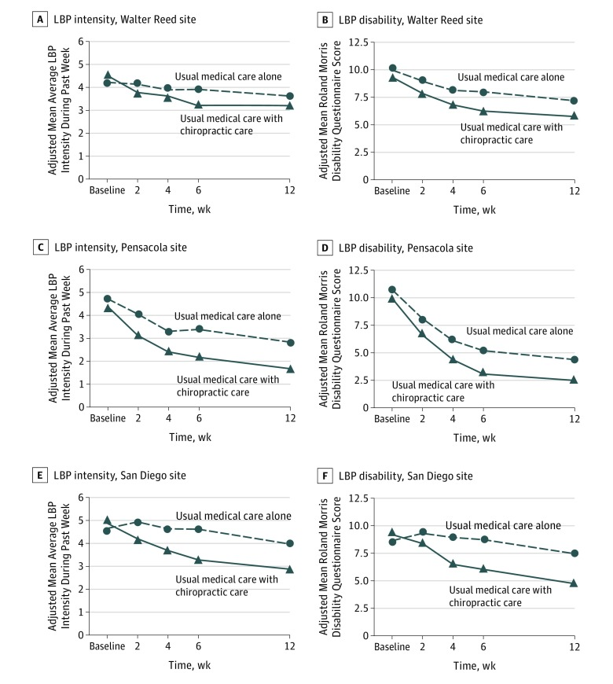(Goertz, et al., 2018)
DeBar, carried out a mixed-methods study on acupuncture and chiropractic care for chronic pain. Due to the growing condition of musculoskeletal pain, the most highly accepted and evidence-supported effective complementary alternative medicine practices are acupuncture and chiropractic for the treatment of chronic musculoskeletal pain. This condition is affecting 60-80% of the American adult population and is one of the top 5 reasons to attend emergency care departments. The study participants are aged 18 and over and suffer from chronic musculoskeletal pain. Users reported they were highly satisfied with acupuncture (53%) and chiropractic (59%) in comparison to (44%) satisfied patients with care from specialist physicians and (34%) from primary care physicians. (DeBar, et al., 2011).
Salehi’s study was to evaluate how effective chiropractic treatment was at improving and removing different diseases by looking at systematic reviews between July and November 2014. 23 systematic reviews were found, out of which, 11 relevant articles were investigated. The studies were on conditions people were suffering from, upper extremity conditions, back pain, neck pain, colic, autism, asthma, gastric conditions, fibromyalgia, sports injuries, and carpal tunnel syndrome. Only one of the articles was with meta-analysis. From all the results it is apparent development of chiropractic care is at different levels globally. Not all the articles were useful for evaluating. The studies showed conclusively there was an improvement by chiropractic treatment in some upper extremity conditions of shoulder and neck pain and sports injuries. According to the other conditions studied, the results were inconclusive and further research is recommended (Salehi, et al., 2015).
Contraindications of Chiropractic
Chiropractic treatment is an extremely safe and effective practice, if it is practiced by trained and skilful, professional chiropractors. However, there are some risks and contraindications that are known.
- After spinal manipulation a patient can experience short-term discomfort in the treated area, fatigue and headaches.
- Chiropractic care is not recommended if patients suffer from spine cancer, spine deformities, high risk of stroke, fractures, dislocations, arthritic symptoms, infections in the treatment area.
- Only gentle procedures of chiropractic care can be carried out if you suffer from osteoporosis (thinning of the bones) or vertebral artery stenosis (narrowing of the arteries to the brain).
- Rarely a patient my suffer from:
- Cervical arterial strokes, as a serious adverse effect when neck pain is being treated.
- Worsening of disc herniations, while adjusting a protruded disc from the spine.
- Cauda equina syndrome, this can occur after a disc herniation when all the nerves in the lower back become compressed and damaged, resulting in long term paralysis (Barhum, 2020).
Therefore, before any treatment is undertaken a form must be filled out to ensure a patient is eligible for the treatment beforehand and only a trained practitioner can determine this through a thorough pre-examination.
In June 2017, a study was conducted to find what risks were found after performing manual treatment on the spine, 250 articles were observed and analysed. The results where benign adverse effects were short-term (maximum 24 hours) neck pain, stiffness, headaches and reported in 23-83% adults as well as children. However serious adverse effects were rare. These were ranging from one out of two million spinal manipulations to 13 per 10,000 patients, for cases of spinal problems, worsening of disc herniations and cervical arterial strokes. The evidence showed those with previous conditions suffered from adverse effects, and benign effects were more common (Swait, et al., 2017).
According to a study conducted by Kranenburg on 117 male patients with a mean age of 45 and females with a mean age of 39, the reported contraindications were 95% after spinal manipulation suffered from short-term neck pain. However, an adverse effect on 55% of females had immediate symptoms of suffering from cervical arterial dissection, therefore women are at a higher risk than men of severe adverse effects after spinal manipulation. Overall, the study showed 46% of spinal manipulation to be safe and 13% to be with harmful effects, and the remaining results were inconclusive and concluded that after spinal manipulation there can be adverse effects (Kranenburg, et al., 2017).

Policies, Guidelines and Regulations of Chiropractic
The British Medical Association (BMA) identified the big five complementary therapies to be fast-growing potential approaches to health care as they can be used with conventional medicinal care. The BMA recognised them to be ‘discrete clinical disciplines’ and recommended them to be regulated by legislation, which is why ‘The Chiropractors Act 1994’ was enacted in the U.K (Chapman-Smith, 1997).
According to ‘The Chiropractors Act 1994’ the chiropractic profession is protected and regulated by law, along with the title ‘chiropractor’. Under this legislation, the statutory regulator a chiropractor must register with is the General Chiropractic Council (GCC) in the UK, otherwise it is deemed illegal to be practising as a Chiro practitioner and you will be fined (Gov.UK, 2021). The GCC, only accept registrations of chiropractors who have the relevant qualifications and agree to follow the code of practice. If a patient feels the chiropractor hasn’t followed the standards of practice, they have the right to complain to the GCC. This registered regulated system for chiropractic, works the same way a conventional medical doctor must be registered with the General Medical Council (GMC) (IDB, 2021).
In the UK the largest representative body for chiropractors to register with is the British Chiropractic Association (British Chiropractic Association, 2021).
To be able to become a chiropractor in the UK, you would need to satisfy and complete the educational requirements according to the GCC, this is an undergraduate four-year degree (three years full-time study and one-year work-based training) in Chiropractic or a postgraduate master’s degree after an undergraduate degree in any healthcare, related subject. The courses undertaken must be recognised by the General Chiropractic Council, and an individual must have the skill, good health and caring character to be able to practise best effectively meeting all the regulations safely (Gov.UK, 2021).

Ethical Considerations
According to the GCC chiropractors must follow the Code, this is an overview of performance standards, conduct and ethics which must be fulfilled and followed by a chiropractor to promote the safety, health and wellbeing of their patients in the UK. The Code is applied and used by practitioners to protect the patient's data, ensure equality, and they are practising with the human rights act 1998 in place. The practitioners must ensure they are open with the patients, so they feel comfortable and involved in understanding their procedures and level of care. There are eight ethical principles of standards that every chiropractor must follow to ensure a person-centred approach is being maintained (GCC, 2016).
Code of Conduct, Performance and Ethics Chiropractors must Follow
- Ensure patients health interests are the priority | Listen to patients concerns, treat them with dignity and respect for their cultural values, protect from harm, in a safe and clean environment
- Maintain high standards of professional conduct through honesty and integrity | Ensure you are qualified, registered and insured, be honest to resolve issues and professional, maintaining patient confidentiality
- Provide a good standard of clinical practice | Always meet patient preferences, stop treatment if asked to, guide patients, carry out assessments, and assess care plans, always provide treatment feedback
- Always maintain a professional relationship with patients | Ensure you do not cross relationship boundaries and a level of professionalism is always upheld
- Ensure patients sign consent for all aspects of patient care | Always ensure consent for care is taken, ask patients for consent for clothes need to be adjusted or removed for examination and procedures, obtain consent if information needs to be shared with third parties
- Maintain effective communication with patients, colleagues and other healthcare professionals | Communicate clearly what care the patients should expect, including risks and benefits, listen to deal with complaints from patients
- Work within your professional knowledge and skills | Always make sure you are updated with professional knowledge and skills, regularly meet with other healthcare professionals
- Always maintain patient confidentiality | Ensure records are updated and kept confidential, adhere to GCC standards always by storing records in a secure way
(GCC, 2016)

Recommendations
It is apparent there are a vast majority of therapies. According to these a recommendation of setting up a separate regulatory body per discipline would be extremely effective to protect the company practicing the therapy and the individual using it (Mills, 2001).
However, the practice of chiropractic should be practiced prevalently on the NHS and offered prevalently globally in an integrated medical system. This would help everyone, as it is currently a high cost to use, and the professional practicing has to be self-employed, therefore earnings can be fluctuating as with a high charge, not everyone can afford the treatment and would therefore prefer to get the conventional treatment which is offered on the NHS. If chiropractic care was available on the NHS, the chiropractor would get a fixed salary, or be given a fixed payment per referral. Therefore, the effectiveness should be researched further along with the cost-effectiveness to be able to consider a higher availability on the NHS (Sharp, et al., 2018).

Conclusion
It is apparent that if we had a more integrated medical system globally, with complementary alternative medicines some illnesses could be prevented completely and create an overall healthier population globally. Chiropractors could most certainly complement the traditional treatments you receive. Therefore, spinal manipulation should be offered globally as a mainstream option of care and evolve from the field of complementary alternative medicine.
In conclusion, further up-to-date studies should be conducted to clarify the specific effectiveness of spinal manipulation due to the low quality of efficacy of spinal manipulation with no treatment or lack of comparison with another traditional treatment and its effects remains uncertain. However, from the studies conducted it is evident the long-term effects of medically prescribed opioids are deemed much more detrimental compared to the efficacy of chiropractic treatment.

References

https://www.ncbi.nlm.nih.gov/pmc/articles/PMC7529450/ Accessed 23.12.2021
https://www.ncbi.nlm.nih.gov/pmc/articles/PMC1119419/ Accessed 23.12.2021
(Innes, et al., 2016) https://www.ncbi.nlm.nih.gov/pmc/articles/PMC5142274/ Accessed 24.12.2021
https://journals.lww.com/clinorthop/Fulltext/2006/03000/Chiropractic__History_and_Overview_of_Theories_and.35.aspx Accessed 24.12.2021
https://www.who.int/medicines/areas/traditional/Chiro-Guidelines.pdf Accessed 25.12.2021
https://www.nhs.uk/conditions/chiropractic/ Accessed 25.12.2021
https://www.thechirocentre.co.uk/blog/chiropractic/chiropractic-how-it-all-began/#.YcdINxPP2CQ Accessed 25.12.2021
https://www.verywellhealth.com/is-chiropractic-adjustment-safe-4588279 Accessed 25.12.2021
https://en.wikipedia.org/wiki/Chiropractic Accessed 27.12.2021
https://www.ncbi.nlm.nih.gov/pmc/articles/PMC3027080/ Accessed 27.12.2021
https://www.ncbi.nlm.nih.gov/pmc/articles/PMC3716373/ Accessed 26.12.2021
(British Chiropractic Association, 2021) https://chiropractic-uk.co.uk/history-and-regulation/ Accessed 26.12.2021
(gov.uk, 2021) https://www.gov.uk/register-chiropractor Accessed 26.12.2021
https://pubmed.ncbi.nlm.nih.gov/9409129/ (Chapman-Smith, 1997) Accessed 26.12.2021
https://nationalcareers.service.gov.uk/job-profiles/chiropractor Accessed 26.12.2021 (gov.uk)
https://www.gcc-uk.org/i-am-a-chiropractor/guidance/the-code Accessed 26.12.2021
https://www.networks.nhs.uk/nhs-networks/nlp-in-healthcare/news/complementary-therapies-on-the-nhs Accessed 28.12.2021
https://pubmed.ncbi.nlm.nih.gov/29234493/ Accessed 28.12.2021 (Swait, et al., 2017)
https://www.frontiersin.org/articles/10.3389/fpain.2021.765921/full#h6 Accessed 27.12.2021 (Gevers-Montoro, et al., 2021)
https://pubmed.ncbi.nlm.nih.gov/30646047/ Accessed 27.12.2021 (Goertz, et al., 2018)
https://academic.oup.com/painmedicine/article/21/2/e139/5575223?login=true Accessed 27.12.2021 (Cocoran, et al., 2019)
https://www.ncbi.nlm.nih.gov/pmc/articles/PMC3256110/ Accessed 27.12.2021 (DeBar, et al., 2011)
https://www.ncbi.nlm.nih.gov/pmc/articles/PMC4591574/ Accessed 27.12.2021 (Salehi, et al., 2015)

