Name:___Scott Burgess___________________

Student Number: _1350316_______________________
__________________________________________________________

WORKSHEET 3 – TESTING (Chickens)

- Original code:
[Copy and paste your original code from Moodle into this box. Do not change it.]

#Food menu
print("What is the chicken fed?:")
print("1. Normal food")
print("2. Superfood")

choice = input("Enter 1 or 2: ")

#days laying and eggs laid

days = int(input("How many days has your chicken been laying? "))

while days < 0:
print("Please enter a positive number of days.")
days = int(input("How many days has your chicken been laying? "))

if choice == "1":
eggsLaid = days
else:
eggsLaid = (days * 3) // 2

if eggsLaid < 2:
print("You need at least 2 eggs to make a cake. Try again later.")

elif eggsLaid > 50:
print("A lot of those eggs may be bad; best start collecting fresh eggs again to be safe!")

#cakes made
else:
cakesMade = eggsLaid // 2
eggsRemaining = eggsLaid % 2

print("Your chicken has laid", eggsLaid, "eggs!")
print("You can make", cakesMade, "cakes!")

if eggsRemaining:
print("You will have", eggsRemaining, "egg(s) left over.")
Code Testing

For each test below, run your code and enter the values provided. Provide a screenshot of what happened when the programme ran. Did the programme behave correctly or did it do something unexpected? Fill in a box for each test below. You should present 8 separate boxes, 1 for each test. (Note: the first box is provided as a template)

Normal food
i. 4 days (should be 4 eggs = 2 cakes)
ii. 9 days (should be 9 eggs = 4 cakes)
iii. -3 days (no cakes or error handled)
iv. 10000 days (program should catch the error – many of these eggs would be bad!)

Superfood
v. 4 days (should be 6 eggs = 3 cakes)
vi. 5 days (should be 7 eggs = 3 cakes)
vii. 1 days (should be 1 egg = 0 cakes)

Test your menu
viii. What happens if you enter “3”?

Test:
Normal food i) 4 days

Screenshot(s) of output:
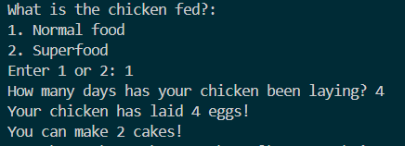
Result: Did the program behave as expected ie syntactically and logically correct?
YES

(Copy and paste box above for each of the rest of the tests)

Test:
Normal food ii. 9 days (should be 9 eggs = 4 cakes)

Screenshot(s) of output:
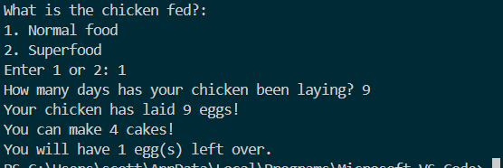
Result: Did the program behave as expected ie syntactically and logically correct?
YES

Test:
Normal food iii. -3 days (no cakes or error handled)

Screenshot(s) of output:
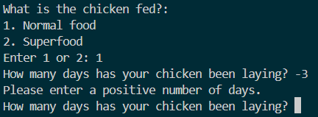
Result: Did the program behave as expected ie syntactically and logically correct?
YES

Test:
Normal food iv. 10000 days (program should catch the error – many of these eggs would be bad!)

Screenshot(s) of output:
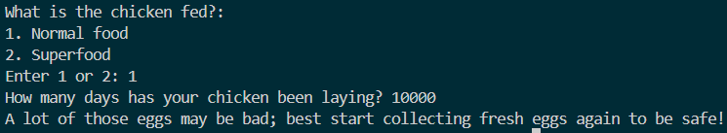
Result: Did the program behave as expected ie syntactically and logically correct?
YES

Test:
Super food v. 4 days (should be 6 eggs = 3 cakes)

Screenshot(s) of output:

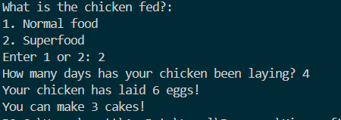
Result: Did the program behave as expected ie syntactically and logically correct?
YES

Test:
Super food vi. 5 days (should be 7 eggs = 3 cakes)

Screenshot(s) of output:
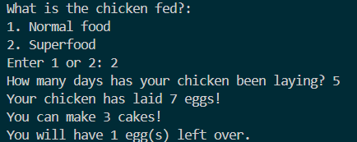
Result: Did the program behave as expected ie syntactically and logically correct?
YES

Test:
Super food vii. 1 days (should be 1 egg = 0 cakes)

Screenshot(s) of output:

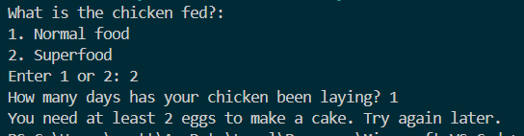
Result: Did the program behave as expected ie syntactically and logically correct?
YES

Test your menu
viii. What happens if you enter “3”?

Screenshot(s) of output:

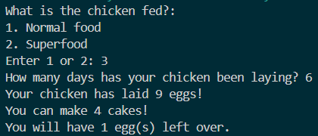
Result: Did the program behave as expected ie syntactically and logically correct?
NO – it has accepted 3 using the Superfood calculation. The program needs validation that only 1 or 2 must be accepted, and if anything else is entered, it should re-prompt the user the question again.

- Consider the results of the above tests and revisit your original code in order to address the tests that failed. (Note: you may not be able to solve all of the problems that were originally encountered, but solve as many as you can.)

Paste your full revised code here :

[Copy and paste your full revised code here – note, do not use a screenshot]

#Food menu

print("What is the chicken fed?:")
print("1. Normal food")
print("2. Superfood")

choice = input("Enter 1 or 2: ")

while choice != "1" and choice != "2":
print("Please enter 1 or 2.")
choice = input("Enter 1 or 2: ")

#days laying and eggs laid

days = int(input("How many days has your chicken been laying? "))

while days < 0:
print("Please enter a positive number of days.")
days = int(input("How many days has your chicken been laying? "))

if choice == "1":
eggsLaid = days
else:
eggsLaid = (days * 3) // 2

if eggsLaid < 2:
print("You need at least 2 eggs to make a cake. Try again later.")

elif eggsLaid > 50:
print("A lot of those eggs may be bad; best start collecting fresh eggs again to be safe!")

#cakes made

else:
cakesMade = eggsLaid // 2
eggsRemaining = eggsLaid % 2

print("Your chicken has laid", eggsLaid, "eggs!")
print("You can make", cakesMade, "cakes!")

if eggsRemaining:
print("You will have", eggsRemaining, "egg(s) left over.")

