

BANKING AND FINANCE ECONOMICS
(LCMB7032)
COMPANY NAME: T-MOBILES
STUDENT ID:2313893

Table of Contents
Overview of T-Mobile US, Inc. 3
Business Model 3
Target Market: 4
Unique Selling Proposition (USP): 5
Key Reasons Why T-Mobile Went Public 5
C) Review of T-Mobile’s S-1: Key Risks and Valuation Considerations 6
Valuation in the Context of These Risks 7
To determine T Mobile US performance, we can assess indicators across various periods. Here are some key details regarding T-Mobile's return 8
The Compound Annual Growth Rate (CAGR) for T-Mobile US, Inc. 9
Sharpe Ratio: 10
Charter Communications (CHTR) 12
The construction option strategies: the Straddle. 15
Performance of the 10-Year Treasury Note (January - December 2023) 17
Impact of Changes in the 10-Year Treasury Yield on Consumer Debt 19

Overview of T-Mobile US, Inc.

T Mobile is having a day, as a brand. Reaching this point was not an overnight success story. It all started back in 1994 when VoiceStream Wireless PCS was founded as part of Western Wireless Corporation. By 1999 VoiceStream had branched out from its parent company and in 2001 Deutsche Telekom acquired VoiceStream leading to the birth of the T Mobile brand on September 4, 2002.
Back in my college days, I worked at a Circuit City store in Colorado selling services when I was approached by a representative from VoiceStream who recruited me to join the company. Since then, I've been part of the journey from VoiceStream to T Mobile. Witnessed the transformation into a powerful T Mobile after merging with Sprint in 2020. Along the way, there have been obstacles. I've come to understand the importance of taking risks and seizing opportunities. Both brands and individuals experience growth when they step out of their comfort zones and embrace challenges, for their customer's sake. (Katz, 2022)

Business Model:
T-Mobile follows a business strategy centered on offering budget services with clear pricing dependable network reach and top-notch customer care. They make money through service subscriptions selling devices and additional services. Their focus is, on serving individuals, families, and small businesses. Important tasks involve maintaining network infrastructure assisting customers and creating products. T-Mobile's triumph stems from providing cost-customer-oriented options. (Cuofano, 2023)
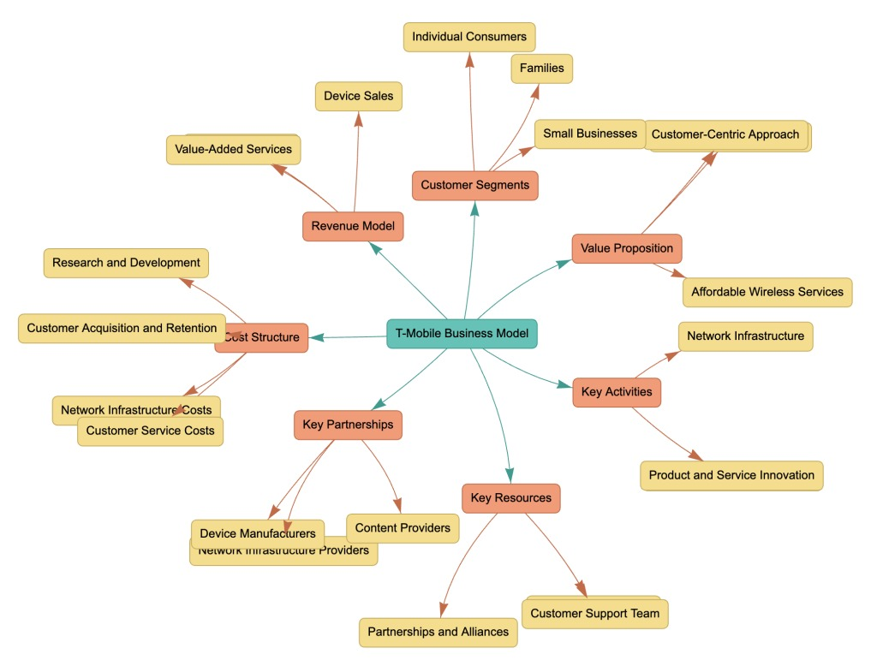
Sources- https://fourweekmba.com/t-mobile-business-model/

Target Market:
T Mobile aims to reach an audience, in the mobile service market. Their marketing approach is mainly geared towards a specific group. Millennials are a focus for T-Mobile as they are typically tech-savvy and mindful of their budget. The company resonates with this demographic through its branding emphasis on data plans and competitive pricing. Moreover, T Mobile uses references from culture and social media trends to engage with the generation.
It's worth mentioning that T Mobiles' appeal extends beyond millennials. Their emphasis on affordability and network coverage also attracts cost customers of all age groups as well as families seeking budget-friendly plans, for multiple lines. (TBH, 2024)

Unique Selling Proposition (USP):
T-Mobile customers enjoy the blend of affordability and excellence along, with a focus on providing top-notch service and a commitment to driving innovation in the wireless industry and, beyond. (T-Mobiles Inc., 2022)

Key Reasons Why T-Mobile Went Public
T Mobile US Inc. (NYSE; TMUS) made an announcement today about starting a sale of 66,150,000 shares of its stock through a registered offering. The company plans to use the money raised for purposes such, as investing in its operations strengthening its financial position, and potentially buying more wireless spectrum, through private deals or government auctions. T Mobile also plans to give the underwriters the option to buy 6,615,000 shares of its stock in this offering. (T-Mobiles Inc., 2013)

- Access, to Funding: -
By going public T Mobile can raise an amount of funds by selling shares. This money can be utilized for expanding networks enhancing technology and upgrading infrastructure. (T-Mobiles Inc., 2013)
- Reducing Debt Burden: -
Public offerings can supply the capital to pay off existing debts. A healthier financial position is appealing to investors. Can enhance the company's wellbeing. (T-Mobiles Inc., 2013)
- Enhanced Visibility and Trustworthiness: -
As a traded entity T Mobiles' presence in the market is boosted, attracting customers and potential partners. It also boosts credibility among investors and stakeholders. (T-Mobiles Inc., 2013)
- Employee Motivation: -
The decision to go public empowers T Mobile to provide employees with stock options and equity compensation. This strategy helps in attracting and retaining talent by aligning employee interests with company success. (T-Mobiles Inc., 2013)
- Market Assessment: -
Through a listing, T-Mobile can determine its market value. This information aids in planning. Serves as a performance benchmark. (T-Mobiles Inc., 2013)
- Flexible Strategic Approach: -
With increased capital and resources at hand, T Mobile can actively pursue endeavors like acquisitions or partnerships. Such flexibility is crucial, in an industry landscape. (T-Mobiles Inc., 2013)

C) Review of T-Mobile’s S-1: Key Risks and Valuation Considerations
T-Mobiles' recent submission of the 10 K form, to the SEC outlines challenges that the company may encounter in the coming year. Let's delve into three risks and evaluate how likely they are to materialize.
- Competition and Industry Consolidation- T-Mobile is up, against competition from wireless carriers, cable companies, and new entrants in the connectivity industry. They strive to stand out in areas like network performance, customer support, pricing strategies, and technological advancements. The ongoing industry mergers, like the union of Dish and DirecTV, may heighten the landscape. (T-Mobile, 2023)

Probability Of Occurrence- The wireless sector is quite competitive with T Mobile expected to encounter rivalry from both existing companies and newcomers. The trend of industry consolidation might further escalate the competition.

- Cybersecurity Breaches and Unauthorized Access- T-Mobile has faced several cybersecurity breaches and instances of individuals gaining access, to customer information and valuable intellectual property. These occurrences can result in expenses harm, to reputation and financial consequences that insurance might not entirely mitigate. (T-Mobile, 2023)

Probability Of Occurrence- The level of risk ranges from, high to high. Companies in the technology and telecommunications industries remain vigilant about cybersecurity threats. Despite T-Mobiles' efforts to implement strategies, the changing threat environment leaves room for potential incidents, in the future.

- Challenges Related to the Sprint Merger- T-Mobile is currently transferring Sprint's long-time customers to its billing systems. This transition may encounter challenges leading to delays that could impact T-Mobile's business, image, and financial health. (T-Mobile, 2023)
Probability Of Occurrence- The level of risk ranges from, high to high. Companies in the technology and telecommunications industries remain vigilant about cybersecurity threats. Despite T-Mobiles efforts to implement strategies, the changing threat environment leaves room for potential incidents, in the future.
Conclusion- In a nutshell, T-Mobile is dealing with challenges posed by rivals, cybersecurity risks, and the complexities of merging. Despite efforts to address these issues they still pose worries that could affect the company's operations and financial results.

Valuation in the Context of These Risks
In T-Mobiles submission, to the SEC, for 2022 they outlined a few challenges that could impact the company. Delve into three risks and evaluate how likely they are to happen:
- The potential effect, on T-Mobile's value is substantial. With heightened competition, there is a risk of impact, on market share and profits potentially resulting in a valuation.

- The effect, on T-Mobile's value could be moderate due to cybersecurity incidents.
However, if the company can uphold customer trust and steer clear of fines the financial consequences might be manageable.

- T Mobile has a history of completing mergers but if there are any delays or problems, during the integration process it might affect the company's value temporarily until those issues are sorted out.

Conclusion
Although T-Mobile is currently valued attractively in relation, to its value and the targets set by analysts investors must consider the effects of significant risks, on the company's future growth and performance. It is vital for T-Mobile to effectively handle competition, cybersecurity risks, and challenges related to mergers to uphold its market standing and provide value to its shareholders.

Part- B
Quantitatively review the share price performance of your selected company from its IPO until December 31, 2023

- T-Mobile's share price performance from its IPO to December 31, 2023: a quantitative review of key metrics and milestones

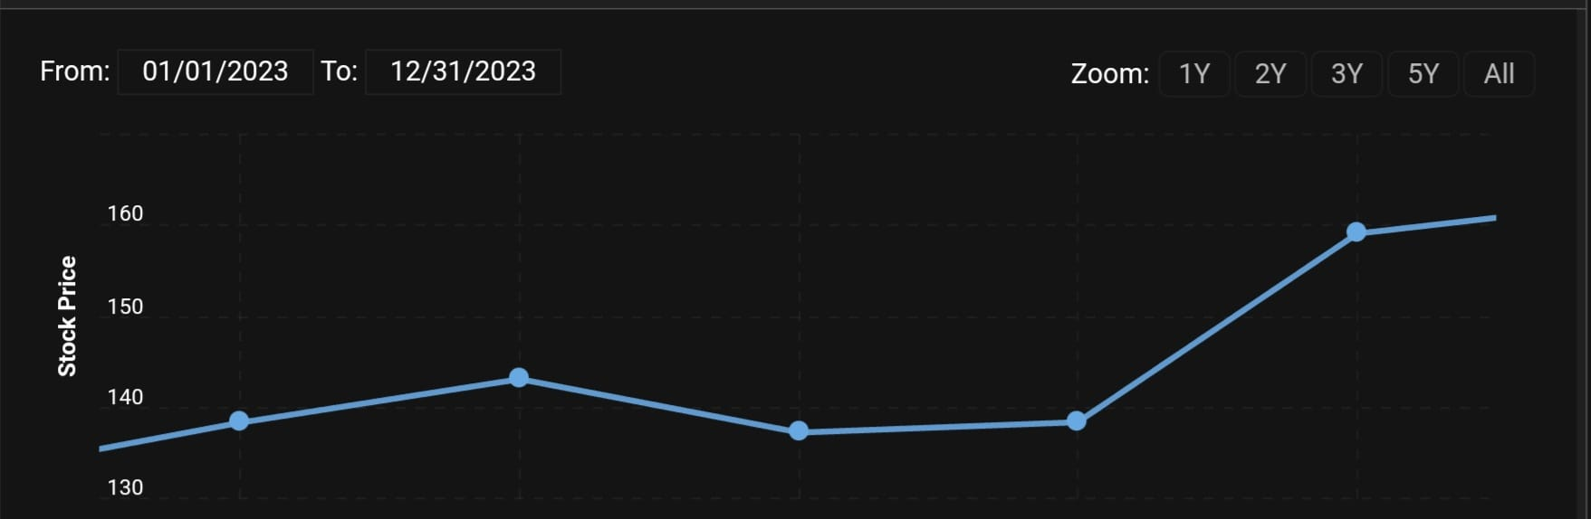
One year in a 52-week Range: $ 131.36(Low) to $160.44 (High).
P/E Ratio:22.96
Dividend yield is 0.41%
All-Time High: $160.44 on December 12, 2023.
Annual Performance the share price increased by 15.31% over the past 365 days, underperforming the S&P 500 by 24%
Comment: The recent performance of T Mobiles stock indicates a blend of perspectives on its prospects. The stock has been moving in the range of $131 36 and $160 44 over the 52 weeks with the latter marking its highest point ever achieved on December 12th, 2023. However, the overall annual performance has not been as impressive with a modest increase of 15-point three one percent, in the past year although it is positive it falls short compared to the broader performance of the S&P 500 trailing behind by twenty-four percent. It appears that while T Mobile has seen some expansion, in its operations it has not quite matched the progress of the market. The P/E ratio of 22 shows that the stock is reasonably valued at its earnings. Not high or too low. This suggests that investors are somewhat optimistic about the company's future profit potential. However, with a dividend yield of 0.41%, it seems like T-Mobile isn't an income-generating stock and probably focuses more on growth and reinvestment rather than giving dividends to shareholders. T Mobile has seen a response, from investors in the year with its stock hitting a new high despite an annual performance that falls short of the S&P 500 at 15.31%. The P/E ratio of 22 indicates the stock is priced, hinting at growth expectations. With a dividend yield of 0.41% T Mobile seems focused on reinvesting for growth rather than offering high returns to shareholders. These factors suggest growth potential. Hint at challenges, from tough competition and market doubts about its ability to outperform broader market trends. While growth-focused investors may find T-Mobile appealing others seeking returns or income alternatives might look elsewhere for opportunities.

To determine T Mobile US performance, we can assess indicators across various periods. Here are some key details regarding T-Mobile's return: -
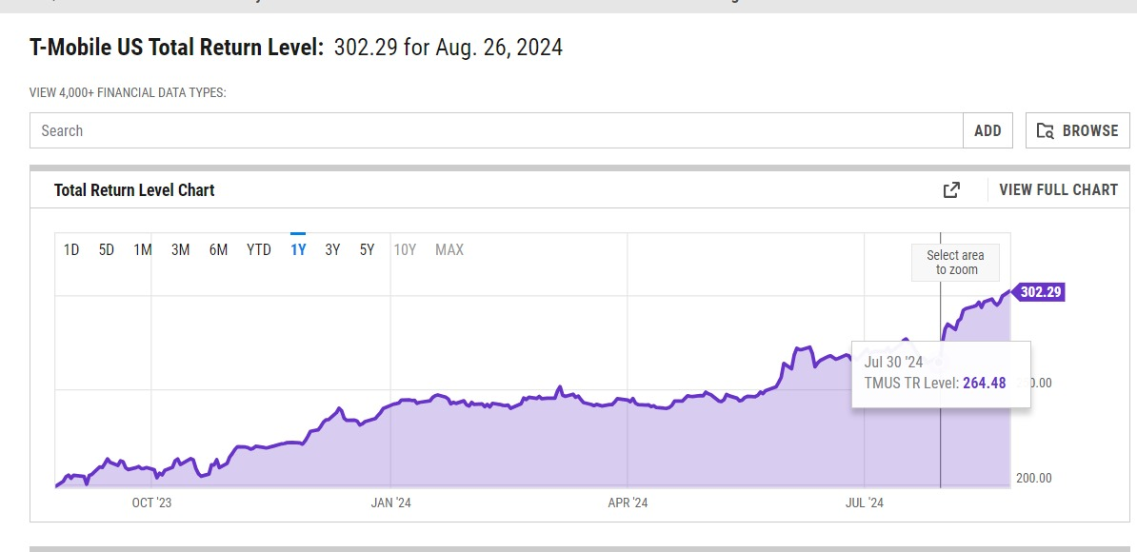
SOURCE- https://ycharts.com/companies/TMUS/total_return_forward_adjusted_price

15-Year Price Total Return, Over the five years T Mobile US has demonstrated an impressive total return of 163.3% indicating substantial growth, in its stock price during this period.
Year to Date (YTD) Price Total Return; Currently T Mobiles YTD price total return is at 3.1% showing an uptick, in its stock price since the start of the year.
Total Return Level, As of July 30,2024 T Mobiles' total return level was recorded at 264.48. (YCharts, 2024)

The Compound Annual Growth Rate (CAGR) for T-Mobile US, Inc.
Definition of CAGR
The compounded annual growth rate (CAGR) illustrates the performance of a factor, over a substantial timeframe and is employed to evaluate the comparative profitability of companies. (Groww, n.d.)
Formula
CAGR= ((BVEV)n1-1) x100
Where:
EV= ENDING VALUE
BV= BEGNING VALUE
N= Numbers of Years
CAGR:(160.33/139.04) =1.153121
=1.153121-1x100
=0.00057

Comment: A Growth Rate (CAGR) of 15.31% showed growth throughout the year indicating a 15.31 % increase in the company's stock price from the beginning to the end of 2023 This growth rate reflects positively on T Mobiles' performance during that period implying successful strategies and potentially favorable market conditions. Investors often rely on this metric as it gives them a view of how the company has been progressing during the specified period. In 2023 T Mobile showed a performance, with a growth rate of 15.31% indicating strategies and favorable market conditions. This suggests that T Mobile effectively navigated the telecom landscape improved its value proposition and maintained growth. Investors can use this growth rate as an indicator of the company's progress showing that T Mobile delivered returns during the period. It's important to consider market trends and the sustainability of this growth when evaluating metrics. Overall this performance is likely to increase investor confidence, in T-Mobiles' ability to execute strategies and create value in a market.

Sharpe Ratio:
The Sharpe ratio is a way to measure how much return an investment portfolio generates compared to the risk involved. It helps investors gauge the trade-off, between risk and reward indicating the level of risk taken to achieve returns. Investors expect to be rewarded for taking on risks beyond what risk-free assets offer.
The Sharpe ratio is versatile. To analyze return data sets without requiring detailed information about volatility or profitability sources. It is commonly used for comparing the risk-adjusted returns of types of investments such, as stocks, ETFs, mutual funds, and investment portfolios. (CMC Markets, n.d.)

Formula of Sharpe ratio:
{R(p)-R (f)}/s(p)
R (p): Portfolio return
R (f): Risk-free rate of return
s (p): Standard deviation of the portfolio
rp-rf=0.3
s(P)=0.011836
rp-rf/s(P)=0.3/0.011836=2.534598

Comment: T-Mobiles portfolio boasts a Sharpe ratio of around 25‌ ‌percent‌ ‌– a figure that signifies remarkably high returns compared to its risk‌ levels. Typically a Sharpe ratio exceeding 1 is considered favorable, surpassing 2 is deemed, and exceeding 3 is exceptional A ratio as substantial as 25% suggests that the portfolio's performance is exceptional with minimal risks in relation, to the returns it yields. This could indicate either an investment approach or stable returns, in T Mobiles portfolio performance. Nevertheless, a value this high may also lead to a review of the data inputs to verify their accuracy.

Treynor Ratio:
The Treynor Ratio is a method, for evaluating how well a portfolio performs while considering the level of risk involved. Unlike the Sharpe Ratio, which considers return on the portfolio's deviation the Treynor Ratio looks at the Portfolio Beta, a gauge of risk. (CFI Team, 2024)
These metrics focus on assessing both the risk and return aspects of a portfolio. Are essentially calculated by dividing return by risk. The Treynor Ratio is named after Jack Treynor, an economist who played a role, in developing the Capital Asset Pricing Model.
Formula of Treynor ratio:
Treynor Ratio = (rp – rf) ÷ βp
rp = Portfolio Return
of = Risk-Free Rate
βp = Beta of the Portfolio
rp-rf=0.03
βp=0.51
(rp – rf) ÷ βp=0.0534598

Comment: The Treynor ratio of the T-Mobile portfolio is around 0,05882 showing the return, for each unit of risk (beta). With a Treynor ratio of 0.05882, it implies that the portfolio generates a return of approximately 5.88 % for every unit of market risk it carries. An elevated Treyson ratio suggests risk-adjusted performance compared to the market. To assess if the return justifies the market risk assumed it is essential to compare this ratio with investments or benchmarks. In terms of value assessment indicates a moderate return considering the amount of systematic risk involved, this could be deemed acceptable based on the investor's risk appetite and prevailing market circumstances. A Treynor ratio of 0.05882 implies that for every unit of risk, T-Mobiles portfolio yields a return of 5.88%. This ratio indicates that the portfolio is offering a return considering the market risk it faces the assessment of whether this return is favorable depends on factors such, as the investor's risk tolerance the goals of the portfolio, and current market conditions to truly gauge the effectiveness of this return it is essential to compare T Mobiles Treynor ratio with benchmarks or similar investments. For example, comparing it with the Treynor ratio of a market index (such as the S&P 500) or comparable companies in the telecom sector can provide insights into how the portfolio performs in terms of risk-adjusted returns. T Mobiles ratio exceeds these benchmarks which suggests that the portfolio is outperforming relative to the market by delivering returns per unit of risk. Conversely, if the ratio is lower it may indicate underperformance compared to the market Return and Risk with a Treynor ratio value of 0.05882 it indicates a return, for the level of systematic risk undertaken. Depending on an investor's risk appetite this could be deemed acceptable for investors a modest return, with controlled risk, might be appealing. On the side, daring investors may be inclined to pursue higher returns despite the risks involved Considering the current market conditions is crucial. In a market that's volatile or uncertain, a Treynor ratio of 0.05882 could be seen in a light indicating a portfolio that can maintain a steady return amidst market fluctuation the acceptability of a 5.88% return per unit of market risk will heavily rely on investor objectives and the broader market landscape. If an investor values stability and modest growth this Treynor ratio could align well with their expectations Nevertheless for investors aiming for returns and willing to take on risk this ratio may fall short leading them to consider more aggressive investment approaches or adjust their portfolio to boost the Treynor ratio T Mobiles Treynor ratio of 0.05882 signifies a portfolio that offers a return to its market risk exposure. This ratio serves as a gauge of the portfolio's performance adjusted for risk and its adequacy should be assessed in comparison, with benchmarks and considering the investor's risk tolerance in a market or one, with fluctuations this ratio could be viewed as offering a balanced and satisfactory return. However, individuals with a risk tolerance might see the return as modest. Overall the Treynor ratio is a tool for investors to assess whether the returns justify the risks associated with the market.

3 Charter Communications (CHTR)

stock price as of the latest data: $315.23
Let's consider an at-the-money call option with the following details:
- Strike price: $315 (closest to current stock price)
- Option premium: $20 (hypothetical, based on typical at-the-money option pricing)
- Expiration: 1 month from now
The payoff diagram:

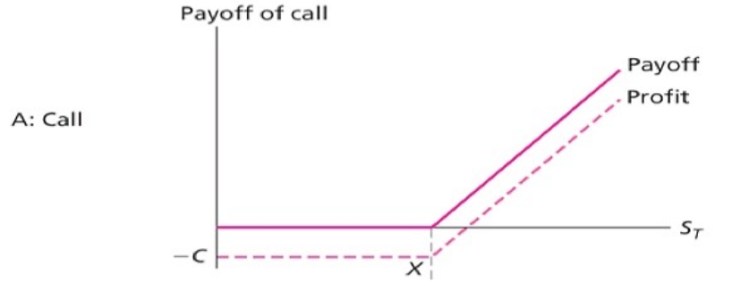
Strike Price Right Now is $ 330.00
Profit as of now is $ 30.77 per share

Explanation of the graph:
The contract ends on 13th September 2024

Hence, the current price of a share is $360.77 is greater than the strike price of $ 330.00, the option is “in the money”
Strike price $ 330.00
Last Price of the call option (premium): $360.00
Inputting the Formula for calculation
Pay off = Current Price of share- Strike Price
Payoff= $360.77- $330.00
Payoff= 30.77

Payoff Profit= payoff- Premium
Payoff Profit= $30.77-$360.00
Payoff Profit= -329.67

Money Put Option

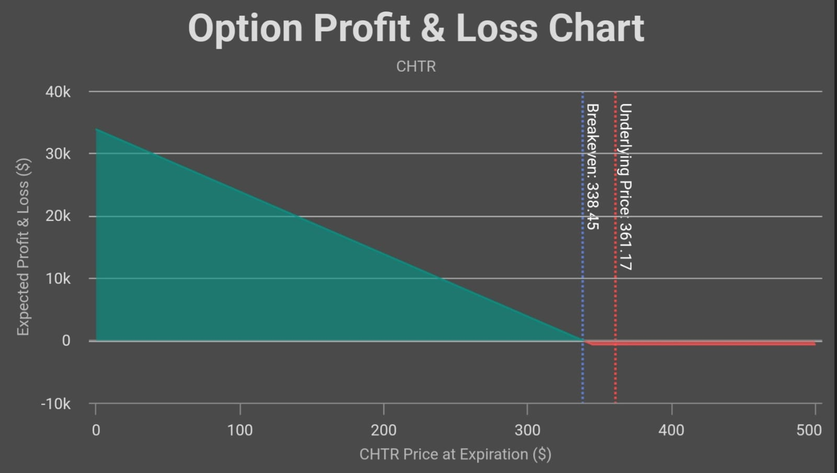

Current Stock Price: $312.77
Breakeven Price: $285.75
Maximum Profit: $28,575.00
Maximum Loss: -$925.00
Payoff Structure
The payoff from a put option is calculated using the formula:

Payoff = Max (Strike Price - Stock Price)
Put option with a strike price of $350.
stock price at $312.77
Payoff = Max (350 - 312.77, 0) = $37.23
The stock price at expiration is $400:
Payoff = Max (350 - 400, 0) = $0
comment of put option payoff:
The breakeven price refers to the stock price where the overall profit or loss, from the option trade becomes zero calculated by subtracting the option cost from the strike price and adding any expenses to it.
Optimal Earnings Potential: This represents the potential profit achievable, with the put option often realized when the stock price reaches its lowest point potentially hitting zero. The maximum loss is the amount you could lose if at expiration the stock price is higher, than the strike price resulting in the put option being worthless. When considering a put option for a company such as, OF Chater Communication Company's stock it could be useful to discuss how the current stock price compares to the strike price.
The stock price for OF Chater Communication Company is currently at $312.If the stock price stays the same. The option has a value of $37. The potential profit, with this option is $28. If the stock price drops to zero. However, the maximum loss is limited to $925. Which represents the premium paid for the option. This arrangement offers an approach to protect against substantial drops, in stock value while minimizing potential losses."
This statement provides background information, on the value and risk/reward characteristics of the option considering the current stock price and option details.

The construction option strategies: the Straddle.
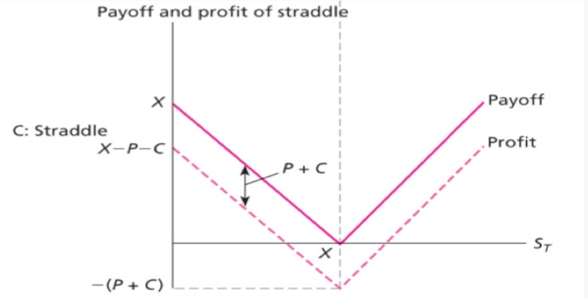

Construction of a Straddle for CHTR:
Current Stock Price: $312.77
Strike Price: $315
Call Option Premium: $15.00
Put Option Premium: $12.00
Total Cost of Straddle = $15.00
$ 15.00(Call)+$12.00 (Put) = $27.00
Payoff Scenarios
The payoff from a straddle is calculated based on the stock price
stock price rises to $350
Call Payoff = Max ($350 -$315) = $35
Put Payoff = Max (315 - 350) = $-35
Total Payoff = 35−27 (cost of straddle) = $8
If the stock price falls to $280
Call Payoff = Max (280 - 315) = $-35
Put Payoff = Max (315 - 280) = $35
Total Payoff =
35−27 (cost of straddle) = $8
stock price remains at $312.77:
Call Payoff = Max (312.77 - 315) = $-2.23
Put Payoff = Max (315 - 312.77) = $2.23
Total Payoff =
2.23−27 = -$24.77 (loss)

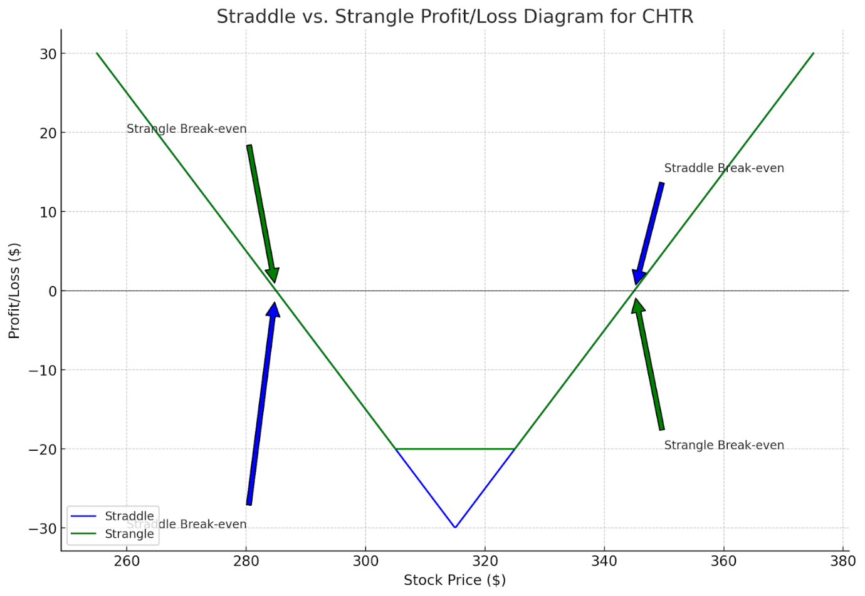

Comments: Successful Situations; The straddle generates profit when the stock price makes a shift from the strike price of $315 in either direction. Reaching $350 or dropping to $280. Which not only covers the straddles expenses but also results in a gain. A situation where the stock price hovers around the strike price of the straddle option strategy without moving in either direction could lead to a loss as the cost of setting up the straddle may not be recouped effectively Earning Opportunity Using a straddle strategy can help protect against price swings in the market. The stock must shift by, over $27 from the strike price to yield a profit. In instances a profit is made from both upward and downward movements exceeding $27 There is a chance of losing money if the stock price stays close, to the strike price of $315 because the straddle might not offset its expenses and result in a loss. The straddle approach works well in situations where you expect price fluctuations, in either direction for a stock. The example talks about a strike price set at $315. To make a profit with the straddle strategy the stock price needs to change by, $27 in either direction from this strike price. This implies that the break-even points are at $342 (315 + 27) on the upside and $288 (315. 27) on the downside. The straddle will only yield a profit if the stock surpasses these points Potential for Profit The straddle can be profitable in both downward movements provided that the price shift exceeds $27 from the strike price. The higher the price movement beyond this threshold the profit since one of the options (either call or put) will gain significant value Risk of Loss. When the stock price hovers near $315 there's a risk of loss with a straddle. This is because neither option may increase enough in value to offset the costs (premiums) of buying both options. In some cases, investors may incur losses as premiums are paid for both calls. Put options could outweigh gains, from minor price shifts. Favorable Market Conditions, The straddle strategy proves to be quite effective, in markets. When there's an anticipation of a notable price shift due to upcoming events like earnings releases, regulatory decisions, or macroeconomic updates. It's an approach that doesn't hinge on the direction of the movement but on the magnitude of the price change Points to consider While the straddle offers a safeguard against price fluctuations in any direction it involves the expense of purchasing two options. This cost needs consideration against profits, especially in cases where market volatility may not be as high as pred. The straddle strategy serves as a tool for traders anticipating price swings in a stock while being unsure about the direction. The condition that requires the stock price to move by more than $27 from the $315 strike price to yield profits highlights how crucial market volatility is for this strategy to succeed. Nonetheless, if the stock price remains close, to the strike price there's a risk of facing losses as the straddle might not generate value to offset expenses. This tactic shines brightest when substantial price fluctuations are expected making it a preferred choice during times of predicted market unrest.

Performance of the 10-Year Treasury Note (January - December 2023)

In 2023 the U.S. Saw changes, in the performance of the 10 Year Treasury Note mainly influenced by factors worries about inflation and decisions made by the Federal Reserve
- Early 2023: At the start of the year yields stood at 3.79% because of worries, about inflation and the Federal Reserve's dedication, to increasing interest rates. (Investing.com)
- Mid-Year Peaks: The Federal Reserve raised interest rates to combat inflation causing bond yields to rise above 4.30% in the summer. This led to a decrease, in bond prices signalling worries, about inflation and economic instability.​ (FRED)
- Late 2023 Stabilization: By the close of 2023 interest rates settled around 3.8%, above levels. This stability was influenced by inflation concerns and the Federal Reserve's actions to steer the economy. ​ (YCharts)
In 2023 the fluctuations, in the 10-Year Treasury Note reflected the ups and downs with the constant struggle to combat inflation.
Recent Developments:
The 10-year Treasury Rate has experienced an uptick, from the market day moving from 3.82% to 3.83%. This small shift reflects how the market is reacting to indicators of Federal Reserve announcements or global geopolitical events.
In comparison to this time of year, the rate has dropped from 4.20% to 3.83%. This decrease suggests that bond yields have declined, in response to expectations of inflation a slowdown in economic growth, or changes in Federal Reserve policies.
Comparative Analysis with Long-Term Averages:
The current rate of 3.83% is below the long-term average of 4.25%. This indicates that historically interest rates have remained relatively low despite fluctuations. The long-term average is influenced by periods of inflation and assertive monetary policies by the Federal Reserve, such as those seen in the late '70s and early '80s.
Historical Background:
The peak of the 10-year Treasury Rate reached 15.84% in 1981 during a period of inflation. This prompted Chairman Paul Volcker and the Federal Reserve to raise interest rates as part of measures to combat rampant inflation—a major economic challenge, at that time.

The 10-year Treasury rate is commonly used by analysts, as the "risk rate when assessing markets or individual securities. This is because U.S. Treasury securities are viewed as having credit risk due to government support.
Fluctuations in the 10-year Treasury rate can impact the valuation of stocks, bonds, and other financial assets. A lower rate typically results in asset valuations as the discount rate for cash flows decreases.
Position on the Yield Curve:
The 10-year Treasury falls within the end of the yield curve, which displays interest rates for bonds with varying maturities. The shape of the yield curve offers insights into market expectations regarding interest rates, economic growth, and inflation.
A rising 10-year Treasury rate compared to shorter-term rates may suggest anticipations of increased inflation or stronger economic growth. Conversely, a declining rate could indicate worries about a slowdown or deflationary trends.

In Conclusion:
The current 10-year Treasury rate reflects a blend of market conditions and historical long-term patterns. Although rates have seen an uptick, from the day they remained below the historical average indicating a relatively low-interest rate environment compared to past standards.
The interest rate holds importance in the realm impacting various aspects such, as mortgage rates and stock value assessments. It also offers insights into the market outlook, of the U.S. Economy.

Impact of Changes in the 10-Year Treasury Yield on Consumer Debt

Fluctuations, in the returns of the 10-Year Treasury Note significantly impact consumer borrowing in sectors, like home loan rates, car financing, and credit card interest charges.
- Mortgage Rates: The 10-year Treasury yield has an impact, on mortgage rates for 30-year fixed-rate mortgages. When yields go up mortgage rates usually follow suit leading to borrowing costs for homebuyers. In 2023 the uptick in the 10-year yield played a role in pushing mortgage rates thereby dampening the housing market as it became less affordable for aspiring homeowners. (YCharts) Some areas even saw mortgage rates exceed 7% greatly affecting the demand, for housing.
- Auto Loans: Increased Treasury bond yields also resulted in interest rates, for car loans. As auto loans typically come with fixed rates the surge in yields during 2023 caused a rise in the cost of financing vehicle acquisitions for consumers. This uptick in loan expenses contributed to a decrease, in automobile sales as buyers encountered elevated payments. (YCharts)
- Credit Card Debt: Credit card interest rates are usually influenced by trends, in interest rates. When the 10-year Treasury yield went up in 2023 credit card interest rates followed suit. This made it more challenging for consumers to manage their debt with inflation squeezing their income and making it tougher to settle outstanding balances. ​ (YCharts)
Throughout 2023 the rise, in the 10-year Treasury yield influenced consumer debt. This resulted in increased borrowing expenses for types of loans making it harder for people to afford them and causing a slowdown, in consumer spending in the housing and automotive industries. Between 2010 and 2012; During this time frame T Mobile US had an amount of long-term debt reflecting its smaller presence, in the market compared to its current size. The debt levels were typical for a company in the process of developing its network and customer base. From 2013 to 2014, T Mobile initiated its "Un-carrier" strategy during this period, which involved making investments in infrastructure and marketing. This led to an increase in long-term debt as the company borrowed funds to support these endeavors.

In the years 2015 and 2016: There was an uptick in long-term debt as T Mobile expanded its network coverage and acquired spectrum to enhance service quality. These investments were essential for T-Mobiles competitiveness against competitors like AT&T and Verizon. During 2017 and 2018, Long-term debt continued to rise partly due to T-Mobiles' preparations for merging with Sprint a move announced in 2018. The company needed financing to handle the merger complexities and sustain its network expansion.

In the period from 2019 completion of the merger with Sprint in 2020 had an impact, on T-Mobiles' standing.
The merger resulted in T Mobile taking on an amount of debt, from Sprint leading to an increase in its long-term debt over the years. In 2021 T-Mobiles' long-term debt amounted to $72.831 billion showing a 2.55% uptick from the year. This indicates that the company was working on stabilizing its financials post-merger and effectively managing its debt while integrating Sprint's assets and customer base. By 2022 the long-term debt had slightly decreased to $72.1 billion signalling a 1% decline from 2021. This reduction suggests that T Mobile was prioritizing reducing its debt load and potentially exploring refinancing options to strengthen its standing following the merger.

However, in 2023 T Mobile experienced another increase in long-term debt reaching $76.412 billion 5.98% surge from the year. This rise could be attributed to investments in enhancing their 5G infrastructure expanding their network reach and covering expenses related to merging Sprint's operations and network. By Q2 of 2024 (as of June 30) T-Mobile's long-term debt had climbed further to $76.557 billion representing a 1.73% increase compared to the year.
The rise, in numbers suggests investments and possibly strategic refinancing or taking on loans to support its operations and competitive stance in the 5G market. Impact of Merger; The merger with Sprint affected T-Mobile's long-term debt increasing its obligations. However, it also positioned T-Mobile as a player in the U.S. Telecommunications market. Focus on 5G Investment; A considerable part of the increased debt in times is likely linked to T Mobiles investment in its 5G infrastructure. The company is committed to maintaining its lead in 5G coverage, which necessitates capital spending. Debt Handling; Despite fluctuations over time T Mobile seems to be managing its debt by engaging in deleveraging and refinancing at intervals to optimize its financial standing. This historical pattern showcases how T Mobile has smartly utilized debt to drive growth expand its network and cement its position, in the telecom sector.

References
- Hargreaves Lansdown (n.d.) T-Mobile US Inc. Share Price Information. Available at: https://www.hl.co.uk/shares/shares-search-results/t/t-mobile-us-inc-usd0.001.
- The Motley Fool (n.d.) T-Mobile US (NASDAQ: TMUS) Stock Quote and News. Available at: https://www.fool.com/quote/nasdaq/tmus/.
- T-Mobile US (n.d.) Historical Look-Up. Available at: https://investor.t-mobile.com/stock-info/Historical-Look-Up/default.aspx.
- T-Mobile US (n.d.) Stock Quote & Chart. Available at: https://investor.t-mobile.com/stock-info/Stock-Quote--Chart/default.aspx.
- Benzinga (2024) Behind the Scenes of Charter Communications' Latest Options Trends. Available at: https://www.benzinga.com/insights/options/24/08/40352217/behind-the-scenes-of-charter-communicationss-latest-options-trends.
- MarketBeat (n.d.) Charter Communications, Inc. (NASDAQ: CHTR) Options. Available at: https://www.marketbeat.com/stocks/NASDAQ/CHTR/options/.
- Barchart (n.d.) Charter Communications Options. Available at: https://www.barchart.com/stocks/quotes/CHTR/options.
- Yahoo Finance (n.d.) Charter Communications (CHTR) Options Chain. Available at: https://finance.yahoo.com/quote/CHTR/options/.
- T-Mobile US (n.d.) Historical Look-Up. Available at: https://investor.t-mobile.com/stock-info/Historical-Look-Up/default.aspx.
- T-Mobile US (n.d.) Stock Quote & Chart. Available at: https://investor.t-mobile.com/stock-info/Stock-Quote--Chart/default.aspx.
- Trading Economics, 2024. United States Government Bond Yield. [online] Available at: https://tradingeconomics.com/united-states/government-bond-yield.
- CME Group, 2024. 10-Year US Treasury Note. [online] Available at: https://www.cmegroup.com/markets/interest-rates/us-treasury/10-year-us-treasury-note.html.
- S&P Global, 2024. SP 10-Year US Treasury Note Futures Total Return Index. [online] Available at: https://www.spglobal.com/spdji/en/indices/fixed-income/sp-10-year-us-treasury-note-futures-total-return-index/.
- Yahoo Finance, 2024. Charter Communications, Inc. Options. [online] Available at: https://finance.yahoo.com/quote/CHTR/options/.
- YCharts, 2024. 10-Year Treasury Rate. [online] Available at: https://ycharts.com/indicators/10_year_treasury_rate.
- MacroTrends, 2024. 10-Year Treasury Bond Rate Yield Chart. [online] Available at: https://www.macrotrends.net/2016/10-year-treasury-bond-rate-yield-chart.
- investing.com. (n.d.). United States 10-Year Bond Historical Data. Investing.com. https://www.investing.com/rates-bonds/u.s.-10-year-bond-yield-historical-data
- Board of Governors of the Federal Reserve System (US). (1962, January 2). 10-Year Treasury Constant Maturity Rate. FRED, Federal Reserve Bank of St. Louis. https://fred.stlouisfed.org/series/DGS10/
- Board of Governors of the Federal Reserve System (US). (1962, January 2). 10-Year Treasury Constant Maturity Rate. FRED, Federal Reserve Bank of St. Louis. https://fred.stlouisfed.org/series/DGS10/
- CFI Team. (2024). Treynor Ratio. Corporate Finance Institute. https://corporatefinanceinstitute.com/resources/career-map/sell-side/capital-markets/treynor-ratio/
- CMC Markets. (n.d.). Sharpe Ratio: Formula & Calculation in Trading | CMC Markets. Www.cmcmarkets.com. https://www.cmcmarkets.com/en-gb/trading-guides/the-sharpe-ratio-definition
- Cuofano, G. (2023, November 7). T-Mobile Business Model. FourWeekMBA. https://fourweekmba.com/t-mobile-business-model/
- Groww. (n.d.). CAGR - Definition & Formula for Compounded Annual Growth Rate. Groww. https://groww.in/p/cagr-compounded-annual-growth-rate
- investing.com. (n.d.). United States 10-Year Bond Historical Data. Investing.com. https://www.investing.com/rates-bonds/u.s.-10-year-bond-yield-historical-data
- Katz, M. (2022, September 1). Reflecting on Roots as T-Mobile Brand Propels Into Future - T-Mobile Newsroom. T-Mobile Newsroom. https://www.t- mobile.com/news/blog/cmo-mike-Katz-voice stream-to-t-mobile-Anniversary
- T-Mobile. (2023, December 31). tmus-20221231. Www.sec.gov. https://www.sec.gov/Archives/edgar/data/1283699/000128369923000016/tmus-20221231.htm
- T-Mobiles Inc. (2013, November 10). T-Mobile Announces Proposed Public Offering of Common Stock. T-Mobiles Inc. https://www.t-mobile.com/news/press/t-mobile-announces-proposed-public-offering-of-common-stock
- T-Mobiles Inc. (2022, February 2). T-Mobile’s Unique Formula Delivers Industry-Leading Service Revenue and Cash Flow Growth and Exceeds 2021 Guidance - T-Mobile Newsroom. T-Mobile Newsroom. https://www.t-mobile.com/news/business/t-mobile-q4-2021-earnings
- TBH, T. (2024, April 9). A Deep Dive into the Marketing Strategies of T-Mobile. The Brand Hopper. https://thebrandhopper.com/2024/04/09/a-deep-dive-into-the-marketing-strategies-of-t-mobile/#google_vignette
- YCharts. (2024). T-Mobile US Total Return Level Trends | YCharts. Ycharts.com; YCharts. https://ycharts.com/companies/TMUS/total_return_forward_adjusted_price

