

LCBB5003 Management economics

Lecthurer:Vasilios Tavlaridis

Stratsimir Milushev 2009416

Date:02.03.2022

Table of content:

Task: Using the appropriate economic theories, discuss and evaluate the possible market structures (Perfect competition, Monopoly, Duopoly, Oligopoly) and their effect on managerial decisions using the appropriate examples

Introduction: What is a Market?

Main body: Perfect competition, Monopoly, Duopoly, Oligopoly

Conclusion:

Reference:

Introduction:

What is a Market?

The market is a concept that describes the interplay between buyers and sellers of products and services, which results in the establishment of prices and quantities, as well as the completion of exchange transactions. The market is a system of economic connections that govern the sale of things in the area of circulation. You go to the store to get the essential goods and services to fulfil a variety of requirements. The demand for these items is formed by the sum of all purchasers of material goods and services. As a result, demand is based on ever-increasing demands, and consumers must pay a set price to fulfil them. Solvent demand refers to their capacity to purchase products and services. Commodity producers, on their part, make things that meet people’s requirements. The supply is made up of all manufacturers together. As a result, supply and demand collide on the market, which is a real or imagined location where the act of selling occurs. The market is an outcome, a condition, and a requirement for property to operate. Markets can be classified into several types:
In terms of territorial boundaries and its scale:

- local

- national

- regional

- global

Complete competition market – an organisational market structure with a large number of participating markets that has access to market information but lacks the power to affect the primary market dynamics (supply and demand) and hence market pricing. Imperfect competition necessitates the inverse or vice versa of the preceding. It is due to so-called market defects – external and internal factors such as a lack of information, uneven improvement of production activities, and the ability of some to respond more quickly to market changes and thus gain more capital, as well as monopoly activities, violations of private property principles, state intervention, and so on. As a result, the market is influenced by a variety of economic pressures that impact market forces and the development of market prices – They have the potential to lead to the formation of monopolies high or monopolistically low colours, monopoly profits, and the limitation of the quantities available. As a result, the market system‘s efficiency is weakened – economic power is imposed on particular economic organisations that have economic supremacy and attempt to limit the scope and strength of free competition as much as possible. The market of imperfect competition, on the other hand, is the natural type of market organisation (because market equilibrium is difficult to achieve and even more difficult to maintain). The mixed economic system‘s organisational structure provides a remedy to the negative impacts of imperfect competition. The state acts as a stimulant for economic processes, with the main aims of safeguarding private property – and the rights and limits that come with it – by governmental punishments; and providing the legal structures that allow the economy to function. As a result of the government‘s participation, an institutional framework for the economy is created, which serves as the foundation for global production, trade, and distribution. The institutional environment is a collection of social, political, and legal laws that govern the market economy‘s institutional structure. This structure represents the market‘s direct agents – businesses, governments, and financial institutions engaging with the market and its participants. The market game‘s rules – a collection of institutional standards of behaviour – are developed.
‌

Main body:

When we talk about “market structure,” we’re talking about a collection of factors that define how a market’s key stakeholders – sellers and buyers – interact.

They are one of the most popular market structures:

- Рerfect competition
- Мonopoly
- Мonopolistic competition
- Duopoly
- Oligopoly

1.Perfect competition market
An organisational market structure that provides equitable access to market information to a wide number of market players but are unable to independently affect the major market dynamics (supply and demand) and, as a result, market pricing formation.

In perfect competition, no company has a considerable amount of power over market processes, especially market pricing. As a consequence, based on supply and demand, the market is in an optimal equilibrium. The following processes and behaviours describe ideal competitive situations:

The product provided by all market participants is precisely similar, resulting in the most elastic demand curve feasible in such a market.
Profit maximisation is the goal of any business.
There are no restrictions on entering or exiting the market.
Everyone has easy access to market information.
There is no sense of giving customers a choice.
When we examine the qualities of perfect competition, we will almost certainly discover that there are few examples of such a market system in use today. Theoretically, it is this market structure that optimally balances supply and demand, output, and pricing, but real-world examples are difficult to come across.

The global financial markets are perhaps one of the greatest instances of ideal competition.
A perfect competition combines a variety of talents and proposals: rationality, a large number of competitors, homogenous commodities…
Rationality is defined as customers’ desire to maximise the pleasure they derive from their purchase and usage of commodities.
The market price is determined by a large number of people. When there is sufficient demand, the price adjusts higher.
Homogeneous goods refers to a product or service in the market that must be visually and qualitatively equal.

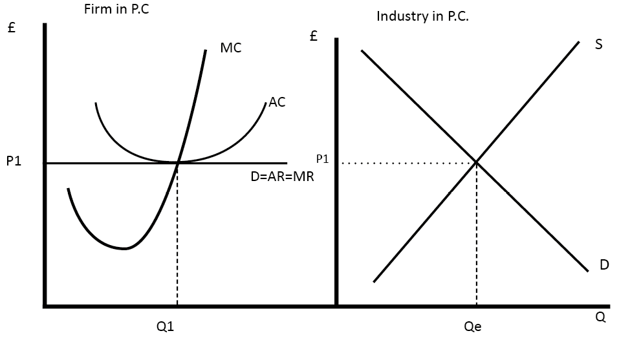
www.economicshelp.org

The industry’s supply and demand determine the market price (diagram on right) This establishes P1’s market equilibrium price. Price takers are individual companies (on the left). Their demand curve is elastomeric.

- A monopoly is a market structure in which one firm dominates the whole market and is the single or primary producer of a product or service.

In its strictest definition, a monopoly means a firm has 100 % market share, yet a lot of governments throughout the globe consider a corporation to have a monopoly if it has a 25 % market share. Because consumers have no other options, a monopoly gives the corporation the most potential market power. As a result, the monopolistic corporation frequently limits its output in order to raise its pricing and profits.

In monopolistic conditions, the following processes and events are common:
There is just one corporation that controls the market, leaving customers with few options.
The monopolist may set any price he wants, resulting in greater market pricing and the most possible profit from the activity.
Entry and exit barriers are strong, making it difficult for other businesses to get into the market.
The monopolist lacks adequate drive to develop and create better products because of its strong position in a non-competitive environment.
The monopolist may force his will on his suppliers as a result of his market strength, resulting in cheaper pricing for them. Monopolies are common in the public sector, where corporations that provide power, water, or rail transportation, for example, have a complete monopoly. Such corporations benefit from massive economies of scale and have high barriers to entry into the sector, making it difficult for any new potential market participant who would have to invest a significant amount of money to enter such a market. Simultaneously, there are cases of monopolies arising as a result of internal organisational efficiency. In this sense, Google, as well as Apple, Amazon, and others, are well-known examples. Most monopolies are undesirable in the public interest because they result in the concentration of significant market power in the hands of a single organisation, which leads to increased pricing and other market inefficiencies. Monopolies are regulated in a lot of nations, which is no coincidence.

Microsoft This is one of the world’s most contentious examples of monopoly and dominance. Its primary product and service area is the hardware and software industry, where it has ushered in a revolution since its foundation.

Bill Gates and Paul Allen founded the company in 1975. Microsoft is in charge of the Windows operating system as well as its add-ons. In the European Union and the United States, there are a number of legal battles regarding monopolies.

Apple is also referred to as a monopolist since it puts limits on its users, as seen by the fact that the majority of the company’s apps are carefully specified and exclusively for this device.

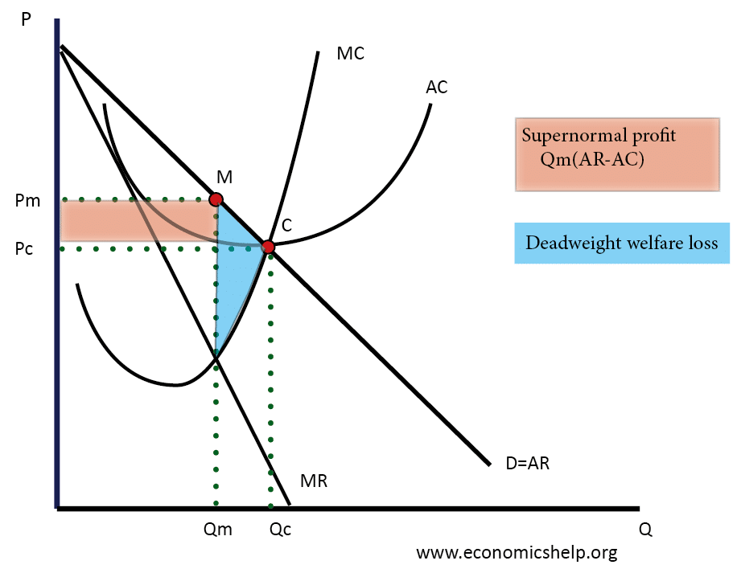

In both the short and long run, the monopoly diagram is widely assumed to be the same. When MR=MC, profit maximisation occurs. As a result, the equilibrium is found at Qm, Pm. (M-point) Because the price (AR) is larger than the average cost (AC), a monopoly can produce supernormal profits.

Monopolistic competition: in this structure, small businesses have and are fighting for certain customers

Unlike the next market structure we’ll look at – ideal competition – these firms provide similar but distinct (different) items. This provides them some market strength, allowing them to pursue their own policies, including changing their pricing to some extent. The following processes and phenomena describe monopolistic competition situations:

Many market participants compete with one another while also attempting to maximise their earnings.

Because a variety of items are accessible, their demand is defined by price inelasticity.
There are no restrictions on entering or exiting the market.
Consumers have a lot of options, and based on the benefits they obtain, they may favour one manufacturer over another. Monopolistic rivalry may be found in a variety of markets, including dairy, bread, muesli, chocolate, alcohol, and many more. There are several manufacturers and brands in each of these industries, each with its own set of unique traits (tastes, colors, sizes, etc.). The competitive strategy of each individual firm in such a market of monopolistic competition is based on these modest distinctive traits.

Diagram monopolistic competition short run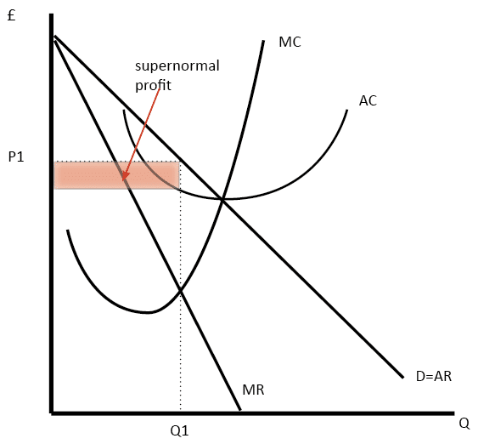

www.economicshelp.org

In the near run, monopolistic competition has the same diagram as a monopoly.

Where MR=MC, the company maximises profit. This is at production Q1 and price P1, resulting in an above-average profit.

Monopolistic competition long run

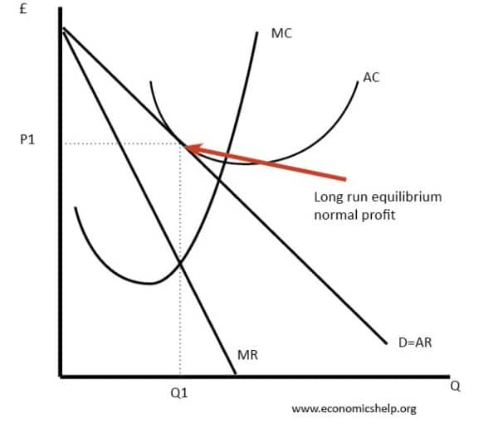

Supernormal profit promotes new enterprises to enter the market in the long run. This decreases demand for current businesses, resulting in typical profit margins.

4.Duopoly

Duopoly (from Greek δύο, duo (two) + πωλεῖν, polein (to sell)) is a type of oligopoly in which two companies have dominant or exclusive control over the market. Because of its simplicity, this is the most widely studied oligopoly. Duopoly sells to consumers in a competitive market where a single customer's decision has no impact on the firm. The interdependence of seller decisions is a distinguishing feature of both duopolies and oligopolies.
Several models of the duopoly are known, but two of them stand out as the main ones: the Cournot duopoly and the Bertrand duopoly.
Cournots approach, in which two firms take over each other's output and treat it as a set quantity, producing in their own companies appropriately.
Bertrand's model, in which one company in a game of two assumes that the other would not respond to its price reductions by raising prices. Both firms will attain Nash equilibrium if they apply this logic. Pepsi and Coca-Cola are examples of duopolies, as are AMD and Intel, McDonald's and Burger King, and others.These are all companies that have almost 100% market share.

Figure 1: Classical Cournot Duopoly Model
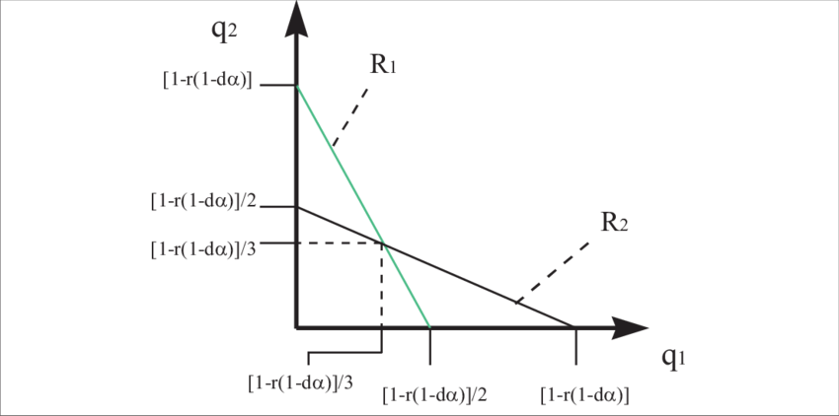
www.researchegate.net

The response functions in the standard Cournot duopoly model are continuous, differentiable, and smooth, as shown in Figure 1. Because of these regularity constraints, each time one business's production varies, the other firm reacts. Indeed, given perfect information, one duopolist will always be aware of the acts of the other duopolist and will always respond. The conjectural variation is zero in equilibrium, which indicates that each business believes that its change in production will have no effect on the other firm. The model established here, on the other hand, is considerably different. As illustrated in Figure 2, the reaction functions are not differentiable nor smooth..

Figure 2: Capacity Constrained Cournot Model
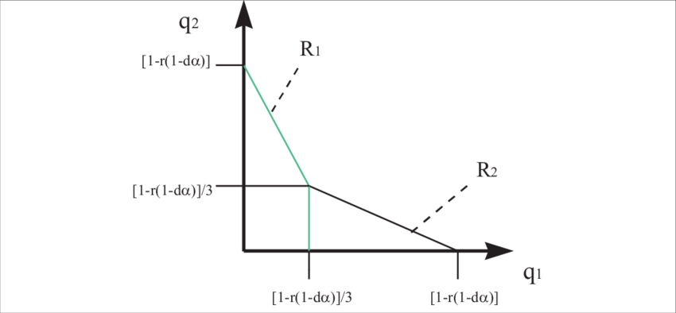
www.researcgate.net

The assumption in this model is that enterprises decide on their production capacity at the start of each session. As a result of its capacity restriction, the duopolist does not have entire freedom to react to the activities of the other enterprise. In reality, each firm's output must fall somewhere between zero and the capital accumulated over the period. In terms of response functions, if firm two decides to cut his level of production for whatever reason, firm one cannot increase its output as a result since its production capacity is limited. This is one of the most significant deviations from the original Cournot model seen in Figure 1. The kinks in the reaction functions are the key to making the standard Cournot equilibrium unstable under the new conditions.

5.Oligopoly

An oligopoly is a market structure in which a small number of enterprises control a product or service market.

One of the most popular market configurations is the oligopoly. The number of firms in it usually ranges from three to five. We can definitely talk about an oligopolistic market structure if this group of enterprises has a market share of 50% or more. There is minimal competition in an oligopoly, and enterprises in the relevant market can either fight with one other or collaborate to raise their total market power, hence rising prices and profits, due to their small number. Yes, you are.

In an oligopoly environment, the following processes and events are common:
There are just a few market actors who are completely independent of one another, which has an impact on how these firms decide on output and pricing.
Oligopolistic firms can fix market prices to their chosen levels, ensuring the best potential profits from the activity.
Companies often avoid competing on pricing, thus there are chances for product differentiation. New market participants are hampered by barriers to entry and departure from the business. Strong brands and associated consumer loyalty, as well as economies of scale, are examples of these hurdles. These hurdles, however, are not as significant as they are in monopolistic market setups. Gas station chains, cellphone operators, grocery store chains, pharmacy chains, bookshop chains, and other retail fuel businesses are examples of oligopolistic marketplaces.

It's tough to break into such oligopolistic industries, and there are major hurdles, because a small number of large corporations control significant financial and material resources, as well as essential raw materials, patents, and other intellectual property.

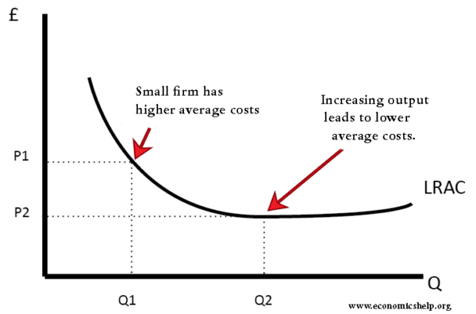

In an oligopoly, the price and output will be the same as in a monopoly. The Quantity Qm will be shared among the cartel's members.

Conclusion:

In summary, the following are the five most common market structures:

Monopoly; Oligopoly; Perfect Competition; Duopoliy; Monopolistic Competition;
Every entrepreneur should be knowledgeable of the market in which he works and what its characteristics are so that he may conduct at least a rudimentary study of the present situation and make projections for his company's future development.

Reference:

1-Petrov, K. (n.d.). [online] Available at: http://bg-pravo.com/2009/12/3_5893.
‌
2-http://novavizia.com/ [Accessed 24 Feb. 2022].
‌
3-www.soas.ac.uk. (n.d.). SOAS University of London. [online] Available at: http://soas.ac.uk.
‌
4-Economics Help. (n.d.). Economics help blog. [online] Available at: http://economicshelp.org/blog/ [Accessed 24 Feb. 2022].
‌5- Research Gate (2019). ResearchGate | share and discover research. [online] ResearchGate. Available at: https://www.researchgate.net/.
‌
6- librarysearch.uwtsd.ac.uk. (n.d.). https://librarysearch.uwtsd.ac.uk/discovery/search?vid=44WHELF_UWTSD:44WHELF_UWTSD_VU1. [online] Available at: http://librarysearch.uwtsd.ac.uk [Accessed 24 Feb. 2022].
‌7-Economics Online. (2020). Oligopoly. [online] Available at: https://www.economicsonline.co.uk/business_economics/oligopoly.html/.
‌8-Boyce, P. (2020). Perfect Competition Definition | 5 Characteristics | 3 Examples | BoyceWire. [online] boycewire.com. Available at: https://boycewire.com/perfect-competition-definition/.
‌9-SendPulse. (n.d.). What is a Duopoly: Features, Advantages, Types - Definition. [online] Available at: https://sendpulse.com/support/glossary/duopoly [Accessed 26 Feb. 2022].
‌10-www.sciencedirect.com. (n.d.). Monopolistic Competition - an overview | ScienceDirect Topics. [online] Available at: https://www.sciencedirect.com/topics/economics-econometrics-and-finance/monopolistic-competition [Accessed 26 Feb. 2022].
‌
11-SendPulse. (n.d.). What is Monopolistic Competition: Basics - Definition. [online] Available at: https://sendpulse.com/support/glossary/monopolistic-competition.
‌
12-Managementstudyguide.com. (2015). What is a Market - Definition and Different types of Markets. [online] Available at: https://www.managementstudyguide.com/what-is-market.htm.
‌

‌

