University of Wales Trinity Saint David
Master of Business Administration
Part II - Dissertation

Research on the factors influencing virtual medical consultation adoption in healthcare industry in Hong Kong

Student Name: Wong Chi Ho, Joe
Student Number: 2119643

Abstract

This research topic is “the factors influencing virtual medical consultation adoption in healthcare industries in Hong Kong”. The research background in this research is based on the situational changes brought out by the COVID-19 pandemic. The development of virtual medical consultation has been accelerated globally during the pandemic. User acceptance of virtual medical consultations has increased in Hong Kong. The trend to keep adopting virtual medical consultation varies from the region during the post-COVID-19 period. It is worth identifying what factors affect the adoption of virtual medical consultation in Hong Kong to make the service more sustainable.

Based on this research motivation, this research study perceived usefulness, perceived ease of use, perceived risk, and eWOM effect on behavioral intention on virtual medical consultations in Hong Kong. Research samples were collected between 1 January 2023 and 15 January 2023. This research uses IBM SPSS 29 to perform analysis against the hypothesis.

Research results confirm that perceived usefulness and perceived ease of use have a positive relationship with behavioral intention while perceived risk has a negative relationship with behavioral intention in virtual medical consultations in Hong Kong. Electronic word of mouth (eWOM) doesn’t show a relationship with the behavioral intention of virtual medical consultations in Hong Kong.

Table of content

I. Table of content I
II. List of figures IV
III. List of Tables V
1. Introduction 1
1.1 Background 1
1.1.1 COVID-19 impacts to Hong Kong virtual consultation 7
1.1.2 COVID-19 create higher demand on online activities in Hong Kong 9
1.2 Research motive 11
1.3 Research questions 11
1.4 Research aims 12
1.5 Research objectives 12
1.6 Research flow 13
1.7 Concluding summary 15
2. Literature Review 16
2.1 Technology Acceptance Model (TAM) 16
2.1.1 Perceived usefulness 18
2.1.2 Perceived ease of use 20
2.2 Perceived risk 21
2.3 Electronic Word of Mouth (eWOM) 27
2.4 Behavioral Intention 28
2.4.1 Definition of behavioral intention 29
2.4.2 Measurement of behavioral intention 29
2.5 Relationship between variables 30
3. Research Methodology 33
3.1 Research Framework 33
3.2 Type of Research 35
3.2.1 Quantitative research 35
3.2.2 Qualitative research 36
3.3 Data collection method 36
3.4 Sampling Method 37
3.5 Questionnaire Design 38
3.5.1 Focus Group 41
3.6 Data Analysis 42
3.6.1 Descriptive statistical analysis 42
3.6.2 Reliability Analysis 43
3.6.3 Correlation analysis 45
3.6.4 Regression analysis 46
3.7 Pilot Test 47
3.8 Formal Survey 49
3.9 Research Ethics 51
4. Research data analysis and results 52
4.1 Survey collection 52
4.2 Descriptive statistical analysis 53
4.2.1 Perceived Usefulness 53
4.2.2 Perceived Ease of Use 54
4.2.3 Perceived Risk 56
4.2.4 eWOM 59
4.2.5 Behavioral Intention 60
4.2.6 Summary of descriptive statistical analysis 61
4.3 Reliability analysis 62
4.4 Correlation analysis 64
4.4.1 Perceived Usefulness and behavioral intention analysis results 65
4.4.2 Perceived ease of use and behavioral intention analysis results 65
4.4.3 eWOM and behavioral intention analysis results 65
4.4.4 Perceived risk and behavioral intention analysis results 66
4.4.5 Summary of the correlation analysis results 66
4.5 Regression analysis 67
4.6 Summary of research data analysis and results 71
5. Conclusion and recommendation 73
5.1 Research conclusion 73
5.2 Research recommendation 75
5.2.1 Perceived usefulness 76
5.2.2 Perceived ease of use 78
5.2.3 Perceived risk: 81
5.2.4 eWOM 83
5.3 Research limitations 85
5.4 Direction of future research 85
6. Reference 87
7. Appendix A – Questionnaire with Chinese translation 99

II. List of figures

Figure 1.1.1 - Top 5 user penetration countries for virtual medical consultation 2
Figure 1.1.2 - Top 5 revenue generation countries for virtual medical consultation 3
Figure 1.1.3 - Revenue of the global virtual medical consultation 4
Figure 1.1.4 - Average revenue per user consumption on virtual medical consultation globally 5
Figure 1.1.5 - number of remote consultations in France 2020 (week 1 - 23) 6
Figure 1.1.6 - Volume of digital engagement in Twilio data 7
Figure 1.1.7 - Distribution of survey response on willingness to use virtual consultation 7
Figure 1.1.8 - User penetration rate of virtual medical consultation in Hong Kong 9
Figure 1.1.9 - Descriptive statistics for online apparel shopping 10
Figure 1.1.10 - Revenue trend for online consumption in different section in Hong Kong 11
Figure 3.1 - Research Model 34
Figure 4.5 – 1st round regression analysis with perceived usefulness, perceived ease of use, eWOM, perceived risk effects on behavioral intention 68
Figure 4.5.1 – Final round regression analysis with perceived risk effects on behavioral intention 70
Figure 4.5.2 – residual analysis histogram 70
Figure 5.2.1 - Highest mean value question in perceived usefulness 77
Figure 5.2.2 - highest mean value question in perceived ease of use 79
Figure 5.2.2.1 - Health expenditure shared by financial scheme in Hong Kong 80
Figure 5.2.3 - the highest mean value question in perceived risk 81
Figure 5.2.4 - the highest mean value question in eWOM 84

III. List of Tables
Table 1.1 - expenditure and population density of high user penetration countries 2
Table 2.1.1 - Summary of literature review on the perceived usefulness 19
Table 2.1.2 - Summary of literature review on the perceived ease of use 21
Table 2.2 - Summary of literature review on the perceived risk 25
Table 2.3 - Summary of literature review on the eWOM 28
Table 2.4 - Summary of literature review on the behavioral intention 29
Table 3.5 - Questionnaire designed by referencing secondary data from academic journals 39
Table 3.6.2 - Cronbach alpha reliability value table 44
Table 3.6.3 - correlation scale 45
Table 3.6.4 – VIF acceptance value 47
Table 3.7 - Reliability test results on each variable during pilot test 48
Table 4.2.1 - descriptive statistical analysis scale for the perceived usefulness 54
Table 4.2.2 - descriptive statistical analysis scale for the perceived ease of use 55
Table 4.2.3 - descriptive statistical analysis scale for the perceived risk 57
Table 4.2.4 - descriptive statistical analysis scale for the eWOM 60
Table 4.2.5 - descriptive statistical analysis scale for the behavioral intention 61
Table 4.3 – Summary of reliability analysis on 5 variables 63
Table 4.4 - Correlations between variables 64
Table 4.4.5 - Validation on hypotheses using correlation analysis 66
Table 5.2 - The highest mean score among the independent variables 75

1. Introduction

In this chapter, it is going to introduce the research background, research questions, research objectives and research flow. A concluding summary will be provided to wrap up those introductory topics.

1.1 Background

Online activities have been popular in recent years. In the healthcare industry, a study review that in rural India virtual medical consultation applied in eyecare enable healthcare organizations to serve the community better. It reduces costs for both healthcare to operate physical clinic space and patient travelling costs to the clinic (Vial, 2019). Although there was technological advancement in the past decade, virtual medical consultation was limited to remote areas (Fernández Coves et al., 2022). Figure 1.1.1 shows that the top countries that have high user penetration in the year 2023 are Canada, Norway, Switzerland, Italy, United Arab Emirates (Statista, 2022). From table 1.1, the high user adoption in Switzerland, Italy and the United Arab Emirates shows that virtual medical consultation no longer depends on population density and health expenditure. There should be other factors affecting the adoption rate in particular countries or regions.

Figure 1.1.1 - Top 5 user penetration countries for virtual medical consultation
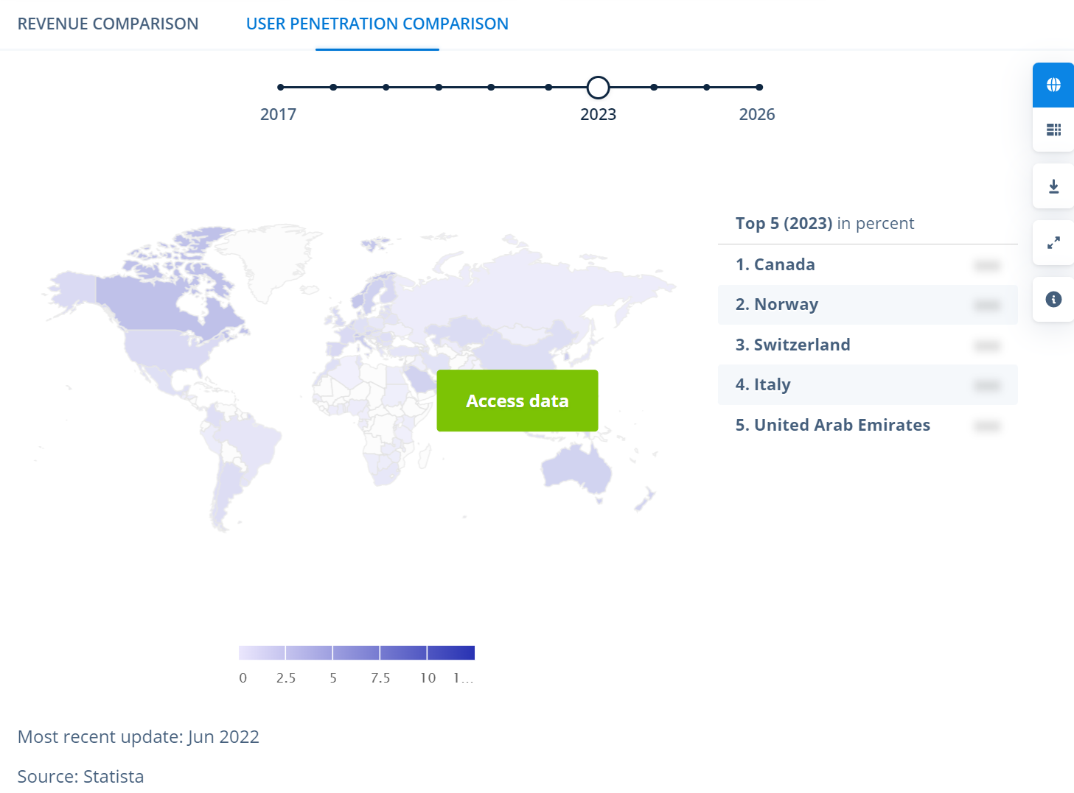
Source: Statista (2022)

Table 1.1 - expenditure and population density of high user penetration countries
Country | Health expenditure (% of GDP) of year 2019  The World Bank (2019a). | Population density as of year 2020 (people per square feet)  The World Bank (2019b)
Canada | 10.84% | 4
Norway | 10.52% | 15
Switzerland | 11.29% | 219
Italy | 8.67% | 201
United Arab Emirates | 4.28% | 131
World (Average) | 9.83% | 60
Source: Constructed by Author

According to Statista (2022), overall user penetration would be 1.45% in year 2023 and it is expected to hit 1.67% by the year 2027. From the geographic distribution, it is currently north America and Europe are of high user penetration. More development to raise user penetration in Asia region like Hong Kong to catch up the growing trends of virtual medical consultation. Regarding the revenue generation, China is being the top in the world (expected US$9,758.00m in 2023). Figure 1.1.2 shows that China and Korea being the Asian countries that manage to high revenue.

Figure 1.1.2 - Top 5 revenue generation countries for virtual medical consultation
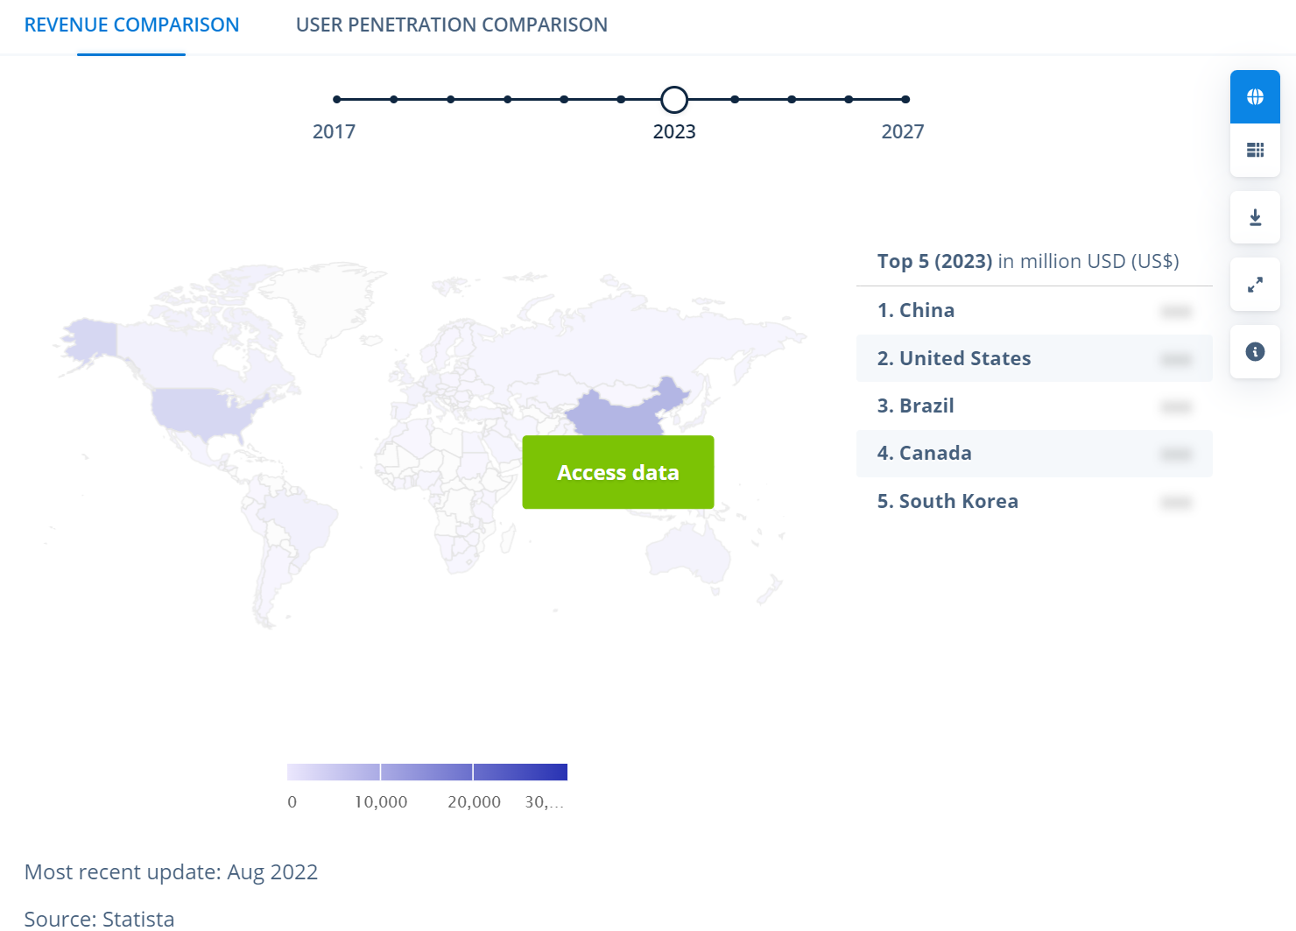
Source: Statista (2022)

Meanwhile, referring to figure 1.1.3, the overall revenue in the world also keeps increasing. It happened a deeper increase from the year 2019 to the year 2020. This should be caused by the increasing consumption of virtual medical consultations worldwide. There is potential to capture the growing virtual medical consultation demands. More changes could be implemented to keep the momentum in the post-pandemic period.

Figure 1.1.3 - Revenue of the global virtual medical consultation

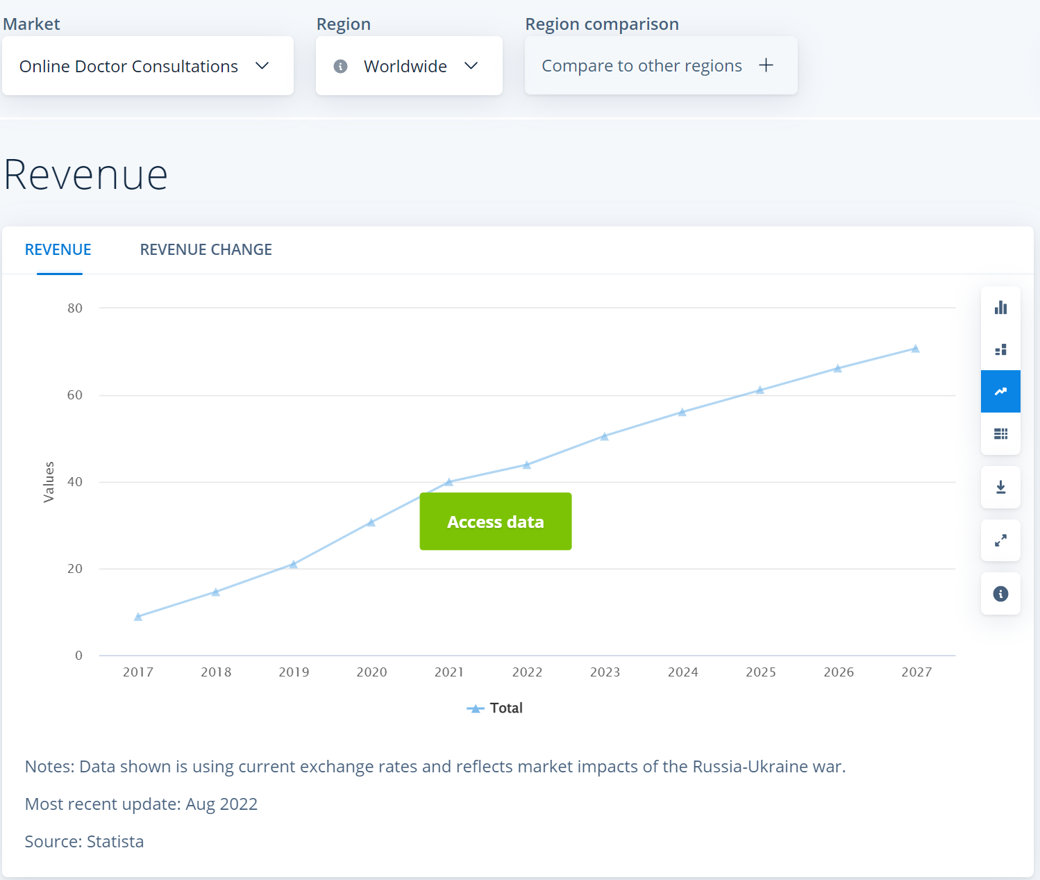
Source: Statista (2022)

With the continuous improvement of virtual medical consultation, the value created is expected to increase. The spending per user is expected to increase. Figure 1.1.4 shows that the average revenue per user consumption is increasing globally. It is worth studying what factor influence more adoption for the user that already experience virtual medical consultations.

Figure 1.1.4 - Average revenue per user consumption on virtual medical consultation globally
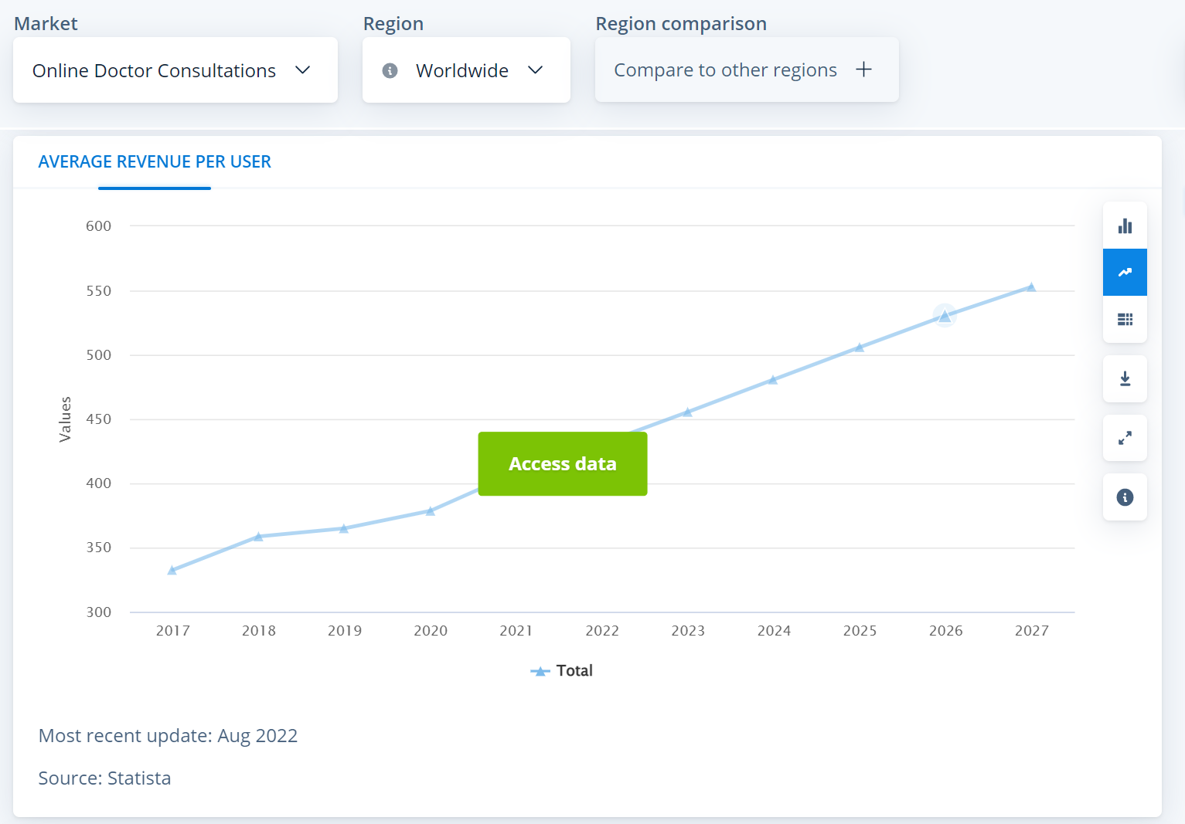
Source: Statista (2022)

COVID-19 is the main reason to accelerate the virtual medical consultation adoption. Online service consumption behaviour has been widely adopted. This could be explained by the React-Cope-Adapt frameworks. Customers first react to the perceived threat of the pandemic situation. With the new online service, customers begin to cope with the issue of social distancing. Finally, customers enter adapting phase where the consumption habits to the new normal (Guthrie, Fosso-Wamba and Arnaud, 2021). COVID-19 accelerate the demands for a virtual consultation. It also raises the demand for the improvement of virtual medical consultation software.

The outbreak of COVID-19 happened in early 2020 has increased the adoption of virtual consultation drastically. During the Chinese New Year in the year 2020, it was estimated 6.7 million online consultations in Mainland China equivalent to an annual increase of 31% (OUR HONG KONG FOUNDATION, 2022). China patients get used to virtual medical consultations and have more and more per-user spending. This could be explained by the highest revenue in the year 2023.

In France, there was a rapid rise in remote consultation right after the lockdown starting in week 12 of the year 2020. This could be illustrated in figure 1.1.5 below. The use cases of remote consultation have increased significantly in Europe during the first few months in the year 2020. Germany’s largest patient portal, Jameda, has increased 10 times on video consultation in March 2020 when compared to February 2020 (Richardson et al., 2020). The lockdown in Europe countries has created a new normal for medical consultation. All these figures show that the COVID-19 outbreak in early 2020 has created a push factor for immediate demand for remote consultation.

Figure 1.1.5 - number of remote consultations in France 2020 (week 1 - 23)
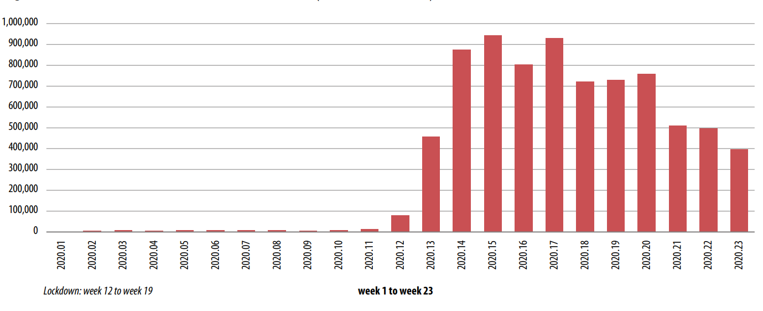
Sources: Richardson et al. (2020)

Figure 1.1.5 shows that the consumption of remote consultation in France was still maintained high after the lockdown ended in the week of 19. It shows that the demand remains after the peak of the COVID-19 wave. Because of the widespread COVID-19 cases, European user penetration was maintained high.
Virtual medical consultation platform consumption in healthcare industries is continuously increasing throughout the COVID-19 pandemic after 2020 (Twilio, 2021). This could be shown in figure 1.1.6 below.

Figure 1.1.6 - Volume of digital engagement in Twilio data
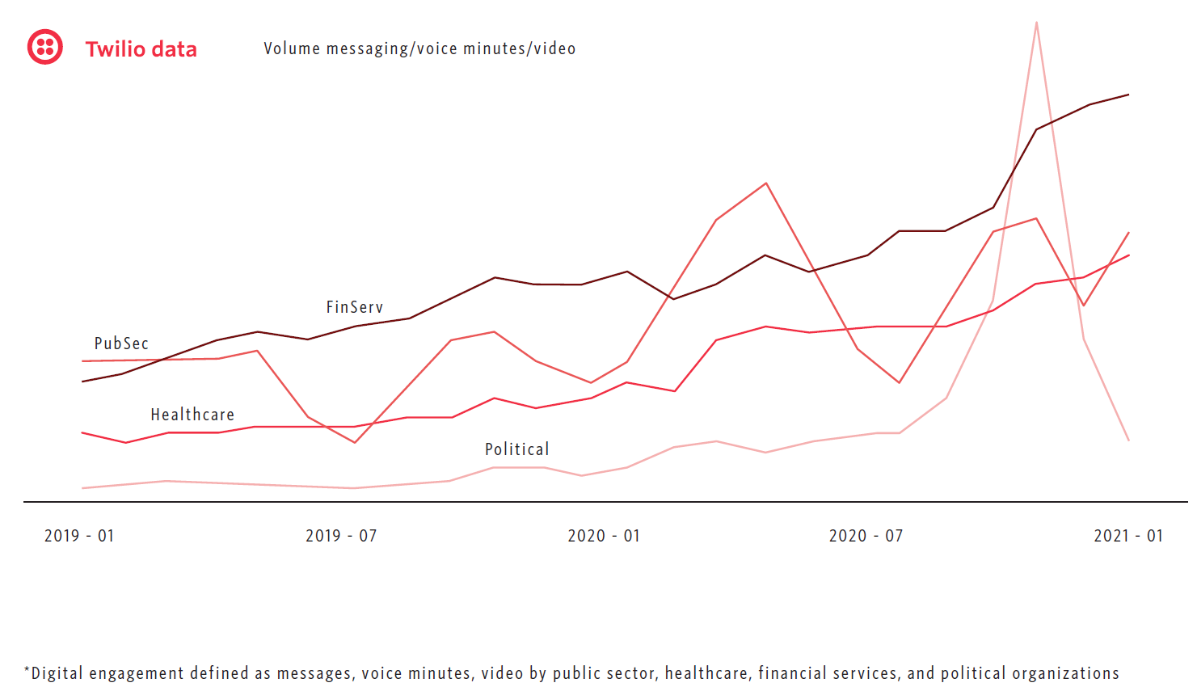
Sources: Twilio (2021)

1.1.1 COVID-19 impacts to Hong Kong virtual consultation

The Hong Kong government start to scale up the medical service through a virtual medical consultation in the public hospital after COVID-19 (HKTDC research, 2020). One of the major clinic chains Quality Healthcare Medical Service (QHMS) started to launch virtual medical consultation software to conduct virtual consultations in April 2020 (China daily HK, 2021). A new player, DrGo, is completely based on digital health and entering the B2C sectors.

In Hong Kong, Lingnan University (2020) surveyed senior citizens aged over 55 to assess their awareness of the COVID-19 outbreak and the virtual consultation. In figure 1.1.7, It was found that over 60% of respondents are willing to try virtual medical consultations after COVID-19.

Figure 1.1.7 - Distribution of survey response on willingness to use virtual consultation

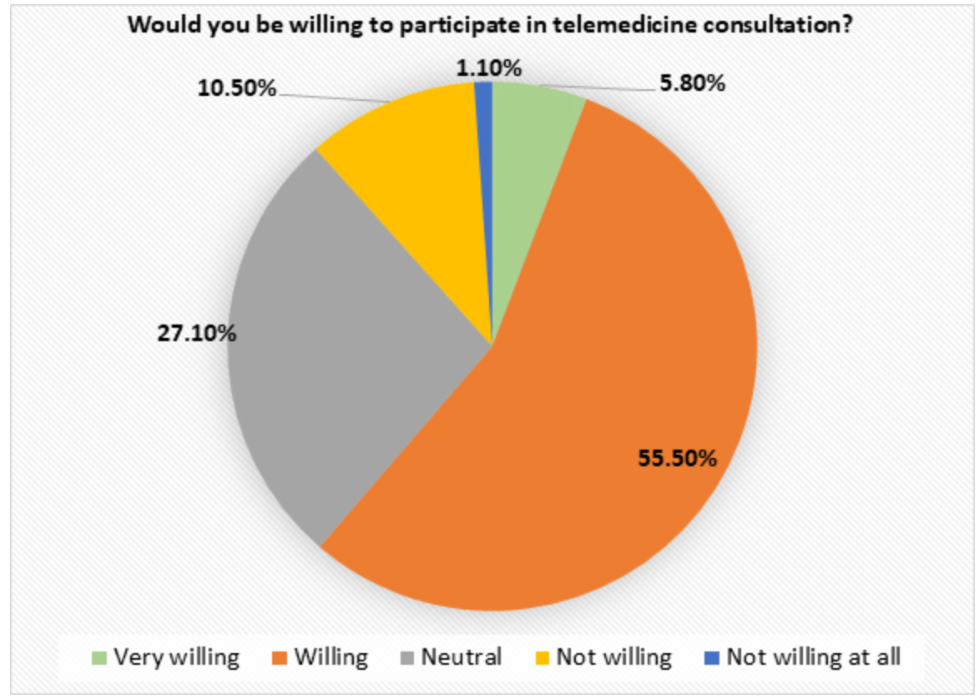
Sources: Lingnan University (2020)

All the above data show that the demand for online virtual consultation has increased since the COVID-19 outbreak in the year 2020. The trend applies to Global, China and Hong Kong. Although the willingness to participate in virtual medical consultations increased, it may not necessarily mean that the adoption rate would be increased substantially.

The adoption trend is not good after the beginning of the year 2020. Figure 1.1.8 below shows that the adoption rate has increased sharply from year 2019 to year 2020 but the increase rate has been dropping substantially afterward. This is worse situation when compared to general trend in the world as shown in figure 1.1.3 before.

Figure 1.1.8 - User penetration rate of virtual medical consultation in Hong Kong
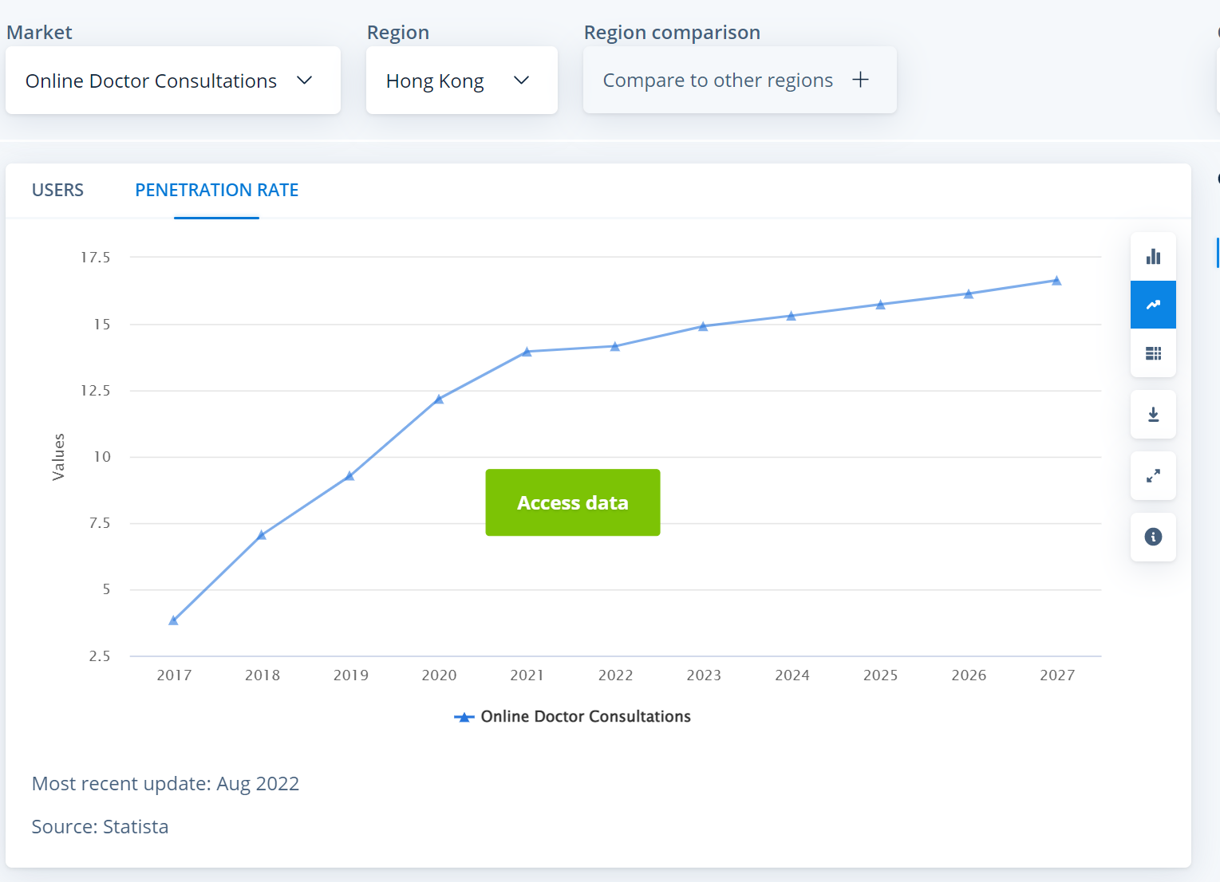
Source: Statista (2022)

Like other countries in the world, Hong Kong has been promoting and delivering the service of virtual medical consultation. We can see the major stakeholders, including the healthcare providers and the Hong Kong government, have spent so much effort to develop this service. There is motivation to study how to boost virtual medical consultation from a customer or patient point of view. This would be beneficial to the service providers to improve the service.

1.1.2 COVID-19 create higher demand on online activities in Hong Kong

On the other hand, Hong Kong citizens increase to use of online shopping even for non-essential products. Vladimirova et al. (2022) revealed that nearly 40% of respondents have an increase in online shopping for apparel after COVID-19, while Hong Kong is slightly higher than the average. This could be illustrated in figure 1.1.9. It becomes an opportunity to retail industries is that the competitor in Hong Kong's retail industries is no longer a physical shop to reduce costs and increase sales. It is believed that this trend would also apply to essential products and services like virtual consultation.

Figure 1.1.9 - Descriptive statistics for online apparel shopping

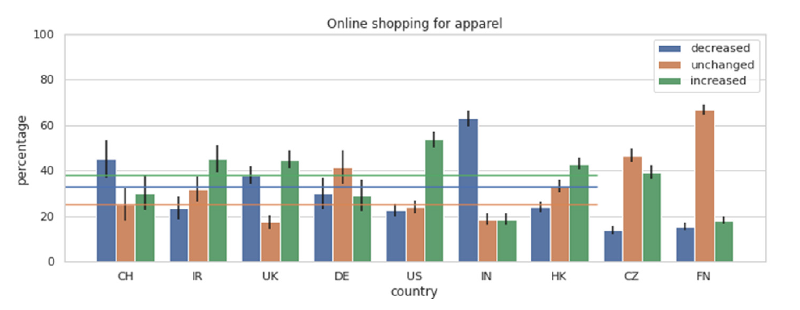
Source: Vladimirova et al. (2022)

Figure 1.1.10 show a good trend for online shopping. However, beauty, health, personal and household care is the second worst among the sectors. Although it generally has an increasing trend, the rate of increase is relatively lower when compared to online shopping. There are opportunities to change to let more online adoption in healthcare.

Figure 1.1.10 - Revenue trend for online consumption in different section in Hong Kong
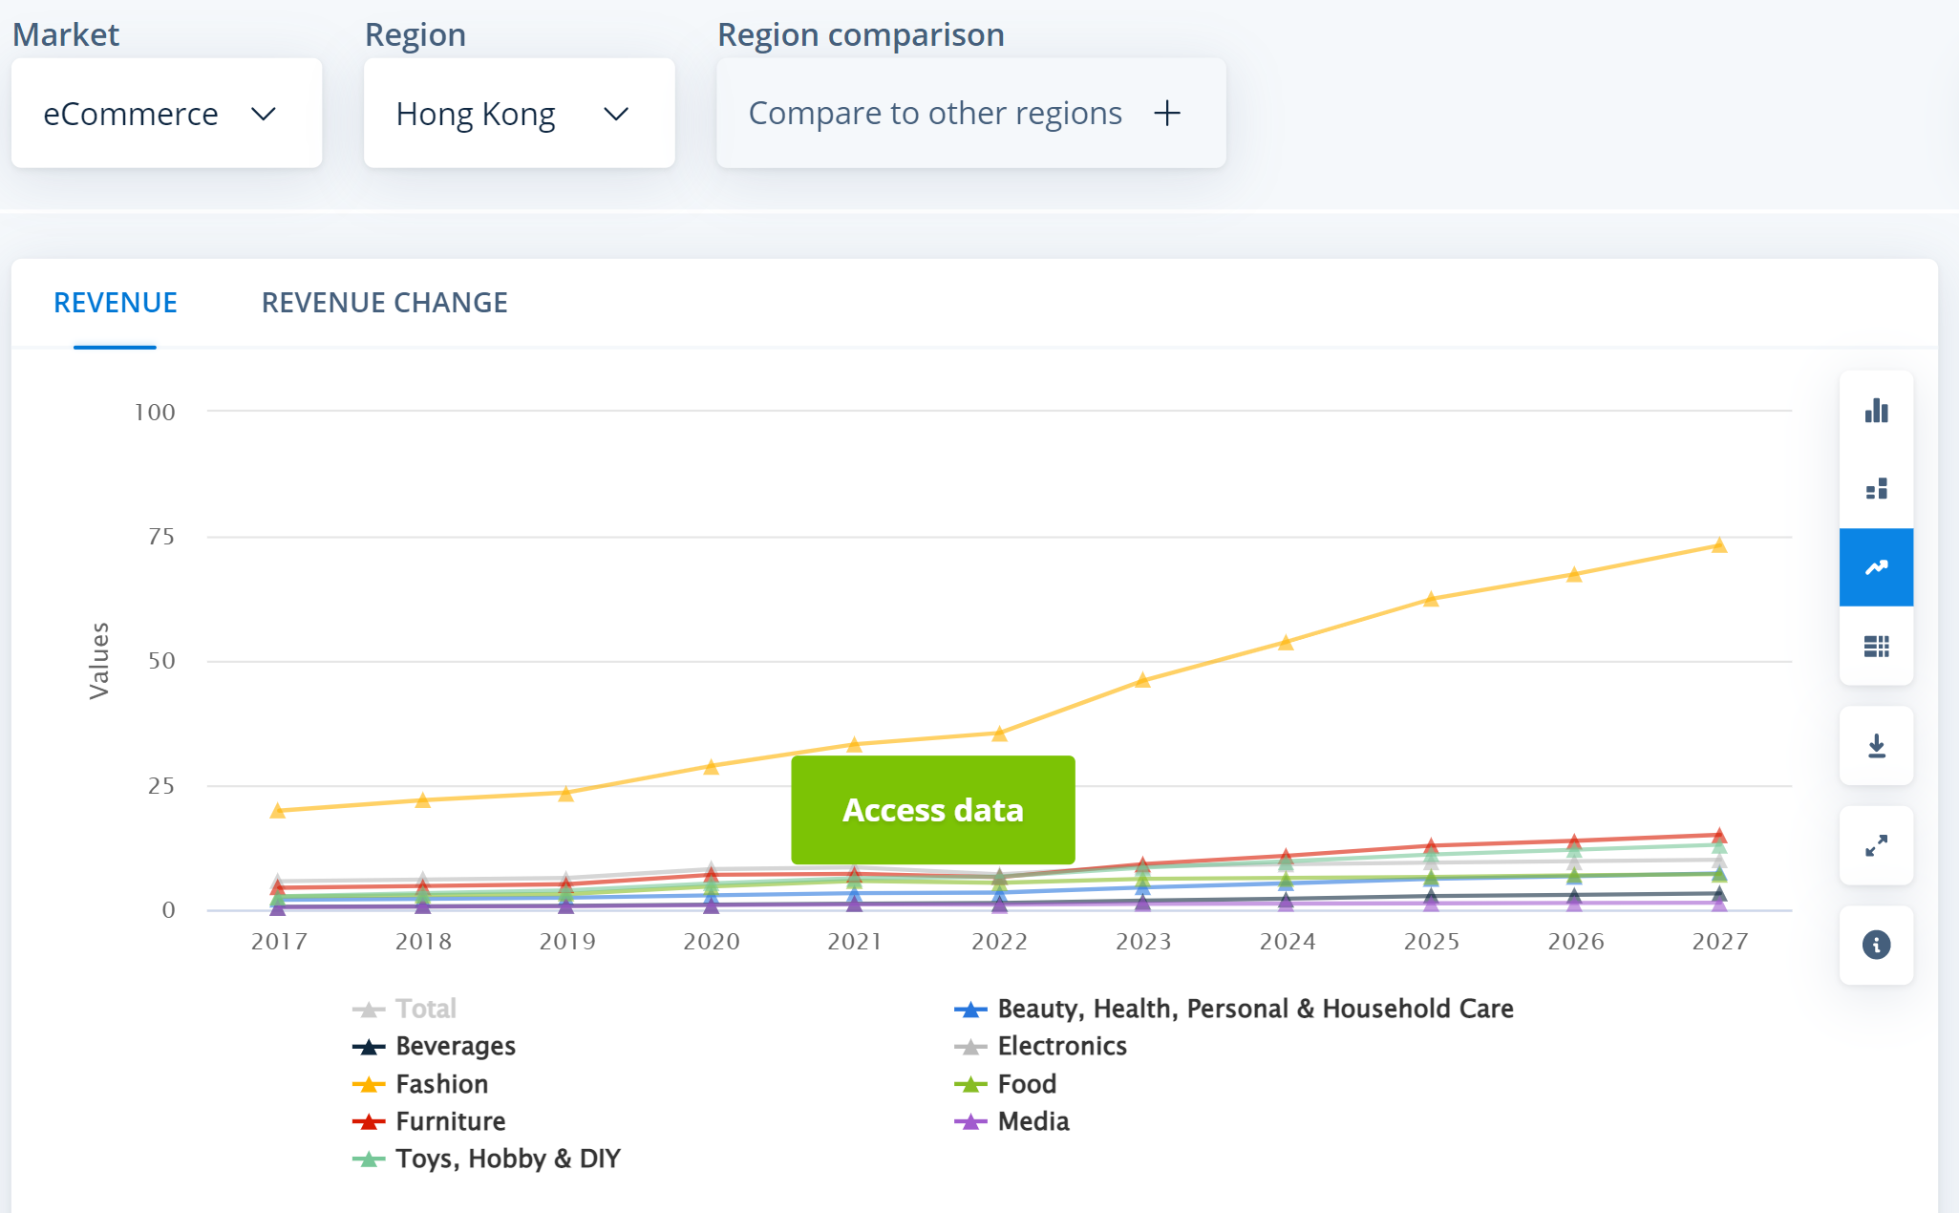
Source: Statista (2022)

1.2 Research motive

There is an increasing demand to serve patients better worldwide after COVID-19. Hong Kong has been one of the regions that have delivered more virtual medical consultations since the pandemic. It is discussed in the previous section that user penetration and revenue are not performed well in Hong Kong when compared to other countries. It is worth identifying what factors affecting the adoption of virtual medical consultation in Hong Kong to make the service more sustainable. On the other hand, online shopping in Hong Kong shows a good increasing trend while the increasing rate of healthcare adoption is decreasing. The motive of the research is to find out how to improve virtual consultation adoption.

1.3 Research questions

Bokolo (2020) has done research based on secondary data to evaluate the factors that affect the adoption of virtual consultation and virtual software platforms. It is revealed that social, technological and organizational factors affect the adoption. It also supported that technological advancement has a high potential to reduce social distancing during COVID-19.

In this report, it is going to address below research questions:
- Which factors affect the intention of using a virtual medical consultation platform?
- What is the relationship between the factors?
- How to increase customer acceptance of using virtual consultation for outpatient services?

1.4 Research aims

This research aims to identify a way to increase customer acceptance of virtual medical consultations in Hong Kong.

1.5 Research objectives

This report will resolve the research questions by studying the customers’ acceptance of virtual medical consultation platforms in Hong Kong. The research will mainly focus on below:
- To find the factors affecting the intention of using virtual medical consultation platforms in Hong Kong
- To verify the relationship between the factors that affect the intention of using virtual medical consultation platform in Hong Kong
- Based on research results to recommend improvement on virtual medical consultation platforms in Hong Kong

1.6 Research flow

Research background and motive (I)

Define research questions, aims and objectives (II)

Literature review (III)
Formulate research framework (IV)\

Draft questionnaire and perform pilot test (V)
Distribute formal survey and collect (VI)
Data collection and analysis (VII)
Research conclusion and recommendation (VIII)

The above flow chart illustrates the overall research flow.

(I) Research background: This has been discussed in section 1.1. This gives a general understanding of how virtual medical consultation evolved globally and compared the situation in Hong Kong. This section creates the motive for this research as already mentioned in section 1.2

(II) Research questions, aims and objectives: These have been discussed in previous sections in Chapter 1 before. It is to ensure that the scope and objective of this research have been clearly set-out. During this stage, research and review of the secondary data from the academic journal would be conducted in parallel. This is to ensure that there would be enough references to support research questions. The relevant information would be sorted out for detailed study after research questions, aims and objectives are confirmed.

(III) Literature review: It would be discussed as an entire Chapter 2. This is an important part to support our research framework and methodology in chapter 3. Based on the confirmed research objectives, search the relevant information from the academic journal. The key concept and conclusion of the study would be evaluated. The key information would then be discussed in the literature review.

(IV) Formulate research framework: It is going to present the research framework and methodology in Chapter 3. The research framework formulation is based on the literature review and research objectives. It is to develop the relationship between the independent variable and dependent variable in this research. This is important to the research methodology, including questionnaire design and collection.

(V) Draft questionnaire and perform pilot test: Based on the research framework, can draft the questionnaire to support primary data collection in this research. The question design would be referencing previous scholars. The pilot test would be distributed with a number that refers to the previous academic journal. The pilot test data would be collected to validate the reliability of the questions and independent variables. A Focus group would also be arranged at the same time to collect feedback on the question design. The questionnaire would be fine tune and finalized for the formal survey.

(VI) Distribute the final survey and collect: The number of questionnaires to be collected would be referring to the academic journal. The distribution period and method would be defined first before actual distribution. Data collected would be used to conduct comprehensive data analysis defined as part of the research methodology.

(VII) Data collection and analysis: Data collected would be using SPSS for analysis. In this report, it is going to use descriptive analysis, reliability analysis, correlation and regression analysis. Those analysis techniques are used to analyze the results from the questionnaire and to identify the key findings.

(VIII) Research conclusion and recommendations: This is an important part of the entire research. It would be based on the analysis results to conclude. The findings from the data analysis would be used to identify opportunities for improvement. More practical recommendations would be raised to the related stakeholders in the healthcare industries in Hong Kong.

1.7 Concluding summary

This research is worth exploring despite COVID-19 has changed the way people use online services to outpatient services. There is motivation to base on the research model to further improve the customer adoption rate towards the service. This is to enable Hong Kong healthcare industries to follow the global trend to deliver quality virtual medical consultations. With clear research questions, objectives and research flow, it is expected the proposed topic will have critical findings and recommendations.

2. Literature Review

This chapter will study those academic journals that are relevant to provide reasons for the research methodology in this report. This will help to identify the factors affecting the behavioral intentions of virtual medical consultation platforms.

2.1 Technology Acceptance Model (TAM)

Technology Acceptance Model (TAM) was developed by Davis in the year 1989 to explain IT usage based on the behaviour model. Its theoretical foundations are based on perceived usefulness and perceived ease of use as key factors of user behaviour (Davis, 1989). The TAM model is simple. It is based on Fisbbein & Ajzen (1975)’s Theory of Reason Action (TRA) where a person's belief may influence the attitude and develop behavioral intention. Hu et al. (1999) mentioned that TRA suggested beliefs influence attitude which in turn generates intention. Regarding the person’s belief, TAM has made use of perceived usefulness and perceived ease of use to explain users’ beliefs related to attitude, behavioral intention and actual system usage. TRA is a key concept that lay the foundation of TAM.

Schultz and Slevin (1975) first suggested perceived usefulness. Exploratory analysis has been conducted in 7 dimensions with 67 questionnaires. One of the dimensions is performance. It was interpreted by Schultz and Slevin (1975) as the effect of the model on the manager's job performance. It was found that such a dimension is highly correlated to the use of self-decision-making (Davis, 1989). There is another important scholar, Robey (1979), further rides on the performance dimension towards the system usage. Robey (1979) discovered that the performance measure is mostly correlated to the objective of system usage. Its theory suggested that “A system that does not help people perform their jobs is not likely to be received favourably in spite of careful implementation efforts”. This lays the foundation on the
job performance associated with the perceived usefulness definition.

Bandura (1982) has undergone self-efficacy research in a human agency. The higher the self-efficacy level, the higher the performance and the lower the emotional issues. Self-efficacy should be defined as “judgement of how well one can execute the course of action required to deal with prospective situations”. The concept of self-efficacy is similar to perceived ease of use. Bandura (1982) distinguishes self-efficacy from outcome judgement. The outcome judgement is similar to perceived usefulness. It is argued that both self-efficacy and outcome judgement influence behaviour. The theory lays the foundation for TAM which has made use of perceived usefulness and perceived ease of use to explain behaviour (Davis, 1989).

Mathieson (1991) later compared TAM and the Theory of Planned Behavior (TPB) to predict people's intention to use the information system. TPB is an extension of TRA. The development of TPB was based on the concept of TRA and added on perceived behaviour control to have a more direct effect on behavioral intention. Perceived behavioral control refers to “people’s perception of ease or difficulty in performing the behaviour of interest (Liao, Chen and Yen, 2007). Mathieson (1991) found that both TAM and TPB are good at predicting behavioral intention to use an information system. However, TAM is easier to apply as it can gather generic information against user comments about the system. Saga and Zmud (1994) identified and reviewed over 20 factual studies on information system acceptance. It is found that the TAM model is the best model to adopt. TAM model become a more famous one to study user acceptance of technology and information system since the 1990s.

In later academic journals, attitude is removed because it is considered a weak predictor of intention (Bhatiasevi and Yoopetch, 2015). Hu et al. (1999) also find that there is a weak relationship between the attitude of the physician to the intention of development in a virtual consultation. It is also found that the perceived ease of use only has little effect on the perceived usefulness and attitude.

Based on the previous research, the variables that are most important in the TAM model would be the perceived usefulness, and perceived ease of use. The below sections (2.1.1, 2.1.2) describe the definition and measurements of two variables.

2.1.1 Perceived usefulness

This section will describe the definition and measurement of perceived usefulness.

2.1.1.1 Definition of perceived usefulness

Davis (1989) mentioned that perceived usefulness is “the degree to which a person believes that using a particular system would enhance his or her job performance”. It could also be defined as a personal belief that using a particular system will improve someone's job performance in an organizational setting (Dulcic, Pavlic and Silic, 2012).

More recent research has made use of the TAM model to study the user acceptance of mobile library applications. An example of perceived usefulness is that users can improve their work performance with the help of library apps in the university library's data. This could be interpreted as an individual believing that using a particular service or system will improve his or her level of task performance (Yoon, 2016). Firmansyah, Yasirandi and Utomo (2022) mentioned that perceived usefulness is the perspective that users’ subjective mind and belief in a specific system will help improve that person’s performance.

2.1.1.2 Measurement of perceived usefulness

Davis (1989) has studied the factors that affected perceived usefulness mostly. The items are 1. Work more quickly; 2. Increase productivity; 3. Job performance; 4. Effectiveness; 5. Make the job easier; 6. Useful. Davis (1989) has designed to apply to system selection study and how likely the system would be put into practice. It was done by research with 40 participants in MBA students at Boston University. The measure applied in the study was self-reported by usage after the training. It is a measurement of the post-use evaluation. The measurement was pretty much a perceptual measure rather than an objective measure (Karahanna and Straub, 1999). As such, perceived usefulness could be measured by conducting survey questions on those related areas. Questions related to effectiveness, productivity, job performance, quality of new technologies, control of work, and speed of the tasks performed could be used to measure perceived usefulness (Dulcic, Pavlic and Silic, 2012). Abd Ghani et al. (2017) suggested that perceived usefulness in internet banking could be measured by making the transaction easier.

Table 2.1.1 - Summary of literature review on the perceived usefulness
Reference | Definition or measurement
Davis (1989) | A person believes that using a particular system will enhance his or her work for performance.
Karahanna and Straub (1999) | The measure applied in the study of email system was self-reported by usage after the training. It is a measurement of the post-use evaluation. The measurement was pretty much a perceptual measure rather than an objective measure
Dulcic, Pavlic and Silic (2012) | A personal belief that using a particular system will improve someone's job performance in an organizational setting
Yoon (2016) | An individual believes that using a particular service or system will improve his or her level of task performance.
Alfadda and Mahdi (2021) | It is suggested in internet banking could be measured by making the transaction easier.
Firmansyah, Yasirandi and Utomo (2022) | A user’ subjectively believe that using a specific application system help improve that person’s performance
Source: Constructed by author

2.1.2 Perceived ease of use

This section will describe the definition and measurement of perceived ease of use.

2.1.2.1 Definition of perceived ease of use

Davis (1989) mentioned that perceived ease of use is “the degree to which a person believes that using a particular system would be free of effort”. Dulcic, Pavlic and Silic (2012) further supplemented perceived ease of use with the subjective perspective that using the system would make them free of mental and physical effort. Yoon (2016) mentioned that perceived ease of use could be defined as the level at which a person feels he/she is free from engaging in mental and physical efforts using the mobile app. Firmansyah, Yasirandi and Utomo (2022) define perceived ease of use as the perception of where to operate technology in a perspective that helps people make their job easier.

2.1.2.2 Measurement of perceived ease of use

Davis (1989) has selected scale items related to the effort to be skilful, mental effort, controllable, cumbersome and frustrating could be used to measure perceived ease of use. He has fine-tuned the design applied to the system selection study and how likely the system would be put into practice. The items are 1. Easy to learn 2. Controllable; 3. Clear and understandable; 4. Flexible; 5. Easy to become skilful; 6. Easy to use. The study was done by research with 40 participants in MBA students at Boston University. The measure applied in the study was self-reported by usage after the training. It is a measurement of the post-use evaluation. The measurement was pretty much a perceptual measure rather than an objective measure (Karahanna and Straub, 1999). Abd Ghani et al. (2017) suggested that customers are more willing to use internet banking if there is ease of use in the process.

Table 2.1.2 - Summary of literature review on the perceived ease of use
Reference | Definition or measurement
Davis (1989) | The degree to which a particular system is used without effort
Karahanna and Straub (1999) | The measure applied in the study was self-reported by usage after the training. It is a measurement of the post-use evaluation. The measurement was pretty much a perceptual measure rather than an objective measure
Dulcic, Pavlic and Silic (2012) | It is expected that the use of a particular system will free the users from mental and physical efforts
Yoon (2016) | Individuals feel free from engaging in mental and physical efforts using the mobile app.
Alfadda and Mahdi (2021) | It is suggested that customers are more willing to use internet banking if there is the ease of use in the process
Source: Constructed by author

2.2 Perceived risk

This section will describe the definition and measurement of perceived risk.

2.2.1 Definition of perceived risk

Bauer (1960) was the first one to introduce perceived risk. It is found that risk only perceived by the customer will influence the behaviour. Bruwer and Cohen (2019) mentioned that risk involved customer perception of the negative results of an action. The perceived risk could be defined as a personal perception of uncertainty when involved in the activities. Ariff et al. (2014) mentioned that customers would be at high-level risk during online purchases rather than in traditional physic stores. In e-commerce, the perceived risk in business-to-customer (B2C) would be focused on the online platform instead of the risk associated with the product or service offering (Glover and Benbasat, 2010).

During purchasing products or services, the customer may feel social pressure and psychological pressure. It could cause financial pressure after the purchase (Cox, 1967). Customers may be exposed to risks when a product or service does not perform to the certain extent it is expected (Laroche et al., 2004). Customers may anticipate risks occurring during purchase. They consider that their wrong choices may cause them to lose their self-esteem in front of relatives and friends (Kushwaha and Shankar, 2013). Perceived risks may also have other unknown costs and future repair costs during purchase (Sweeney, Soutar and Johnson, 1999).

2.2.2 Construct of perceived risk and the corresponding measurement

Since Bauer (1960) introduced perceived risk, there are a lot of researchers who have considered different constructs of perceived risk to investigate customer behaviour. Those constructs have not been well defined, or the findings may have even conflicted with each other. To identify the varieties of the perceived risk construct, different terminology was consolidated when the definition was the same. Besides, the concept of hypothesis purchase situation was developed and evaluated in each situation. There were 5 types of perceived risk constructs found since 1970. They are namely performance, physical, financial psychological and social risk. Roselius (1971) has identified one more construct of the perceived risk, i.e. Time loss. It also includes some risk reduction strategies in the study, e.g attending product rating service, engaging word of mouth conversation etc. The study tried to investigate the relationship among a different kind of perceived risk and how it collectively contribute to overall perceived risk. It was found that all the different constructs of the perceived risk could be considered independent of each other. Whenever the risk level of one construct increase, the other risk varieties may remain unchanged, increase or decrease (Jacoby and Kaplan, 2013).

The modern risk structure could be divided into 6 constructs: functional, physical, financial, social, psychological and time risk (Stone and Grønhaug, 1993). Crespo, del Bosque and de los Salmones Sánchez (2009) suggested that perceived risk should be measured and analyzed in a multidimensional manner. The main perceived risk dimensions are physical, financial, functional, psychological, social and time. Ariff et al. (2014) reviewed six types of perceived risk for online shopping. The research has excluded social risk and privacy risk and only included four types of risks that are most suitable for the research. There is flexibility to include risk dimensions are most relevant to the research topic.

Below further discuss the 6 constructs commonly applied in modern risk structures. The measurement of the perceived risks could be done through a questionnaire in the survey based on the definition of each construct below. These constructs could be used to measure the overall perceived risk.

- Functional risk:

The product or service does not function as what it is expected (Stone and Grønhaug, 1993). If the product or service doesn’t meet the desired function, the customer will face a certain degree of perceived risk (Bruwer and Cohen, 2019). Boksberger, Bieger and Laesser (2007) mentioned that functional risk in air transport is the perceived probability of a service failure or lower service quality implying that a passenger will not attain the best possible benefit.

- Physical risk

Boksberger, Bieger and Laesser (2007) mentioned that physical risk in the air transport industry is the risk that due to a service failure, the physical flying may be under reduced oxygen pressure and air humidity. This may lead to the passenger getting injured.

- Financial risk

Boksberger, Bieger and Laesser (2007) mentioned that the perceived probability of purchasing an air ticket is not the best value for money due to a service replacement or being overpriced. In general, it is a risk that the service purchased may not be worth of money spent. Stone and Grønhaug (1993) also mentioned that financial risk is the probability that the product or service is overpriced or even has quality problems.

- Social risk

Boksberger, Bieger and Laesser (2007) mentioned that there is the probability that an image or reputation of the airline adversely being purchased by someone affects the way other people think about the purchaser. Stone and Grønhaug (1993) suggested that social risk is the probability of being ridiculed by others or even alienated by others when buying a product or using a service. The customer may also avoid choosing a particular product or service to cope with a peer group or friends’ preference (Bruwer and Cohen, 2019).

- Psychological risk

Boksberger, Bieger and Laesser (2007) mentioned the probability to be at risk of embarrassment or the loss of self-esteem resulting from air travelling. It is also the risk of a negative effect on purchaser experience as a result of the difficulties among airline passengers. Stone and Grønhaug (1993) mentioned that the customer may be emotionally hurt by a decision to purchase a product or use a service. Bruwer and Cohen (2019) mentioned that customers may not be able to get rid of suffering because they have been harmed by similar products or services.

- Time risk

Stone and Grønhaug (1993) mentioned that there is a chance that the purchased product will need to be repaired or returned. This would lead to more time the customer needs to spend getting the products of what they expected. Bruwer and Cohen (2019) mentioned that time risk is associated with taking extra time to deal with post-purchase issues which are unexpected and a waste time.

Table 2.2 - Summary of literature review on the perceived risk
Reference | Definition or measurement
Bauer (1960) | Risk only perceived by the customer will influence the behaviour
Cox (1967) | During purchasing products or services, customer may feel social pressure and psychological pressure. It could cause financial pressure after the purchase
Roselius (1971) | Time loss is one of the risk construct to perceived risk
Stone and Grønhaug (1993) | The modern risk structure could be divided into 6 constructs: functional, physical, financial, social, psychological and time risk  Functional risk: The product or service does not function as what it is expected  Financial risk: The probability that the product or service is overpriced or even has a quality problem.  Social risk: Probability of being ridiculed by others or even alienated by others when buying a product or using a service.  Psychological risk: Customer may be emotionally hurt by a decision to purchase a product or use a service  Time risk: There is a chance that the purchased product will need to be repaired or returned
Sweeney, Soutar and Johnson (1999) | Perceived risks may also have other unknown costs and future repair costs during purchase
Laroche et al. (2004) | Customers may be exposed to risks when a product or service does not perform to certain extent it is expected
Boksberger, Bieger and Laesser (2007) | Social risk: there is the probability that an image or a reputation of the airline adversely being purchased by someone affects the way other people think about the purchaser  Functional risk: The perceived probability of a service failure or lower service quality implying that a passenger will not attain the best possible benefit  Financial risk: Perceived probability purchased air ticket is not the best value for money due to a service replacement or overpriced. In general, it is the risk that the service purchased may not worth of money spent.  Psychological risk: Probability to be at risk of embarrassment or the loss of self-esteem resulting from air travelling. It is also the risk of a negative effect on purchaser experience as a result of the difficulties among airline passengers
Crespo, del Bosque and de los Salmones Sánchez (2009) | Perceived risk should be measured and analyzed in a multidimensional manner
Glover and Benbasat (2010) | In e-commerce, the perceived risk in business to customer (B2C) would be focused on online platform instead of the risk associated with the product or service offering
Jacoby and Kaplan (2013) | All the different constructs of the perceived risk could be considered as independent to each other. Whenever risk level of one construct increase, the other risk varieties may remain unchanged, increase or decrease
Kushwaha and Shankar (2013) | Customers may anticipate risk occurred during purchase. They consider that their wrong choices may cause them to lose their self-esteem in front of relatives and friends
Ariff et al. (2014) | Customer would be of high-level risk during online purchase rather than traditional physic store.  Reviewed six types of perceived risk for online shopping. The research has excluded social risk and privacy risk and only included four types of risks that are most suitable for the research
Bruwer and Cohen (2019) | The risk involved customer perception of the negative results of an action. The perceived risk could be defined as a personal perception of uncertainty when involved in the activities.  Functional risk: If the product or service doesn’t meet the desired function, the customer will face a certain degree of perceived risk.  Social risk: The customer may also avoid choosing a particular product or service to cope with a peer group or friends’ preference  Psychological risk: the customer may not be able to get rid of suffering because they have been harmed by similar products or services.  Time risk: Taking extra time to deal with the post-purchase issues which are unexpected and a waste time.
Source: Constructed by author

2.3 Electronic Word of Mouth (eWOM)

This section will describe the definition and measurement of eWOM.

2.3.1 Definition of eWOM

Word of Mouth (WOM) is one of the most important interpersonal communications regarding a product or service. The power of WOM could influence the market for the customer. With the popularity of the internet, the channel for product reviews could be done on a retail website, social networking site (e.g Facebook, Instagram), or message boards. Electronic WOM (eWOM) connects people who have no prior relationship to connect. It allows the customer to share their view on the products or services without knowing their identities (Lee and Youn, 2009). eWOM could be defined as any comments, no matter positive or negative, by existing, former or potential customers about the product, service or company through an internet channel (Hu and Kim, 2018).

2.3.2 Measurement of eWOM

The internet and different social media platforms are considered eWOM platforms. Information adoption is a kind of measurement of eWOM (Cheung and Thadani, 2012). Not all eWOM information posted on social media would have the same effect on the customer. However, the customer who adopts the information from eWOM will have more purchasing intention (Erkan and Evans, 2016). Based on this concept, this study examines the effect of eWOM adoption on behavioral intention. Park et al. (2011) also mentioned that the measurement of eWOM could be on eWOM credibility and eWOM effect. The typical questions could be measured in these two aspects.

Table 2.3 - Summary of literature review on the eWOM
Reference | Definition or measurement
Lee and Youn (2009) | Electronic WOM (eWOM) has connected people who have no prior relationship to connect. It allows the customer to share their view on the products or service without knowing their identities
Park et al. (2011) | the measurement of eWOM could be on eWOM credibility and eWOM effect. The typical questions could be measured in these two aspects.
Cheung and Thadani (2012) | The internet and different social media platforms are considered eWOM platforms. Information adoption is a kind of measurement of eWOM
Erkan and Evans (2016) | Not all eWOM information posted on social media would have the same effect on the customer. However, the customer who adopts the information from eWOM will have more purchasing intention
Hu and Kim (2018) | eWOM could be defined any comments, no matter positive or negative, by existing, former or potential customers about the product, service or the company through internet channel
Source: Constructed by author

2.4 Behavioral Intention

This section will describe the definition and measurement of behavioral intention

2.4.1 Definition of behavioral intention

Behavioral intention is the dependent variable in the TAM model. Davis (1989) has done a study on the prediction of the future use of chart-master and pendraw. Twelve scale items analysis has been set up with six set up with perceived usefulness and six set up with ease of use. The participants were asked two seven-point scale questions with likely/unlikely adjectives and probable/improbable adjectives. These 2 sets of adjectives define the intention to use the application (Davis, 1989).

Mokha and Kumar (2021) mentioned that behavioral intention is the intention to use technology. The intention is “degree to which an individual is willing to try and invest in the particular behaviour on the amount of effort one is willing to exert to perform a particular act” (Mokha and Kumar, 2021). Alfadda and Mahdi (2021) define behavioral intention as an individual’s intention to use technology. Rad et al. (2022) also supplemented that intention is the desire for a person to use the technology in the future.

2.4.2 Measurement of behavioral intention

Davis (1989) mentioned that behavioral intention could be measured both at the time before and later time after the usage. It is found that there is a significant effect on behavioral intention after one-hour training (Davis, 1989). Lazim et al. (2021) suggested that behavioral intention is the measure of the likelihood of an individual employing the technology application.

Table 2.4 - Summary of literature review on the behavioral intention
Reference | Definition or measurement
Davis (1989) | The like/unlike and probable/improbable to use the application
Alfadda and Mahdi (2021) | As an individual’s intention to use the technology.
Lazim et al. (2021) | The measure of likelihood for an individual to employ the technology application
Mokha and Kumar (2021) | Intention is “degree to which an individual is willing to try and invest in the particular behaviour on the amount of effort one is willing to exert in order to perform a particular act
Rad et al. (2022) | The desire to use the technology in the future
Source: Constructed by author

2.5 Relationship between variables

This section describes the relationship between variables. It consists of 4 parts. The first part is the relationship between perceived ease of use and behavioral intention. The second part is the relationship between perceived usefulness and behavioral intention. The third part is the relationship between perceived risk and behavioral intention. The final part is the relationship between eWOM and behavioral intention.

2.5.1 Influence of perceived ease of use on behavioral intention. Perceived ease of use is positively related to behavioral intention

According to Davis (1989), perceived usefulness has a significant effect on behavioral intention through attitude towards as a mediator. In later academic journals, attitude is removed because it is considered a weak predictor of intention (Bhatiasevi and Yoopetch, 2015). Bhatiasevi and Yoopetch (2015) have proven that the perceived ease of use of eBook in Thailand has a significant positive effect on behavioral intention. Below are examples of recent research showing that perceived ease of use has a positive effect on behavioral intention.

Mohamad, Radzi and Hanafiah (2021) have studied the tourist mobile hotel booking behaviour by using the modified TAM model. One of the hypotheses is to study the perceived ease of use on behavioral intention. From the path analysis, it was confirmed that perceived ease of use has a positive influence on behavioral intention. Basuki et al. (2022) also performed research on a modified TAM online movie. The results confirmed that perceived ease of use also has a positive relationship with behavioral intention.

2.5.2 Influence of perceived usefulness on behavioral intention. Perceived usefulness is positively related to behavioral intention

According to Davis (1989), perceived usefulness has a significant positive effect on usage intention. This established the early foundation of the relationship in the TAM model. Pai and Huang (2011) mentioned that there was research on hospital employees using electronic means on patient case histories. It was found that the user's intention was influenced by their feeling about whether it is easy to use. This study proves that perceived usefulness has a positive relationship with behavioral intention. Below are examples of recent research showing that perceived usefulness has a positive effect on behavioral intention

Mokha and Kumar (2021) have undergone research on electronic customer relationship management (e-CRM) in the banking industries. Perceived usefulness has a significant positive relationship with behavioral intention. Na et al. (2022) also performed research on applying AI in the construction industry. Perceived usefulness also has a positive relationship with behavioral intention.

2.5.3 Influence of perceived risk on behavioral intention

Crespo, del Bosque and de los Salmones Sánchez (2009) mentioned that perceived risk in e-commerce has a negative influence on purchase intention. Lee (2009) also established the relation of financial risk, which is one of the constructs of perceived risk, has a negative influence on online banking usage intention.

Maiwald, Wieseke and Everhartz (2014) performed a study on industrial product servicing that perceived risk is a key challenge from customer-centric point of view. Pelaez, Chen and Chen (2017) conducts research to deduce the effects of perceived risk to the intention to purchase under e-commerce environment using meta-analysis approach. The literature generally supported the negative relationship. The effect was particularly stronger in B2C and B2B context. As such, the relationship is very strong with the business context need to be customer-centric and with stronger B2C/B2B online business nature.

2.5.4 Influence of eWOM on behavioral intention

See-To et al. (2014) show that eWOM information has a considerable impact on consumer buying intention. Serra Cantallops and Salvi (2014) study the influence of eWOM in the hotel industry. The impact of the online review was one of the mainlines of the research from the customer and company perspective. It is found that the booking intention of the hotel is one of the main impacts of eWOM. Erkan and Evans (2016) have also proven a relationship between eWOM information acceptance and customer buying intention on social platforms.

In recent years, the zakat management organization in Indonesia started to implement the digitalization strategy. As such, more recent research has been done in the year 2021 to study the behavioral intention to use online zakat. It was found that eWOM behavioral intention was reliable to behavioral intention for the digitalization journey. eWOM has a positive effect on behavioral intention (Purwanto, Sulthon and Wafirah, 2021).

3. Research Methodology
This chapter will discuss the research methodology adopted by this research. It is based on the foundation of the literature review to determine those independent and dependent variables. These include perceived usefulness, perceived ease of use, perceived risk, eWOM and behavioral intention. The research frameworks would be introduced in the first section of this chapter. The hypothesis would all be defined within the research framework. In the second section, different types of research would be elaborated. The research methodology would be further discussed in this section. The third section would be to introduce the data collection method. The fourth section is to discuss sampling method. The fifth section is to introduce the methodology of questionnaire design. This includes focus group discussions and pilot tests. The sixth section is to talk about the formal survey. The seventh section would finally mention the data analysis methodology. This includes descriptive statistical analysis, reliability analysis, correlation and regression analysis. The eighth section would be research ethics.

3.1 Research Framework

The purpose of this study is to investigate the relationship among perceived usefulness, perceived ease of use, perceived risk, eWOM and behavioral intentions. Figure 3.1 below depicts the research framework diagram in this study. In this context, the hypothesis is described a detailed relationship for each variable. Those hypotheses proposed in the research framework was supported by academic journal discussed in the literature review. This research framework would be further studied and validated by the research methodology as described in the coming sections.

Figure 3.1 - Research Model
Perceived Usefulness
Behavioral Intentions

H1 +

Perceived Ease of Use

H2 +

Perceived Risk
H3 -

H4 +

eWOM

Sources: Constructed by author

H1: Perceived usefulness positively effects on behavioral intention of virtual consultation (Davis, 1989)

H2: Perceived ease of use positively effects on behavioral intention of virtual consultation (Davis, 1989)

H3: Perceived risk negatively effects on behavioral intention of virtual consultation (Lee, 2009; Crespo, del Bosque and de los Salmones Sánchez, 2009))

H4: eWOM positively effects on behavioral intention of virtual consultation (See-To et al. ,2014; Erkan and Evans, 2016)

3.2 Type of Research

This section will briefly discuss the type of research to be applied in this research study. It includes quantitative research and qualitative research.

3.2.1 Quantitative research

The most common means to undergo quantitative research is by conducting a survey and correlation study. A survey is a research technique to collect data directly from a person through the form of questions that obtain perceptions and opinions. A correlation study is to explore the relationship between two or more variables (Queirós, Faria and Almeida, 2017).

The quantitative research in this report first made use of many academic journals as secondary data to support the findings of the TAM model. It was successful in drawing the correlation between the independent variable, e.g perceived ease of use, and the dependent variable, e.g behavioral intention. With the support from secondary data from academic journal, the research framework incorporates perceived risk, eWOM with TAM model for a behavioral intention to use virtual medical consultation.

The research objective would be achieved by studying the relationship between factors affecting how Hong Kong citizen acceptance of virtual medical consultation. The research framework is constructed based on the research framework with the support of literature. To fulfil the research objective, primary data is required to collect according to the research framework. As such, a survey would be conducted to collect primary data for further analysis.

3.2.2 Qualitative research

Qualitative research focuses on the interpretation of subjective meanings and descriptions of social context. This may involve exploring the pattern of interaction with a particular social group. The research questions should be specific in response to the research context (Fossey et al., 2002). The optimum number of focus group interviews is suggested to be between 6 to 8 participants (Rabiee, 2004).

This report will conduct focus group interviews as part of the primary data source to collect the idea of a particular social group when preparing the questionnaire design.

3.3 Data collection method

Data would be collected through primary and secondary sources.

Secondary data could be defined as conclusions or knowledge or data that has been collected the third parties and is available in the world (Johnston, 2014). The most common secondary data sources could be 1. literature review 2. secondary data already collected from the government or large institutions. In this research, most of the secondary data has been collected, integrated and applied in Chapters 1 and 2.

Primary data could be defined as data obtained by the researcher that is more tailored to the target research framework. The advantage of primary data is that it enables the researcher to collect data specifically to address the issue of the research topic. A survey and questionnaire would be a channel to collect data for quantitation analysis (Hox and Boeije, 2005).

3.4 Sampling Method

The sampling method could be categorized as non-probability and probability sampling. Non-probability sampling would be based on the point that elements in this universe will have a chance in one of the study samples. On the contrary, probability sampling would be more on a random design that every item in the universe would have an equal chance to present in the sample (Etikan and Bala, 2017).

Probability sampling is good for the statistical researcher as the entire population has been included by its random design. However, it takes time to handle. Non-probability sampling enables the researcher more collaborate with the respondent and the lead time to find out the sample would be faster. However, it may ignore some of the population that is also meaningful to the research.

In this research, the target population would be based on ages over 18 and Hong Kong citizens. It is going to use snowball sampling despite the efficiency of the sampling. The survey would be initially distributed by using a researcher network. It would be non-probability sampling. It would then be randomly distributed to the target audience based on the snowball effect (Goodman, 1961).

The most common confidence interval in social science is 90 and 95%. The confidence interval means the percentage of study confidence would include the population mean if running many times (Albers, 2017). A minimum of 384 sample size is required for a population larger than 1 million (Krejcie and Morgan, 1970). The virtual medical consultation population is targeted at age 15 or above. According to Census (2022), there was 87.7% of Hong Kong's population, equivalent to 6.4 million people, for age 15 or above in the year 2021. If following Albert (2017), it needs 384 sample data. However, there is another scholar mentioned that the sample size would be dependent on the number of predictors. It supported the principle that the sample size should be larger or equal to 50 + 8m for the multiple correlations, where m is the number of predictors (independent variable) (Green, 1991). In the research framework, there are 4 independent variables – Perceived usefulness, Perceived ease of use, Perceived risk and eWOM. According to the formula from Green (1991), the sample size = 50 + 8x4=82. These are the sampling method adopted on the sample size.

3.5 Questionnaire Design

The questionnaire design would be based on the research framework. The questionnaire design in this research would be mainly based on the secondary data from academic journals with fine-tuning of the question to fit the purpose of this research topic.

The question for the pilot test would be referred to an academic journal based on different constructs. The TAM model mainly consists of 3 constructs. They are perceived ease of use, perceived usefulness and behavior intention. Mohamad, Radzi and Hanafiah (2021) confirmed that perceived usefulness and perceived ease of use are the key elements to determining user adoption of mobile hotel bookings. The questionnaire design would be taking reference from Mohamad, Radzi and Hanafiah (2021) and replace mobile hotel bookings with virtual consultation platforms (4 questions for perceived usefulness, 4 questions for perceived ease of use and 3 questions for behavioral intentions).

Questions for eWOM would be taking reference from Erkan and Evans (2016) and replacing objects with a virtual consultation platform (4 questions). For the perceived risk, the risk dimension could be categorized into functional, physical, financial, social, psychological and time (Bruwer and Cohen, 2019). The wine by glass (WBG) would be replaced by virtual consultation applications in the questionnaire design. 21 questions of perceived risks questions would be referencing Bruwer and Cohen (2019).

Table 3.5 below summarized all questions that are selected and fine-tuned.

Table 3.5 - Questionnaire designed by referencing secondary data from academic journals
Construct | Code | Questions | Reference
Perceived usefulness | PU1 | Using the virtual consultation platform enables me to accomplish my medical consultations faster? | Mohamad, Radzi and Hanafiah (2021)
Perceived usefulness | PU2 | Using the virtual consultation platform makes it easier for me to perform medical consultations? | Mohamad, Radzi and Hanafiah (2021)
Perceived usefulness | PU3 | Using the virtual consultation platform to make an immediate response when I am sick? | Mohamad, Radzi and Hanafiah (2021)
Perceived usefulness | PU4 | Using the virtual consultation platform to make my medical consultations is advantageous? | Mohamad, Radzi and Hanafiah (2021)
Perceived ease of use | PEOU1 | Learning to make medical consultations through the virtual consultation platform is easy for me. | Mohamad, Radzi and Hanafiah (2021)
Perceived ease of use | PEOU2 | It is easier to find information for medical consultations through the virtual consultation platform. | Mohamad, Radzi and Hanafiah (2021)
Perceived ease of use | PEOU3 | Making appointment with a doctor on the virtual consultation platform is easier | Mohamad, Radzi and Hanafiah (2021)
Perceived ease of use | PEOU4 | I believe that the virtual consultation platform are easy to use. | Mohamad, Radzi and Hanafiah (2021)
eWOM – information adoption | IA1 | I will trust the information about the virtual consultation services shared in the social platform. | (Erkan and Evans, 2016)
eWOM – information adoption | IA2 | Information about services shared in social platform make me easier to make decision on virtual consultation platform. | (Erkan and Evans, 2016)
eWOM – information adoption | IA3 | Information about services shared in social platform enhance my effectiveness in using virtual consultation platform. | (Erkan and Evans, 2016)
eWOM – information adoption | IA4 | Information about services shared in social platform motivates me in using virtual consultation platform. | (Erkan and Evans, 2016)
Perceived Risk – Function | PR1 | The virtual consultation platform facilitates doctor and patients meeting. | (Bruwer and Cohen, 2019)
Perceived Risk – Function | PR2 | I would be afraid that the virtual consultation platform would not provide me with the level of benefits that I expected it to. | (Bruwer and Cohen, 2019)
Perceived Risk – Function | PR3 | When attending virtual consultation, I would worry about how reliable the virtual consultation platform would be in terms of my expectation. | (Bruwer and Cohen, 2019)
Perceived Risk – Physical | PR4 | I prefer virtual consultation platform instead of physical visit when sick. | (Bruwer and Cohen, 2019)
Perceived Risk – Physical | PR5 | The virtual consultation platform can moderate my medical consultation experience. | (Bruwer and Cohen, 2019)
Perceived Risk – Physical | PR6 | The virtual consultation platform can minimize the social distance problems. | (Bruwer and Cohen, 2019)
Perceived Risk – Financial | PR7 | The virtual consultation platform can minimize financial lost. | (Bruwer and Cohen, 2019)
Perceived Risk – Financial | PR8 | The virtual consultation platform to spend less money per medical consultations. | (Bruwer and Cohen, 2019)
Perceived Risk – Financial | PR9 | The virtual consultation platform can provide money worth services. | (Bruwer and Cohen, 2019)
Perceived Risk – Social | PR10 | My friends’ opinions on performing virtual consultation would cause me to feel concern. | (Bruwer and Cohen, 2019)
Perceived Risk – Social | PR11 | I think virtual consultation is not antisocial behavior. | (Bruwer and Cohen, 2019)
Perceived Risk – Social | PR12 | When attending virtual consultation, I would concern about what people whose opinion is of value to me think that I made a bad choice. | (Bruwer and Cohen, 2019)
Perceived Risk – Psychological | PR13 | The virtual consultation makes it possible to try new medical doctors. | (Bruwer and Cohen, 2019)
 | PR14 | The virtual consultation helps me to learn more about patient visit experience. | (Bruwer and Cohen, 2019)
 | PR15 | I would not worry a lot when attending virtual consultation service. | (Bruwer and Cohen, 2019)
 | PR16 | The thought of attending virtual consultation service would not fill me with anxiety. | (Bruwer and Cohen, 2019)
 | PR17 | The virtual consultation service because physical doctor visit makes me feel anxious | (Bruwer and Cohen, 2019)
Perceived Risk – Time | PR18 | The virtual consultation service could save time for works. | (Bruwer and Cohen, 2019)
 | PR19 | The virtual consultation service could save time for meeting during office hours | (Bruwer and Cohen, 2019)
 | PR20 | I choose the virtual consultation service because it is quicker to decide as there are fewer choices on the doctor list. | (Bruwer and Cohen, 2019)
 | PR21 | I choose the virtual consultation service because the time spent on queuing virtual medical consultation is not affected by my doctor choices | (Bruwer and Cohen, 2019)
Behaviour Intention | BI1 | I would use the virtual consultation platform to conduct online medical consultation according to my needs. | (Mohamad et al., 2021)
Behaviour Intention | BI2 | Using the virtual consultation platform in medical consultation is something I would do. | (Mohamad et al., 2021)
Behaviour Intention | BI3 | I would see myself using the virtual consultation platform to handle my future medical consultation. | (Mohamad et al., 2021)
Source: Constructed by author

The Likert 6-point scale would be adopted in this research. 6 means “Strong agree”; 5 means “Agree”; 4 means “Slightly agree”; 3 means “Slight disagree”; 2 means “Disagree”; 1 means “Strongly disagree” (Taherdoost, 2019).

3.5.1 Focus Group

Preliminary tests of the questionnaire items by the focus group. This is one of the ways researchers could identify potential confusion and any improvement area of the items. Such review would be done in parallel to the pilot test (Tsang, Royse and Terkawi, 2017).

The selection of interviewees comes from different functions working in healthcare industries, e.g information technology, clinic operation and doctor relationship management team. The focus group include 8 people and was conducted face-to-face on 8 December 2022. They are experienced in delivering virtual medical consultation platforms and services. Through the focus group discussion, the terminology used in the questions has been fine tune so that it makes more specific to healthcare industries and is more understandable for the public. Besides, it was commented that the number of questions in the perceived risk section is too many. Questions PR17 is suggested to remove. As such, the number of questions perceived risk has been reduced from 22 to 21. The total number of questions in the survey has been reduced from 36 to 35.

Removed question is listed below.
PR17 | The virtual consultation service because physical doctor visit makes me feel anxious

3.6 Data Analysis

Data analysis in this research includes descriptive statistical analysis, reliability analysis, correlation analysis and regression analysis.

3.6.1 Descriptive statistical analysis

The descriptive statistic could be categorized into 2 main types: 1. Measurement of central tendency (such as mean, mode, median) 2. Dissension (such as frequency distribution, range, and standard deviation) (Fisher and Marshall, 2009). The standard normal distribution is the most important probability with a bell-shaped curve. It is mainly described by means and standard deviation. When the data follow a normal distribution, then the results with means +/- 1 SD, +/- 2 SD, and +/- 3 SD would be 68.2%, 95.4% and 99.7% respectively. Many statistical methods have been riding on the assumption that normality would exist. If this is the case, we could represent the data using means value (Gupta et al., 2019).

In this research, the Likert scale 6 point scale has been adopted to eliminate the neutral option. As such, to analyze the results using mean, if the average value of the interviewee's answer is larger than 6+1/2 = 3.5, it means the results tend to agree, and vice versa (Allen and Seaman, 2007). Besides, if the standard deviation is large, the mean may not be so representable in the analysis results (Ali and Bhaskar, 2016). In this research, means and standard deviation would be used to analyze the results

3.6.2 Reliability Analysis

Reliability is to measure the level of consistent results that could be provided when the testing is done repeatedly. It could be concluded as reliability is the result is the same when the test doing again under the same conditions (Taherdoost, 2016).

Cronbach Alpha coefficient (α) would be used to illustrate the reliability of each of the constructs. It is used to estimate the correlation of two random samples. Cronbach Alpha’s > 0.9 represent strongly reliable; between 0.8 and 0.9 represent very reliable; between 0.7 and 0.8 represent reliable; between 0.6 and 0.7 represent sufficient reliable; between 0.5 and 0.6 represent barely reliable; less than or equal to 0.5 is unacceptable (Cronbach, 1951). The value measurement could be summarized in table 3.6.2 below.

Table 3.6.2 - Cronbach alpha reliability value table
Cronbach alpha (α) | Meaning
α > 0.9 | Strongly reliable
0.8 < α <= 0.9 | Very reliable
0.7 < α <= 0.8 | Reliable
0.6 < α <= 0.7 | Sufficient reliable
0.5 < α <= 0.6 | Barely reliable
α <= 0.5 | Unacceptable
Source: Constructed by author

Straub and Gefen (2004) suggested that reliability should be equal to or above 0.6 for an exploratory or pilot study. However, it is common to make use of the 0.7 Cronbach Alpha coefficient as the threshold to agree on consistent reliability (Taherdoost, 2016). This research is going to make use of 0.7 as an indicative value for the reliability test.

Although Cronbach's alpha is already good to determine reliability, an additional measure that could be in place is the corrected item-total correlations. It is suggested to the value of the corrected item-total correlation range from 0.30 to 0.70 for a good scale (Ferketich, 1991). There are different levels of acceptable values of 0.2 or 0.3. Streiner, Norman and Cairney (2015) adopted a more liberal level of 0.2. In this research, it is going to use a 0.2 corrected item-total correlation to cross-check the question as a second-level correlation validation.

3.6.3 Correlation analysis

Correlation analysis is a term to define the association or relationship between two or even more variables during statistical analysis (Gogtay, 2010).

Correlation analysis is based on a Pearson coefficient. It is used to measure the degree of correlation between two variables. It is called the “r” value (Pearson, 1920). Its values lie between -1 and +1. When the value is between 0 and 1, it means the variables have a positive relationship. On the contrary, when the value is between 0 and -1, it means the variables have a negative relationship. The larger the absolute value of “r”, the larger correlation between the variable. However, if the value of “r” equal 0, it means there is no relationship between the two variables (Lin, 1989).

Taylor (1990) suggested that Pearson coefficient “r” value <= 0.35 are low or weak correlation; 0.36 to 0.67 are modest correlation; 0.68 to 0.9 are strong or high correlation while r >=0.9 is a very high correlation. In this research, we would measure the correlation between the dependent variable and independent variables using this scale. Table 3.6.3 summarized the scale of Pearson coefficient with the corresponding meanings.

Table 3.6.3 - correlation scale
Pearson coefficient r | Level of correlation
r <=0.35 | Low or weak correlation
0.35<r<=0.67 | Modest correlation
0.67<r<0.9 | Strong or high correlation
r>=0.9 | Very high correlation
Source: Constructed by author

3.6.4 Regression analysis

Simple linear regression could measure how strong the direction of the relationship between the independent variable and dependent variable. This supplements the limitation of the correlation coefficient that mainly explains the level of correlation (Zou, Tuncali and Silverman, 2003). Multiple regression analysis would be adopted to perform advanced testing. The sample regression model could be interpreted as Y_{j}=a + b₁X_{1j} + b₂X_{2j} +….+ b_{k}X_{kj} + e_{j}. Using multiple regression analysis establish the relationship between independent variables and dependent variables and predict how strong the relationship is by using the value associated with the variables (Berry et al., 1985). multivariable linear regression could be interpreted by Y as the independent variable and x1, x2 and x3 as dependent variables. The formula could be expressed as y = β₀ + β₁x₁ + β₂x₂ + β₃x₃ + ε where β₀, β₁, β₂ and β₃ are the regression coefficients and ε is the error term (P. Vatcheva and Lee, 2016). As such, regression analysis could fulfil the objectives of multiple hypotheses set up in the research framework.

Besides, regression analysis is also evaluated with Variance Inflation Factor (VIF) which measure the inflation in the variances of the variable due to multicollinearity caused by correlated variable. The lower the value of VIF, the better the results. If the VIF value >10, it indicates that there is collinearity in the independent variable and should be deleted (P. Vatcheva and Lee, 2016). Table 3.6.4 summarize the VIF acceptance level.

Table 3.6.4 – VIF acceptance value
VIF | Acceptance
1-10 | Yes
>= 10 | No
Source: Constructed by author

The overall explanation of the model is also based on the typical factor R². It is a measure on goodness-of-fit measure for the linear regression model. The value of R² is always between 0 and 100%. The percentage indicates the variance in the dependent variable that independent variables explain collectively. The low R² may not always been a problem. Study reveals that human behaviour generates have R² less than 50%. On the other hand, high R² may be due to the data consistently above or below the regression line. As such, a residual versus fit plot could be used to check whether it is in good trend (Frost, 2018).

3.7 Pilot Test

The pilot test aim to ensure that reliability and validity are achieved during primary data research analysis. It helps to pre-test the research instrument and identify the problem at an early stage so that the researcher could make adjustments to questions before the formal survey is conducted (Gani, Rathakrishnan and Krishnasamy, 2020).

A preliminary test of the questionnaire items with 30 – 50 respondents is recommended. This is one of the ways researchers could identify potential confusion and any improvement area of the items. This also helps to obtain a preliminary understanding of the response distribution (Tsang, Royse and Terkawi, 2017).

The purpose of pilot test would be used to ensure the data reliability test for each question and the variable as adopted in the research framework. The most common reliability test is using Cronbach Alpha coefficient. It is common to make use of the 0.7 Cronbach Alpha coefficient as the threshold to agree on consistent reliability (Taherdoost, 2016). Those questions that don’t meet the criteria would be taken out or fine-tuned during the formal survey.

The pilot test has been conducted between 12 December and 18 December 2022. The questionnaire has been distributed through a google form. 22 surveys have been distributed through WhatsApp. One zoom meeting has been arranged with 10 attendees on 18 December 2022. This is to collect feedback on the questions to see if there is any suggestion or fine-tuning the questionnaire. On the other hand, ensure the questionnaire for the 10 attendees is collected immediately.

There were in total 32 questionnaires have been received, including 10 received by zoom meeting. Another 22 surveys have all been received from the WhatsApp distribution method. Data received would be analyzed using IBM SPSS 29 on the reliability test. Table 3.7 below are the results of Cronbach alpha for each variable as adopted in the research framework.

Table 3.7 - Reliability test results on each variable during pilot test
Construct | Cronbach’s alpha value
Perceived usefulness | 0.936
Perceived ease of use | 0.942
eWOM | 0.915
Perceived risk | 0.960
Behavioral intention | 0.980
Source: Constructed by author

The statistical results from IBM SPSS show that each variable in the research framework is of high reliability during pilot test.

3.8 Formal Survey

After the pilot test, there are few amendments generally applied to the questionnaire after seeking comments from a zoom meeting of 10 interviewees. This is to fine-tune the questions to ensure it is easier to understand.

- Replace virtual consultation with virtual medical consultation
- Add a Chinese translation for each question
- Question PR11, rephrase the question to ease understanding

During the hypothesis setup, perceived risk has a negative relationship with behavioral intention. The question set up for perceived risk is generally in the reverse direction. As such, the answer will remain in the same direction as other constructs. Questions PR2, PR3, PR10, and PR12 were rewritten to follow this direction. Those changes on question are summarized in table 3.8 below.

Table 3.8 – Revision of questionnaire pilot test
Construct | Code | Before revision | After revision | Reason for the change
Perceived risk | PR2 | I would be afraid that the virtual consultation platform would not provide me with the level of benefits that I expected it to. | The virtual medical consultation platform would provide me with the level of benefits that I expected it to. | Adjust the question to align same direction as other construct. Also to rephase the sentence for easier understanding
Perceived risk | PR3 | When attending virtual consultation, I would worry about how reliable the virtual consultation platform would be in terms of my expectation. | When attending virtual medical consultation, I would not worry about how reliable the virtual medical consultation platform | Adjust the question to align same direction as other construct.
Perceived risk | PR10 | My friends’ opinions on performing virtual consultation would cause me to feel concern. | My friends’ opinions would not cause me to feel concern when using virtual medical consultation | Adjust the question to align same direction as other construct.
Perceived risk | PR12 | I think virtual consultation is not antisocial behavior. | I think virtual medical consultation would not hinder social behavior. | Per comments from zoom meeting, rephase the sentence for easier understanding
Source: Constructed by author

The questionnaire has been updated with the above adjustment. A formal survey would be conducted by distributing Google online form to the research target. Everyone would then ask to name a certain number of individuals through WhatsApp and email to fill in the questionnaire. The data stored and captured by Google Forms could be exported for further analysis.

The formal survey has been conducted between 1 January 2023 and 15 January 2023. The original plan is to target to adopt Albert's (2017) rules to collect 384 samples. After the first week of formal survey distribution, the number of collected data would be reviewed. If it could not meet 100 surveys, a follow-up reminder message would be sent out. In case the final survey could not meet 384 surveys as suggested by Albert (2017), it would still target as Green (1991) suggested 82 surveys. The final number of surveys received was 106.

3.9 Research Ethics

The handling of the data collected from the survey would be following the personal data (privacy) ordinance “PDPO”. Data collected would be sorely for the research analysis purpose. It won’t be used excessively for other purposes. After the research completion, data would be erased accordingly (PCPD HK, 2012).

4. Research data analysis and results
This chapter would base on the data collected from the formal survey to conduct data analysis. It is targeted to validate the relationship between the independent variables and dependent variable that has been established with the hypothesis in chapter 3. There would be 6 sections in this chapter. 1. Formal survey collection. 2. Descriptive statistical analysis 3. Reliability analysis. 4. Correlation analysis 5. Regression analysis 6. Summary of research data analysis.

4.1 Survey collection

A formal survey has been distributed between 1 January 2023 and 15 January 2023 through Google Forms. The survey was conducted anonymously. It was based on the contact list from the researcher and then based on the snowball effect to invite the friends of the survey interviewee. Since the target sample is aged over 18, the interviewee is reminded to send it to some friends which already reached age 18. Besides, the survey also asked a question whether the interviewee who fills the survey had reached age 18.

After the first week of formal survey distribution on 8 January 2023. The number of responses was just 35. As such, a follow-up reminder message would be sent out. It was found that only 35 surveys were received in the first week. A reminder has been followed up with the friends of the researchers to seek help to invite friends of friends as the survey interviewee. The final number of surveys received was 106. This number already fulfills Green (1991) suggested 50 + N x 8 = 82 where N is the number of independent variables.

The data is readily available on 15 January after the survey period is completed. It is extracted into excel and imported into SPSS 29.0 for further analysis. The data analysis results would then be summarized. All useful results would be listed in this chapter and would finally be used to validate all those hypotheses in the research framework as stated in chapter 3. As such, the research objective as stated in chapter 1 would be achieved.

4.2 Descriptive statistical analysis

This research would base on the 106 collected surveys to conduct descriptive statistical analysis. The analysis results are based on the average value among the questions under each variable. It is sorted by highest average mean value to the lowest average mean value.

4.2.1 Perceived Usefulness

The average mean value of the 4 questions in the perceived usefulness was 4.32. It is above the value of 3.5 which is above average using the likert 6 scales. It is the highest average value among all other variables as listed in the research framework. This indicates that perceived usefulness in virtual medical consultation is the most agreed variable by the interviewee.

From table 4.2.1, the question “PU Q2 - Using the virtual medical consultation platform makes it easier for me to perform medical consultations?” is having the highest mean 4.51 and standard derivation is the second lowest 1.20. They generally think that virtual medical consultation platform makes them easier to perform medical consultations. It also echoes what chapter 2 mentioned by Abd Ghani et al. (2017) suggesting that perceived usefulness in internet banking could be measured by making the transaction easier. However, by considering the standard deviation of 1.2, the respondence with +/- 1 SD fall between 3.31 to 5.71, which means some of the answers are still < 3.5. The data result is quite dispersed.

The question “PU Q4 - Using the virtual medical consultation platform to make my medical consultations is advantageous?” is the lowest mean is 4.17 with a standard deviation of 1.26. The means value is still larger than 3.5 which means generally agree. It may be just virtual medical consultation may not always be an advantage to them. They may still obtain a similar or better benefit when visiting a doctor physically. However, the data is quite dispersed as the standard deviation is larger than 1 once again.

Table 4.2.1 - descriptive statistical analysis scale for the perceived usefulness
Question | Mean | Standard Deviation
PU Q1 - Using the virtual medical consultation platform enables me to accomplish my medical consultations faster? | 4.35 | 1.17
PU Q2 - Using the virtual medical consultation platform makes it easier for me to perform medical consultations? | 4.51 | 1.20
PU Q3 - Using the virtual medical consultation platform to make an immediate response when I am sick? | 4.25 | 1.26
PU Q4 - Using the virtual medical consultation platform to make my medical consultations is advantageous? | 4.17 | 1.25
Average value of 4 questions in perceived usefulness | 4.32 | 1.00
Source: constructed by author

4.2.2 Perceived Ease of Use

The average means value of 4 questions in the perceived ease of use is 4.27, which is quite close to that of perceived usefulness. This indicates that the interviewee similarly agrees with the perceived ease of use in the virtual medical consultation.

From table 4.2.2, the question “PEOU Q3 - Making an appointment with a doctor on the virtual medical consultation platform is easier” is having the highest mean value of 4.42 with standard derivation 1.27. This also aligned with what chapter 2 mentioned that Firmansyah, Yasirandi and Utomo (2022) have defined the perceived ease of use as the perception of where to operate technology in a perspective that helps people make their job easier. However, by considering the standard deviation of 1.27, the respondence with +/- 1 SD fall between 3.15 to 5.69, which means some of the answers are still < 3.5. The data result is quite dispersed.

The question “PEOU Q2 - It is easier to find information for medical consultations through the virtual medical consultation platform” is of the lowest mean value of 4.15 with a standard deviation of 1.14. It is still greater than 3.5 which means generally agree. However, the data is quite dispersed as the standard deviation is larger than 1 once again.

Table 4.2.2 - descriptive statistical analysis scale for the perceived ease of use
Question | Mean | Standard Deviation
PEOU Q1 - Learning to make medical consultations through the virtual medical consultation platform is easy for me. | 4.25 | 1.19
PEOU Q2 - It is easier to find information for medical consultations through the virtual medical consultation platform. | 4.15 | 1.14
PEOU Q3 - Making appointment with a doctor on the virtual medical consultation platform is easier. | 4.42 | 1.27
PEOU Q4 - I believe that the virtual medical consultation platforms are easy to use. | 4.25 | 1.17
Average value of 4 questions in perceived ease of use | 4.27 | 1.00
Source: constructed by author

4.2.3 Perceived Risk

The average mean value of 20 questions for the perceived risk is 3.99. All the items in this variable are reverse questions to reflect the negative effects on behavioral intention. As such, the score received from survey data is already adjusted in the same direction as other variables. Interviewees generally agree on the perceived risk of virtual medical consultation.

From table 4.2.3, the question “PR Q6 - The virtual medical consultation platform can minimize the social distance problems” has the highest mean value of 4.72 with a standard deviation of 1.29. This demonstrated that virtual medical consultation has a positive image to reduce the social distance in reducing social distancing. This is important during the COVID-19 pandemic. However, the data is quite dispersed. By considering a standard deviation of 1.29, the respondence with +/- 1 SD fall between 3.43 to 6. It is the best score among all questions in this survey.

On the contrary, the question “PR Q4 - I prefer virtual medical consultation platform instead of the physical visit when sick” has the lowest mean value of 3.28 with a standard deviation of 1.31. It demonstrates that the interviewee still does not accept the risk of virtual consultation when sick. Both the highest mean and lowest mean values originate from the physical construct.

Out of the six constructs, the highest average mean value is time construct 4.28 with a standard deviation of 1.04. The lowest average mean value is financial construct 3.70 with a standard deviation of 1.17, which is still higher than 3.5. It is still generally agreed. The sequence of the importance among the six-construct based on average mean value are time, functional, psychological, physical, social and financial.

Table 4.2.3 - descriptive statistical analysis scale for the perceived risk
Construct | Question | Mean | Standard Deviation
Functional | PR Q1 - The virtual medical consultation platform facilitates doctor and patients meeting. | 4.61 | 1.20
Functional | PR Q2 - The virtual medical consultation platform would provide me with the level of benefits that I expected it to. | 4.04 | 1.14
Functional | PR Q3 - When attending virtual medical consultation, I would not worry about how reliable the virtual medical consultation platform | 3.73 | 1.17
Average of Functional | Average of PR Q1 to Q3 | 4.13 | 0.96
Physical | PR Q4 - I prefer virtual medical consultation platform instead of physical visit when sick. | 3.28 | 1.31
Physical | PR Q5 - The virtual medical consultation platform can moderate my medical consultation experience. | 3.79 | 1.13
Physical | PR Q6 - The virtual medical consultation platform can minimize the social distance problems. | 4.72 | 1.29
Average of Physical | Average of PR Q4 to Q6 | 3.93 | 0.96
Financial | PR Q7 - The virtual medical consultation platform can minimize financial lost. | 3.66 | 1.28
Financial | PR Q8 - The virtual medical consultation platform to spend less money per medical consultations. | 3.75 | 1.33
Financial | PR Q9 - The virtual medical consultation platform can provide money worth services. | 3.69 | 1.31
Average of Financial | Average of PR Q7 to Q9 | 3.70 | 1.17
Social | PR Q10 - My friends’ opinions would not cause me to feel concern when using virtual medical consultation | 3.64 | 1.24
Social | PR Q11 - I think virtual medical consultation would not hinder social behavior. | 4.25 | 1.24
Social | PR Q12 - When attending virtual medical consultation, I would concern about what people whose opinion is of value to me think that I made a bad choice. | 3.55 | 1.21
Average of Social | Average of PR Q10 to Q12 | 3.81 | 0.83
Psychological | PR Q13 - The virtual medical consultation makes it possible to try new medical doctors. | 4.30 | 1.13
Psychological | PR Q14 - The virtual medical consultation helps me to learn more about patient visit experience. | 3.97 | 1.07
Psychological | PR Q15 - I would not worry a lot when attending virtual medical consultation service. | 3.91 | 1.18
Psychological | PR Q16 - The thought of attending virtual medical consultation service would not fill me with anxiety. | 3.86 | 1.12
Average of psychological | Average of PR Q13 to Q16 | 4.01 | 1.00
Time | PR Q17 - The virtual medical consultation service could save time for works. | 4.67 | 1.08
Time | PR Q18 - The virtual medical consultation service could save time for meeting during office hours. | 4.69 | 1.20
Time | PR Q19 - I choose the virtual medical consultation service because it is quicker to decide as there are fewer choices on the doctor list. | 3.73 | 1.47
Time | PR Q20 - I choose the virtual medical consultation service because the time spent on queuing virtual medical consultation is not affected by my doctor choices | 4.02 | 1.19
Average of psychological | Average of PR Q17 to Q20 | 4.28 | 1.04
Overall average | Average value of 20 questions in perceived risk | 3.99 | 0.85
Source: constructed by author

4.2.4 eWOM

The average mean value of 4 questions in eWOM is 3.43. It is slightly less than the benchmark value of 3.5. In such measure, the results slightly disagreed with eWOM on virtual medical consultation services. This variable is having the least average mean value and is the only variable to be below 3.5.

From table 4.2.4, the question “eWOM Q4 - Information about services shared in social platform motivates me in using virtual medical consultation platform” have the highest mean value of 3.55 with a standard deviation of 1.29.

On the contrary, the question “eWOM Q1 - I will trust the information about the virtual medical consultation services shared in the social platform” is having the least mean value of 3.23 with a standard deviation of 1.31.

The results in eWOM are generally lower than 3.5. It is the lowest score among 5 variables in the research framework.

Table 4.2.4 - descriptive statistical analysis scale for the eWOM
Question | Mean | Standard Deviation
eWOM Q1 - I will trust the information about the virtual medical consultation services shared in the social platform. | 3.23 | 1.31
eWOM Q2 - Information about services shared in social platform make me easier to make decision on virtual medical consultation platform. | 3.43 | 1.29
eWOM Q3 - Information about services shared in social platform enhance my effectiveness in using virtual medical consultation platform. | 3.52 | 1.13
eWOM Q4 - Information about services shared in social platform motivates me in using virtual medical consultation platform. | 3.55 | 1.29
Average value of 4 questions in eWOM | 3.43 | 1.09
Source: constructed by author

4.2.5 Behavioral Intention

The average mean value of 3 questions in behavioral intention is 4.21. It is higher than 4 and therefore, it is generally more than slightly agreed that behavioral intention on virtual consultation platforms.

From table 4.2.5, the questions with the highest mean value are 4.4 “BI Q1 - I would use the virtual medical consultation platform to conduct online medical consultation according to my needs” with a standard deviation of 1.28. However, the data is quite dispersed. By considering the standard deviation of 1.28, the respondence with +/- 1 SD fall between 3.12 to 5.68 which means some of the answers are still < 3.5.

On the contrary, the lowest mean value is 4.08 “ Using the virtual medical consultation platform in medical consultation is something I would do” with a standard deviation of 1.22. All the mean values are higher than 4. It is consistent with more than slightly agreed with the behavioral intention toward virtual medical consultation.

Table 4.2.5 - descriptive statistical analysis scale for the behavioral intention
Question | Mean | Standard Deviation
BI Q1 - I would use the virtual medical consultation platform to conduct online medical consultation according to my needs. | 4.40 | 1.28
BI Q2 - Using the virtual medical consultation platform in medical consultation is something I would do. | 4.08 | 1.22
BI Q3 - I would see myself using the virtual medical consultation platform to handle my future medical consultation. | 4.17 | 1.30
Average value of 3 questions in behavioral intention | 4.21 | 1.16
Source: constructed by author

4.2.6 Summary of descriptive statistical analysis

The average means value is perceived usefulness, perceived ease of use, perceived risk, eWOM and behavioral intention 4.32, 4.27, 3.99, 3.43 and 4.21. The standard deviation is all >=1 which means the results from the respondent are quite dispersed. The results generally reach slightly agreed for perceived usefulness, perceived ease of use, perceived risk and behavioral intention while eWOM is less than slightly agreed. The results revealed that there is room for improvement on the independent variable in terms of perceived usefulness, perceived ease of use, perceived risk and eWOM for virtual medical consultation.

Among all questions, the question with the highest score is “PR Q6 - The virtual medical consultation platform can minimize the social distance problems” which is under perceived risk, having a value of 4.72. The highest score for perceived usefulness is “PU Q2 - Using the virtual medical consultation platform makes it easier for me to perform medical consultations”, having 4.51. The highest score for perceived ease of use is “PEOU Q3 Making an appointment with a doctor on the virtual medical consultation platform is easier”, having a value of 4.42. The highest score for eWOM is “eWOM Q4 - Information about services shared in social platform motivates me in using virtual medical consultation platform”, having a value of 3.55. All these are the represented questions under each independent variable.

4.3 Reliability analysis

The cronbach alpha factor would be determined for each variable in the research frameworks. It will be cross check whether the value is >= 0.7. This is the main factor of reliability analysis. On the other hand, the corrected item–total correlation value for each question item would be checked if it is >=0.2.

From table 4.3, Cronbach alpha values of perceived usefulness, perceived ease of use, eWOM, perceived risk, behavioral intention are 0.836, 0.864, 0.891, 0.945, and 0.902 respectively. All of them are > 0.8 which means very reliable. For the perceived risk and behavioral intention, it is even > 0.9. It means strongly reliable. The corrected item–total correlation value from 0.25 to 0.870. It represents all questions meet the requirement of reliability.

Table 4.3 – Summary of reliability analysis on 5 variables
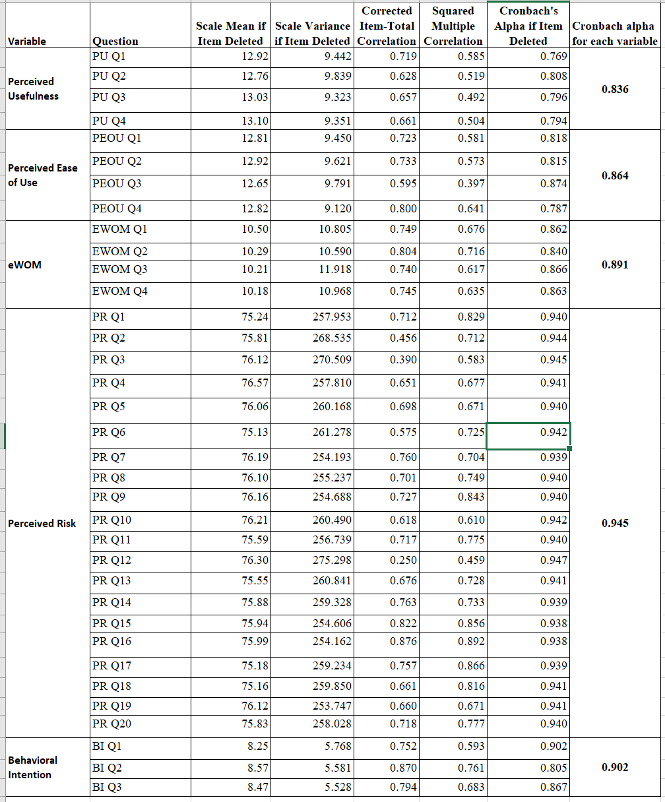
Source: constructed by author

The results show that all independent and dependent variables passed the reliability test.

4.4 Correlation analysis

This section is based on SPSS 29 to generate the results in terms of Pearson r value. It measures the relationship between two variables. The value is from -1 to 1. When r>0, it means there is positive relation while r < 0 represents negative relation. Data obtained from SPSS for each variable has been summarized in table 4.4 below.

Table 4.4 - Correlations between variables
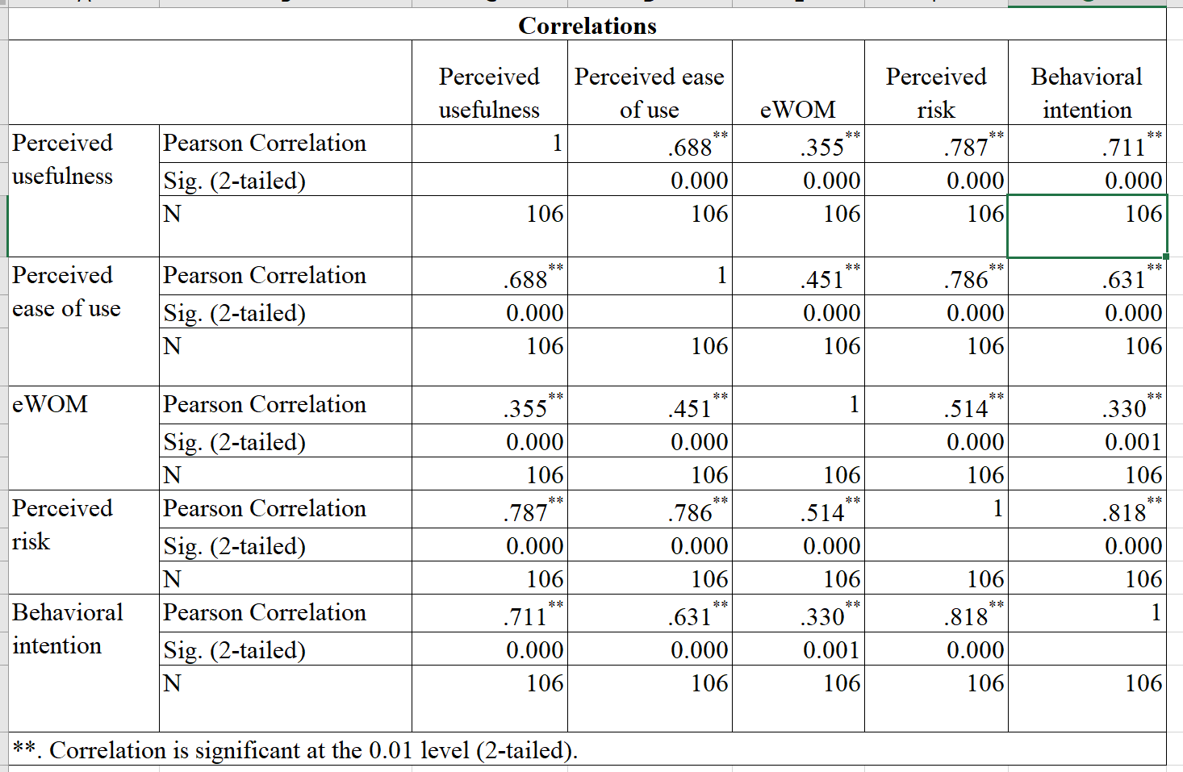
Sources: Constructed by author

In the below sections, the data collected would be applied to evaluate each hypothesis as set up during research frameworks.

4.4.1 Perceived Usefulness and behavioral intention analysis results

In the analysis of perceived usefulness and behavioral intention, r=0.711**, which is >0. It represents a positive relationship. Besides, correlation significant =0.000 (<0.01). Since the r value is 0.67<r<0.9, it validates that the perceived usefulness and behavioral intention has a strong or high correlation.

4.4.2 Perceived ease of use and behavioral intention analysis results

In the analysis of perceived ease of use and behavioral intention, r=0.631**, which is >0. It represents a positive relationship. Besides, correlation significant =0.000 (<0.01). Since the r value is 0.35<r<0.67, it validates that the perceived ease of use and behavioral intention has a modest correlation.

4.4.3 eWOM and behavioral intention analysis results

In the analysis of eWOM and behavioral intention, r=0.330**, which is >0. It represents a positive relationship. Besides, correlation significant =0.001 (<0.01). However, the r-value is <=0.35 which validates that the eWOM and behavioral intention has a low or weak correlation.

4.4.4 Perceived risk and behavioral intention analysis results

In the analysis of perceived risk and behavioral intention, r=0.818**, which is >0. It represents a positive relationship. Besides, correlation significant =0.001 (<0.01). However, the r-value is under 0.67<r<0.9. It validates that the perceived risk and behavioral intention have a strong or .high correlation. It is the highest correlation among the 4 variables with behavioral intention.

4.4.5 Summary of the correlation analysis results

The r value for the perceived usefulness and behavioral intention is 0.711; for the perceived ease of use and behavioral intention is 0.631 for the perceived risk and behavioral intention is 0.818. All three above relationships are positive relations and are modest to strong correlations. They are all under significant =0.001 (0.01), meaning that the results have significant confidence. On the other hand, it is found that eWOM and behavioral intention has a very low r-value of 0.33, which means a weak correlation. Based on the correlation analysis, the results could be summarized in table 4.4.5 below.

Table 4.4.5 - Validation on hypotheses using correlation analysis
Item | Hypotheses | Results
H1 | Perceived usefulness positively effects on behavioral intention of virtual consultation | Accepted
H2 | Perceived ease of use positively effects on behavioral intention of virtual consultation | Accepted
H3 | Perceived risk negatively effects on behavioral intention of virtual consultation | Accepted
H4 | eWOM positively effects on behavioral intention of virtual consultation | Rejected
Source: Constructed by author

4.5 Regression analysis

To explore how perceived usefulness, perceived ease of use, eWOM, and perceived risk effects on behavioral intention of the virtual medical consultation, this research has made use of multiple regression analysis to determine how significant the relationship is. The focus on multiple regression analysis considers all the independent variables together to identify which factor is the most influential to the dependent variable.

Figure 4.5 shows that the significant value for the average mean of perceived usefulness, perceived ease of use, eWOM, and perceived risk are 0.064, 0.594, 0.103 and <0.001 respectively. That means only perceived risk is having significant value <0.05. Other independent variable doesn’t meet the required significant value.

Figure 4.5 – 1st round regression analysis with perceived usefulness, perceived ease of use, eWOM, perceived risk effects on behavioral intention
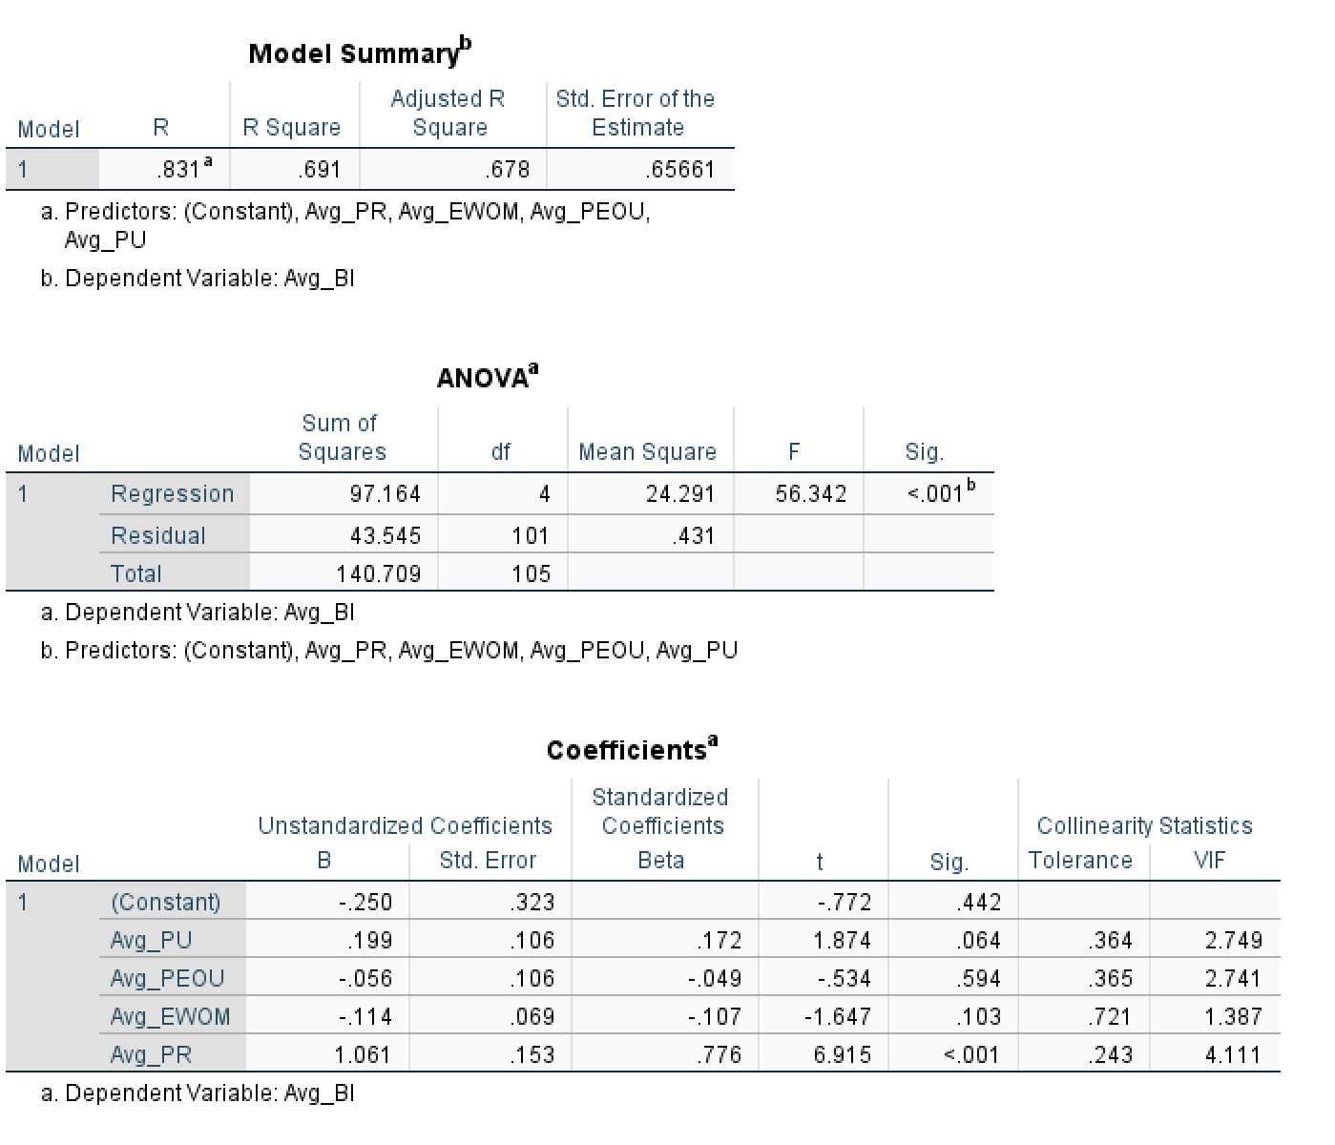
Source: Constructed by author

Another multiple regression analysis is recommended. The approach for the second-round analysis is to remove the variable that is having the largest significant value. As such, the perceived ease of use has been removed. It was found that the significant value for the average mean of perceived usefulness, eWOM, and perceived risk are 0.073, 0.088 and <0.001 respectively. That means only perceived risk is having significant value <0.05. Although perceived usefulness and eWOM in the second-round regression analysis are near 0.05, it still doesn’t meet the required significant value. As such, the third round of regression analysis is required. The eWOM is removed as it is the largest significant value. It is found that the significant value for the average mean of perceived usefulness and perceived risk are 0.053 and <0.001 respectively. That means only perceived risk is having significant value <0.05. Although the perceived usefulness in the third-round regression analysis is near 0.05, it still doesn’t meet the required significant value. As such, the fourth round of regression analysis is required. That is to only involve perceived risk. This would be the final round of regression tests. The results have been captured in figure 4.5.1.

According to figure 4.5.1, the R2 is 0.666. It indicates the fitting degree of the linear equation and the original data, which can reflect 64.8%. In general, the R2 above 0.6 is a very good level. The analytic results have F=209.935 and a significant value =0.000. As such, it means the chance of the independent variable not affecting the dependent value =0%. Since there is only perceived risk remains as one independent valuable, further evaluation of its significant value is enough. The significant value for the average mean of perceived risk is <0.001. Besides, the VIF = 1, which is <10. It further concludes that perceived risk has a significant negative influence on behavioral intention. The constant value could be ignored as its significant value = 0.430 (>0.05).

Figure 4.5.1 – Final round regression analysis with perceived risk effects on behavioral intention
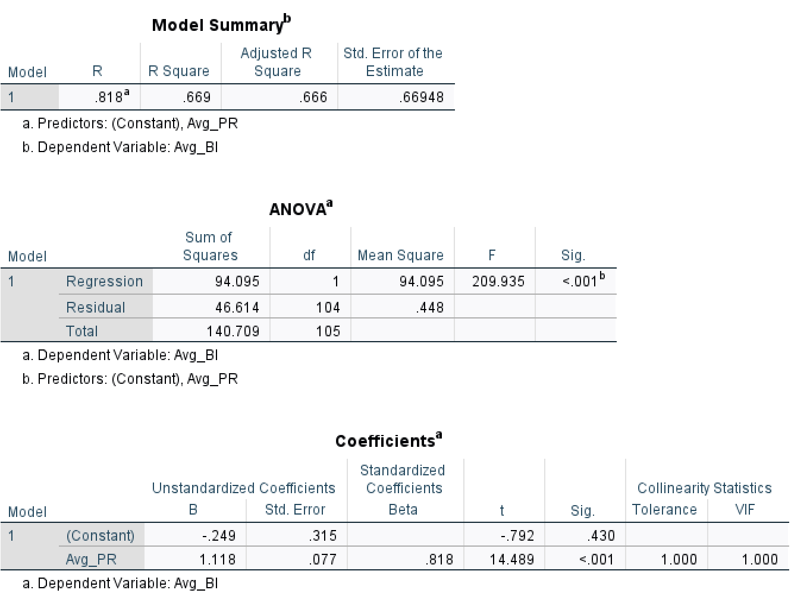
Source: constructed by author

Although the R2 figure looks good, further performed residual analysis is recommended to ensure that it is in a good trend. From figure 4.5.2, the histogram shows a bell shape. Although there are some off-track, the left side and right side are generally balanced. It could be concluded that the results of the residual analysis are positive.

Figure 4.5.2 – residual analysis histogram

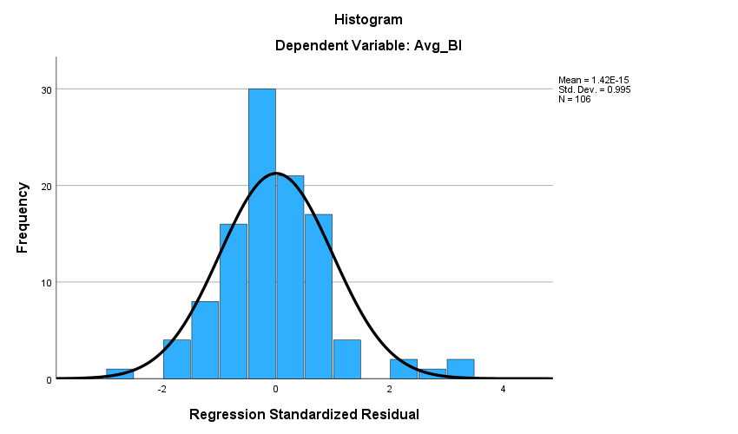
Source: Constructed by author

4.6 Summary of research data analysis and results

The reliability analysis shows that all the independent and dependent variables are reliable in the sense that similar results would be obtained if the same conditions data research is repeated in the future. It provides confidence in this research data analysis for further discussion.

In the statistical descriptive analysis, the means value per each variable in sorted descending order are perceived usefulness, perceived ease of use, behavioral intention, perceived risk and eWOM. It shows that the least agreed variable for the respondent on virtual medical consultation is eWOM. Although the perceived risk is the second lowest, it did have one question related to social distancing having the highest score. The question is under social construct from the perceived risk variable. This show that perceived risk is still significantly important during the statistical study.

During the correlation analysis, the Pearson coefficient “r” values in descending order are perceived risk, perceived usefulness, perceived ease of use and eWOM. eWOM was rejected meaning that there is no correlation between eWOM and perceived intention. On the other hand, it is proved that perceived risk is having the strongest negative effect on behavioral intention.

Finally, the regression analysis shows that when comparing multiple independent variables, only perceived risk has significant confidence with the relationship to behavioral intention.

5. Conclusion and recommendation

This chapter would first draw conclusions based on the research findings. The second section would respond to the research objective and make research recommendations. The third section would then discuss the limitation of the research while the final section would discuss future research.

5.1 Research conclusion

This research set up the objective in chapter 1 to identify the factors affecting the behavioral intention of using the virtual platform in Hong Kong. This research study is based on a literature review to establish research frameworks to explore the relationship between perceived usefulness, perceived ease of use, eWOM, and perceived risk as independent variables of behavioral intention. It is then based on a questionnaire design to collect survey data for analysis. This research confirms through empirical evidence through correlation analysis with the below findings on the hypothesis testing:

- “Perceived usefulness” has a positive effect towards “behavioral intention” in virtual medical consultation with accepted results
- “Perceived ease of use” has a positive effect towards “behavioral intention” in virtual medical consultation with accepted results
- “Perceived risk” has a negative effect towards “behavioral intention” in virtual medical consultation with accepted results
- “eWOM” has a positive effect towards “behavioral intention” in virtual medical consultation with rejected results

From all the hypotheses, only the eWOM effect towards behavioral intention has a rejected result.

eWOM applied better to affect behavioral intention in other industries. However, it may not be the case for healthcare services. Gebele et al. (2014) suggested that there may have confusion about information about the medical service in terms of accuracy, quality and quantity. Information from third-party sources includes healthcare providers, expert sources such as a primary physician, health insurance and the non-expert source such as eWOM. The patient needs the kind of information that would be involved more in the health decision-making process. However, they may have a perception of information similarity, overload and ambiguity. As such, this may lead to the eWOM effect on behavioral intention being minimal. Park and Lee (2008) also find that customer involvement is the mediator for the eWOM effect on behavioral intention. Virtual medical consultation has been the new product that was accelerated to evolve during COVID-19. Customer involvement may not be significant enough to establish the eWOM effect on behavioral intention.

During the regression analysis, it was found that only perceived risk has a significant value <0.05. It reveals that when considering all independent variables together, only perceived risk has significant effects towards behavioral intention. Dash et al. (2021) study found that perceived risk influence the intention to adopt virtual medical consultation mediating through perceived usefulness and perceived ease of use respectively. Our research further supplements that out of perceived usefulness, perceived ease of use, eWOM, and perceived risk, the most influential criterion towards behavioral intention is perceived risk. Besides, Dash et al. (2021) study focuses on the financial risk and performance risk only. In our research, it is a well-balanced perceived risk which involved 6 common constructs financial, physical, social, functional, psychological and time. It covers a more comprehensive landscape of perceived risk. The regression study in this research revealed that perceived risk is the most critical predictor of the behavioral intention of virtual medical consultation.

5.2 Research recommendation

The results of this study provided insight into managerial recommendations. The results of the analysis are summarized below. This could be explained by the questions with the highest score in their corresponding variables under table 5.2.

Table 5.2 - The highest mean score among the independent variables
Variables | Question | Mean | Standard Deviation
Perceived usefulness | PU Q2 - Using the virtual medical consultation platform makes it easier for me to perform medical consultations? | 4.51 | 1.20
Perceived ease of use | PEOU Q3 - Making appointment with a doctor on the virtual medical consultation platform is easier. | 4.42 | 1.27
Perceived risk | PR Q6 - The virtual medical consultation platform can minimize the social distance problems. | 4.72 | 1.29
eWOM | eWOM Q4 - Information about services shared in social platform motivates me in using virtual medical consultation platform. | 3.55 | 1.29
Source: Constructed by author

The questions with the highest mean value were larger than 4 for perceived usefulness, perceived ease of use, and perceived risk. Their values are 4.51. 4.42 and 4.72 respectively. This study makes the following recommendation to put the application into practice and provide research suggestions for future researchers to continue research. For eWOM, the relationship with behavioral intention is rejected in the correlation analysis and the value of the highest means is a low value of 3.55. It is worth analyzing and providing insight into why this happened in virtual medical consultations service. The below subsection recommend how to improve different independent variables

5.2.1 Perceived usefulness

The question about virtual medical consultation makes it easier for the interviewee to perform medical consultations have a mean value of 4.51. The mean value is more than slightly agree >4 and <5. On the other hand, in figure 5.2.1, there are over 58% selected agree or strongly agreed. It demonstrates that most of the respondent generally agreed with this question. However, the standard deviation value also revealed that the interviewee response are quite dispersed. There is room for improvement to further raise the level of perceived usefulness.

Figure 5.2.1 - Highest mean value question in perceived usefulness
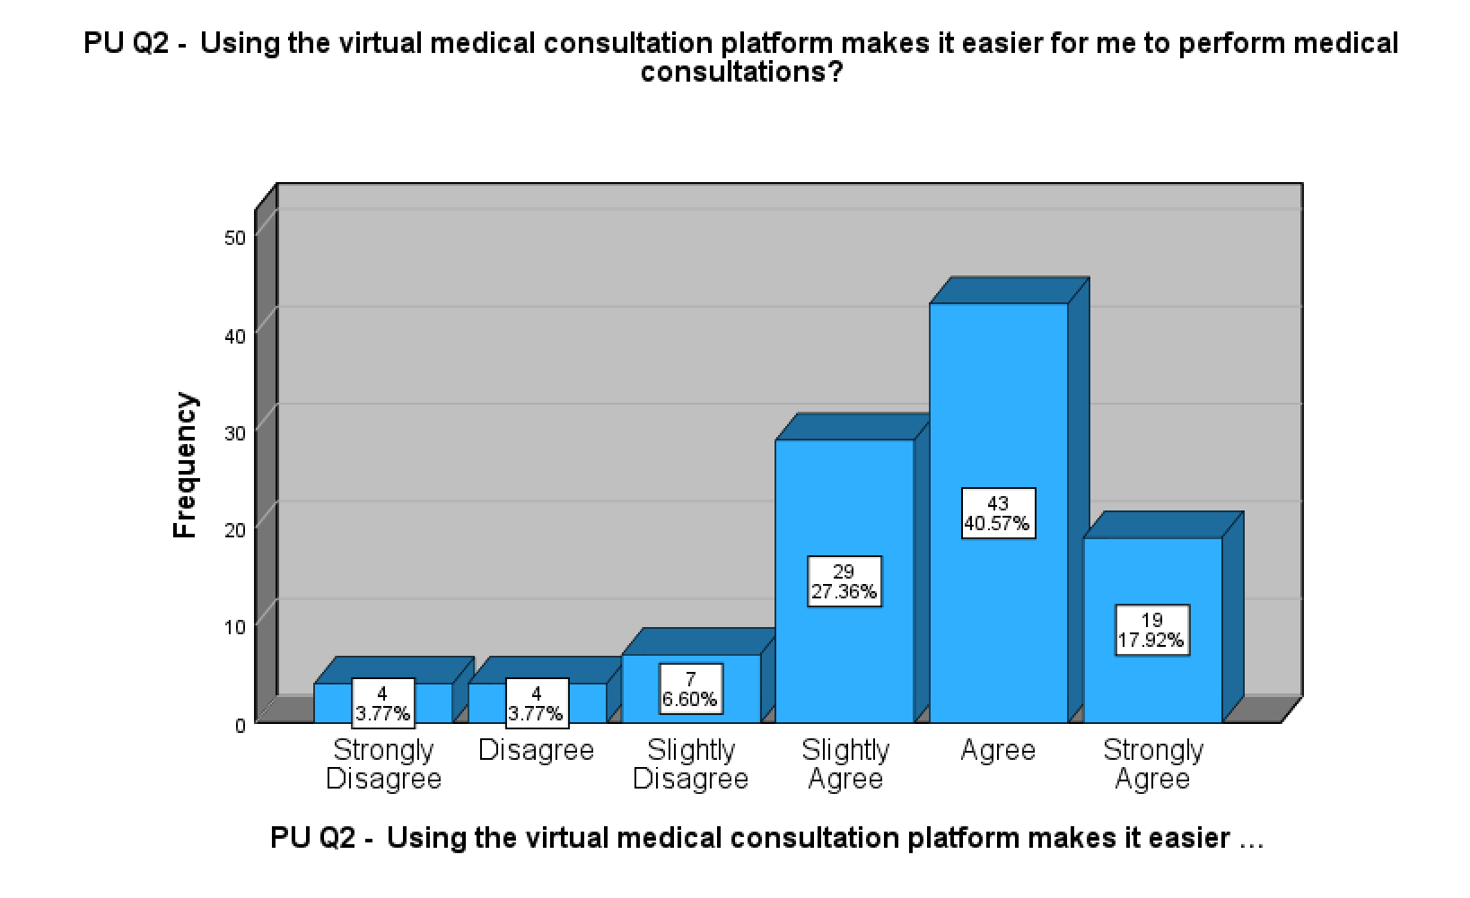
Source: constructed by author

Al-Samarraie et al. (2020) study shows that there exist individual barriers in most middle east countries that the patient lack of experience or knowledge in using virtual medical consultation. It is revealed that the awareness of the benefit of virtual medical consultation could help with behavioral intention and adoption. It is recommended to implement an e-health system and provide training and education for healthcare professionals and patients (Al-Samarraie et al, 2020). In Hong Kong, the government has launched HA GO in December 2019. This is an all-in-one mobile application to ease patient management on its appointments, medical records, and even undergoing virtual medical consultations (HA Go, 2023). To increase awareness of patients, it is recommended private service providers develop a similar all-in-one mobile application to facilitate convenient management of appointments, booking, and payment of virtual medical consultations. More marketing and promotion through social media could be done with the video to educate the customer or patient on the benefit of using virtual medical consultations.

Besides, there was a study in Minnesota on the perceived usefulness of electronic personal health records in preventive healthcare. The participant indicates that it makes “things easier”. Some participants also think that preventive screen information is useful. Some participants even indicate that the platform should provide an optional monthly reminder on upcoming laboratory tests and doctor appointments (Ant Ozok et al., 2014). It is recommended that private healthcare providers in Hong Kong could integrate electronic health records from hospital authorities in their mobile applications so that laboratory and imaging are available. This would further develop virtual medical consultation in the specialist visit. The patient with long-term illness would find the benefit of avoiding travelling and waiting at a clinic for a regular revisit. The consultation would be easier than a physical visit.

5.2.2 Perceived ease of use

The question of making an appointment with a doctor on the virtual medical consultation platform is easier have a mean value of 4.42. The mean value is more than slightly agree >4 and <5. It is not reached the agreed level. On the other hand, in figure 5.2.2, there are around 50% selected agree or strongly agreed. It demonstrates that the majority of the respondent generally agreed with this question. However, the standard deviation value also revealed that the interviewee response are quite dispersed. There is room for improvement to further raise the level of perceived ease of use.

Figure 5.2.2 - highest mean value question in perceived ease of use
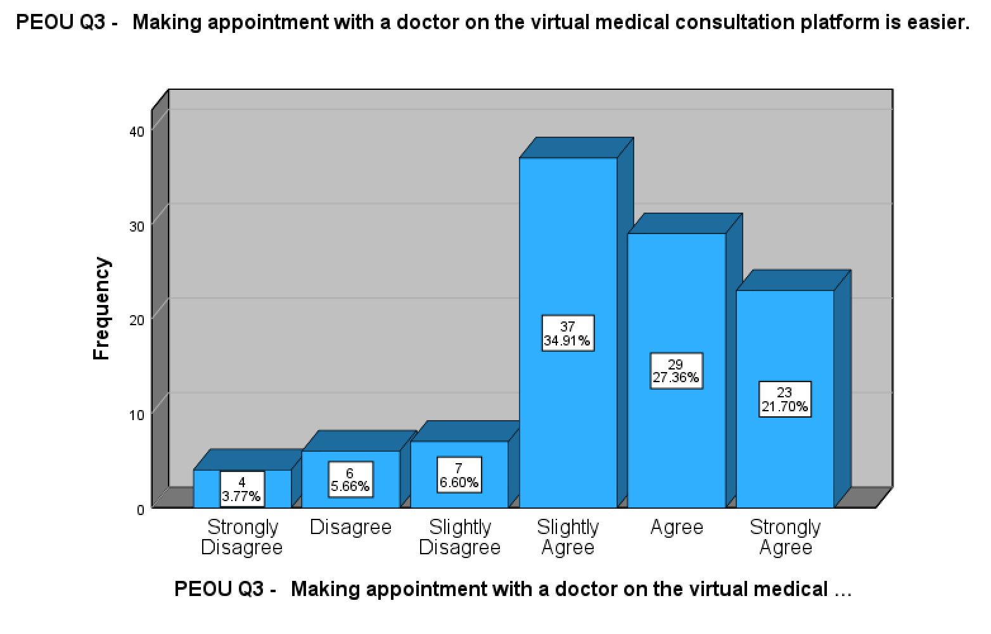
Source: Constructed by author

Kitsios et al. (2023) study user satisfaction and the implication of digital platforms in healthcare in Greek. It is found that the perceived ease of use of the e-appointment system is the most important patient satisfaction. In this research, it is also an important factor in making an appointment with the doctor for a virtual medical consultation. It is recommended the healthcare service provider could allocate enough quota for the virtual consultation versus physical visit. The mobile application should consider the user experience from selecting a doctor, viewing doctor availability and ensuring the doctor could use the virtual medical consultation. This would increase the overall perceived ease of use of the virtual medical consultation.
On the other hand, there was a growing trend of health expenditure funded by private and employer-provided insurance. This is illustrated in figure 5.2.2.1 There was nearly 20% of expenditure funded by the insurance policy in the year 2019/20. There is a potential collaboration between insurance companies and healthcare providers. The member could directly use the insurance company's mobile application to check the availability of the doctor under insurance coverage, book an appointment directly and undergo the virtual consultation through the insurance application. Major healthcare providers should actively collaborate with insurance companies to co-create value to promote virtual medical consultation. That’s the way to raise awareness of the benefit associated with the virtual medical consultation

Figure 5.2.2.1 - Health expenditure shared by financial scheme in Hong Kong
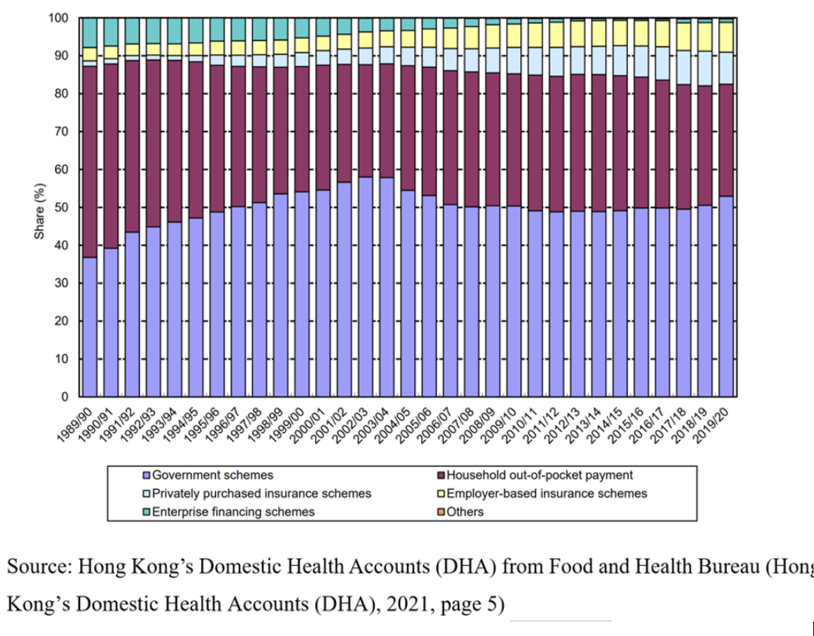

5.2.3 Perceived risk:

The question virtual medical consultation platform can minimize social distance problems has a mean value of 4.72. The mean value is more than slightly agree >4 and <5. It is not reached the agreed level. On the other hand, in figure 5.2.3, there are over 65% selected agree or strongly agreed. It demonstrates that the majority of the respondent generally agreed with this question. However, the standard deviation value also revealed that the interviewee responses are quite dispersed. This is the highest mean value and the highest percentage of respondents selected agreed or strongly agreed in the overall questionnaire. It is worth exploring a way for further improvement.

Figure 5.2.3 - the highest mean value question in perceived risk
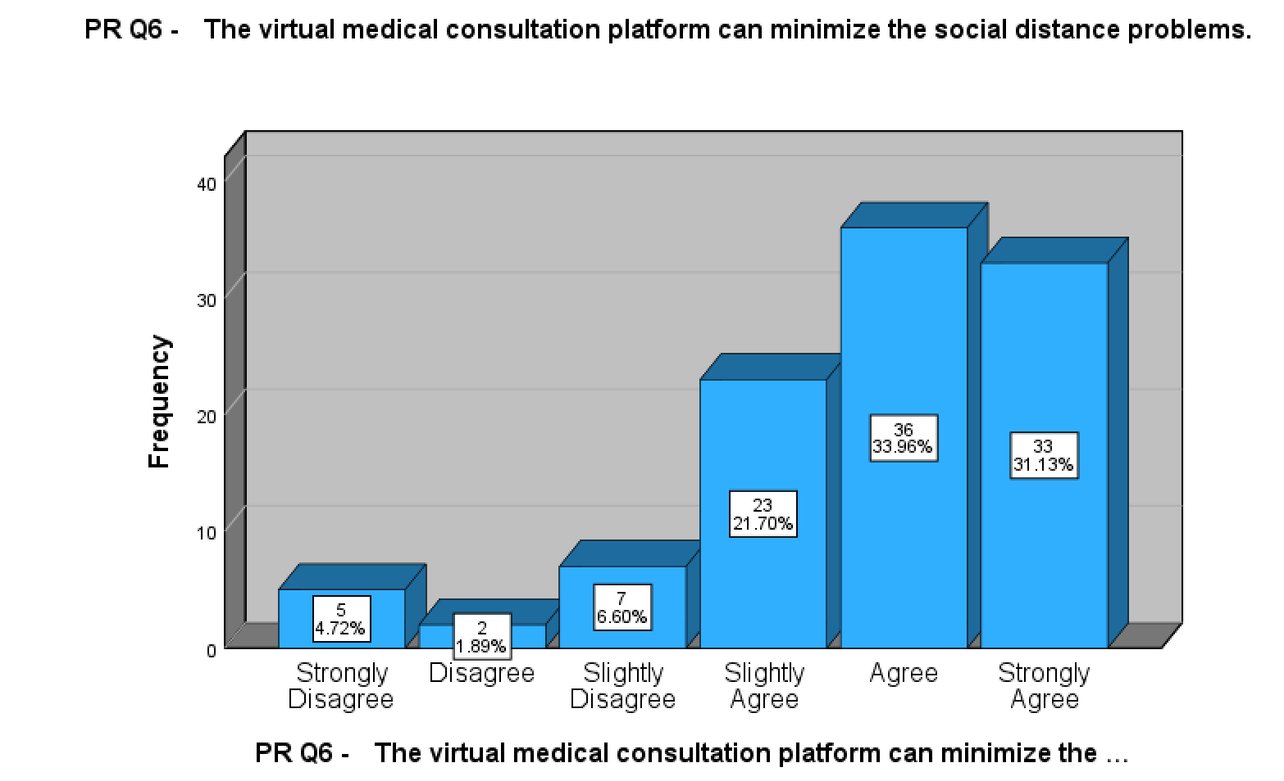
Source: Constructed by author
The study revealed that virtual medical consultation was introduced during the COVID-19 pandemic because of social distancing and city lockdown. It was found that the perceived risk of COVID-19 was very high. Bangladeshi government introduced virtual medical consultation to avoid transmission of disease by reducing social distancing. Research studies show that the perceived risk of COVID-19 has been associated with virtual medical healthcare adoption in Bangladesh hospitals. The participants mostly found that virtual medical consultation is acceptable and has perceived benefits, and accessibility. The study also found that the participant with a greater perceived risk of COVID-19 is more likely to have a lesser concern about the other risk factors such as the expertise of healthcare professionals in delivering the service (Hosseinzadeh et al., 2023).

In this research, the regression analysis suggested that perceived risk has been the only one that has significant effects on behavioral intention. This should be echoing Hosseinzadeh et al. (2023) recent study on the perceived risk of COVID-19 effects diminishing other risk factors or even other independent variables. Dash et al. (2021) also study the multiple factors affecting virtual medical consultation. In their study, the perceived risk influenced the adoption of virtual medical consultation mediating through perceived usefulness and perceived ease of use respectively. The two hypotheses have been supported. It was found that many patients are interested to adopt virtual medical consultations to adhere to social distancing.

The further development that is recommended in our research findings is to link up the social distancing with the perceived usefulness and perceived ease of use. Social distancing measure has started to release as a result of the post-COVID-19 pandemic period. It is recommended that the Hong Kong government and healthcare service providers should spend more resources to educate the citizens on the risks associated with the transmission of diseases during physical visits. This would help to maintain the awareness of the risk associated when travelling to the hospital and clinic, to higher risk patients, such as critical illness. Virtual medical consultation should also be promoted and adopted for specialist revisit for those long-term illnesses. The virtual healthcare application could be extended to include the integration of IoT devices to collect patient vital signs such as body temperature, and blood pressure. The patient and the physician should be further educated on the perceived benefits associated with virtual medical consultation during the revisit. This would make the virtual medical consultation sustainable during the post-COVID-19 period.

5.2.4 eWOM

The question with Information about services shared on social platforms motivates me in using virtual medical consultation platforms has a mean value of 3.55. The mean value is < 4. It is even reaching the slightly agree level. On the other hand, in figure 5.2.4, there are just 28% selected agree or strongly agreed. It demonstrates that only a minority of respondents agree with this question. Besides, the standard deviation value also revealed that the interviewee responses are quite dispersed. In the correlation study, the eWOM effect towards behavioral intention has a rejected result.

Figure 5.2.4 - the highest mean value question in eWOM
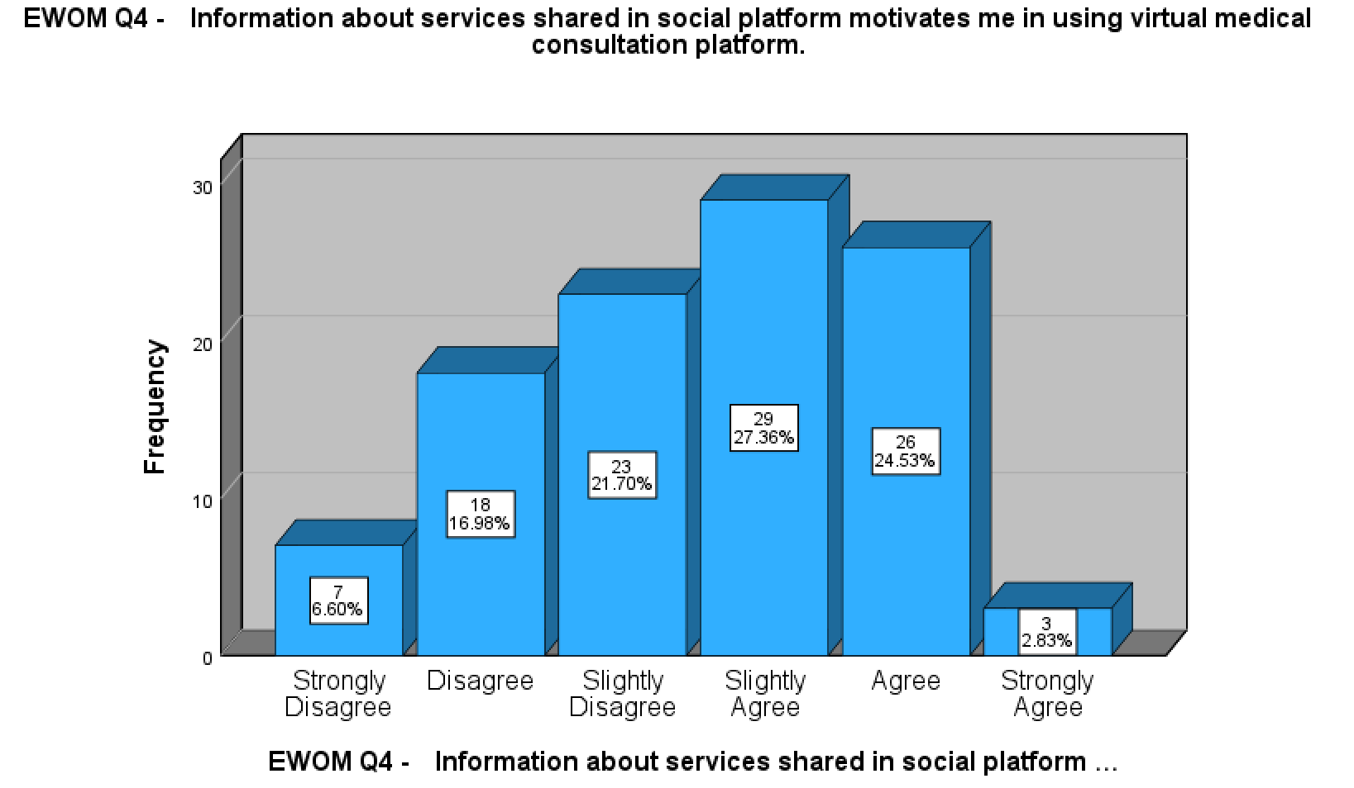
Source: Constructed by author

As mentioned in section 5.1, Park and Lee (2008) customer involvement is the mediator for the eWOM effect on behavioral intention. The social platform has been one of the most popular platforms to share information nowadays where the customer could also provide instant feedback to the post from the service providers or other customers’ experience. The highest score in the eWOM variable also suggested this finding. It is recommended the government and healthcare providers join to form a single platform to promote and allow the general public to exchange information about virtual medical consultation through social media. This will not only increase customer involvement in eWOm but also reduce the concern of patient confusion about the information in various third-party eWOM channels.

5.3 Research limitations

This research is strived to conduct in a structured research methodology to deliver value to fulfil the research objective. However, there are still a few research limitations.

First, due to resources, and time concerns, the sampling method for this research is using the non-probability method. It may ignore some sample that is meaningful to the research topic. Second, the study is focused on online surveys, it may ignore those traditional sources to do surveys directly in clinics. The opinion of the physician is not included. Third, only behavioral intention was evaluated in the research framework. The actual behaviour was not included. Fourth, a focus group has been arranged as part of the research methodology to comment on the questionnaire questions. They come from the healthcare industry. There would be different understandings based on different occupations in various industries. Fifth, behavioral intention may be varied by different age, income and educational background in Hong Kong. There is no evidence that the results would be generic in these demographic factors from within and outside the Hong Kong region. The research methodology has not collected these data elements for further categorization and analysis.

5.4 Direction of future research

The research results and limitations provide opportunities for further research in terms of different samples and designs for the research study. Below is the suggestion for future research.

First, to further see how perceived risk affects behavioral intention, additional mediation for the perceived usefulness and perceived ease of use as mentioned by (Dash et al., 2021), should be considered. Besides, the additional variable of social influence could be used to replace eWOM. Second, the research could be partnered with local universities or hospitals. Working under their name, it is easier to obtain approval to conduct a physical survey from different clinic chains, hospitals and even over the streets. As such, it is easier to reach out to those respondents who have experienced virtual medical consultations. Besides, the sampling could be more random. Third, another focus group could be arranged with a group of specialists in different areas, such as university professors, administrative officers in government, major users and patients from different virtual healthcare providers. This focus group aims to obtain the concept and idea of the current and future virtual medical consultation development through focus group discussions with a wider variety of professionals. Such qualitative data should be used to design further research frameworks and questionnaires. Finally, further research could be done on how geographic location is a mediator to the dependent variable of behavior intention. This would help to derive the strategy to increase virtual consultation adoption in different countries or regions.

6. Reference
Abd Ghani, M., Rahi, S., Yasin, N.M. and Alnaser, F.M., (2017). Adoption of internet banking: extending the role of technology acceptance model (TAM) with e-customer service and customer satisfaction. World Applied Sciences Journal, 35(9), pp.1918-1929.

Al-Samarraie, H., Ghazal, S., Alzahrani, A.I. and Moody, L. (2020). Telemedicine in Middle Eastern countries: Progress, barriers, and policy recommendations. International Journal of Medical Informatics, 141, p.104232. doi:https://doi.org/10.1016/j.ijmedinf.2020.104232.
‌Albers, M. J. (2017). Introduction to Quantitative Data Analysis in the Behavioral and Social Sciences. New York: John Wiley & Sons. https://doi.org/10.1002/9781119290384.
Alfadda, H.A. and Mahdi, H.S. (2021). Measuring Students’ Use of Zoom Application in Language Course Based on the Technology Acceptance Model (TAM). Journal of Psycholinguistic Research. doi:10.1007/s10936-020-09752-1.

Ali, Z. and Bhaskar, Sb. (2016). Basic statistical tools in research and data analysis. Indian Journal of Anaesthesia, [online] 60(9), p.662. doi:https://doi.org/10.4103/0019-5049.190623.

Allen, I. and Seaman, C. (2007). Likert Scales and Data Analyses. [online] Available at: https://www.bayviewanalytics.com/reports/asq/likert-scales-and-data-analyses.pdf.

Ant Ozok, A., Wu, H., Garrido, M., Pronovost, P.J. and Gurses, A.P. (2014). Usability and perceived usefulness of personal health records for preventive health care: A case study focusing on patients’ and primary care providers’ perspectives. Applied Ergonomics, 45(3), pp.613–628. doi:https://doi.org/10.1016/j.apergo.2013.09.005.

Ariff, M.S.M., Sylvester, M., Zakuan, N., Ismail, K. and Ali, K.M. (2014). Consumer Perceived Risk, Attitude and Online Shopping Behaviour; Empirical Evidence from Malaysia. IOP Conference Series: Materials Science and Engineering, [online] 58(1), p.012007. doi:10.1088/1757-899x/58/1/012007.

‌‌Bandura, A. (1982). Self-efficacy mechanism in human agency. American Psychologist, 37(2), pp.122–147. doi:10.1037/0003-066x.37.2.122.

Basuki, R., Tarigan, Z.J.H., Siagian, H., Limanta, L.S., Setiawan, D. and Mochtar, J. (2022). The effects of perceived ease of use, usefulness, enjoyment and intention to use online platforms on behavioral intention in online movie watching during the pandemic era. International Journal of Data and Network Science, 6(1), pp.253–262.
‌Bauer, R.A., (1960). Consumer behavior as risk taking. In: Hancock, R.H. (Ed.), Dynamic Marketing for a Changing World. American Marketing Association, Chicago, IL, pp. 389–398.
Berry, W.D., Berry, W.D., Feldman, S. and Dr, S.F. (1985). Multiple Regression in Practice. [online] Google Books. SAGE. Available at: https://books.google.com.hk/books?hl=en&lr=&id=tbNWi_KjJ-sC&oi=fnd&pg=PA11&dq=Berry+et+al+1985&ots=dX8fxx8wau&sig=gOckbrLcBN3EkmhdoSY2luhOMWQ&redir_esc=y#v=onepage&q=Berry%20et%20al%201985&f=false (Accessed 21 Feb. 2023).
‌Bhatiasevi, V. and Yoopetch, C. (2015). The determinants of intention to use electronic booking among young users in Thailand. Journal of Hospitality and Tourism Management, 23, pp.1–11. doi:10.1016/j.jhtm.2014.12.004.
Bokolo, A.Jnr. (2020). Exploring the adoption of telemedicine and virtual software for care of outpatients during and after COVID-19 pandemic. Irish Journal of Medical Science (1971 -). doi:10.1007/s11845-020-02299-z.

Boksberger, P.E., Bieger, T. and Laesser, C. (2007). Multidimensional analysis of perceived risk in commercial air travel. Journal of Air Transport Management, 13(2), pp.90–96.
‌Bruwer, J. and Cohen, J. (2019). Restaurants and wine by-the-glass consumption: Motivational process model of risk perception, involvement and information-related behaviour. International Journal of Hospitality Management, 77, pp.270–280. doi:10.1016/j.ijhm.2018.07.006.
Census. (2022). Statistical Product. [online] Available at: https://www.censtatd.gov.hk/en/EIndexbySubject.html?pcode=B1120106&scode=600t/B11201062021XXXXB01.pdf (Accessed 19 Nov. 2022).

Cheung, C.M.K. and Thadani, D.R. (2012). The impact of electronic word-of-mouth communication: A literature analysis and integrative model. Decision Support Systems, [online] 54(1), pp.461–470. doi:10.1016/j.dss.2012.06.008.

China Daily HK. (2021). COVID spurs telemedicine, less waiting, no contact. Available at: https://www.chinadailyhk.com/article/158821 (Accessed 19 Nov. 2022).

Cox, D.F. (1967). Risk taking and information handling in consumer behavior. agris.fao.org. Available at: https://agris.fao.org/agris-search/search.do?recordID=US201300599126 (Accessed 26 Jan. 2023).

Crespo, Á.H., del Bosque, I.R. and de los Salmones Sánchez, M.M.G. (2009). The influence of perceived risk on Internet shopping behavior: a multidimensional perspective. Journal of Risk Research, 12(2), pp.259–277. doi:10.1080/13669870802497744.

Cronbach, L.J. (1951). Coefficient alpha and the internal structure of tests. Psychometrika, 16(3), pp.297–334. doi:https://doi.org/10.1007/bf02310555.
Dash, M., Shadangi, P.Y., Muduli, K., Luhach, A.K. and Mohamed, A. (2021). Predicting the motivators of telemedicine acceptance in COVID-19 pandemic using multiple regression and ANN approach. Journal of Statistics and Management Systems, 24(2), pp.319–339. doi:https://doi.org/10.1080/09720510.2021.1875570.

‌Dash, M., Shadangi, P.Y., Muduli, K., Luhach, A.K. and Mohamed, A. (2021). Predicting the motivators of telemedicine acceptance in COVID-19 pandemic using multiple regression and ANN approach. Journal of Statistics and Management Systems, 24(2), pp.319–339. doi:https://doi.org/10.1080/09720510.2021.1875570.
Davis, F.D. (1989). Perceived Usefulness, Perceived Ease of Use, and User Acceptance of Information Technology. MIS Quarterly, 13(3), pp.319–340. doi:https://doi.org/10.2307/249008.
Dulcic, Z., Pavlic, D. and Silic, I. (2012). Evaluating the Intended Use of Decision Support System (DSS) by Applying Technology Acceptance Model (TAM) in Business Organizations in Croatia. Procedia - Social and Behavioral Sciences, 58, pp.1565–1575. doi:10.1016/j.sbspro.2012.09.1143.

Erkan, I. and Evans, C. (2016). The influence of eWOM in social media on consumers’ purchase intentions: An extended approach to information adoption. Computers in Human Behavior, [online] 61(1), pp.47–55. doi:10.1016/j.chb.2016.03.003.
‌Etikan, I. and Bala, K. (2017). Sampling and Sampling Methods. Biometrics & Biostatistics International Journal, [online] 5(6), pp.215–217. doi:10.15406/bbij.2017.05.00149.
Ferketich, S. (1991). Focus on psychometrics. Aspects of item analysis. Research in Nursing & Health, 14(2), pp.165–168. doi:https://doi.org/10.1002/nur.4770140211.

Fernández Coves, A., Yeung, K.H.T., van der Putten, I.M. and Nelson, E.A.S. (2022). Teleconsultation adoption since COVID-19: Comparison of barriers and facilitators in primary care settings in Hong Kong and the Netherlands. Health Policy, [online] 126(10), pp.933–944. doi:10.1016/j.healthpol.2022.07.012.

Firmansyah, I.A., Yasirandi, R. and Utomo, R.G. (2022). The influence of efficacy, credibility, and normative pressure to M-banking adoption level in Indonesia. Procedia Computer Science, 197, pp.51–60. doi:10.1016/j.procs.2021.12.117

Fishbein, M. & Ajzen, I. (1975). Belief, Attitude, Intention and Behavior: An Introduction to Theory and Research. Reading, MA: Addison-Wesley.
‌Fisher, M.J. and Marshall, A.P. (2009). Understanding descriptive statistics. Australian Critical Care, 22(2), pp.93–97. doi:10.1016/j.aucc.2008.11.003.
Fossey, E., Harvey, C., Mcdermott, F. and Davidson, L. (2002). Understanding and Evaluating Qualitative research. Australian and New Zealand Journal of Psychiatry, [online] 36(6), pp.717–732. doi:10.1046/j.1440-1614.2002.01100.x.
Frost, J. (2018). How To Interpret R-squared in Regression Analysis. [online] Statistics By Jim. Available at: https://statisticsbyjim.com/regression/interpret-r-squared-regression/ (Accessed 26 Feb. 2023).

‌Gani, N.I.A., Rathakrishnan, M. and Krishnasamy, H.N. (2020). A PILOT TEST FOR ESTABLISHING VALIDITY AND RELIABILITY OF QUALITATIVE INTERVIEW IN THE BLENDED LEARNING ENGLISH PROFICIENCY COURSE. Journal of critical reviews, 7(05). doi:https://doi.org/10.31838/jcr.07.05.23.

‌Gebele, C., Tscheulin, D.K., Lindenmeier, J., Drevs, F. and Seemann, A.-K. (2014). Applying the concept of consumer confusion to healthcare: development and validation of a patient confusion model. Health Services Management Research, [online] 27(1-2), pp.10–21. doi:https://doi.org/10.1177/0951484814546959.
‌Glover, S. and Benbasat, I. (2010). A Comprehensive Model of Perceived Risk of E-Commerce Transactions. International Journal of Electronic Commerce, 15(2), pp.47–78. doi:10.2753/jec1086-4415150202.
Gogtay, N. (2010). Principles of sample size calculation. Indian Journal of Ophthalmology, 58(6), p.517. doi:https://doi.org/10.4103/0301-4738.71692.
‌‌Goodman, L.A. (1961). Snowball Sampling. The Annals of Mathematical Statistics, [online] 32(1), pp.148–170. Available at: https://www.jstor.org/stable/2237615.
Green, S.B. (1991). How Many Subjects Does It Take To Do A Regression Analysis. Multivariate Behavioral Research, [online] 26(3), pp.499–510. doi:10.1207/s15327906mbr2603_7.
‌Guthrie, C., Fosso-Wamba, S. and Arnaud, J.B. (2021). Online consumer resilience during a pandemic: An exploratory study of e-commerce behavior before, during and after a COVID-19 lockdown. Journal of Retailing and Consumer Services, 61, p.102570. doi:10.1016/j.jretconser.2021.102570.
Gupta, A., Mishra, P., Pandey, C., Singh, U., Sahu, C. and Keshri, A. (2019). Descriptive Statistics and Normality Tests for Statistical Data. Annals of Cardiac Anaesthesia, 22(1), p.67.‌

HA Go. (2023). Benefits of HA Go. Available at: https://www2.ha.org.hk/hago/en/about-ha-go/ha-go/benefits-of-ha-go (Accessed 9 Mar. 2023).
‌Hair, J. F. et al. (2010). Multivariate data analysis (7th ed.). Upper Saddle River, NJ: Prentice-Hall
‌Hong Kong’s Domestic Health Accounts (DHA). (2021). Available at: https://www.fhb.gov.hk/statistics/download/dha/en/a_estimate_1920.pdf (Accessed 11 Mar. 2023).
Hosseinzadeh, H., Ratan, Z.A., Nahar, K., Dadich, A., Al-Mamun, A., Ali, S., Niknami, M., Verma, I., Edwards, J., Shnaigat, M., Malak, M.A., Rahman, M.M. and Okely, A. (2023). Telemedicine Use and the Perceived Risk of COVID-19: Patient Experience. International Journal of Environmental Research and Public Health, 20(4), p.3061. doi:https://doi.org/10.3390/ijerph20043061.
‌Hox, J. J. and Boeije, H. R. (2005). Data collection, primary versus secondary
HKTDC research. (2020). [online] Available at: https://research.hktdc.com/en/article/NTkzOTE0MDg4 (Accessed 26 Nov. 2022).

Hu, Y. and Kim, H.J. (2018). Positive and negative eWOM motivations and hotel customers’ eWOM behavior: Does personality matter? International Journal of Hospitality Management, 75, pp.27–37. doi:10.1016/j.ijhm.2018.03.004.

Hu, P.J., Chau, P.Y.K., Sheng, O.R.L. and Tam, K.Y. (1999). Examining the Technology Acceptance Model Using Physician Acceptance of Telemedicine Technology. Journal of Management Information Systems, [online] 16(2), pp.91–112. doi:10.1080/07421222.1999.11518247.

Jacoby, J. and Kaplan, L.B. (2013). The Components of Perceived Risk. ACR Special Volumes, [online] SV-02. Available at: https://www.acrwebsite.org/volumes/12016/volumes%20/sv02/SV-02.
‌Johnston, M.P. (2014). Secondary Data Analysis: A Method of which the Time Has Come. Qualitative and Quantitative Methods in Libraries, [online] 3(3), pp.619–626. Available at: https://www.qqml-journal.net/index.php/qqml/article/view/169.
Karahanna, E. and Straub, D.W. (1999). The psychological origins of perceived usefulness and ease-of-use. Information & Management, 35(4), pp.237–250.

Kitsios, F., Stefanakakis, S., Kamariotou, M. and Dermentzoglou, L. (2023). Digital Service Platform and Innovation in Healthcare: Measuring Users’ Satisfaction and Implications. Electronics, 12(3), p.662. doi:https://doi.org/10.3390/electronics12030662.
‌Kushwaha, T. and Shankar, V. (2013). Are Multichannel Customers Really more Valuable? The Moderating Role of Product Category Characteristics. Journal of Marketing, 77(4), pp.67–85. doi:10.1509/jm.11.0297.
‌Krejcie, R. V, & Morgan, D. W. (1970). Determining Sample Size for Research Activities. Educational and Psychological Measurement, 30, 607–610. https://doi.org/10.1177/001316447003000308
Laroche, M., McDougall, G.H.G., Bergeron, J. and Yang, Z. (2004). Exploring How Intangibility Affects Perceived Risk. Journal of Service Research, [online] 6(4), pp.373–389. doi:10.1177/1094670503262955.
‌Lee, M.-C. (2009). Factors influencing the adoption of internet banking: An integration of TAM and TPB with perceived risk and perceived benefit. Electronic Commerce Research and Applications, 8(3), pp.130–141. doi:10.1016/j.elerap.2008.11.006.
‌Lee, M. and Youn, S. (2009). Electronic word of mouth (eWOM). International Journal of Advertising, 28(3), pp.473–499.
Liao, C., Chen, J.-L. and Yen, D.C. (2007). Theory of planning behavior (TPB) and customer satisfaction in the continued use of e-service: An integrated model. Computers in Human Behavior, 23(6), pp.2804–2822. doi:10.1016/j.chb.2006.05.006.

Lin, L.I-Kuei. (1989). A Concordance Correlation Coefficient to Evaluate Reproducibility. Biometrics, 45(1), p.255. doi:https://doi.org/10.2307/2532051.

Lingnan University (2020). Survey finds over 60% senior citizens are willing to try online medical consultations. [online] Available at: https://www.ln.edu.hk/research-and-impact/research-press-conferences/survey-findings-on-video-medical-consultation-for-elderly (Accessed 26 Nov. 2022).

Lu, Y., Zhou, T. and Wang, B. (2009). Exploring Chinese users’ acceptance of instant messaging using the theory of planned behavior, the technology acceptance model, and the flow theory. Computers in Human Behavior, 25(1), pp.29–39. doi:10.1016/j.chb.2008.06.002.

Maiwald, K., Wieseke, J. and Everhartz, J. (2014). The Dark Side of Providing Industrial Product-service Systems – Perceived Risk as a key Challenge from a Customer-centric Point of View. Procedia CIRP, 16, pp.241–246.

Mathieson, K. (1991). Predicting User Intentions: Comparing the Technology Acceptance Model with the Theory of Planned Behavior. Information Systems Research, 2(3), pp.173–191. doi:10.1287/isre.2.3.173.

Mohamad, M.A., Radzi, S.M. and Hanafiah, M.H. (2021). Understanding tourist mobile hotel booking behaviour: Incorporating perceived enjoyment and perceived price value in the modified Technology Acceptance Model. Tourism & Management Studies, 17(1), pp.19–30. doi:10.18089/tms.2021.170102.

Mokha, A.K. and Kumar, P. (2021). Using the Technology Acceptance Model (TAM) in Understanding Customers’ Behavioural Intention to Use E-CRM: Evidence from the Banking Industry. Vision: The Journal of Business Perspective, p.097226292110605.

Na, S., Heo, S., Han, S., Shin, Y. and Roh, Y. (2022). Acceptance Model of Artificial Intelligence (AI)-Based Technologies in Construction Firms: Applying the Technology Acceptance Model (TAM) in Combination with the Technology–Organisation–Environment (TOE) Framework. Buildings, 12(2), p.90. doi:10.3390/buildings12020090.

Nunkoo, R., Ramkissoon, H. and Gursoy, D. (2013). Use of Structural Equation Modeling in Tourism Research. Journal of Travel Research, 52(6), pp.759–771. doi:10.1177/0047287513478503.

Nyshadham, E.A. (2000). Privacy policies of air travel web sites: a survey and analysis. Journal of Air Transport Management, 6(3), pp.143–152. doi:10.1016/s0969-6997(00)00007-7.

OUR HONG KONG FOUNDATION. (2022). COVID-19 highlights SAR’s need for a comprehensive digital health blueprint. Available at: https://www.ourhkfoundation.org.hk/en/report/36/healthcare-and-ageing/covid-19-highlights-sar%E2%80%99s-need-comprehensive-digital-health (Accessed 20 Dec. 2022).

P. Vatcheva, K. and Lee, M. (2016). Multicollinearity in Regression Analyses Conducted in Epidemiologic Studies. Epidemiology: Open Access, [online] 06(02). doi:https://doi.org/10.4172/2161-1165.1000227.
‌Padilla, M.A. and Divers, J. (2015). A Comparison of Composite Reliability Estimators. Educational and Psychological Measurement, 76(3), pp.436–453. doi:10.1177/0013164415593776.
Park, C., Wang, Y., Yao, Y. and Kang, Y.R. (2011). Factors influencing eWOM effects: Using experience, credibility, and susceptibility. International Journal of Social Science and Humanity, [online] 1(1), pp.74–79. Available at: http://ijssh.org/papers/13-H10193.pdf.
‌Park, D.-H. and Lee, J. (2008). eWOM overload and its effect on consumer behavioral intention depending on consumer involvement. Electronic Commerce Research and Applications, 7(4), pp.386–398. doi:https://doi.org/10.1016/j.elerap.2007.11.004.
PCPD HK (2012). The Personal Data (Privacy) Ordinance. [online] Available at: https://www.pcpd.org.hk/english/data_privacy_law/ordinance_at_a_Glance/ordinance.html (Accessed 3 Dec. 2022).

Pearson, K. (1920). Notes on the History of Correlation. Biometrika, 13(1), p.25. doi:https://doi.org/10.2307/2331722.

Pelaez, A., Chen, C.-W. and Chen, Y.X. (2017). Effects of Perceived Risk on Intention to Purchase: A Meta-Analysis. Journal of Computer Information Systems, 59(1), pp.73–84.

Purwanto, P., Sulthon, M. and Wafirah, M. (2021). Behavior Intention to Use Online Zakat: Application of Technology Acceptance Model with Development. ZISWAF: JURNAL ZAKAT DAN WAKAF, 8(1), p.44. doi:https://doi.org/10.21043/ziswaf.v8i1.10457.
‌‌‌‌Queirós, A., Faria, D. and Almeida, F. (2017). Strengths and limitations of qualitative and quantitative research methods. European Journal of Education Studies, [online] 3(9). doi:10.5281/zenodo.887089.
‌Rabiee, F. (2004). Focus-group interview and data analysis. Proceedings of the Nutrition Society, [online] 63(04), pp.655–660. doi:10.1079/pns2004399.
Rad, D., Egerau, A., Roman, A., Dughi, T., Balas, E., Maier, R., Ignat, S. and Rad, G. (2022). A Preliminary Investigation of the Technology Acceptance Model (TAM) in Early Childhood Education and Care. BRAIN. Broad Research in Artificial Intelligence and Neuroscience, 13(1), pp.518–533. doi:10.18662/brain/13.1/297
Richardson, E., Aissat, D., Williams, G.A. and Fahy, N., (2020). Keeping what works: remote consultations during the COVID-19 pandemic. Eurohealth, 26(2), pp.73-76.
Robey, D. (1979). User Attitudes and Management Information System Use. Academy of Management Journal, 22(3), pp.527–538. doi:10.5465/255742.

Roselius, T. (1971). Consumer Rankings of Risk Reduction Methods. Journal of Marketing, 35(1), pp.56–61.
‌‌Saga, V.L. and Zmud, R.W. (1994). The nature and determinants of IT acceptance, routinization, and infusion. In Proceedings of the IFIP TC8 working conference on diffusion, transfer and implementation of information technology, pp. 67-86.
Schultz, R.L. and Slevin, D.P. (1975). Implementing operations research/management science. agris.fao.org. Available at: https://agris.fao.org/agris-search/search.do?recordID=US201300518359 (Accessed 25 Jan. 2023).
‌See-To, E.W.K. and Ho, K.K.W. (2014). Value co-creation and purchase intention in social network sites: The role of electronic Word-of-Mouth and trust – A theoretical analysis. Computers in Human Behavior, 31(1), pp.182–189. doi:10.1016/j.chb.2013.10.013.
Serra Cantallops, A. and Salvi, F. (2014). New Consumer behavior: a Review of Research on eWOM and Hotels. International Journal of Hospitality Management, [online] 36(1), pp.41–51. doi:https://doi.org/10.1016/j.ijhm.2013.08.007.
‌Statista. (2022). Online Doctor Consultations - Global | Market Forecast. Available at: https://www.statista.com/outlook/dmo/digital-health/ehealth/online-doctor-consultations/worldwide#revenue (Accessed 21 Jan. 2023).

Stone, R.N. and Grønhaug, K. (1993). Perceived Risk: Further Considerations for the Marketing Discipline. European Journal of Marketing, 27(3), pp.39–50. doi:10.1108/03090569310026637.
‌Straub, D. and Gefen, D. (2004). Validation Guidelines for IS Positivist Research. Communications of the Association for Information Systems, 13, pp.380–427. doi:10.17705/1cais.01324.
Streiner, D.L., Norman, G.R. and Cairney, J. (2015). Health Measurement Scales: A Practical Guide to Their Development and Use. Google Books. Oxford University Press. Available at: https://books.google.com.hk/books?hl=en&lr=&id=JH3OBAAAQBAJ&oi=fnd&pg=PP1&ots=tk4Dvd9Fgh&sig=ED5W2-KsDePBWGPhiN4AgDMdtiU&redir_esc=y#v=onepage&q=corrected%20item&f=false (Accessed 25 Feb. 2023).
‌Sweeney, J.C., Soutar, G.N. and Johnson, L.W. (1999). The role of perceived risk in the quality-value relationship: A study in a retail environment. Journal of Retailing, 75(1), pp.77–105. doi:10.1016/s0022-4359(99)80005-0.
‌‌Taherdoost, H. (2016). Validity and Reliability of the Research Instrument; How to Test the Validation of a Questionnaire/Survey in a Research. SSRN Electronic Journal, 5(3), pp.28–36. doi:10.2139/ssrn.3205040.
Taherdoost, H. (2019). What Is the Best Response Scale for Survey and Questionnaire Design; Review of Different Lengths of Rating Scale / Attitude Scale / Likert Scale. [online] papers.ssrn.com. Available at: https://papers.ssrn.com/sol3/papers.cfm?abstract_id=3588604.

Taylor, R. (1990). Interpretation of the Correlation Coefficient: A Basic Review. Journal of Diagnostic Medical Sonography, [online] 6(1), pp.35–39. doi:https://doi.org/10.1177/875647939000600106.
‌
The World Bank (2019a). Current health expenditure (% of GDP) | Data. [online] Worldbank.org. Available at: https://data.worldbank.org/indicator/SH.XPD.CHEX.GD.ZS.

The World Bank (2019b). Population density (people per sq. km of land area) | Data. [online] Worldbank.org. Available at: https://data.worldbank.org/indicator/EN.POP.DNST.
‌
Tsang, S., Royse, C. and Terkawi, A. (2017). Guidelines for developing, translating, and validating a questionnaire in perioperative and pain medicine. Saudi Journal of Anaesthesia, [online] 11(5), p.80. doi:10.4103/sja.sja_203_17.
Twilio - State of Customer Engagement Report (2021). Twilio - Full Report. [online] Available at: https://www.twilio.com/go/2021-state-of-customer-engagement-1-ty. (Accessed 21 Mar. 2022).
‌‌Vial, G. (2019). Understanding digital transformation: A review and a research agenda. The Journal of Strategic Information Systems, 28(2), pp.118–144.
Vladimirova, K., Henninger, C.E., Joyner-Martinez, C., Iran, S., Diddi, S., Durrani, M., Iyer, K., Jestratijevic, I., McCormick, H., Niinimäki, K., Thangavelu, P., Sauerwein, M., Singh, R., Simek, P. and Wallaschkowski, S. (2022). Fashion consumption during COVID-19: Comparative analysis of changing acquisition practices across nine countries and implications for sustainability. Cleaner and Responsible Consumption, [online] 5, p.100056. doi:10.1016/j.clrc.2022.100056.
Yoon, H.-Y. (2016). User Acceptance of Mobile Library Applications in Academic Libraries: An Application of the Technology Acceptance Model. The Journal of Academic Librarianship, 42(6), pp.687–693. doi:10.1016/j.acalib.2016.08.003
Zou, K.H., Tuncali, K. and Silverman, S.G. (2003). Correlation and Simple Linear Regression. Radiology, 227(3), pp.617–628. doi:10.1148/radiol.2273011499.
‌

7. Appendix A – Questionnaire with Chinese translation
Construct | Code | Items | Reference
Perceived usefulness | PU1 | Using the virtual medical consultation platform enables me to accomplish my medical consultations faster?  使用虛擬問診平台可以讓我更快地完成問診？ | Mohamad, Radzi and Hanafiah (2021)
Perceived usefulness | PU2 | Using the virtual medical consultation platform makes it easier for me to perform medical consultations?  使用虛擬問診平台讓我更方便地進行問診？ | Mohamad, Radzi and Hanafiah (2021)
Perceived usefulness | PU3 | Using the virtual medical consultation platform to make an immediate response when I am sick?  有病時候用虛擬問診平台能夠第一時間做出反應？ | Mohamad, Radzi and Hanafiah (2021)
Perceived usefulness | PU4 | Using the virtual medical consultation platform to make my medical consultations is advantageous?  使用虛擬問診平台進行我的問診有優勢嗎？ | Mohamad, Radzi and Hanafiah (2021)
Perceived ease of use | PEOU1 | Learning to make medical consultations through the virtual medical consultation platform is easy for me.  通過虛擬醫療諮詢平台學習醫療諮詢對我來說很容易。 | Mohamad, Radzi and Hanafiah (2021)
Perceived ease of use | PEOU2 | It is easier to find information for medical consultations through the virtual medical consultation platform.  通過虛擬醫療諮詢平台，更容易找到醫療諮詢的信息。 | Mohamad, Radzi and Hanafiah (2021)
Perceived ease of use | PEOU3 | Making appointment with a doctor on the virtual medical consultation platform is easier.  虛擬醫療諮詢平台預約醫生更簡單。 | Mohamad, Radzi and Hanafiah (2021)
Perceived ease of use | PEOU4 | I believe that the virtual medical consultation platforms are easy to use.  我相信虛擬醫療諮詢平台很容易使用。 | Mohamad, Radzi and Hanafiah (2021)
eWOM – information adoption | IA1 | I will trust the information about the virtual medical consultation services shared in the social platform.  我會信任社交平台上分享的有關虛擬醫療諮詢服務的信息。 | (Erkan and Evans, 2016)
eWOM – information adoption | IA2 | Information about services shared in social platform make me easier to make decision on virtual medical consultation platform.  社交平台上共享的服務信息讓我更容易在虛擬醫療諮詢平台上做出決定。 | (Erkan and Evans, 2016)
eWOM – information adoption | IA3 | Information about services shared in social platform enhance my effectiveness in using virtual medical consultation platform.  在社交平台上分享的服務信息提高了我使用虛擬醫療諮詢平台的效率。 | (Erkan and Evans, 2016)
eWOM – information adoption | IA4 | Information about services shared in social platform motivates me in using virtual medical consultation platform.  社交平台上分享的有關服務的信息促使我使用虛擬醫療諮詢平台。 | (Erkan and Evans, 2016)
Perceived Risk – Function | PR1 | The virtual medical consultation platform facilitates doctor and patients meeting.  虛擬問診平台方便醫生與病人見面。 | (Bruwer and Cohen, 2019)
Perceived Risk – Function | PR2 | The virtual medical consultation platform would provide me with the level of benefits that I expected it to.  虛擬醫療諮詢平台將為我提供我所期望的福利水平。 | (Bruwer and Cohen, 2019)
Perceived Risk – Function | PR3 | When attending virtual medical consultation, I would not worry about how reliable the virtual medical consultation platform  參加虛擬問診時，我不會擔心虛擬問診平台的可靠性 | (Bruwer and Cohen, 2019)
Perceived Risk – Physical | PR4 | I prefer virtual medical consultation platform instead of physical visit when sick.  當生病時，我更喜歡虛擬醫療諮詢平台而不是實體診所訪問。 | (Bruwer and Cohen, 2019)
Perceived Risk – Physical | PR5 | The virtual medical consultation platform can moderate my medical consultation experience.  虛擬問診平台可以緩和我的問診體驗。 | (Bruwer and Cohen, 2019)
Perceived Risk – Physical | PR6 | The virtual medical consultation platform can minimize the social distance problems.  虛擬醫療諮詢平台可以減少社交距離問題。 | (Bruwer and Cohen, 2019)
Perceived Risk – Financial | PR7 | The virtual medical consultation platform can minimize financial lost.  虛擬醫療諮詢平台可以減少經濟損失。 | (Bruwer and Cohen, 2019)
Perceived Risk – Financial | PR8 | The virtual medical consultation platform to spend less money per medical consultations.  虛擬醫療諮詢平台可以減少每次醫療諮詢的費用。 | (Bruwer and Cohen, 2019)
Perceived Risk – Financial | PR9 | The virtual medical consultation platform can provide money worth services.  虛擬醫療諮詢平台可以提供物超所值的服務。 | (Bruwer and Cohen, 2019)
Perceived Risk – Social | PR10 | My friends’ opinions would not cause me to feel concern when using virtual medical consultation  朋友的意見不會讓我在使用虛擬問診時感到擔心 | (Bruwer and Cohen, 2019)
Perceived Risk – Social | PR11 | I think virtual medical consultation would not hinder social behavior.  我認為虛擬醫療諮詢不會阻礙社交。 | (Bruwer and Cohen, 2019)
Perceived Risk – Social | PR12 | When attending virtual medical consultation, I would concern about what people whose opinion is of value to me think that I made a bad choice.  在參加虛擬問診時，我會關心哪些對我有價值的人認為我做了一個錯誤的選擇。 | (Bruwer and Cohen, 2019)
Perceived Risk – Psychological | PR13 | The virtual medical consultation makes it possible to try new medical doctors.  虛擬醫療諮詢使嘗試新醫生成為可能。 | (Bruwer and Cohen, 2019)
 | PR14 | The virtual medical consultation helps me to learn more about patient visit experience.  虛擬醫療諮詢幫助我了解更多患者就診體驗。 | (Bruwer and Cohen, 2019)
 | PR15 | I would not worry a lot when attending virtual medical consultation service.  使用虛擬醫療諮詢服務時，我不會很擔心。 | (Bruwer and Cohen, 2019)
 | PR16 | The thought of attending virtual medical consultation service would not fill me with anxiety.  一想到參加虛擬醫療諮詢服務，我就不會感到焦慮。 | (Bruwer and Cohen, 2019)
Perceived Risk – Time | PR17 | The virtual medical consultation service could save time for works.  虛擬醫療諮詢服務可以節省工作時間。 | (Bruwer and Cohen, 2019)
 | PR18 | The virtual medical consultation service could save time for meeting during office hours.  虛擬醫療諮詢服務可以節省時間以至辦公時間內的會議可以如期進行。 | (Bruwer and Cohen, 2019)
 | PR19 | I choose the virtual medical consultation service because it is quicker to decide as there are fewer choices on the doctor list.  我選擇虛擬醫療諮詢服務，因為醫生名單上的選擇較少，因此可以更快地做出決定。 | (Bruwer and Cohen, 2019)
 | PR20 | I choose the virtual medical consultation service because the time spent on queuing virtual medical consultation is not affected by my doctor choices  我選擇虛擬問診服務是因為排隊虛擬問診的時間不受我的醫生選擇而影響 | (Bruwer and Cohen, 2019)
Behaviour Intention | BI1 | I would use the virtual medical consultation platform to conduct online medical consultation according to my needs.  我會根據自己的需要而使用虛擬問診平台進行在線問診。 | Mohamad, Radzi and Hanafiah (2021)
Behaviour Intention | BI2 | Using the virtual medical consultation platform in medical consultation is something I would do.  在醫療諮詢中使用虛擬醫療諮詢平台是我會做的事情。 | Mohamad, Radzi and Hanafiah (2021)
Behaviour Intention | BI3 | I would see myself using the virtual medical consultation platform to handle my future medical consultation.  我會使用虛擬醫療諮詢平台來處理我未來的醫療諮詢。 | Mohamad, Radzi and Hanafiah (2021)

