Student name: Lauren Evans
P Number: 1703142
Programme of study: Surface pattern design
Gwenllian Beynon

“Colors are forces, radiant energies that affect us positively or negatively, whether we are aware of it or not” – Itten (1970, p12).
Johannes Itten uses the same ideology of which I would base my exhibition upon. Within this text I will be covering 5 pieces of art that provide the audience with different emotions depending on the room, of which there will be five. I will also go into detail surrounding the venue of the exhibition and why I have chosen this location.
I have decided to use installation artists because I wanted the work to fill up the entire room so that the audience instantly feels a connection of some sort with the coloured art work. My exhibition will take place in the Georgia O’Keeffe museum because of its layout. Each room leads into another by a single door, which means only one installation will be viewed at a time. After doing my research it came to my attention that the artists and exhibitions I have chosen are quite modern and have been made in the last 20 years. Although the work is modern I believe it will appeal to every age group because of its main theme, colour.
Gage argues that Goethe would rely “on the eye as sufficient tool for the study of colour and his directing his readers to many examples of colour-phenomena in the world around them, which they could experience for themselves,” (201:1993) This implies that it is for the human experience. It should be experienced as well as seen. This is what I aim to achieve with my exhibition, by including work from artists like William Forsythe with his installation, Scattered Crowed. The Room will be filled with white balloons and should give a sensory experience whilst walking through them. White is associated with light, innocence, purity and cleanliness. The viewer might feel one of these while they inhabit and alter the configuration that make up this constantly shifting, ecstatic world, that he has created.
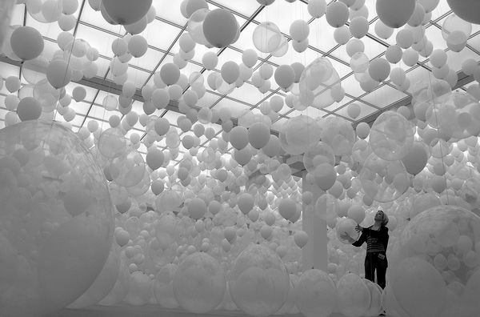William Forsythe, Scattered Crowd, 2002

The next room will be the Seizure exhibition by Roger Hiorns. It will be “lined with a thick layer of glistening, knife-sharp copper-sulphate crystals – creating an angular cave that was at once alluring, sensuous and needlingly dangerous.” Higgins, C (2013). The colour blue is associated with feelings of calmness or serenity it is often described as peaceful, tranquil, secure and orderly. Hiorns recalls with some amazement that “it became for people a spiritual space – a place that people used to stoke their inner lives”. (2013) Although many visitors will discover similar emotions whilst viewing the exhibition. The feelings evoked by certain colors are not necessarily universal. Cultural differences sometimes play a role in how people perceive colour. Individual experiences also have an important effect on the moods that colours can create. If you associate the colour blue with a vivacious and lively friend, then you might see it as a high energy colour that evokes a sense of excitement.
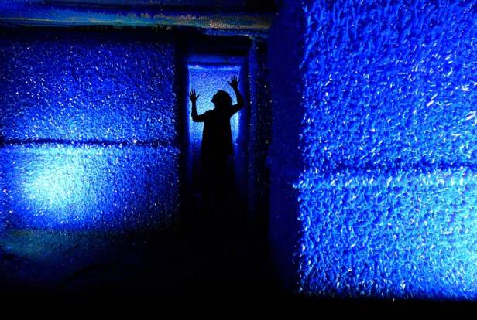Roger Hiorns Seizure 2008
Goldstein expanded on Goethe’s intuitions, positing that certain colors (e.g., red, yellow) produce systematic physiological reactions manifest in emotional experience (e.g., negative arousal), cognitive orientation (e.g., outward focus), and overt action (e.g., forceful behaviour). Goldstein, K (1942) This next installation will hopefully induce feelings of love, anger and danger. Like many of the installations I’ve chosen, it contains objects suspended from the ceiling, this one is called Dream by Cai Guo-Qiang. The harsh geometric shapes also contribute to the idea of anger or rage.
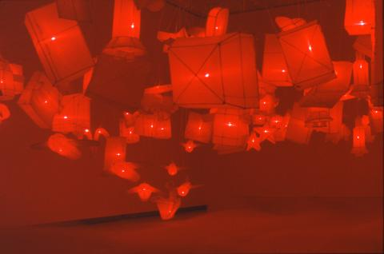Cai Guo-Qiang, Dream, 2005
Instantly when I think of the colour green I think of nature which is why I find Per Kristian Nygards work interesting. His concept is to bring the outside in and he explores the limitations and possibilities of space. “Green symbolizes growth, harmony, freshness, fertility and environment.” Bourn, J (2011) This space
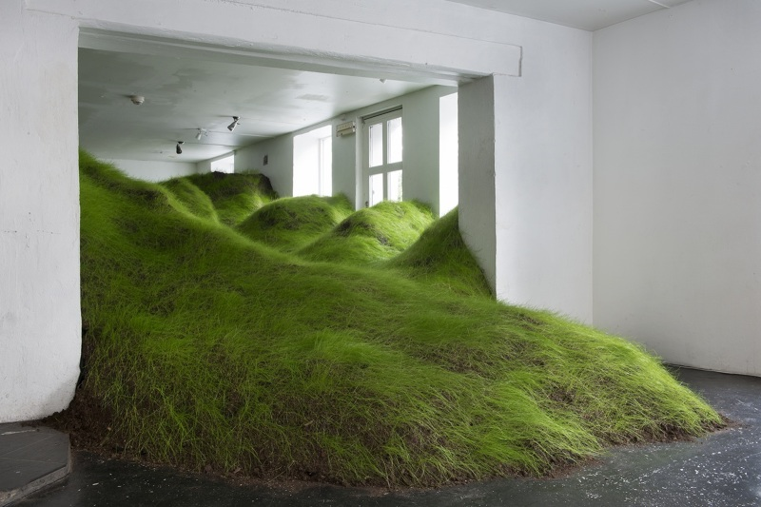Per Kristian Nygard, Not Red But Green, 2014
I wanted to end the exhibition with a yellow themed room, because of its association with joy, intellect, energy and happiness. Yellow is the strongest colour, psychologically. The correct yellow will lift spirits and self-esteem; it is the colour of confidence and optimism. The idea of using real flowers also adds to the subject to growth which links back to optimism, hopefulness and confidence about the future or success of something.

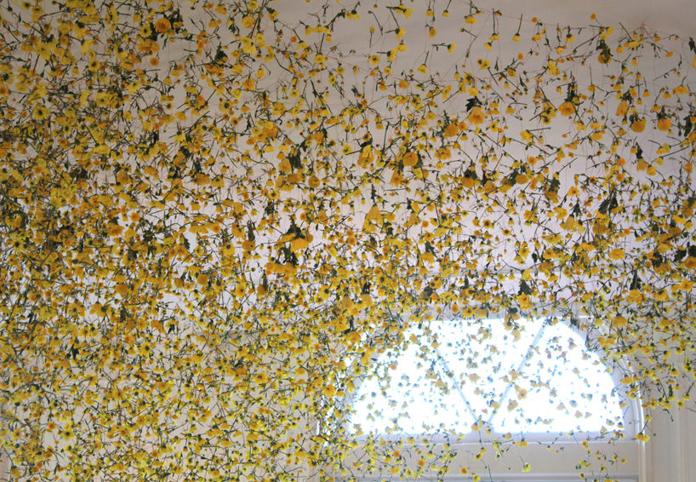
Rebecca Louise Law, The Yellow Flower, 2014

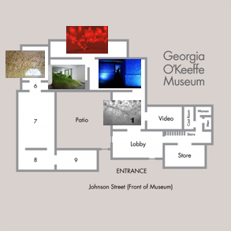

Bibliography
Gage, J (1993)” Colour and culture: practice and meaning from antiquity to abstraction” London: Thames + Hudson.
Itten, J (1970)” The Elements of Colour, John Wiley & Sons, Germany.
Goldstein K. (1942). Some experimental observations concerning the influence of colors on the function of the organism. Occup. Ther. Rehab. 21 147–151
Law, Rebecca Louise (2014) The yellow flower, installation. Available at:
http://www.rebeccalouiselaw.com/artworks/the-yellow-flower
(Accessed on 3rd May 2018)

Jobson, Christopher (23rd November, 2012) Scattered Crowd: Thousands of White Balloons Suspended by William Forsythe. Available at:
http://www.thisiscolossal.com/2012/11/scattered-crowd-thousands-of-white-balloons-suspended-by-william-forsythe/
Forsythe, William (15th March 2002) William Forsythe Choreographic Objects- Scattered Crowd. Available at:
https://www.williamforsythe.com/installations.html?detail=1&no_cache=1&uid=22
(Accessed on 3rd May 2018)
Nygard, Per Kristian (2014) Not Red But Green. Available at:
http://www.perkristiannygaard.com/Not-Red-But-Green
(Accessed on 2nd May 2018)
Guo-Qiang, Cai (2005) Dream. Available at:
http://www.caiguoqiang.com/projects/dream-2005-waltham-ma-usa
(Accessed on 5th May 2018)

Higgings, Charlotte (13th June 2013) Seizure, glistening cave of copper-sulphate crystals, moves to Yorkshire. Available at:
https://www.theguardian.com/artanddesign/2013/jun/13/seizure-copper-sulphate-crystals-yorkshire
(Accessed on 5th May 2018)
Arts Council Collection (2008) Seizure by Roger Hiorns. Available at:

http://www.artscouncilcollection.org.uk/sculpture-longside/seizure-roger-hiorns
(Accessed on 5th May 2018)

Bourn, Jennifer (25th January 2011) Color Meaning: Meaning of The Color Green. Available at:
https://www.bourncreative.com/meaning-of-the-color-green/
(Accessed on 28th April 2018)

