The Impact of Virtual Learning Moodle on student’s learning experience in the UWTSD London Campus
Assignment 2nd Term

Digital Skills and Research Methods
Module: BMSW4003
Lecture: Dr Anupam Mazumdar

Sara El Sehaly - ID 1907851 
Table of Contents
1. Introduction 3
2. Rational of the Research 3
3. Literature Review 3
3.1 Virtual Learning Environment 4
3.2 The impact of VLE 4
3.3 Different types of VLE 5
3.4 Advantages of VLE 5
3.5 Disadvantages of VLE 5
4. Research Methods and Methodologies 5
4.1 Qualitative 6
4.2 Quantitative 6
4.3 Sample and sample size 6
4.5 Data collection Tools 6
4.6 Ethical Considerations 6
5. Analysis and Discussions 7
5.1 Findings 11
6. Limitations of the Research 12
7. Recommendations for the future research 12
8. Conclusion 12
9. References 14
10. Appendix 15

Introduction
Nowadays we are all rising in a modern technological civilization because the world is chancing in a way that never did before. This progression has influenced and has changed the previous outline and our life. The effect of Internet usage in the educational system has increased in the last years and in some ways improve student learning. Indeed, University education has to align with it. The academic teachers are encouraged to use both modes of teaching: add to the traditional face-to-face learning towards digital learning. This can be helpful and also could be a positive challenge for the future. A very well structured tool of Virtual Learning it is Moodle, it is used for instruction and learning education.

Rational of the Research
The purpose of this study it was to understand the VLE of Moodle discover if student find Moodle a well tool to improve their education or not, in order to define the utility of the tool. The research will also explore the impact of Moodle on students learning experience. It will show as primary data collection, the relevant result of the questionnaire, made to a group of students from the University of Wales Trinity Saint David London Campus in 2020. On the other hand will show some secondary data from other academic source.

Literature Review
As mentioned in the introduction Virtual Learning is a new way to combine traditional and digital teaching at higher education. Moodle is one of the platforms that some university utilize as open-source e-learning, it is possible to create a course website and ensuring their access only for the student of the course. The students can learn through contents in different forms, image, text, sound, video, as well they can interact with the teachers and classmate using chat, messages or video conference. In addition, Moodle has the option to registering, observe and analyse the academic activity, it allows the contents’ management via web (Costa et al. 2012). In line with Piotrowsky approach, e-learning platforms represents a system that provides support for 6 completely different activities: creation, organization, delivery, communication, collaboration and assessment (Piotrowsky, 2010).
A research conducted by Baker and his colleagues through a survey it was to investigate about the impact of Moodle on students learning. They use a quantitative research method. A survey with Excel analysis. The questions were made around three main topics: Moodle has a positive impact on students learning; Moodle helps to develop independent learning and Moodle increase students’ motivation. They invited 650 students of the second year at SFC to complete the survey. The minimum sample size required was 242 (Baker and Gossman, 2013).
The research suggests that 53% of the scholars agree or strongly agree that Moodle includes a positive impact on learning. The 55% of the scholars agree or strongly agree that the utilization of Moodle helps to develop independent learning and finally the 43% of the scholars agree or strongly agree that the use of Moodle increase motivation to learn (Baker and Gossman, 2013).
They also find that 75.8% can access to Moodle easily, 20.6% has some problems and 3.6% had not tried. Regarding the use of Moodle as integrated part of student learning, 35.29% use it as large extent, 43.2% use it as small extent and 4.1% did not use it at all (Baker and Gossman, 2013).

3.1 Virtual Learning Environment
Virtual Learning Environment is the modern ways to learn today. It is an on-line system that gives you the opportunity to learn and improve your education. It is a technological educational system of teaching and learning through the use of a computer and Internet. It facilitates on-line interaction between students, the teachers and the school. The main concept is dynamic because there is a constant evolution due to the digital improvement of the technologies (Alves et al. 2017). It has different platforms to help the educational system on improve the learning experience of the students. Can be use as the only tool or it is used in parallel time of the traditional face-to-face teaching.

3.2 The impact of VLE
Virtual Learning Environment has a positive impact on the students learning experience. Helps student in learn how to manage their life between study, family and work. Promote digital skills. The student recognized the importance of VLE in order to promote their learning (Baker and Gossman, 2013).

3.3 Different types of VLE
There are many different types of VLE some of them are: Distance Degree Programs, Professional Certificate Course, High School Classes, Video Tutorial, Audio or Video Lecture, E-books, Articles, other Writings, Podcast and University Lessons, Moodle. This research is focus on Moodle type (Baker and Gossman, 2013).

3.4 Advantages of VLE
Some of the advantages on using VLE as a tool for the learning experience are flexibility, effective time management, improving your Digital Skills, managing family life and financial saving (Baker and Gossman, 2013).

3.5 Disadvantages of VLE
Disadvantage could be first if you have technical issue with your computer or Internet connection, poor self-motivation, losing your self in the material, increase learners’ isolation, feedback is limited (Baker and Gossman, 2013).

Research Methods and Methodologies
Research is the approach through different technique with how the researcher decide to conduct his work in order to collect data or evidence and analyse and understand better a specific topic. There are lots of different types of methods that use different tools to collect data such as: Focus Group, Questionnaire, Interviews, Observation, Experiments and Mixed Methods (Research Methods, 2020).
In this paper will be use the Questionnaire Methods, will be investigate on the impact of Moodle on student learning experience through eight closed-ended statement with a range of five answers. The questionnaire it was sent to 25 students via university e-mail (Research Methods, 2020).

4.1 Qualitative
Qualitative is a categorical data that does not involve numbers at all, it can be ordinal: in order by grade or it is a range or nominal: by name, brand or flat statement. It involves language or word and may use picture or photos and observation (Research Methods, 2020).

4.2 Quantitative
Quantitative is a numerical data that, we ha two groups of them, namely: discrete are the whole numbers (ex. 15) countable items and the continuous numbers (ex. 15.5) data measurement (Research Methods, 2020).
This research has been conduct using the quantitative method because it needs to quantify the impact of the learning experience of Moodle on students.

4.3 Sample and sample size
In general, in a research a sample size is the number of people that are called to give their opinions and they belong to a specific group, in order to understand the whole group (Research Methods, 2020).
In this paper this is the structure of the qualitative research: Population: all students at UWTSD; Sample: the students of the London Campus; Sample size: 25 students.

4.5 Data collection Tools
During the conduction of this report the data that were collected was keep saved for all the time, they were shared only with the teacher and the university, were conduct in anonymous. At the end of the assignment the data will remain secret.

4.6 Ethical Considerations
During the research process it was avoided any misconducts, it is ensuring that all information was true, the questionnaire it was anonymous and confidentially. No one was paid to answer the questions.

Analysis and Discussions
A questionnaire was conduct on the student of the London campus. It was sent by e-mail to 25 students and 21 answered. It was use liker scale to collect the responses for each question: Strongly Agree, Agree, Do Not Know, Disagree and Strongly Disagree. The approach used to analyse the data it was focus on numbers in order to have statistical and mathematical data. It made by using words and images. The analysis shows the result of 21 respondents.
Q1 - Moodle is easy to use.
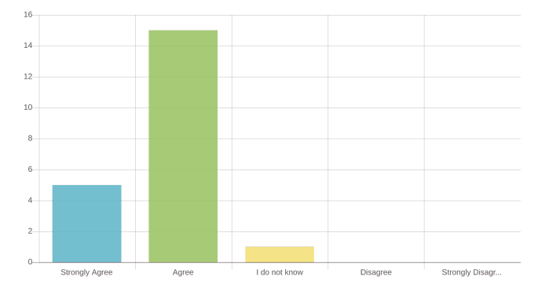
This bar chart it shows that the 71% of the students agree that Moodle is easy to use and 24% strongly agree. No one disagree. In this case the result it is a positive one.
Q2- Moodle helps to understand the course material.
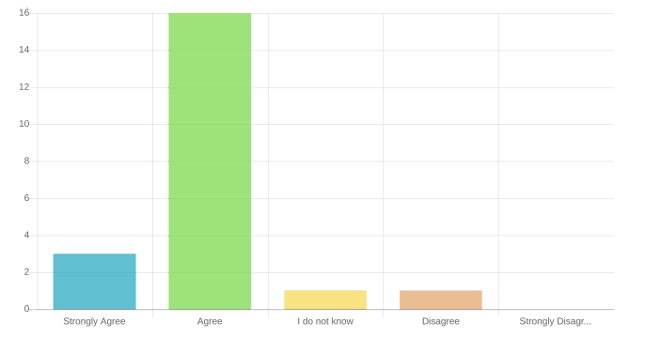
This bar chart it shows that the 76% of the students agree that Moodle helps to understand the course material, the 14% strongly agree and a 5% do not know or disagree. In this case the result it is a positive one.
Q3 - Moodle provides richer education experience.
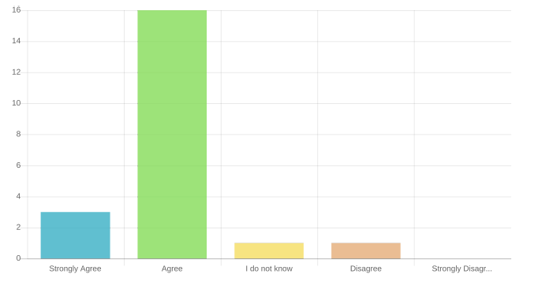
This bar chart it shows that the 76% of the students agree that Moodle provides a richer education experience, the 14% strongly agree and a 5% do not know or disagree. In this case the result it is a positive one.

Q4 - Moodle improves student participation in the educational process.
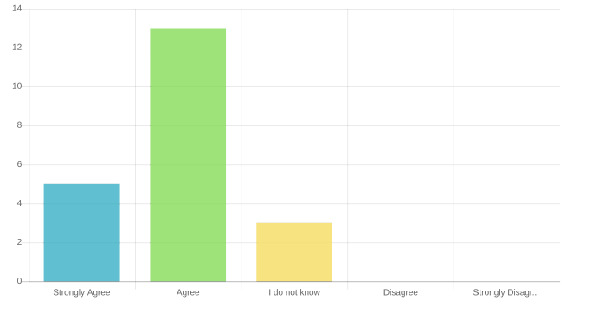 This bar chart it shows that the 62% of the students agree that Moodle improves the participation in the educational process, the 24% strongly agree and a 14% do not know. In this case the result it is a positive one.
Q5 - Moodle improves you digital skills.
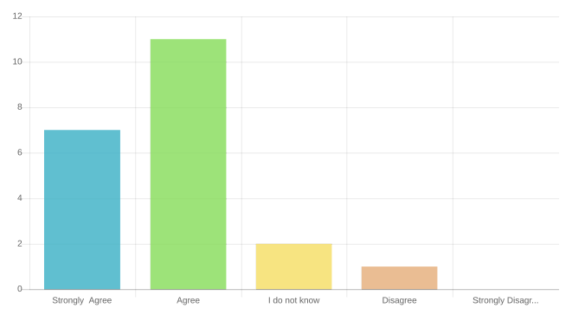
This bar chart it shows that the 52% of the students agree that Moodle improves their digital skills, the 33% strongly agree and a 10% do not know and 5% disagree. In this case the result it is a positive one.
Q6 - Moodle is an essential part of the university teaching of today.
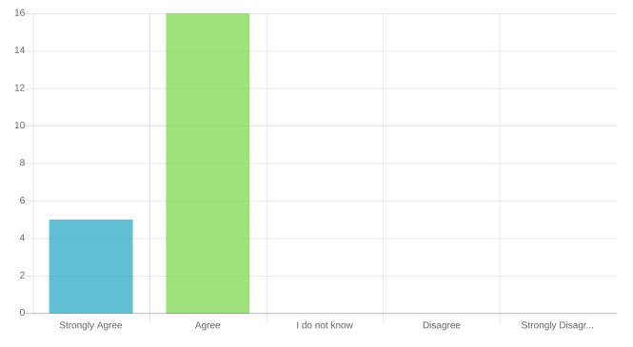
This bar chart it shows that the 76% of the students agree that Moodle is an essential part of the university teaching of today and the 24% strongly agree. No one disagree. In this case the result it is a positive one.
Q7 - Accessed to Moodle at any time helps students to improve time managing.
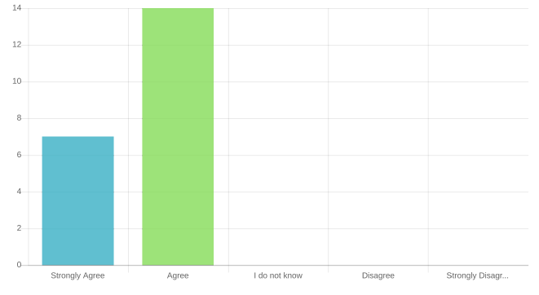
This bar chart it shows that the 67% of the students agree that Moodle helps to improve time managing and the 33% strongly agree. No one disagree. In this case the result it is a positive one.
Q8 - Moodle ha a positive impact on student learning experience.
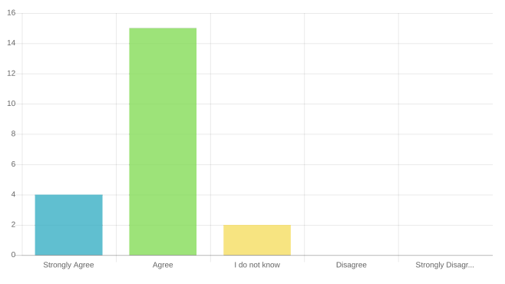
This bar chart it shows that the 71% of the students agree that Moodle has a positive impact on their learning experience, the 19% strongly agree and a 10% do not know. No one disagree. In this case the result it is a positive one.

5.1 Findings
Most of the students 91.21% stated that Moodle has a positive impact on their learning experience, the 5.5% do not know and the 2.5% are not happy. Overall Moodle is a very effective learning tool because it is easy to use, helps to understand the course material, provides a richer education, improves student participation in the educational process, improves digital skills. It is an essential part of the way to teach at university today.

Limitations of the Research
During the research it was complicated and long the process to contact and to receive the feedback of the questionnaire from the student because of the Covid-19. It was supposed to collect the questionnaire in person at the university during the lecture, but due to the virus all it was shutdown. Several emails and text messages were sent to the students in order to have back the questionnaire.
Another limitation due the shutdown of the university it was that we could not finish our term in class, and we had only on-line classes. It was difficult to interact with the teacher and understand clearly the task.

Recommendations for the future research
A possible recommendation for the future research is to start to build the questionnaire as soon as possible in order to have enough time to send it to the sample size have it back and analyse it.
Relating to the shutdown of the university, that it has been something exceptional but the feeling it could happen it was around, the manager of the campus could have organized some tutorial in class to explain how to approach at the on-line lesson and show all tools available in order to use it efficiently.

Conclusion
Moodle is a very well structure open source of learning in the academic environment. It provides an important interactive support to the effective learning in the 21st century as a new challenge for the university education. Indeed, it will open new possibilities for student, teachers and university to improve the learning experience.
Moodle is use also has a big support to exchange course material but students still need to effectively utilize. The majority part of the student demonstrated a positive impact on the tool and on the learning experience. They recognize the importance of using the tool in all its own part in order to be successfully in learning.
The usage of Moodle and also the student expertise can increase and consequently will increase the worth of it as an important tool for the university education.

References

Alves, P., Miranda, L. & Morais, C. (2017) ‘The influence of virtual learning environments in students’ performance’, Research Gate, March. [Online]. Available at: https://www.researchgate.net/publication/317307245_The_Influence_of_Virtual_Learning_Environments_in_Students'_Performance (Accessed: 28th April 2020).
Barker, J. & Gossman, P. (2013) ‘The learning impact of a virtual learning environment: students’ views’, Tean Journal 5 (2), July. [Online]. Available at: http://insight.cumbria.ac.uk/id/eprint/1455/1/146-574-1-PB.pdf (Accessed: 1st May 2020).
Costa, C., Alvelos, H. and Teixeira, L. (2012) ‘The use of Moodle e-learning platform: a study in a Portuguese University’. [Online]. Available online at www.sciencedirect.com (Accessed: 1st May 2020).
Piotrowski, M., 2010. What is an e-learning platform? in Learning management system technologies and software solutions for online teaching: tools and applications. I. Global.

Research and methodology (2020) Research Methods. [Online]. Available at: https://research-methodology.net/research-methods/ (Accessed: 29th April 2020).

Appendix

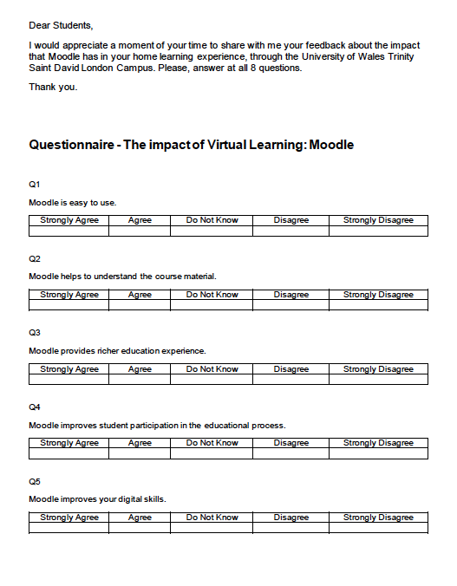
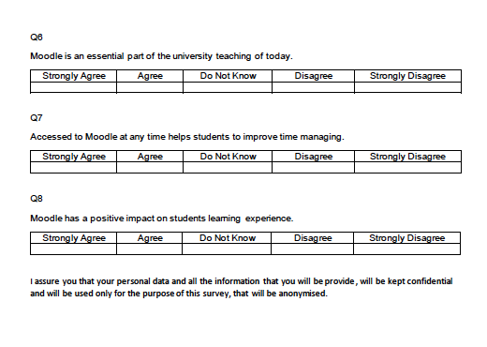
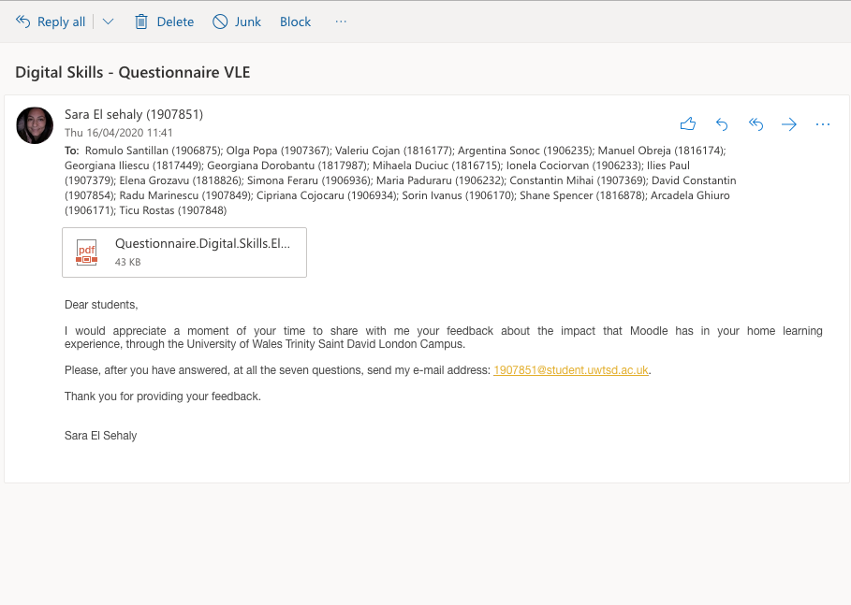
In-class exercises


