Digital skills and research methods

Steve David Tipan Morocho
1915309
Introduction 3
Methodology 3
Results 4
The number of students in higher education 4
Gender of students 4
Age of students 5
Students from the UK 6
Students with certificates 6
Students enjoying VLE 7
Difficulty level 8
Pros and Cons of VLE 8
The time students are using Virtual Learning. 10
Students interested in continuing with VLE 10
Conclusion 11
References‌ 13
Appendix 14

Abstract
This report reviews the analysis of surveys that have given to the students from the University of Wales Trinity Saint David, London campus. The data collected will be to recognise the impacts of the virtual learning environment on pupils from this campus, utilising pie charts and bar charts to procedure the analysis. The primary purpose of this analytic report is to see how many students are still excited and motivated to continue with their studies even after the previous pandemic, considering the con and pros that virtual learning can offer to all learners. The analysis showed a firm number of students in the UK that would like to not continue with virtual learning as they see much cons than pros. However, it concluded that most of the students want to continue with it.

Introduction
This report will be to understand the impact of the virtual learning environment, which is a web-based platform for academic aspects, as well as evaluating the thoughts of 13 students at University of Wales Trinity Saint David. This current situation of the global pandemic caused by the Covid-19 had made a massive effect on students learning, meaning they forced to finish their studies virtually. However, with the help of technology evolution students have been allowed to keep studying and attend classes online. On the other hand, some of the students are not satisfied with virtual learning due to technical issues, lack of motivation and the increase of the theory instead of practice. Some students agree to study at home for the flexibility of studying anywhere, the time saving, and new IT skills gained. To try to understand what students think, I have created a survey as a primary data to some students at university, keeping their anonymous answers to avoid any problem, and some of the responses that were received were exceptional to analyse. I also used graphs as secondary data, and it was awe-inspiring to examine them, to find out how students feel with all this situation.

Methodology
The purpose of this study is to gain students insights about virtual learning at the University of Wales Trinity Saint David. For example, how difficult was for students this new method of learning, the pros and cons they see, or how many students would like to continue with virtual learning, to analyse the thoughts I made questionaries, transform them to a survey and transfers that information into an excel document. However, it was required to use the graph to have an in-depth analyse of the answers from the pupils. Therefore, I used pie charts to analyse the percentage of students that responded and bar charts from knowing the numbers of students. I also used academics articles to reinforce my analyses and make then more coherent. Finally, this analysis was beneficial to understand if virtual learning is useful for students or if virtual leaning needs to be out of the academic environment. "It's encouraging to see that a majority of students who are studying fully online are reporting great value and satisfaction with their online programs which are largely tied to ambitious career goals,". Stage by Todd Zipper. (Schaffhauser, 2018)

Results

The number of students in higher education

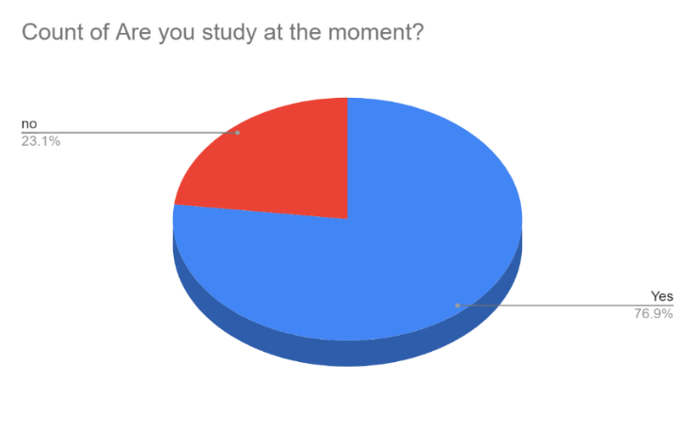
Fig 1. Shows students studying in higher education.
This pie chart represents the numbers of students that are studying in higher education. 76.9% of the students responded as yes. However, 23.1% of the students responded as a no. This suggests that for specific reasons, pupils stopped their studies because they feel uncomfortable studying online, due to the lack of communication and motivation. This can verify from the newspaper "The Guardian". They reported that in 2016 nearly 6 % of the students in higher education did not complete their first year of studies, even with their institution's support. Pupils decided not to continue studying for some reasons like the economy, personal issues, or health conditions. (Williams, 2016)

Gender of students

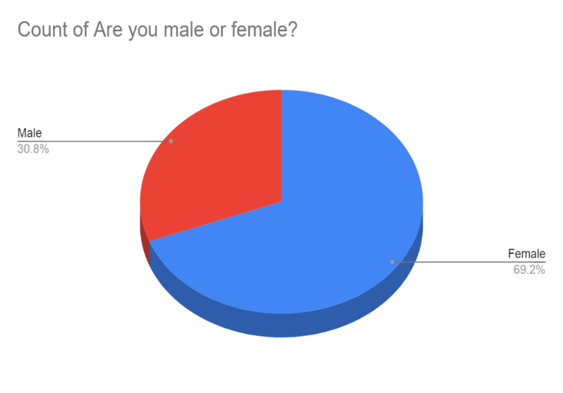
Fig 2. Shows the gender of students.
The next pie chart shows the number of female and male students currently studying at the University of Wales during the 2019/2020 academic year. 69.2% of the students are female, and 30.8% are males. According to the newspaper "Independent", in the last few years, more than 100,000 women applied to UK universities, unlike men. It is true that more students, European and international, are contributing to the higher education system. However, women, in particular, are demonstrating, taking power and becoming successful in their degree. (Kershaw, 2018)

Age of students

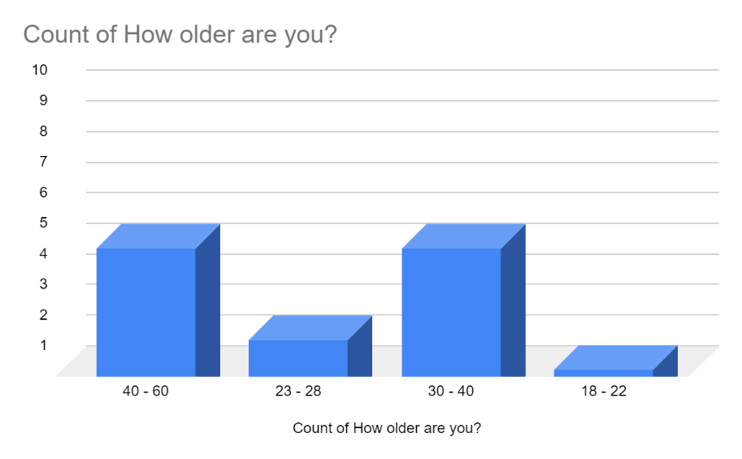
Fig 3. Shows the age of students.
This bar chart represents the age of students. Five students are age 40-60, two students are age 23-28, five students are age 30-40, and only one student is age 18-22. There are a variety of students of different ages which shows that it is never too late to study and that age does not always matter. It should be pointed out that the United Kingdom is a country that offers excellent opportunities and chances for students, such as loans, internships, and many more. Also, UCAS2 has stated that “approximately half of mature undergraduate UK entrants in 2017 are aged between 21 and 24, 39% are between 25 and 39, and only 12% are over 40 years old”. (Mature and part-time students, n.d.)

Students from the UK

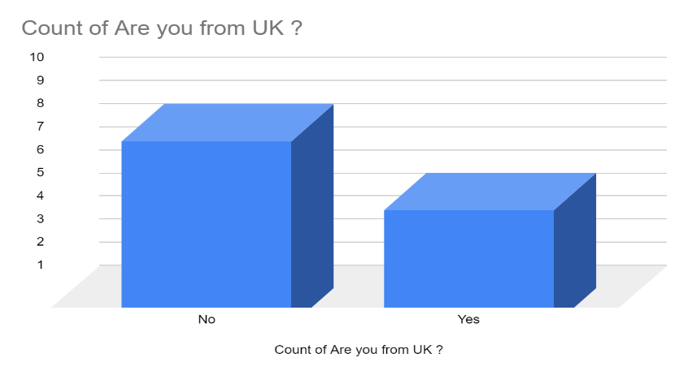
Fig 4. Shows students from the UK.
This bar chart represents the number of students from the UK . Eight students are not from the UK, and five of them are Britain. Considering the facts, most of the pupils that are currently studying at this university are from different nationalities. According to statistics of the last couple of years, the number of the non-international students has increased a lot. Most of the foreign students studying higher education in the UK are from China (35%), there is also India, the USA, Hong Kon, Malaysia, Nigeria, Spain etc. (Study in UK, 2019)

Students with certificates

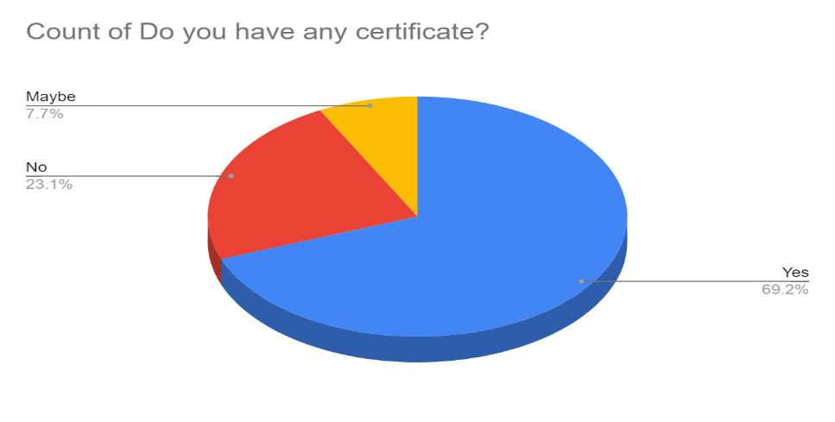
Fig 5. Shows students with certificates.
This pie chart expresses whether the students have their certification. It shows that 69.2% of the students have a certificate, 23.1 % have not, and the 7.7% could have a certification. This means they are not waiting for confirmation if they have passed the course. Even though some students have not completed their studies, they are still able to apply for higher education as some universities accept students through work experience. However, foreign students are not sure about the equivalence of their students in the UK and are not aware of the benefits, for example, the increase of job opportunities, discover new passions and expanding their knowledge. (International Career Institute UK, 2018)

Students enjoying VLE

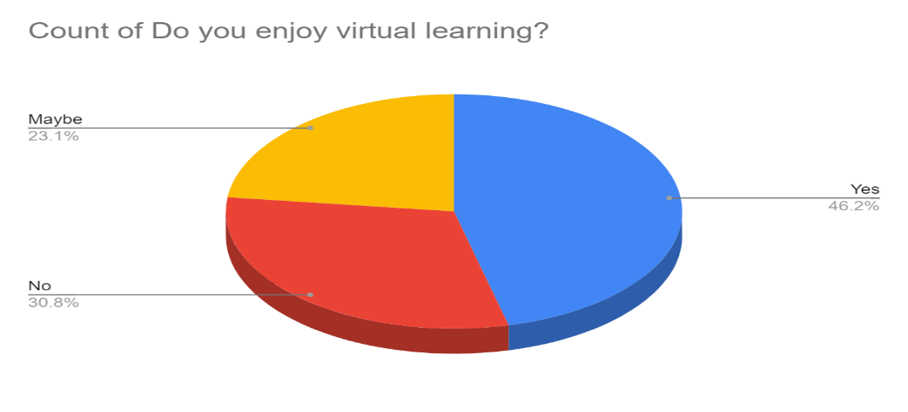
Fig 6. Shows students enjoying VLE.
The following pie chart outlines the numbers of students that enjoy this new mode of learning. Students in blue (46.6%) responded yes, suggesting that there are a high number of students that prefers this online method because of time-saving. 30.8% gave a negative answer because they might find complicated this online system due to technical issues. 3.1% replied maybe, and this can be because there are students that might be not happy with the online material, but they like the flexibility of virtual learning. As stated by ‘’The guardian’’, new research show that half of the students that studying higher education are willing to continue with the virtual learning, and the other half preferred to have classes on campus. (Razavi, 2020)

Difficulty level

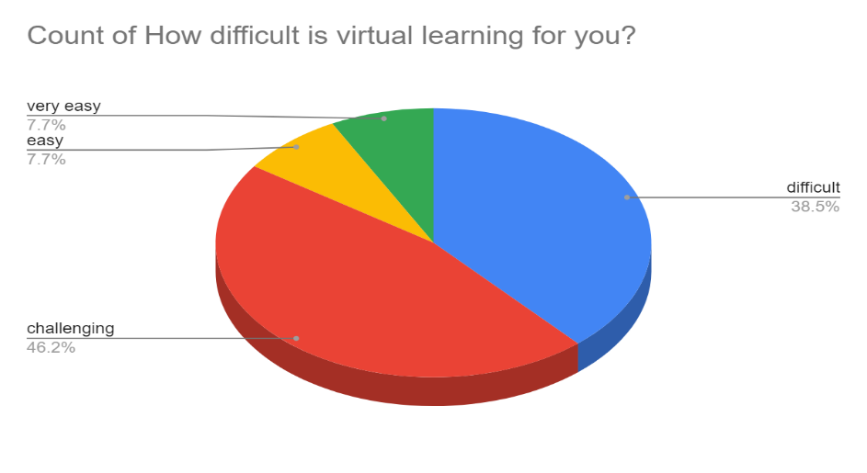
Fig 7. Shows difficulty of VLE.
This pie chart represents how difficult students find virtual learning. Most of the students, 46.2% in red, agreed that it is challenging, but can handle it. This suggests that some students try their best to follow the classes but sometimes requires responsibility, time management and self-study. Also, 38.5% of the students in blue admitted that find it difficult as some students with learning difficulty demand extra support. On the other hand, only 7.7% find it quite effortless. According to the ‘’The guardian’’, a student from Kingston University finds virtual learning extremely hard. This is because she has difficulties opening online portals due to her condition. “I’m finding the entire ordeal very stressful, and I have emailed lecturers, but I’ve received no reply” She stated. (Hall and Batty, 2020)

Pros and Cons of VLE
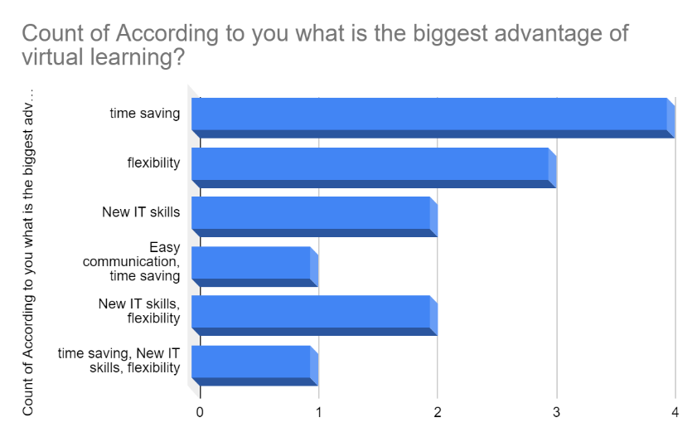
Fig 8. Shows advantages of VLE.
The following bar chart presents the number of students that have chosen their biggest advantages of virtual learning. Four students agreed that virtual learning saves much time. Now they only need to be on time on online platforms, such as teams, zoom, skype, etc. Three students agreed that the most advantage is flexibility as now they have more time for other activities or can connect anywhere. The new IT skills have also been considered as an advantage. The rest of the students agreed that the three options are advantages. As attested by ''The Guardian'', a professional professor said that online learning should have had more importance time ago, because now lectures can create high-quality multimedia experiences for their students and develop the quality of education. (Razavi, 2020)

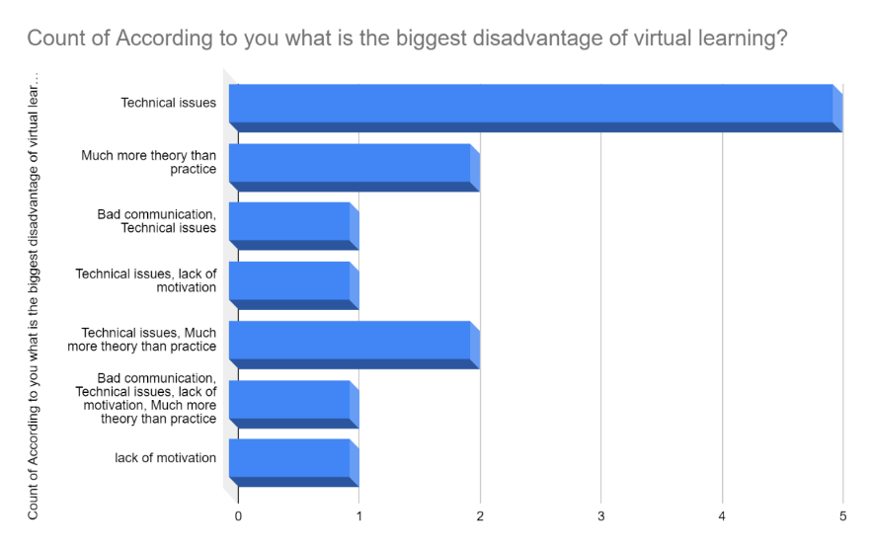
Fig 9. Shows disadvantages of VLE.
Technical issues, lack of motivation were the options that students had to choose as their biggest limitations of virtual learning. The bar chart demonstrates that there is a high number of students that agreed that technical issues are the biggest obstacles in virtual education. On some occasions, the bad connection is a huge issue, making difficult the access and demotivates students. Other students added that virtual learning is about more theory than practice, especially in these times, where pupils only get watch teachers and the PowerPoint they have prepared. For other students, it is better to play the presentations in front of other students as they acquire self-confidence skills that cannot get through virtual learning. (Razavi, 2020)

The time students are using Virtual Learning.

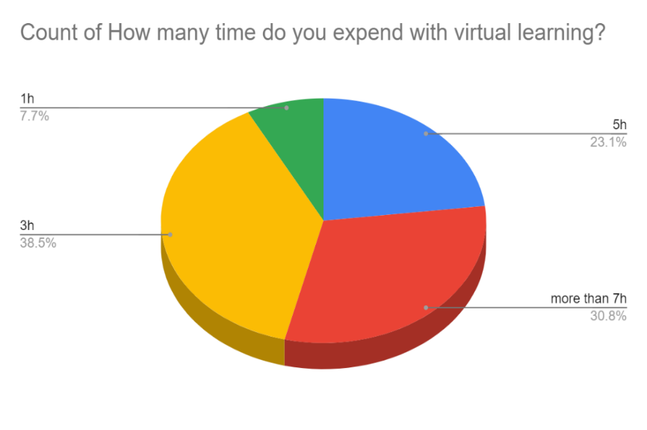
Fig 10. Shows time spending in VLE.
2020 has been a year of many drastic changes. Many students have been affected by the pandemic and have had to stop going to classes on campus and, start everything virtually. All these things considered, it is true that is a fortune that some students have access to courses and virtually material. However, this has caused poor performance in students, as many have lost motivation. The next chart exposes the time of students expends using virtual learning. Only 30.8% of the students use more than 7hrs using VLE, and 38.5% of the students spend less than 3h. For some students, especially the young ones, if they are not well organised or motivate, and do not know how to manage their time can be a problem to self-study. For them, it is more beneficial to study on campus. (www.uis.edu, n.d.)

Students interested in continuing with VLE

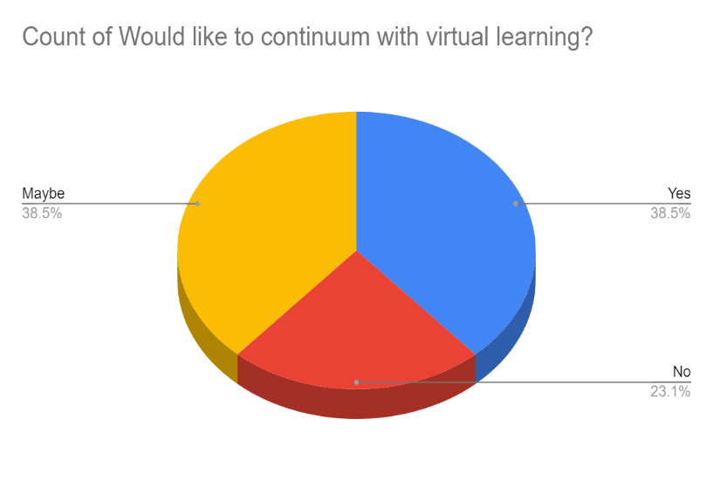
Fig 11. Shows students interested in continuing with VLE.
38.5% of the students answered that they are not sure if they would continue with the online classes, as some of them are hoping to go back to the campuses. At the same time, the same percentage of students agreed that they are thrilled to continue. This suggests that even all the adversities some students still believe that due to the circumstances is better to keep studying online as it sometimes makes student's life easier and comfortable. The rest, 23.1% said that prefer to stop virtual learning. However, according to" inside higher ed" a survey to 1000 students and 4000 professors in different institutions demonstrate that most of the responses were unsatisfied about virtual leaning and they do not want to continue with this new online teaching. The three-fifths of lectures said it was tough to keep students attracted. (www.insidehighered.com, n.d.)

Conclusion
This report showed that the number of students in higher education has a significant percentage to stay with virtual learning. However, there are considering several students that want to start a face to face learning, as well as there are students that already left virtual learning. It also exposed that there are more senior students than youngers. Consequently, this means that young people have lost the interest to study, which is sad because most of the students have stated with their responses that they are enjoying with virtual learning. Almost same numbers of students considered this new method as a challenge, even though the difficulties like technical issues, poor communication and the increase of the theory, they still see the advantages like the flexibility to study anywhere, or the time-saving as well as improving their IT skills. After collecting all the data from students and academic articles, my conclusion is that some students want easy work without facing reality and the reality is this new way to study and the flexibility that offers. However, I agree with the numbers of students that want to come back with face to face teaching. In my opinion, be at a room with your partners, professor and feel the pressure of an academic environment cannot change this comfort that is your house, that instead of a help to study, makes people lost the motivation.

References‌
‌ Hall, R. and Batty, D. (2020). “I can’t get motivated”: the students struggling with online learning. The Guardian. [online] 4 May. Available at: https://www.theguardian.com/education/2020/may/04/i-cant-get-motivated-the-students-struggling-with-online-learning
International Career Institute UK. (2018). The Benefits Of Getting Qualifications and Diplomas. [online] Available at: https://www.icieducation.co.uk/blog/benefits-getting-qualifications-diplomas
Kershaw, A. (2018). Almost 100,000 more women than men applying to UK universities as gender gap grows. The Independent. [online] 11 Jul. Available at: https://www.independent.co.uk/news/education/gender-gap-university-students-men-women-applications-uk-a8442941.html.
Mature and part-time students. (n.d.). [online] Available at: https://www.officeforstudents.org.uk/media/3da8f27a-333f-49e7-acb3-841feda54135/topic-briefing_mature-students.pdf.
Razavi, L. (2020). “Students like the flexibility”: why online universities are here to stay. The Guardian. [online] 27 May. Available at: https://www.theguardian.com/education/2020/may/27/students-like-the-flexibility-why-online-universities-are-here-to-stay.
Schaffhauser, D. (2018a). Survey: Most Students Say Online Learning Is as Good or Better Than Face-to-Face.[online] 18 jun. Available at: https://campustechnology.com/articles/2018/06/18/most-students-say-online-learning-is-as-good-or-better-than-face-to-face.aspx.
Study in UK. (2019). International Student Statistics in UK 2019 - Study in UK. [online] Available at: https://www.studying-in-uk.org/international-student-statistics-in-uk/
Williams, Z. (2016). Why one in 10 students drop out of uni in their first year. The Guardian. [online] 6 Sep. Available at: https://www.theguardian.com/education/shortcuts/2016/sep/06/why-one-in-10-students-drop-out-university-in-first-year
www.insidehighered.com. (n.d.). What kept students studying remotely satisfied this spring? Well-designed and well-delivered courses | Inside Higher Ed. [online] Available at: https://www.insidehighered.com/digital-learning/article/2020/07/08/what-kept-students-studying-remotely-satisfied-spring-well .
www.uis.edu. (n.d.). Strengths and Weaknesses of Online Learning - ION Professional eLearning Programs - UIS. [online] Available at: https://www.uis.edu/ion/resources/tutorials/online-education-overview/strengths-and-weaknesses/#weaknesses . [Accessed 15 Aug. 2020]

Appendix

Appendix A
Survey for students at The University of Wales Trinity Saint David
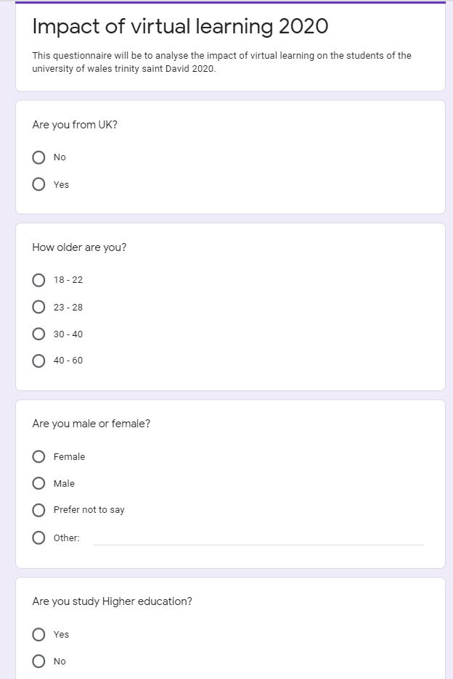

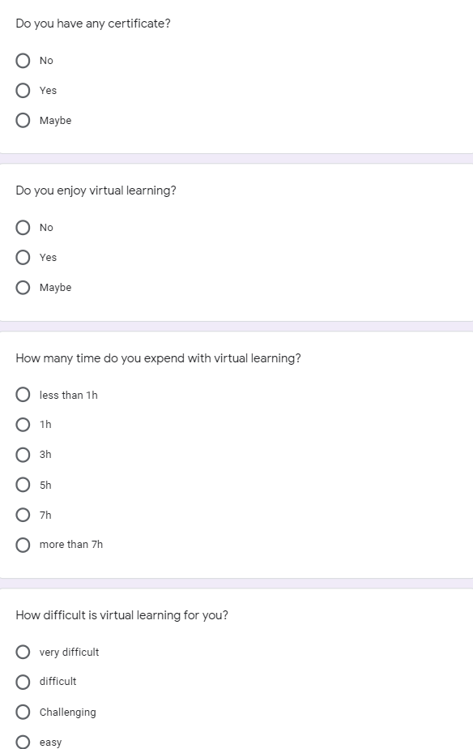

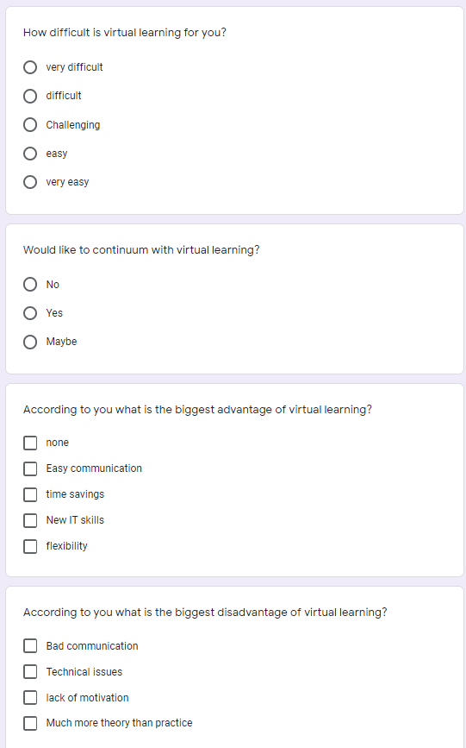

Appendix B
excel document


