

Name: Mitchell Rankine
University number: 2132006
Degree: BSc (Hons) Professional Policing
Honours Project title: “A critical evaluation of Police officer retention in Gwent Police today”.

Next Page -
Acknowledgements - students can write their acknowledgements here.

Next page - Students are accepted to put the declaration and 4 statements below within their dissertation. Must be signed and dated.
Declaration
This work has not previously been accepted in substance for any degree and is not being concurrently submitted in candidature for any degree.
Date:

STATEMENT 1
This dissertation is being submitted in partial fulfilment of the requirements for the degree of BA.
Date:

STATEMENT 2
This dissertation is the result of my own independent work/investigation, except where otherwise stated.
Other sources are acknowledged by footnotes giving explicit references. A bibliography is appended.

Date:

STATEMENT 3
I hereby give consent for my dissertation, if accepted, to be available for photocopying and for interlibrary loan, and for the title and summary to be made available to outside organisations.

Date:

STATEMENT 4
I hereby give consent for my dissertation, if accepted, to be available on the university’s IT system to those who have consent to use the system.
Date:
The purpose of this research project is to dissect and analyse the retention rates of Gwent police officers and gain an insight into the opinions of serving Gwent police officers to identify areas of improvement to encourage change and improve retention rates. This idea began from seeing government figures of police officer retention rates across the UK and the large change in figures over the last decade. Due to this change taking place over a short period of time there has been limited research conducted to understand why retention rates have been affected and what can be done to help improve them. This research is required to help close this gap and help Gwent police provide a better service.
The methodology used to gather data from Gwent Police officers was the use of a anonymous questionnaire design to ask specific targeted questions that link to data gathered from other sources throughout this project. These findings will be used and compared with previous completed research to offer recommendations.

Aims and Objectives
Aims – To investigate the change that Police forces across the UK have seen in their retention rates. This project will investigate the research that has previously been completed and compare it with the research undertaken with the participation of currently serving police officers. The aim is to analyse the results to identify where recommendations can be made that will lead to officers continuing their employment and contributing to a more effective police force.
Objectives:
- The impact of physical and mental health(burnout) on retention rates

- An investigation into why the female retention rate across police officers is lower than males.

- An investigation of the retention rates of Gwent police officers with more than 5 years’ service.

Introduction

The retention of police officers in Gwent Police is a critical issue as recent years have seen significant discussions on police officer retention rates across the United Kingdom (UK). Between March 2009 and March 2019, the police service saw a decrease of 20,580 officers (Home Office, 2023) [1]. This decrease followed a series of budget cuts made by the government during this period, despite an increase in the demand on officers as crimes committed rose (Leicester Police Federation, 2018).
A healthy and experienced workforce is vital for police forces to provide a professional service that meets community needs. Providing such a service helps create a strong public perception and trust between the public and police forces. To counter the decline in officer numbers, the government initiated Operation Uplift in 2019, promising to recruit 20,000 new police officers across the UK by 2023 (GOV, 2023). Figures provided by forces have shown an increase of 20,947 officers, surpassing the initial target.

However, the government’s national statistics indicate a significant rise in voluntary resignations among officers. In 2021, there were 1,996 voluntary resignations, which rose to 3,433 in 2022—a 72% increase (GOV, 2024). The number increased by a further 33% to 4,575 in 2023 (GOV, 2024). This is concerning as there were only 1,158 voluntary resignations in 2012, marking a 295% increase compared to the most recent figures (Charman, 2022).

Understanding the reasons behind falling retention rates can provide insights into making practical changes to policing practices and policies. This research aims to assist Gwent Police with data-backed insights and recommendations on identified issues, enabling policies and procedures that strive toward providing the necessary support to police officers. The ultimate objective is to positively impact retention rates.

Additionally, higher retention rates could offer secondary benefits to Gwent Police by reducing the investment needed for recruiting and training new officers, allowing for more productive budget management. The research will focus on analysing the opinions of current serving police officers and comparing them with existing research on specific issues in policing and their effects on retention rates.

Previous research has shown that the average attrition rate of officers across the UK is 6.8%, with 73.4% having less than five years of service (Police Federation, 2022) [1]. This indicates opportunities to make changes and improve the efficiency of the police service and the efforts made to employ more officers.
Literature review

The retention of police officers is a challenge that police forces around the world must consider in their attempts to reduce crime, prevent damage to property and prevent harm. Having a high turnover rate would lead to multiple negative implications for a police force. It would lead to an increase in recruitment and training costs. As stated by (Wilson et al, 2023) a loss of expired personnel which would have a negative impact on the quality of investigations in light of changing workloads and performance expectations. According to Morris (2021), this would also cause issues for community relations as the loss of experienced personnel undermines the effectiveness of a police force. This negatively affects public trust in officers which is crucial for an effective police service. Police forces are constantly required to adapt with new investigation techniques to keep up with changing tactics being utilised by criminals especially in a time where digital crime is becoming more common. However with the sudden shift police forces have seen in retention rates there has been no major changes made to combat this. This literature review aims to investigate the factors affecting police retention rates in the UK, with a specific focus on Gwent Police. By evaluating existing research, this review will provide an understanding in line with the aims and objectives of this project and the factors influencing retention.
Government reports show between 2009 and 2019 police forces across the UK saw a decrease of 20,580 officers (Home office, 2023) [1]. This reduction in officers was largely attributed to budget cuts imposed by the government that had taken place for several years. This has coincided with an increase in crime which has placed an additional strain on officers (Leicester Police Federation, 2018). This has led to the government's introduction of operation 'uplift' whereby funding was being provided to employ 20,000 new police officers across the UK. This figure had been met however information shows a spike in the attrition rates of officers standing at 6.8% in 2022 with 73.4% of which having less than five years service (Police Federation, 2022) [1]. A concerning statistic coupled with the data showing a 295% increase in voluntary resignations since 2012 (Charman, 2022).
Figure 1 - Breakdown from the Home Office, the number of police leavers and their exit route. (Home Office, 2023) [2].
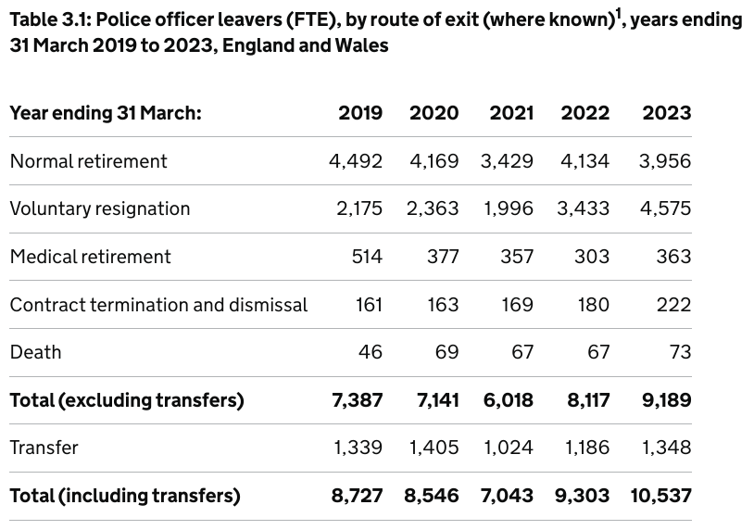This highlights the challenges that are being faced to maintain a stable and experienced workforce, due to the increase in voluntary resignations.
The financial strain that high attrition rates put on a force can be significant. This is due to the costly and time consuming nature of training new officers, this will bare a substantial weight on the budget of a police force. Having a high resignation rate means that more financial resources will have to be allocated to the recruitment process and training rather than critical areas. According to Myhill and Bradford (2013), the cost of training an officer can range from £60,000 to £100,000, depending on the duration and complexity of the training programme required due to the various methods of entry to employment as a police officer. For a relatively small force like Gwent police. Due to the high turnover rates with the current attrition rates this can be a substantial cost in the forces annual budget meaning less is available for operational needs and the development of criminal prevention strategies. Given this increase it has been shown that retention is more efficient than recruitment (Wilson, 2023).
Reducing the attrition rates would all allow Gwent Police to allocate their budget more effectively. A more stable workforce could invest in ongoing professional development, better equipment, and community engagement programs, all of which can enhance overall police effectiveness and public safety. Retaining experienced officers is crucial for maintaining institutional knowledge and fostering stronger community relationships, which have been shown to be essential components of effective policing (Stickle and Felson, 2019).
Although operation uplift has been seen by many as a success reaching and surpassing initial goals set out by the program. However research shows that with an increase in population since 2010 the police service has decreased its police officer per capita to the general population (Police federation, 2023) [2]. This would suggest ‘uplift’ has not been as successful as it appears on the surface as it would be expected for demand to increase in conjunction with the population.

Physical and Mental Health

The physical and mental health of police officers in a matter that needs a great deal of attention brought to it. Policing is inherently stressful due to the nature of work and the consistent threat of harm that officers are often exposed to. This can impact the physical and mental health of officers and its impact on retention cannot be underestimated. There has been a vast amount of research into the health of police officers and the result of which can often be surprising as the police are so often relied upon in times of need. In the research of Edwards and Kotera, 2020 it was found that half of officers had taken sick leave relating to mental health issues in the last five years. This was not only limited to the UK but was seen as a widespread issue which in some cases was even more prevalent. This highlights that this issue is being faced by all police forces and developing suitable solutions would have global benefits. research conducted by the police federation, 2022 shows over 13 thousand officers had time off work due to a mental health related issue such as depression, anxiety or post-traumatic stress disorder (PTSD) in the prior financial year. The Police Federation completed a study on 17,000 officers that showed 21% of which reported having symptoms that aligned with PTSD or more severe complex PTSD which is considerably higher when compared to that of the general population (Police Federation, 2019). Furthermore research completed by charity Mind found that 70.4% of police personnel had personal experience with mental health problems (Mind,2019). However studies show that officers still believe there is a stigma in the workplace toward mental illness where they believe reporting it would be both professionally and personally a risk (Bikos, L.J, 2020).
This view can be an issue that contributes to burnout as officers will be less likely to reach out for support they may be vitally needed. McCarthy et al describes burnout as emotional exhaustion, a person can feel detached and not themselves, and feel a lack of personal accomplishment. This is a significant predictor of turnover intentions among police officers (McCarty et al., 2007). This is supported by further research that indicates officers experiencing high levels of stress and burnout are more likely to leave the force (Burke, 2017). Physical and mental health issues can often arise from the demanding nature of police work, this combined with continuing to attend challenging situations and not getting the appropriate support can exacerbate this problem. The impact this has across the UK has been shown to be the equivalent of 1600 being off for a full year (Police Federation,2023) [1]. Furthermore this is at a time where the police services demand is very high and 88% of officers do not feel there are enough officers to manage the demand that is currently being faced, which is adding to the stress of the role (Police Federation, 2023) [1].

Male and female retention rates

From the inception of the police service it has been a male dominated environment. Recent figures show that females make up 35% of officers in England and Wales which is the highest proportion since 2010 (Allen and Audickas,2020). Research from 2010 shows that at that time females contributed to 25.7% of the total officers (Sigurdsson and Dhani, 2010). Home office research shows that there are disparities in the retention rates of males and females, where in 2023 30.9% of police officers leavers were female (Home office, 2023) [2]. Although this is not too dissimilar to the percentage of females in employment 59.5% noted their reason for leaving being voluntary resignation compared to only 45.4% of male leavers (Home Office, 2023) [2]. This would point towards there being internal and external factors between the genders that would account for this difference. Addressing this difference would be vital in continuing to develop the number of female officers to reflect the general population.
Due to the irregular shift pattern and long hours of police officers it is likely that it will clash with familial obligations, this traditionally has a bigger impact on women (Shelley, Morabito and tobin-Gurley, 2011). This traditional approach results in more women being unable to commit to working full time hours and will have an impact on their view of work. This is supported by research completed by the Institute for Fiscal Studies that shows women are more likely to give up work or reduce their hours which is consistent even with high earning women (Andrew, Et al, 2021). This shows there are still societal expectations placed on women which is likely to cause additional stress on their daily life.
As research has shown police forces have been dominated by a male workforce which has seen a slow increase in female officers. (Home Office, 2022) Figure 2
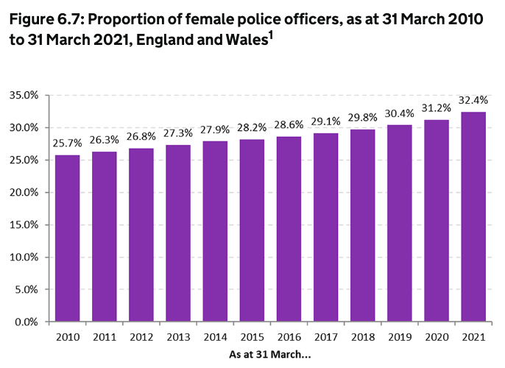

This graph highlights the small ongoing recruitment of female officers. However female police officers have not always had such numbers, with the first women police officer with power of arrest being appointed in 1915 sometime after the beginning of the police service. Due to the slow rate in which women police officers have increased there is a perceived masculine culture still within the police service (Silvestri, 2017). This has been reported by female officers feeling marginalised because they have experienced a lack of support from male counterparts and supervisors. This support would impact their moral and confidence in the role which could impact their decision to continue their employment.
Unexpectedly there is also research that shows sexual harassment within police forces is not uncommon. Research conducted by Magsi and Ariel (2024) shows two studies conducted with American police officers. The first found that 92.5% of females had at least one encounter with sexually harassing behaviour within the last year. Male police officers were slightly lower than this at 82.6% (Lonsway, Paynich and Hall, 2013). During this research interestingly less than 1% would state they were a victim of sexual harassment. The second was completed with more female officers across the nation. This showed that 93.8% experienced at least one occasion of sexual harassment in their career, however only 27.2% labelled it as sexual harassment. Research that has been conducted by Shelley et al (2011) into experiences of discrimination female officers show that these negative experiences are linked to higher levels of stress and job dissatisfaction. This can lead to an increase in the turnover rates and the turnover intentions of officers.

Retention Rates of Police Officers with More Than 5 Years’ Service

Keeping officers in service is vital for gaining a knowledgeable police service and having officers with experience and skills to be an effective resource for the community. Research shows that during this time of operation uplift and the vast amount of officers being employed officers with less than five years’ service make up 36% of officers (Home Office, 2023) [2]. Naturally it would be assumed that the attrition rates would be a similar reflection to this. However, research shown by National Police Chiefs Council shows that officers with less than five years’ service made up 73.4% of all leavers in the 22/23 period (Police Federation, 2023) [3]. The same source provides a graph that also shows what percent of leavers are accounted for by the differing amounts of service. Figure 3
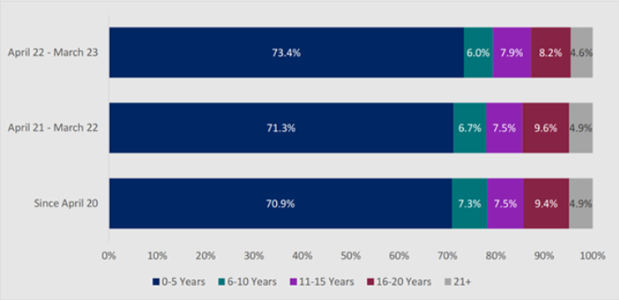
This graph highlights the importance of keeping officers in employment for longer than five years as the retention rates are significantly improved. The reasons behind this discrepancy have not been specifically identified as the majority were recorded as unknown. This poor record keeping could have provided valuable data into developments that needs to be made to reduce these figures. In recent years there have been changes made that could have made an impact on these figures.
One of these being the introduction of the PEQF and DHEP police constable degree apprenticeships. This is the most common route for officers to become a police officer. It requires employees to complete either a degree or diploma alongside their role as a police constable. It has been introduced as a result of police forces trying to move away from traditional training and provide a more professional development within the police force (Shohel et al, 2020). As this research shows this decision was met with some push back and was challenged by the chief constable of Lincolnshire due to the increased burden police forces will face. Research completed by Kardy and Lambert, (2022) showed that officers felt no cohesion between their studies and their daily operational role. This also correlated with their perception of the partnership between their police force and university being disjointed.
Research also shows that new recruits can often face the issue of job dissatisfaction due to their expectations of the role and the reality of the demands of the role (Harris and Baldwin, 1999). The stressful nature of policing such as long hours, highly stressful situations and exposure to traumatic incidents which impacts the attrition rates of new recruits. Their expectations of the role may have been based on past experiences or information they receive. Research has suggested that the media can impact the public's perception of the police depending on where they consume their media from due to the type of content they usually portray (Franklin et al, 2019). This research suggests that if media outlets portray a positive image of the police, then citizens without a prior arrest have an improved perception of the police. Alternatively, when misconduct allegations are highly publicised this would increase the negative perceptions of the police service.

Conclusion
As shown in the research above there are a variety of factors that affect a person’s decision to resign or continue their employment within the police service. It is not only their personal life which plays a role but the working environment they are in and the support they have from their constabulary. This will impact the stressors officers are facing and how this is managed is an essential part of a healthy work life balance. Each person will be affected in a different way with their particular circumstances.
Due to this variety and current world issues being far from a utopia the cost and budget implications this would place on a constabulary would be a considerable amount meaning most forces would not have the capability to develop systems or strategies to tackle all of these issues. Suggesting there is a strong need for forces to be proficient in implementing changes that are going to create the most impact overall. Being efficient and effective in these changes is essential for their sustainability especially for smaller forces such as Gwent Police as their overall budget is smaller. Being successful in reducing the turnover rate would ultimately lead to a decrease in expenditure for recruitment and a more knowledgeable service to better serve the community.
This paper will now move onto the methodology for gathering the research from service officers of Gwent Police to identify areas for improvement and resignation plans.

References :
Alison Andrew, Oriana Bandiera, Monica Costa Dias, Camille Landais (2021) Institute for Fiscal Studies. Women much more likely than men to give up paid work or cut hours after childbirth even when they earn more. [online] Available at: https://ifs.org.uk/news/women-much-more-likely-men-give-paid-work-or-cut-hours-after-childbirth-even-when-they-earn. ‌(Accessed 6th of July 2024)

Allen, G. and Lukas Audickas (2020). Police service strength. [online] House of Commons Library. Available at: https://commonslibrary.parliament.uk/research-briefings/sn00634/.
(Accessed: 5th of July 2024)
Bikos, L.J. (2020). ‘It’s all window dressing:’ Canadian police officers’ perceptions of mental health stigma in their workplace. Policing: An International Journal, 44(1), pp.63–76. doi:https://doi.org/10.1108/pijpsm-07-2020-0126. (Accessed: 30th of June 2024)
‌
Burke, R.J. (2017). Stress in policing: Sources, consequences and interventions. In Burke, R.J. and Paton, D. (eds.), Stress in Policing: Sources, Consequences and Interventions, pp.3-26. Abingdon: Routledge. Available at: https://www.routledge.com/Stress-in-Policing-Sources-Consequences-and-Interventions/Burke-Paton/p/book/9781138702522 (Accessed: 28 June 2024)

Charman, S. (2022). Police officer resignations have risen by 72% in the last year – we asked former officers why | University of Portsmouth. [online] www.port.ac.uk. Available at: https://www.port.ac.uk/news-events-and-blogs/blogs/democratic-citizenship/police-officer-resignations-have-risen-by-72-in-the-last-year-we-asked-former-officers-why. (Accessed 28th of June 2024)

Edwards, A.-M. and Kotera, Y. (2020). Mental Health in the UK Police Force: a Qualitative Investigation into the Stigma with Mental Illness. International Journal of Mental Health and Addiction, [online] 19(4). Available at: https://link.springer.com/article/10.1007/s11469-019-00214-x. (Accessed 31st of June 2024)

Franklin, A.S., Perkins, R.K., Kirby, M.D. and Richmond, K.P. (2019). The Influence of Police Related Media, Victimization, and Satisfaction on African American College Students’ Perceptions of Police. Frontiers in Sociology, 4(65). doi:https://doi.org/10.3389/fsoc.2019.00065. (Accessed on 18 of July 2024)
‌
GOV.UK. (2023). Police officer uplift, final position as at March 2023. [online] Available at: https://www.gov.uk/government/statistics/police-officer-uplift-final-position-as-at-march-2023/police-officer-uplift-final-position-as-at-march-2023.
(Accessed: 25 June 2024)

GOV.UK. (2024). Police workforce, England and Wales: 31 March 2023. [online] Available at: https://www.gov.uk/government/statistics/police-workforce-england-and-wales-31-march-2023/police-workforce-england-and-wales-31-march-2023#promotions-joiners-and-leavers. (Accessed 15th of July 2024)

Harris, L.M. and Baldwin, J.Norman. (1999). Voluntary turnover of field operations officers. Journal of Criminal Justice, 27(6), pp.483–493. doi:https://doi.org/10.1016/s0047-2352(99)00019-7. (Accessed on 16th of July 2024)

Hartley, T.A., Knox, S.S., Fekedulegn, D., Barbosa-Leiker, C., Violanti, J.M., Andrew, M.E. and Burchfiel, C.M. (2011). Association between depressive symptoms and metabolic syndrome in police officers: Results from two cross-sectional studies. Journal of Environmental and Public Health, 2012, Article ID 861219. Available at: https://www.hindawi.com/journals/jeph/2012/861219/ (Accessed: 28 June 2024)

Home Office (2022). Police workforce, England and Wales: 31 March 2021. [online] GOV.UK. Available at: https://www.gov.uk/government/statistics/police-workforce-england-and-wales-31-march-2021/police-workforce-england-and-wales-31-march-2021. (Accessed 6th of July 2024)

[1] Home Office (2023). Police workforce, England and Wales: 30 September 2022. [online] Available at: https://www.gov.uk/government/statistics/police-workforce-england-and-wales-30-september-2022/police-workforce-england-and-wales-30-september-2022.
(Accessed: 8th July 2024)

[2] Home Office (2023). Police workforce, England and Wales: 31 March 2023. [online] GOV.UK. Available at: https://www.gov.uk/government/statistics/police-workforce-england-and-wales-31-march-2023/police-workforce-england-and-wales-31-march-2023. (Accessed: 6th of July 2024)

Kadry, A. and Lambert, J. (2022). Overcoming organisational obstacles in policing in order maximise the benefits of the Police Education Qualification Framework. [online] oro.open.ac.uk. Available at: https://oro.open.ac.uk/83141/.
(Accessed: 21st July 2024)

Lali Magsi and Ariel, B. (2024). Internal sexual harassment among police personnel: Insights from a Birmingham, UK cross-sectional survey. Policing, 18. doi:https://doi.org/10.1093/police/paae049. (Accessed: 12th of July, 2024)

Lonsway, K.A., Paynich, R. and Hall, J.N. (2013). Sexual Harassment in Law Enforcement. Police Quarterly, 16(2), pp.177–210. doi:https://doi.org/10.1177/1098611113475630. (Accessed: 12th of July 2024)

McCarty, W.P., Zhao, J. and Garland, B.E. (2007). Occupational stress and burnout between male and female police officers: Are there any gender differences?. Policing: An International Journal of Police Strategies & Management, 30(4), pp.672-691. Available at: https://www.emerald.com/insight/content/doi/10.1108/13639510710833938/full/html (Accessed: 28 June 2024).

Mind. (2019). 2019 Survey Police Service Summary. Available at: https://www.mind.org.uk/media-a/4849/2019-survey-police-service-summary.pdf. (Accessed: 30 June 2024)

Morris, R. (2021). The implications of police turnover for public safety and community trust. Policing: A Journal of Policy and Practice, 16(3), 462-475. Oxford Academic https://academic.oup.com/policing/article-abstract/16/3/462/6566284?redirectedFrom=fulltext
(Accessed: 30th June 2024)

Myhill, A., and Bradford, B. (2013). Overcoming Impediments to Public Trust in Policing. International Journal of Public Administration, 36(3), pp. 215-227. Available at: https://www.tandfonline.com/doi/full/10.1080/01900692.2012.756888 (Accessed: 28th June 2024).

‌ Police Federation (2022) [1]. Attrition Rates Show More Must Be Done to Retain New Recruits. [online] www.polfed.org. Available at: https://www.polfed.org/news/latest-news/2022/attrition-rates-show-more-must-be-done-to-retain-new-recruits/. (Accessed: 18th July 2024)

Police Federation (2023) [1]. Mental health crisis in policing: Whose responsibility is it? [online] Available at: https://www.polfed.org/news/blogs/2023/mental-health-crisis-in-policing-whose-responsibility-is-it/#accept
[Accessed 1 Jul. 2024].

Police Federation (2023) [2]. Police Uplift Programme: a Flawed Success Story. [online] www.polfed.org. Available at: https://www.polfed.org/news/latest-news/2023/police-uplift-programme-a-flawed-success-story/.(Accessed 21st of July 2024)
‌

Police Federation (2022) [2]. Mental health-related absences soar to record highs. [online] Available at: https://www.polfed.org/news/latest-news/2022/mental-health-related-absences-soar-to-record-highs/#:~:text=Record%20numbers%20of%20police%20officers.

Police Federation (2019). Post-Traumatic Stress Disorder widespread in policing. [online] Available at: https://www.polfed.org/news/latest-news/2019/post-traumatic-stress-disorder-widespread-in-policing/.

Police Federation (2023) [3]. The storm of police officer resignations: Part 1. [online] www.polfed.org. Available at: https://www.polfed.org/news/latest-news/2023/the-storm-of-police-officer-resignations-part-1/.(Accessed: 12 of July 2024)

Shelley, T.O., Morabito, M.S. and Tobin-Gurley, J. (2011). Gendered institutions and gender roles: understanding the experiences of women in policing. Criminal Justice Studies, 24(4), pp.351–367. doi:https://doi.org/10.1080/1478601x.2011.625698. (accessed on 6th of July 2024)

Shohel, M.M.C., Uddin, G., Parker-McLeod, J. and Silverstone, D. (2020). Police Education in the United Kingdom: Challenges and Future Directions. [online] www.intechopen.com. IntechOpen. Available at: https://www.intechopen.com/chapters/72435. (Accessed on 15th of July 2024)
‌
‌Sigurdsson, J. and Dhani, A. (2010). Police Service Strength. [online] Available at: https://assets.publishing.service.gov.uk/media/5a7a3dc0ed915d1a6421c0f7/hosb1410.pdf. ‌(accessed on 5th of July 2024)

Silvestri, M. (2017). Police Culture and Gender: Revisiting the ‘Cult of Masculinity’. Policing: A Journal of Policy and Practice, [online] 11(3), pp.289–300. Available at: https://eprints.kingston.ac.uk/id/eprint/37039/1/Silvestri-M-37039-AAM.pdf. (Accessed 6th of July 2024)

Stickle, B., and Felson, M. (2019). The Impact of Turnover on Police Performance: An Analysis of Attrition in Policing. Criminal Justice Studies, 32(4), pp. 321-337. Available at: https://www.tandfonline.com/doi/full/10.1080/1478601X.2019.1672345 (Accessed: 28 June 2024).

Wilson, J.M., Grammich, C.A., Cherry, T. and Gibson, A. (2023). Police Retention: A Systematic Review of the Research. Policing: A Journal of Policy and Practice, 17. doi:https://doi.org/10.1093/police/paac117. (Accessed: 7th July 2024)

www.polfed.org. (n.d.). Increase in crime after police cuts. [online] Available at: https://www.polfed.org/Leics/news/2018/increase-in-crime-after-police-cuts/#:~:text=%E2%80%9CThe%20Government%E2%80%99s%20cuts%20programme%20has%20reduced%20police%20officer. (Accessed: 29th June 2024)

Chapter one - Introduction . . . . . . .3
  - background . . . . . . . . . . . . . . . . 4
  - Aim and objectives . . . . . . . . . . .6
  - Rationale . . . . . . .. . . . . . . . . . . .7
  - Structure . . . . . . . . . . . . . . . . . .8
  - Conclusion . . . . . . . . . . . . . . . .10

Chapters should be:
- Introduction
- Literature Review
- Methodology
- Analysis of results
- Conclusion and recommendations
- Bibliography
- Appendix

Appendix - to include questionnaires/all data results/charts etc.

