Farming and water challenges
Tom Vidovic
1805226

Farming is one of the most important activities of our species as it enables our civilization to flourish and sustain itself. We often take for granted the fact that there will always be farms and farmers and that food should never be a daily worry. Climate change is however increasingly shaking these beliefs. Beyond the economic sustainability issues striking many farmers, water supply can prove to be scarce. This is not only because there is more and more pressure on the resource but also because its availability is gradually becoming more seasonal that it has ever been. This article aims to ascertain whether water rarefaction is as severe as the media make it sound. It also highlights the current challenges around water management and presents the latest solutions which have been deployed by businesses and authorities to secure water supplies around the world.

Global Water supply and management trends

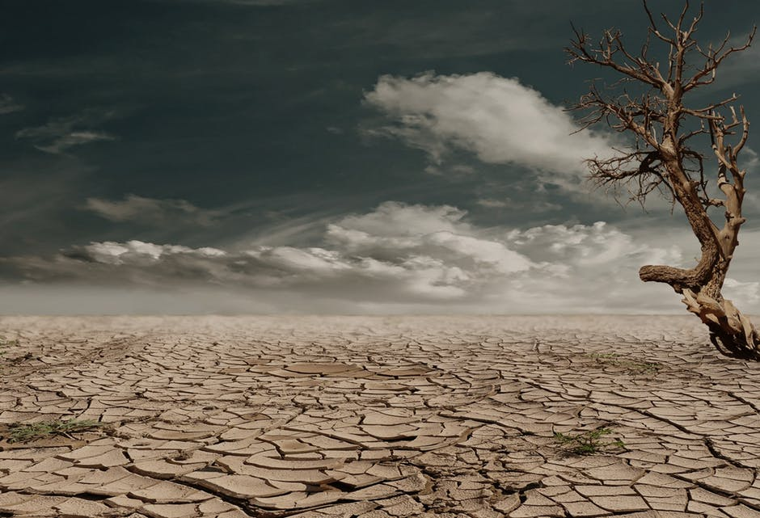
Change is afoot in all regions of the world. This most definitely affects Africa and was well documented by Molua and Lambi (2016) who found that farmers’ net revenue decreases along with precipitations. Temperatures also significantly impact revenue as they rise. Their study documented that agriculture in Cameroon is regularly restricted by the irregularity and varying volumes of precipitations. This confirms what the average observer with elementary agronomic knowledge would anticipate. Such observer notices via the news more and more frequent droughts and heat waves with a considerable impact on yields while other areas suffer from floods. Water is still all around us but its visits are increasingly erratic and capricious, making it hard for businesses to plan their crops, manage the water resource and remain sustainable.

Other arid regions such as in the United States have managed to cope to date but are now facing tougher challenges. Xu, Lowe and Adams (2014) explain in their paper how earlier snowmelts in regions which heavily depends on them changed water management for farmers. Snow melts characteristically release most of the water early in the season and this is when most water is sourced. However, earlier snow melts pose issues as farmers need to be able to either use the resource. This in turns means that ways of storing water have to be revisited to accommodate larger volumes early in the season. Their study also allowed them to conclude that each degree of temperature increase substantially decreases the average harvest yield by approximately $113.9 per acre, or approximately 18% of the current average harvest yield between 2007 and 2011. These are very tangible consequences which are bound to worsen without efficient resource management. The inability to source the whole amount of water necessary to water intensive but valuable crops leads the most junior water rights holders (i.e. farmers who fall at the bottom of the water distribution system) to plant lower value and drought tolerant varieties. Crops being no stranger to elementary economic rules, this worsens the financial situation of all businesses in the area as the increased supply lowers the prices and the overall revenue. Their study estimated that climate change could lower farmers’ income by as much as 32%. Such scenario could jeopardize the sustainability of many businesses not just in in Idaho but world-wide.

In Mediterranean areas, Boithias et al. (2014) focused on the North-East Spain basin region. Their study is very helpful as it reminds us of the elementary factors: water availability is strongly influenced by how much demand it has to meet and how much water is available. This is very rudimentary but we often fail to remember that with an ever-increasing population, farmers need to grow enough crops to meet everybody’s needs. When projecting scenarios where water scarcity is severe, their study showed that a key solution would be to reduce the number of irrigated crops. Some animated debates regularly take place in Spain (with some media cover) regarding the choice the country has to face: rerouting rivers or building additional desalination plants. Business will therefore need to make much better use of the water available to them to optimise their outputs with reduced input.

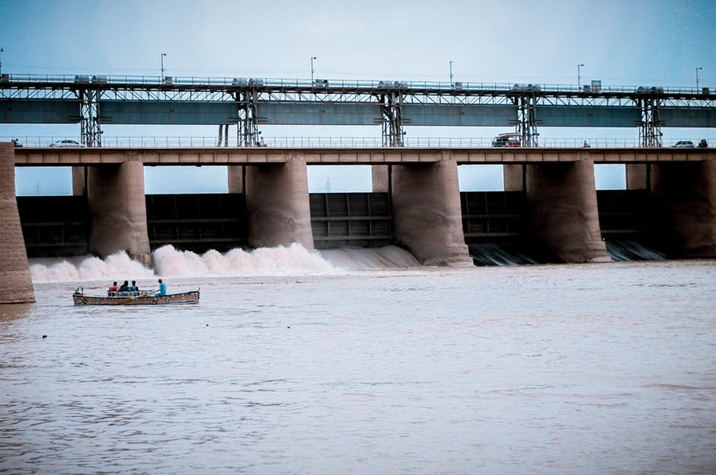
Abdolvandet et al. (2015) studied central Asia, an area where water is closely linked to energy and security politics. Their study allowed them to better understand how water, abundant in the region due to its numerous mountains, is managed (and disputed) among Kazakhstan, Uzbekistan, Turkmenistan, Tajikistan and Kyrgyzstan. In Central Asia, the agricultural sector uses over 90 % of the overall supply of water against 70% globally. Given the regional aridity, farming cannot sustain itself without irrigation. While theoretically feasible, sufficient supply of fresh water to all farms is still a struggle in the area. Globally, the prime issue tends to be water scarcity but Abdolvandet et al. point out that Central Asia suffers from a limited specialised knowledge to manage the problem. Not enough skilled water professionals, poor management and inadequate laws and regulations add to the problems in the region. Prior to the end of the Soviet era, water was traditionally stored upstream in winter and released during the summer to enable irrigation. But this changed in the 90’s when dams started to release much larger quantities of water in winter. This enabled the upstream states to meet higher winter energy needs which were no longer met by the centralised soviet government. The new pattern caused downstream states to experience floods. Reservoirs had to be built to both avoid flooding and attend to crops in summer. This reminds us that water management is a constant balancing exercise between scarcities and overabundance. Abdolvandet et al. (2015) also describe how since 2008, the Germany-led “Berlin Process” aims to develop integrated water management to ensure an efficient and sustainable supply. It is however experiencing a range of challenges, the key one being the lack of interest from Central Asians students to choose to educate themselves via the program. They tend to study abroad in non-water management related fields. The road for sustainable water management in Central Asia appears to be long, leaving farmers uncertain and less able to plan ahead.

Solutions currently deployed to address water challenges


The above challenges have prompted many countries and regions, often the most impacted by droughts and dwindling precipitations, to develop new solutions and water-management strategies. These strategies and solutions often include new technologies. Babu and Babu (2018) for example describe how the internet of things can be used for weather forecasting and monitoring, more accurate decision making, farm monitoring and to manage remote farm irrigation system. Their research goes into a great level of details, illustrating what systems need to be connected together (such as temperature sensors, moisture sensors, PH sensors or soil sensors) to be able to monitor crops. With such systems the farmer receives an alert on their smart phone (on the Jai Kisan App) when the values fall or exceed a defined threshold. The app also allows the farmer to send pictures of their potentially ill crops to specialists so that a diagnosis can be attempted. These are the key features but a lot more is possible, including group chats to share experiences, an online archive for quick fixes or yield monitoring. A fascinating aspect of their study is their work on crop clusters. Crop clusters are a type of crop grown to ensure the area becomes self-sufficient in the given crop.

The internet of things helps to determine which crops are the most suitable for a defined area based on factors such as expected rain falls or average sunshine period. Beyond self-sufficiency, the cluster crop strategy aims to ensure farming is a profitable profession and increase cultivated surfaces and productivity. Agriculture is bound to evolve to use more and more robots and drones as these are very complimentary to sensors. Together, robots and drones help in controlling weeds, planting seeds, harvests, monitoring and analysing substrates.

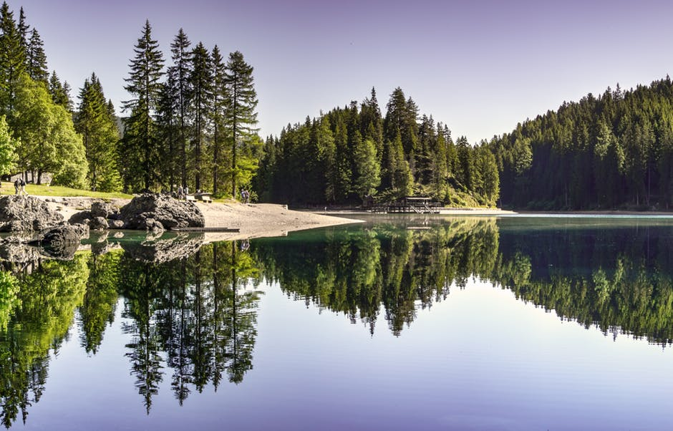
A leading country which has driven the use of the above described solutions among a range of strategies on a national scale is Israel. Since its creation, Israel has seen its population multiplied by ten. The activity and size of the industrial and agricultural sectors also boomed, further driving Israel to roll out a very ambitious water management strategy. Becker and Ward (2015) have researched Israel’s integrated approach to water management. One of the key actions taken by Israel was to start treating waste water in the 90s’ and systematically allocating 75% of it to irrigation. Beyond recycling waste water, Israel pushed farmers to invest in means to save water, such as drip irrigation technologies. Although Israel is the highest-ranking country in a dry area in terms of drip technology, business owners are reluctant to use the technology due to the costs involved in installing it. It should however become increasingly popular as water scarcity increases. A large quantity of Israel’s water comes from desalinisation, with most of the purified water being sent to the Tiberias Lake, which is used a natural reservoir.

Taking another example with the northern provinces of China, the well-established practice of farming wheat and maize is being threatened by inefficient water management strategies that are believed to have serious consequences on the Yellow River. Should water management not progress, both the waterways and crops will suffer. To tackle the issue, the government has started to develop so called ‘water-saving agriculture’. The concept of water-saving agriculture is based on farming practices which combine natural rainfall and irrigation with agility. This was defined as early as 2006 by Deng, Shan, Zhan and Turner who advised that the main challenge resides in raising the water utilization and use effectiveness to achieve a high yield on irrigated crops with a minimal amount of water while making full use of rain. Should a majority of farmers approach the issues from three main angles, sustainable farming could become a reality in the area. To put it in simpler terms, the farmer needs to (i) develop water-saving irrigation, (ii) only irrigate when strictly necessary, and (iii) redirect natural rainfalls to areas which cannot be irrigated. Figure 1 below, developed by the authors, shows the elements farmers should consider to optimize water use.
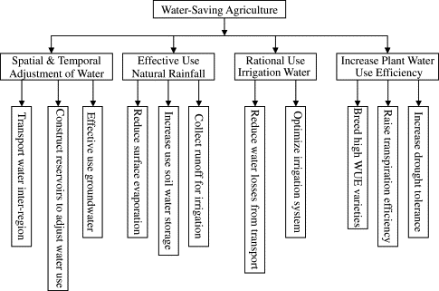
Fig. 1. Components of a water-saving agricultural system and its regulating elements (Deng, Shan, Zhang and Turner, 2006)
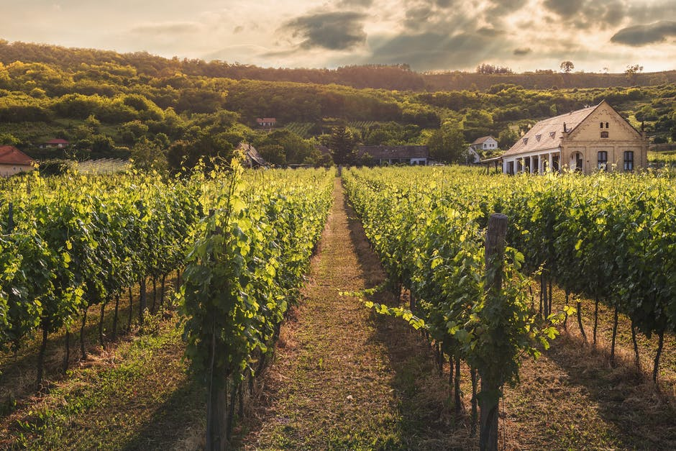
A final example and approach to dealing with water scarcity is closer to home with the case of southern Europe. Costa et al. (2016) examined how Portuguese and Spanish wine producers adapted their business models in the face of water scarcity. The region’s issues around water appear to be a substantial challenge as in Europe, irrigation of vineyards is below the world average but necessary to counterbalance raising average temperature and an environment more hostile than it used to. The authors suggest three areas for intervention: the vineyard, winery and region. The measures Costa et al. (2016) suggest are very detailed and features methods such as flow meters on pits, well maintained irrigation system, the use of well adapted variety/rootstock, precise crop/soil monitoring, the of use pond process water or the use of waterless cleaning and sterilisation procedures. It is important to note that there is no silver bullet to better manage the resource. The research suggests that the more collective, widespread and holistic the effort is, the more tangible the outcome that can be achieved. Interestingly, the authors do point out to the fact that recycling waste water is a very efficient water management strategy but also a potential risk as conventional water often contains nutrients which would not be found in natural water. In practice, some of its aspects such as nitrogen and phosphorous have the potential to alter berries’ structure and plant’s water use efficiency. The solutions have to be terroir specific as good practices in one area (such as cover crops used to avoid bare land between grape wines) might be detrimental to the crops in another. Their study also corroborates the benefits of using high end technology and the internet of things to monitor and treat crops.

Conclusion
The above strategies show to businesses that, where all stakeholders work together, water scarcity can be managed. It may require governance to evolve in some regions and authorities may have to increase their long-term planning provisions and infrastructural investments. Efficient lobbying combined with a collective and state-of-the-art water management, farming tools and systems appear to be one of the keys to sustainable agricultural businesses.

References:

Abdolvandet, B. et al. (2015) ‘The dimension of water in Central Asia: security concerns and the long road of capacity building’, Environmental earth sciences, 73(2), pp. 897-912.
Babu, T. and Babu, G. (2018) ‘IoT (Internet of Things) & Big Data Solutions to Boost Yield and Reduce Waste in Farming’, 2018 IADS International Conference on Computing, Communications & Data Engineering (CCODE). 7-8 February 2018 1(2). Available at: https://papers.ssrn.com/sol3/papers.cfm?abstract_id=3167801 (Accessed: 21/10/2018).
Becker, N. and Ward, F. (2015) ‘Adaptation strategies for agricultural water management under climate change in Europe’, Agricultural Water Management, 155(1), pp. 113-124.
Becker, N. and Ward, F. (2015) ‘Adaptive water management in Israel: structure and policy options, International Journal of Water Resources Development’, International Journal of Water Resources Development, 31(4), pp. 540-557.
Boithias, L. et al. (2014) ‘Assessment of the water supply:demand ratios in a Mediterranean basin under different global change scenarios and mitigation alternatives’, Science of The Total Environment, 470–471(1), pp. 567-577.
Costa, J et al. (2016) ‘Modern viticulture in southern Europe: Vulnerabilities and strategies for adaptation to water scarcity’, Agricultural Water Management, 164(1), pp. 5-18.
Deng, X., Shan, L., Zhang, H. and Turner, N. (2006) ‘Improving agricultural water use efficiency in arid and semiarid areas of China’, Agricultural Water Management, 80(1-3), pp. 23-40.
Molua, E. and Lambi, C. (2016) The Economic Impact of Climate Change on Agriculture in Cameroon. World Bank Policy Research Working Paper No. 4364: World Bank.
Xu, W., Lowe, S. and Adams, R. (2014) ‘Climate change, water rights, and water supply: The case of irrigated agriculture in Idaho’, Water Resources Research, 50(12), pp. 9675-9695.

