Kings of Justice:
Law as a Political Tool of Mesopotamian Rulers

How could the legal codes of kings be successfully used in maintaining their empire?

By Elizabeth A. Bull
1600598
Contents:

Research Proposal

❖

Literature Review

❖

Measuring Success (Methodology)

❖

Results

❖

Bibliography

❖

2 Sources: a Reflection

❖

Annotated Bibliography

❖

Further Reading

❖
Research Proposal

For my project I initially set out to see how law codes aided a civilisation’s success, pertaining to the Code of Hammurabi and Mesopotamia. My first problem arose when I sought to quantify the success of a civilisation and then apply it to Mesopotamia. The difficulty was a flawed perception of the Near East, in which many academic papers generalise the region under ‘Mesopotamia’, this is impossible to do due the lack of a central government for the whole of Mesopotamia. Regional divisions meant any empires were short lived and self-contained in parts of the Near East (Tainter, 1988). I therefore wanted to deconstruct the idea of Mesopotamia as united region; instead I propose that from the perspective of my research, it should be seen as a collection of states that each rose to dominate over the other, consequently it could not be regarded as a ‘whole’. In order to do this I chose to focus on specific case studies of the Law Codes of individual kings and their potential effects on their dynasties, thus I researched the individual cases of Lipit-Ishtar and Hammurabi for comparison, with an emphasis on the latter. I used a variety of academic texts on both Mesopotamian Archaeology as well as Historical Anthropology as well as further reading of translations of each Law Code, with a particular focus on Prologues and Epilogues. I wanted to look at the social implications of such a texts, why they were written, what that reflected of society at the time and how it was used, ultimately to assess in what way it contributed to success, deriving my measurement from Gordon V. Childe (1936). My interest came from my consideration of law to be a highly sophisticated tool of social organisation, perceived to be a modern invention, I was therefore intrigued by what role the Law would have to play in the ancient world.

❖

Literary Review

Before summarising my results I would first like to critically asses the field in which my research sits, as upon my investigation I came across many limitations in Mesopotamian Archaeology. Firstly there appears to be a bias towards the Stele of Hammurabi, which I admit is reflected in my work due to the availability of theory and resources. This is for many reasons; firstly, it is one of the most complete texts, as well as having been better preserved in general it is also the most aesthetically pleasing, which I believe may be evidence of the other bias in antiquity scholarship: elitism. It can be suggested that most archaeologists from the 19th and early 20th century were more drawn to artefacts that were of a higher calibre of craftsmanship and material value, thus overlooking other artefacts that held more intellectual value. A prime example of this is the Code of Lipit-Ishtar that was discovered 3 years prior to the Stele of Hammurabi but was not translated and published until the late 1920s, leading to many misconceptions in the field of Mesopotamian archaeology due to the misrepresentation of Law Codes. This misrepresentation is exacerbated by the largely dated literature in this field, such as Steele’s 1947 article, with many papers published or relying on their predecessors that have since been proven to offer an incomplete understanding of Mesopotamia. Nonetheless it is this academia that has fuelled many attitudes still applied today. Finally I would like to comment on the current difficulties in researching Mesopotamian sites due to political tensions in the East, these limitations have caused a reliance on previous discoveries that were not always properly published. It also leaves many theories unproven, such as locating the stele of Lipit-Ishtar referenced by the tablet which might still be undiscovered in Isin (Steele, 1947.)
Despite the above many shortcomings, there were also many useful resources that provided insight into Mesopotamian culture which helped apply the deeper connotations of Law codes. One article in particular, “Hammurabi’s Wronged Man” (Roth, 2002), helped direct my research to the benefits of the stele beyond the material results of fixed Law codes and to deeper cultural uses. Therefore I believe my research has lead me into a very recent field of Historical Anthropology that looks at the social and psychological agency of artefacts, often overlooked in favour of materialistic assessment.

❖

Measuring Success

Childe proposed that the success of a civilisation can logically be measured by quantity, using population growth and technological advances; he theorised a correlational increase in both signalled success(McNain, 1980). However, this assumption is very broad and cannot be applied to Mesopotamia, for most cases of accelerated population growth were swiftly followed by collapse of the civilisation, such as with the Third Dynasty of Ur (Tainter, 1988). I therefore propose applying the foundation of Childe’s theory to such an unstable political climate by quantifying success through longevity of stability as opposed to an increase in material wealth, as I believe the latter to be the symptom of success but not an identifier. The power dynamics in Mesopotamia was fractured in to regions of independent city states that fluctuated between peace and war with each other, often only achieving peace by dominating surrounding cities and establishing a dynasty (Postgate, 1992). This led to periods of stability that may have allowed for accelerated social development. In my research I will be paying particular attention to the role of law and social order in contributing to the stability of a dynasty, through the study of translations of the Codes as well as supporting academic literature.

❖

Results

The Political State of Mesopotamia & Kingship
The political environment of Mesopotamia makes it nearly impossible to measure the success of the civilisation as a whole, therefore I will be looking at individual dynasties, primarily Hammurabi’s, as they rose to prominence, and evaluating how law codes aided their success. The natural tension between cities could be the result of strong sub-cultural identities that divided the regions, fuelled by the belief system that assigned a deity to each city (Kramer, 1963). Thus not only was an individual identity established, it was also backed by divine recognition; this would have made the wider population harder to suppress and unify as there was an inability to claim divine right over other cities. This was perhaps a driving cause of internal disputes for centuries as cities would try to overpower others, reasoning that the gods willed either their success or their failure depending on the outcome, giving the gods the cultural reputation as being unpredictable (Kramer, 1963). With such an insubstantial base of political power, any claim would have been in the changeable decree of the gods, it is therefore understandable why Law became an attractive tool for stability.
Within this political climate the office of King was hard won and harder maintained; the independent nature of city states meant that conflict over circles of influence was often only resolved by conquering their competitors (Postgate, 1992). Thus the ascension to power in Mesopotamia was based in unrest and conflict, two of the most destructive influences to a centralised body of government; consequently Mesopotamian kings were often faced with the problem of how to legitimise their power without resorting to violence. The solution, as with most bodies of absolute power, was to turn to a belief system in which an idealised society was promised if citizens adhered to a rigid structure of social norms. Within Mesopotamia this was a twofold process with the embodiment of law, which was then seen as a gift from the gods to maintain the cosmic order that had been derived from chaos (Bertman, 2003). It was this alignment with the gods as an enforcer of their will that allowed a King to assert social order that would allow for a more stable rule (Assman, 2011) . Law Codes were published on stele, erected in the king’s capital city and other major sites, spreading the codes but also representing a royal presence throughout the kingdoms (Bertman, 2003).

The Origins of Law
Dating the origins of law codes themselves is the first difficulty in studying Mesopotamian archaeology, as those artefacts that have been recovered cannot identify a direct conception of the law. The first published discovery was of Hammurabi’s stele, dated to circa 1780 BC, gaining the reputation of being the oldest legal code in the world; however the clay tablet of Lipit- Ishtar’s Code, published in 1929, predates Hammurabi by nearly 200 years. This too was then displaced as the oldest law code in 1952 by the discovery of the tablet of Ur-Nammu which originated from 2100 BCE. Although an earlier law code has yet to be discovered, the evidence provided by the shared format and content of these law codes suggests that the tradition of law making in relation to the king is a tradition that predated Hammurabi by centuries, potentially millennia.
This has many connotations; an initial interpretation of this practice is that law was reflection of the values of the civilisation, in particular a high regard for “goodness and truth, law and order, justice and freedom, wisdom and learning, courage and loyalty - in short, all of man’s most desirable virtues and qualities” (Kramer, 1963. pg. 264). A deeper evaluation of the social implications of law suggests that it has long been a tool used by those in power to suppress internal uprisings. In order to be King, one had to assume control of regions with a strong cultural identity, such as Sumerians or Akkadians; it is therefore understandable that internal tensions between these groups would have to be managed to prevent internal rifts that were just as destructive as external enemies (Selz, 2007).

The Role of a Law Code
As a political tool, Law Codes may have been multi-functional, they established social order, acted as propaganda for the King and finally were an effective pacifier for the dissatisfied masses.
In regards to social order, Law Codes secured class boundaries through decreeing different levels of punishment based on an individual’s standing within society. Such was the case of Hammurabi Codes 202-205:
202. If any one strike the body of a man higher in rank than he, he shall receive sixty blows with an ox-whip in public.
203. If a free-born man strike the body of another free-born man or equal rank, he shall pay one gold mina.
204. If a freed man strike the body of another freed man, he shall pay ten shekels in money.
205. If the slave of a freed man strike the body of a freed man, his ear shall be cut off.’(King, 1910)
Here social boundaries are enforced legally, with harsher punishments on the lower classes or those who dare to commit crimes against their superiors (Roth, 2002). These laws are evidence of the influence of the elite classes to the point of lighter legal reprimand. However it also highlights the imbalance between social order and justice, which could encourage rebellion.
The representation of the King in these Legal Codes is thus one of the most important tools in securing his position as beyond compromise. As previously stated, the Law was seen as the practice of cosmic order, this association with the gods was an effective tool Kings used, often establishing themselves as an intermediary between man and gods (Selz, 2007) within the prologue. The idea behind divine kingship is a cross-cultural mechanism which is used throughout the world to explain the prominence of an individual. Where Mesopotamians differed is that they rarely express themselves as a direct relation to the gods, unlike some cultures in which rulers claim to be embodiments or descendants of Gods. In Hammurabi’s code he claims to be chosen by the Sky god Anu: “then Anu and Bel called by name me, Hammurabi, the exalted prince” (King, 1910). This is the tradition of most prologues, as corroborated by the Codes of Lipit-Ishtar who describes his ascension to the throne as being 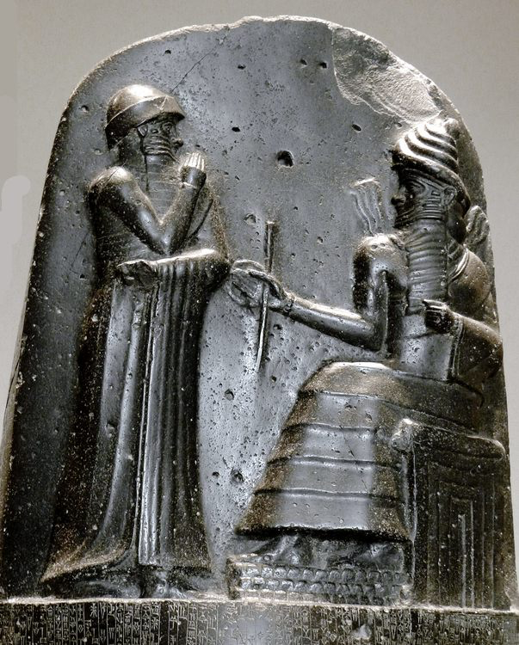called upon by Anu and Enlil, referring to himself as the “the wise shepherd, whose name had been pronounced by Nunamnir” (Kramer, 1963). However in his epilogue he extends his identity into the divine when he claims “I, Lipit-Ishtar, son of Enlil” (Kramer, 1963). This imagery of the King sharing space with the Gods is best shown at the head of Hammurabi’s Stele (depicted left) where the King is depicted next to the god Shamash receiving the tools of justice: a measuring rope and a rod. The 2’ high relief holds many points of interest, mainly the King’s position on the same level, standing before a slightly larger, seated God, but nonetheless the association transfigures the King into a divinity (Bahrini, 2007). Within the relief Hammurabi’s hand is raised to his lips in prayer, painting his image as a pious king, which is reiterated within his prologue. Therefore it was important for the King to not be depicted as the creator of Law but the enactor of divine will; this distinction absolved him from blame for less popular Laws as well as granted his decrees spiritual weight (Zaccagnini, 1994).
Hammurabi and Shamash (MbZT, 2012)
The representation of the King had to incorporate a more human element than divine backing; it also had to serve as a reminder of the King’s military strength. Although the emphasis was on his identity as a reverent king and servant to the gods, subtle allusions are made to military victories within the prologues and epilogues. In Lipit-Ishtar’s prologue he pronounces his intentions to “establish justice in the land, banish complaints, to turn back enmity (and) rebellion by the force of arm, (and) to bring well-being to the Sumerians and Akkadians” (Kramer, 1963, pg. 336). Here the threat is barely veiled by its justification of bringing peace; Lipit-Ishtar warns his people that uprising will be met and suppressed with physical force. This warning is reiterated with spiritual consequences in the epilogue, which is unfortunately partially destroyed and therefore not fully translated, and refers to a curse to anyone who defaces, destroys or writes upon his Stele (Kramer, 1963). Within Hammurabi’s code, which emphasises his role as the bringer of justice, his military success as the conquerer of the “four quarters of the world” (King, 1910) is nevertheless one of his first qualities mentioned. Therefore Legal Codes were to serve as a reminder of the physical and divinely enforced power of a King over his people; he alone could end the life and identity of a person, as his codes could justify the excommunication of an individual from society (Bahrani, 2007).

The role of Law as a deterrent for unrest has been established, however threats alone did not successfully quell rebellion. Indeed the Laws offered a way for citizens to seek satisfaction against those who wronged them, and anyone could present a legal case so long as they had evidence. This does not guarantee legal success or rectification of those wronged, therefore the question of how to console those grieved without undermining a statute of law had to be reached to prevent dissatisfaction spreading and leading to insubordination. Roth (2002) argues that this is where the Stele also acted as a spiritual judge, reinterpreting the below statement to mean the stele is to be prayed to for spiritual rectification that may not become physically apparent:
May the wronged man who has a law case come before the statue of me, the king of justice, and may he read aloud my inscribed stela, and thus may he head my precious pronouncements, and may my stela produce the law case for him; may he perceive his case; may he ease his heart (Roth, 1995)
Roth concludes that although the wronged man may not gain the material compensation they felt entitled to, they would be mentally and emotionally satisfied with the belief that the case would be in the hands of the gods and therefore beyond physical action (Roth 2002).

To conclude, the Legal Codes of Mesopotamian Rulers were used as a social tool to pacify the masses by establishing irreproachable social boundaries, promoting the image of the King as the people’s hero and by offering a spiritual outlet for justice when people were unsatisfied with the physical outcome of their case. In this way people were constantly reminded of the power of the King as well his influence over the daily aspects of their lives. I argue that from a social perspective the Law Codes were a successful system in preventing uprisings, as to do so would be seen as an act against the gods. Nonetheless I would like to suggest that Legal Codes were only an aid and could not be identified as the single factor in maintaining a successful dynasty, as made evident by Hammurabi, whose dynasty only ended shortly after the succession of his son (Bertman, 2003).

❖

Bibliography

Assmanm J. 2011. Cultural Memory and Early Civilisations: Writing, Remembrance and Political Imagination. Cambridge. Cambridge University Press

Bertman, S. 2003. Handbook to Life in Ancient Mesopotamia. New York. Facts on File

Hammurabi. King, L. W (trans.). 1910. The Code of Hammurabi. [Available at: http://avalon.law.yale.edu/ancient/hamframe.asp] (Last Accessed: 10/03/19)

Kramer, S. N. 1963. The Sumerians: Their History, Culture and Character. London. University of Chicago Press

Bahrani, Z. The Babylonian Visual Image
Selz, G. J. Power, Economy and Social Organisation in Babylonia.
In Leik, G. (ed). 2007. The Babylonian World. London. Routledge

McNairn, B.1980. The Method and Theory of V. Gordon Childe. Edinburgh. Edinburgh University Press

Postgate, J.N. 1992. Early Mesopotamia: Society and Economy at the Dawn of History. London. Routledge

Roth, M. T. 1995. Law Collections from Mesopotamia and Asia Minor. SBL Writings from the Ancient World, vol. 6. Alyanta Scholars Press
2002. Hammurabi’s Wronged Man. Journal of American Oriental Society. Vol. 122, No. 1 (Jan-March, 2002) pgs. 38-45.

Steele, F. R. 1947. The Lipit- Ishtar Law Code. The American Journal of Archaeology Vol. 51. No. 2. Pp. 158-164. Archaeological Institute of America.

Tainter, J. 1988. The Collapse of Complex Societies. Cambridge. Cambridge University Press

Zaccagnini, C. 1994. Sacred and Human Components in Ancient Near Eastern Law. History of Religions. Vol. 33 No. 3 (Feb. 1994). pgs. 265-286

Images:
MbZT. 2012. Hammurabi and Shamash. Photograph. [Available at: https://www.ancient.eu/image/541/hammurabi-and-shamash/] (Last Accessed: 10/03/19)

❖

2 Sources: a Reflection

Two key examples of Ancient Mesopotamian Law Codes are the codes of Lipit- Ishtar and of Hammurabi. These two codes not only greatly influence our understanding of Mesopotamian power structures and culture, but with the discovery of each code the archaeological understanding of Mesopotamia was dramatically changed. These two law codes are key examples of cultural differences of regional rulers as 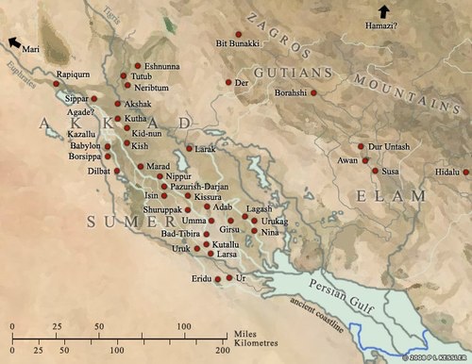well as establishing a shared cultural identity within Mesopotamia.
Illustration of ancient Mesopotamia (Kessler, 2013)

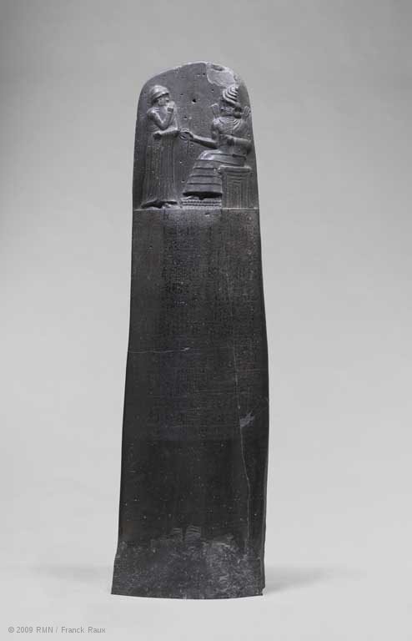Despite being created 200 years after Lipit-Ishtar’s Codex, I will first reflect on Hammurabi’s codes as it was translated and published first, which has had a lasting effect on Mesopotamian archaeological literature. Discovered in 1901 by F.J Morgan and translated in 1902 and is now on display at the Louvre, Paris. The Stele is carved from black basalt, is roughly 7’4” tall and weighs about 4 tons (Claire, Louvre Museum).It was created between 1792-1750 BC, theorised to have been erected during Hammurabi’s 35th year of rule. The Stele itself is a prime example of both the skill and wealth available to the king as evident by the highly detailed code that had been carved into a very hard surface and has therefore been perfectly preserved for thousands of years. Its labour-intensive creation as well as royal and divine association meant that the stele would have been highly significant both within and after Hammurabi’s reign; this would explain why it was later moved by the Elamites from Sippar to Susa in the 12th Century BC (Bahrani, 2007). At the top is a 2 foot high relief of Hammurabi receiving the law codes from the God Shamash, the God of Justice and also Babylon (Bertman, 2003). Upon closer inspection of the relief it is evident that Hammurabi is in an act of prayer with his left hand at his lips, thus upholding his reputation as a pious and god fearing king. Nonetheless he is depicted within the space of a god, and only slightly smaller, therefore although he has no direct divine link (like Lipit-Ishtar who refers to himself as the son of Enlil), his position alongside the god cements his position as a man with the authority of life and death over his people (Bahrini, 2007).
Law Code of Hammurabi, king of Babylon (Raux 2009)

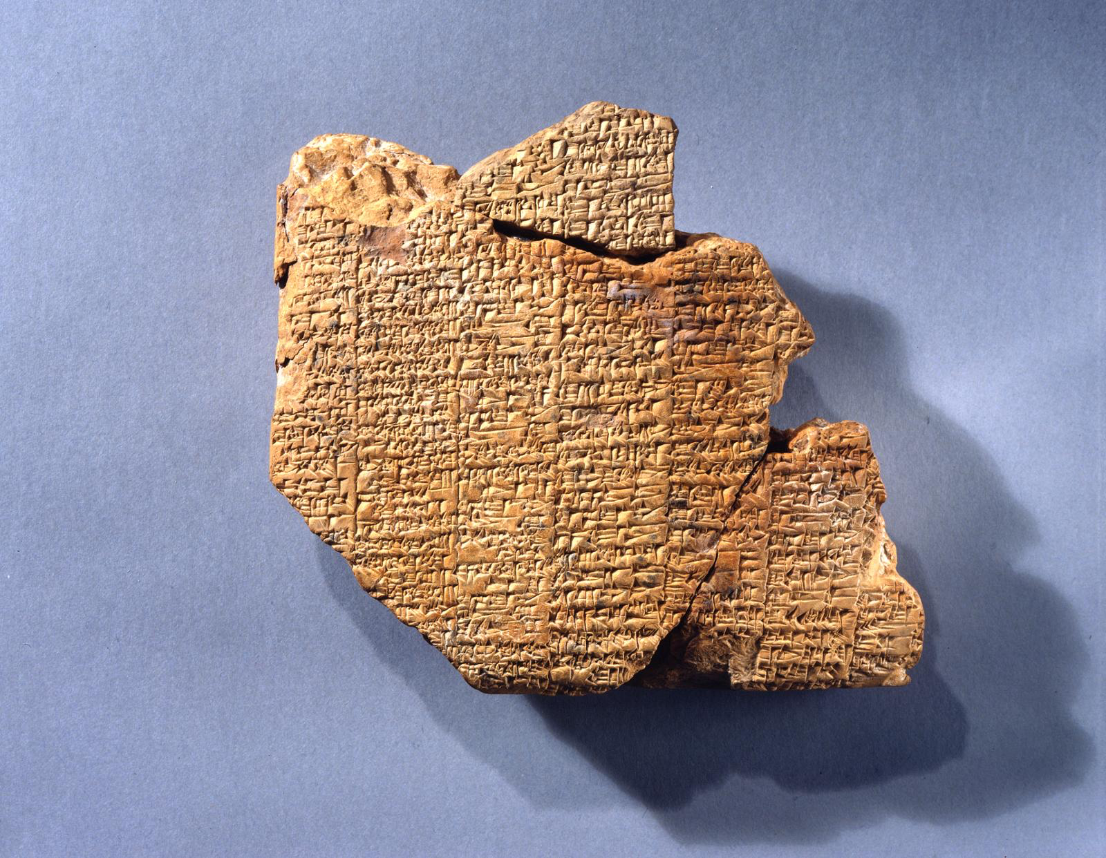The only surviving record of the Lipit-Ishtar Codes (or LICs) is a clay tablet that was found in 1899 by excavations by the University of Pennsylvania, however due to it being found in broken remnants, it was placed in storage where it was not reassembled and translated for 30 years (Duhaime, 2011). The clay tablet, when reassembled and measured, was estimated to be 11” by 9” with 10 columns of text on each side, however only 400 of the approximate 1200 original lines have been deciphered due to the majority being incomplete or illegible (Steele, 1947). Although found in Nippur the tablet is thought to have originated from Isin, the capital city under Lipit-Ishtar (Steele, 1947). This is where the text itself can be incorporated into identifying the origins of the Codes; within the Epilogue a pedestal in a storeroom is mentioned, where the original stelae would have been displayed. This is because Law Codes were often associated with temples where sentences cases would have been heard (Postgate, 1992). These tablets would have been copied from the original stele onto smaller tablets for a number of reasons, such as for scribe training (Kramer, 1963) or even, when considering the role of the Law Codes as a statement of “sovereign rule” (Bahrani, 2007), for distribution to surrounding areas.
(OBJECT 29-16-55, Penn Museum)
From a materialities perspective, the content of this tablet is what would have made it valuable as the manufacture of the clay required no specialist skills due to its high mallability and availability, thus it was the writing itself that gave the tablet purpose and therefore meaning.

The discovery of each of these stele challenged preconceptions on Mesopotamian History and the existence of Law codes prior to the Bible (Steele, 1947). The structure of these Law Codes is identical, with a distinct prologue establishing the divine right or inspiration behind the laws, then the laws are followed by an epilogue that reiterates the prologue, further stating repercussions to those who destroy the stele or disobey the laws. This fixed format firstly reveals that the CoH were based on LICs, secondly it suggests that there was a pre-existing Law Code known to both kings that they based theirs on, most likely Ur- Nammu from 2100 BC (Bertman, 2003).

Bibliography

Claire, I. Law Codes of Hammurabi, King of Babylon. [Available at: https://www.louvre.fr/en/oeuvre-notices/law-code-hammurabi-king-babylon] (Last Accessed: 07/03/19)

Law Code of Lipit- Ishtar Year. [Clay]. At: University of Pennsylvania Museum of Archaeology and Anthropology (Penn Museum): Collection Storage, Babylonia. Object 29-16-55.

Kessler, P. L. 2013. Map of Sumer. Digital Image. [Available at: https://www.ancient.eu/image/1352/map-of-sumer//] (Last Accessed: 10/03/19)

Raux, F. 2009. Law Code of Hammurabi, king of Babylon. Louvre. [Available at: https://www.louvre.fr/en/oeuvre-notices/law-code-hammurabi-king-babylon] (Last Accessed: 07/03/19)

❖

Annotated Bibliography

Steele, F. R. 1947. The Lipit- Ishtar Law Code. The American Journal of Archaeology Vol. 51. No. 2. Pp. 158-164. Archaeological Institute of America.
In this article Steele compares the Code of Lipit--Ishtar to that of Hammurabi and assess the role of the Sumerians in the development, he proposes establishment, of Mesopotamian Law. He argues that the code of Hammurabi was based on Lipit-Ishtar’s, and that consequently Mesopotamian culture was based in Sumerian. Although this text is useful in reflecting the attitudes of many historians in Mesopotamian archaeology, this theory is undermined by the later discovery of an earlier law code. This work benefited my research in understanding the school of Mesopotamian archaeology which was largely based in the 19th/20th century and supported the theory of a Law code being a long standing political device. However it also highlights the outdated theories often found in research.

McNairn, B. 1980. The Method and Theory of V. Gordon Childe. Edinburgh. Edinburgh University Press.
In this book McNairn assesses the works of Childe in relation to other anthropological and archaeological theory with the aim of showing how his theories still uphold in modern day scholarship. McNain successfully presents Childe’s theories with in-depth explanations supported by research by other scholars to prove its relevance to modern day academia. The theories in this book are thoroughly explored and supported or critically assessed using further scholarship, allowing for a well-rounded understanding of the theories presented. This book was indirectly important to my research; although it offered little information on my topic it was highly useful for gaining a grasp of the theory in assessing social progressions of a civilisation.

Roth, M. T. 2002. Hammurabi’s Wronged Man. Journal of the American Oriental Society, Vol. 122, No. 1 (Jan-March, 2002) pgs. 38-45.
The author of this article investigates the role of stelae and law codes in a king’s reign; she presents the case that the stelae were never intended as actual law codes but instead as monuments to symbolically connect the king to his people and prevent unrest. This theory was a turning point in my essay as it focussed my research on the effectiveness of this practice, however I was limited in finding supporting research. In my opinion this article is revolutionary in understanding the power dynamic of Mesopotamia and the methodology used in cementing a ruler’s position.

Bahrani, Z. The Babylonian Visual Image. In The Babylonian World (Gwendolyn Leick ed.) 2007.. Oxford. Routledge.
Bahrani argues against the interpretation of Hammurabi’s Stele as a Law Code and redefines it as a piece of propaganda, representing the concept of law and order in Mesopotamia in direct relation to the sovereign. This theory was largely based on Bottéro and their own research which is only briefly mentioned. Although highly useful in providing critical assessment of the use of the Stele, I found the article too short and more of a summary of a theory than an explanation in itself. Nonetheless it helped to frame my research by providing critical evidence for the symbolism of law in relation to a king.

Assmanm J. 2011. Cultural Memory and Early Civilisations: Writing, Remembrance and Political Imagination. Cambridge. Cambridge University Press
In her chapter on Law, Assman argues that it is the sense of obligation and establishment of rigid social order that forces people to remember the past, which she argues would not be done naturally. She proposes the institution of Law and ‘binding obligations’ creates a sense of duty towards an individual’s culture that forces them to record and preserve their history. Assman’s work is useful for gaining an anthropological perspective of the past, however the information offered is highly based in theory and therefore must be respected as only one approach. This text was useful for theory for the motives behind the royal tradition of Law codes as well as aiding in understanding their wider social implications.

❖

Further Reading
Andrén, A. 1998. Between Artifacts andTexts: Historical Archaeology in Global Perspective. New York. Plenum Press

Westbrook, R. 1984. The Enforcement of Morals in Mesopotamian Law. Journal of the American Oriental Society, Vol. 104, No. 4 (Oct. - Dec. 1984), pgs. 753-756

See 2 Sources: a Reflection for discovery and publication dates.
See Annotated Bibliography
in Hammurabi’s Wronged Man by Roth 2002, pg.1
However it became a common practice amongst Mesopotamian Kings to erect stelae with their law-codes within the first year of their rule to cement their power (Selz, 2007)

