Workplace culture and its impact on Organisational Efficiency

Module Code: BMSW5105
Tutor: Hossein Shokri
Student: Daniel Costache
Student ID: 1916533

Executive Summary

This report provides a critical assessment of Daimler AG’s culture and how external factors affect its performance. Daimler is a German based auto manufacturing company that builds passenger cars, vans, trucks and buses and it’s one of the world’s most successful company thanks to it’s high quality and luxury vehicles. A PESTEL analysis reveals that Daimler faces external pressures like policies and regulations in the area of sustainable development and reduction of co2 emissions, as well as technological with the advent of electric vehicles. Porter’s Five Forces indicate that the company is well positioned in regard to its customers and suppliers but faces intense rivalry from its competitors. The culture within the company is based on high standards, performance and innovation with a focus on delivering excellence. Due to those values Daimler manages to increase its efficiency and maintain its profitability in challenging times like the covid crisis and develop new technologies in line with the market trends. The ethical dilemma the company faces is whether to continue producing combustion engine-based models from which it takes most of its revenue or to focus entirely on electric vehicles. Given its position as a leader in the market it is recommended that Daimler takes the forefront in introducing the latest technologies and shape the future of the automotive industry.

Contents

Executive Summary 2
Introduction 4
Company Background 4
Business Environment Analysis Tools 4
External Environment and Industry Analysis 5
Company culture 8
Impact of External factors on Organisational Culture 9
Impact of Company’s Culture on Performance 10
Ethical Dilemma 11
Recommendations 11
Conclusion 12
Individual Reflection 12
References 14
Appendixes 15

Introduction

The focus on this report is on Daimler AG, a car manufacturing company and provides an analysis of the company’s culture and business environment with consideration to the COVID crisis with the purpose of understanding how these factors affect its performance in the industry. After the company background, the report provides a critical analysis in the company’s environment with the external and industry factors using analytical tools like PESTEL and Porter’s Five Forces, after which the Cultural Web model is used to determine the organisational culture. The external factors that affect their culture are analysed and their impact on its performance are determined. Next an ethical dilemma is identified and recommendations are made for actions that can help the company overcome the challenges it faces.

Company Background

Daimler AG is a German based motor vehicle manufacturing company that offers five types of products namely cars, vans, trucks, buses and financial packages. Carl Benz and Gottlieb Daimler founded the company in 1886 who notably, also invented the automobile. Since then, Daimler AG has been the world leader in the development of the internal combustion engine which turned it into one of the world’s most successful automotive company, operating in most countries and with production facilities on all continents except Australia and Antarctica. The main brands through which the company operates are: Mercede-Benz Cars which deals with high quality and luxury small cars; Mercedes-Benz Vans which sells medium and large size vans; Daimler Trucks includes small, medium and large trucks as well as special and municipal vehicles; Daimler Buses which mainly sells completely built buses and coaches and also chasses for this type of vehicle; and Daimler Mobility through which it supports the sale of its automotive brands with financing, leasing packages, insurance and investments (Marketline, 2021). In the category of vans and trucks it is the world’s biggest producer. On 31 December 2020 the group had more than 288000 employees and during 2020 it sold 2.840.402 vehicles totalling 154.3 billion Euro in revenue. Due to the consequences of the Covid pandemic its sales decreased by 15% compared to 2019 as the global economy contracted (Annual Report 2020, 2021, p. 2). In the EU market, the company maintains a market share of around 5% for the first half of 2021 (Wagner, 2021).

Business Environment Analysis Tools

There are a number of models that will be used to analyse the business environment and gain an understanding of the company culture at Daimler. PESTEL will be used to understand the external factors that affect the company. This model provides insight in the Political factors like taxes, policies, government influences and attitudes towards the industry; Economic factors as inflation, exchange rates, minimum wage, investments; Socio-cultural with changes in values and lifestyle, health consciousness, income, education; Technological factors like changes in the rate of technological innovation, new products developments, automation, research; Environmental like ethical factors, sustainability, energy consumption; and Legal factors such as new laws that affect the industry, international trade, employment and safety laws(Mullins, 2016, pp.77-78).
In his 1980 book ‘Competitive strategy : techniques for analysing industries and competitors’ Michael Porter describes five forces that can be analysed to gain an understanding of the competitive environment any company deals with in its industry. These forces are: Threat of entry where the threat of new competition can contribute to keep the prices and thus profit low, this threat is dependant on the barriers of entry like the cost of entry, economics of scale, product differentiation, access to distribution channels, government barriers; Intensity of rivalries between competitors which raises the cost of competing and drives down profits; Threat of competing products where substitute products that do the same thing can decrease profitability; Bargaining power of customers where the buyers have many alternatives available and a low cost of switching, they can demand lower prices or better services; Bargaining power of suppliers where powerful suppliers with low competition can ask for higher prices or the switching cost is high for the company gives suppliers leverage to negotiate better terms (Porter, 1980).
The final model used is the Cultural Web which was developed in 1992 by Kevan Scholes and Gerry Johnson. Through it the culture of Daimler is mapped to understand the different aspects that influence it, using the six elements that comprise the model. The first, Stories refers to previous events that the company sees valuable and keep as a testament to its values. Symbols like branding, logos are a visual expression of the company and the message it wants to transmit. The Power Structures show how the power is distributed and who controls the decision making. Organisational Structures can be flat or hierarchical and provide insight on contributions the company values more. The Control Systems refers to how good performance is rewarded; poor performance is penalised and where the company’s focus is in terms of workers management. Lastly, Routines and Rituals are the behaviours that the employees carry day to day at work and are considered normal by the company.

External Environment and Industry Analysis

The PESTEL analysis reveals the external factors that will have an impact on Daimler (fig. 1)
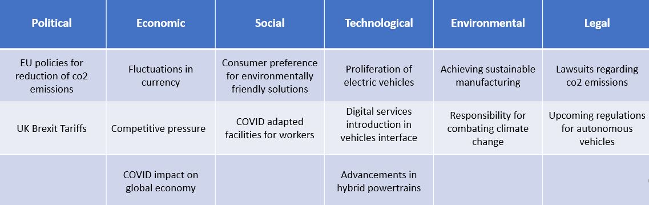
- POLITICAL: The EU introduced new policies for the reduction of CO2 with the purpose which affect Small and commercial vehicles producers applicable from January 2020. Under these regulations manufacturers have to label the fuel efficiency and reduce CO2 emissions of their new vehicles to 147g CO2/km per vehicle. From 2025 a further 15% in emissions will have to be reduced and from 2030 a further 10% (Regulation 2019/631, 2019). This will force the company to improve their manufacturing standards and will generate additional costs. With the advent of Brexit, the UK imposed 10% tariffs for EU imports which will decrease profits for the company in this market (Allan, 2020).
- ECONOMIC: Fluctuations in world currencies might hurt the bottom-line profits. For example, US inflation rose to 5.4% in 2021 from 1.4% in 2020 which might see a depreciation against the EURO (Appendix 1). Competitive pressure from companies like Tesla is forcing Daimler to improve efficiency in their production facilities (Interim Report Q1, 2021). The COVID pandemic had negative effects on the global economy which decreased the company’s profits by 15% in 2020 (Annual Report 2020, 2021).
- SOCIAL: With the threat of global warming, consumers have shifted their focus toward environmentally friendly solutions for their cars and vehicles. In response, Daimler has pledged to stop developing the combustion engine and is committed to become an EV only manufacturer (Eddy, 2021). With the COVID pandemic and workplace regulations that followed, employees have developed new awareness towards mental health, personal safety and general wellbeing. They require better suited workplaces that reflect those values. In response, Daimler made changed the planning of plants to cater to the safety of its employees (Sustainability Report 2020, 2021, p.146).
- TECHNOLOGICAL: In recent years, the market has rapidly proliferated towards hybrid and electric vehicles mainly due to market pressure received from Tesla and Nissan. Advancements in digital services have also accelerated. In response, the company introduced new electric models with the EQ range, from luxury small cars to vans and trucks. Digital services like HABBL and Fleetboard are being introduced for trucks to optimise logistics, and OmniPlus for buses (Sustainability Report 2020, 2021, pp.88-90). The technological factors are a major aspect for the company and it will have to bring innovations to their products to stay competitive
- ENVIRONMENTAL: In 2015 the UN introduced the Paris Agreement which set out a global framework in combating climate change. By 2020, 197 countries ratified the deal which comprise a large part of Daimler’s market. This has increased the responsibility of the company to take steps to achieve sustainable manufacturing and for commercial vehicle companies like Daimler to decrease greenhouse gases emissions.
- LEGAL: In 2020, the company agreed in a US court to pay $1.5 billion in settlements over a lawsuit that claimed Daimler designed it’s diesel vehicles to cheat emission tests (BBC News, 2020). Furthermore, in 2021 in Germany a consumer rights group files a lawsuit that will set a precedent for customers to seek compensations in case their vehicle was installed with illegal software designed to cheat emissions (Reuters, 2021). Countries that are considered important markets for the company like the US, China, Germany, Canada, are setting frameworks to regulate the upcoming autonomous vehicles systems. Daimler set a strategy to develop such systems for their commercial vehicles, therefore these regulations will impact innovations in this space (Annual Report 2020, 2021, pp. 32-33).
Using the Five Forces models, the industry will be analysed to understand the competitive environment Daimler AG finds itself in (fig. 2).
- Bargaining power of customers. Considering that Daimler makes high end vehicles which have relatively high prices, the cost of switching for it’s clients can be considered high relative to the industry average. A lower price alternative available for its small car clients is public transport where the company still holds significant power due to its very successful Daimler Buses division. That being said, the market offers quite a few alternatives for the same types of vehicles which forces the company to keep it’s prices competitive. Buyers of commercial vehicles and fleets hold a higher bargaining power due to higher spending, therefore the bargaining power of customers can be considered moderate.
- Bargaining power of suppliers. Daimler has a diversified list of suppliers for it’s main components (Appendix 2) spread in multiple countries, and since they are of relatively small size, it is important to keep business with such a large company, which keeps their pressure low to the benefit of Daimler. An exception to that is the recent microchip shortage that rose the price of these components and gave suppliers in this category more leverage. Overall, their bargaining power can be considered low.
- The threat from new entrants in the automobile industry is low due major barriers new companies would face. There are high costs for research and development of such complex products, advertising and brand recognition face stifle competition from established companies, developing a global supply network and achieving economy of scale with would require competitive prices for raw materials and large investments in manufacturing plants. The latest entrant that can compete to some extent can be considered Tesla, which managed to establish itself on the global car market with a viable electric vehicle and huge capital investments. This contributed to Daimler’s accelerated shift and huge investments towards EV’s (Eddy, 2021).
- Threat of substitutes. There are many alternative services for transport like public transport, human powered vehicles like bicycles, ride hailing services, trains which offer low costs and are accessible to the public. In terms of automobiles the market offers strong alternatives in all sectors the company operates. For commercial vehicles there is Man, Scania, Volvo, Iveco, the small car section has BMW, Audi, Porsche, Lexus, Ferrari. All these companies have products that compete with Daimler for a share of the market. The threat of substitutes can be considered high and this forces the company to constantly innovate and use competitive pricing to stay successful.
- The rivalry among existing competitors is very high. The industry is very competitive and companies invest large amounts in research and development driving innovation in this market. New models are released every year with improvements on performance, powertrain, technology, design, forcing Daimler to do the same in order to maintain their market position. In promoting their products, the rivalry is just as high and aggressive marketing tactics are used to maintain brand image in some cases with very direct competition (Appendix 3). The only category where Daimler maintains a clear advantage is trucks, where it is the largest producer in the world.
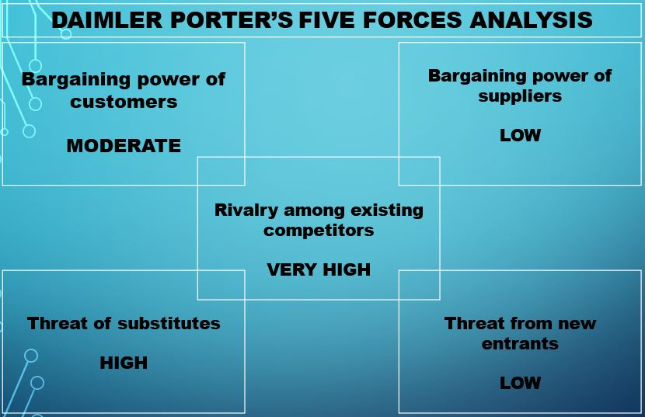

Company culture

The company culture at Daimler will be defined using the 6 elements the Cultural Web model provides.
- Stories. The company prides itself with its founders, Daimler and Benz and with the fact that they invented the automobile. It’s stories relate to the long history and success in delivering high quality vehicles (Tradition | Daimler, n.d.). This shows the company values long term performance, quality of their products and it’s focused on the future.
- Symbols. Daimler’s slogan “The best or nothing at all” is a testament to the company’s commitment to deliver excellence in everything it does and focus towards being the best in their industry. The three-start logo surrounded by laurels that that it has been using since 1925 represents the company’s strength, longevity and is being associated with luxury and quality.
- Power structures. As of 2020, the company has organised its organisational structure to reflect its strategy of becoming carbon neutral and focus on electric vehicles. At the heart of this is the CEO, Olla Kallenius who directs the company towards its goals with a focus on the future, the product strategy and steering are controlled by Wolf-Dieter Kurz who is tasked with focusing on customer centricity and reports directly to the CEO, the chief operating officer is in charge of all areas that are related to innovation and value creation, and the four brands are controlled directly by CFO’s (Daimler organisational structure, 2020). The power at Daimler is organised around highly professional executives, who are tasked with achieving the strategic goals and through them the company maintains close control of the key aspects of its strategy. This power distribution can hinder the company’s response to changing situations and slow it’s response to external threats.
- Organisational structures. Daimler has a hierarchical structure with top-down management and direct communication between the levels. It has formal positions and direct reporting up the chain of command (Appendix 4). The manufacturing plants offer a highly professional environment with clear roles focused on collaboration rather than competition (Car & Performance TV, 2020).
- Control systems. The most closely controlled aspect in the company is performance, with benefits above base salary for those who achieve it. The company carries out regular spot checks to determine how the compensation system is being applied (Compensation and benefits., n.d.). The focus is on reward rather than penalties, and it reflects the company’s long-term values of achieving excellence and maintaining high quality.
- Routines and rituals. Daimler has training and development programs available for it’s employees to improve their qualifications and advance their positions in the company. INspire helps them gain skills for specialised or management positions, Daimler Academic programs offers them options to study while working, and the company uses a strategic approach for developing their human resource through which they plan ahead for the skills and qualifications needed in the future (Sustainability Report 2020, 2021, pp.88-90). Within the workplace emphasis is put on quality and performance and their workers enter an environment of professionalism (Car & Performance TV, 2020). The values this shows are of performance, quality and innovation.
Overall, the company culture at Daimler AG is in line with it’s values. Their drive to achieve excellence with their products translates in a culture focused on quality in performing tasks, respect for its history and traditions and increasing efficiency in production. The big investments they make in their employees and technological advancement show a commitment to and long-term orientation through innovations for the future. The somewhat rigid organisational structure and power focused on a few people show a tight control over the company’s direction and operations.

Impact of External factors on Organisational Culture

The intense competition Daimler sees in the auto market forces it to adopt the highest standards possible in order to remain a leader in the industry and to have a strong focus on innovation and technology development. The company adjusted it’s market strategy to reflect these goals through the organisation restructuring and large investments towards new technologies like EV development and digital services. In the 2020 Annual Results Conference (2021, p. 26) the strategic goals it set for 2021 are raising performance, accelerating technology and preparing project focus. The values it focused on for achieving the strategy are customer centricity and drive for innovation. The Covid-19 crisis had an impact on the company in terms of sales and generated changes in the mindset of the leadership which affected the company's culture. The members of the supervisory board attended voluntary courses to increase their ability towards performing their tasks, and communication between the senior management was increased to exchange opinions and find better solutions to arising problems. Independent audit committees were brought in to review board meetings and provide opinions on them (Annual Report 2020, 2021, pp. 15-17). These changes show an orientation towards increasing communication and cooperation with the purpose of increasing operational efficiency. While these are positive adjustments in the company culture, the rigid management structure can pose a challenge in achieving the high levels of innovation the company strives for. Regulations regarding lowering of co2 emissions and general sustainability made Daimler enact a strategy called Ambition 2039. In this strategy the company aims to achieve carbon neutrality through the design of new manufacturing facilities to use renewable energy sources, control the raw materials supply chain to ensure they meet these standards and help them achieve by conducting workshops with them to identify sustainable measures they can apply (Källenius, 2019). That being said the company still operates 93 factories that are incompatible with the carbon neutral model and will be an obstacle in achieving this milestone. In order for these goals to be better accomplished, the company could shift from it’s top-down decision making to a more relaxed culture that encourages lower departments to come up with new ideas and provide communication channels for them to be heard.

Impact of Company’s Culture on Performance

The organisational culture at Daimler is based on high standards, excellence and innovation. These values can be seen across their operations from production to strategy to leadership and through them the company achieves high performance and aims to be the best at what it does providing high quality products and services to their customers. The previous 2 years performance show how these values are benefiting the company. Even though their revenue decreased by 9% overall in 2020 compared to 2019, their net profits have risen by 48% in the same period by achieving increased efficiency across the board (fig. 3) 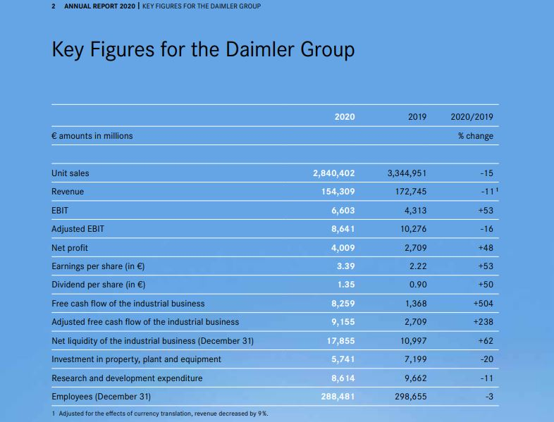
The company has kept up with developments in the automotive industry and through innovations in technology it introduced 11 new electric vehicle models including 4 passenger cars, 3 vans and 4 trucks, in line with their pledge towards sustainability (Going Electric into the Future, n.d.). Even though the Covid crisis decreased investments in their workforce, the company is committed to developing their employees, and still allocates significant sums towards training them (fig. 4).
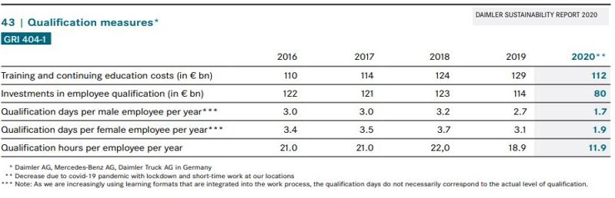

Ethical Dilemma

An ethical dilemma is a situation where there is a conflict between two moral choices. In modern businesses these are the result of unethical decisions that give rise to difficult moral questions and involve high level decision making regarding changes or managing internal activities. They can take many forms and include different aspects of the business like in marketing there is a choice between making honest advertisements that might not get great results or overstating benefits and using manipulation tactics like positive enforcement, subliminal messaging, etc. to increase engagement. In the workforce a common scenario is nepotism where people close to the employer could be favoured over more qualified applicants generating an ethical dilemma. A recent example in Daimler was the emissions scandal where the company decided to make an unethical decision and use software to cheat emissions tests instead of making investments to comply with regulatory measures and achieve lower emissions in their vehicles. This decision backfired when the cheating was revealed and resulted in large penalties for them (BBC News, 2020). The current dilemma the company faces involves the change to electric vehicles and even though it has pledged to shift towards these technologies it still receives a large part of their revenue from sales of combustion engine-based ones. This creates an ethical dilemma for Daimler in the environmental area where it has to choose between focusing on the development and sales of vehicles with zero emissions or maintain their market position and profits by continuing to release new models of polluting ones. The company seems to be making a gradual choice in the moral direction by promoting their EV range and developing new models while still releasing petroleum-based cars with increasingly lower emissions each year.

Recommendations

For increasing the innovative ideas, Daimler should adjust their organisational structure from the hierarchical model it currently enacts to include elements of a flat structure like developing communication channels between the 4 different categories and encourage lower-level employees to come up with new ideas of efficientising their workplace and provide better services. For achieving the sustainability goals the company should find ways to bring changes to their current manufacturing facilities like extending the controls and standards it imposes on it’s raw materials suppliers to include energy suppliers and ensure they come from renewable sources. Given that it is one of the most successful companies in their industry, they could make a statement towards sustainability by discontinuing their combustion-engine based models and release only EV’s going forward. Even if that means lowering their revenue, since the market is moving in that direction anyway and with their position they could accelerate the process industry wise and establish themselves as leaders in sustainable development.

Conclusion

The report provides insight into Daimler’s culture and how external factors affect its performance through an analysis of the factors that have an impact on it. Daimler AG is one of the worlds most successful company in the automotive industry and it distinguishes itself through high quality vehicles and has a long history of excellence in their operations. Their values are reflected internally through high manufacturing standards, a highly professional workforce and a focus on innovation. It focuses on long term results and continues their pioneering tradition by making constant investments in the latest technologies and methods keeping itself at the forefront of the market. The culture they promote is essential in achieving their goals and has very few shortcomings which will help the company stay successful in the highly competitive environment it faces.

Individual Reflection

During this term on the module Workplace culture and its impact on Organisational Efficiency I learned to evaluate the environment of an organisation with both internal and external factors and how that impacts its performance and behaviour. Its culture is a system of shared values held by all its members and distinguishes an organisation from others. I understood the internal factors like different types of organisational structures like hierarchical or flat and how each have benefits and drawbacks and are better suited for different types of companies depending on their needs and define how well it can operate. The values of its leadership define the elements that comprise its culture like morality and sustainability, they are the first steps in its creation and determine how a culture is reinforced and maintained within a company. Employees are shaped to follow the company’s culture and reflect in their behaviour through a socialisation processes they are exposed to when they enter it where they learn about its stories, rituals and processes. Some of these values generate the business ethics which have implications on their stakeholders and how the organisation is perceived. In some cases, the ethics can generate dilemmas where doing the right thing might have lower results than otherwise and they can put an organisation in positions where tough choices have to be made. The company’s culture is crucial in its ability to perform successfully and there are different types of thinking that define how it approaches its operations like inductive or deductive reasoning and a company that operates in multiple parts of the world might encounter different types of it.
I learned about analytical models that help identify factors that affect an organisation like the PESTEL model who deals with macroeconomic factors that affect a company, SWOT for internal ones and Porter's Five Forces that show how the external factors from within its industry that affect an organisation. The Cultural Web model provides a framework through which practical factors can be used to analyse a company’s values to identify its culture. Mckinsey’s 7’s model is useful for facilitating change in an organisations strategy, structure, staff, operations. Other models that affect an organisations performance were explained to me as the Beer model which identifies 6 barriers that prevent a company from being successful, the Organisational Health Index that analyses actions and processes to identify how well they align with a company’s long-term goals and ultimately define its success and Haanan and Freeman’s theory that analyses hoe an organisation performs in challenging environments. I had good examples of how to apply them and I am confident that I can use any of these models to make an analysis in a practical way for any organisation.

References

Marketline, 2021. Daimler AG. [online] Advantage-marketline-com.ezproxy.uwtsd.ac.uk. Available at: <https://advantage-marketline-com.ezproxy.uwtsd.ac.uk/Company/Profile/daimler_ag?companyprofile#BusinessDescription> .
2021. Annual Report 2020. [pdf] Daimler, p.2, 32-33. Available at: <https://www.daimler.com/documents/investors/reports/annual-report/daimler/daimler-ir-annual-report-2020-incl-combined-management-report-daimler-ag.pdf> .
Wagner, I., 2021. Mercedes: market share in the EU 2021 | Statista. [online] Statista. Available at: <https://www.statista.com/statistics/276309/mercedes-market-share-of-new-car-registrations-in-the-eu/> .
Mullins, L., 2016. Management & organisational behaviour. 11th ed. Harlow: Pearson, pp.77-78, 543-544.
Porter, M., 1980. Competitive strategy Techniques for Analysing Industry and Competitors. New York: Free Press, pp.25-45.
Official Journal of the European Union, 2019. REGULATION (EU) 2019/631 OF THE EUROPEAN PARLIAMENT AND OF THE COUNCIL. [online] 111(13). Available at: <https://eur-lex.europa.eu/legal-content/EN/TXT/?uri=CELEX%3A32019R0631> .
Allan, L., 2020. Confirmed: 10% import tax on new cars from European Union | Autocar. [online] Autocar. Available at: <https://www.autocar.co.uk/car-news/industry/confirmed-10-import-tax-new-cars-european-union#:~:text=Cars%20imported%20into%20the%20UK,the%20UK%20government%20has%20confirmed.&text=The%2010%25%20levy%20will%20apply,the%20end%20of%20this%20year.> .
Daimler.com. 2021. Interim Report Q1. [online] Available at: <https://www.daimler.com/documents/investors/reports/interim-reports/q1/daimler-ir-interimreport-q1-2021.pdf> .
Eddy, N., 2021. Daimler speeds up plans to be electric-only automaker. [online] Automotive News Europe. Available at: <https://europe.autonews.com/automakers/daimler-speeds-plans-be-electric-only-automaker> .
2021. Sustainability Report 2020. [pdf] Daimler, pp. 88-90, 139-141, 146. Available at: <https://sustainabilityreport.daimler.com/2020/servicepages/downloads/files/daimler-sr-2020.pdf> .
BBC News. 2020. Daimler to pay $1.5bn over emissions cheat claims in US. [online] Available at: <https://www.bbc.co.uk/news/business-54153126> .
Reuters, 2021. German consumer group files diesel emissions lawsuit against Daimler. [online] Reuters. Available at: <https://www.reuters.com/business/autos-transportation/german-consumer-group-files-diesel-emissions-lawsuit-against-daimler-2021-07-07/> .
Daimler. n.d. Tradition|Daimler. [online] Available at: <https://www.daimler.com/company/tradition/> .
Daimler. 2020. Daimler organisational structure. [online] Available at: <https://www.daimler.com/company/news/organizational-structure.html>
Car & Performance TV, 2020. Mercedes PRODUCTION - Germany CAR FACTORY. [video] Available at: <https://www.youtube.com/watch?v=GmqtZlYpqWg> .
Daimler. n.d. Compensation and benefits.. [online] Available at: <https://www.daimler.com/career/about-us/culture-benefits/compensations-and-benefits/> .
2021. Annual Results Conference 2020. [pdf] Daimler, p.26. Available at: <https://www.daimler.com/dokumente/investoren/berichte/geschaeftsberichte/daimler/daimler-ir-capitalmarketpresentation-fy-2020.pdf> .
Källenius, O., 2019. Ambition2039: Ola Källenius on LinkedIn | Daimler. [online] Daimler. Available at: <https://www.daimler.com/company/corporate-governance/board-of-management/kaellenius/linkedin/ambition-2039.html>
Daimler. n.d. Going Electric into the Future. [online] Available at: <https://www.daimler.com/sustainability/climate/electric-offensive.html> .

Appendixes

Appendix 1
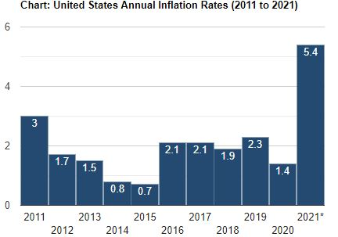

Appendix 2
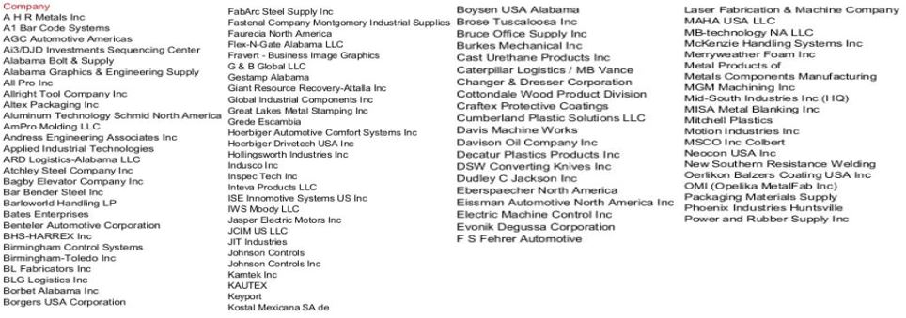

Appendix 3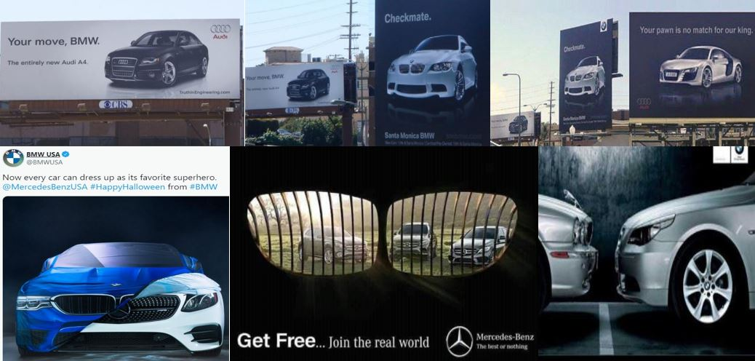

Appendix 4

